
MSc Public Health and Social Care in Practice
Module Name: Health Care System, Organisation and Leadership
Module code: LCHS7002
Lecturer: DR. Fahad Khan
Student Name: Isha Patel
Student ID: 2503804

Case Study Analysis Report: Comparative report on COVID19 leadership responses

Table of Contents
Introduction 3
Rich Picture Approach 4
Spain’s Rich Picture 4
South Korea’s Rich Picture 5
Canada’s Rich Picture 6
Key for Rich Picture 7
Centralised vs. Decentralised Healthcare Systems 7
South Korea: Centralised vs. Decentralised System 9
Canada: Centralised vs. Decentralised System 10
Leadership Theories Overview 11
Leadership in Spain 11
Leadership in South Korea 12
Leadership in Canada 12
Comparative Discussion 13
Conclusion 14
Reference list 16

Introduction
The COVID-19 outbreak that developed at the end of 2019 quickly turned into one of the most considerable global health crises in contemporary history (Pollard et al., 2020). The healthcare systems, the economy, and governance system worldwide were disrupted. It affected much more than the medical community, challenging the abilities of governments to handle uncertainty, communicate efficiently and introduce the kind of policies which would balance both the need to prioritise the health of the population with the realities of the socioeconomic environment. The pandemic has shown the strengths and weaknesses of the healthcare systems of various countries. It has also demonstrated how the institutional organisation, the leadership style, and trust of the people all played a role in the outcomes of the crisis. In this regard, the knowledge of country-specific reactions provides essential information about global readiness, flexibility, and resistance during unexpected outbreaks of public illnesses. The difference in the responses of countries was based on differences in the governance of health systems. Aubrecht et al. (2022) argue that some countries had a highly centralised model which facilitated quick decision-making, while others were based on a decentralised model that allowed regional freedom. Two important dimensions in this comparative analysis are the degree of centralisation and decentralisation of health care systems and leadership in time of crisis. With a centralised healthcare framework, the national government retains the power to make decisions, which is why it is easy to implement policies rapidly with uniformity, whereas in a decentralised system, the power is shared between regional or local units, with policy-makers able to make decisions that are specific to the context.
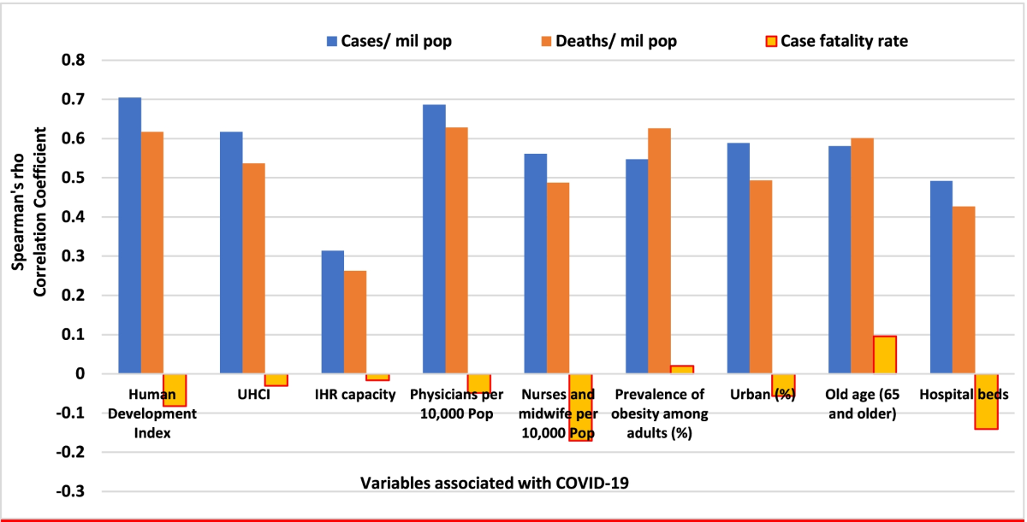
Figure 1: Impact of COVID-19
(Source:Assefa et al., 2022)
The strike of these two directions played a great role in the way the countries dealt with lockdowns, testing, and vaccination. As well as structural organisation, leadership approaches were also critical determinants of influencing the behaviour of the people, trust, and compliance. According to Koutsona (2020), The pandemic required the kind of leaders who could inspire confidence, speak candidly, and make critical decisions under high levels of pressure in a manner that is data-oriented. This report aims to compare the way Spain, South Korea and Canada structured and managed the healthcare system during the COVID-19 pandemic. This will be done about the interaction between the institutional structures and leadership styles. It analyses the impact of the levels of centralisation on the national coordination and the application of the different theories of leadership by different leaders, such as Spain, South Korea and Canada through the examples. The analysis using the existing theoretical frameworks unveils the role of the governance structures and leadership in shaping policy coherence, public trust, and health outcomes. The report will consist of rich pictures to map out the responses of each country visually, then the systematic comparative analysis of the organisation and the leadership styles in healthcare systems. It ends by giving major lessons about resilience, flexibility, and policy integration and providing details on future pandemic preparedness and health governance reform.

Rich Picture Approach
The Rich Picture is a visual systems tool that is applied to visualise the complexity and interrelationships of a specific situation or problem (Gates, 2023). It has arisen as an extension of the systems theory which provides a global view of an issue not only by acting as a presenter of the main facets of a problem but also by portraying how they connect, relate as well as the feedback loops involved. Unlike a linear diagram or a statistical model, a Rich Picture is a mixture of qualitative and contextual data, which includes the opinion of stakeholders, emotionality, and organisational processes as stated by Kado et al. (2023). This makes it particularly applicable to the analysis of complicated scenarios including outbreak of the COVID-19 pandemic when health outcomes were mediated by the interaction of medical, political, social and economic variables. Through mapping these dimensions that are linked with each other, the Rich Picture assists in defining the key leverage points, systemic bottlenecks, and areas of success or failure in the response strategy of each country.
By methodology the Rich Picture presents a method by which to incorporate different sources of information, policy documents, statements by the people, and health performance measures to a single visual story (Tracy, 2024). It underscores the impact of the decisions of the leaders to the functioning of the healthcare systems, the strategies of communication with the population, and the policy execution based on the institutional structures. As an example, direction of influence could be represented in the form of arrows in the diagrams, and different colours and shapes could be used to represent entities like government ministries, hospitals or community actors. This visual mapping facilitated a better explanation of the way power centralisation or decentralisation influenced responsiveness, coordination, and involvement of the people. The Rich Picture of the respective countries will be contextualised in this report: Spain will present the tensions of decentralisation and long time to coordinate, South Korea will present the picture of successful central command and integration of technologies, and Canada will present the picture of federal-provincial collaboration challenges.

Spain’s Rich Picture
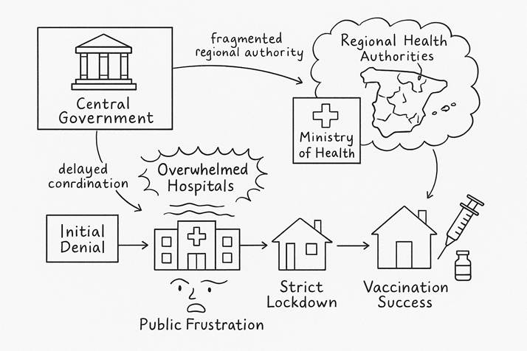
Figure 2: Spain Rich Picture
(Source: Self-developed)
The Rich Picture of the COVID-19 response in Spain gives a vivid picture of the way the lack of coordination and fragmented governance conditioned the first challenges and the ultimate salvaging of the country. At the head of the diagram, there are the Central Government and the Ministry of Health as the main authorities in the policy direction and the communicator of the crisis. Nonetheless, Sánchez-Bayón et al. (2022) has mentioned that the 17 Autonomous Communities of Spain, which were portrayed as Regional Health Authorities, had a major influence on the healthcare delivery, resulting in fragmentation and irregular responses at the regional level during the early part of the pandemic. This decentralised structure established communication blocks among the national bodies and regional bodies which was displayed in arrows signifying delayed coordination and poor systemic integration (Valle and de Olagüe-Smithson, 2021). The chronology of the events, denoted in a chronological order, starting with Initial Denial - Overwhelmed Hospitals - Strict Lockdown - Vaccination Success, serves to describe the process of the development of the pandemic management in Spain.
The First stage of Denial provides more emphasis on the initial underestimation of the risk where the government reassurances were met by the explosion of cases. This saw the creation of Overwhelmed Hospitals, which metaphorically represented the pressure on health care systems and personnel. Royo (2020) points out that public Frustration is the visual expression of anxiety and distrust experienced in the society when infections were on the rise and health systems were overwhelmed with them. The Strict Lockdown phase becomes a turning point to a centralised approach to emergency control, provisionally consolidating the power to make decision-making on a national level. This point of turning enabled better coordination and distribution of resources as well as containment. Lastly, the Vaccination Success stage, which is represented by a needle and a bottle of vaccine, symbolises the redemption of Spain through one of the most effective vaccination programs in the entire of Europe (Catalán-Matamoros and Langbecker, 2023). This stage underscores the healing process of trust and productive cooperation between the local and national governments.

South Korea’s Rich Picture

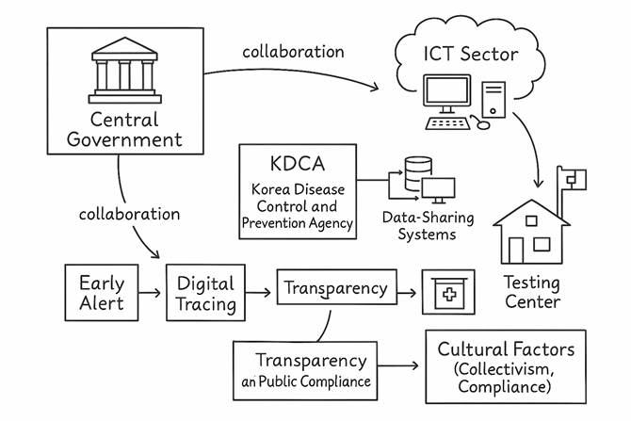
Figure 3: South Korea Rich Picture
(Source: Self-developed)
The Rich Picture that represents the response of the South Korea to COVID-19 provides a clear and systematic account of the coordinated and technology-oriented strategy of the country. The heart of this network is the Central Government that worked legibly with the Korea Disease Control and Prevention Agency (KDCA) and with the Ministry of Health and Welfare as well as the ICT sector to establish a harmonized national reaction (Kim et al., 2021). The described timeline Early Alert - Digital Tracing - Transparency and Public Compliance shows a proactive and organised strategy of South Korea, which enabled it to manage the virus without lockdowns on a large scale. The Early Alert stage denotes the rapid mobilisation of the government as soon as the first confirmed cases had been reported and it was backed up by scientific monitoring and communication systems of the KDCA. Digital Tracing, which is introduced on the basis of developed data-sharing platforms and mobile applications, is an example of technology and governance interaction. As per the findings of Yoon et al. (2025), the ICT sector contributed greatly to contact tracing in real-time, public notification, and effective testing management. This collaboration is depicted by arrows between the data-sharing systems, testing centres, and central authorities as the inter-agency collaboration is of a high level. The public communication strategy in the government was based on transparency, which guaranteed the flow of information between the government and the people. This openness cultivated Citizen Trust, which created a feeling of Collectivism and Compliance based on the culture of South Korea.

Canada’s Rich Picture
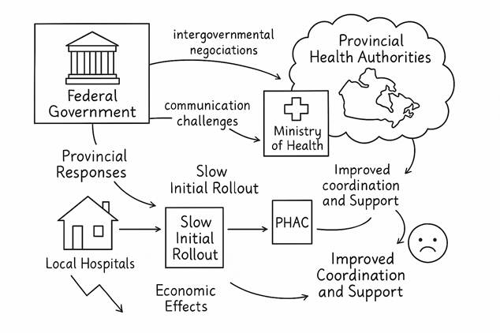
Figure 4: Canada Rich Picture
(Source: Self-developed)
The Rich Picture that describes the response to the COVID-19 in Canada is a well-structured, scholarly visualisation of the role the federal system of governance in the nation played in managing the pandemic. At the centre of the diagram, the Federal Government appears to be a centralising body that negotiates with the Provincial Health Authorities intergovernmental, which is characteristic of the Canadian healthcare system of decentralisation (Smith et al., 2022). The PHAC and the Ministry of Health are the overall coordinating agencies charged with the responsibility of guiding policy in the country and providing data collection. The timeline, Provincial Responses, Slow Initial Rollout, Improved Coordination and Support show how the strategy to better response by the Canadian government evolved since having a disjointed start. At first, different provinces implemented different actions, which resulted in the uneven rates of restrictions and speed of vaccine delivery. The communication challenges arrows highlight the challenges around synchronisation of public communications and resources mobilisation over the regions. According to Chan et al. (2023), the Local Hospitals in the community level are the first lines of healthcare services and the regional autonomy resulted in both flexibility and capacity and access inequalities. The broader systemic interactions such as economic effects of lockdowns and the co-occurring increase in pressure on mental health throughout the society are also covered in the diagram.

Key for Rich Picture
As stated by Bell et al. (2019), a key to the Rich Picture diagrams is an indicator of how to interpret the symbols, structures, and book text elements that have been applied throughout the visual representations of the response to COVID-19 in Spain, South Korea, and Canada. Systemic interactions within the healthcare and government systems of the respective countries are all mirrored in each component of the visual elements. Boxes denote key stakeholders, including central governments, health ministries, and regional authorities, as well as such agencies as PHAC or KDCA. These entities are placed in such a way as to demonstrate hierarchical or shared relationships. Arrows represent the direction of communication, policy or influence between actors, solid arrows represent good coordination, curved or fragmented arrows indicate slow or decentralised responses. The timeline sequences (for instance, Initial Denial- Lockdown-Vaccination Success) are used to capture the chronological sequence of the pandemic management processes. The institutional roles are represented by icons and buildings (e.g., hospitals, houses, government structures), whereas the decentralised systems, uncertainty as well as collective entities (such as regional authorities) are depicted using cloud shapes. Face and wavy lines refer to emotional or social aspects like general dissatisfaction, trust or obedience. Also, the digital integration and technology-driven responses are accentuated in data servers or computers, especially the case of South Korea. The diagram in Canada depicts economic and mental health impacts by use of a downward arrow, or emotive symbol to depict ripple impacts which are not in public health. Clarity and comparability is ensured by the consistent use of minimal colour and clean lines (Allen et al., 2022).

Centralised vs. Decentralised Healthcare Systems
Healthcare system centralisation and decentralisation affect governance, service delivery, and crisis management. According to Krenyacz and Revesz (2025), centralised healthcare consolidates national decision-making and resource control. This structure supports system-wide policy, guidelines, and resource allocation. To maintain consistency and accountability, the central government, generally a health ministry, establishes priorities and controls all operational levels. On the contrary, Oliveira et al. (2024) state that regional or local governments have greater influence over policy, resource allocation, and healthcare delivery under a decentralised system. National programs can be tailored to regional population needs and epidemiological circumstances to be flexible and respond to the context by regional organisations. The WHO advises equal power distribution between central and local in order to promote responsiveness and equity in the governance of the health systems. WHO health system governance framework enhances accountability, transparency and stewardship. Both methods can be effective provided that they are coordinated and linked to a national objective. The tradeoff between agility and coordination in crisis management demonstrates the importance of centralising or decentralising it. Hierarchical decision-making and lean command structures ensure centralised systems such as New Zealand and South Korea respond fast and correctly. This will speed up the implementation of policies, national communication, and mobilisation of national resources such as testing kits, immunisations, and medical staff. Emergency compliance needs to be consistent with messaging as a way of minimizing confusion and establishing trust in the population. Nevertheless, Shishkin et al. (2025) believe that centralisation can be so much that it prevents the in-depth adaptation of local levels by filtering decisions through the bureaucratic apparatus. In such systems as Canada or Spain, which are decentralised, policy formulation can be done at the regional level using local data and resources. In case of poor intergovernmental communication, independence can divide the collaboration and slow down national unity.
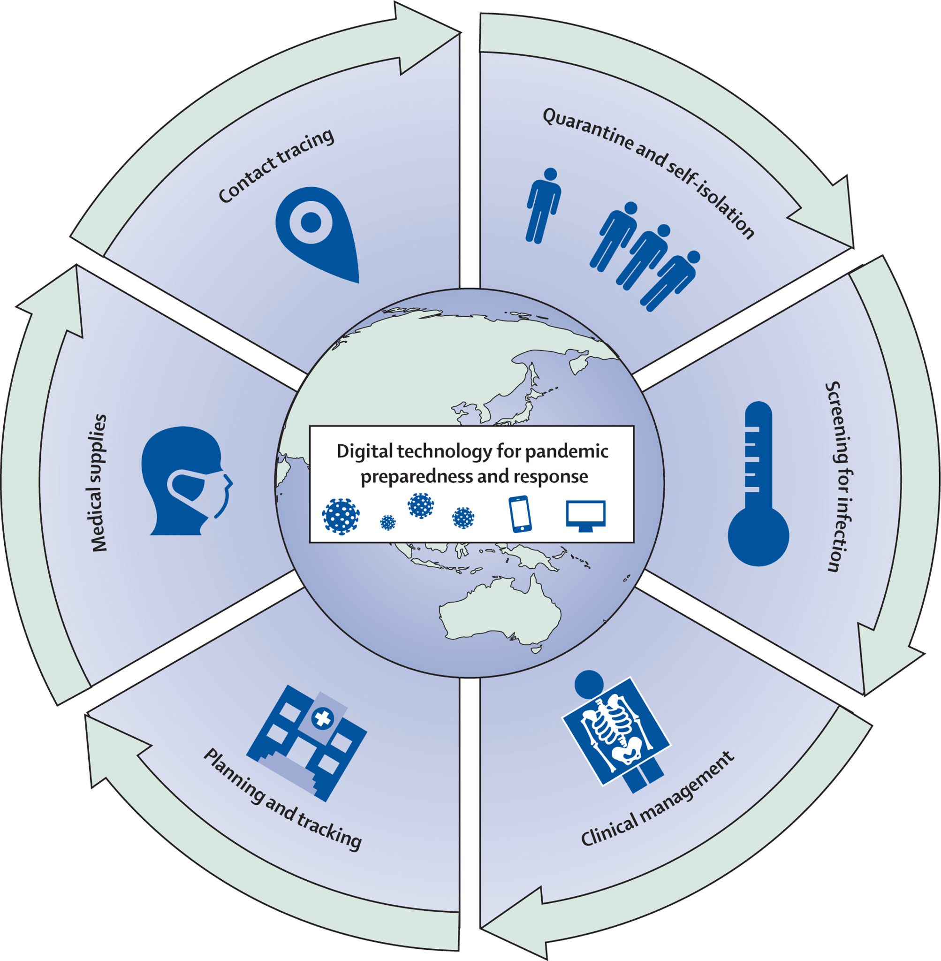
Figure 5: Digital infrastructure during COVID-19
(Source: Whitelaw et al., 2020)
Coordinated command centres, digital infrastructure, and national emergency preparations in centralised countries enabled early discovery, testing, and isolation. KDCA cooperation in South Korea illustrated how national leadership and technological integration enabled monitoring and containment (Tejerina and Kang, 2024). Spain's 17 autonomous municipalities and Canada's province governments have various lockdown and immunisation policies, causing infection control challenges (Sánchez-Bayón et al., 2022). These disparities highlighted local autonomy vs national integration. Centralised systems procured and provided immunisations equitably, but decentralised ones were delayed by jurisdictional arguments and supply chain concerns. However, decentralisation tailored local information to population needs. The pandemic indicated that the strongest systems have central leadership for strategic direction and decentralised execution for operational flexibility. Structural balance, effective communication, and national-local accountability support efficient health system governance during global health emergencies.
Spain: Centralised vs. Decentralised System
Decentralised healthcare, resource allocation, and hospital management are managed by Spain's 17 Autonomous Communities (Sánchez-Bayón et al., 2022). The National Ministry of Health managed regional health operations with little direct control before the COVID-19 pandemic. This organisation was flexible and locally responsive in normal times but failed amid a nationwide health crisis. Decentralisation affected healthcare infrastructure, preparedness, and data management regionally. Madrid and Catalonia had advanced hospitals and testing facilities, whereas others lacked money and collaboration. As the virus spread rapidly in early 2020, Spain had no national mechanism to coordinate testing, hospital admissions, and critical care. Regional infection rates and hospital capacity differed during the first pandemic. The Autonomous Communities responded in various ways- some of them limited early on, others waited and had uneven containment. According to Royo (2020), the initial accusation made against the administration of Pedro Sánchez was the underestimation of the threat, Health Minister Salvador Illa informing that the system was ready as diseases spread rapidly. The March 2020 Spanish State of Alarm was the transition of decentralisation to centralisation; this was transitory (Erkoreka et al., 2021). Rapidly, the government nationalised the regional hospital regimes, made lockdowns standard, organised supply chains, and made national regulations.
This enhanced coherence and resource management, stabilising the operations of hospitals and flattening the infection curve. According to the World Health Organisation (2021), six weeks after the lockdown, the number of new cases decreased in Spain by 70 percent, which demonstrates that centralised activity can bring sanity and collaboration. The central government's EU logistical and procurement collaboration made Spain's post-crisis immunisation program one of Europe's most successful. By mid-2022, centralised vaccine procurement and regional distribution networks immunised over 90% of Spain's adults, balancing national leadership with local execution (Falcón et al., 2023). Restoring decentralisation increased regional-national medical supply finance and delivery issues. Regions challenged the federal government for greater power over restrictions and economic opportunities. Spain's shifting government style necessitates leadership flexibility and structural alignment with situational urgency, per Contingency Theory. Decentralisation provides for individualised decision-making in regular conditions, but centralisation ensures consistency, speed, and direction in emergencies. Spanish experience highlights the need of adaptable leadership that can move between decentralised autonomy and centralised authority depending on risk and urgency.

South Korea: Centralised vs. Decentralised System
The Korea Disease Control and Prevention Agency (KDCA) and Ministry of Health and Welfare run South Korea's highly centralised healthcare system. National authorities may oversee and coordinate quickly across all areas during public health crises using this governance approach. South Korea created an integrated command structure that shared information between national agencies, hospitals, and local governments from the start of the COVID-19 epidemic. As Yang et al. (2020) found out, early epidemiological infrastructure investment after the 2015 MERS pandemic prepared the nation for quick mobilisation. The KDCA consolidated data reporting, approved testing facilities nationally, and offered public daily briefings to guarantee accurate and consistent information within days of the first COVID-19 instances. Unlike decentralised systems that failed to synchronise activities, this strategy generated a consistent national response that reduced regional differences and confusion.
South Korean pandemic response used the “3T” framework—Testing, Tracing, and Treatment (Broadband Commission, 2020). Through government partnerships with biotechnology companies, test kits were mass-produced in weeks, achieving one of the world's fastest testing rates. Digital contact tracking required national surveillance systems to integrate mobile applications, GPS data, and credit card histories. Community awareness without nationwide lockdowns was maintained via mobile alerts about local ailments. By April 2020, South Korea ran over 20,000 tests each day to detect positive cases early and prevent exponential growth (Exemplars.health, 2025). Every communication was open, and KDCA Director briefings created confidence. Openness boosted compliance due to cultural collectivism and central government faith. South Korea miraculously levelled its infection curve by mid-2020 without lockdowns, sustaining economic and social stability.
Success of South Korea's centralised approach correlates with Transformational and Systems Leadership theories. Visionary leaders like Prime Minister Chung Sye-kyun and President Moon Jae-in stressed communication, empathy, and empowerment to inspire community purpose and trust (Tworek et al., 2020). Through systems leadership, the government combined technology, science, and citizen involvement into a national response. Policy, innovation, and citizen conduct were interrelated pieces of the system. This overall coordination, supported by strong leadership and public confidence, made South Korea a pandemic management leader.

Canada: Centralised vs. Decentralised System
Provinces and territories supply and operate Canada's healthcare system, which the federal government finances and oversees. Canada's constitution encourages regional autonomy, therefore jurisdictional division. This decentralisation affected national collaboration during COVID-19 owing to jurisdictional difficulties. PHAC was a central advisory body, although provinces interpreted its advice differently. Allin et al. (2021) noticed that British Columbia took precautions swiftly, while Ontario and Quebec hesitated, increasing infection rates. Canada's dependency on foreign suppliers slowed vaccine procurement and deployment compared to other OECD nations. Canada's decentralised model has advantages despite these drawbacks. Community-level adaptation might help regional governments manage testing, contact tracking, and education campaigns for local epidemic circumstances. Lower-population provinces reduced healthcare demand via flexible local containment. This autonomy generated miscommunication, unequal travel limitations, and public confusion regarding rule changes. Inconsistent province data sharing lowered national awareness.
Canada demonstrates decentralised collaboration and accountability via Distributed Leadership Theory (Hansen and Cyr, 2020). Provincial premiers, federal ministers, public health officials, and local authorities led with expertise and authority throughout the outbreak. Prime Minister Justin Trudeau favoured consensus over directives. Federal-province logistical and budgetary agreements boosted vaccination implementation later in the outbreak. After early decentralisation hampered crisis response in Canada, cooperation across levels of government proved that dispersed leadership may enable decision-makers to adapt, collaborate, and share responsibility in a federal system.

Leadership Theories Overview
Different leadership theories describe how crisis leaders persuade, direct, and mobilise others. Transformational leadership drives followers to put the collective first. Health problems need unity and flexibility, which fosters creativity and emotion. Transactional Leadership promotes structure, incentives, and laws to preserve order and discipline in operations. Situational leadership holds that excellent leaders adjust to followers' readiness and the situation. Distributed leadership, especially in complex institutions like hospital governance, promotes accountability and collaboration. Coping with crises like COVID-19 needs dexterity. Hassan (2023) mentioned that transformational and situational methods work best when they encourage speedy innovation, open communication, and emotional resilience. While on the other hand, participative and adaptive leadership increased public compliance and recovery speed, according to WHO (2021). Flexibility was hard for rigid transactional models. Thus, chaotic global health crises benefit best from hybrid leadership that combines structure, collaboration, and inspiration.

Leadership in Spain
Through political turmoil and strategic shifts, Spain led COVID-19. Pedro Sánchez's government first looked hesitant and reactive, trying to coordinate a fractured political and healthcare system. Government health minister Salvador Illa's early claims that the country was “prepared to confront the situation” indicated the outbreak was overestimated. Decentralised Spain's 17 Autonomous Communities prevented rapid national coordination, resulting in varied regional responses and congested hospitals, notably in Madrid and Catalonia (Sánchez-Bayón et al., 2022). Early epidemic weeks highlighted governance flaws and the dangers of laissez-faire leadership, when delayed action and inadequate foresight increased infections. As the government was accused of inaction and underreporting case data, public trust fell, requiring a readjusting. Sánchez embraced Situational Leadership when things deteriorated. With the March 2020 “State of Alarm”, leadership centralised (Erkoreka et al., 2021). This briefly unified national government decision-making, improving medical supply distribution, resource mobilisation, and information management. The tight lockdown was required to regulate transmission but realistic in crisis dynamics. Transactional features included penalties and emergency decrees for compliance and national unity. Scientific news briefings reduced deception and improved transparency. As per White et al. (2021), public trust was rebuilt by transparency and government vaccine procurement and coordination.
By centralizing the supply chain of vaccines and relying on regional healthcare networks, the government reached one of the highest immunization rates in Europe, approximately 90 percent by the middle of 2022 (Falcón et al., 2023). According to Losa Diaz et al. (2020), Spanish crisis leadership revealed that it is necessary to learn and make mistakes, alter communication strategies, and combine authority and empathy. Spain also became a transition between anarchy and stability, and joint recovery producing under situational and partially transformational leadership, increasing its political and institutional ability to handle future crises.

Leadership in South Korea
Spain was slow in responding, and aggressive, science-oriented, and moral government was run by the Prime Minister of South Korea, Chung Sye-kyun, and President, Moon Jae-in. Transformational and Participative Leadership focused on transparency and speedy decision-making and interaction with people since the beginning of the pandemic. Scientific rationality manifested in the government in terms of rapid activation of emergency services, building extensive testing facilities, and incorporating data analytics. Through Moon, there was more community involvement and open communication that made people more trustful and less fearful and misinformed. Servant Leadership encourages humility, respect, and empowerment as opposed to top-down authority as stated by Stahel et al. (2022). Both chiefs banded together with the KDCA to enable the professionals to make national policy. South Korea also emerged successful through the cooperation of the institution. ICT industry monitored contact through mobile alerts and online surveillance, and the government aligned with the commercial biotechnology firms in creating and supplying test kits in a rapid manner. This multi-disciplinary teamwork exhibited Systems Leadership in which networks are substituted with hierarchies. The outbreak of the infection and the travel history were shared to educate about self-responsibility, rather than to enforce it. The 3T plan: Testing, Tracing, Treatment, the so-called 3T is a worldwide strategy of containment of pandemics that integrated both science and social cooperation (Broadband Commission, 2020).
This was an effective leadership style. South Korea did not go into lockdowns, continued with economic activity, and managed the epidemic at an early stage and maintained morale. By the middle of 2020, its governance was proven as the country had fewer than 100 cases of infection daily (Kang et al., 2020). The data ethics and privacy of South Korea were recognized in the world. Measuring crisis leadership was based on legitimacy and moral trust, and not on infection control. The government's imaginative approach, based on empathy, competence, and collaborations showed that moral authority and social cohesiveness are as important as policy performance in pandemic leadership. South Korea became a worldwide model for resilient, ethical, and systemically integrated crisis leadership, contrasted with nations with fragmented leadership that eroded public confidence.

Leadership in Canada
Justin Trudeau spearheaded an empathetic, inclusive, and communication-driven COVID-19 approach to unite a decentralised federation. From the outset, Trudeau promoted national togetherness, compassion, and shared responsibility as Democratic and Transformational Leader. He encouraged cooperation between the country's provinces and territories, which had substantial public health policy autonomy, while supporting local governments with national directives. This strategy was necessary since As mentioned by Marchildon (2017), Canada's constitution allows provinces to operate health care and the federal government to finance and coordinate. Trudeau must communicate, be transparent, and empathise to coordinate a multi-jurisdictional response without an authoritarian leader. In his leadership, Trudeau stressed collaboration and public reassurance. He offered calm, compassionate briefings on mental health, family welfare, and societal resilience from his house on television. His tone contrasted with aggressive comments in other nations, preserving public confidence during uncertainty. The messages united Canadians in support of their health and reduced fatigue of the pandemic. Trudeau introduced CERB and wages subsidy to safeguard jobs in time of recessions (Koebel et al., 2020). They presented him as a loving leader who put people first before politics. The federal government partnered with the Indigenous tribes, healthcare providers, and vulnerable individuals to deliver equitable health care, vaccines, and economic aid. This inclusion oriented approach was led with Transformational Leadership which emphasized morality rather than compliance. This federalism gave structural difficulties to Trudeau because the nation could not enforce it. Regions did not respond equally because lockdowns, school closures and testing were regulated by the provinces. In British Columbia, there were fewer restrictions but in Ontario, there were prolonged closings and overcrowding of hospitals. The absence of a national way forward disoriented individuals and made the response to the pandemic in Canada slow. The delay in Canadian vaccine procurement during the early period in 2021 showed that it was relying on foreign suppliers and production challenges. The problems were increased by unequal federal-provincial communication, which created criticism of logistical inefficiency. Democratic leadership stressed co-operation and provincial autonomy over centralisation as experienced through his willingness to outsource decision making to the provincial governments. Being empathetic and including people is the reward that Trudeau pays; however, it is not an easy task. With the availability of vaccines, the federal government collaborated with provincial systems to achieve more than 79% vaccination in Canada by February 2022, which is one of the highest rates in the world (Razak et al., 2022). This was done through the improvement of the intergovernmental coordination and faith in the federal administration. Trudeau urged people to work together in their communities, recognized the mental health impacts of isolation, and applauded frontline workers. Emotional intelligence and moral leadership helped Trudeau unite the country across parties.

Comparative Discussion
A COVID-19 pandemic comparison of Spain, South Korea, and Canada illustrates how healthcare governance and leadership styles influenced crisis outcomes differently yet illuminatingly. Each country's prosperity depends on how successfully centralised or decentralised political leadership handled power. Due to jurisdictional fragmentation and inconsistent policy execution, Spain and Canada with decentralised healthcare systems failed to collaborate. According to Lee and Wong (2021), South Korea's centralised approach, led by the KDCA, demonstrated how unified governance may enable fast, consistent, and technologically sophisticated responses. Leadership vision, communication, and trust-building were equally critical in national resilience, therefore structural design alone cannot predict success. Decentralised government in Spain's 17 Autonomous Communities slowed pandemic policy response (Sánchez-Bayón et al., 2022). Regional governments administered health care separately, hindering a united response. After the central government declared a "State of Alarm," Spain coordinated (Erkoreka et al., 2021). Extreme situations may need temporary centralisation. Canada's federal system has similar coordination challenges but a distinct character. Each province and territory regulated public health autonomously, producing a patchwork of severe and lenient regulations depending on leadership and healthcare skills. This enabled local adaptability but inhibited national testing, immunisation, and lockdown. South Korea's highly centralised government enabled the KDCA's direct authority and close integration with the Ministry of Health and ICT sector to promote an early and coordinated national reaction. Centralisation enabled early containment without lockdowns via statewide testing, monitoring, and data interchange. However, Song and Choi (2022) argue that cultural collectivism, technological innovation, and trust-building leadership made the Korean model successful.
Leadership-wise, the three scenarios show different but complimentary crisis management models. Under Pedro Sánchez, Spain's leadership moved from responsiveness to adaptive control, reflecting Situational Leadership. After centralising power and communicating more clearly, public confidence in the government increased after its early risk misjudgment and lack of cooperation. Cucciniello et al. (2025) opine that when pragmatic decision-making and clear message replaced political division during immunisation, things changed. South Korean Prime Minister Chung Sye-kyun and President Moon Jae-in used science, transparency, and technology to mobilise communal action. Their proactive interaction with people and dependence on expert institutions made citizens active policy participants. The ethical communication, participatory decision-making, and technical accuracy of South Korea made the country a model of managing the pandemic. Canadian Prime Minister, Justin Trudeau demonstrated democratic, distributed leadership founded on empathy and inclusiveness. Trudeau did not bring together provinces but a complex federal system by speaking and caring. His emphasis on mental health, family well-being, and free dialogue even over institutional barriers enhanced national unity. These examples show how structure and leadership can guarantee the successes of the governance models. Quick, speedy, and transparent, South Korean centralised crisis communication networks need credibility and ethical governance to prevent authoritarian decay. Contextual flexibility of decentralised systems such as Spain and Canada is associated with the risk of fragmentation without a powerful and a sense of responsibility. Canadian inclusive communication, and South Korean involvement in public proved that open and caring leadership-maintained compliance and social strengths. According to Chanyalew (2024), the intersection between governance and leadership has to exist: institutional design establishes the boundaries of power, and leadership adjusts.

Conclusion
On the comparison between Spain, South Korea, and Canada, the design of the health system and leadership influenced the results of the pandemic. The style of leadership influenced the level of trust, compliance and morale in the population, whereas the type of organisation which was centralised or decentralised defined the speed of national reaction and coherence. The centralised style and the transformative and data-driven leadership in South Korea have allowed fast containment through a united decision-making process and technical innovation. The decentralised systems of Spain and Canada at the first-place discouraged coordination, but flexible and understanding management made the system stable and restored confidence. The data demonstrates that crisis management needs institutional structures and the learning, adaptive, and communicative skills of leaders. The findings endorse the adaptive leadership and hybrid governance in which there is flexibility, cooperation, and accountability in the levels of government. New health crises require systems that are integrated to achieve national coordination and local response. A final consequence of global health resilience is that the openness of data, the decentralised autonomy, and the compassionate communication should be integrated to unite the scientific precision with the social understanding. A hybrid paradigm can establish trust and efficiency in efficient and robust global crisis management.

Reference list
Allen, J., Brou, R., Wiggins, S., Dubrow, S., Ratwani, K. and Lerario, M. (2022). Assessment and Feedback Applications of Rich Picture Methodology. [online] Available at: https://apps.dtic.mil/sti/pdfs/AD1185237.pdf [Accessed 31 Oct. 2025].
Allin, S., Fitzpatrick, T., Marchildon, G. and Quesnel-Vallée, A. (2021). The Federal Government and Canada’s COVID-19 Responses: From ‘We’re ready, we’re prepared’ to ‘Fires are burning’. Health Economics, Policy and Law, 17(1), pp.1–40. doi:https://doi.org/10.1017/s1744133121000220.
Assefa, Y., Gilks, C.F., Reid, S., van de Pas, R., Gete, D.G. and Van Damme, W. (2022). Analysis of the COVID-19 pandemic: lessons towards a more effective response to public health emergencies. Globalization and Health, 18(1). doi:https://doi.org/10.1186/s12992-022-00805-9.
Aubrecht, P., Essink, J., Kovac, M. and Vandenberghe, A.-S. (2022). Centralised and Decentralised Responses to COVID-19: the EU and the USA Compared. Utrecht Law Review, 18(1), pp.93–107. doi:https://doi.org/10.36633/ulr.738.
Bell, S., Berg, T. and Morse, S. (2019). Towards an Understanding of Rich Picture Interpretation. Systemic Practice and Action Research, 32, pp.601–614. doi:https://doi.org/10.1007/s11213-018-9476-5.
Broadband Commission (2020). Korea’s infectious disease control and prevention of COVID-19. [online] Broadband Commission. Available at: https://www.broadbandcommission.org/insight/koreas-infectious-disease-control-and-prevention-of-covid19/ [Accessed 31 Oct. 2025].
Catalán-Matamoros, D. and Langbecker, A. (2023). How Does the Public Receive Information about Vaccines during the COVID-19 Pandemic? A Nationwide Cross-Sectional Study in Spain. Societies, 13(3), pp.62–62. doi:https://doi.org/10.3390/soc13030062.
Chan, C.K., Magaz, M., Williams, V.R., Wong, J., Klein-Nouri, M., Feldman, S., O’Brien, J., Salt, N., Simor, A.E., Charles, J., Wong, B.M., Shadowitz, S., Fleming, K., Chan, A.K. and Leis, J.A. (2023). Integration of hospital with congregate care homes in response to the COVID-19 pandemic. Canada Communicable Disease Report, 49(2/3), pp.67–75. doi:https://doi.org/10.14745/ccdr.v49i23a06.
Chanyalew , M.A. (2024). Leadership and Governance. [online] Google Books. Available at: https://books.google.co.in/books?hl=en&lr=&id=m3gyEQAAQBAJ&oi=fnd&pg=PA185&dq=healthcare+Governance+and+leadership+must+intersect:+institutional+design+sets+power+limitations [Accessed 31 Oct. 2025].
Cucciniello, M., Cristofoli, D., Micacchi, M., Trivellato, B. and Valotti, G. (2025). When rationality and pragmatism combine into robust models. The case of the COVID-19 vaccination campaign in Lombardy. Public Management Review, pp.1–32. doi:https://doi.org/10.1080/14719037.2025.2551196.
Erkoreka, M., Grau Creus, M. and Kölling, M. (2021). Decentralisation and Covid-19. Comparative Federalism and Covid-19, pp.33–50. doi:https://doi.org/10.4324/9781003166771-4.
Exemplars.health (2025). Emerging COVID-19 Success Story: South Korea Learned the Lessons of MERS. [online] exemplars.health. Available at: https://www.exemplars.health/emerging-topics/epidemic-preparedness-and-response/covid-19/south-korea [Accessed 31 Oct. 2025].
Falcón, M., Rodriguez-Blazquez, C., Romay-Barja, M., Ayala, A., Burgos, A., de, J. and Maria João Forjaz (2023). COVID-19 vaccine hesitancy in Spain and associated factors. Frontiers in Public Health, 11. doi:https://doi.org/10.3389/fpubh.2023.1129079.
Gates, E. (2023). Rich Pictures: A Visual Method for Sensemaking Amid Complexity. American Journal of Evaluation, 45(2). doi:https://doi.org/10.1177/10982140231204847.
Hansen, G. and Cyr, A. (2020). Canada’s Decentralized ‘Human-Driven’ Approach During the Early COVID-19 Pandemic (Preprint). JMIR Public Health and Surveillance, 6(4). doi:https://doi.org/10.2196/20343.
Hassan, A. (2023). BALANCING LEADERSHIP STYLES: FINDING YOUR MANAGEMENT APPROACH. Global Journal of Econometrics and Finance, [online] 1(01), pp.13–24. Available at: http://gjeaf.com/index.php/Journal/article/view/21.
Kado, S.K., Clarke, S. and Carr, S. (2023). ‘I Would Have Never Told You that’ – Using Rich Pictures as a Qualitative Tool to Uncover Tacit Perspectives on Leadership. International journal of qualitative methods, 22. doi:https://doi.org/10.1177/16094069231182633.
Kang, J., Jang, Y.Y., Kim, J., Han, S.-H., Lee, K.R., Kim, M. and Eom, J.S. (2020). South Korea’s responses to stop the COVID-19 pandemic. American Journal of Infection Control, 48(9), pp.1080–1086. doi:https://doi.org/10.1016/j.ajic.2020.06.003.
Kim, W., Jung, T.Y., Roth, S., Um, W. and Kim, C. (2021). Management of the COVID-19 Pandemic in the Republic of Korea from the Perspective of Governance and Public-Private Partnership. Yonsei Medical Journal, 62(9), p.777. doi:https://doi.org/10.3349/ymj.2021.62.9.777.
Koebel, K., Pohler, D., Gomez, R. and Mohan, A. (2020). Public Policy in a Time of Crisis: A Framework for Evaluating Canada’s COVID-19 Income Support Programs. Canadian Public Policy, COVID-19(2), p.e2020117. doi:https://doi.org/10.3138/cpp.2020-117.
Koutsona, A. (2020). Leadership and decision-making through crisis: the case of Covid-19 crisis. Lib.uom.gr. [online] doi:http://dspace.lib.uom.gr/handle/2159/31109.
Krenyacz, E. and Revesz, E.E. (2025). Consequences of centralized healthcare systems: changing role and autonomy of hospital managers – insights from a Hungarian case. Journal of Health Organization and Management, [online] 39(9), pp.177–191. doi:https://doi.org/10.1108/jhom-08-2024-0358.
Lee, S. and Wong, R. (2021). COVID-19 Responses of South Korea as Hybrids of Governance Modes. Frontiers in Public Health, 9. doi:https://doi.org/10.3389/fpubh.2021.654945.
Losa Díaz, J.C., Rodríguez Fernández, L. and Paniagua Rojano, F.J. (2020). Comunicación gubernamental y emociones en la crisis del Covid-19 en España. Revista Latina, (78), pp.23–40. doi:https://doi.org/10.4185/rlcs-2020-1467.
Marchildon, G.P. (2017). Canada, Health System of. International Encyclopedia of Public Health, [online] p.320. doi:https://doi.org/10.1016/B978-0-12-803678-5.00044-8.
Oliveira, R., Santinha, G. and Sá Marques, T. (2024). The Impacts of Health Decentralization on Equity, Efficiency, and Effectiveness: A Scoping Review. Sustainability, [online] 16(1), p.386. doi:https://doi.org/10.3390/su16010386.
Pollard, C.A., Morran, M.P. and Nestor-Kalinoski, A.L. (2020). The COVID-19 Pandemic: A Global Health Crisis. Physiological Genomics, [online] 52(11). doi:https://doi.org/10.1152/physiolgenomics.00089.2020.
Razak, F., Shin, S., Naylor, C.D. and Slutsky, A.S. (2022). Canada’s Response to the Initial 2 Years of the COVID-19 pandemic: a Comparison with Peer Countries. Canadian Medical Association Journal, [online] 194(25), pp.E870–E877. doi:https://doi.org/10.1503/cmaj.220316.
Royo, S. (2020). Responding to COVID‐19: The Case of Spain. European Policy Analysis, 6(2). doi:https://doi.org/10.1002/epa2.1099.
Sánchez-Bayón, A., González-Arnedo, E. and Andreu-Escario, Á. (2022). Spanish Healthcare Sector Management in the COVID-19 Crisis Under the Perspective of Austrian Economics and New-Institutional Economics. Frontiers in Public Health, 10. doi:https://doi.org/10.3389/fpubh.2022.801525.
Shishkin, S., Sheiman, I., Potapchik, E., Vlassov, V. and Sazhina, S. (2025). The impact of centralization on structural changes in healthcare: when it works. Frontiers in Health Services, 5. doi:https://doi.org/10.3389/frhs.2025.1484225.
Smith, R.W., Jarvis, T., Sandhu, H.S., Pinto, A.D., O’Neill, M., Di Ruggiero, E., Pawa, J., Rosella, L. and Allin, S. (2022). Centralization and integration of public health systems: Perspectives of public health leaders on factors facilitating and impeding COVID-19 responses in three Canadian provinces. Health Policy, [online] 127, pp.19–28. doi:https://doi.org/10.1016/j.healthpol.2022.11.011.
Song, S. and Choi, Y. (2022). Differences in the COVID-19 Pandemic Response between South Korea and the United States: A Comparative Analysis of Culture and Policies. Journal of Asian and African Studies, 58(2), pp.196–213. doi:https://doi.org/10.1177/00219096221137655.
Stahel, P.F., Ahankoob, N. and Nguyen, C. (2022). Servant leadership: an endangered species? Patient Safety in Surgery, [online] 16(1). doi:https://doi.org/10.1186/s13037-022-00321-0.
Tejerina, L. and Kang, D. (2024). The Republic of Korea’s Digital Tools for Fighting COVID-19. [online] doi:https://doi.org/10.18235/0005670.
Tracy, S.J. (2024). Qualitative Research Methods. [online] Google Books. Available at: https://books.google.co.in/books?hl=en&lr=&id=EVwcEQAAQBAJ&oi=fnd&pg=PA17&dq=By+methodology+the+Rich+Picture+presents+a+method+by+which+to+incorporate+different+sources+of+information [Accessed 31 Oct. 2025].
Tworek, H., Beacock, I. and Ojo, E. (2020). Democratic Health Communications during Covid-19: A RAPID Response. [online] Available at: https://democracy.ubc.ca/wp-content/uploads/sites/65/2025/02/Democratic-Health-Communication-during-Covid_FINAL.pdf.
Valle, J.M. and de Olagüe-Smithson, C. (2021). The Spanish Response to the Covid-19 Pandemic: From Joint Governance to Lack of Governance. Primary and Secondary Education During Covid-19, pp.283–301. doi:https://doi.org/10.1007/978-3-030-81500-4_11.
White, T.M., Cash-Gibson, L., Martin-Moreno, J.M., Matesanz, R., Crespo, J., Alfonso-Sanchez, J.L., Villapol, S., El-Mohandes, A. and Lazarus, J.V. (2021). COVID-SCORE Spain: public perceptions of key government COVID-19 control measures. European Journal of Public Health, 31(5). doi:https://doi.org/10.1093/eurpub/ckab066.
Whitelaw, S., Mamas, M.A., Topol, E. and Spall, H.G.C.V. (2020). Applications of digital technology in COVID-19 pandemic planning and response. The Lancet Digital Health, [online] 2(8), pp.435–440. doi:https://doi.org/10.1016/S2589-7500(20)30142-4.
Yang, T.U., Noh, J.Y., Song, J.-Y., Cheong, H.J. and Kim, W.J. (2020). How lessons learned from the 2015 MERS outbreak affected the effective response to the COVID-19 epidemic in the Republic of Korea. The Korean Journal of Internal Medicine, 36(2). doi:https://doi.org/10.3904/kjim.2020.371.
Yoon, S., Lee, J., Kim, I. and Roh, S. (2025). South Korea’s Response to COVID-19 Using ICT. 연구보고서, [online] pp.1–75. Available at: https://www.dbpia.co.kr/Journal/articleDetail?nodeId=NODE10505520 [Accessed 31 Oct. 2025].

