MODULE CODE: BMSK5001
DEVELOPING WORKPLACE CRITICAL THINKING
Module Lecturer’s Name: Dr Husham Helmi
STUDENT NAME: FIRON MIAH
STUDENT ID:1605305

Table of Contents
1.0 Introduction 1
2.0 Identification of a management theory relevant to my role and critical assessment of its impact on my own beliefs, attitudes and values. (AC) 2
2.1 Rokeach’s RVS Theory 2
2.2 McGregor’s Theory X and Theory Y 4
2.3 Maslow’s Hierarchy of Needs 7
3.0 Critical assessment of the impact of beliefs, attitudes and values on own workplace behaviour. (AC) 8
3.1 Hawthorne Study 9
3.2 Herzberg’s ‘Motivator Hygiene Theory’ 11
3.3 Contingency Theory 12
4.0 Conclusion 13
References 14

1.0 Introduction
Beliefs, attitudes and values are quite ambiguous concept and abstract in nature but these are embedded in every human being and very significant in organisational culture and workplace. To be a successful manager or an employee, an individual should understand the concept of beliefs, attitudes and values properly. Beliefs are the statements or the concepts which an individual hold as true and almost every actions and statements of that particular individual reflects the beliefs. A belief can be in form of anything- universal truths which are true in any circumstances and to anybody or subjective beliefs which may vary from person to person or circumstances to circumstances. A belief can stem from anything as well- mathematical evidence, cultural influence, own experience and so on (Brooks, 2009). However, the values are the life-long version of the beliefs on which a person establish all his/her judgements. Values are quite important for an individual as a human being does not hold any values to the issues which do not matter to him/her. The attitude is the perception an individual hold to any subjective concepts or objective matters or even people. These all might seem different but these concepts are heavily interlinked with each other. In this report, the impact of beliefs attitudes and values on the behavior of individuals in organisational contexts will be thoroughly analysed and assessed with the assistance of various management theories and models because the relevance of these concepts to the organisational behavior is quite high. The management philosophers have emphasized on understanding the beliefs, values and attitudes a person possess because to motivate or capitalise the human resource understanding the behavioral stance of that individual is quite important. For this assignment, an organisational context need to be chose and the organisation which was picked is: Sainsbury. Sainsbury is a super-market chain which is the second largest in terms of their market share in the UK. This company occupies almost 16.9% of the total market share in the supermarket sector. The company was founded back in 1869 with a departmental store by James J Sainsbury and now the holding company J Sainsbury Plc has three divisions: Sainsbury’s Supermarkets, Sainsbury’s Banks and Sainsbury’s Argos and numerous subsidiaries under these divisions. The company is listed in London Stock Exchange and the majority of the company shares (21.9%) are owned by Qatar Investment Authority (Sainsbury’s, 2018). The culture of this organisation is very vibrant with 161,000 employees all across the countries the organisation operates and managing these employees is a daunting task.

2.0 Identification of a management theory relevant to my role and critical assessment of its impact on my own beliefs, attitudes and values. (AC)

Beliefs, attitudes and values are three different things though these can be related to one another from different perspective and this relation can be described through theoretical models.

2.1 Rokeach’s RVS Theory
Milton Rokeach, a social psychologist developed a theory which he described that belief, attitude and value of individuals should be in harmony and at the same time interconnected with one another. In his theory, the importance of each of the three aspects have been interpreted by Rokeach in terms of persuasion through which individual can be persuaded. This theory thus, considered as one of the most comprehensive theories through which the attitude-behaviour divergence issue can get a solution (Griffin & Moorhead, 2011). For proper understanding about the theory of beliefs, attitudes and values, each of the components of the theory has to be understood such as what they depict, how they are interconnected etc.
Belief can be referred as an idea or some ideas which are strictly hold by a person as truth. Certainties, probabilities etc. can be the bases of a person’s belief which can come from various sources such as personal experience, from other people or from society (Schein, 2010). For example, bribery is not a good practice in humans’ life and this is a belief of some people who avoid bribery or this type of acts as they hold this as a belief.
Attitudes are the mental dispositions of people through which they judge others and the dispositions comes from the common beliefs and values underlying in human’s mind. In fact, attitude is the way people judge others negatively or positively from their own beliefs and set of values (Locke & Henne, 2016). It is also can be mind set of people such as; a person set his mind that he will not attend the meeting at any cost as the objective of the meeting does not match his values therefore, this is the person’s attitude.
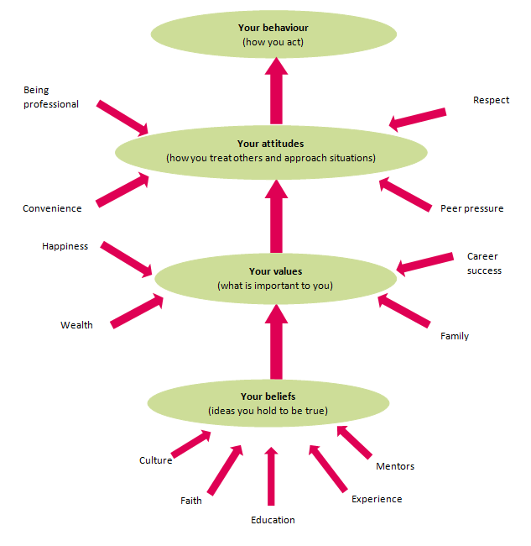
Figure 1: The relationship of beliefs, values and attitudes
Source: Cole, 2010
Values are those kinds of beliefs through which a person’s life is guided and these helps to live well. An individual may have hundreds or thousands of beliefs and attitudes but in comparison to those, the number of values he/she has may be very low. Values can be categorized in two different types which are instrumental and terminal and they can be explained through different examples of values. When a person holds honesty, virtuousness and righteousness inside himself/herself then these will be regarded as the instrumental values of a human being. Sometimes, individual believes that getting a degree from a renowned institution will set his/her life and this is the terminal value of his/her life.
The attitude-behaviour discrepancy is a problem of human’s nature which can be solved through the beliefs, attitude and values theory. The attitude-behaviour discrepancy means the difference or inconsistency between attitude and behaviour of an individual. Generally, people demonstrate their attitude toward an object and their attitude must be determined and their perception of a specific situation should also be understood and determined (Mullin, 2017). According to the theory of Rokeach, particular attitude is expressed by a person in such situation where the behaviour of that person is related to his/her attitude and the relation is rewarded. Similarly, the vice versa can be occurred. If an individual finds out that he/she will not be rewarded if he/she exhibits particular attitude to a situation then, he/she is refrained from behaving or showing attitude. Therefore, the attitudes depend on certain beliefs and according to the beliefs, people react or exhibit attitude. For example, a person has decided not to attend the important meeting of his office and this might bring very heavy outcome for him and thinking about the consequences, he has not express his attitude. Conversely, the outcome of that person’s behaviour may be opposite he is thinking now and the organization may respect his decision and listen to him what he opines about the meeting and in such case, the person will surely express his attitudes. From the above two situations, it can be assumed that attitudes depend on beliefs and values also. When an individual has a strong belief or value about something then, he/she will show attitude according to the beliefs thus they are interconnected in human’s nature.

2.2 McGregor’s Theory X and Theory Y
As I have been appointed in Sainsbury as sales manager and performing the role of a manager in this organization is quite challenging as he has to achieve the sales target by setting some strategies regarding sales. In explaining the role of sales manager at Sainsbury, the theory of Douglas McGregor regarding motivation will be appropriate. In his book named ‘The Human Side of Management’, theory X and theory Y were introduced where the detailed explanation of two different styles of management is provided. In his theory, these two styles define two types of management one of which is authoritarian management (theory X) and another one is participative management (theory Y) (Locke & Henne, 2016). In the development of an organization and improvement of the culture of an organization, this theory of McGregor is considered first in today’s developing business world. In motivating and managing employees within organization, the role of manager is very significant and with a view to providing assistance to the manger, this theory suggests some natural rules which have been discussed in accordance with the role of myself at Sainsbury.

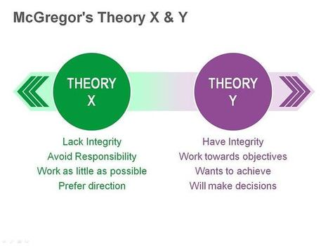
Figure 2: McGregor’s X theory and Y theory
Source: Locke & Henne, 2016
In some situation, managers need to be autocratic when the employees seem unmotivated and dislike to complete their tasks and there is a role of manager to push them for accomplishing the tasks within time at any cost either by rewarding them or punishing them and this is theory X. Naturally managers feel pessimistic about the outcome and centralized control over work and employees is really needed. When such situation occurs at Sainsbury that employees are averse to work, avoid the responsibilities; they need to be supervised and at the same time controlled and threatened so that they deliver the tasks on time. As a sales manager, I need to take the authority of intervening and supervising the employees directly and providing them with rewards or punishment which one is necessary for them. This theory works best only to the situation when workers are averse to work and their controlling is needed for the workplace. There is no delegation of authority as the manager has to control the power of getting things done through the employees therefore, this theory is called the authoritarian theory. Although the theory X is not the actual style which is followed by all the organization and the practices is not appreciated by the management but in some cases, the need for applying the autocracy is indefinable (Greenberg & Baron, 2013). Therefore, adopting the theory may be also suitable for Sainsbury if such situation occurs. For example, a group in Sainsbury was given a group task of attaining sales target which had to be achieved within two weeks and therefore, their task was described properly. In spite of describing that, the team members grew different opinions among themselves which hampered the group performance. As a result, the organization would face the consequences of the reluctance of employees if I did not take the autocratic role and forced them to do that task within time.
When manager is pessimistic about the performance and employees and holds positive perception then, decentralized and participative management style is noticed in an organization which defines theory Y or participative management. Employees under theory Y work happily and involve themselves in making organizational decision by taking part in decision making process with the manager. Some characteristics can be seen among the people who can be categorized under theory Y such as self-motivating, take the ownership of their own tasks, creative and imaginative for solving problems etc. In participative management style, manager encourages the positive aspects of employees and involve them in decision making process so that some creative outcome can be established and as a result organization will be the ultimate beneficiary (McKenna, 2010). Theory Y is adaptive in most of the situation within an organization and Sainsbury also faced several managerial problems when the participative behaviour of employees showed the right track to manager through which the right decision was taken. Moreover, employees under my team of Sainsbury in most of the cases show their skills and willingness to take the challenge from their own interest. Therefore, the managerial role in such situation is to motivate them for better performance through appreciation, encouragement and performance appraisals. Another role under theory Y which I must perform as a sales manager is to involve the team members in devising effective strategies for attaining sales target. In mapping potential customers, the members of theory Y can be very helpful.

2.3 Maslow’s Hierarchy of Needs
Individual’s behaviour and attitudes are being affected by his/her own beliefs and values and they behave differently while performing different roles inside and outside of organizations. As a sales manager, I must be very conscious about my behaviour toward my employees and my own attitudes, beliefs and values can relate to Maslow’s hierarchy of needs theory and critical assessment can be provides as well through describing my role according to this theory of Abraham H Maslow. In the theory of hierarchy of needs, Maslow developed five-tier model of human needs though which employees can be motivated. The needs of an employee can emerge at five different levels which are physiological, safety, love and belonging, esteem, self-actualization.

Figure 3: Maslow’s hierarchy of needs
Source: Cole, 2010
For demonstrating my own particular attitudes, values and beliefs by relating them with a particular management theory, I have decided to select the hierarchy of needs theory of Maslow so that the impact of these three aspects of mine can be exhibited explicitly. In the level of physiological needs, people feel the deprivation of their basic need of water, food, warmth etc. and as a manager I consider these as one of my values to fulfil these basic needs. If these needs are fulfilled, the human body will response in work optimally and all other needs of human being become secondary needs if these needs are not contented. Once the physiological needs are satisfied, people generally realize the need of security and protection in society which Maslow stated as safety needs of human. For example, employees of Sainsbury will expect safety measures from the organization such as employment laws, workplace safety laws etc. for ensuring their safety rights within organization. In the third level of the hierarchy, the needs for belongingness and love appears when people crave for intimate relationship, friends as the interpersonal relationship helps in motivating behaviour of individual (Cole, 2010). As a manager, I have the responsibility to create such atmosphere for building more social values among employees. Trust and acceptance are built through fulfilling the needs of belongingness and taking the opportunity for motivating employees, I can create a bond and mutual understanding with them which actually represents the values I have. As I think that achieving esteem for myself is really needed in order to hold a position in the society through which respect and dignity rom the society can be earned and according to these, I have to set my behaviour pattern and this attitude will certainly give me the reputation. In Maslow’s theory, he called these needs as esteem needs of human. Similarly, each person must have these needs and I should provide the employees of my sales group of Sainsbury with the opportunities of achieving something and attain a status in the society as well as in the organization. After the fulfilment of all these four kinds of needs, the fifth stage arrives which is also called the growth needs in other words. The level of motivation among people decreases after meeting the deficiency needs which have been already discussed. According to Wood et al. (2014), When the needs for self-fulfillment, personal growth are satisfied then people’s motivation level increases for achieving more and more and reaching the peak point which is known as self-actualization need. In attaining the objectives of Sainsbury, I am fulfilling my roles by setting up sales target, devising strategies etc. and for doing these, I need to motivate employees so that they deliver their best effort in attaining the objectives. At a time of employment, everyone desires for personal achievement and top position and therefore, this need should also be fulfilled.

3.0 Critical assessment of the impact of beliefs, attitudes and values on own workplace behaviour. (AC)
There is a major impact of beliefs, attitudes and values on one’s behaviors in the workplace because these three abstract concepts actually shape an individual’s behavior. The beliefs are the foundation for the values an individual hold and based on those values the perception is built to anything and thus attitude grows as well. The impact of these three concepts on the workplace behavior can be understood and explained better from the behavioral school of management rather than the classical school (Beck, 2013). Because, the classical theories of management are too task-oriented and these theories focuses on efficiency and therefore take the human as a factor of production. But the behaviorist theories understand that the human being is a complex creature with different set of emotions and drives. Therefore, the impact of the beliefs, values and attitudes can clearly be depicted through the Hawthorne Studies which was a milestone in the behavioral management.

3.1 Hawthorne Study
Hawthorne study was conducted by Elton Mayo and Fritz Roethlisberger back in the 1920 in the Hawthorne plant of General Electric Company. This study introduced the term Hawthorne effect which highlighted on the correlation between the social context of a workplace and the productivity of the employees (Beck, 2013. The beliefs, values and attitudes of the employees are directly related with the job satisfaction of the employees and thus these concepts also contribute in the level of the productivity of the employees.
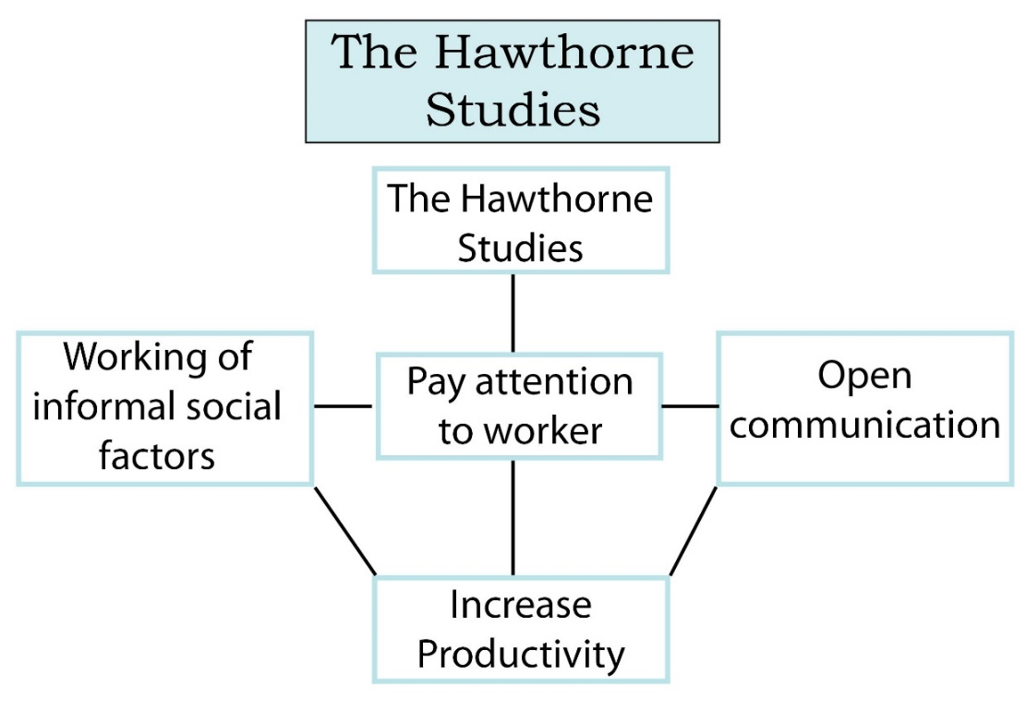
Figure 4: Hawthorne Studies Effect
Source: Rollinson, 2018
However, the impact of the values and attitudes on the job performance can be justified through this management theory which is one of the most prominent work in the behavioral school of management. In this study, a group of workers were brought into an experiment initialized by Elton Mayo and Fritz Roethlisberger. At first their natural job performance and productivity was observed when they worked in the usual environment. Later, they were replaced in a special room and their job performance got enhanced to a significant extent. There was no difference in treatment towards the employees except the change of workplace (Robbins et al., 2013). But still the performance of the employees got increased by a big margin because of the attention they were paid, better flow of communication and obviously the social factors such as beliefs, values and attitudes. They started to believe themselves as more capable and efficient, they were thinking that the company was valuing them highly and thus the attitude towards their job got changed.
The impact of the beliefs, values and attitudes on my behavior or performance can be explained through the Hawthorne Studies. Sainsbury’s has provided me with the scope to exert my creativity and expertise on the subordinates and let me practice my managerial actions in the store which actually made me believe that the company believes in me and thus I started to believe that I am capable of managing the superstore properly. Thus, the values that I possess got changed gradually and I started to respect my job more and my performance got more intense. For example, during the early days of my job in Sainsbury’s sometimes I arrived late in the store. But when my values got changed and I started to think that I am quite crucial to the company and henceforth is responsible for the performance of the superstore, I started to come in the right time. Furthermore, my attitude towards the job started to change as well. I took the job as a routine work and worked for earning my livelihood. But, the delegation of authority by the Sainsbury’s and the room to exercise my expertise has made my job attitude more positive. I started to care about the betterment of the employees working under me and the company’s productivity and the profitability as well. Thus, the job satisfaction has increased to a great extent and I could work with more vigor and enthusiasm in the office.
However, managing the subordinates is a daunting task to me because they have come from different cultural backgrounds and every one of them has different beliefs, values and attitudes. Therefore, I applied Hawthorne Effect to managing them as well. I offered them various opportunities beyond their job duties such as making decisions and handling customer complaints or supervising some particular department of the superstore. As a result, the attitudes and values of those employees who got these sorts of opportunities changed and the productivity level and workplace behavior got enhanced as well.

Management philosophers have developed various theories and models to increase the efficiency and effectiveness of the management in any particular organisation or the project. All of these theories can be practically linked to the real life organisational context (Schein, 2010). However, there are a range of theories regarding management which I can relate to my role in Sainsbury’s. I have been working as the store supervisor in Sainsbury’s and I have several job duties like: managing the sales representatives in the store, checking the inventory level and update it on the regular basis, solving any issues with the customers and handling any contingencies, reporting the performances to the head office etc. The theories which presumably are relevant to my job role and often been practiced are as follows:

3.2 Herzberg’s ‘Motivator Hygiene Theory’
The concept of satisfaction is heavily subject to one’s attitude and it may vary from person to person even being in the same circumstances. Therefore, job satisfaction is also dependent on the personal attitude of an employee. However, there are lots of factors which contributes to job satisfaction. According to Herzberg, the factors which lead an individual to job satisfaction or dissatisfaction can be classified into two types: Motivator factors and Hygiene factors. These factors are the by-product of our beliefs and values (Wood et al., 2014). For instance, it is commonly believed that self-esteem and private space is required for jobs which are creative. Therefore, the ones who are engaged in creative type of work might be in need of these requisites. However, Herzberg has highlighted that the hygiene factors in an organisation do not motivate employees or create satisfaction rather these factors only prevent dissatisfaction. On contrast, motivator factors actually motivate employees and make them satisfied towards their jobs. In my managerial role, I try to provide both these factors to the employees in Sainsbury’s superstore in a balanced way to make them satisfied towards their job to a significant extent. And, thus providing the hygiene factors which are related to their context or the environment of the workplace make them somewhat neutral and providing the motivator factors which are related to their content of work make them satisfied. Hygiene factors comprise the company policy such as the flexibility for the workers, compensation package, good work environment etc. On the contrast, the motivator factors are recognition of employees, achievement, success celebration, the scope of work or the degree of authority delegated etc (Robbins et al., 2013).
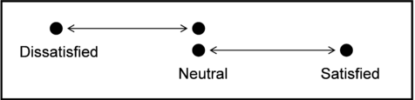
Figure 5: Herzberg’s Two Factor Theory
Source: Mullins, 2017

3.3 Contingency Theory
Contingency theory is rather a new concept which was developed in 1950 and evolved later through practices around many organisations. Contingency theory states that there is no single best way to structure an organisation rather an organisation should structure as per the circumstances or contingencies. Contingency refers to the situations which arise abruptly and are not usual or premeditated according to plan (Brooks, 2009). Therefore, management needs to handle contingencies in a better way to run organisations in an efficient and effective manner. According to this theory, managers should diagnose the people working in the organisations, tasks which are assigned and the environment in which the organisations is being operated. In Sainsbury’s many contingency and unwanted circumstances occur such as sharp decline in sales or shortages in inventory or customer complaints over a batch of products and so on (Sainsbury’s, 2018). Therefore, to manage or handle these contingencies, I often analyse the employees whether they are compatible or fit for solving any particular contingency or not. Furthermore, I also analyse the tasks which are needed to undertake for solving the contingencies and overall environment for solving the contingency in the organisation.
Apart from these two theories, the theories which are mentioned above has equally significant to my role in the Sainsbury’s as a supervisor and managing the employees, motivating them and so on. As their beliefs, values and attitudes are quite important therefore the Rokeach’s RVS theory, McGregor’s Theory X and Theory Y and Maslow’s Hierarchy of Needs theories provide a valuable insight regarding the management of employees in an efficient and effective manner.

4.0 Conclusion
In developing a critical approach to workplace, related management theories have been applied in this assignment and a managerial role has also been chosen for making assessments critically on three aspects of human’s nature beliefs, attitudes and values. The theoretical model of Rokeach on beliefs, attitudes and values will assist in discriminating and analysing the difference these aspects within the context of an organization which has been discussed here. Individual can make assessment of own beliefs, values and attitudes and also their impacts on workplace behaviour such as how they will express their attitudes in certain issues or how values can be grown and the theory of McGregor can relate in explaining individual’s role. I have demonstrated my own beliefs, values and attitudes relevant to my role in Sainsbury which has also been discussed based on hierarchy of needs theory. How these can impact my behavior in the workplace is also explained with examples. Clear identification to my role in the workplace has been described through some management theories which are Hertzberg’s theory, Hawthorne Studies, Contingency theory etc. These theories include various behavioral stance of management which have been using in many organisations to manage the organisations in an efficient and effective manner. Therefore, managers should put more emphasis on the beliefs, value and attitudes of the employees for better achievement of organisational goals.

References
Beck, C. (2013). Motivation: Theories and principles, 4/e. Pearson Education India.
Brooks, I. (2009). Organisational behaviour: individuals, groups and organisation. Pearson Education.
Cole, A. (2010). Organisational behaviour: Theory and practice. Cengage Learning EMEA.
Greenberg, J. and Baron, A. (2013). Behavior in organizations: Understanding and managing the human side of work. Pearson College Division.
Griffin, R. and Moorhead, G. (2011). Organizational behavior. Nelson Education.
Locke. A. and Henne, D. (2016). Work motivation theories. International review of industrial and organizational psychology, 1, pp.1-35.
McKenna, F. (2010). Business psychology and organisational behaviour: a student's handbook. Psychology Press.
Mullins, J. (2017). Management and organisational behaviour. Pearson education.
Robbins, P., Judge, T. and Breward, K. (2013). Essentials of organizational behavior (Vol. 7). Upper Saddle River, NJ: Prentice Hall.
Rollinson, D. (2018). Organisational behaviour and analysis: An integrated approach. Pearson Education.
Sainsburys.co.uk. (2018). Sainsbury's. [online] Available at: https://sainsburys.co.uk [Accessed 2 Aug. 2018].
Schein, H. (2010). Organizational culture (Vol. 45, No. 2, p. 109). American Psychological Association.
Wood, M., Chapman, A., Fromholtz, M., Wallace, P. and Zeffane, R. (2014). Organisational behaviour: A global perspective.

