Question 1

a)
In this circuit, IC1 is a single supply CMOS micropower op-amp configured as an integrator. The capacitor C1 charges at a rate dependant on the current and time. A current input of 1nA produces an increase of 0.5mV/S at the op-amps output. This output is a positive voltage, as integrator inverts the negative input. The reset button is used to discharge the capacitor and reset the output of the integrator. This would reset the UV light monitor to zero.

b)
In this circuit, IC2 is a Schmitt trigger comparator. The threshold is settable using the positive input. The output from IC1 is connected to the negative input.

In this circuit, the variable resistor R3 is used to set the reference voltage of the comparator. Once the output of IC1 reaches the reference voltage, the comparator output is grounded, causing the alarm to be sounded indicated the UV light limit has been reached.

The voltage across R3 is maintained using the 2.5V zener diode LM385-2.5 by pulling any voltage over this threshold to ground. R4 is used to keep a minimum of 10µA to allow the zener diode to function correctly. This is important, as in a battery system the voltage will drop as the battery discharges.

c)
The diode device on the far left of the circuit is a photodiode. They respond to light, allowing more current to flow in the reverse bias as more light is applied. The current which passes is very small and using the UV filter reduces this further. The UV optical filter is used to allow only the UV light through, UV light is what causes skin to tan.

d)
One disadvantage to using this simple analogue implementation of a suntan monitor is caused by the UV filter. The output of the photodiode with the UV filter is in the nanoamps range, roughly reducing the output to 1000 times less than it would be without the filter. There is a risk of small amounts of unwanted light can leak through this filter, and due to the size of the reduction this filter provides, the error caused by this leaking can be massive, causing the alarm to sound much sooner than required.

This could be overcome by removing the UV filter and using an op-amp configured as a current to voltage converter. The voltage output could then be integrated before being compared to a reference voltage using a comparator as with the original circuit. The output from the integrator in this implementation would be negative, so a split supply must be used to provide a negative reference voltage. The issue with this improved circuit is the complexity.

Question two

a)
The function of each block is explained below.

6502 CPU
This is the microprocessor. It is the master device and will control all other sections of the system. It is responsible for carrying out the complex calculations used on the temperature and ultrasonic transducers inputs and act accordingly to the results. It is connected to the data bus and the address bus.

6464 8k RAM
Ram is the Random Access Memory. The CPU will take instructions from the EPROM on start-up and move them to the RAM before executing them. The results of these instructions is also stored in the RAM. The RAM is volatile memory, meaning it is lost when the device is powered down. The CPU can read and write from this device.

27C256 32K EPROM
EPROM is Erasable Programable Read Only Memory. This is where the software/program instructions are written to. It cannot be written to by the CPU and is non-volatile, meaning data is stored even when powered down. Calibration data is also stored here. EPROM data can only be erased using UV light. The more modern version, EEPROM can be erased electrically.

D7002 4ch ADC
This is a 4 channel ADC. It can convert 4 analogue values into digital values for the CPU to process. In this circuit, this is used to convert the output from the analogue temperature sensor into digital data, which is then read by the CPU.

74590 8bit counter x2
This device is used to count the time it takes the ultrasonic signal to travel from the transmitter to the receiver through the 30cm cavity. They are connected to the output of an AND gate, which is connected to the clock gate logic and the 16MHz clock. Every time the clock gate logic and the 16MHz clock are ‘high’ at the same time, the counters receiver a signal and increment the counter.
The two 8-bit counters are likely cascaded together to provide a 16bit counter, likely due to no 16-bit counters being available. The output will be read by the CPU and used in the CO2 level calculations.

6522 VIA
The Virtual Interface Adapter is used to provide additional I/O connections. It is used to trigger the ultrasonic transmitter, trigger the alarm and use I2C photocall to connect to the additional EEPROM. It also sends pulses to the watchdog timer. If the watchdog timer does not receive this pulse for a set time, it indicates the software has crashed and resets the CPU.

2KB EEPROM
This is electrically erasable programmable memory, similar to the EPROM however it is electrically erasable. This device uses I2C data protocol, meaning it only needs an SCL and SDA line to transmit 2k of data.

Oscilloscope
This provides two clock speeds using a prescaler. The 16MHz clock speed is needed for measuring the time between the transmitter and receiver, the 2MHz clock speed is used for the CPU clock.

Chip select device
This is used to select the active device the CPU reads from. It is known as a 3 to 8 decode. Only one output pin is active at any time, each one is assigned to a different module.

b)

The data bus is 8bits.

c)
13 pins are connected to the address bus from the 8k RAM to allow it to access all 8k memory locations.

d)
pseudocode

Initialize and set variables and I/O pins

Send Watchdog pulse every 0.5 seconds

Measure CO2
Send signal from TX to RX // Sends ultrasonic signal through cavity
Read value sent to counter // Reads output from logic circuitry
Read temperature sensor value from ADC
Carry out CO2 calculations and store value in CO2Level//Calculates CO2

If CO2Level is ≥ CO2Max then:
Set Alarm on

IF Not then repeat Measure CO2

END

e)
When choosing a microcontroller, the designer would need to consider the following:

- Clock speed – the Microcontroller would need to be able to incorporate a counter which works at a 16Mhz clock speed. The clock my use an external high accuracy crystal.
- The microcontroller should have a 10-bit ADC channel to read the temperature sensor
- It must have enough non-volatile memory to store the software program

Question 3

a & b)
Phase angle control is used to limit the amount of power going to a device with an AC voltage. It can be used to reduce the power of heating elements, control a motor speed and dim a light.

A thyristor will not conduct until it receives a pulse at the gate. Once it receives this pulse, it will conduct until there is no current. It will also only conduct in one direction. In an AC waveform, this means the thyristor will not conduct during the negative wave, and will only conduct for the positive wave after it receives a pulse at the gate. Figure one shows an example of a Thyristor output where it is connected to an AC supply and it receives a pulse at the gate when the phase angle is 90° and 270°.

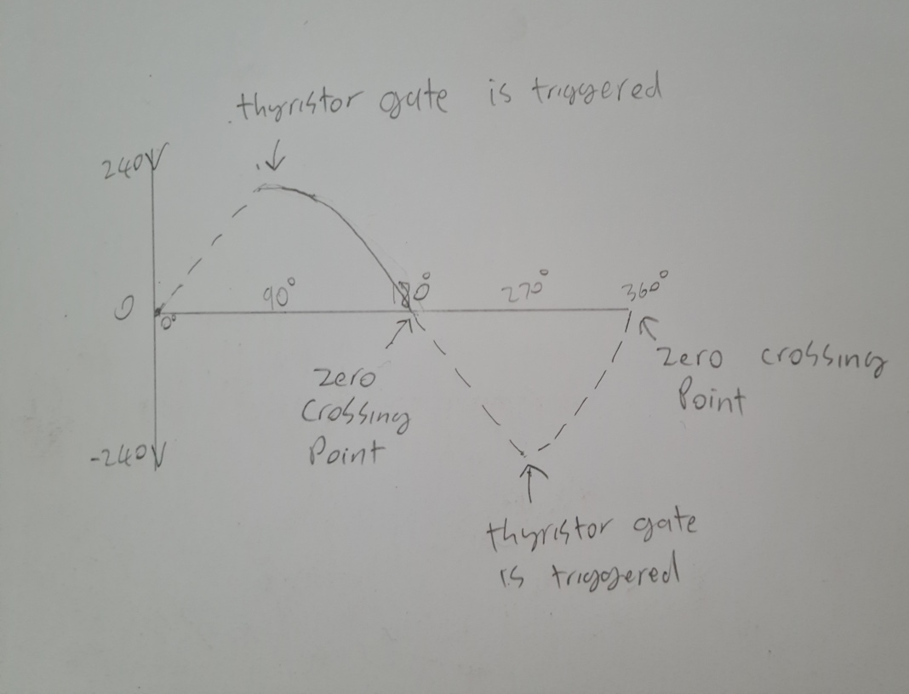
Figure 1 – Thyristor output with gate triggered at 90° and 270°

In this illustration a solid line means there is voltage being conducted, and the dotted line means the voltage is not being conducted. As shown, the thyristor output is only on from 90° to 180° of the sine wave. This means the power is only on for ¼ of the time.
The gate being triggered when the voltage is negative has no effect, as the thyristor does not conduct in reverse polarity.
The thyristor is closed when the voltage is zero and remains closed until the gate is triggered again, so the thyristor would not conduct when the voltage returns to positive. This is known as zero crossing detection. At this point in the AC waveform, the voltage and current are both zero. The zero crossing points are highlighted in figure 1.

C)

The two semiconductor components in this diagram are a diac and a triac.

The Triac is essentially two thyristors put together. The functionality is the same, exempt they conduct bidirectionally, so can allow the negative half of the AC waveform to pass through. Like with the thyristor, they will not switch on until the gate is activated and will switch off again at the zero crossing point.

The Diac is a diode which will only conduct one a certain voltage is reached, known as a breakover voltage. Once the breakover voltage is reached, the diac creates an output surge. They are commonly used to trigger triacs, as a triac requires a solid gate signal to operate.

In this circuit, the capacitor C3 is charged up at a rate determined by the variable resistor. Decreasing this resistance will decrease the charge time of C3, increasing this resistance will increase the charge time of C3. Once the capacitor charge reaches the breakover voltage of the Diac, the diac output is activated, causing the triac to conduct until the zero crossing point. This also discharges C3 so this process can repeat. This creates a lighting circuit using phase angle control.

d)

An op-amp configured as a zero crossing detector is shown in figure 2. The op-amp is a comparator, when Vi switches from positive to negative, so does the comparator output. When Vi switches from negative to positive, so does the comparator output. R1 then discharges the capacitor, causing the output signal to only be high at zero crossing, as shown in the output signal sketch.
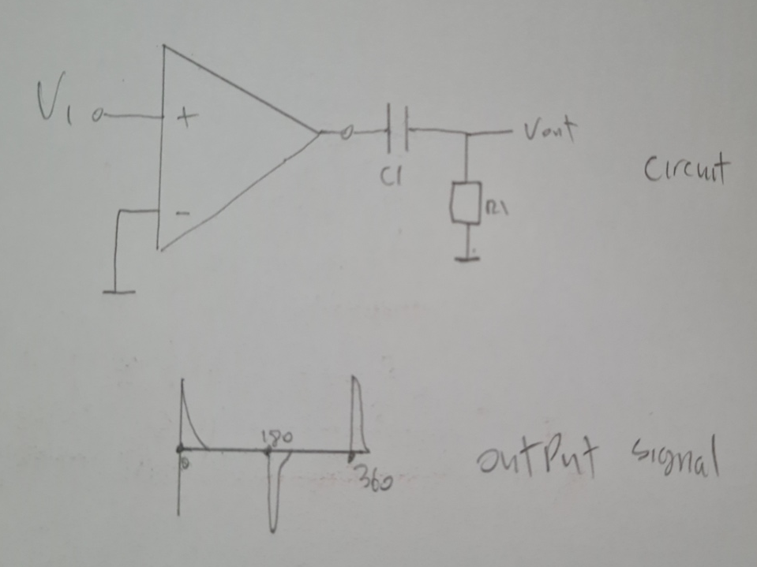
Figure 2 – Op-amp as a zero crossing detector


