

Student Name: Hamza khan

Student ID: 2504521

Module Name: Marketing Management

Module Code: LCMB7024

Lecturer’s Name: Dr Laila Maazouz (London)

Work Count: 2580

Term 1

Table of contents:
Element 1: STDP Analysis 3
Company Introduction 3
2. New Brand Concept Introduction 3
Segmentation (S) 4
Targeting (T) 4
Differentiation (D) 5
Positioning (P) 5
Element 2: Marketing Mix (4Ps) 5
Marketing Mix (4Ps) 5
1. Product 6
2. Price 6
3. Place (Distribution) 7
4. Promotion 7
Element 3: Marketing Strategy Pitch 8
Element 4: Reflection 9
References 11
Poster 13

List of tables:
Table 1 STDP Table 4
Table 2 Marketing Mix (4Ps) 8

List of figures:
Figure 1: Air buds Nano (concept visualization) 4

“AIRBUDS NANO: Marketing Strategy Portfolio for Apple’s Invisible Smart Wearable”

Element 1: STDP Analysis

Company Introduction
Apple Inc. is one of the most successful technology firms in the world, with a premium brand positioning, vertically integrated ecosystem, and never-ending innovation in the field of personal electronics. Its current line of wearables, such as AirPods, Apple Watch, and sensor-powered health software, has helped cement the idea of Apple providing smooth user experiences that are backed by powerful hardware and AI-based features (Kalantari, 2017). Apple has consistently invested in miniaturisation, its own proprietary chipsets, like the H-series used in audio devices, and its overall integration across iOS, MacOS, and watchOS, enabling it to make the next step into the next generation of miniaturised wearable platforms. This is the key advantage that makes Apple the perfect company to roll out AirPods NANO, a new product category that is disruptive, signifying the integration of AI, bio-wearables, and invisible technology.

New Brand Concept Introduction
AIRBUDS NANO is launched as a sub-brand of Apple Wearables. It is imagined as a smart ear, a small-scale, nano-technology, AI-based, and totally invisible ear implant, which fits completely within the ear canal. In contrast to visible earbuds, the NANO product makes use of the micro-vibration audio transmission, thereby allowing the user to make phone calls, listen to music, and use Siri hands-free, without external devices. The gadget also incorporates health-sensing abilities, including ear temperature, hydration, and stress-related indicators, which are becoming more and more popular with consumers across the wellness and hybrid-working scenarios (Seshadri et al., 2019). The increasing popularity of AI assistants, the necessity to use the discreet audio options during a meeting, and the increased use of personal health control technologies present a solid rationale behind the popularity of AIRBUDS NANO. These shifts in behaviour are a product of wider movements in the wearable computing market, whereby consumers are increasingly demanding smaller, smarter, and less obtrusive devices (Sultan, 2015).
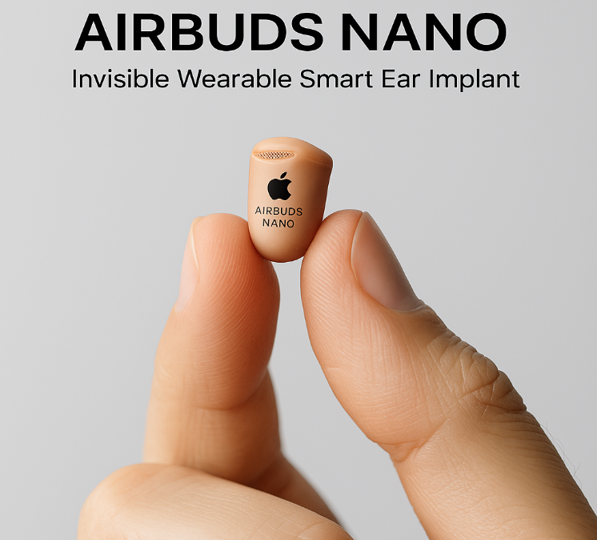
Figure 1: Air Buds Nano (concept visualization)

Segmentation (S)
AIRBUDS NANO can be segmented into a potential market based on the demographic variables, psychographic variables, behavioural variables, and geographic variables. In terms of demographics, the product will mainly target technologically-focused people between the age of 18-45, particularly professionals and middle-high and high-income customers who are already interested in the high-end ecosystem of Apple. It has been revealed that this group is highly willing to embrace wearable technologies and is willing to pay a premium to gain more convenience and productivity (Chuah et al., 2016). Psychographically, the device is aimed at early adopters, lifestyle innovators, privacy-conscious users, and people who appreciate discreet communication devices. Self-enhancement, technological sophistication, and efficiency are the factors that usually stimulate these consumers (Nunes, Afonso & Domingues, 2018). The behavioural segments are heavy earbud users, multitaskers, frequent callers, language learners, and people who depend on health-tracking applications. Research suggests that the behavioural intention to wearables grows when users experience the functional benefits of the device including hands-free communication and health information (Yin et al., 2022). In terms of geography, Apple can first focus on urban markets of North America, UK, EU, Gulf countries, Singapore, South Korea and Japan, where the levels of disposable income are high, digital infrastructure is developed.

Targeting (T)
The target market is mainly formed by young professionals (22 to 40) who need to have a discreet communication and a built-in AI support to work, be productive, and mobile. This market has a very high purchasing power and is already integrated into the product ecosystem of Apple which guarantees more cross device synergy and less resistance to adoption. The secondary target market encompasses the students of universities, people who use the fitness products, who travel a lot and have to have the opportunity to use the real-time translator and the people who are fond of technologies and lifestyle. Such consumer segments are very willing to new wearables and are driven by the need to be convenient, personal efficiency, and being constantly connected. The selection of these segments will help Apple to use the available brand loyalty to enter the new micro-wearable niches that have a high growth potential.

Differentiation (D)
AIRBUDS NANO is differentiating itself in four strategic pillars. First, invisibility: as opposed to AirPods or Samsung Galaxy Buds, the product can be used without being spotted and is utterly discreet. Second, AI implementation provides the possibility of automatic volume control, non-hands-free communication, and language translation in real-time. Third, the micro-vibration technology uses cartilage conduction to deliver audio, which means that users are aware of the environment, a critical driver of safety in wearable studies (Sultan, 2015). Fourth, its health-tracking sensors offer temperature, hydration, and stress analytics, which support the increased inclusion of wellness in consumer wearables.

Positioning (P)
AIRBUDS NANO will be built as a high-end, futuristic, ultra-discreet wearable. This positioning statement is as follows: AIRBUDS NANO is the first invisible smart ear implant in the world that provides tech-savvy people with seamless, hands-free communication, with AI-based sound, privacy, and comfort, unlike other visible earbuds. This is very much in line with the accepted philosophy of innovation, simplicity, and user-centric design at Apple.
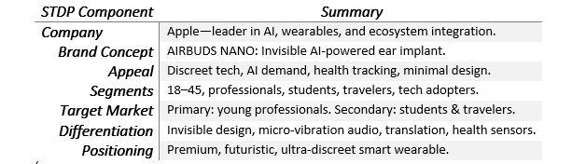
Table 1 STDP Table

Element 2: Marketing Mix (4Ps)

Marketing Mix (4Ps)
AIRBUDS NANO, the proposed brand of an invisible and AI-driven smart ear implant introduced by Apple, has to be introduced into the market with a coherent marketing mix approach, enhancing the competitive position of this product without becoming a detriment to the brand image of Apple. The 4Ps mix ( Product, Price, Place, Promotion) will make sure that every strategic aspect underpins the innovation, high quality, and integration of the ecosystem Apple is reputed to have.

1. Product
AIRBUDS NANO is a significant breakthrough in the field of wearable technology due to its invisibility and nanosize, which fit entirely within the ear canal. The device is based on micro-vibration audio delivery, a technology that resembles tissue-conduction technologies, using which it is possible to deliver the sound and remain environmentally conscious. Studies have shown that wearable devices with low-profile and minimal invasiveness can greatly increase the level of user acceptance and long-term adoption (Kim and Shin, 2020). The invisible design thus solves the consumer pain point related to the old-fashioned earbuds, including soreness, visibility in the workplace, and the chances of dropping or losing them.
The product incorporates the custom AI of Apple with the ability to translate languages in real-time, adaptive noise-level control, and complete hands-free activation of Siri. These features react to the international need for wearable computing, being contextual (Amoroso & Lim, 2017). The implant also has embedded sensors that monitor temperature, hydration, and stress responses, and these enhance the increasingly large digital health ecosystem that Apple has developed. It has been indicated that wearable technology use through biometric monitoring is currently becoming the primary focus of younger and health-conscious consumers (Piwek et al., 2016).
The device will also be connected to a specific mobile app, AIRSENSE, with a few customisable options, including an equaliser, AI-assistant, and health dashboard. Minimalist packaging and environmentally friendly materials, which Apple has made its trademark, will further support sustainability promises and high-quality branding. The product will also be available in various nano form factors to fit the various shapes of ears so that it can be universally comfortable and inclusive (Hoffman and Novak, 2018).

2. Price
Apple will implement a high-price strategy to represent the high level of technology, the investment into the research and development, and the exclusive value proposition of AIRBUDS NANO. Premium pricing is an established strategy that has been applied in the Apple strategy, and it is applied to enhance brand equity and indicate better performance (Hinterhuber, 2018). An estimated retail price of £299-349 would place the product above the conventional earbuds and in line with the perceived value of Apple and the likelihood of customers paying more to get the innovative features.
Along with the premium pricing option, Apple can also employ value-based pricing, which is important to make sure that the pricing does not exceed the perceived functional and emotional values. Research has shown that the convenience, social identity, and technological superiority drive users of high-end wearables instead of minimizing costs (Breidbach and Maglio, 2020). This will render price elasticity as lower among the average customers Apple has, especially young professionals and early adopters. Elective, subscription-based add-ons, e.g., superior translators’ packs or superior health insights, can help in the diversification of the revenues and attract users seeking a more customisable experience. Such a hybrid pricing system is in line with the broader industry trends in which hardware is supplemented with value-added digital services (Wirtz & Zeithaml, 2018).

3. Place (Distribution)
AIRBUDS NANO will be distributed based on the existing omnichannel strategy of Apple, combining physical and digital contacts. The product will be sold in Apple stores across the globe, where experiential retailing can be conducted in personalised demonstrations and technical consultations. Experience-based research demonstrates that experience retail can achieve a great level of consumer trust and a desire to buy technologically advanced goods (Grewal et al., 2020).
Physical retailing will be combined with online distribution on the site and mobile application of Apple, which will allow reaching the customers worldwide and purchasing products easily. Apple can first introduce AIRBUDS NANO in the first stage in the developed markets like United States, United Kingdom, Germany, UAE, Singapore, Japan and South Korea which are, these regions are typified by a robust digital infrastructure, high disposable income and high wearable adoption rates. Wider availability will also be served through selected premium electronics partners and resellers who will be authorised. The integrated supply chain capability of Apple, which is well known worldwide as efficient and reliable, will result in quick distributions and uniform worldwide stock (Christopher, 2016).

4. Promotion
The marketing campaign will be aimed at creating momentum on the invisibility, the intelligence, and the health-monitoring features of AIRBUDS NANO. Apple is characterized by emotionally persuasive and minimalistic messages, and this strategy will be preserved in the form of the multi-channel promotion mix. It was a launch campaign with the message of Hear Nothing. Wear Nothing. It will underline the invisibility of the design of the product. The product will be presented at one of the Apple Keynote events, capitalizing on the media coverage around the world and the strong fanbase of the brand. Studies indicate that event-based marketing has great potential in boosting perceived innovation and brand credibility of technology products (Urdea & Constantin, 2021).
Online marketing campaigns, such as teasing with social media, influencer reviews, and immersive product demonstration videos, will focus on tech-oriented customers on YouTube, Instagram, TikTok, and other platforms. The concept of influencer partnership proves especially successful when it comes to marketing new wearable technologies because younger audiences trust such partnerships more (Lou and Yuan, 2019). The promotional activities held in-store will also involve demo areas and augmented reality (AR) visualisations, where a user will get to know what the implant looks like once invisibly placed inside the ear. The distinguishing features that will be brought to light in promotional content include AI-based translation, biometric tracking, as well as contextual audio intelligence.
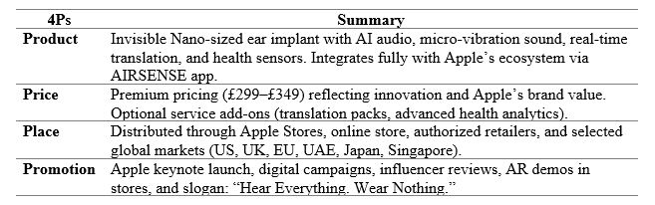
Table 2 Marketing Mix (4Ps)

Element 3: Marketing Strategy Pitch
Think about a time when you can listen to the radio, talk on the cell phone, and intelligence can be blended into your life, but without anything in your ears. Apple is introducing AIRBUDS NANO, the first invisible, AI-enabled smart ear implant in the world, and it is the next generation of wearable technology. Constructed based on nano-engineered micro-vibration sound, AIRBUDS NANO brings crystal-clear sound to the ear by means of tissue conduction, and the ear remains fully open, which gives it great comfort and environmental consciousness.
With a focus on young professionals, innovators, and world travellers, AIRBUDS NANO is a product that is designed to answer the rising need for discreet connectivity, real-time translation, and constant health tracking. Having features like adaptive sound control, biometric sensing, Siri-optimised interaction, and easy integration into the Apple ecosystem, the device reinvents the meaning of hands-free conversation. We make our distinction easy, but profound: invisibility, intelligence, and wellness in a single nano-sized device - a combination which does not exist in any audio product on the market. Starring at the upper end of the price spectrum and sold over the Apple global omnichannel distribution network, AIRBUDS NANO will be a strategic move to tap into the fast-developing micro-wearables segment.
In the case of AIRBUDS NANO, Apple is not foreshadowing the future; it is providing it. Listen, no clothes worn, and have the future upgrade of personal technology.

Element 4: Reflection
The concept of the AIRBUDS NANO brand and building up the entire marketing strategy was a valuable learning experience that enhanced my perception of marketing and strategic brand building based on innovation. Initial conceptualisation of an entirely invisible artificial intelligence-enabled ear implant meant thinking outside the box of conventional product groupings and working with the new trends in micro-wearables, digital health, and AI integration. The process has assisted me in valuing the fact that consumer needs are increasingly changing to a more unobtrusive, seamless type of technology, and how firms like Apple have to keep innovating to ensure that they remain relevant. The translation of these insights into a formal STDP analysis helped me to be more critical in market segmentation, defend decisions on targeting, and explain clear differentiation and positioning.
The creation of the marketing mix helped me to enhance my practical perception of the way in which theoretical frameworks are converted into actions. As an example, the product aspect in the product development process involved shaping the product based not only on emphasizing the technicalities but also on the user comfort, safety, and value creation within the Apple ecosystem. Likewise, the development of pricing and distribution strategies demonstrated to me the level of correlation that marketing choices have to make with brand identity, operational ability, and target market expectations. I also got to know that there is a need to ensure that all four Ps are coherent, such that every component supports and adds weight to the story that the entire brand is telling.
Another aspect of learning was the preparation of the marketing strategy pitch. The need to break a complex innovation into a brief, compelling message gave more strength to the values of brevity, storytelling, and audience interest. It forced me to discover the most important value proposition and be able to describe it properly in a short period of time. The experience made me grow more competent in communication and more mindful about the way in which ideas that address the needs of customers, investors, and internal stakeholders should be pitched so that these ideas resonate with all of them. I have also realised the importance of creating a memorable message and concluding with a powerful strategic call-to-action.
Conducting a reflection on the comprehensive process, I have singled out two major areas where I would like to improve in the future. First, I would intensify market research in order to enhance the evidence base that underpins strategic decisions, particularly as to consumer acceptance of micro-wearables and privacy issues. Second, I would consider developing additional visual prototypes or mock-ups at the initial stages, as they might allow the concept to become more creative and enable the idea to be shared better with non-technical audiences. All in all, the experience of creating AIRBUDS NANO was a good experience to combine both theoretical knowledge and creativity as a strategy, enhance analytical flexibility, and work on the skills of presentations and critical thinking in the next professional projects.

References
Amoroso, D. & Lim, R. (2017) ‘The mediating effects of habit on continuance intention: Empirical evidence from wearable device users’, International Journal of Information Management, 37(6), pp. 693–702. doi:10.1016/j.ijinfomgt.2017.05.003.
Breidbach, C. & Maglio, P. (2016) ‘Technology-enabled value co-creation: An empirical analysis of actors, resources, and practices’, Industrial Marketing Management, 56, pp. 73–85.
Christopher, M. (2016) Logistics & Supply Chain Management. 5th edn. Harlow: Pearson.
Chuah, S.H.-W., Rauschnabel, P.A., Krey, N., Nguyen, B., Ramayah, T. & Lade, S. (2016) ‘Wearable technologies: The role of usefulness and visibility in smartwatch adoption’, Computers in Human Behavior, 65, pp. 276–284.
Grewal, D., Roggeveen, A.L. & Nordfält, J. (2020) ‘The future of in-store technology’, Journal of Retailing, 96(1), pp. 116–129.
Hinterhuber, A. (2018) ‘Thoughts: Premium pricing in B2C and B2B’, Journal of Revenue and Pricing Management, 17(4), pp. 247–254. doi:10.1057/s41272-018-0138-0.
Hoffman, D.L. & Novak, T.P. (2018) ‘Consumer and object experience in the Internet of Things: An assemblage theory approach’, Journal of Consumer Research, 44(6), pp. 1178–1204.
Kalantari, M. (2017) ‘Consumers’ adoption of wearable technologies: Literature review, synthesis, and future research agenda’, International Journal of Technology Marketing, 12(3), pp. 274–307. doi:10.1504/IJTMKT.2017.089665.
Kim, K.J. & Shin, D.H. (2015) ‘An acceptance model for smart watches: Implications for the adoption of future wearable technology’, Internet Research, 25(4), pp. 527–541.
Lou, C. & Yuan, S. (2019) ‘Influencer marketing: How message value and credibility affect consumer trust of branded content on social media’, Journal of Interactive Advertising, 19(1), pp. 58–73.
Nunes, G.S., Afonso, C. & Domingues, C. (2018) ‘Consumer behavior regarding wearable technologies: Google Glass’, International Journal of Market Research, 60(3), pp. 230–248.
Piwek, L., Ellis, D.A., Andrews, S. & Joinson, A. (2016) ‘The rise of consumer health wearables: Promises and barriers’, PLOS Medicine, 13(2), e1001953.
Seshadri, D.R., Li, J., Voos, J.E., Rowbottom, J.R., Alfes, C.M. & Zorman, C.A. (2019) ‘Wearable sensors for monitoring the physiological and biochemical profile of the athlete’, npj Digital Medicine, 2, 72. doi:10.1038/s41746-019-0150-9.
Sultan, N. (2015) ‘Reflective thoughts on the potential and challenges of wearable technology for healthcare provision and medical education’, International Journal of Information Management, 35(5), pp. 521–526. doi:10.1016/j.ijinfomgt.2015.04.010.
Urdea, A.-M. & Constantin, C.-P. (2021) ‘Experts’ perspectives on the development and implementation of experiential marketing’, Journal of Risk and Financial Management, 14(10), 502. doi:10.3390/jrfm14100502.
Wirtz, J. & Zeithaml, V. (2018) ‘Cost-effective service excellence’, Journal of the Academy of Marketing Science, 46(1), pp. 59–80.
Yin, Z., Yan, J., Fang, S., Wang, D. & Han, D. (2022) ‘User acceptance of wearable intelligent medical devices through a modified unified theory of acceptance and use of technology’, Annals of Translational Medicine, 10(11), p. 629. doi:10.21037/atm-21-5510.

Poster


