Finite Element Analysis
FEA Analysis of a Permanent Magnet Smart PIG Assembly

Joseph SCOTT ¹

¹ Advanced Materials Laboratory, University of Wales Trinity Saint David
Phone: 01792 481000, e-mail: jscott.137237@student.uwtsd.ac.uk

Abstract
This report simulates a MFL sensor used on a smart PIG scanning two types of defects within the interior walls of a pipeline. The data produced show the size and nature of the responses given in the form of flux leakage from the pipe wall. The results are mostly consistent with what was expected showing the differences between a 22mm diameter defect, one which had penetrated through 20% the thickness of the pipe and the other 40% through the thickness of the pipe, pipe wall thickness being 25mm.

Introduction
Smart PIGs (pipeline inspection gauges) are NDT scanning tools that are effective at detecting defects on the inside wall of piping. They are widely used in the oil and gas industry to inspect pipelines either under the sea or on land. A smart pig is a long, cylinder shaped probe array that fits inside the pipe with its circumference very close to the circumference of the inside of the pipe wall, leaving only a small gap of 1 or 2 millimetres or less depending on what kind of scanning method is being used.
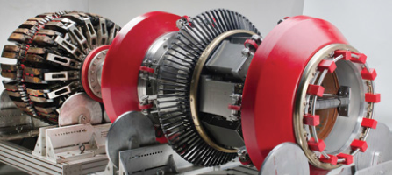
Figure 1 – Photo of a smart PIG (Technology and Operations Management.com, 2016)
A variety of scanning tools can be used on a smart pig including Magnetic Flux Leakage sensors (MFL), ultrasonic sensors (pipeline needs to be full of water to work effectively) and Electromagnetic Acoustic Transduction sensors (EMATs).

The method being focused on is MFL. MFL uses two magnets on opposite sides of a bridge to create a magnetic circuit when placed on a ferromagnetic material. This report will be simulating a MFL circuit that would be used on the interior wall of a pipeline. It will simulate two scenarios. With two different defects. The data produced will be analysed and we will be looking for a response from the defect in the form of flux leakage.

Aims of this report:
- To simulate the smart PIG travelling down the inside of a pipe and look for data showing a response from the two defects using MFL
- Analyse the data and explain the findings

Background Theory
A magnetic flux leakage sensor (MFL) works using magnetic circuits to detect defects on the surface being scanned. It works by saturating the material being scanned with magnetic flux. When defects are present the loss in material will cause flux to leak out in the location of the defect.

A materials magnetic permeability describes how much magnetic flux a material can take before being saturated. Permeability can also be described as the ratio between the flux density and the magnetising field. (NDT Resoruce Center, n.d.).

Ferromagnetic materials are made up of magnetic domains. If these domains are not aligned then no magnetic field is generated. If they are fully aligned then the maximum magnetic field is generated.
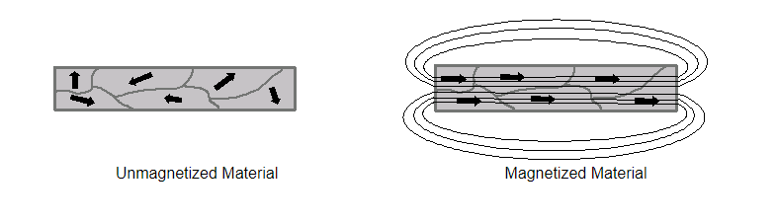
Figure 2 – Picture showing crude example of how magnetic domains align and create a magnetic field (NDT Resoruce Center, n.d.)
There is a point in all magnetic materials where the domains are fully aligned and then material cannot take on any more flux. This is called the saturation point. Further increase in flux will result in flux leaking from the material being magnetised. It is this flux which is detected by the sensor on the MFL array. A visualisation of a materials permeability can be represented as a B-H curve as shown in figure 3.
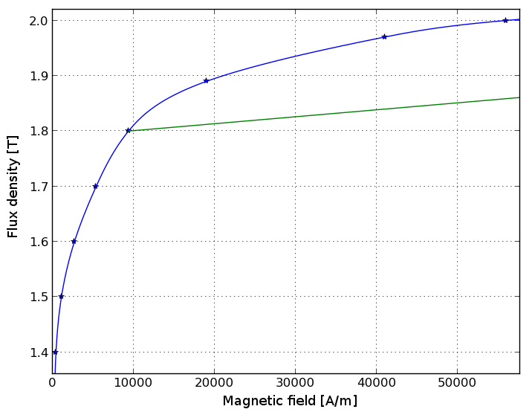
Figure 3 – Example of a B-H curve for a ferromagnetic material (Emetor.com, n.d.)
The MFL saturates the material being scanned in flux. A sensor is placed in the middle of the two poles, typically 2mm above the surface. Assuming the surface is completely flat and defect free and the material is perfectly saturated then there would be no or very little flux being detected by the sensor. If however a defect where present then the loss of material means the flux density within the material is higher at that point, causing it to be over saturated and so leak flux into the surrounding air. It is this flux which is picked up by the sensors, signalling a defect at that location.

Methodology
A two-dimensional model of the magnetic circuit was constructed using the FEMM (Finite Element Method Magnetics) software package. The components included the Bridge, magnets, pole pieces and the pipe wall. The model is shown in figure 4.

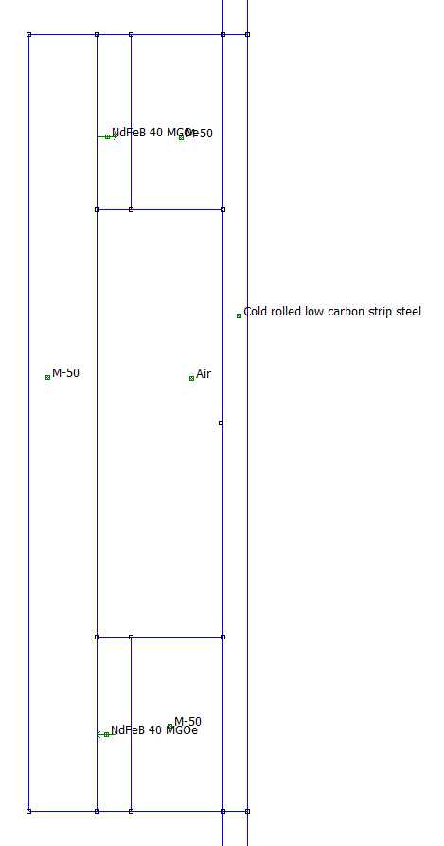
Pipe wall
Bridge
Permeant magnet
Pole piece
Figure 4 – Screenshot showing model of magnet bridge assembly within the FEMM software
Dimensions for the model:
- Bridge length = 800mm
- Pipe wall thickness = 25mm
- Magnet length = 35 mm
- Magnet and pole piece thickness = 180 mm
Two defects where introduced into the model. The defect was the shape of a sphere of 22mm diameter. It was then pushed into the pipe wall penetrating at 20% for one test then at 40% for the second test. Both defects are shown in figure 5.


Figure 5 – Two defect sizes. Left 20% wall thickness and right 40% wall thickness
Two separate models where then constructed. One with the 20% defect and one with the 40% defect.

The goal from there was to scan over each defect and example how much flux is leaked from the pipe wall.

3.1 Mesh density optimisation

Mesh optimisation is the process in finding the balance between simulation accuracy and simulation solve time. The lower the mesh size the more nodes are generated within the model. As each node must be calculated individually, models with high node counts have high solve times. Lowering mesh size gives diminishing returns, as can be seen in graph figure 6, therefore there is an optimum point where the user can get the best accuracy for the shortest solve time.

Figure 6 – Graph showing the mesh optimisation curve

By looking at table 1 and graph figure 6 the simulation results start levelling off after a mesh size of 1. There an almost negligible difference between mesh sizes of 0.8 and 0.6 however the solve time increases from 183 seconds for 0.8 to 418 seconds for 0.6, an increase of 128%. Because of this huge time increase with a relatively negligible difference in simulation accuracy, the mesh size of 0.8 is the most optimal and is the size chosen to run the simulation on.
Mesh Size |  | Nodes | Solve time (s) | Energy reading
5 |  | 14969 | 5.5 | 1287.07
4 |  | 20200 | 6 | 1286.19
3 |  | 28900 | 8 | 1285.33
2 |  | 57386 | 19 | 1283.61
1 |  | 200017 | 101 | 1282.82
0.8 |  | 301104 | 183 | 1282.57
0.6 |  | 526549 | 418 | 1282.52
Table 1 – Mesh sizes and their respective solve times

3.2 Test Method
The goal is to look for change in flux density as the sensor passes over the defect. To test this an incremental method was applied. The FEMM software doesn’t have dynamic simulation capability so only static testing is available. As a result, each increment must be simulated individually.

The first step is to simulate the model where the defect is not present inside the bridge. This is to analyse the model’s functionality without a defect in and also get a zero reading.

The defect was then moved into a position where it was just inside the bridge, between the poles as shown in figure (). This was the starting point.
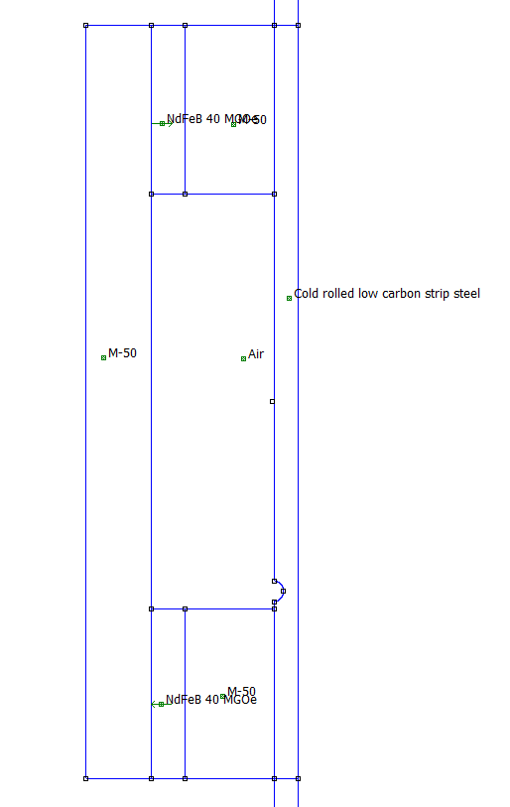
Figure 7 – Diagram showing the defect within the poles
After the defect was placed in its starting point, the first simulation was run. Then the defect was moved 50mm upwards where it was re-meshed and then the simulation was re-run. The closer to the defect moved towards the sensor the smaller the increments. A total of 35 simulations where run for both defect sizes. The increments used are shown in table 2.

The largest gap in increments where 50mm when the defect was farthest away from the sensor. The smallest increments taken where just before the defect and just after at just 2.5mm in size.

1 | -1105
2 | -1055
3 | -1005
4 | -980
5 | -955
6 | -950
7 | -945
8 | -940
9 | -935
10 | -930
11 | -927.5
12 | -925
13 | -922.5
14 | -920
15 | -917.5
16 | -915
17 | -912.5
18 | -910
19 | -907.5
20 | -905
21 | -902.5
22 | -900
23 | -897.5
24 | -895
25 | -892.5
26 | -890
27 | -887.5
28 | -885
29 | -882.5
30 | -880
31 | -875
32 | -865
33 | -840
34 | -815
35 | -765
36 | -715
Table 2 – Increments simulated.

Results and analysis

4.1 Zero Mark

The zero mark is the reading at the probe when the defect is far enough outside the bridge where it has no effect. The values for the zero point are:

|B| = 0.0315263 T
Br = 0.000464758 T
Bz = -0.0315228 T

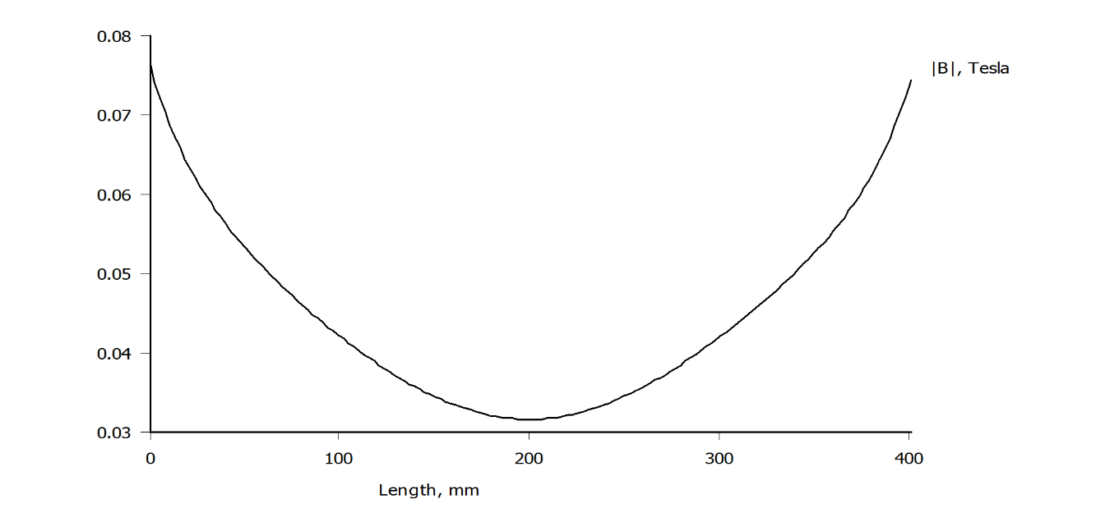
Figure 8 – Graph showing flux curve over the length of pipe wall within the two poles

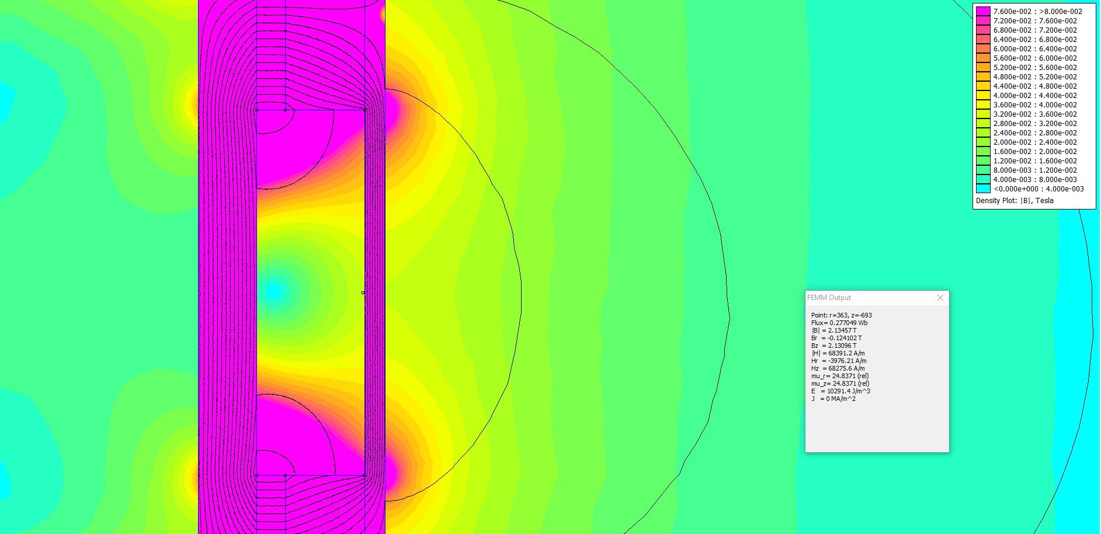
Figure 9 – Screenshot from FEMM showing the flux density of the assembly when defect not within poles

4.2 Defect at 20% wall thickness
Clear data was produced from the simulations form the 20% defect.

4.2.1 Flux in r dimension

We can see a clearly that the defect is easily detected by the sensor. Before the sensor passes over the defect at the start of the movement, flux density is at negative flux, however very small, at a value of only -0.0004 tesla’s. As it crosses over the defect, the flux density in r dimension decreases significantly into negative flux. It peaks at -0.074 tesla’s. As it crosses the centre of the defect, it reaches a net flux of zero, before it passes over the centre and then results in a high positive flux mirroring that of the negative peak at 0.75 tesla’s. It then levels out again but with a slight positive flux.

Figure 10 – Graph showing flux in r dimension going over the defect at 20%
The flip from positive to negative shows the change in direction of the flux. This is because the defect moves from being close to one pole then to the other. Looking at the screenshot in figure 11 we can see two permanent magnets of the same material used in the same model, however their sizes and distances from each other is different. It serves as an example to show the paths of flux between the two magnets from positive to negative. The Br value represents the ‘direction’ of ‘flow’ of the flux, however in reality magnetic flux is static and does not physically flow. Negative Br is flux going from left to right on the screen. Positive Br is flux travelling from right to left.

Negative Br flux is circled in black in figure (). Positive Br flux is circled in yellow. Note it is the direction of flow in the r dimension only. Flow in the x dimension does not affect this value.
By looking at figure () we can see why the flux Br is slightly negative approaching the defect then slightly positive coming away from the defect. This is because it was following the natural direction of the lines of flux generated by the magnets.
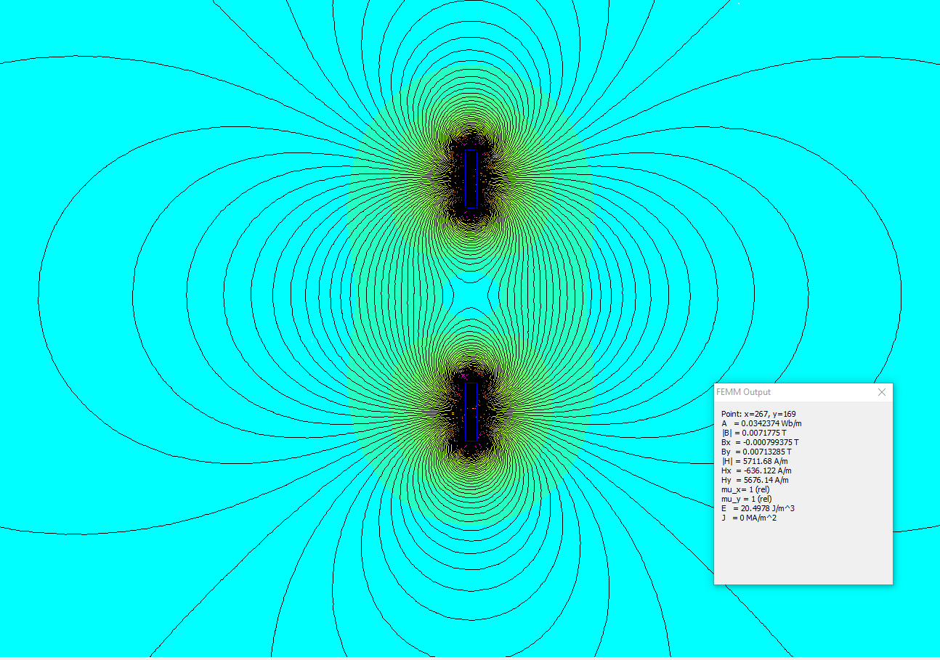
Figure 11 – Screenshot from FEMM software showing two of the same permeant magnets with different sizes and distances apart from the main model
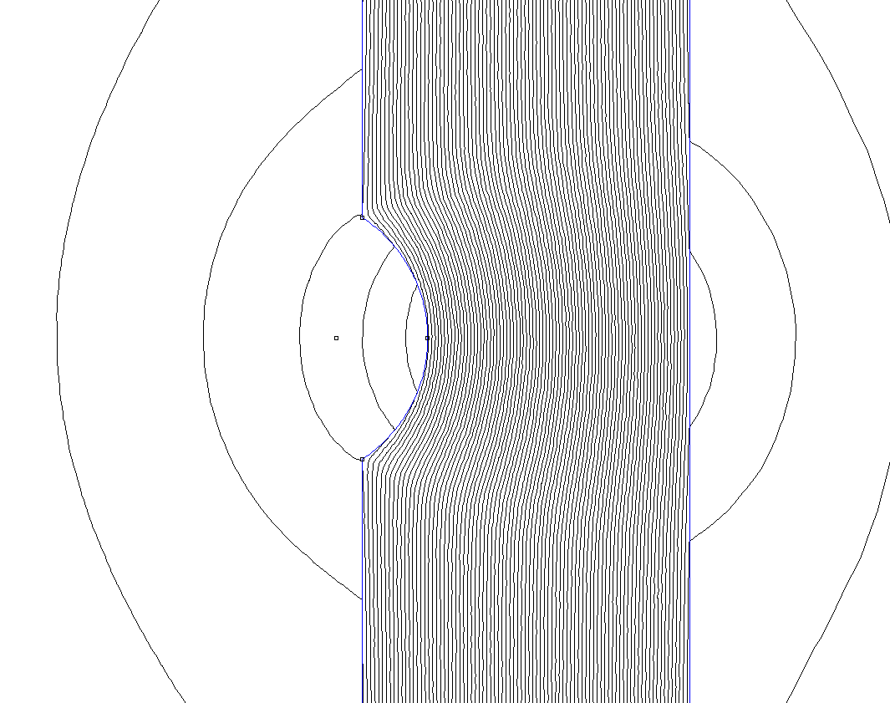
5
4
3
2
1
Figure 12 – Screenshot from FEMM software showing directions of flux around the 20% defect
Looking at figure 10 it can be seen clearly why there is a huge negative then a positive spike. This is explained in 5 steps shown in figures 12 & 13.

- Flux is very slightly in the negative direction
- Rapid increase in negative flux
- Direction of flux is 0 in the r dimension, levels out thus gives a reading of zero tesla’s
- Flux starts moving in the positive direction in the r dimension
- Flux levels out again at slightly positive

5
4
2
3
1
Figure 13 – Graph showing flux Br 20% defect with labels describing the stages of the sensor pass over

4.2.2 Total flux density reading
As the sensor passed over the defect it is clear that the flux density increased greatly as can be seen in figure 14. The sensor was directly over the defect centre position at -910. This is where the flux density is also at its highest.

Figure 14 – Graph showing the total flux when travelling over the defect at 20%
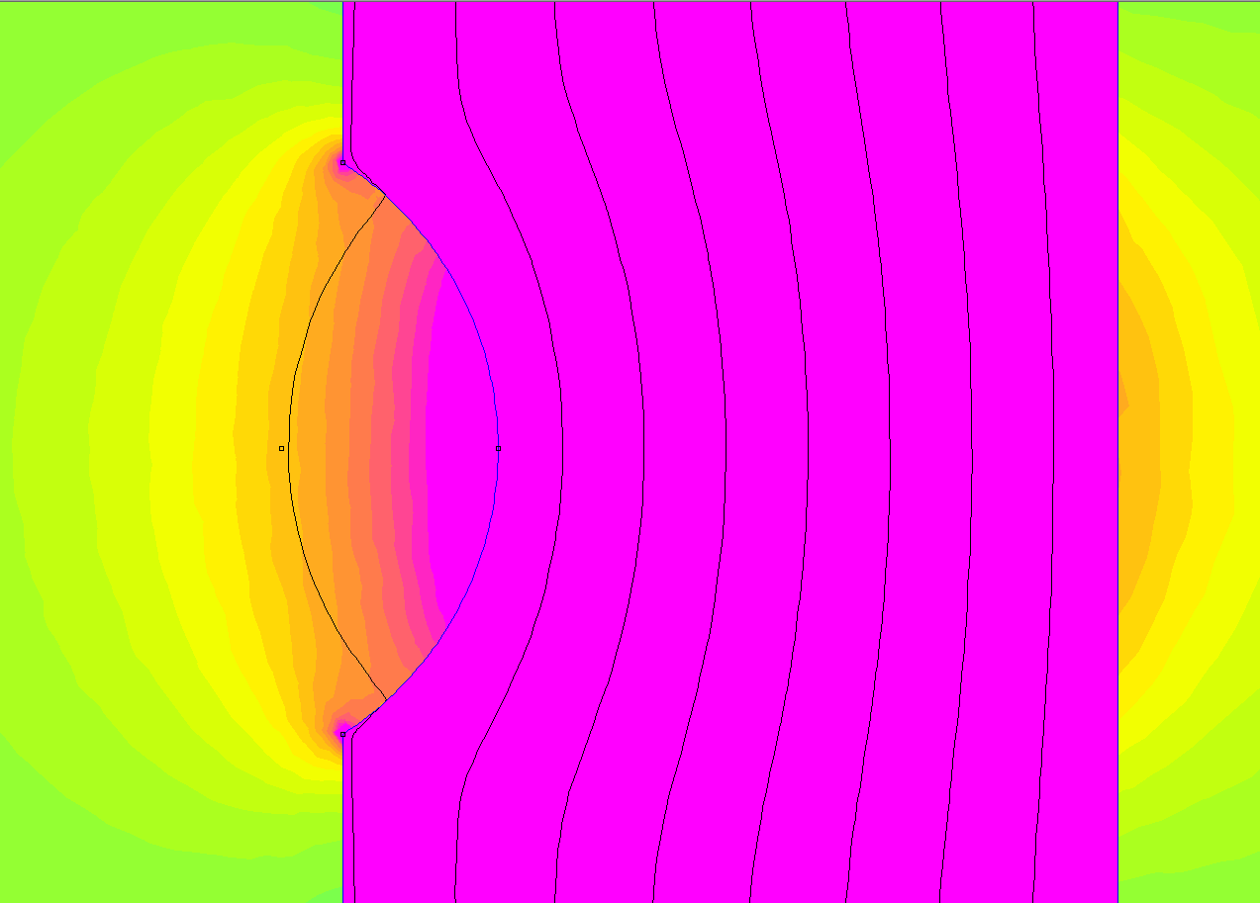
Figure 15 – Screenshot showing flux density of 20% defect with sensor at dead centre
The increase in flux density can be clearly visualised in figure 15. The flux density forms an arc over the defect. The flux density in the path of the sensor is at its highest in the centre of the defect, thus we see it reach its peak at -910 centre of the defect. If the sensor would to move either way from the centre then it would start to read a decrease in flux.

4.3 Defect at 40% wall thickness

4.3.1 Flux in r dimension
As expected by looking at the results, the plot for the 40% defect mirrors the plot for the 20% defect. The same process of going from positive flux to negative flux occurs. This can be better visualised in figure 16.

Figure 16 – Graph showing flux in r dimension travelling over defect at 40%

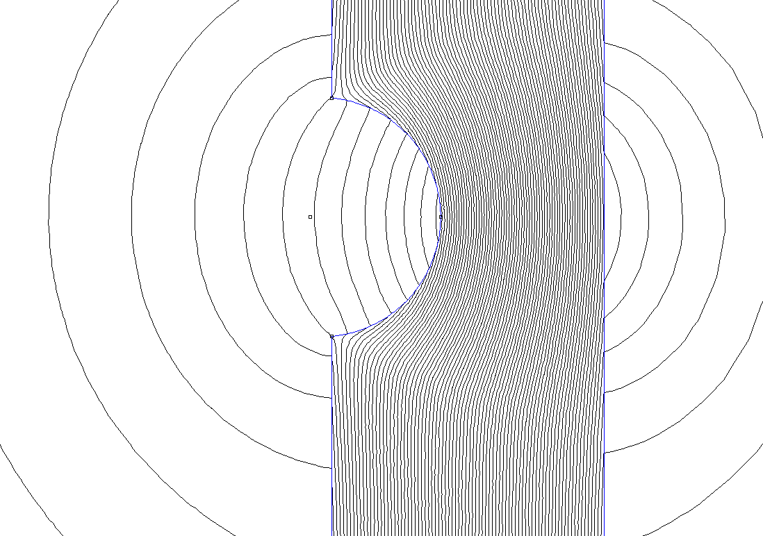
1
2
3
4
5
Figure 17 – Screenshot showing the lines of flux on the 40% model
As with the 20% defect, the same five distinct steps play out the same way:

- Flux is very slightly in the negative direction
- Rapid increase in negative flux
- Direction of flux is 0 in the r dimension, levels out thus gives a reading of zero tesla’s
- Flux starts moving in the positive direction in the r dimension
- Flux levels out again at slightly positive

4.3.2 Total flux density reading

Unlike the 20% defect there is not a single peak where the flux leakage is at its highest. This is shown in figure 18. Instead there are two peaks with a dip where the centre of the defect aligns exactly with the sensor. The reason for this is that the flux density is higher at the edges of the defect than at the centre along the r axis. As the defect is so deep, the flux leakage at the centre does not reach the sensor as much as with the 20% defect.

Figure 18 – Graph showing total flux when travelling over the defect at 40%
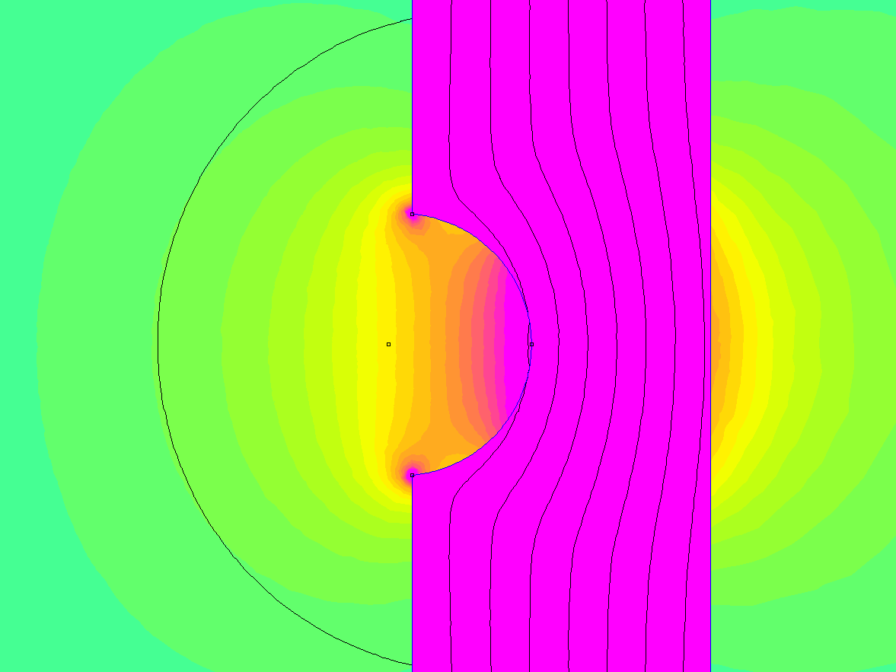

Figure 19 – Screenshot showing the flux density around the defect at 40% with sensor at dead center
The screenshot in figure 19 shows the sensor over the defect at dead centre. The lines of flux density dip in the centre where the sensor is present. The main body of leakage is deep within the defect and does not rise out of the defect in the same way that the 20% model did. The two points of flux leakage at the corners of the defect (circled in black) also have high flux leakage, but as they closer to the defect in the r axis then their lines of flux reach the sensor and so give it a high flux reading.

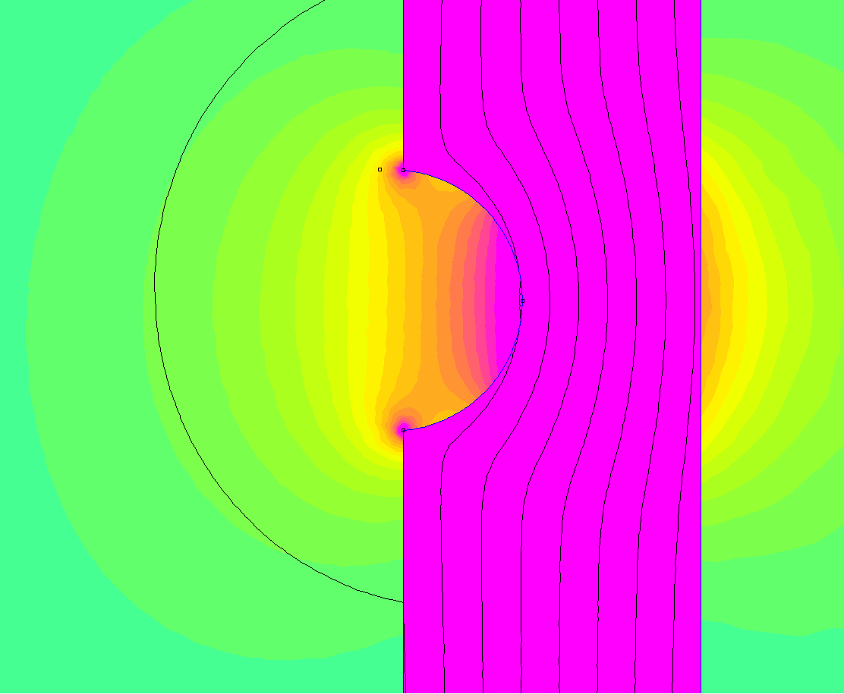
Figure 20 – Screenshot showing the flux density around the defect at 40% with the sensor above right corner
In figure 20 it shows the same defect but with the sensor over the right-hand corner. The sensor (circled in black) is directly over the corner where it experiences a higher flux density than in the centre of the defect. This explains why there are two peaks in graph figure 18 and not one peak like in the 20% defect.

4.4 Comparison of both defects
As the two defects where of considerably different sizes then a difference is flux is to be expected.

4.4.1 Comparison of flux Br

Figure 21 – Graph comparing the flux Br of both defects
The amount of flux that is leaked from the pipe wall is considerably greater on the 40% defect that the 20% defect. This is because there is a much larger loss of material and so more flux has leaked out as a result.

4.4.2 Comparison of flux |B|

The highest flux density at detected at the sensor for the 20% defect was 0.124 tesla’s at -910, centre of defect. The highest flux density detected for the 40% defect was considerably higher at 0.2242 tesla’s at both peaks, 80% higher than the 20% defect. This can be seen in graph 22. As much more material was removed from the pipe wall for the 40% compared to the 20% much more flux leaked into the surrounding air resulting in the huge increase.

Figure 22 – Graph showing the total flux comparison of both defects

4.5 Saturation of pipe wall
The flux density in the pipe wall is over 2 tesla’s for a significant proportion of the length between the bridges. The steel used in the pipe (cold rolled low carbon strip steel) starts to become saturated at about 1.8-1.9 tesla as shown in the B-H curve in figure 24. This means that the pipe wall is fully saturated in magnetic flux. As a result small amounts of flux leakage occur between 0.1 and 0.04 tesla’s along the length of the pipe wall. This could have an impact on sensor readings and has the potential to give technicians inaccurate data.

It is also to be noted that the flux density decreases the closer to the centre of the two bridges, until at the direct centre it reaches its lowest level (this is true for when no defect is present, when a defect is present then the flux density is much greater as can be seen in figure 23.
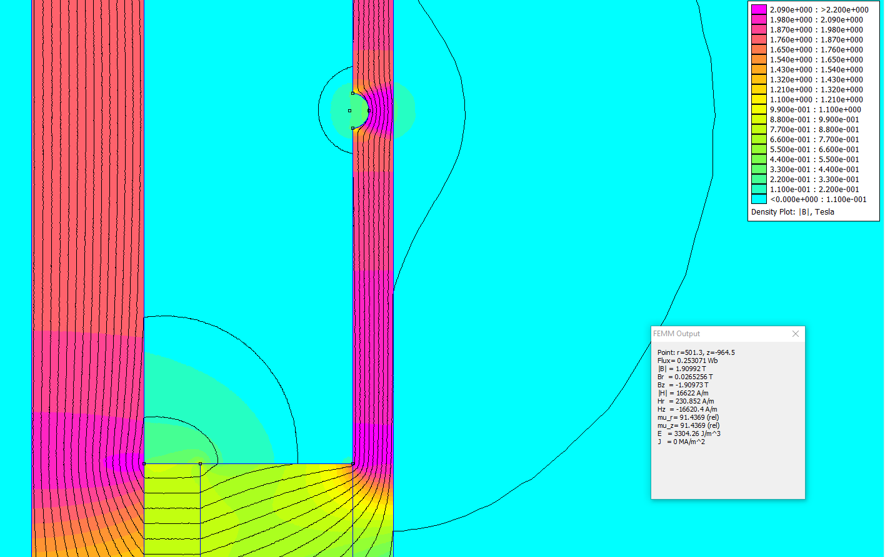
Figure 23 – Screenshot showing the flux densities on the model with the 40% defect in place
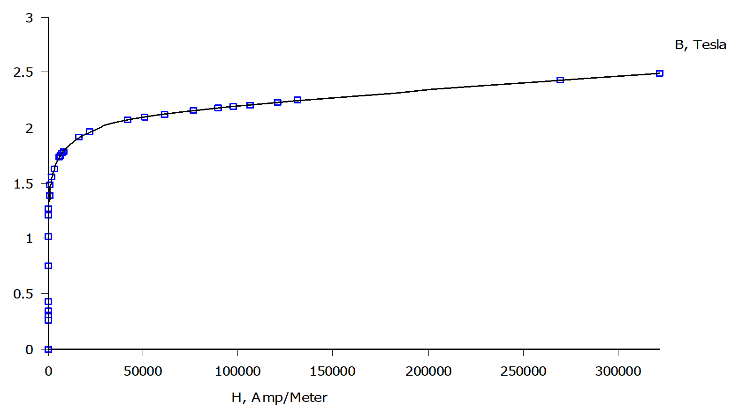
Figure 24- Graph showing the B-H curve of the steel used in the pipe wall

Conclusion
The report was successful in showing the response from two sized defects on the inside of the pipe wall. Both responses where prominent and gave clear data.
The findings also proved that a larger defect or loss of material would result in more flux leakage but depending on size and nature of the defect might give different data as seen in figure 22.
FEMM’s value as a predictive tool was demonstrated. Showing it is a useful tool to calibrate the sensors on the smart PIG depending on what thickness pipe is being scanned and the material it comprises of.

Bibliography
Emetor.com. (n.d.). Interpolation-and-extrapolation-b-h-curves-emetor-materials-library: Emetor. Retrieved from Emetor: https://www.emetor.com/blog/post/interpolation-and-extrapolation-b-h-curves-emetor-materials-library/
NDT Resoruce Center. (n.d.). NDT Course Material,NDT Resoruce Center. Retrieved from NDT Resoruce Center: https://www.nde-ed.org/EducationResources/CommunityCollege/MagParticle/Physics/Permeability.php
Technology and Operations Management.com. (2016, November 18). Evolution of the smart pig: Technology and Operations Management. Retrieved from Technology and Operations Management : https://rctom.hbs.org/submission/evolution-of-the-smart-pig/

