Kieron Biscoe

Assignment: Computer Architecture and operating systems

Contents
Introduction 2
Key functions of general operating systems 3
Use of Windows Commands 4
Use of Linux Commands 9
Use of Windows Scripts 13
Use of Linux Scripts 16

Introduction
Today I have been tasked to explain the key features of general operating systems, commands & scripts for windows and commands & scripts for linux. This document shows the different commands, scripts for windows and linux as well as key features of an operating system.

Key functions of general operating systems
File management – an operating system needs to allow you to store, create, retrieve and organise files and directories efficiently. Copy, Paste, Delete and search are mandatory functions in an OS [1]
Security – Security is essential in an OS, Security is a list of policies that is designed to protect users on the internet by encrypting data and enforcing access controls. [2]
Networking – Networks connect users across a local or wide-area network, this allows users devices to communicate with each other and allow them to share information. [3]
Software features – Software features are programs on a computer, this software assists in running/managing the computer system such as security software (to protect the PC) or file management software (to organise the system) [4]
User interface design – The OS acts as an interface between the user and PC hardware, An interface allows the user to execute (run) programs conveniently and efficiently. Its also designed to make the computers environment more comfortable and easy to use [5]

Use of Windows Commands [6]

- Dir – Lists all files
Output:
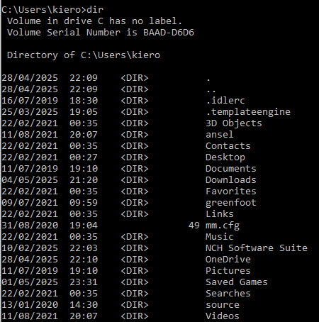
- Tasklist – lists al processes that are running
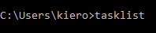
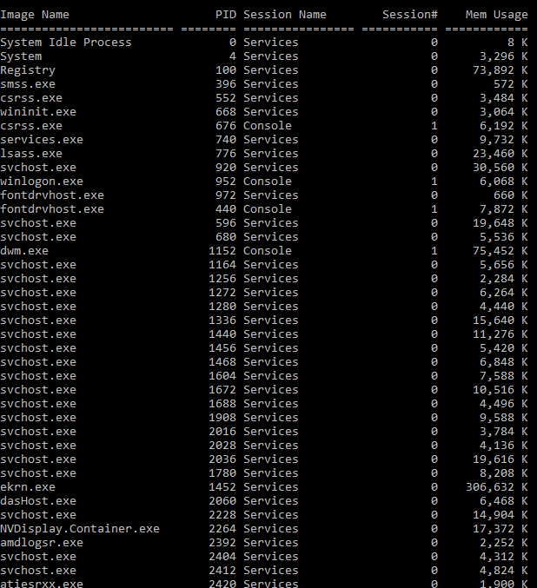

- Ping – tests connectivity
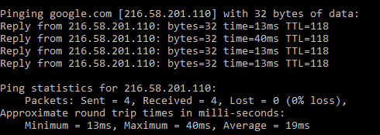
- TASKKILL – terminates processes
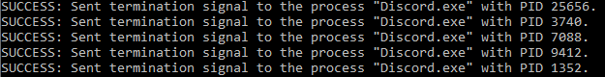
- ECHO – outputs what you type when enabled
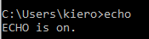
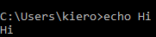
- SET – sets variables (Use with Echo)
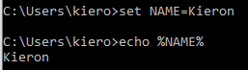
- PAUSE – stops executing the script until the user inputs something
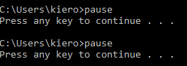
- CLS – clears command prompt
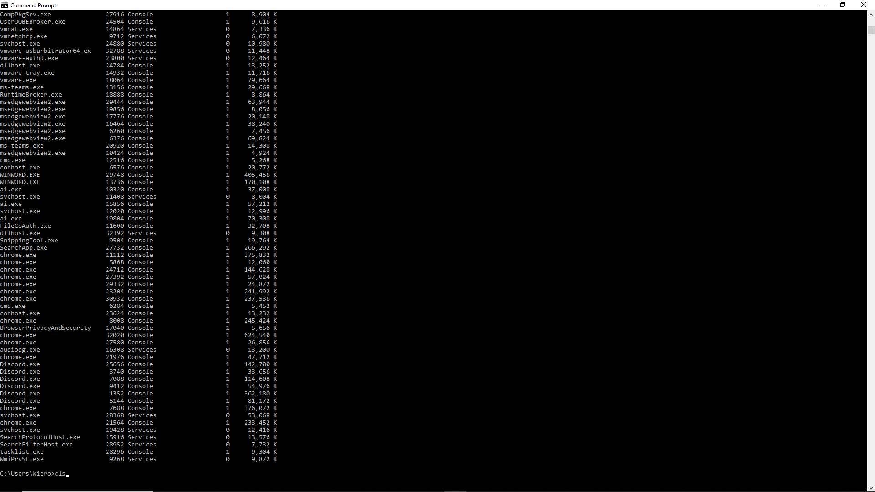
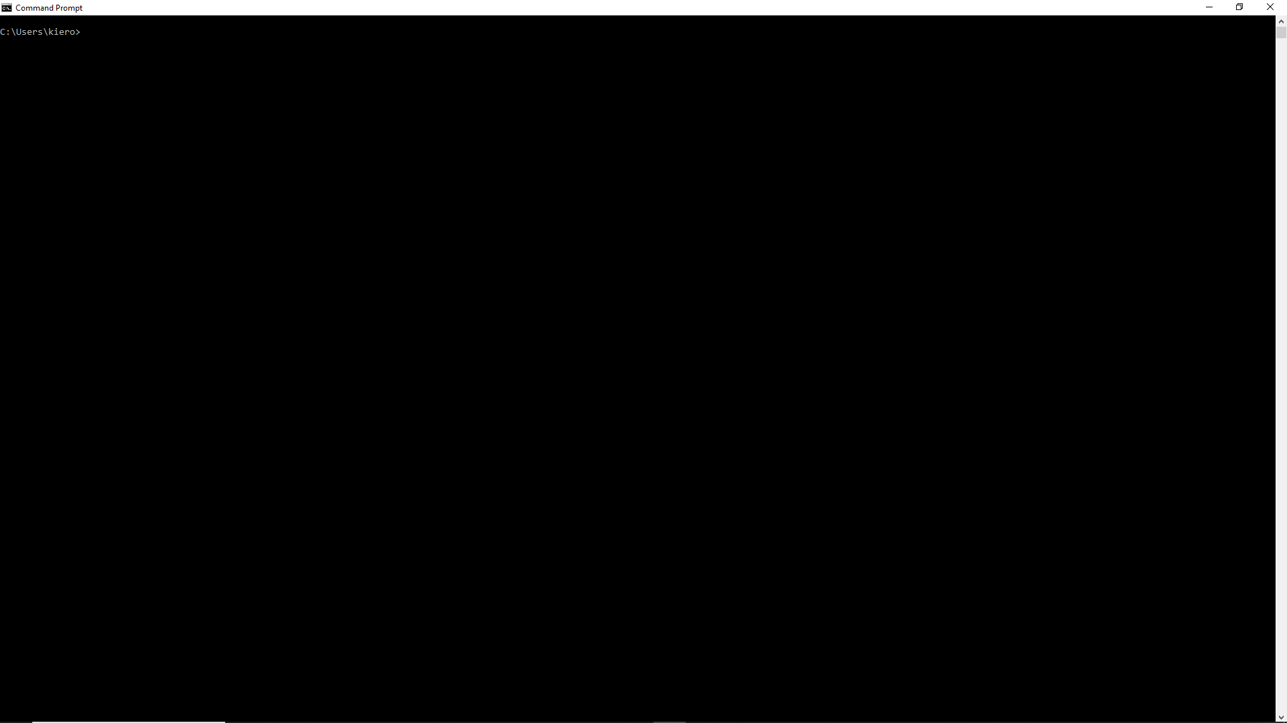
- CHOICE – gives the user a choice
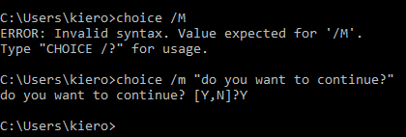

- TITLE – sets the title for the command prompt windows
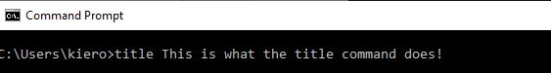
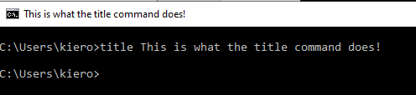

Use of Linux Commands [7]
- Whoami – shows who is logged-in
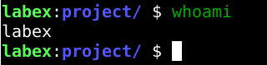
- Date – shows the current date/time ect
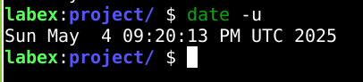
- Uptime – shows how long it has been running
- History – Shows the latest commands entered
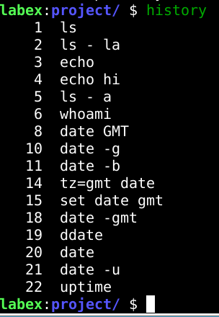
- Env – prints environmental variables
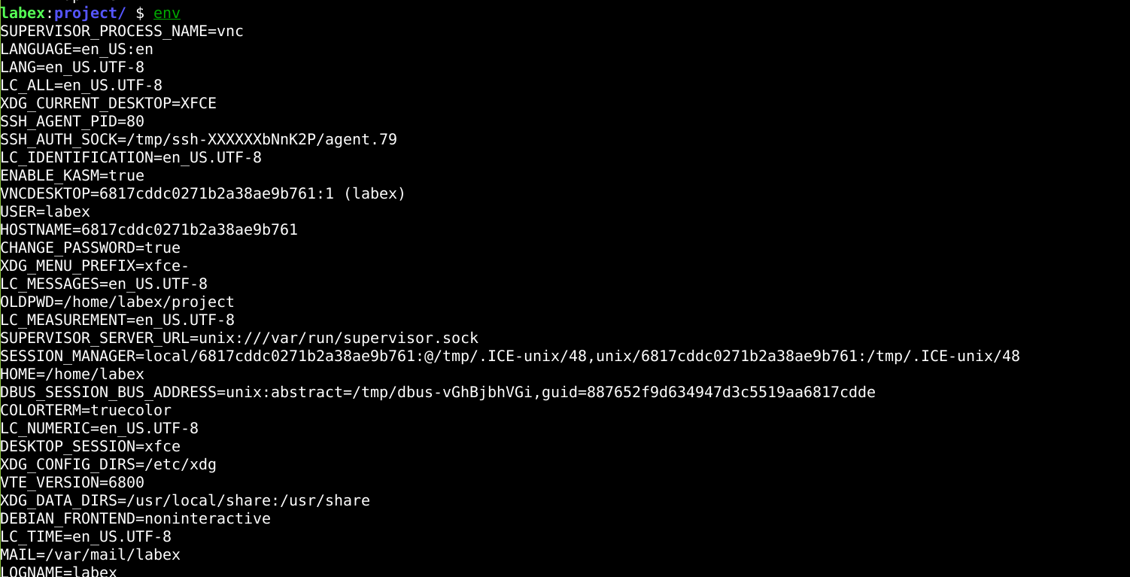
- Alias – shows/defines shell command shortcuts
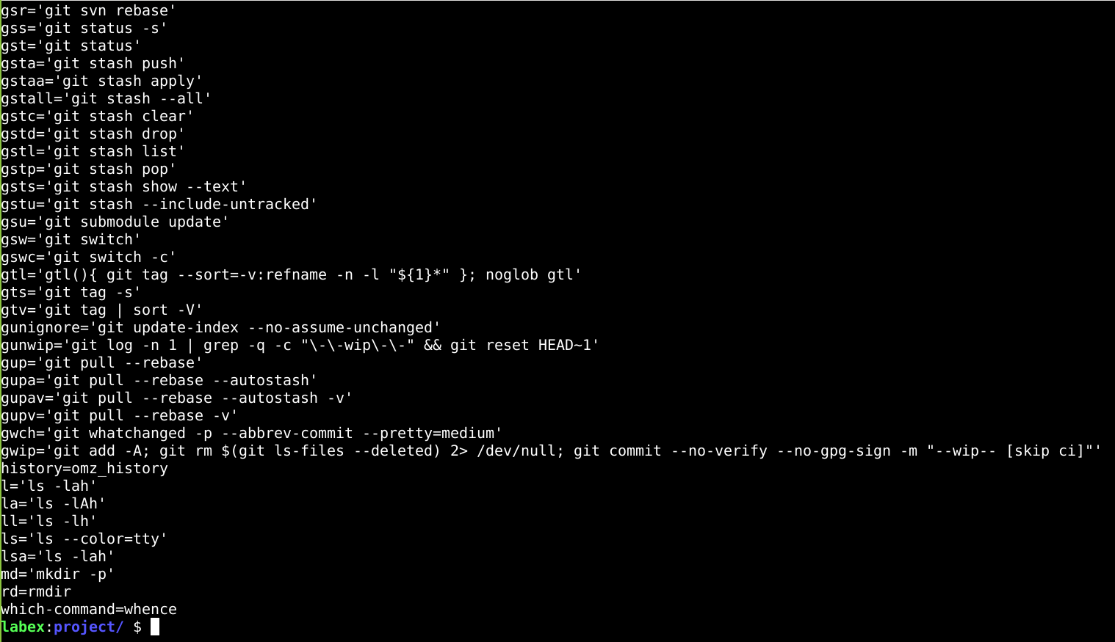
- Top – displays a real-time display of the CPU and memory usage
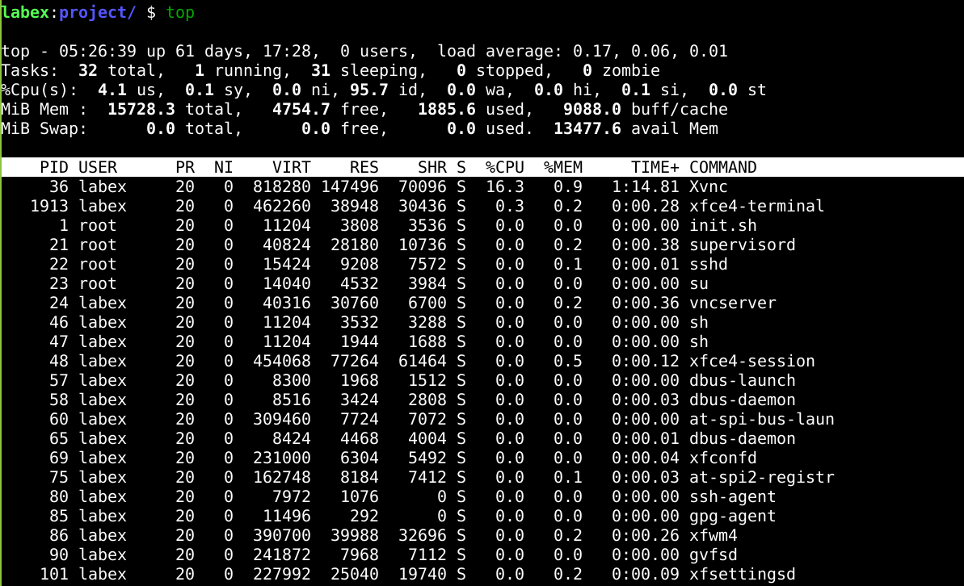

- ps aux – shows running processes
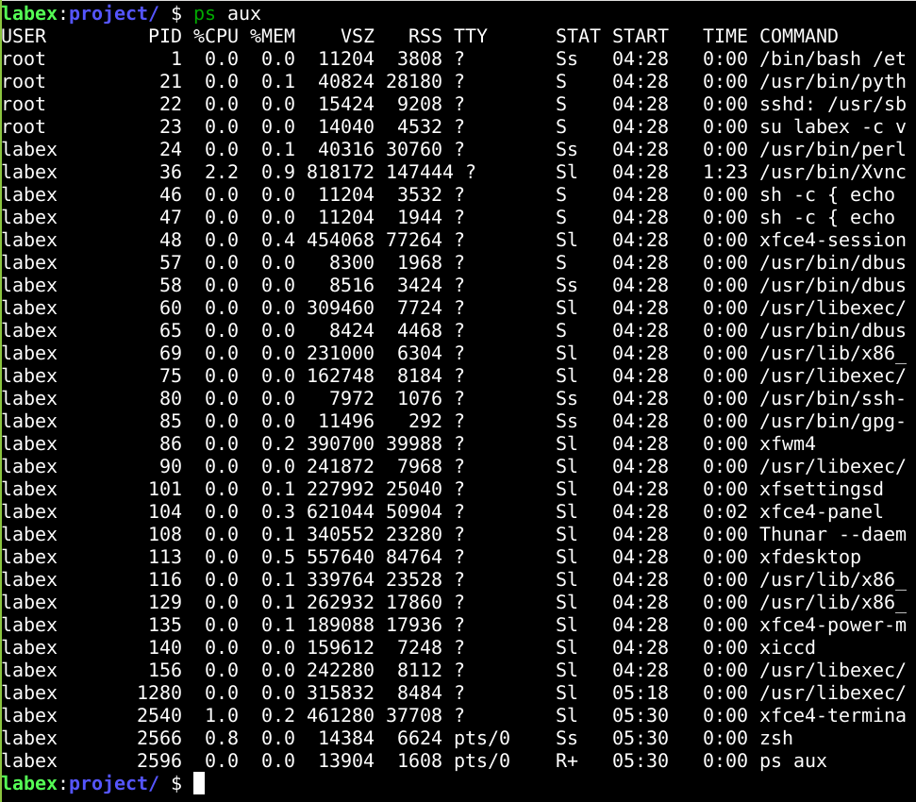
- hostname – prints the name of the system host
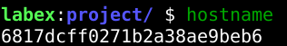
- shows the user ID etc

Use of Windows Scripts [8]
- Outputs something to the screen
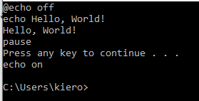
- Display system information – Find hardware info ect easily
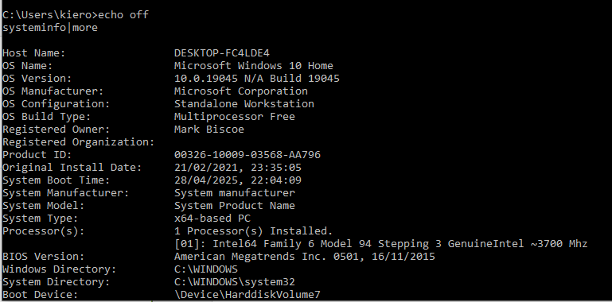
- Create folders
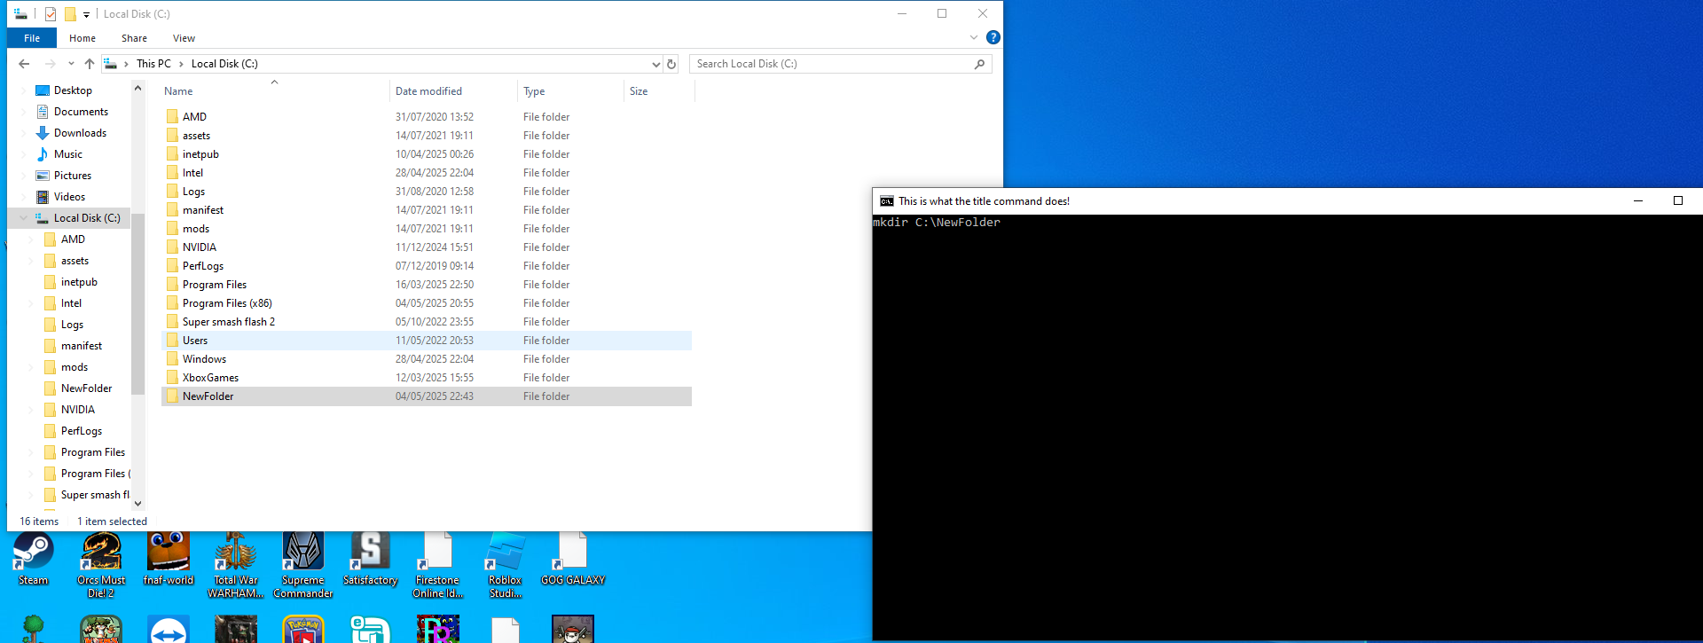
- Copy files from one place to another
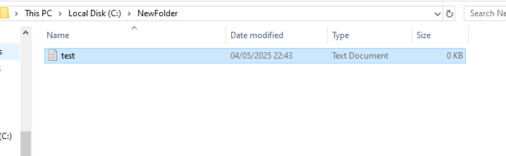
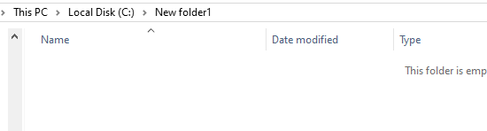
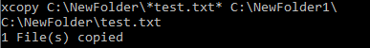
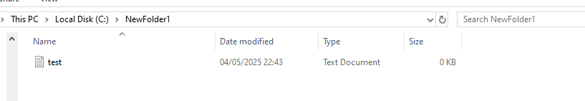
- Display time and date
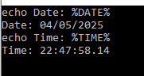
- Ping a website

- Delete files
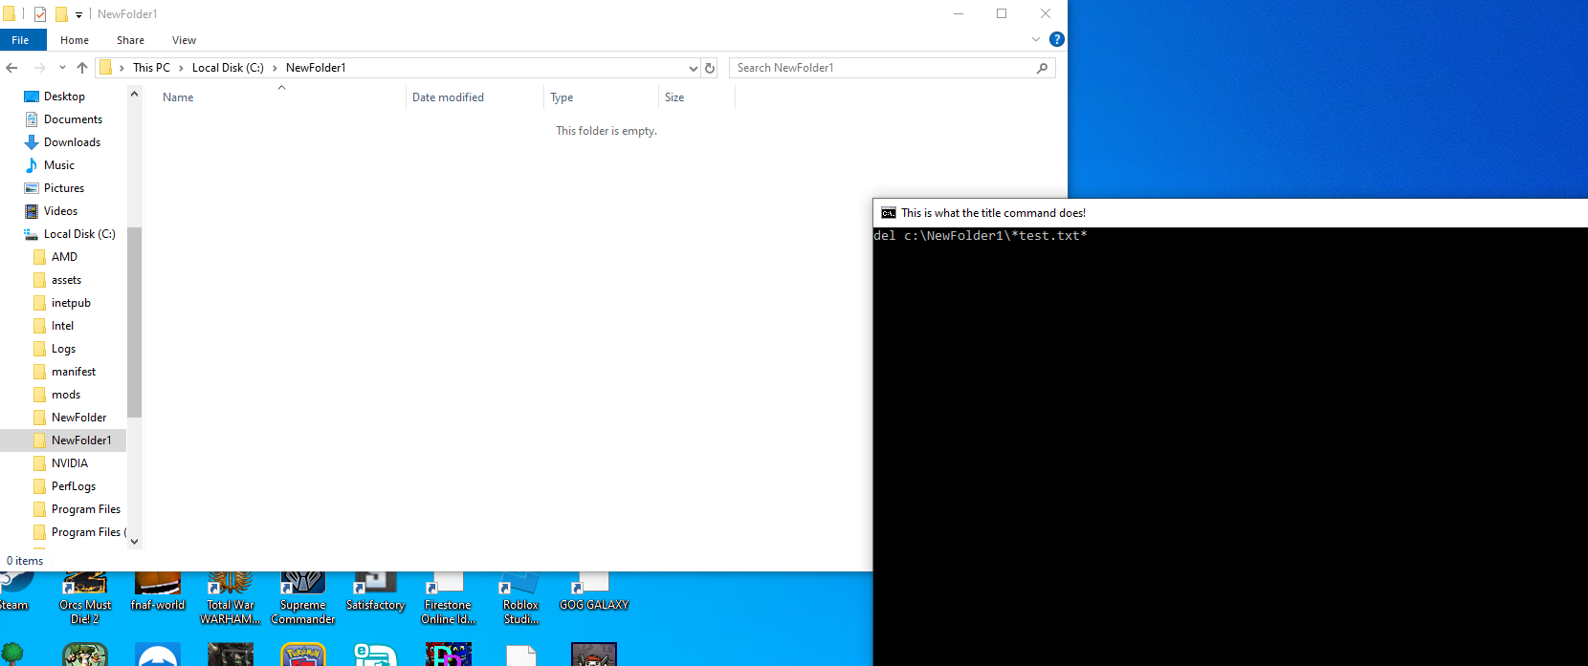
- Open a website
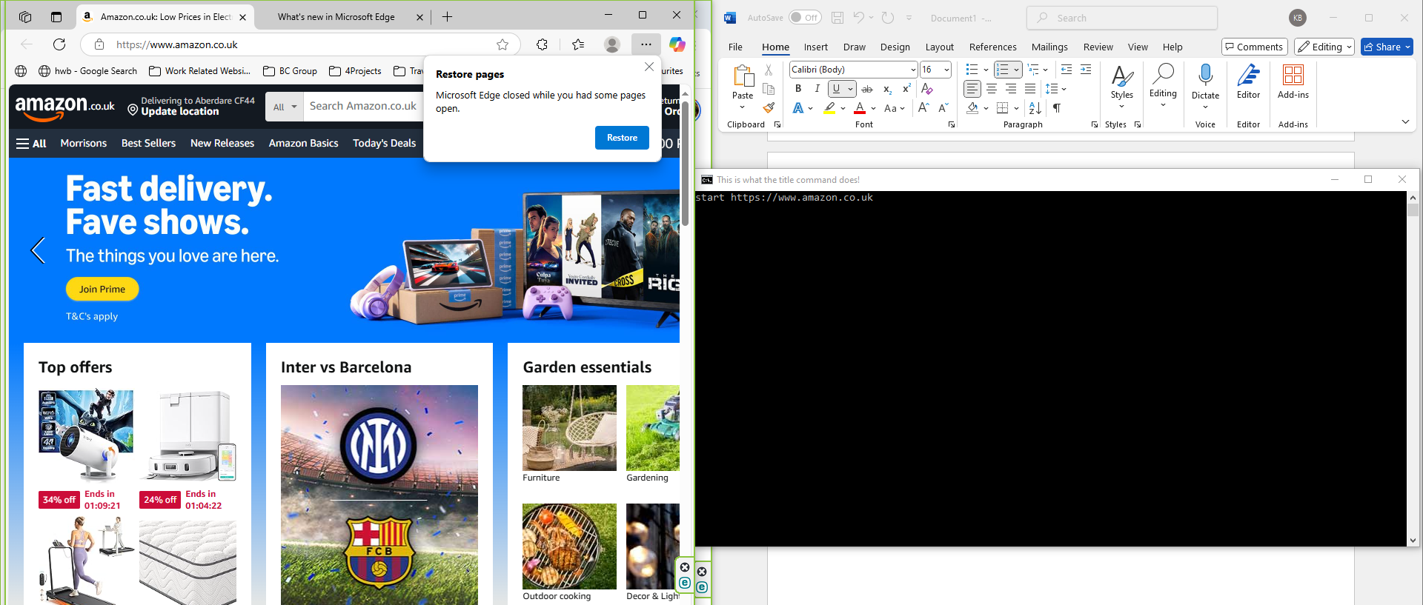

Use of Linux Scripts [9]
- System monitoring
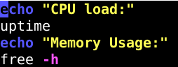
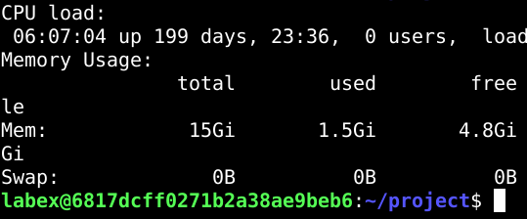
- User input an interaction
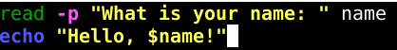
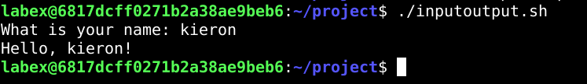
- Show the current user
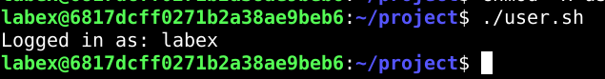

- Simple Calculator
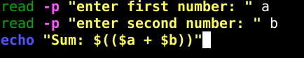
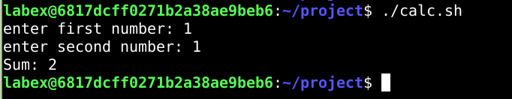
- Count Down Timer
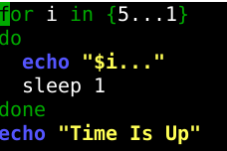
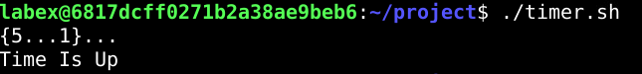

References
[1] Source bare - https://sourcebae.com/blog/what-are-the-features-of-an-operating-system/
[2] Techtarget - https://www.techtarget.com/whatis/definition/operating-system-OS
[3] SynchroNet - https://synchronet.net/operating-system-key-function/
[4] bbc bitesize - https://www.bbc.co.uk/bitesize/guides/zkkkw6f/revision/5
[5] geeksforgeeks - https://www.geeksforgeeks.org/functions-of-operating-system/
[6] Microsoft - https://learn.microsoft.com/en-us/windows-server/administration/windows-commands/windows-commands
[7] gnu.org - https://www.gnu.org/software/bash/manual/bash.html
[8] computer hope - https://www.computerhope.com/batch.htm
[9] linuxcommand.org - http://linuxcommand.org/

