Materials:
Materials and manufacturing of a rear Bicycle Sprocket

Contents
Introduction 3
Literature review 4
Discussion 5
Conclusion 8
Bibliography 9

Introduction

Aims:
To understand the steps that must be undergone to decide on a manufacturing technique and material for a given scenario. Use sources plus CES to better understand material choices that must be made in the manufacturing industry.
Objectives:
Pick 3 manufacturing techniques explaining how they work and the advantages and disadvantages of each process for the scenario. Also decide on a material that works with the manufacturing technique, CES must be used to decide on a material that best suites the application considering such things as; Cost, Weight, different measures of strength.

Literature review

Hobbing:
The first process chosen is hobbing. Hobbing is a form of milling process that consists of a rotating drum with rows of cutting teeth. The hobbing process is defined as a ‘generating process’; during the process the profile cut out of the sprocket is not paired perfectly with the cutting tool (gimpert, 1994) this is caused by the rotation of the gear, which leads to the entrance point of the tool being different from the exit point. Creating a v shape if you display the path of the cutting tool on the sprocket. The process of hobbing is split into 2 sections; roughing and finishing. The roughing stage makes the largest cut and therefore takes off the largest amount of material from the cog (Klocke, et al., 2016). However, this stage due to the force being applied to the material, is not very accurate. Accuracy is important in a bicycle cog as it will determine how well the chain meshes with the cog. This is then where the finishing stage takes place. The finishing stage uses a tool which is slightly larger than the roughing tool and takes a far smaller amount of material of the gear to produce an accurate finish which fits a variety of tolerances depending on its needed application.
Metal injection moulding:
Metal injection moulding is a forming process that is used to create small or medium parts with high levels of accuracy. The process starts with a metal powder with particle size less than 20 micrometres in diameter (AmTech International, 2000-2018) This powder is mixed with a wax and thermoplastic based binding agent, this is to make a consistent spread of metal and increases the life of the machine due to increasing the materials ability to be injection moulded (Optimim, 2018) This mix of metal powder and binding agent is known as the feedstock. It is put into a hopper and pushed through heating elements by means of a rotating worm gear. The gear has a decreasing pitch to increase the pressure applied at the end of the nozzle. It is then pushed into the needed form in this case a bicycle cog to produce what is known as a ‘green’ part. The part then undergoes a binder removal stage where heat is applied to melt Away the thermoplastic and wax binding agent. The final stage is the Sintering stage where a larger amount of heat is applied to the part, at this stage the part will reduce in size by up to 20% due to the holes left in the part from the binding agent. This size reduction of the part must be accounted for when designing and making the mould for the part (Innovar communications, 2015).
Laser cutting:
A laser source is generated using an anode and cathode with a combination of carbon dioxide and nitrogen where it is then reflected off a series of mirrors and a converging lens is used to focus the beam at the distance of the material. Laser cutters are also gas assisted to promote localised heat generation, Oxygen is the most commonly used gas due to its abundance and its flammable properties. When working with an oxygen assisted laser, the pressure of the Oxygen is decided by how thick the metal is; as at higher thicknesses the cutting ability of the laser is more dependent on the Oxygen supply so needs to be slower to allow for a more complete combustion of the Oxygen. (The Linde Group, 2018). The laser then cuts the shape of the sprocket in a very short amount of time and with an accuracy that varies from machine to machine of about 0.2mm (Dikova, et al., 2011)

Current methods of production:
Due to low cost and proven efficiency in field most manufacturers still use CNC machining, usually consisting of stages like: roughing machining and a finishing machining stage. This is simply because of the versatility of CNC machines and there long proven track record of mass production. The metals most commonly used include carbon steel and alloy steel simply due to its properties. The material properties required of a bike sprocket is that it needs to withstand forces in the order of 400-700N therefore the material required must be strong and low elasticity. Due to its application, most bicycle manufacturers want to get the bike as light as possible, therefore the material chosen must have a high weight to strength ratio. The material must also be wear and weather resistant to stop the part corroding from mud/water which will increase the life of the part.

Discussion

Advantages and Disadvantages of each process:
Hobbing:
Hobbing is one of the more accurate methods of gear creation, which is necessary for sprocket creation as it will affect how smoothly and tightly the bike chain will mesh with the sprocket. As hobbing is also a form of milling it is a comparatively cheap method of production only requiring a machine that can rotate the tooling, but much like any manufacture device the more you upscale the production of the sprocket the more expensive it gets: one reason for its comparatively low cost is down to the fact that no heat is required for the process to take place. This manufacturing method does allow for a high scale level of production with industrial scale machines accessible for businesses as this source shows. Hobbing is also a very simple method and has been around since the 1900s which means it is incredibly reliable therefore reducing maintenance costs and breakdown repairs (Star-SU, 2018) However Hobbing has disadvantages too; it cannot use sheet metal directly to produce a gear, there must be processing before and after to produce the final product. The hobbing process could be paired with CNC machining where the CNC machine produces a ‘blank’ which then undergoes hobbing to give an accurate finish on the teeth, this will then raise the costs of production which could end up in being more expensive than other methods that only undergo 1 process. If this were to be done on an industrial application to maintain high levels of accuracy the tooling would have to be replaced on a frequent basis, which would add another regular cost to this method.
Metal Injection Moulding (MIM):
Injection moulding as a general process whether applied to Metal or Plastics, is a common process for bulk manufacture as, although the initial cost is expensive, there are few costs after than besides the cost of material, after that initial cost is paid, the MIM process will cope with very high scale and demand of product and can produce a large variety of parts with a change of the mould. As the machines deal with hot metals there is far less stress and fatigue applied to the active parts of the device compared to a machining process like CNC machining. This then increases the longevity of the machine as a whole. MIM is also another highly accurate method of production necessary for a bike gear to work as accurately and affectively as possible. On the other hand, as previously mentioned the initial cost for injection moulding machines is very high and the mould must be specifically made to produce an accurate final product. MIM also requires heat to run which will increase the running costs of the procedure. Other components of the feedstock will also increase the regular costs such as the wax and thermoplastic mix. Another issue with MIM is that there are many other stages such as the Thermal de-binding and Sintering which are both very energy intensive processes again increasing running costs of the machine. These added stages also call for more equipment besides the injection moulding machine.
Laser cutting:
Laser cutting is commonly used in production lines that cut from sheet metal, which in this scenario is ideal as the sprockets can easily be made from sheet metal. Not only will it be a fast process but it is another highly accurate process which, as previously mentioned, is accurate to 0.2mm. There is also no physical work being done by a tool, which means replacement tools and maintenance of the machine is low cost. This also means it is a very reliable procedure that can be easily repeated by other machines if necessary this has good application for brands that have multiple factories, it will ensure very consistent results. On the other hand, running a laser cutter is very expensive due to its high demand for power (Mainstay, 2016). Another down side is that running a laser cutter correctly and making sure it all works is also a job that requires a highly skilled employee, this adds another cost for the manufacturer. Although as previously mentioned; it is a very reliable system, in the event of a breakage or component replacement it will be very expensive to replace due to the nature of the device.

Process Choice:
After reviewing each choice, the final choice of manufacturing is metal injection moulding. The reasons for this choice are as follows: Unlike Hobbing and Laser cutting, MIM delivers the final product directly from the process. It still requires the de-binding stages after the injection moulding took place however the extra machinery required for these stages is minimal compared to the extra machines required for the other 2 processes. MIM like regular injection moulding is a fast process that is very repeatable and has very high accuracy.

Materials:
One of the most important properties for a gear is its ability to withstand shear stress. This is because in a sprocket the chain generates a force that acts parallel to the sprocket. This makes materials such as carbon fibre useless in this scenario as their high strength depends on the force acting perpendicular to the surface of the material. Below shows a graph that compares the price of a material to its shear modulus, measured in GBP and GPa respectively. The graph is filtered to only show materials that the chosen processes can use.

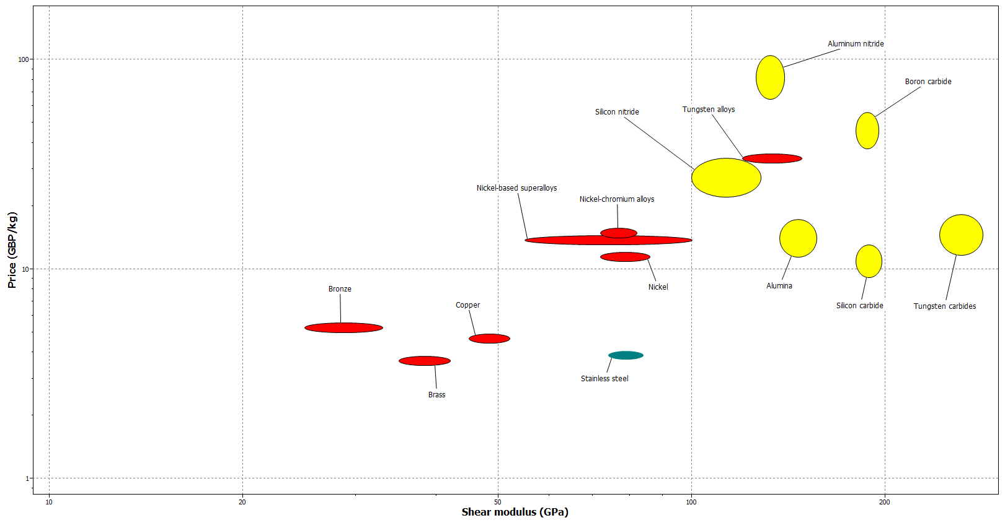
Fig 1. Graph comparing Shear modulus and Price (CES EduPack 2015, 2018)

Another important property of the material in this application its resistance to fracture. When shifting gears there is a lot of stress that acts perpendicular to the regular stress of the chain acting on the gear, this kind of movement could lead to to fractures to form. A fracture in a bike sprocket could be detrimental to the bike and the saftey of rider so must be considered. Below shows a graph comparing Materials fracture toughness to its Price.
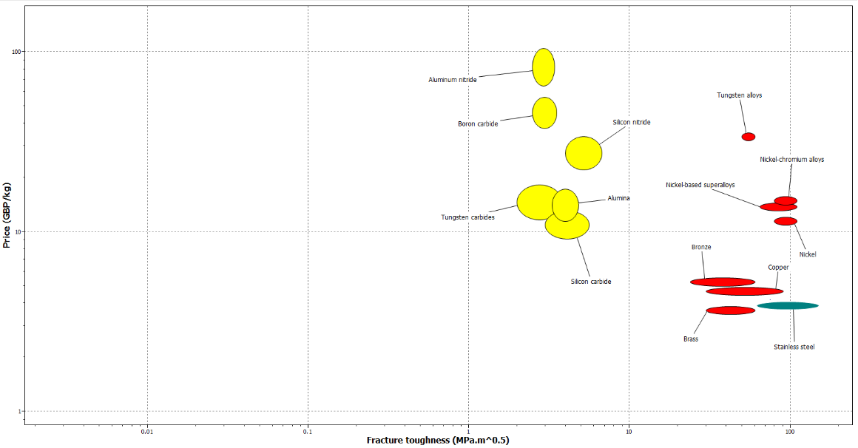

Fig. 2 Graph comparing Fracture toughness and price (CES EduPack 2015, 2018)

Final material choice:
Based on these results my material of choice is Stainless steel. Fig 1 shows that it has one of the lowest shear modulus to price ratios. This means production costs are as low as possible for the force it can withstand. An arguably more important measure is the fracture resistance as fracture would be damaging to the users and the companies reputation. Stainless steel has the highest fracture toughness of all the materials and one of the least costly materials, making it’s a viable choice for the application. Stainless steel can also be metal injection moulded easily enough. Although there are other components needed in the MIM process, because stainless steels low cost it made the extra component costs negligible compared to the extra machinery needed in the other processes. According to (CES EduPack, 2018) stainless steel scores a 4/5 rating on its cast ability and once the Thermoplastic and wax mix is added to the Stainless steel powder its melting point is lowered therefore reducing the energy input needed which in turn reduces costs. Another benefit of using stainless steel is that it does not rust very easily at all which is important if is to undergo harsh outdoor conditions. In terms of long term usage of stainless steel, it is a very sustainable metal to use as is easily recycled. To further prevent any rusting or wear, stainless steel can also be easily coated for further protection. Precipitation hardening can also be used on stainless steel if a harder finish is needed. Stainless steel has an ultimate tensile stress of 860MPa which means it can withstand 860,000,000 Newtons per m^2 before It breaks making it more than strong enough for the application.

Conclusion
In summary, the chosen material was stainless steel and would be shaped by using metal injection moulding, for the purpose of mass production rates, accuracy and reproducibility of the method. Metal injection moulding also requires no further mechanical processing and meets the strength requirements needed for the application.

Bibliography
CES EduPack 2015, 2018. Price (GBP/kg) vs. Fracture toughness (MPa.m^0.5), s.l.: Granta deisgn.
CES EduPack 2015, 2018. Price (GBP/kg) vs. Shear modulus (GPa), s.l.: Granta design.
CES EduPack, 2018. Stainless steel, s.l.: Granta Design.
Dikova, T., Stavrev, D., Waren, V. & Misra, D., 2011. Dimensions Accuracy in Different Laser Cutting Schemes. Machines, Technologies, Materials, p. 15.
gimpert, D., 1994. The Gear Hobbing Process. Gear Technology, p. 38.
Innovar communications, 2015. An overview of the metal injection moudling process. [Online]
Available at: http://www.pim-international.com/metal-injection-molding/applications-for-mim-ii-the-automotive-industry/
[Accessed 20th February 2018].
Klocke, F., lopenhaus, C. & Sari, D., 2016. Process concepts for gear finish hobbing. 48th CIRP Conference on MANUFACTURING SYSTEM .
Mainstay, 2016. advantages of laser cutting. [Online]
Available at: http://mainstaymfg.com/advantages-disadvantages-of-laser-cutting/
[Accessed 23rd February 2018].
Optimim, 2018. the MIM process. [Online]
Available at: https://www.optimim.com/mim-process
[Accessed 20th February 2018].
Star-SU, 2018. Hobbing macines. [Online]
Available at: http://www.star-su.com/machine-tools/hobbing-machines
[Accessed 22nd February 2018].
The Linde Group, 2018. Laser cutting with Oxygen. [Online]
Available at: http://www.linde-gas.com/en/processes/cutting_joining_and_heating/cutting/laser_cutting/laser_cutting_with_oxygen/index.html
[Accessed 22nd Febuary 2018].

