Student Name: Deimantas Salvys
P Number: 2306866
Programme of Study: Graphic Design
Module: Research in Context
Lecturer: Donna Williams

Can Graphic design really save your life?
Word count: 2262

The question today we will be talking and exploring about is a famous saying “can graphic design save a life’. In our current generation we see Graphic Design anywhere we go or do in our day-to-day lives, this could include, looking at social media on the phone, walking or driving to the shop, going to a doctor's appointment, or taking your kids to School. Graphic design has been around us for many thousands of years ago and we keep discovering older forms of graphic design as the years go on such as the Egyptian cave art where they used symbols and images to convey meaning. These symbols and images converted showed us the messages of afterlife, religious beliefs, and the power of the pharaohs, these art pieces were mostly found in tombs, temples, and monuments (Robinson, A. (2001). And over the years we have seen a mass improvement in the graphic design world where now it is shown in a lot of places and a lot of it is to do with helping the community follow instructions.
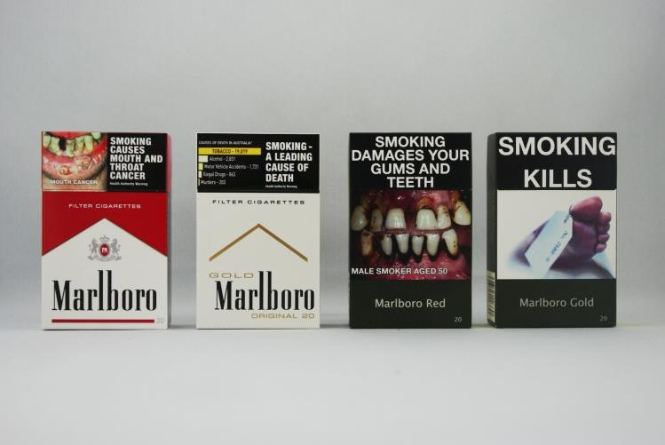
Figure 1. Julia,B.

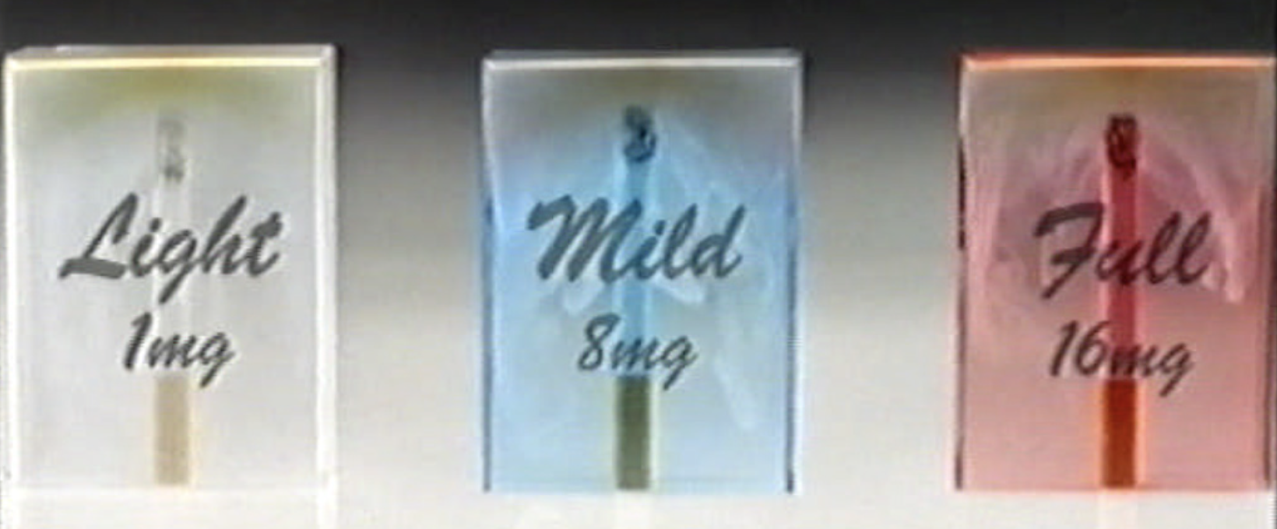

Figure 2

Cigarette Packaging
Smoking has been an extremely popular but bad habit for many people for decades, and cigarette packaging has changed dramatically over the years from being all based on graphics and colours to plain boring with a real life graphical image colours that are least used and graphical images to try turn the smokers away from smoking, Cigarette packaging is no exception, however the way these cigarette packages were designed carefully, unlike many other product packages were discarded once finished with but with smokers it is a little bit different, as these packs were retained until the pack was empty, these cigarette packages were always being publicly displayed while smoked as the users would pull the packet out before smoking or even leave it on the side while smoking or even just being thrown or left in public areas in this way these packages became a way to publicly promote the company without actually doing any advertisement where the public would see these packaging and attract particular audience where the packet design might match the persons personality more. Before all the other brands that came into the packaging industry these cigarettes were socially visible which led the “cigarettes to be known as the “Badge product”. The use of badge product associated the user with the brand image giving the user some sort of identity and personality of the brand image” (Wakefield et al., 2002b).
A cigarette package designer John Digianni, stated “A cigarette package is unique because the consumer carries it around with him all day . . .it's a part of a smoker's clothing, and when he saunters into a bar and plunks it down, he makes a statement about himself.” When a consumer displays a badge product, it is witnessed by others, providing a living testimonial endorsement of the user on behalf of the brand product (Wakefield et al., 2002b). For most of the past 100 years, cigarette manufacturers have told their buyers that their products do not damage their health due to it not being proven to be injurious or effective to their health. To make this even worse all these companies frequently implied to their buyers that their product is safer than the rest of their competitors because the smoke was less irritating, smoother, and milder this was done as a sort of a lure advertisement to try lure more and more customers. (Cummings, Brown and O’Connor, 2007). This means that it was making cigarette smokers inhale the smoke more deeply into their lungs. The “Family Smoking Prevention and Tabacco
Control Act” (FSPTCA), passed in 2009 in US, this gave the U.S Food and Drug Administration (FDA) authority to regulate Tabacco products. This authority implemented a new rule to the designs of these packaging to these companies where they prohibited these companies from manufacturing packaging that included labels that had the terms “Light”, “Mild”, “Low” because these descriptions are misleading and were luring customers by lying to them. However, there is growing evidence that the colour of the packaging has the same meaning as “Light”, “Mild”, “Low” in other countries like the United Kingdom and Canada these colours on the packaging indicate that the lighter colour packs are easier to quit compared to the darker coloured packs which are harder to quit due to the strength of nicotine in each pack. (Bansal-Travers et al., 2011). These studies also show that the smokers in the UK and Canada associate “descriptors” in the name of brands, the packs that included “smooth” meant that it had a reduced harm rate and in the US there is a considerable evidence that brands that are labeled as “light” and “mild” are seen as less harmful but there is little to no evidence on perception of other descriptors or the impact of colours and brand imagery. Companies in the US have altered their packaging to comply with the new ban on “light” and “mild” descriptors, it is imperative to understand how the revised packs will be perceived by consumers. Packages shown in figure 2

In the Tobaco industry the governments are also making the companies to create packaging to communicate directly with the consumers making sure that there is no false information such as light, mild or low on packaging and must contain a graphical image. In response more than two dozen countries have implemented prominent health warnings on the front and the back of the cigarrete packaging. This includes graphical warning to communicate and spread the risks of smoking. The designs that has not changed until 1985 in the US was a four text – based warnings that rotate and are printed on the side panel of a cigarette pack but since 1985 the FSPTCA specifies that nine warning statements must appear on cigarette packs, with an increased warning label sized 50% of the pack face and the inclusion of graphic image alongside the text, within 39 months of enactment. (Bansal-Travers et al., 2011)

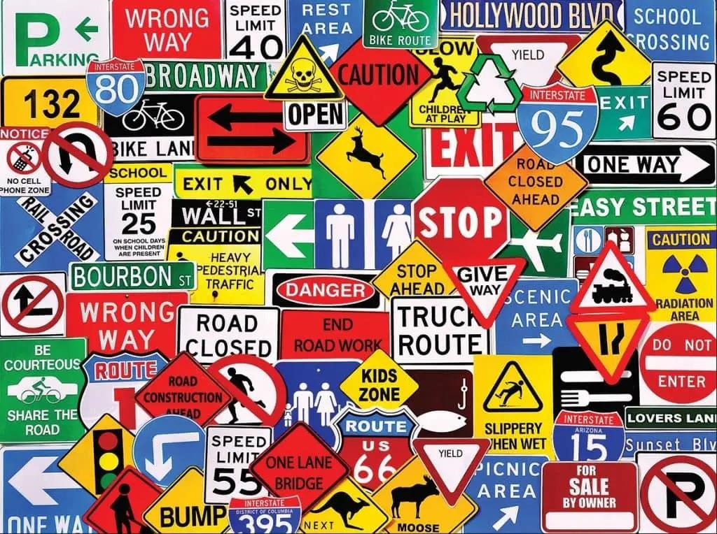
Figure 3
(Mercedes-Benz of Littleton, October 2024)
Signs
Road signs are seen daily around the world and are a vital part of the road users and pedestrians. This can include navigation, poor weather, upcoming danger etc. This also works the same for pedestrians as it allows them to understand where they are going and what's ahead or what to look out for. Over the years these road signs have changed around the world, in south Korea They have proved that accidents at night are a lot greater than the daytime but to partially prevent such fatal road accidents at night and provide better night road signs to their drivers, the Ministry of Land, Infrastructure, and Transport (MLIT) established a regulation to
change the roads signs to install lighting on the road signs using the Road Sign Rules in 2016. This changed the road signs from being just reflective at night when the lights are shined onto the sign to reflect it to the road user to having it lit at night where it can be seen a lot easier without needed a reflection, however, considering the development of lighting technology and the autonomous risk response of road management agencies, the permissive range of illuminated road signs has been regulated. Additionally, in 2018, The National Police Agency (NPA) did some testing by publishing and testing of these illuminated and luminescent traffic signs which were installed to full scale, and this proved that it improved nighttime driving safety and convenience and drew positive responses from the public institution and citizens (Choi, Sung and Chong, 2023), Most road signs are usually created from symbols instead of just text this is due to it being much easier to understand to someone that is in need of the instructions. the use of the sign and these symbols are more quickly readable by only looking at them and not taking time to read, These signs also have a huge advantage than text because anyone in the area can understand these symbols since some people reading the sign may not be from that country which bypasses the language barrier, another advantage of symbols is that the compactness in representing concepts in a spatially condensed form, as there is limited space on road signs where text could get very difficult to read unless you are up close. (Dewar and Pronin, 2023)

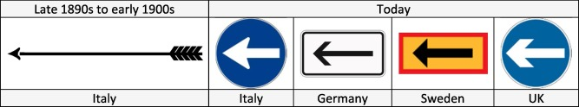
Figure 4, Directional arrows then and now.

The earliest signs were created by the Roman Empire where stones were marked with words and numerals. (Dewar and Pronin, 2023) The universal need for sign warnings and roadway hazards did not manifest itself, these were only implemented in the 19th century. These clubs created the first modern road signs which were based only on text. This was done because club members started crossing national borders but soon, they realized that they needed to change these road signs to symbols to overcome language barriers, as shown in figure 4. They did this by designing a realistic symbol of an archery arrow indicating the direction and following on few years these signs evolved to having symbols for warnings of uneven roads, sharp curves, steep hills, intersections and level crossing. The design of an Arrow is still used in most countries as this style is based on simplicity of the design. (Dewar and Pronin, 2023)
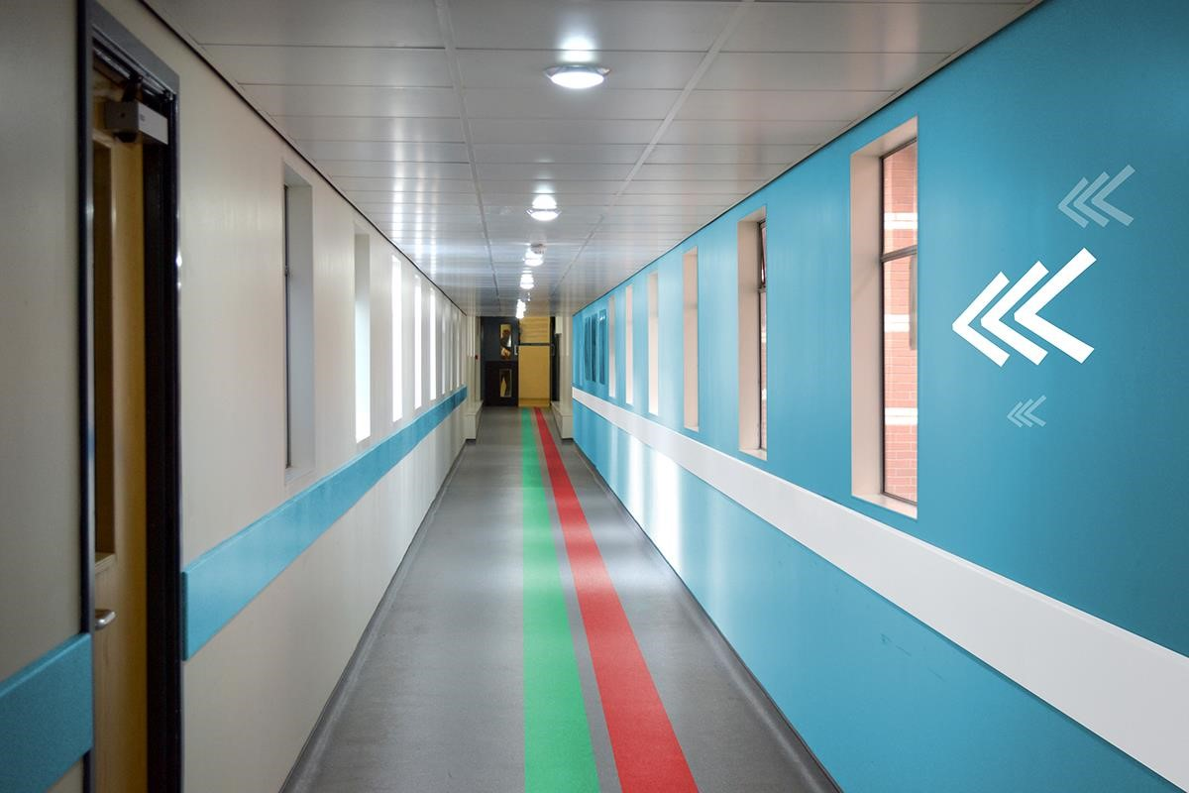

Fig 5. (Anna Campbell, 2016)
Way-Finding
finders are a way that graphic designers design withing a place such as a hospital for clients/patients to allow them to navigate around the building at ease, way finding is used in many places in our daily lives, these include a lot of static signs such as Identification signs, this informs the user when they have arrived at their destination with simple and clear information you usually see these on door plaques, departmental markers or landmark signage. Another static sign is called directional signs, this gives the user the direction they need to follow to reach their destination, this normally has arrows pointing to the direction they must take to reach their destination, the places you would normally see these at are, junction signs, directory signage and directional colored lines on the floor. There is also one for information, this gives the user the information they need when located in a specific area, these are mostly seen in entry and reception areas such as lobbies or waiting rooms. This signage gives the users primary information of what they are looking for such as the bathroom, when a business is closed, or how often the area is sanitized. Examples of where you would see these signs are amenities and accommodation, facilities signage, business information. And lastly, we also have regulatory signage, regulatory signage is usually focused on safety and liability concerns. This also sets boundaries for the user by telling them what they can and can't do or where they can go or can't go. This gives the place a reinforced rule, safety and privacy standards. The examples of where you would find these signs are rules and regulations, compliance standards and access control.
Floor markings are also a critical part of wayfinding, these act just like signs, they have a different use and purpose but are similar in nature; identification, directional, informative, and regulatory floor markings can be easily identified.
A good example of using wayfinding was during the recent pandemic Covid-19, almost everywhere you would be seeing way finding this was from following instructions of the floor or wall which gave you the instruction on how many meters to stay apart or where to stand for each person, reading posters on step by step on how to correctly clean and sanitize yourself in the bathrooms and even floor markings such as yellow and black stripe which was showing an area that may expose the person to physical or hazards area of the place. (Sarrette, 2021,
[Accessed 01/12/2024])
Way finding is also very popular and a critical piece of design in emergency buildings, for example a hospital. This is done to allow the patients to easily navigate around a huge building like a hospital. This allows the patients to quickly find the sections of the hospitals they need, for example these building will have marking such as coloured lines on the floor or walls to follow for certain sections such as Yellow for x-rays, green for the pharmacy or red for operations. These 100% help as personally I have needed to navigate around hospitals and not always you can find someone to help you and when you are in a rush emergency these will take you exactly to the location you need as they have very vibrant understanding colours and big enough text with symbols to see from a distance.

Conclusion
In conclusion I personally think that graphic design can Definitely save lives, not physically but for sure gives the correct information at the speed where a life could be saved, graphic design permeates every aspect of our daily lives, from cigarette packaging that communicates the danger of smoking allowing the users understand the damage it is causing to their self's, to illuminated road signs that enhance nighttime driving safety allowing road users to see critical information at night and wayfinding system in hospitals that help patients navigate critical environments during emergencies allowing the patients to quickly get help which can 100% save someone's life.
The evolution of graphic design from ancient Egyptian symbols to modern designs illustrates its enduring role in conveying vital information effectively, this still has many similarities on how the information is displayed but has improved dramatically to allow all kinds of users around the world to understand even with a language barrier. Whether through graphic health warnings on cigarette packs or universal symbols on road signs, designs have the power to inform, warn and guide individuals, ultimately savings lives. The clarity, accessibility, and immediacy that well executed graphic design brings to communication underscores its pivotal role in fostering safety and well-being in society. So yes, I think that graphic design can certainly save someone's
life.
Bibliography
1. Robinson, A. (2001) The story of writing: Alphabets, hieroglyphs & pictograms. London: Thames & Hudson.

2. Cummings, K.M., Brown, A. and O’Connor, R. (2007). The Cigarette Controversy. Cancer
Epidemiology and Prevention Biomarkers, [online] 16(6), pp.1070–1076.
doi:https://doi.org/10.1158/1055-9965.EPI-06-0912.
- Bansal-Travers, M., Hammond, D., Smith, P. and Cummings, K.M. (2011). The Impact of Cigarette Pack Design, Descriptors, and Warning Labels on Risk Perception in the U.S. American
Journal of Preventive Medicine, 40(6), pp.674–682. doi:https://doi.org/10.1016/j.amepre.2011.01.021.
- 3. Bansal-Travers, M., Hammond, D., Smith, P. and Cummings, K.M. (2011). The Impact of Cigarette Pack Design, Descriptors, and Warning Labels on Risk Perception in the U.S. American
Journal of Preventive Medicine, 40(6), pp.674–682. doi:https://doi.org/10.1016/j.amepre.2011.01.021.
5.Wakefield, M., Morley, C., Horan, J.K. and Cummings, K.M. (2002b). The cigarette pack as image: new evidence from tobacco industry documents. Tobacco Control, 11(Supplement 1), pp.i73–i80. doi:https://doi.org/10.1136/tc.11.suppl_1.i73.
6.Sarrette, C. (2021). Wayfinding or The Art Of Navigation. [online] BAM Creative. Available at: https://bamcreative.io/wayfinding-or-the-art-of-navigation/.
7. Dewar, R. and Pronin, M. (2023). Designing road sign symbols. Transportation Research Part F: Traffic Psychology and Behaviour, 94, pp.466–491. doi:https://doi.org/10.1016/j.trf.2022.12.008.

Image bibliography
Fig 1. Belluz, J. (2016). The US hasn’t updated the health warnings on cigarette packs in 31 years.
[online] Vox. Available at: https://www.vox.com/2016/6/2/11818692/plain-packaging-policy-usaustralia.
Fig 2. Yong, H.-H., Borland, R., Cummings, K.M., Hammond, D., O’Connor, R.J., Hastings, G. and King, B. (2011). Impact of the removal of misleading terms on cigarette pack on smokers’ beliefs about Light/Mild cigarettes: Cross-country comparisons. Addiction (Abingdon, England), pp.2204–2213. doi:https://doi.org/10.1111/j.1360-0443.2011.03533.x.
Fig 3 . Littleton, M.-B. of (2024). Mercedes-Benz of Littleton. [online] Mercedes-Benz of Littleton.
Available at: https://www.mercedesoflittleton.com/the-history-of-traffic-signs/ [Accessed 1 Dec.
2024].
Fig 4. Dewar, R. and Pronin, M. (2023b). Designing road sign symbols. Transportation Research Part F: Traffic Psychology and Behaviour, pp.466–491. doi:https://doi.org/10.1016/j.trf.2022.12.008.
Fig5 .Behance (2016). Accessible Hospitals Wayfinding Proposal. [online] Behance. Available at: https://www.behance.net/gallery/36641887/Accessible-Hospitals-Wayfinding-Proposal.

