Design of an Electronic Blind Assist Cane
Bailey Armin

Table of Contents
Design of an Electronic Blind Assist Cane 1
Table of Contents 2
Table of Figures 3
Background and Purpose 4
UK Sight Loss Statistics 4
Market Gap and Opportunity 5
Limitations / Evaluation of Existing Solutions 5
Adoption of Mobility Aids 5
Trends in Smart Mobility Research 6
Where Our Product Fits in the Market 6
Aims and Objectives 7
Team Organisation and Role Expectations 7
Electronics, Coding, and Peripherals 8
Architecture and Peripherals 8
Coding Logic Principles 9
Open-Source and Research Foundation 9
Opportunities, Challenges, and Safety 10
Planned Testing and Validation Strategy 10
Design Considerations 11
Project Risks and Mitigations 11
Reflection 12
References 13
Bibliography 16
Appendices 17
Appendix A 17
Appendix B 18
Appendix C 19
Appendix D 20
Appendix E 21
Appendix F 22
Appendix G 24

Table of Figures
Figure 1: Estimated Expected Number of Blind People. 4
Figure 2: Data Showing the amount of white cane and guide dog users 6
Figure 3: Bill of Materials (BOM) 17
Figure 4: Group Contract 18
Figure 5: Gantt Chart Timetable 19
Figure 6: Diary of In-Person Meetings 20
Figure 7: Diary of Online Meetings 21
Figure 8: Flowchart for the Smart Cane 24

Background and Purpose
Vision impairment is increasing across the UK, with over two million people currently affected and this expected to rise to four million by 2050 (RNIB, 2021). Around 250 people lose their sight every day (RNIB, 2021). Existing mobility aids, mainly white canes and guide dogs, offer slight protection against upper-body hazards, which leads to frequent collisions. This report outlines the market need for a low-cost electronic cane and where it could offer value.

UK Sight Loss Statistics
NHS Digital (2023) reports 268,500 registered blind or partially sighted people in England, though registration is voluntary, so the real number is higher (OHID, 2024). RNIB (2025) estimates that severe sight loss will rise from 298,000 to 379,000 by 2050. Only 2–8% of visually impaired individuals use a standard cane (Yin, 2019), suggesting major barriers to adoption.

Figure 1: Estimated Expected Number of Blind People.
Figure shows a steady rise towards 2050, indicating increasing long-term demand for mobility aids.

Market Gap and Opportunity
Traditional canes detect only ground-level hazards and often miss signs, branches, and overhead objects. Several electronic canes still suffer from narrow detection ranges, such as the Glasgow example with a 1.8m range and 30° field of view (Hersh & Ramirez, 2018).
Cost is the biggest barrier:
- WeWALK V2 – £700
- UltraCane – £635
- Budget prototypes – £180+
Singh et al. (2020) note that India’s Smart Cane reached only 70,000 of five million potential users due to cost. An affordable design under £100 would be far more accessible, especially for new users.

Limitations / Evaluation of Existing Solutions
Electronic canes detect more hazards but introduce new challenges. Dos Santos et al. (2021) found they detected 79% of overhead obstacles missed by white canes, but users walked slower. Weight, battery life and unfamiliar feedback often limit usability. Sahoo et al. (2019) emphasise devices must remain “lightweight, simple and cost-effective” to be accepted. Many existing systems fail due to high price, complexity, or unreliable sensing.

Adoption of Mobility Aids
Only 2% of visually impaired people use a white cane (Partially Sighted Society, 2020). Only 10,000 guide dogs exist in the UK (RNIB, 2021), covering a tiny fraction of those needing support. Manduchi & Kurniawan (2010) found 40% of users experience head-level collisions annually, with 23% leading to injury. While electronic canes reduce hazard risk (Sato et al., 2020), high cost and training requirements contribute to up to 30% abandonment (Federici et al., 2016).

Figure 2: Data Showing the amount of white cane and guide dog users
Shows extremely low adoption of both tools, highlighting a large, underserved population.

Trends in Smart Mobility Research
Recent research trends include multi-sensor integration (ultrasonic, LiDAR, IMU, cameras) and improved mapping (Mai et al., 2023). The global smart cane market was valued at $450 million in 2024 and is projected to reach $1.2 billion by 2033 (Market Research Intellect, 2025). This growth reflects increasing demand and technological improvements.

Where Our Product Fits in the Market
Our design aims to be:
- Under £100, vastly cheaper than commercial alternatives
- Able to detect both upper and lower obstacles, unlike most canes
- Vibration-based, avoiding audio distractions
- Lightweight and simple, supporting higher adoption
Given rising sight loss rates and extremely low cane and guide dog usage, a low-cost, practical, and reliable smart cane could address a clear gap in the mobility aid market.

Aims and Objectives
Aim: Develop a low-cost smart cane to improve mobility for visually impaired users.
Objective: Use affordable components like Arduino and ultrasonic sensors to build a prototype costing under £100.
Aim: Increase user safety and awareness.
Objective: Detect obstacles using sensors and provide clear vibration feedback without blocking environmental sounds.
Aim: Keep the design simple and reliable.
Objective: Use open-source code and straightforward electronics to ensure the cane is easy to use, charge, and maintain.

Team Organisation and Role Expectations
Our project team has three members with defined responsibilities.
My primary role is the project manager, focusing on the organisational structure for this project, including allocating roles, scheduling meetings, and setting up collaborative shared files. My technical role focuses on the electronics and software development, including selecting the system architecture and creating the code for distance detection and haptic feedback.
A second member is responsible for the mechanical design, covering the cane’s structure, ergonomics, weight distribution, and user safety.
The third member leads the research and procurement of materials, including budgeting, sourcing, and data collection.
We maintain communication through weekly meetings, with collaboration record evidence documented in Appendix D - In-Person Meeting Diary, and Appendix E – Online Meeting Diary. Shared files via Microsoft Teams allow for better team collaboration. Our timeline, including buffer periods for potential delays is shown in Appendix C - Project Gantt Chart. All responsibilities and communication expectations are formalised in Appendix B - Group Contract.

Electronics, Coding, and Peripherals

Architecture and Peripherals
For system control, we selected an Arduino microcontroller because it is low-cost, easy to program, and widely supported, making it ideal for rapid prototyping (Sahoo et al., 2019). It is also more energy-efficient than a Raspberry Pi, which is designed for complex computing and requires more power. Since the cane only needs to read sensor data and activate feedback, Arduino provides faster responses, longer battery life, and no need for an operating system.
Obstacle detection will be handled using ultrasonic sensors, commonly used in smart cane designs for their low cost, reliability, and ability to detect nearby hazards (Mai et al., 2023). Additional sensors such as IR may be considered later, but ultrasonic modules meet current detection requirements.
Haptic alerts are to be delivered with vibration motors in the handle, which provide feedback without blocking important environmental sounds. Although some studies use multiple motors for directional cues, we will begin with a single motor and expand depending on testing outcomes (Kim and Cho, 2013). LED indicators and potentially a speaker may be included later.
Battery life is a major challenge. Our goal is for the cane to operate for at least a full day per charge. Using Arduino over Raspberry Pi supports lower power consumption, and we will further reduce usage through low-power components and sleep modes where the system remains responsive but conserves energy (Singh et al., 2020). The battery must also remain compact to avoid negatively affecting cane comfort.
More detailed information on the components and architecture chosen, and their justifications are found in Appendix A – Bill of Materials.

Coding Logic Principles
The system will operate using a continuous loop structure that checks sensor data, determines whether feedback is needed, and triggers alerts accordingly. A simplified flowchart of the planned code logic is shown in Appendix G - Smart Cane Flowchart, showing the cycle from distance detection to vibration response and power management.

Open-Source and Research Foundation
There is strong existing support for projects like ours. GitHub provides relevant open-source Arduino examples for ultrasonic sensing and vibration feedback, helping reduce development time. Sahoo et al. (2019) confirm ultrasonic sensors can detect obstacles and deliver vibration alerts effectively. More studies explore improved safety using different sensor positioning, mainly for upper-body hazard detection (Panazan & Dulf, 2024; Sudharshan & Kaur, 2024). These examples give both practical and academic bases for our design. Additional research is summarised in Appendix F - Supporting Supplementary Research.

Opportunities, Challenges, and Safety
Coding opportunities include making feedback smarter. Vibration intensity can increase as distance decreases, and with multiple motors we could introduce directional cues (Mai et al., 2023). However, ultrasonic sensors can create false readings, especially with angled surfaces, meaning filtering will be needed (Sato et al., 2020). Timing must remain fast to avoid delayed warnings.
Power management is another factor. Kim and Cho (2013) noted, efficient alert behaviour and low-power design remain essential in assistive technologies. The cane should also stay safe during faults, if the battery is empty or a sensor fails, the user must be alerted, and the cane must continue working as a standard cane regardless of electronics.

Planned Testing and Validation Strategy
Testing will focus on accuracy, responsiveness, and user safety:
- Sensor reliability: common indoor hazards positioned at different heights to check detection range and responsiveness
- Code validation: simulated distances ensuring vibration behaviour matches code.
- Battery performance: extended use tests, measuring how voltage falls over time and battery life.
- User trials: guided indoor walking tests (e.g. blindfolded participants) to test for alerts and comfort
Results will guide adjustments such as motor placement, alert thresholds, and sensor layout.

Design Considerations
The system is designed to remain intuitive for visually impaired users. Haptic alerts are prioritised because they deliver immediate warnings without masking vital traffic sounds. The cane should function automatically with minimal user input to reduce distraction. Reliability and cost-effectiveness influenced component choices, the Arduino for stable performance, ultrasonic sensors for robust detection, and a rechargeable, protected battery for safe daily charging. While future versions could incorporate additional alerts or smartphone connectivity, the current aim prioritises an accessible and lightweight mobility solution.

Project Risks and Mitigations
Several project risks have been identified with possible mitigations:
- Delivery delays
  - Alternative suppliers and early ordering.
- Coding faults in real-world use
  - Gradual testing and careful integration.
- User comfort issues
  - Prototype feedback on vibration strength and comfort.
- Coordination challenges
  - Regular meetings and shared documentation.
These risks will be reviewed again after prototype testing to ensure mitigations remain effective.

Reflection
At the start of the project, I was responsible for choosing the system architecture for the smart cane. I felt some pressure, as the choice would impact how well the electronics, sensors, and software could work together. After researching options like Raspberry Pi and Arduino, I decided Arduino was better suited for our power and simplicity needs. This helped me understand how system-level decisions affect design feasibility. It also gave me more confidence in justifying technical choices to others. I realised good architecture can reduce complexity and improve project direction early on. I’ll continue practicing early design mapping and document trade-offs more clearly.
Although I haven’t started coding yet, I’ve been planning the logic for the Arduino. Initially, I felt overwhelmed by the idea of handling multiple components in a single system. Reviewing past code, studying similar Arduino projects, and outlining a basic logic flow helped reduce that anxiety. This preparation aligns with UK-SPEC Competency B, as it involves using theory and research to plan problem-solving strategies (Engineering Council, 2021). Breaking things down into smaller tasks and planning logic early helps me feel more capable. I’ll build up my coding gradually during the next phase, starting with simple sensor tests.
Explaining electronics ideas to my group was sometimes challenging. I worried that I might confuse others or dominate technical discussions. Using sketches and examples helped bridge the gap and encouraged more group interaction. This improved my communication skills and reflected UK-SPEC Competency D (Engineering Council, 2021). Clear collaboration makes the whole team stronger. I’ll continue using visuals and check for understanding in group discussions.

References
- Dos Santos, A.D.P., Medola, F.O., Cinelli, M.J. et al. (2021) Are electronic white canes better than traditional canes? A comparative study with blind and blindfolded participants. Univ Access Inf Soc 20, 93–103. https://doi.org/10.1007/s10209-020-00712-z
- Engineering Council (2021) UK Standard for Professional Engineering Competence and Commitment (UK-SPEC), 4th Edition. Available at: https://www.engc.org.uk/ukspec
- Federici, S., Meloni, F., Borsci, S., and Mealli, M. (2016) ‘Device abandonment in assistive technology: A self-report survey’. Available at: https://oro.open.ac.uk/87866/1/87866.pdf
- GitHub (2023) Smart Cane and Walking Stick Open-Source Projects. Available at: https://github.com/topics/smart-cane.
- Kazi, W., Limu, T.J., & Rakibuzzaman, M. (2023). Smart Cane: A Low Cost Assistive Device for the Visually Impaired. EAI Endorsed Trans. on Internet of Things, 8(4), e5. Available at: publications.eai.eu.
- Kim, S.Y. and Cho, K. (2013) ‘Usability and design guidelines of smart canes for users with visual impairments’, International Journal of Design, 7(1), pp. 99–110. Available at: https://www.ijdesign.org/index.php/IJDesign/article/view/1209/559
- Mai, C., Xie, D., Zeng, L., Li, Z., Li, Z., Qiao, Z., Qu, Y., Liu, G. and Li, L. (2023). Laser Sensing and Vision Sensing Smart Blind Cane: A Review. Sensors, [online] 23(2), p.869. doi:https://doi.org/10.3390/s23020869.
- Manduchi, R. and Kurniawan, S. (2010) ‘Watch Your Head, Mind Your Step: Mobility-Related Accidents Experienced by People with Visual Impairment’. Available at: https://tr.soe.ucsc.edu/sites/default/files/technical-reports/UCSC-SOE-10-24.pdf#:~:text=,11
- Market Research Intellect (2025). Smart Cane For The Blind Market. [online] Market Research Intellect. Available at: https://www.marketresearchintellect.com/product/smart-cane-for-the-blind-market/
- NHS Digital (2023) ‘Registered blind and partially sighted people, England 2022–23’. Available at: https://digital.nhs.uk/data-and-information/publications/statistical/registered-blind-and-partially-sighted-people/registered-blind-and-partially-sighted-people-england-2022-23/total-registrations-as-at-the-end-of-the-reporting-period
- OHID (Office for Health Improvement and Disparities) (2024) ‘Vision profile statistical commentary: May 2024 update’. Available at: https://www.gov.uk/government/statistics/vision-profile-may-2024-update/vision-profile-statistical-commentary-may-2024
- Panazan, C.-E., & Dulf, E.-H. (2024). Intelligent Cane for Assisting the Visually Impaired. Technologies, 12, 75. Available at: pdfs.semanticscholar.org.
- Partially Sighted Society (2020) ‘I am visually impaired – do I need a white cane?’. Available at: https://www.partsight.org.uk/news/post/i-am-visually-impaired
- RNIB (Royal National Institute of Blind People) (2021) ‘Key information and statistics on sight loss in the UK’. Available at: https://www.rnib.org.uk/professionals/research-and-data/key-information-and-statistics-on-sight-loss-in-the-uk/
- Sahoo, N., Lin, H.-W. and Chang, Y.-H. (2019) ‘Design and implementation of a walking stick aid for visually challenged people’, Sensors, 19(1), article 130. DOI: 10.3390/s19010130
- Sato, D., Zhao, Y., and Asakawa, C. (2020) ‘Are electronic white canes better than traditional canes? A comparative study’. Universal Access in the Information Society, 19(4), pp. 901–913. Available at: https://link.springer.com/article/10.1007/s10209-020-00712-z
- Singh, S., Tomar, M. and Mahendra, V.S. (2020) Rapid Review of Assistive Technologies for Persons with Disability in India. New Delhi: Amaltas Consulting Private Limited for the South Asia Research Hub, Department for International Development. Available at: https://assets.publishing.service.gov.uk/media/5ed6321bd3bf7f4606f1e15b/DFID-AT_Report.pdf
- Sudharshan, M., & Kaur, K. (2024). Rechargeable Smart Cane using Arduino Nano. In Proc. of ICICC 2024 (Innovative Computing & Communication) . Available at: papers.ssrn.com.
- WeWalk (2025). WeWalk V2 smart cane. [online] Rnib.org.uk. Available at: https://shop.rnib.org.uk/products/wewalk-v2-smart-cane-copy
- Yin, S. (2019). Why is creating electronic canes for the blind so hard? [online] WHYY. Available at: https://whyy.org/segments/why-is-creating-electronic-canes-for-the-blind-so-hard/

Bibliography
- Guide Dogs (2025) Our Impact. Guide Dogs for the Blind Association. Available at: https://www.guidedogs.org.uk/about-us/what-we-do/our-impact/
- IAPB (2020). Global data - IAPB Vision Atlas. [online] IAPB Vision Atlas. Available at: https://visionatlas.iapb.org/global-data/#economics
- Meganathan, M. (2021). Arduino Smart Walking Cane project – Ultrasonic obstacle detection with haptic feedback. Available at: github.com.
- Slimen, M. (2023). Smart Cane for the Visually Impaired (IoT Project). Available at: github.com.
- World Health Organization (2023). Blindness and vision impairment. [online] world health organization. Available at: https://www.who.int/news-room/fact-sheets/detail/blindness-and-visual-impairment
- Yogeshwaran, P. (2025). Smart Blind Stick (Arduino Ultrasonic Stick) code repository. Available at: github.com.

Appendices

Appendix A

Bill of Materials
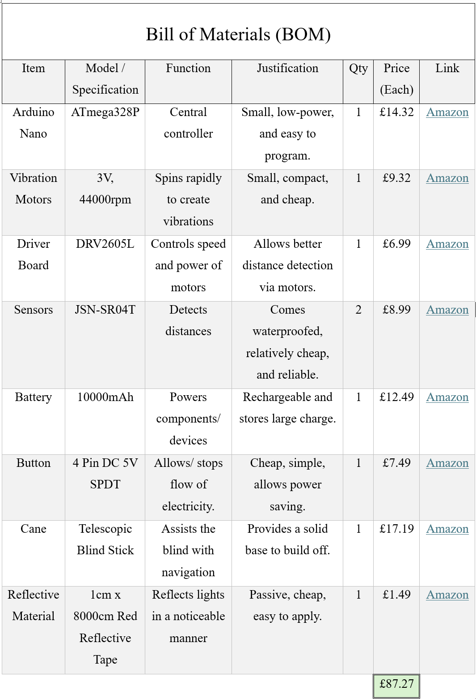
Figure 3: Bill of Materials (BOM)
Appendix A gives the full Bill of Materials (BOM) for the smart cane prototype. It shows every component used, including the Arduino microcontroller, ultrasonic sensor, vibration motors, and rechargeable battery, along with their prices, sources, justification, and intended function in the system. By selecting lightweight and low-power components, the cane remains comfortable to use for long periods while still supporting long battery life. The waterproof ultrasonic sensor allows the system to operate reliably outdoors, even in rain or near puddles. All components are fully compatible with Arduino, which reduces build complexity and helps speed up software development. Keeping the overall cost under £100 is a key design requirement, so the BOM plays an essential role in confirming that the product remains affordable for visually impaired users.

Appendix B

Group Contract
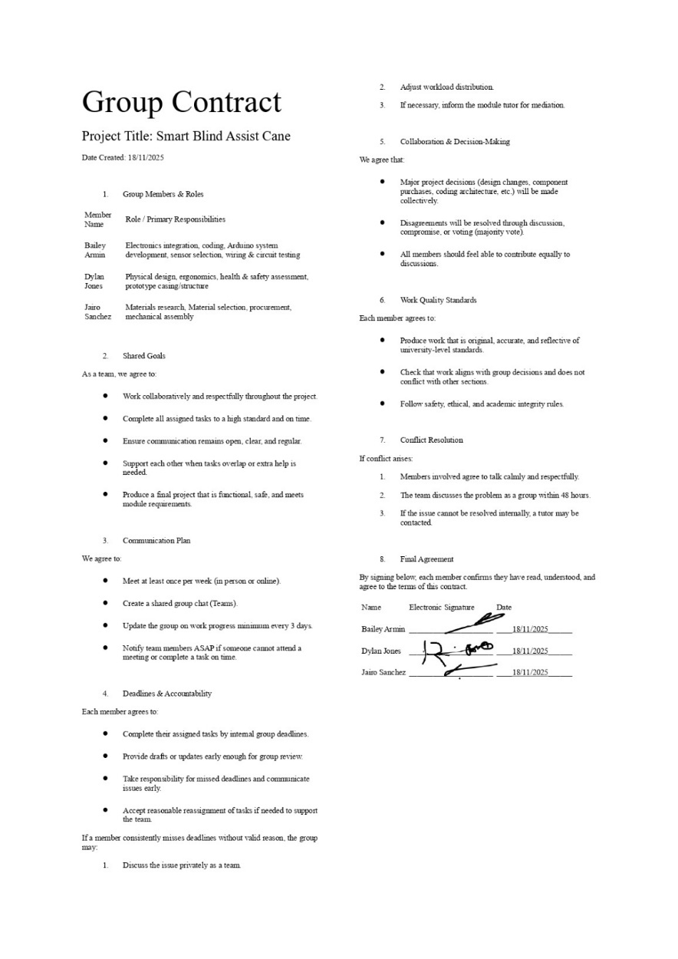
Figure 4: Group Contract
Appendix B shows the signed group contract created during the early stages of the project. The contract agreement details each team member’s responsibilities, expected behaviour, and communication commitments and more. It confirms that one member is responsible for electronics and programming, another for mechanical design, and the final member for user research and procurement activities. It also includes expectations for meeting attendance, progress updates, shared decision-making, and how the group would deal with any disagreements or challenges. By establishing these guidelines early, the team ensured that everyone understood their role and how their work contributed toward the outcome. The contract helps to show accountability, encourages consistent collaboration, and provides a reference for maintaining professionalism throughout the project.

Appendix C

Gantt Chart
Figure 5: Gantt Chart Timetable
Appendix C shows the Gantt chart used to structure the project timeline. This includes the key phases such as research, component investigation, coding and electronic testing, prototype development, evaluation planning, and report completion. The Gantt chart helped the group divide tasks evenly across the project period and monitor progress week by week. It also includes built-in buffer time to account for common technical issues like delayed component delivery or problems with code that may need reworking. By visually outlining when and how each task should be completed, the Gantt chart ensured that the team remained organised and aligned with deadlines, improving time management and overall workflow efficiency.

Appendix D

In-Person Meeting Diary
Figure 6: Diary of In-Person Meetings
Appendix D presents the in-person meeting diary, which records all live sessions held throughout the project. Each meeting entry includes the date, duration, attendance, and the main activities completed, such as project planning, hardware investigation, and presentation development. These meetings played a key role in progressing the physical and design-focused aspects of the project, as face-to-face collaboration allowed the team to discuss practical ideas more efficiently. The diary also demonstrates consistent attendance and engagement from all group members, showing a shared commitment to maintaining momentum throughout the early and mid-project phases. Overall, the in-person meeting log provides clear evidence of continuous teamwork and structured project development.

Appendix E

Online Meeting Diary
Figure 7: Diary of Online Meetings
Appendix E includes the online meeting diary, which documents regular virtual communication between in-person sessions. These shorter meetings were particularly useful for quick updates, setting weekly goals, assigning tasks, reviewing shared research, and making adjustments to the Gantt chart. They provided a flexible way to maintain progress when group members could not physically meet, ensuring that important decisions were not delayed. Attendance remained strong, demonstrating that the team used remote collaboration effectively to keep the project organised and on track. This diary highlights the value of continuous communication and helps show that progress was steady throughout the full project timeline.

Appendix F

Open-Source and Research Foundations for Smart Cane Development
There is already a huge amount of open-source and academic work on Arduino based smart canes. This makes it much easier for new developers, such as us to build on and improve on existing designs rather than starting from scratch. A lot of Arduino code and documentation is freely available online, especially on platforms like GitHub, showing how to integrate ultrasonic sensors, vibration motors, and buzzers into affordable assistive devices.
For example, the Smart Blind Stick (Arduino + Ultrasonic) project provides simple, reusable Arduino code that measures distance and triggers alerts by changing buzzer tone or LED blink speed as obstacles get closer. Similarly, a Smart Walking Cane with Haptic Feedback uses multiple ultrasonic sensors and small vibration motors fitted in the handle to create “directional” haptic cues, also adding a possible water sensor to warn about puddles. More advanced designs, like the IoT Smart Cane, pair Arduino Uno boards with both vibration and audio feedback, so the user gets spoken alerts as well as tactile ones (GitHub, 2023).
Academic research supports and expands on these community efforts. Sahoo et al (2019) demonstrated an early smart stick that converted ultrasonic readings directly into either vibration or buzzer alerts which shows how a basic sensor input can provide practical haptic or audio feedback. Building on that idea, Panazan and Dulf (2024) developed an “Intelligent Cane” using dual ultrasonic sensors. In their system, “the distances from ultrasonic sensors were continuously monitored, and alerts were triggered based on predefined threshold values” (Panazan and Dulf, 2024), meaning the microcontroller constantly scans for obstacles and gives different feedback depending on proximity. They also included a Bluetooth linked mobile application so that “the user can change the buzzer state using buttons in the application, enabling the start and stop of sound alerts through the buzzer to locate the cane in case of loss” (Panazan and Dulf, 2024).
Other studies have refined these ideas further. Sudharshan and Kaur (2024) designed a rechargeable Arduino Nano based smart cane, which “incorporates ultrasonic sensors and vibration feedback mechanisms” (Sudharshan and Kaur, 2024). In their design, the ultrasonic sensors are “strategically positioned to detect obstacles at various heights, including head-level, ensuring comprehensive coverage” (Sudharshan and Kaur, 2024). Similarly, Kazi et al (2023) introduced a low-cost smart cane emphasizing audio feedback. They explain that “the speech output will guide a blind person to take a safe path making the stroll more comfortable and secure” (Kazi et al, 2023).
Across these designs, researchers consistently share software flowcharts, pseudocode, and block diagrams, essentially forming a public “basic blueprint” for smart cane software and hardware, and although the “blueprint” is there, a company has yet to create a low cost, simple, and practical product.
Together, these open-source repositories and peer-reviewed studies form a very strong technical foundation for any new development. They show proven methods for handling sensor data, managing power, and delivering feedback, all of which can be adapted and extended for this project.

Appendix G

Smart Cane Flowchart
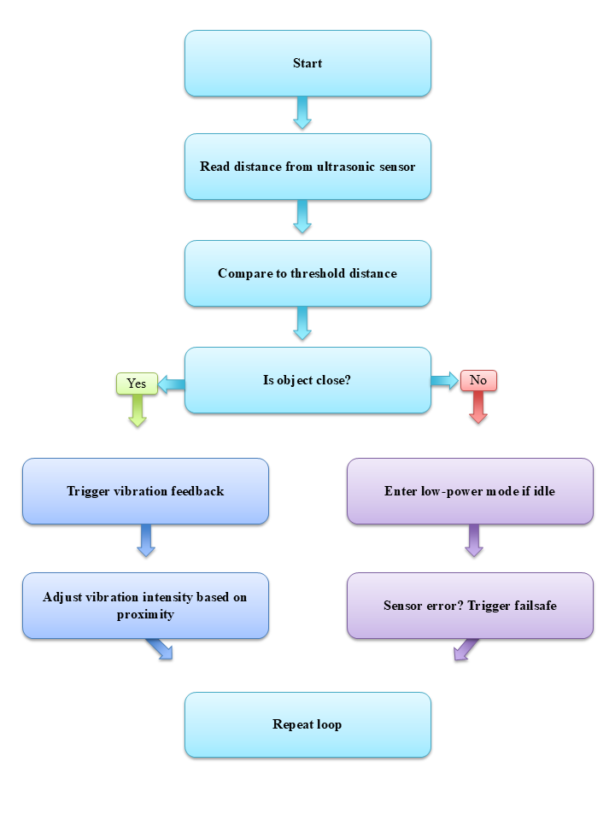
Figure 8: Flowchart for the Smart Cane
Appendix G shows a flowchart created illustrating the “thought” process of the code logic. The flowchart outlines the planned software logic for the smart cane’s obstacle detection system. The Arduino will continuously read distance data from ultrasonic sensors and compare it against a safety threshold. If an object is detected within range, the system will activate vibration feedback, with intensity increasing as the object gets closer. If no obstacles are present or the system is idle, it will enter a low-power mode to save energy. A failsafe step is also included in case a sensor stops responding. This loop ensures the system remains responsive while managing power efficiently.

