

Student name:Lucky Osagiede Osagiede
Student ID: 2312706

Module name: Empowering the older person
Module code: BMHP6027
Lecturer’s name: Dr Laila Surani

Empowerment of Older Adults in the UK.  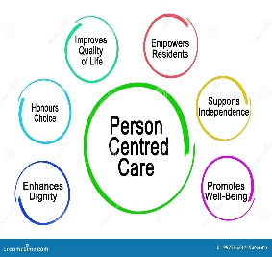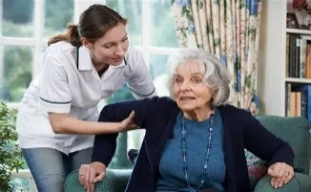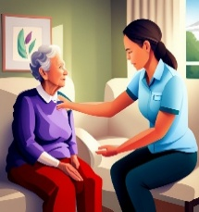  ( Centre for Ageing Better ,2025). |  | Critical Evaluation of the Care, Empowerment and Support Needs of Older People in the Uk:  - Older people in the UK require person-centered, holistic care that addresses physical, psychological, emotional, social and cultural needs rather than focusing solely on medical conditions.  - Maintaining functional ability is essential for healthy ageing. For example, physiotherapy, occupational therapy, exercise and nutritional support, fall prevention to help retain mobility and perform activities of daily living.  - Ensuring freedom and choice is a fundamental principle of UK health and social care.  - Promoting independence enables older people to remain in their own homes for longer, reducing unnecessary hospital admission and dependence on institutional care. Nevertheless, independence should be balanced with appropriate risk management because excessive protection may unintentionally reduce confidence and self-reliance. |  | 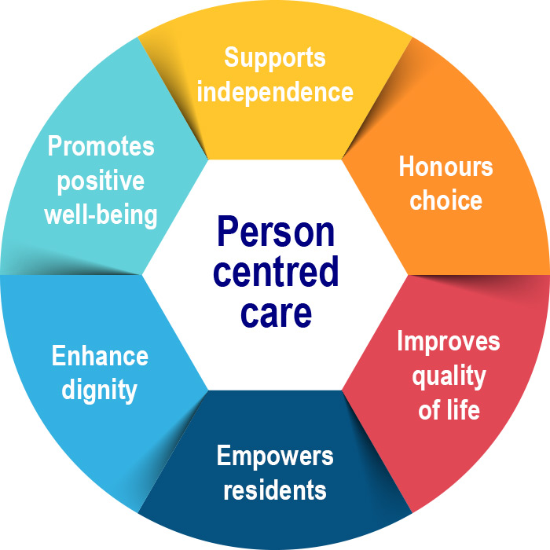  (Centre for Ageing Better, 2025).
Introduction  Older adults frequently require personalized care and support to maintain their independence, dignity, and quality of life. As people age, they may experience physical, psychological, and social changes that affect their ability to carry out everyday activities. Health and social care services in the UK aim to empower older people by promoting autonomy, informed decision-making, and person-centered care. Effective support enables older adults to remain active, participate in their communities, and retain control over their lives. However, challenges such as long-term health conditions, reducing mobility, social isolation, and limited access to services can affect their functional ability and overall well-being. This presentation critically examines the care, empowerment, and support needs of older people, evaluates current interventions and UK policies, explores, the barriers they face in maintaining independence, and provides recommendations for improving services that enhances healthy ageing and quality of life (Department of Health and Social Care, 2021; World Health Organization,2021). |  |  |  | Challenges Encountered by older people in maintaining Healthy, Independence and Functional Ability  - Chronic health conditions:  Long-term illnesses such as arthritis, diabetic, stroke, and hearth disease reduce mobility and independence (WHO,2021).  - Frailty and falls: Muscles’ weakness and poor balance increase the risk of falls, injuries and loss of functional ability (NHS England, 2023).  - Cognitive decline: Dementia and memory problems affect decision-making, self-care, and the ability to live independently (Age UK,2024).  - Social isolation: Loliness and limited social support negatively affect physical and mental wellbeing.  - Financial and digital barriers: Limited income and poor digital skills can restrict access to healthcare, support services, and information.  Recommendations for Improvement of Services to Empower Older People in the UK  - Promote person-centered care by involving older people in decisions about their health and social care, which improves autonomy, dignity and satisfaction (NICE,2023).  - Increase access to integrated health and social care services to ensure coordinated support for physical, mental and social needs, reduces service fragmentation (NHS England, 2024).  - Expand community-based programs that encourage social participation, physical activity and lifelong learning to reduce loneliness and maintain functional ability (WHO, 2021).  - Improve digital inclusion by providing training and accessible technologies, enabling older adults to use online healthcare services and remain independent (Age UK, 2023)  - Strengthen advocacy and safeguarding services to protect older people’s rights, promote informed choices and empower them to live independently (Care Act, 2014).  Conclusion  Empowering older adults demands a holistic strategy combining strong policies, proven interventions, and personalized care. UK efforts like the Care Act 2014 have improved support for independence, yet ageism, underfunding, and disjointed services still limit autonomy.  Future services must involve older people in design, expand preventive community support, and combat attitudes. Only integrated, right-based approaches can uphold dignity, choice, and full societal participation in later life.

The effectiveness and benefits of approaching and intervention of the empowerment of older people and the theory about it:
Effectiveness and Benefits of Empowering older adults /people in the UK:
- Empowering older adults enables them to participate actively in decisions about their health and social care, improving autonomy, dignity, and quality of life (National institute of Health and Care Excellent 2015).
- Person-centered care encourages independence by recognizing individuals’ preferences, strengths and goals, leading to greater satisfaction with care and improved wellbeing (NHS England, 2019).
- Empowerment promotes self-management of long-term conditions, helping older adults maintain functional ability, reduce hospital admissions, and increase confidence in managing their health (World Health Organization,2020).
- Providing advocacy, social support, and community services reduces loneliness and social isolation, which are associated with better mental health and healthier ageing (WHO,2020).

Relevant Theories of Empowerment:
1. The Care Act 2014 promotes independence by encouraging older adults to make informed choices, build confidence, and actively manage their own care.
Albert Bandura’s Self-Efficacy Theory (1977)
- This theory suggests that people who believe in their ability to perform tasks are more likely to manage their health successfully.
- In older people, improving self-efficacy encourages independence, adherence to treatment, and confidence in making healthcare decisions.
2. The Equality Act 2010 protects older adults from age discrimination, ensuring equal access to health and social care services while promoting inclusion and empowerment (UK Government, 2010).
- John Rawls (1971) primarily related to Social Justice that it focuses on equality, fairness, non-discrimination, and equal access to health and social care for older adults.
- He believes the Equality Act 2010 promotes fairness by preventing age discrimination and ensuring older adults receive equal, respectful healthcare access. (UK Government 2010 equality Act 2010).

References

Abdi, S., Spann, A., Borilovic, J., de Witte, L. and Hawley, M., 2019. Understanding the care and support needs of older people: a scoping review and categorisation using the WHO international classification of functioning, disability and health framework (ICF). BMC geriatrics, 19(1), p.195.
Age UK (2023) Later life in the United Kingdom 2023. London: Age UK. Available at: http://www.ageuk.org.uk /information-advice/work-learning/technology-and-internet (Accessed: 16 July 2026).
Barnes, M. and Walker, A., 1996. Consumerism versus empowerment: a principled approach to the involvement of older service users. Policy & Politics, 24(4), pp.375-393.
Camilleri, D., 2025. Quality of life in residential care homes: older disabled persons’ and allied health professionals’ perspectives (master’s thesis, University of Malta).
Chadborn, N., Craig, C., Sands, G., Schneider, J. and Gladman, J., 2019. Improving community support for older people’s needs through commissioning third sector services: a qualitative study. Journal of Health Services Research & Policy, 24(2), pp.116-123.
Davis, K. and Hobbs, A., 2022. Innovation in adult social care. UK Parliament POST, 670, pp.1-20.
Fitzpatrick, J.M., Bianchi, L.A., Hayes, N., Da Silva, T. and Harris, R., 2023. Professional development and career planning for nurses working in care homes for older people: A scoping review. International journal of older people nursing, 18(1), p.e12519.
HM Government (2014) Care Act 2014. London: The stationery Office. Available at: https://www.legislation.gov.uk/ukpga/2014/23contents (Accessed: 16 July 2026).
Hodge, G., Lang, I., Byng, R. and Pearce, S., 2024. Older peoples lived experiences of personalized care in care homes: A meta‐ethnography. International journal of older people nursing, 19(1), p.e12585.
Iliffe, S., Walters, K., Manthorpe, J., Goodman, C. and Kharicha, K., 2017. Health and well-being promotion strategies for ‘hard to reach’older people in England: A mapping exercise. Primary health care research & development, 18(6), pp.563-573.
McPhee, J.S., French, D.P., Jackson, D., Nazroo, J., Pendleton, N. and Degens, H., 2016. Physical activity in older age: perspectives for healthy ageing and frailty. Biogerontology, 17(3), pp.567-580.
National Institute for Health and Care Excellence (NICE) (2023) share decision making (NG197). London: NICE. Available at: https://www.nice.org.uk/guidance/ng197 accessed :16 July 2026.
NHS England (2023) provides proactive care for people living in care homes: Enhanced Health in Care Homes Framework. London: NHS England. Available at: https://www.englang.nhs.uklong-read/providing-proactive -care-for-people-livingin-care-homes-enhanced-health-incare-homes-framework/ (Accessed:16 July 2026).
Oliver, D., Foot, C. and Humphries, R., 2014. Making our health and care systems fit for an ageing popula.tion. London: UK: King's Fund.
World Health Organization (WHO) (2021) Decade of Healthy Ageing: Baseline Report. Geneva: World Health Organization. Available at: https://www.who.int/publications/i/item/9789240017900 (Accessed: 16 July 2026).

