MODULE NAME: Employability and Career Development
MODULE CODE: LCLM4005-LON
STUDENT ID: 2439787
STUDENT NAME: VERONICA KONADU
LECTURER: ANITA NAN
ASSIGNMENT: MOCK INTERVIEW

Job Advertisement:
The Job Title: Store Assistant
Location: London, (BA16)
Hourly rate: 18.50 PAYE/25,676 per annum
Contract Length: Permanent
Working Pattern: Full Time (44 hours a week)
Days: Monday to Friday.
Job Duties:
These are some main duties:
Helping Customers,
. Greet customers when they walk into the store.
. Answering questions about products (prices, size or colours).
. Helping people find what they are looking for.
2. Working at the Till (Cashier)
. Taking payments in cash. Card or phone apps.
. Scanning items and telling the customer the total price.
. Bagging the items carefully and giving receipts.
3. Filling the Shelves (Stocking)
. Unpack new boxes of products when they arrive.
. Putting items on the shelves neatly.
. Checking the use-by date on food to make sure everything is fresh.
4. Handling Deliveries,
. Checking the delivery list to make sure the store received the right items.
. Putting price tags or security tags on new products.
5. Keeping the store Clean,
. Sweeping or mopping the floor to keep it safe and clean.
. Folding clothes or tidying up messy displays.
. Removing any trash or empty boxes.
- We are looking for someone who is Good with your hands you can fold clothes neatly you can make the shop look tidy and pretty.
- Hardworking thus you are happy to stand and move all day, can lift boxes and fill shelves.
- Friendly and Polite, you smile and say hello to customers. You are happy to people find things.
- Organized, you notice when things are messy and fix them also you are always on time for work.
The shop wants someone who is candidate offers excellent customer service and strong verbal communication, with good personal presentation and the ability to work effectively, as part of the team. They will be adaptable, quick to learn new information and able, support sales activity, while maintaining the physical capability to move stock and carry out tasks safely.

Veronica Konadu
London, UK Email: Konaduv@ymail.com

Personal Profile
A calm, reliable and people focused support professional with experience across hospital, school and community environments. I communicate clearly with staff, patients pupils and parents and I work well under pressure. My background has strengthened my empathy, patience and attention to detail especially when supporting vulnerable individuals, I am now looking to progress into a mental health support role where I can build on my safeguarding knowledge, develop clinical skills and contribute to safe person centred care.

Key Strengths
- Strong communication skills . able to explain information simply and calmly.
- Empathy and patience, with a natural ability to reassure anxious individuals.
- Reliable work ethic punctual consistent attendance and willingness to cover shifts.
- Good observation skills; able to notice small changes in behaviour , appetite or mood.
- Basic safeguarding awareness and understanding of escalation procedures.
- Comfortable working in fast paced, multi disciplinary environments.

Areas for Development
- Building formal knowledge of mental-health legislation and assessment frameworks.
- Improving confidence with structured case-note writing and risk-assessment formats.
- Completing accredited de-escalation training (PMVA or equivalent).
- Working towards NVQ Level 3 Health & Social Care.

Employment History
Teaching Assistant
Primary School, London 1 year
- Supported classroom activities and small-group literacy sessions.
- Adapted explanations to suit pupils’ needs and learning styles.
- Helped manage behaviour calmly and consistently.
- Built positive relationships with pupils, teachers and parents. Feedback: “Patient, adaptable and able to build rapport quickly with pupils.”

Hospital Kitchen Assistant
NHS Hospital, London 6 months
- Prepared and delivered meals to patients with varied dietary needs.
- Followed infection-control procedures and completed temperature/dietary logs accurately.
- Communicated dietary concerns to nursing staff and supported patients respectfully at mealtimes. Feedback: “Consistently follows procedures and treats patients with respect.”

Midday Supervisor (Dinner Lady)
Primary School, London 2 years (part-time)
- Managed lunchtime routines and supported children with additional needs.
- Liaised with parents and pastoral staff when concerns arose.
- Stayed calm during busy or challenging situations. Feedback: “Remains calm under pressure and manages situations sensitively.”

Transferable Skills
- Record keeping: Experience completing kitchen logs, observation notes and incident forms.
- Safeguarding: Familiar with reporting procedures in both school and hospital settings.
- Teamwork: Worked alongside nurses, teachers, pastoral staff and catering teams.
- Adaptability: Comfortable switching between roles, routines and environments.
- Communication: Able to give clear handovers and explain information in a straightforward way.

Training & Development
- Safeguarding (school and hospital mandatory training)
- Infection control
- Basic first aid
- Behaviour management mentoring from senior staff
- Ongoing self directed learning in mental health awareness

Education
Level 4 in Business

Additional Information
- Flexible with shifts and willing to take on extra responsibilities.
- Motivated to progress into mental-health support work and complete NVQ Level 3.
- Open to shadowing, volunteering and further training to build confidence in clinical settings.

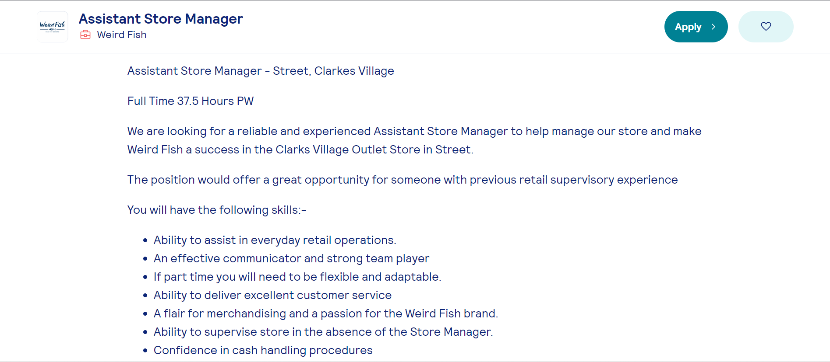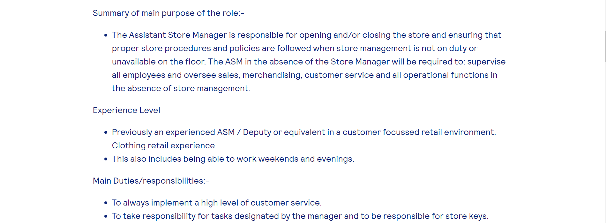

veronica Konadu
Johnson Anthony southeast Anthony
Ferndale food Ltd London
23 Wolvercote road, London se28 0es
09/03/2026

Dear Hiring Manager,
I wish to apply for the role of Store Manager, currently being advertised on at job centre. Please find enclosed my CV for your consideration.
As you can see from my attached CV, I have over 2 years’ experience in retail industry, and I believe my ability to lead teams and hit sales targets
during this time make me the right/perfect candidate for the role.
In my current role as a Store Manager at Morrisons, I have been responsible for running the daily operations of the store and managing the staff. During this time, I learned how to give customers great product information so they feel happy to buy. I also have a Level 4 Certificate in business skill for the workplace, ich helps me manage the team and solve problems well.
All of this coupled with my enthusiasm and dedication such as consistently exceeding monthly sales targets
has helped increase the stores performance and customer satisfaction.
i am confident that i can bring this level of success with me to your organisation and help Ferndale Food Ltd build upon their reputation as leading retailer in the local area. with my previous experience and expertise i believe my contribution will have a positive impact on your team.

Thank you for your time and consideration I look forward to hearing from you

Yours faithfully

Veronic Konadu

0

0

