Research Proposal Title: Social Media Influencers and Their Impact on Fast Fashion and Sustainable Fashion Sales.

Introduction
The textiles industry is one of the most polluting industries on the planet, second only to the automotive and technology industries (Environmental Audit Committee, 2019, p. 5). It is imperative therefore that ways are found to reduce the consumption of throw-away fast fashion and to stop adding to textile landfills. The UK has signed up to a UN agreement regarding clothing production and consumption, but there are no signs yet of fast fashion consumption in the UK slowing down anytime soon. According to evidence provided by contributors to a report compiled by the House of Commons, ‘more than $500 billion of value is lost every year due to clothing underutilisation and the lack of recycling’. By 2030, clothing purchases are projected to increase ‘by 63%, from 62 million tons today to 102 million tons—equivalent to more than 500 billion additional T-shirts'. Furthermore, the UN claims that ‘by 2050 the equivalent of almost three planets could be required to provide the natural resources needed to sustain current lifestyles given the growth in global population’ (Environmental Audit Committee, 2019, p. 5).
The textiles industry is polluting in a variety of ways. Many fabrics, especially fast fashion clothes, are made from synthetic materials such as polyester which have a high carbon footprint and produce microfibre shedding that creates tiny plastic fibres that are now found everywhere on the planet, including in our food chain. Materials that are produced from plants such as cotton take up evermore land and require high volumes of water and harmful pesticides to grow. The dyes used in textiles, many of them toxic, run into waterways causing massive pollution and death of aquatic creatures. There are concerns about animal welfare in the production of animal derived materials for clothing (Environmental Audit Committee, 2019, p. 28-33) and the exploitative working conditions of many textile factories including modern-day slavery (Environmental Audit Committee, 2019, p. 16).

Part of the marketing of fast fashion is increasingly dependent on Social Media Influencers (SMIs) who communicate approval of fast fashion consumption by wearing clothes provided by companies and encourage one-wear use of clothes. Over the last five years there has been a noticeable increase in the number of SIMs to be found online. Particularly during and after the Covid 19 pandemic, ‘more than 50 million people around the world now consider themselves to be influencers (or creators)’ (Gagliese, 2022). As a result, they have become an integral part of clothes marketing.
This research proposal aims to investigate how SMIs contribute to fast fashion consumption and how they might become part of the solution. The interest and focus of this research project is to explore the following:
- How do social media influencers impact on fast and slow fashion sales?
- Can they help reduce harmful environmental and unfair labour practises conducted by many fast fashion companies, or is their role inevitably to increase the sales of fast fashion brands driven by the need for high volume sales of low-quality, cheap products?
- Can SMIs make slow fashion more popular?
- How does adopting slow fashion approaches impact on a company’s profits?
Using case studies, I will investigate the positive and negative roles social media influencers can play on the sales of fast and more ethical slow fashion brands. The companies I will use as case studies include Tala, which is a new sports ethical clothing range, and Pretty Little Thing and Shein which are both fast fashion outlets. All these companies are online shopping only; none of them have stores.

Literature Review
The way we make, use and throw away our clothes is unsustainable. Textile production contributes more to climate change than international aviation and shipping combined, consumes lake-sized volumes of fresh water and creates chemical and plastic pollution. Synthetic fibres are being found in the deep sea, in Arctic Sea ice, in fish and shellfish.
(Environmental Audit Committee, 2019, p. 3).
This is the opening statement of a key parliamentary report produced by the UK Government called ‘Fixing Fashion: Clothing Consumption and Sustainability’ laying out the devastating impact that fast fashion is having on the environment and the UK’s contribution to the problem. It continues:
We buy more clothes per person in the UK than any other country in Europe. A glut of second-hand clothing swamping the market is depressing prices for used textiles. What can’t be sold is torn up and turned into insulation and mattress stuffing… Worse still, around 300,000 tonnes of textile waste ends up in household black bins every year, sent to landfill or incinerators. Less than 1% of material used to produce clothing is recycled into new clothing at the end of its life. Meanwhile, retailers are burning new unsold stock merely to preserve their brand.
(Environmental Audit Committee, 2019, p. 5).
Over the last couple of decades clothes have come to be seen as one-wear only disposable items rather than garments to be worn multiple times over many years. As a result, many clothing items are now worn once and then thrown away to end up in landfill. The report goes on to list a number of recommendations, but interestingly, none of these includes the need to find ways to persuade young people to adopt slow fashion.
This rise in fast fashion, both in the UK and around the world, has been aided by social media marketing. With fast fashion brands booming and demand rising for affordable fashion, low-quality items of clothing are now being made with the deliberate intention to be one wear, disposable items. In a recent Channel 4 documentary called ‘Inside the Shein Machine’ the growth of the Chinese clothing brand has boomed, especially during the covid-19 pandemic (Inside The Shine Machine, 2022). Shein copies the latest fashion trends and, using social media platforms such as TikTok, can reach an international audience to whom they sell a huge volume of clothing at a very low cost, even to the extent of not requiring unwanted items to be returned (Inside The Shine Machine, 2022, 3.19). Shein’s sales figures have skyrocketed by 400% to 14.5 million (Inside The Shine Machine, 2022). Linked to this is an increase in the number of high street shops closing with a shift towards being exclusively online, such as Pretty Little Thing, Boohoo, and Shein to name just a few. These businesses rely on their social media presence to increase sales through the use of influencers. But many of these companies are now being scrutinised not only for their unsustainable manufacturing and sales methods, but also for their exploitative sweat shop labour models and abusive employment practices (Goldfingle, 2018).
According to the latest Shopper Profile report from power retail, fast fashion shoppers are mostly women under the age of thirty-five years (Feiam, 2019). In all of this, to what extent does this demographic, and the social media influencers who promote fast fashion sales, truly understand the environmental and human welfare ramifications of their marketing? Or is it unrealistic to expect young people to change their behaviour, and should retail companies be made to shoulder the responsibility instead? These are the kinds of questions that the Parliamentary Report has considered which need to be addressed at both a domestic and international level. As seen in the graph below (fig 1.) there is a growing number of people using social media, which results in consumers having more exposure to SMIs as most clothes sales are now online. According to Norris (2022), ‘67% of brands now us[e] Instagram for influencer marketing’ (Norris, 2022).
In order to understand the impact of social influencers on fast fashion sales, it is important to understand how the relationship between the retailer, influencer and the consumer operates. Campbell and Grimm 2019, cited in Balaban and Szambolics 2022, point out that ‘SMIs are people with large communities of followers who post on social media in exchange for compensation.’ This suggests that it is in the interests of the influencer to encourage the sales of as many items of clothing as possible as this increases their renumeration and their online presence. Interestingly Campbell and Grimm use the word community here when describing people who follow influencers on their social media platforms, giving the impression that there is a deep connection between the influencers and the individuals who follow them.
SMIs are becoming more noticeable across social media platforms, with companies like Pretty Little Thing using familiar and popular faces and names to help market their brand and sell their products. A key example of a social media platform used by more and more companies for marketing is Instagram, a site for posting photographs and short video clips. Companies such as Shein use so-called micro influencers, people who have a social media presence ‘larger than a normal person’s but smaller than a celebrity’s, landing between 1,000 and 100,000 followers’ (Hunter, 2022). A person with a following with less than around 10,000 followers is described as a ‘nano-influencer’ (Hunter, 2022). Micro and nano influencers are on a similar level with their followers and can ‘provide an authentic endorsement of their products at a much lower price tag than celebrity influencers’ (Hunter, 2022). Such influencers are vital to companies like Shein for promoting their clothing ranges for very little cost. Free clothes are sent to the SMI’s in return for posting a video on their social media platform promoting the clothes and the brand (Inside The Shine Machine, 2022, 3.28). Popular SMI’s become the face of the brand and introduce their followers to the brand. The customers and viewers will see an SMI that they follow advertise and promote the brand, putting the name out there across these platforms ( Inside The Shine Machine, 2022).
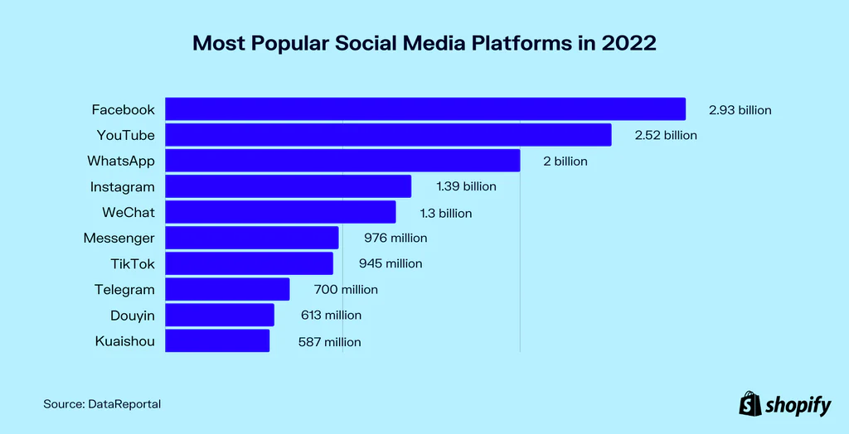
Fig.1 (Shopfiy, 2022)
We can see from the graph above the most used social media platforms of 2022 (shopify, 2022). If we use the example of Instagram, there were a total of 1.39 billion people who used the Instagram app in 2022. The audience numbers that a brand could have the potential to reach on these platforms is growing.
With the rise in social media use and SMIs becoming ever more popular and influential, this research proposal is timely and pertinent. The textiles industry needs to change, but it also needs to make a profit: new sustainable approaches to producing and marketing clothes are urgently required, and influencers may be part of the solution not just part of the problem.
Companies such as Tala (set up by an influencer) are using SMIs to promote more expensive items of clothing that are designed to last longer. At the very least, the idea of one wear disposable items must become unacceptable. Influencers are in an ideal position to both promote and educate.
A paper written by Perthuis and Findlay explores the dynamics of how SMIs influence fashion online. ‘A familiar figure wears these familiar clothes: the fashionable ideal, repackaged here for a millennial and post-millennial audience, personifying a paradox’ (Perthuis and Findlay, 2019). What is being posted on social media platforms is not necessarily new but something that is familiar to the audience in order to catch their attention and spark their interest; to make them feel that they too can look like the models and influencers that they see online. It also makes it more believable for the customer if they see online not only someone that they recognise but also someone who looks similar to them wearing branded clothing.
Social media has become a part of most people’s everyday lives, a way for people to share their experiences with others. Perthuis and Findlay describe the young person’s identification with the influencer and their aspiration to become like them as critical to the appeal of SMIs and how they operate:
Here is the everyday and not-everyday at once: a person who, before transforming herself into an influencer, did not work in the fashion industry. She is like us! At the same time, she embodies the qualities recognised within the industry as ideal: young, slender, conventionally beautiful, able bodied, and, most often, a cisgender woman. She mediates these qualities by discursively inviting her followers to vicariously participate in her every day, and yet at the same time, reinforces the aspirational quality of her Insta-life by posting content that bears little relation to the actuality of quotidian human experiences
(Perthuis and Findlay, 2019).
The social media audience see only a small glimpse into the influencers life but are made to feel that they know all about them, who they are, and most importantly in this example, can access and wear what they wear. These influencers might not be models per say, but they still hold the qualities that may be attributed to a model, the difference being that the audience, the customers, feel more connected to them thus encouraging them to buy the same clothing that they see the influencers wearing.
In the report released by the House of Commons entitled Fixing fashion: Clothes Consumption and Sustainability the author's state: ‘Many of our witnesses criticised the fast fashion business model for driving overconsumption, the production of clothes so cheap they are being treated disposably, and excessive waste’ (Environmental Audit Committee, 2019, p. 6). The clothes that are made for these companies are treated as throw away items that manufacturers can create at short notice and at incredibly high volume, often using exploitative working practices. The benefit for the customer is that they can receive their clothes in a very short time after ordering them. The House of Commons report describes how this practice is having a devastating impact on the planet, and suggests actions to be taken to tackle the problem, including calls to make manufacturers accountable for their unsustainable practices. The report also makes suggestions on changes that could make fast fashion more sustainable.
The Report states ‘In conducting our inquiry into the sustainability of the fashion industry we decided to focus on both environmental and social sustainability in line with the UN sustainable Development Goals, which the UK government signed in 2015’ (Environmental Audit Committee, 2019, p. 9). The UK government are trying to act to tackle this growing problem and to bring more attention to the matter. While this report has created greater awareness of these issues, it could be argued that while acknowledging the problems, the government is still not taking decisive action. In fact, the 2019 report puts the onus largely on the customer rather than on industry and the government.
The report presented evidence that ‘17% of young people questioned said they wouldn’t wear an outfit again if it had been on Instagram (Environmental Audit Committee, London Waste and Recycling Board, Written Evidence, 2019, p. 7), suggesting they would not want to be seen wearing the same item twice. The only other reference to the impact of SMIs and social media platforms in the report is evidence submitted by ECO AGE LTD, who acknowledge the influence of SMIs as drivers of fast fashion, specifically using ‘[w]ebsite cookies [so that] retailers can target individuals with fast fashion adverts as they browse the Internet.’ ECO AGE note that online consumers are automatically guided towards information such as price and links of photos of clothing worn by SMIs; they are in effect pushed into buying. Eco Age call for ‘stricter regulation for online marketing’. They are the only contributor to the House of Commons Report who recognise the importance of SMIs in the psychology of clothes marketing and consumption (Environmental Audit Committee, ECO AGE LTD, Written Evidence, 2019, p. 7).
The Welsh Government is taking a slightly different approach to the problem by focusing on slow fashion practices within existing slow fashion companies to ecnourage and promote slow fashion companies. For example, ‘At the Hiut Denim Company, fast fashion will never be part of the business plan.’ Huit Denim Company in West Wales produces around 100 pairs of jeans per week (Welsh Government, 2021). The Welsh Government is highlighting the companies that are focusing on slow fashion manufacture methods, to make clothes that will last. Bringing more notice and awareness to slow fashion companies means that attention can be taken away from the fast fashion in order to highlight the importance of slow fashion and the companies within Wales that are a part of this movement.
One way that SMI’s influences fast fashion is explored by Senft (2008), cited by Abidin, 2016). They write:
In the past 5 years, Influencer commerce has experienced an exponential growth, resulting in new forms of digital practise among young women. Influencers are one form of microcelebrity who accumulate a following on blogs and social media through the textual and visual narration of their personal, everyday life, upon which paid advertorials- advertisements written in the form of editorial opinions- for products and services are permitted.
(Senft 2008, cited in Abidin, 2016)
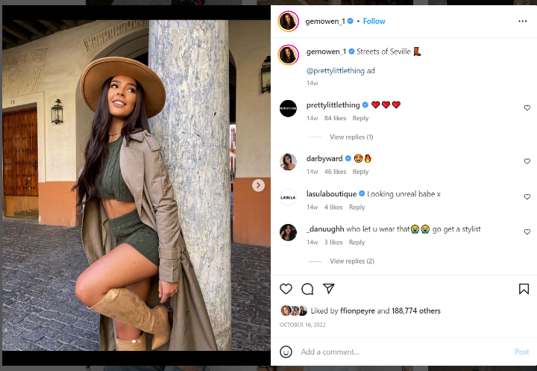
Figure 2 (Owen. G, @gemowen_1 October 26, 2022)
Many SMI’s get paid to promote brands on their social media platforms. If we take a look at Figure 2, we can see an example of an SMI who came to fame from a reality TV show now promoting clothes for the brand Pretty Little Thing, simply by wearing the clothes that are from that brand and adding the brand’s link onto her caption. By doing this it allows the audience to see the brand of clothing that see wears but also it demonstrates that they too can wear the same clothes as an SMI that they follow and admire.

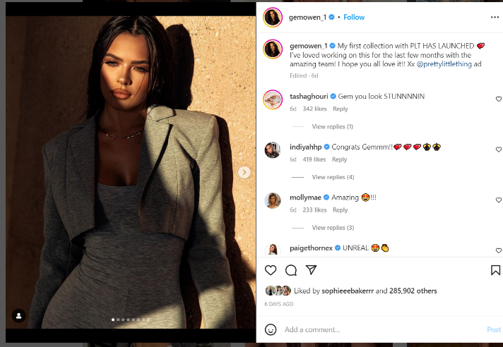
Fig. 3 (Owen. G, @gemowen_1 January 17, 2023)
Figure 3 shows another example from the same influencer and brand (Pretty Little Thing) but this time it is more of a collaboration between the SMI and the brand, rather than simply an advert. A collaboration means that people who follow this SMI can not only look like her but also feel closer to her. This is clothing that the SMI has been a part of creating; it has her name on it, and therefore has the potential to attract more people into purchasing the items. As Senft notes: ‘everyday Instagram users are beginning to model themselves after influencers, taking up the “cultural scripts”’(Senft 2008, cited in Abidin, 2016).

Methods
Social Media Influencers are potentially crucial not only in encouraging fast fashion but also raising awareness of the negative impact it has and helping young people understand how they can buy more responsibly. Many young people follow influencers because they trust them and feel they know them personally. Should there be more responsibility on influencers, therefore, to ensure they have a positive impact on the problem? To understand the role of SMIs for both good and bad and their impact on young people’s clothes shopping choices, there are three elements to my research.
First, I want to understand the impact of social influencers on fast fashion and their potential positive role. To do this, anonymous surveys will be conducted, targeted at young people both male, female, trans and non-binary from the age of 16 upwards, using Survey Monkey to find out how SMIs impact on their buying choices. Key questions to ask in this young people survey include: Do they understand what fast fashion is? How often do they buy fast fashion items? Why do they choose to buy fast fashion? What are the key things that attract them to make a purchase? Do they follow many influencers and if so, do the SMIs influence what they buy?
Second, SMIs will be surveyed to find out how much they understand about the fast fashion world, its impact on the environment, and their role in the matter, again using an anonymous questionnaire generated by Survey Monkey. Key questions are: Do they understand what fast fashion is? How do they see their role in the fast fashion industry? What are their views on slow fashion?
Finally, ethical clothes companies will be approached to understand how they use their voice and knowledge to raise awareness regarding alternative ethical choices, and how they use SMIs to help promote a more positive, sustainable fashion future. Specifically, ethical companies such as Tala will be approached, the CEO of which is Grace Beverly, an SMI who has created a successful ethical gym clothing brand. This research will seek to discover how she has used her platform not only to help expand her brand but to also to raise awareness of the negative side of fast fashion.
Tala regularly makes posts about the company on YouTube. As this research is concerned with social media marketing it seems appropriate that platforms like YouTube are also used to gather information and research as it fits in with the information that is needed.
The online surveys will be posted across multiple social media platforms in order to try and reach as many people as possible. The two main platforms that will be used are Instagram and Facebook. Looking at the graph in the literature review (p.6), it is clear that Facebook is the most popular social media platform to use, hence why it has been chosen as a key platform on which to share my survey. Instagram is also important as a lot of SMIs and fast fashion brands use it as their key platform to post and promote their businesses.
To encourage people to participate in the public survey the questionnaire should be quick and easy to complete with no more than 10 questions. While most of the questions will require a response to a Lickert scale (strongly agree, agree, neutral, disagree, strongly disagree) producing qualitative date, the option will also be given for respondents to add comments producing qualitative data. To ensure that the survey runs smoothly a trial will be created involving a small number of participants to check that the survey is working correctly and that the questions are generating the relevant information.
Once the surveys have been created, they will be posted across social media platforms and left there for a minimum of two weeks allowing enough time for a sizeable number of responses to be collected. The aim would be to collect a minimum of fifty completed questionaries from the public survey. The influencer survey will aim to gain feedback from between 10 to 20 SMIs.
Below is a timeline for the research:


Results and Conclusions
The surveys will produce both qualitative and quantitative data. Survey Monkey will automatically turn some of the data into graphs which can then be further analysed. The qualitative data will need to be sorted into themes that can be discussed more generally and may provide useful direction for further research.
It is anticipated that the data collected will provide insight into fast fashion shopping tends and the influence of SMIs on shoppers. It will be interesting to see if there is a gender difference and to what extent age affects buying choices in the context of fast fashion. It is likely that many people will have some awareness of the damage that fast fashion causes to the planet, and that SMI’s are having a growing influence on buying choices, but the price and SMI endorsement of fast fashion is what attracts people to buy into a brand and this may be the overwhelming factor for buying clothes, with very few people choosing clothing based purely on environmental factors.
Limitations to the research include the tendency of positive bias, in which individuals may not be completely honest in order to present a better image of themselves; this could apply particularly to the influencer interviews as being an SMI is all about image.
Another area of concerns is the extent to which slow fashion offers a realistic alternative to fast fashion in the sense of profits for the companies. This may be an area that requires further research. Similarly, the booming second-hand clothing market is also outside the scope of this research project.
It is possible that the outcome of this research will indicate that much more awareness and attention needs to be brought to the topic of fast fashion, so that consumers understand the negative impact it is having, both environmentally and in terms of exploitative labour practices. SMIs have a potentially positive role in this and could promote more sustainable and ethical clothing. SMIs and slow fashion brands could collaborate to promote the idea and trend of buying into slow fashion brands, and to help educate their audiences not only about the negative impact that fast fashion has but the alternative options that are out there that will benefit not only the environment but also the customers.

Reference list

Bernhardt, G. (2022) ‘Top 10 most popular social media platforms in 2023’. Available at: https://www.shopify.com/uk/blog/most-popular-social-media-platforms (Accessed 12 December 2022)
Campbell C. and Grimm, P. E. (2019), cited in Balaban D. C. and Szambolics J. (2022) ‘A Proposed Model of Self‐Perceived Authenticity of Social Media Influencers, Media and Communication Volume 10, Issue 1, pp. X–X. Available at: https://doi.org/10.17645/mac.v10i1.4765 (Accessed 14 February 2023)
Channel 4 (2022) Inside the Shine machine: UNTOLD, Available at: https://www.channel4.com/programmes/inside-the-shein-machine-untold (Accessed: 7 January 2023)
Environmental Audit Committee (2019) ‘Fixing Fashion: Clothing Consumption and Sustainability’, UK Parliament. Available at: https://publications.parliament.uk/pa/cm201719/cmselect/cmenvaud/1952/full-report.html#content (Accessed: 10 February 2023)
Feiam, A. (2019) What Does the Average Fast Fashion Shopper Look Like. Available at: https://powerretail.com.au/in-focus/what-does-the-average-fast-fashion-shopper-look-like/ (Accessed: February 13 2023).
Gagliese, J. (2022) The rise of the influencer: Predictions for ways they’ll change the world. Available at: https://www.forbes.com/sites/theyec/2022/07/08/the-rise-of-the-influencer-predictions-for-ways-theyll-change-the-world/?sh=595f217d43a7 (Accessed: 13 February 2023)
Goldfingle, G. (2018) Fast-fashion retailers called before Parliament. Available at: https://www.retail-week.com/fashion/fast-fashion-retailers-called-before-parliament/7030369.article?authent=1 (Accessed: 13 December 2022)
Hunter, T. (2022) What is a micro-influencer, and why do brands use them? Available at: https://builtin.com/marketing/micro-influencer (Accessed: 12 February 2023)
Norris, O. (2022) The Age of Fast Fashion: How Consumer Behaviour Has Changed and How It’s Impacting on our Environment. Available at:https://amplyfi.com/2022/01/10/the-age-of-fast-fashion/#:~:text=These%20companies%20have%20seen%20particular,in%20the%20world%20of%20fashion (Accessed: 11 February 2023).
Owen. G, @gemowen_1 [Instagram] January 17 ‘My first collection with PLT HAS LAUNCHED https://www.instagram.com/p/CnhbxfWL2hm/
Perthuis, K. and Findlay, R. (2019) ‘How fashion travels: The Fashionable Ideal in the age of Instagram’, Fashion Theory, 23 (2) pp.220-225 Available at: file:///C:/Users/elind/Documents/UNI%20ABERTAWE/how%20fast%20fashion%20travels.pdf (Accessed: 13 December 2022).
Senft T. M. (2008) Camgirls: Celebrity and Community in the Age of Social Networks. New York: Peter Lang, cited in Abidin, C. (2016) ‘Visibility labour: Engaging with Influencers’ fashion brands and #OOTD advertorial campaigns on Instagram’ Media International Australia pp. 1-15. Available at: DOI: 10.1177/1329878X1666517 (Accessed: 14 February 2023).
Trade & Investment Wales (2021), Wales is speeding up sustainability and slowing down fast fashion. Available at: https://tradeandinvest.wales/inside-story/wales-speeding-sustainability-and-slowing-down-fast-fashion (Accessed: 25 January 2023).

