University of wales Trinity Saint David

- Course: Skills for the Workplace
- Teacher: Akinseye Aluko
- Class: Effective Team Working and Communication (ETW)
- Name: Osvaldo Francisco
- Number: 1913130

Table of Contents
- Abstract……………………………………………………………………..………………………………………….3
- Introduction ...............................................................................................................4
- What is effective communication...............................................................................5
- What is communication..............................................................................................5
- What is competent communication............................................................................6
- The different tips of communications ........................................................................6
- Verbal Communication...............................................................................................6
- The written communication........................................................................................7
- Non-verbal.................................................................................................................7
- Body language............................................................................................................8
- The Organization .......................................................................................................9
- Communication barriers ...........................................................................................10
- The role of communication on employees’ psychological well-being……………………11
- Conclusions ................................................................................................................12
- Reference……………………………………………………………………………………………………………….13

Abstract
Considerable research has been conducted to analyse the effects of elements such as information technology, efficiency and innovation on a company's performance. Some of the problems reported in organizations, the knowledge and skills of some employees are not put into practice, they are hidden because they do not adapt to the governed policies and standards of the corporation.
the lack of communication and ineffective and disproportionate remuneration for the position. These are some of the topics mentioned by employees.
so that society understands that the quality of life is concentrated not only in companies but also in residential, cultural and natural environments.

This is a way to prevent various work-related illnesses and some gaps in organizations, such as an inadequate work environment, interpersonal conflicts and organizational culture.
There are several tools to combat the poor quality of a work environment, such as: making communication more effective and preventing interpersonal conflicts, among others. And for society, it is good to know that people have the right to appeal

Introduction
Without communication, it would be impossible to live. Communicate and receive communication. it is what allows human beings to coexist in society and in cultural production.
Communication is a fundamental element of social life and has been one of the most important elements in the constitution of the society of the socio-cultural unity of any human group;
it consists of a process by which ideas and feelings are transmitted from individual to individual, enabling social interaction.
Everything in life is communication, including life”. In fact, without communication, life would be impossible, because in all so-called living phenomena there is some communication process involved.
And that is why in this article I will mention some types of communication.
As I mentioned above, it is not easy to talk about communication, because it is so broad that there is even some confusion about communication.
Verbal and non-verbal communication. Effective and commercial communication. body language,
however, it is like a person or company that influences the other: it is the true carrier of the social process.
It is communication that allows interaction and it is through it that human beings become social beings and remain so. Without a means of communication, people and companies could not get together.

What is effective Communication
Effective communication is what we talk about is always understood. And it effectively achieves the objective, which is to transmit a message clearly through the interlocutor. using the most diverse types of communication channels for this. In other words, it is basically when the sender passes information to its receiver.
and the receiver understands the message exactly as it was transmitted, without adding anything to this interpretation. For that, it is necessary to cut out any type of noise, prevent misunderstandings and end the frustration of a message transmitted in half or in the wrong way.

- good communication requires us to dedicate ourselves to listening to each other. it must be both verbal and non-verbal.
- controlling emotions and avoiding stressful situations helps to achieve more effective communication.
- being emphatic and demonstrating your ideas is essential.

What is Communication
Communication is a process that involves at least two or more individual who sender a message and a recipient. through mutually understandable signs. It’s a people dialoguing, one is who transmitting information from one place to another.
Ex: The Ideas, emotions, feeling, knowledge, culture and experience of your work or life.
communication skills are the most important quality for everyone can have, it’s about de communication skills are to understand the emotion and intentions behind the information. When the other person is talking to you and the way you get this information, if you got something else you will have misunderstandings and if you didn’t like what you heard you will be frustration, and have conflicts ensue. This can cause problems for you at home, school, work or in your personal life.

WHAT IS COMPETENT COMMUNICATION
Competent communication and the ability to transmit messages that generate understanding and feedback and the opposite, to understand and give adequate feedback to messages received. For this, it is necessary to have skills, attitudes and behaviours when transmitting or receiving messages, highlighting:
competent communication and Used in different types of body languages. Verbal, oral, written. visual, sound, artistic and digital languages, etc., etc. as well as to express and share information, experiences, ideas and feelings in different contexts and to produce meanings that lead to mutual understanding.
- Mastery of verbal language and ability to speak clearly and objectively,
- be convincing and create empathy and generate interest in each conversation.
- Listen to the message and process it before providing the appropriate response.
- Always listen carefully
- Communicates in a structured way for specific purposes,
- Stay focused when asking or answering open-ended questions

For good communication, it is necessary to be able to listen to others with attention, interest and to have respect for their ideas and feelings. express ideas and opinions clearly. It is also necessary to ask appropriate questions, to maintain the focus and to know how to use silence when it is necessary.

The different tips of communications
We usually use two tips the Communication verbal and nonverbal. Oral, Computer, Tv, phone, message, books, newspaper, radio and letter.

Verbal Communication is when you use of sounds and words to express yourself or share information with the other people which includes face-to-face both spoken and written. Communication is about passing information from one person to another group of persons.
This means that both the sending and the receiving of the message are equally important. therefore, requires both a speaker or writer to transmit the message, and a listener or reader to make sense of the message.
Ex: telephone, radio or television and other media.
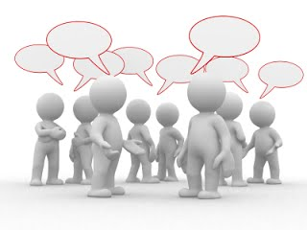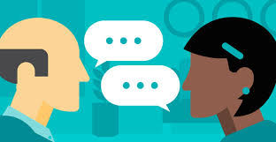

The written communication we can say that it is both communication verbal and non-verbal, writing includes letters, e-mails, social media, books, magazines, Internet and other media as we can see in magazines and newspapers we can observe certain content that obtains images.
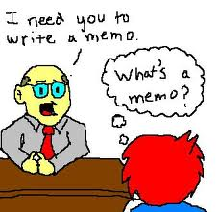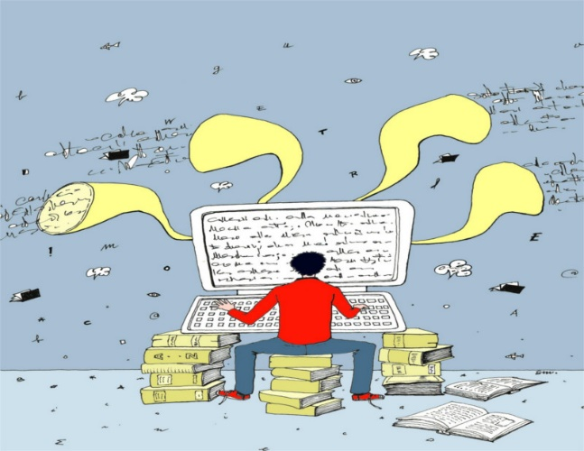
Non-verbal communication occurs through gestures, sound codes, signals, facial or body expressions, images, codes. The way we dress or act, tips of jewellery, where we are and even our perfume. There are many subtle ways to communicate with others. Also, it means the way we talk.
example the tone of the voice can provide clues about mood or emotional state, while hand signals or gestures can add a spoken message

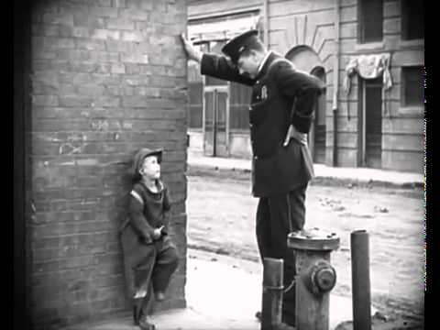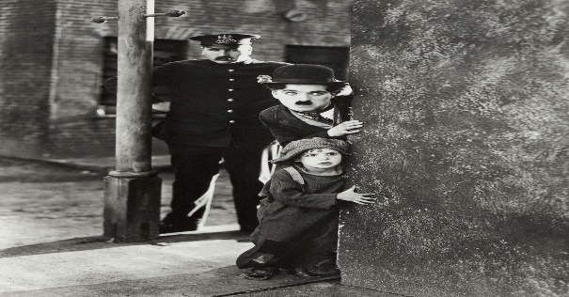

Body language

Body language hides many secrets. does mean that the wrong posture can reveal insecurity, fear, distrust and more, and on the other hand, the correct posture gives the impression of strength, power and self-confidence.
This refers to communication the nonverbal signals. people speak using their entire bodies to communicate their feelings and intentions. It includes our posture, your facial expressions, and your hand gestures.
Ex: You arrive all excited for a business meeting with the client and he is frowning, lips tight, wrinkles on his forehead and arms crossed, and then you can see the body language what the client is talking or is thinking.
this tip of communications shows their problems, their feelings that other people cannot see, and they might have?

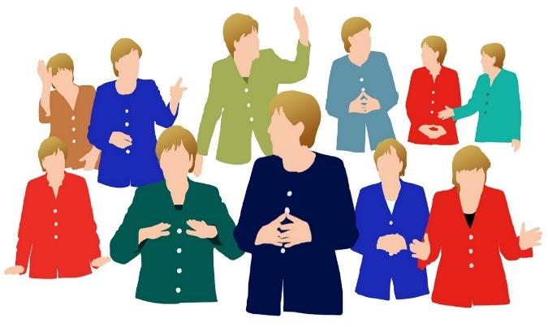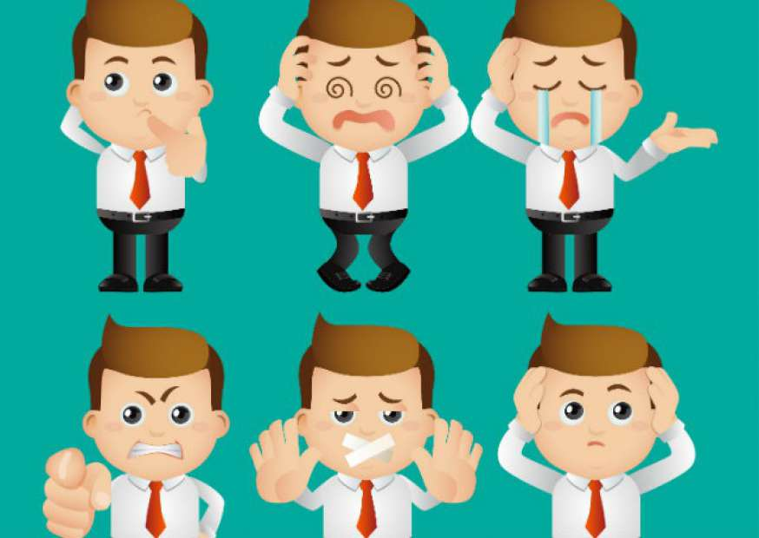

The Organization
Ortygia Sicilia is a small Italian soap and flavour company founded in Sicily in 2006 by Sue Townsend. The luxurious line of soaps, aromas, creams, candles and lotions is formulated with natural products native to Sicily and inspired by the aesthetics, colours and aromas of the most historic and tropical region of Sicily Italy. The basis of all products is natural perfume and natural ingredients. These products are not tested on animals. and All Ortygia products are manufactured by small family businesses.
Customers have the following options to buy their products face - to - face or online shopping. Each people in the company exercise their role.
that is why it is necessary to be a leader who understands internal and external situations and knows how to communicate well so that it is not misunderstood. When there are poor communication and misinterpretation among shareholders, this will cause serious financial damage and personal and organizational constraint. besides the malaise among the employees.
Often the lack of information or lack of communication on the part of the central office puts us in a bad situation with customers. And when that happens, the central office tries to minimize financial damage.

Communication barriers
The organization that communicates efficiently gets extraordinary results because communication makes all departments work together. probably about 70% to 80% of the problems existing in companies are directly or indirectly related to the lack of communication.
Organizational communication focuses largely on building relationships and interacting with internal members of the organization and external stakeholders.
Dealing with these barriers in organizations requires time and studies to identify them accurately and safely. Based on this business analysis, it is possible to seek communication tools that can positively contribute to this process, making it more efficient. That is why it is extremely important that leaders are involved and committed to solving these obstacles, which hinder professional and business growth. it is necessary to understand that nothing in a company happens overnight.
Therefore, it is necessary to take due care with the small obstacles, as this can generate several losses, not only for the business but also for the

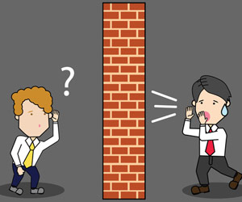

The role of communication on employees’ psychological well-being
employee well-being companies must invest in a positive environment. knowing that the boss cares about them, the employees felt excited and motivated to work, get sick less and are more committed, if the company doesn't hear a healthy hamburger it can leave the employees in the following states. Stress, depression, unmotivated and even having burnout syndrome, these are some of the psychological disorders that most afflict professionals.
well-being translates into the balance of our physical and psychological health, elementary so that we can carry out our activities with pleasure and without wearing out the body and mind in the process.
American Steven Aldana, one of the leading experts in health and well-being in the workplace. During her more than 20 years at the academy, Aldana, who was a professor of lifestyle medicine at Brigham Young University, wrote 75 scientific articles and seven books on health risk management, healthy living and wellness promotion programs that together, they sold more than 1 million copies.
he recommends that small and medium-sized companies have a well- being advocate in their structure, someone interested in helping others to feel good. "Without good leadership to help manage well-being, the program will have difficulties.

Conclusion
as we can see throughout the work, the evolution of the media has followed and continues today to the evolution of communication. In this way, we verify that as the human being advances his knowledge and deepens his abilities to communicate and emerging more and more varied means of communication.
We see today that the use of the means of communication allows shortening the distances at the geographical level with the populations of the whole world, whereas in the past the means of communication were essential to communicate with the person who was before another.
I understood the role of the organizational psychologist in corporations. It became evident during the research process that the quality of life at work is becoming relevant in organizations. In developing this article, I realized that the degree of responsibility that this professional has with his employees.

When studying each topic mentioned I had the perception that there are several tools to combat the poor quality of a work environment, and how to make communication more effective and how to prevent interpersonal conflicts.

Reference
Melinda Smith, M.A. Last updated: June 2019.Effective communication is about more than
https://www.helpguide.org/articles/relationships-communication/effective-communication.htm

(Goldhaber 20); and 5) Organizational communication largely focuses on building relationships and interacting with internal organizational members and interested external/
https://courses.lumenlearning.com/introductiontocommunication/chapter/what-is-organizational-communication/

use to reveal our true feelings and emotions. Our gestures, facial expressions and posture.
https://www.mindtools.com/pages/article/Body_Language.htm

Arms folded in front of the body. Minimal or tense facial expression. Body turned away from you. Eyes downcast, maintaining little contact. https://www.mindtools.com/pages/article/Body_Language.htm

not be received exactly the way the sender intended. It is,
https://www.skillsyouneed.com/ips/barriers-communication.html
Dr. Steven Aldana is one of the nation’s foremost experts on healthy living
https://www.stevealdana.com/index_bio.php

https://www.rospa.com/Safety-Training/Work/iosh-courses/IOSH-Managing-Occupational-Health-and-Wellbeing?gclid=EAIaIQobChMI2-Dsz-eE6QIVF-DtCh0EngthEAAYASAAEgJ5-_D_BwE
Considerable research has been conducted to analyse the effects of elements
file:///C:/Users/Osvaldo/Desktop/ETW%20-%20Affective%20Team/4_349_Uche.pdf

