


Program: BA Business Management
Module: Data Handling and Business Intelligence
Module code: LCBB5000
Lecturer/Module Leader: Dr. Xavier Matieni
Student name: Gabriela Grudeva
Student number: 2218257
Contents
Part 1 3
How was the sales trend over the months? 4
Most Frequently Purchased Products 5
What are the most frequently purchased products? 5
Customer Purchases per Transactions 6
How many products does the customer purchase in each transaction? 6
Geographical Segmentation 7
Most Profitable Customers (United Kingdom) 8
What are the most profitable segment customers? 8
Based on your findings, what strategy could you recommend to the business to gain more profit? 8
Part 2 9
Gender Distribution of Male and Female Students 9
Total Number of Male and Female Students 10
Students Qualifying for reduced/free lunch 11
Students Eligible for Free or Reduced Lunch 11
Mean and Median of Students Qualifying and Not Qualifying for free lunch 12
Clustering (ex. K-Means Clustering) 13
Definition of Clusters 14
Advantages and Disadvantages of using SPSS and Excel 14
References 16

Part 1

Sales Trends Over the Months

November

Row Labels | Sum of Price
11/17/2019 | 29,374
11/18/2019 | 26,079
11/20/2019 | 28,985
11/21/2019 | 26,706
11/22/2019 | 32,499
11/23/2019 | 16,505
11/24/2019 | 16,781
11/25/2019 | 14,223
11/27/2019 | 11,527
11/28/2019 | 16,051
11/29/2019 | 18,937
11/30/2019 | 15,265
Grand Total | 252,933

December

Row Labels | Sum of Price
12/01/2019 | 13,079
12/02/2019 | 13,430
12/04/2019 | 10,176
12/05/2019 | 23,767
12/06/2019 | 14,840
12/07/2019 | 11,256
12/08/2019 | 20,446
12/09/2019 | 9,540
Grand Total | 116,534

How was the sales trend over the months?

Online purchasing has revolutionized both corporate operations and consumer behavior in recent years. Online sales of goods have opened up domestic and worldwide marketplaces to companies of all sizes. Additionally, it has provided customers with an easy way to browse, purchase, and pick up a wide range of things from a distance (BigCommerce, 2020).
All businesses have to continuously evaluate their performance and business environment to make necessary adjustments to their long-term strategy. This entails keeping an eye on the market, rivals, vendors, clients, and so on.

The first Pivot table shows the sales over November 2019 and the pattern that is following, based on which a company or a business could make a forecast of suggested purchases for the following month or year, depending on products and a specification of a business.
The sales showed decreased demand from mid-November till the end of the month, as the most demanding period was during the first 5 days of the second week of the month.
The sales in December are for the first week of the month, and the demand is consistent with a range between 9 thousand and 23 thousand. Again, this can be used to predict future demand based on these sales, and a business could decide if this product is profitable, and how much of this product should be purchased and would make a good turnover for the business.

Most Frequently Purchased Products

What are the most frequently purchased products?
Data analysis may be used to determine seasonal, rapidly expanding client groupings, fast-selling goods, and geographical sales.
The top 30 products in the graph are the most selling items, and it shows exactly how many of them are sold in total. The top 5 most purchase items are:
Rabbit Night Light
Paper Chain Kit 50'S Christmas
Popcorn Holder
Paper Chain Kit Vintage Christmas
Gardeners Kneeling Pad Keep Calm

This can be helpful for businesses to identify the demand for these products, and make an accurate forecast to predict the sales for the future and fulfil customer demand.
These data and knowledge may assist build better marketing campaigns, product bundles, and shop layouts, resulting in a higher-performing business.

Customer Purchases per Transactions

How many products does the customer purchase in each transaction?
In the chart above the data allows to analyse how many purchases are made by customers and how many transactions, roughly between 0 and 2,500. Data on customers, orders, items, and their relationships are all included in a data model for handling customer orders. One customer may place several orders, but only one client will place an order at a time. This is the nature of the relationship between customers and orders. Undoubtedly, several goods can be found in a single order, and a single product might be found in numerous orders. In a database, several relationship types may be modeled.

Geographical Segmentation

Most Profitable Customers (United Kingdom)

What are the most profitable segment customers?
As most profitable customers are shown the customers in the United Kingdom. The geographical segmentation in the United Kingdom is way above the rest of the countries with £333,210. Beyond just classifying people, segmenting clients involves more. Understanding a client's wants and preferences through segmentation may also enhance customer service.

Based on your findings, what strategy could you recommend to the business to gain more profit?

Improving client satisfaction and offering a loyalty program to encourage repeat business, particularly with Norway and the UK, two of the most valuable consumers on the market, is one of the many improvements that could lead to better results.
Create a flawless omnichannel atmosphere and be available to customers via the website, shops, and other platforms (Leachman and Scheibenreif, 2023).
Acquiring new clients from other nations would also be advantageous, as would dividing up the various cultures and learning about their requirements and preferences to provide them with a better selection of goods that would draw them in as possible purchasers.

Part 2

Gender Distribution of Male and Female Students

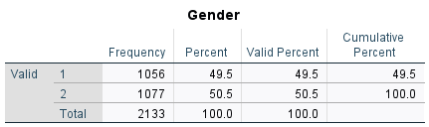

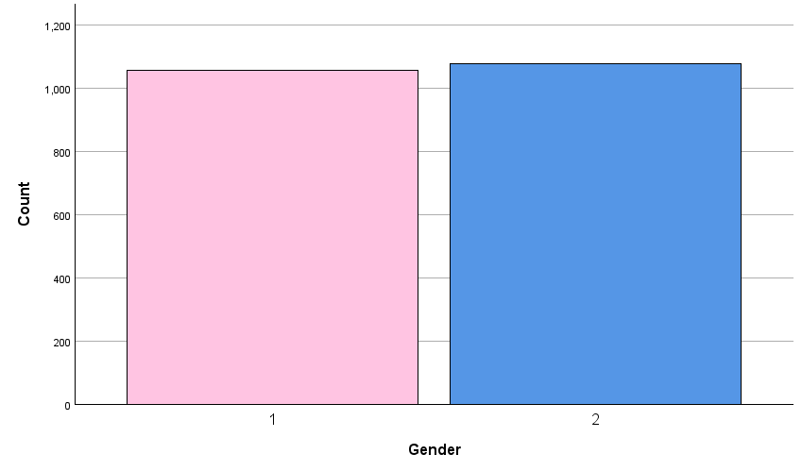

Total Number of Male and Female Students

According to the results section's descriptive statistics:
There are 2133 students in all in the dataset.
Among students, women make up 52.1%. Given that there are 2133 pupils in total:
1108 is equal to 52.1% of 2133, rounded to the closest whole number. Thus, 1108 female students are enrolled.
There are still male students.
The number of male pupils is 2133 - 1108 = 1025 if there are 2133 total students and 1108 are female.

Students Qualifying for reduced/free lunch

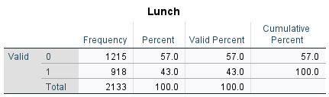

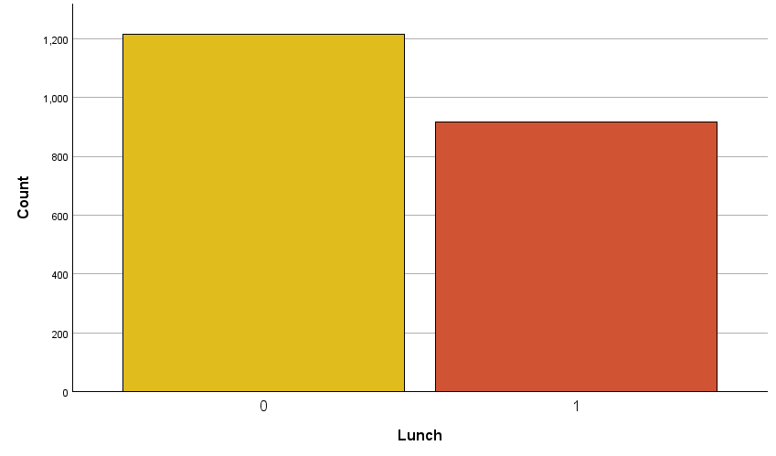

Students Eligible for Free or Reduced Lunch
Descriptive statistics show that 41.2% of students are eligible for free or reduced meals.
Given that there are 2133 students in total, 878 (rounded to the next whole number) is 41.2% of 2133.
As a result, the total number of pupils in each group is:
878 students are eligible for free or reduced meals.
1255 students are not eligible for free or reduced lunches.

Mean and Median of Students Qualifying and Not Qualifying for free lunch

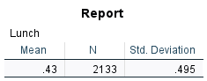

Clustering (ex. K-Means Clustering)

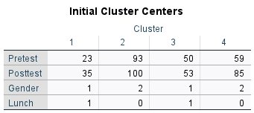
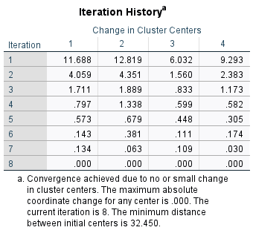

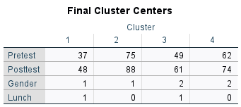

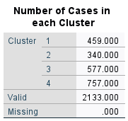

Definition of Clusters

When specific data is categorized into many groups according to common attributes or traits, clusters are created. Any kind of data, including values, objects, and numbers, is acceptable. Data clustering is the technique of using a cluster in conjunction with classification, which is common in mathematics. A person can create a data set out of a group of numbers that are near together by using data clustering.
The goal of clustering approaches is the identification of homogeneous groups of records, or clusters, by defining suitable metrics and the induced ideas of distance and similarity between pairs of observations. The observations included in each cluster must be near to one other and far from those included in other clusters about the particular distances chosen.
In the above tables, the data is gathered together to show and summarize the information that represents all total numbers as a result of the calculations.

Advantages and Disadvantages of using SPSS and Excel

SPSS vs. Excel: Advantages and Disadvantages
Criteria | SPSS Advantages | SPSS Disadvantages | Excel Advantages | Excel Disadvantages
Statistical Analysis | Extensive range of statistical tests and procedures (e.g., regression, ANOVA, factor analysis) | Requires an understanding of statistical concepts | Basic statistical functions available (e.g., mean, standard deviation, t-tests) | Limited statistical capabilities compared to SPSS
Data Management | Handles large datasets efficiently; robust data cleaning and manipulation tools | Can be resource-intensive; and may require a powerful computer | Easy to use for smaller datasets; familiar interface for many users | Can become slow and cumbersome with large datasets
Visualization | High-quality, publication-ready graphs and charts; extensive customization options | Visualization tools may not be as intuitive as Excel | Simple and familiar charting tools; easy to create basic graphs | Limited customization options compared to SPSS

References
BigCommerce (2020). Ecommerce: The History and Future of Online Shopping. [online] BigCommerce. Available at: https://www.bigcommerce.com/articles/ecommerce/ [Accessed 3 May 2024].
BigCommerce (2022). Average Order Value: Importance + Key AOV Strategies. [online] BigCommerce. Available at: https://www.bigcommerce.com/articles/ecommerce/average-order-value/ [Accessed 2 May 2024].
Connolly, T. (2015). Database systems : a practical approach to design, implementation, and management . 6th edn. Boston: Pearson.
FasterCapital (2023). Product mix: Optimizing Product Mix to Maximize Segment Margin. [online] FasterCapital. Available at: https://fastercapital.com/content/Product-mix--Optimizing-Product-Mix-to-Maximize-Segment-Margin.html [Accessed 2 May 2024].
Leachman, L. and Scheibenreif, D. (2023). Using technology to create a better customer experience. [online] Harvard Business Review. Available at: https://hbr.org/2023/03/using-technology-to-create-a-better-customer-experience [Accessed 2 May 2024].
Maheshwari, A. (2015). Business Intelligence and Data Mining. New York: Business Expert Press.
Stevens, K. (2019). Global Expansion Strategies: 3 Economic Indicators to Consider | HBS Online. [online] Business Insights - Blog. Available at: https://online.hbs.edu/blog/post/global-expansion-strategies [Accessed 3 May 2024].
Vercellis, C. (2009). Business intelligence [electronic resource] : data mining and optimization for decision making. Chichester, U.K.: Wiley.

