
Sports Independent Project
Applied Portfolio

Student Name:  Alfie Parry | Project Title:  Ways to Integrate Students with mental and physical disabilities into Mainstream Sports Programs at Primary Schools in Swansea
Project Aim (1)
- The creation of a website aimed at enhancing inclusive delivery in primary schools’ physical education.

Objectives (3/4)
- To research and develop a comprehensive dissertation proposal, including an ethics form.
- To critically evaluate existing and emerging PE curricula and produce through literature review.
- To develop a user-friendly website that supports primary school teachers in delivering inclusive PE lessons

Contents Page

1. Introduction
1.1 The Landscape of Primary School Physical Education
1.2 Aim and Objectives
2. Literature Review
2.1 Coaching and Teacher Professional Development for Inclusive PE
2.1.1 Effective Instructional Practices
2.1.2 Ongoing Training, Mentorship and CPD
2.2 Inclusive Fitness Initiatives
2.2.1 Designing Adaptable Exercise Programmes
2.2.2 Promoting Social Inclusion Through Group Activities
2.3 Organising and Delivering Inclusive PE Lessons
2.3.1 Strategic Planning, Collaboration and Resource Management
2.3.2 Utilising Adaptive Technologies and Digital Tools
2.4 Health and Well-Being Benefits in Primary Education
2.4.1 Physical, Cognitive and Emotional Advantages
2.4.2 Creating a Supportive and Inclusive Environment
2.5 Student and Educator Progression
2.5.1 Holistic Approaches to Development
2.5.2 Enhancing Teaching Practices in Diverse Classrooms
2.6 Learning Environments, Facilities and Digital Resources
2.6.1 Creating Accessible Spaces and Equipment
2.6.2 The Role of Online Platforms and Adaptive Materials
2.7 Curriculum and Policy in Wales: Current and New Perspectives
2.7.1 Analysis of Existing and Emerging PE Curricula
2.7.2 Implications for Enhancing Inclusivity
2.8 Nutrition and Health Education in PE
2.8.1 Evidence-Based Dietary Strategies
2.8.2 Integrating Nutrition with Physical Activity
2.9 Integrating Students with Mental and Physical Disabilities into Mainstream Sports Programmes
2.9.1 Strategies for Successful Integration
2.9.2 Case Studies and Best Practices in Wales
2.10 The Role of Disability Sport Wales and Community Engagement
2.10.1 Collaborative Initiatives and Resource Sharing
2.10.2 Real-World Impact on Inclusive PE
3. Conclusion
4. Reflection / Conclusion / Recommendations
4.1 Reflection
4.2 Conclusion
4.3 Key Learning Points and Recommendations
5. Practical Outputs
5.1 Website Overview
5.2 YouTube Video Links
6. References
7. Bibliography
8. Appendices

Element 1 - Individual Presentation (5 minutes – Online)
Dissertation proposals video: https://youtu.be/-p8tgmuGJrU?si=LmuLrYkqJ3wH870b
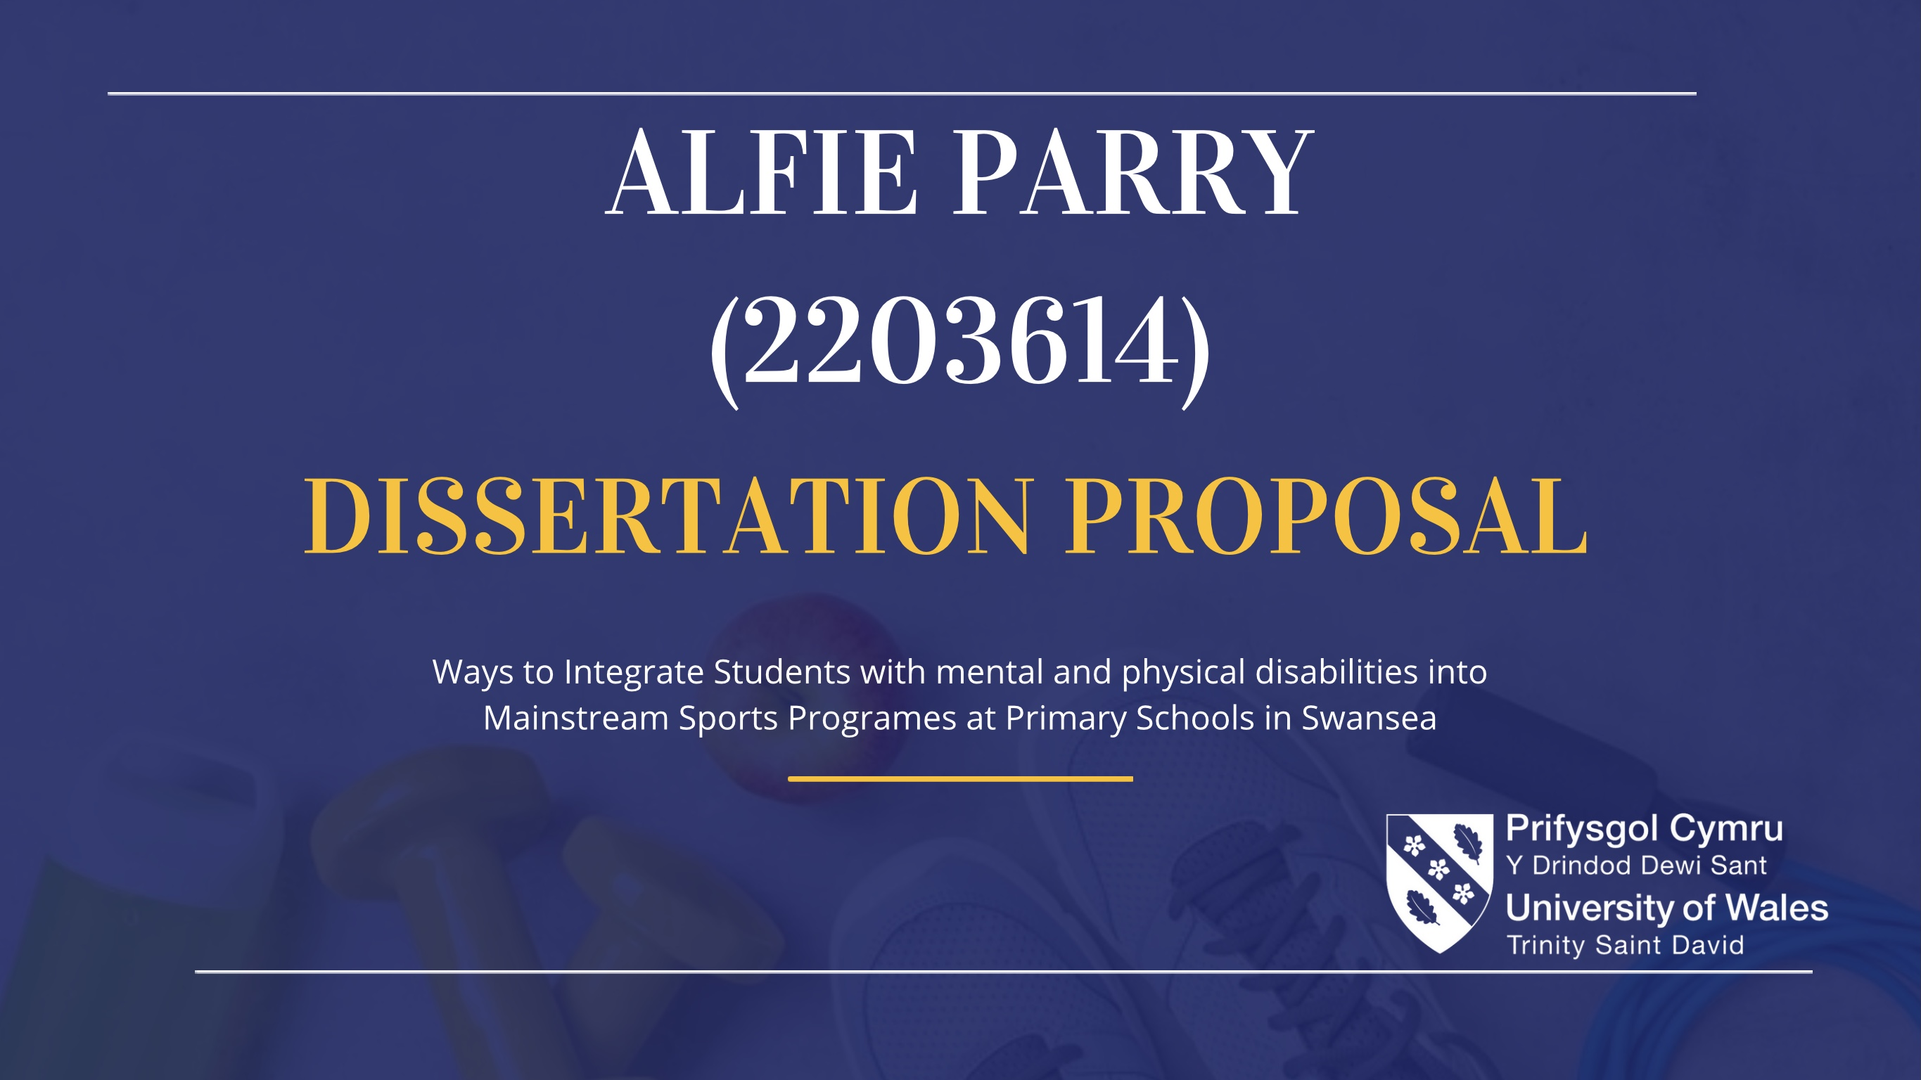

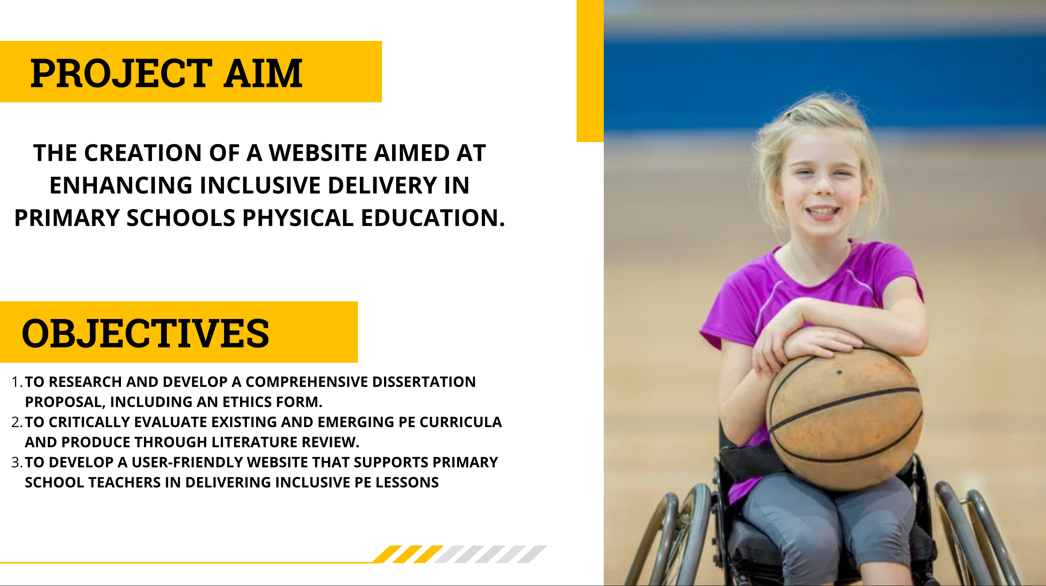

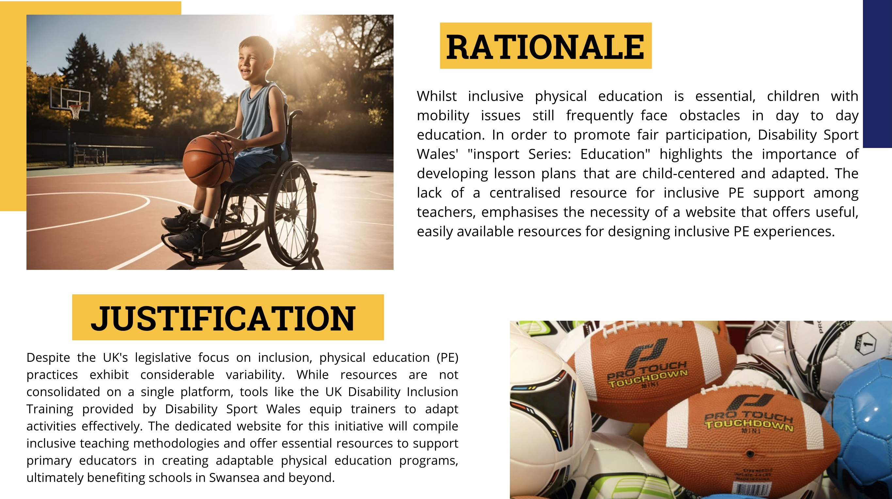

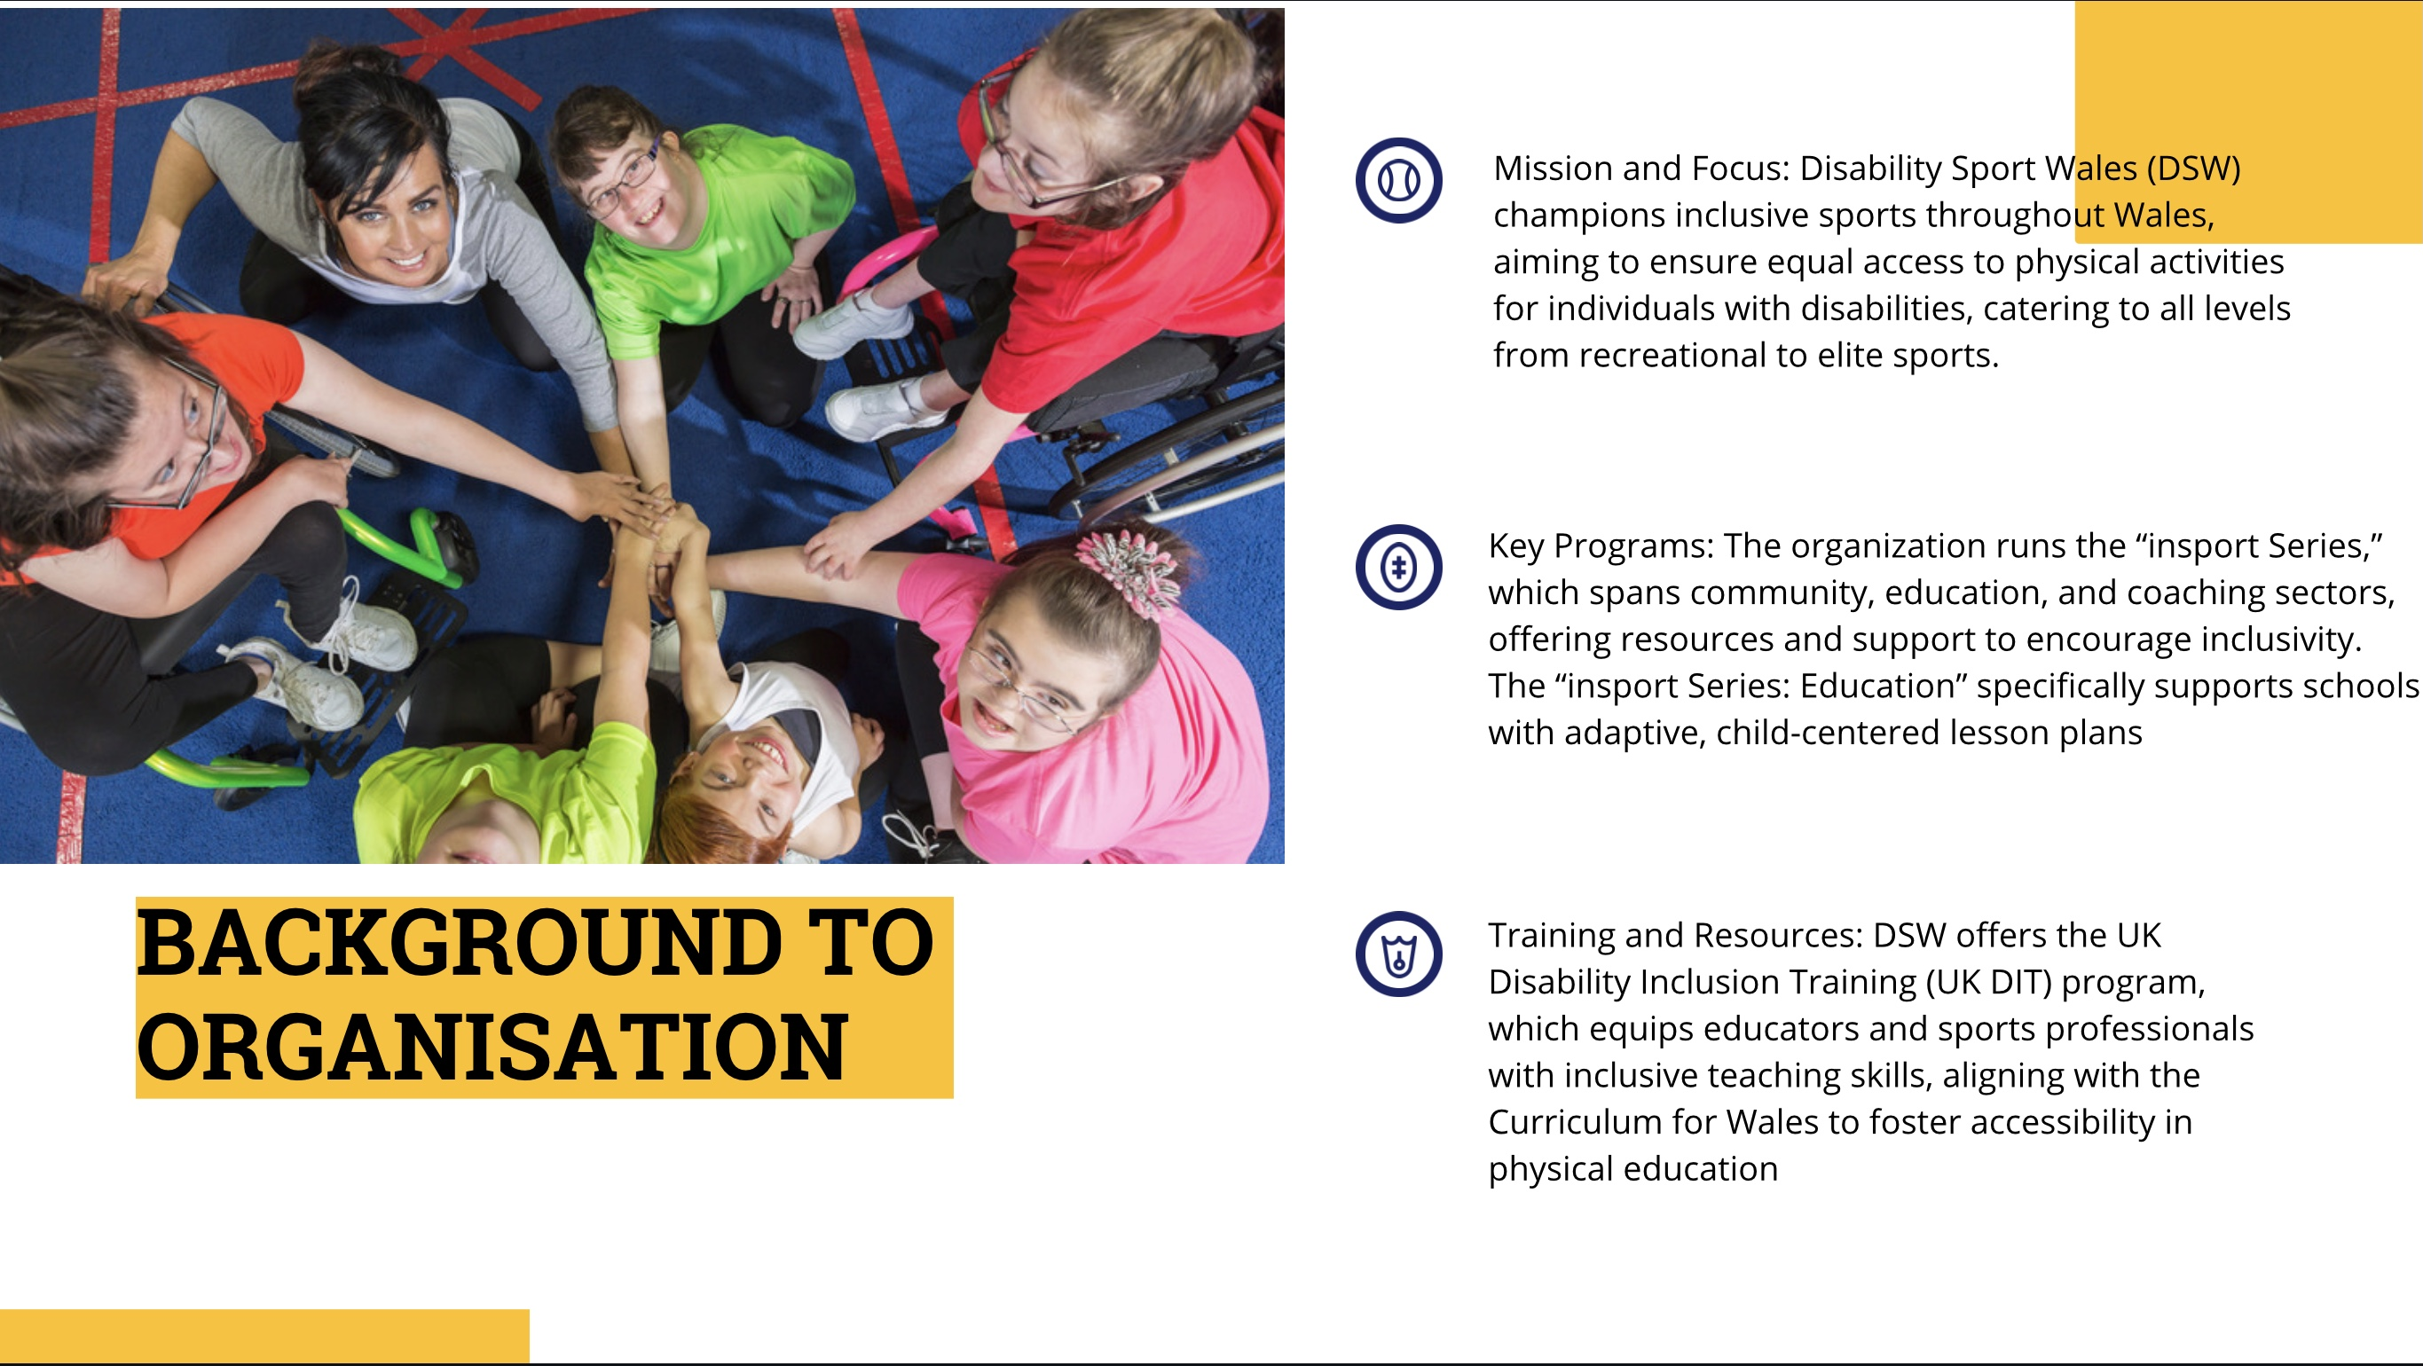

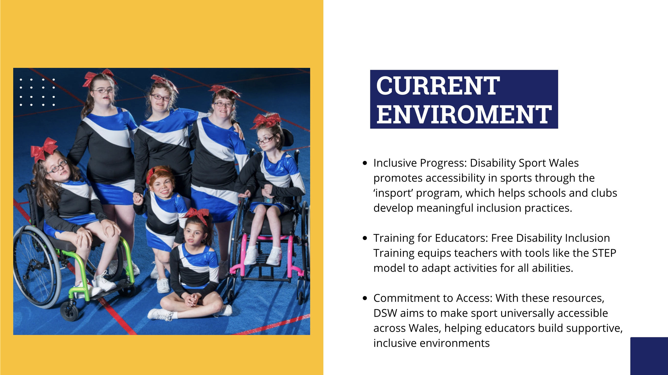

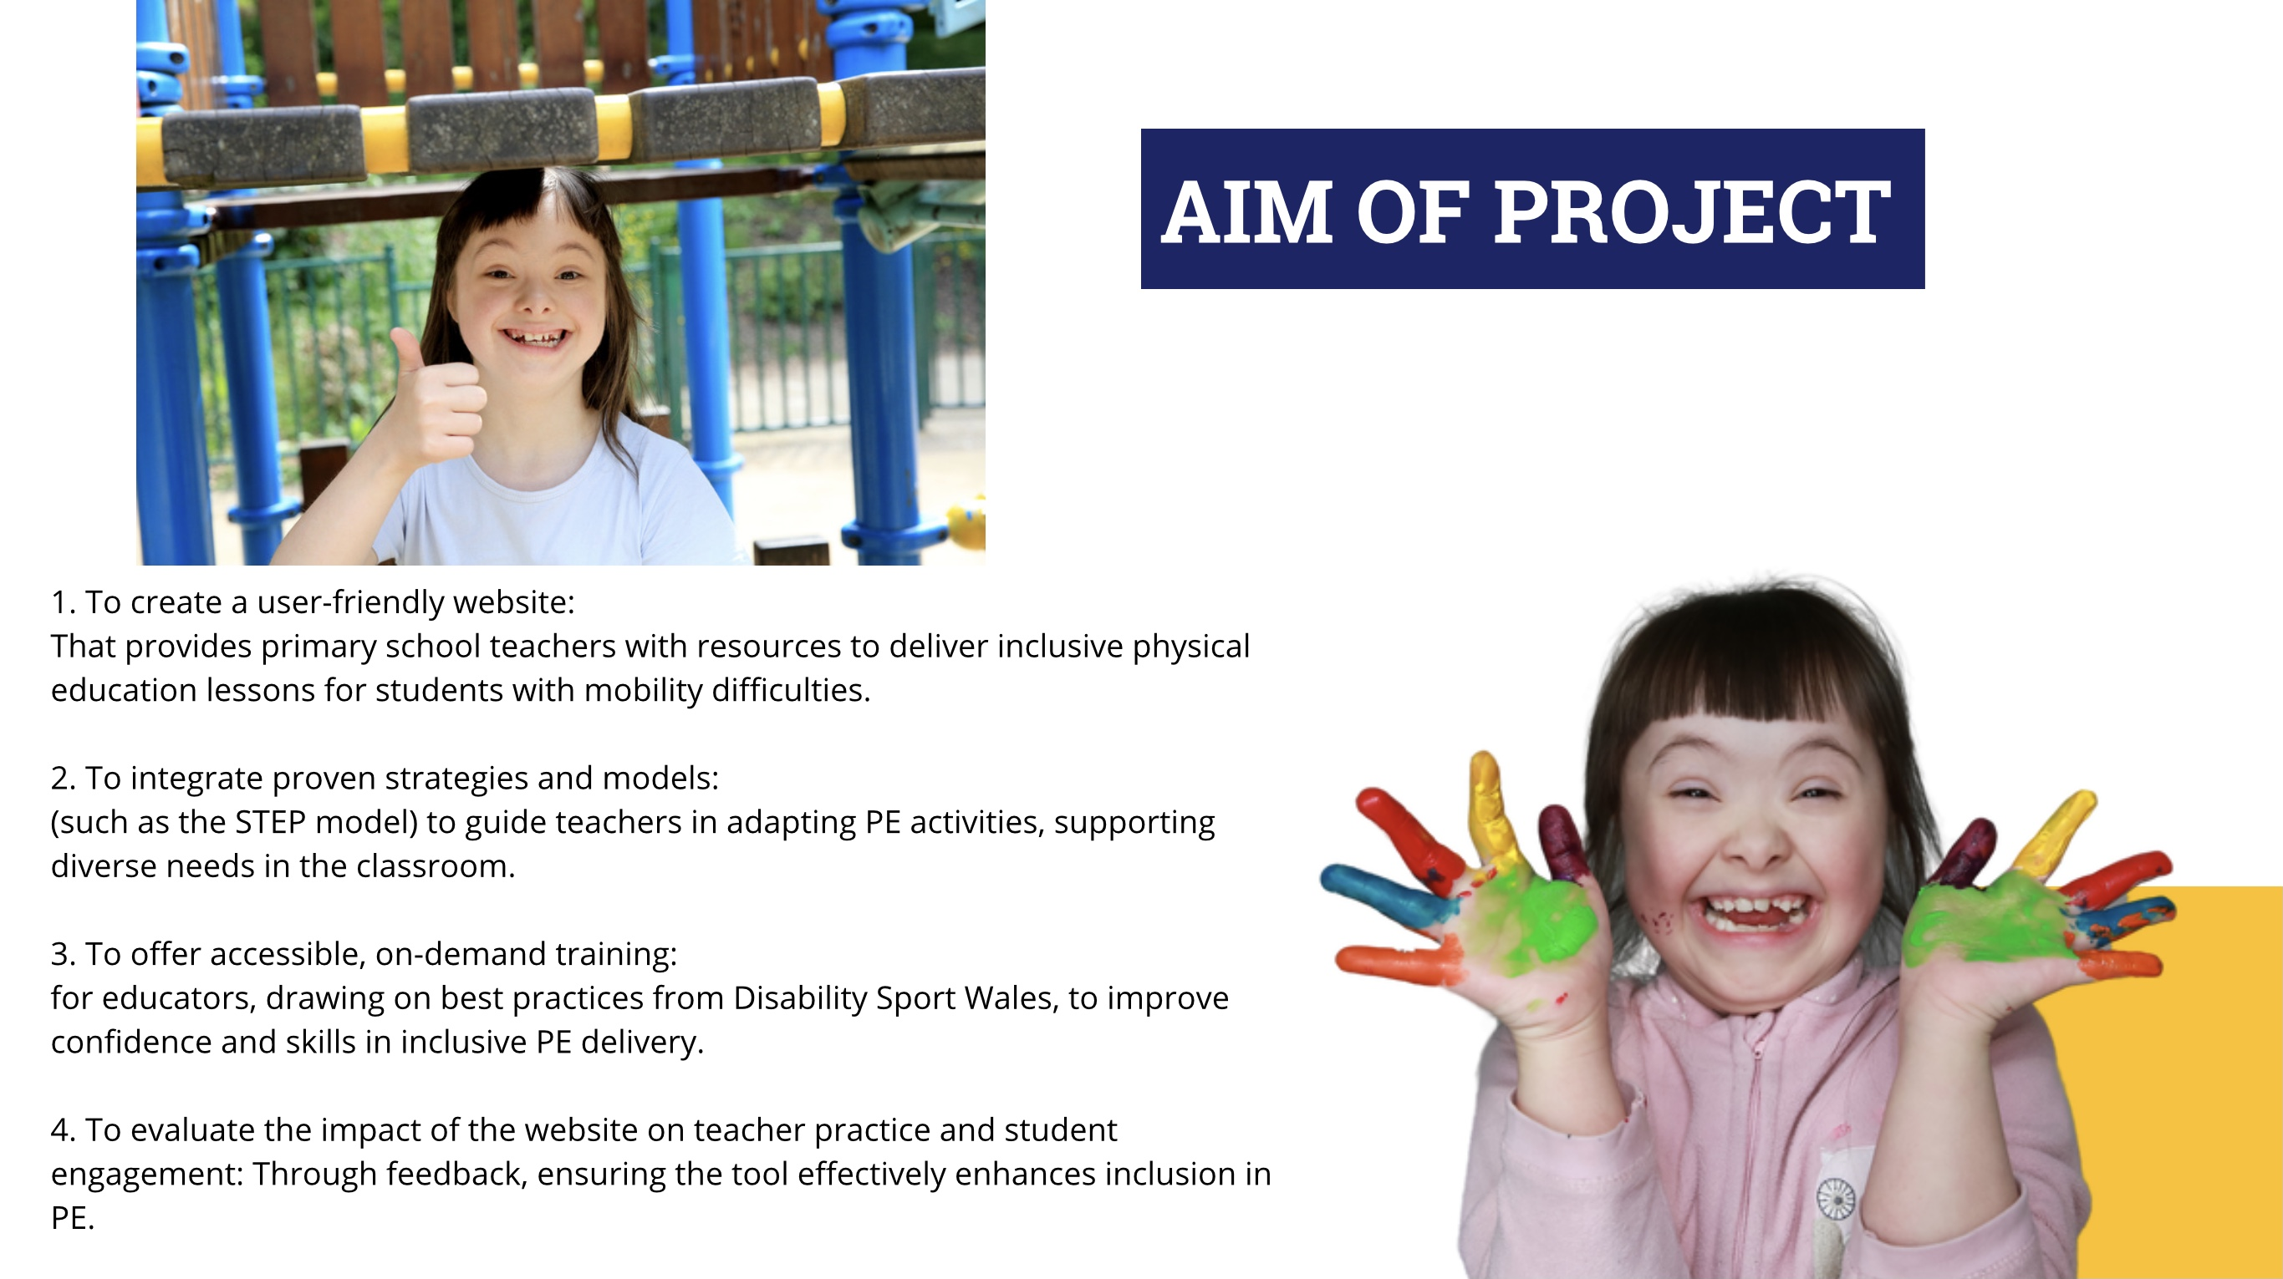

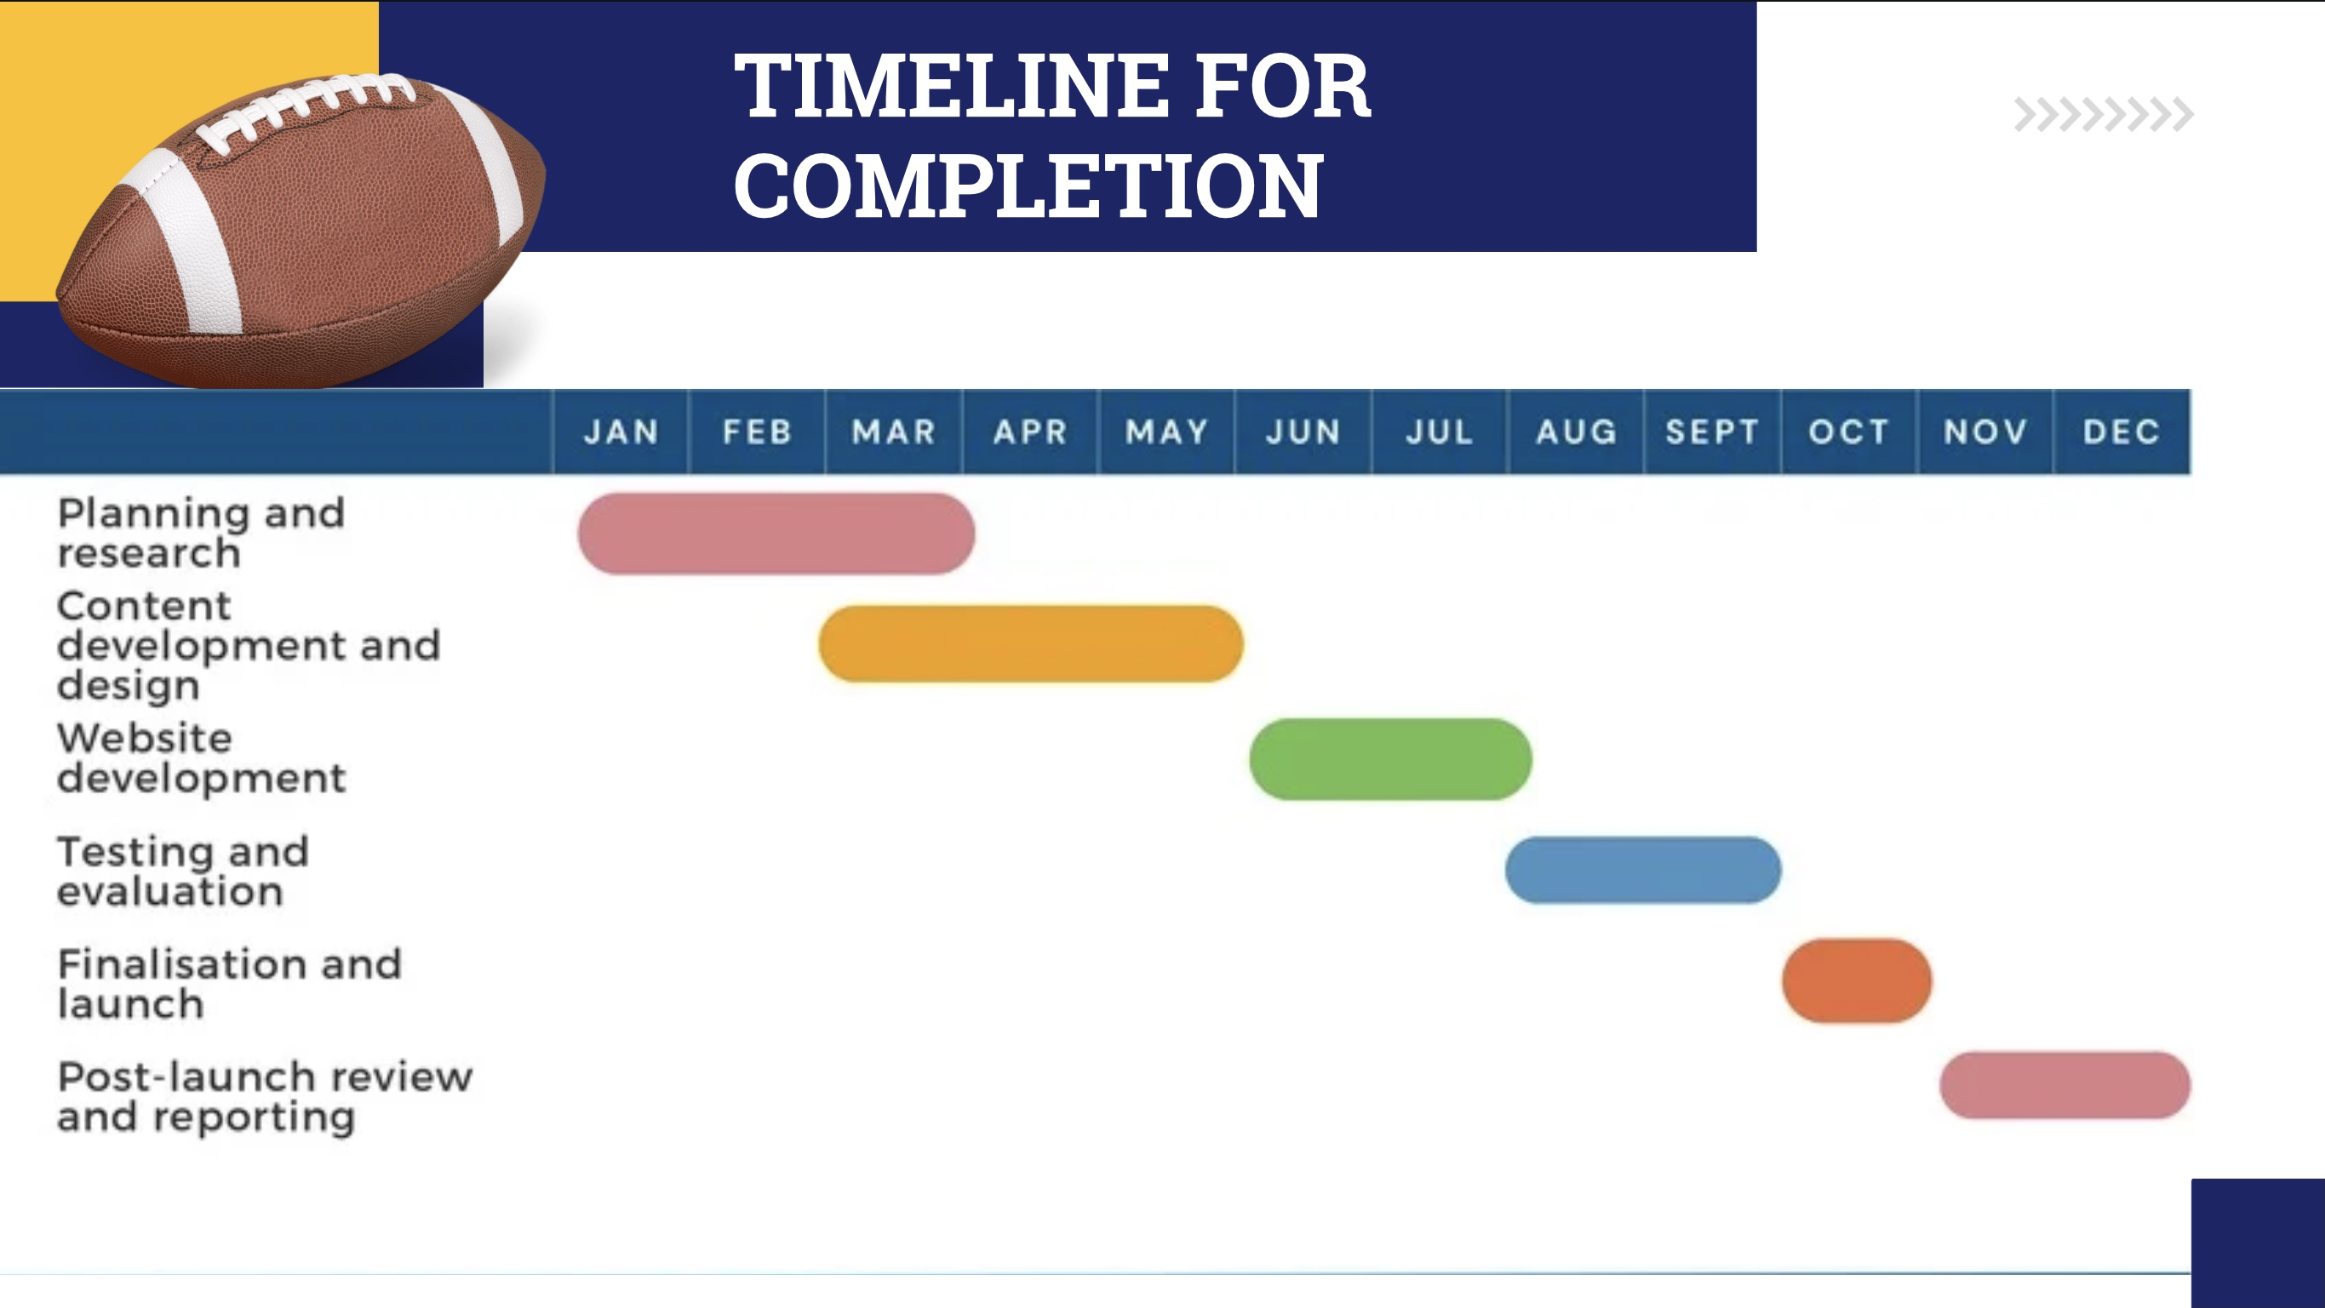



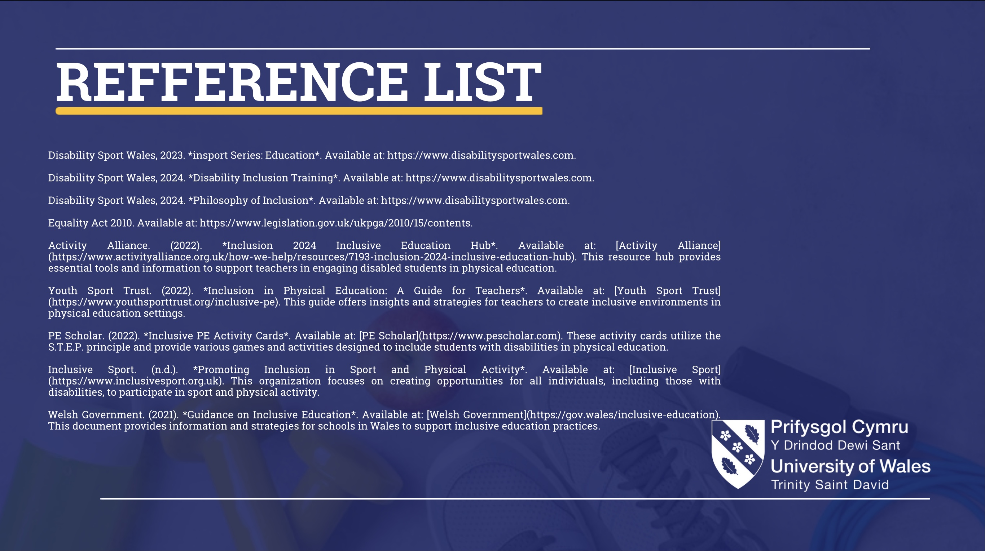

Element 1 – Ethics Form (All Pages)

ETHICAL CONSIDERATIONS

In order for research to result in benefit and minimise risk of harm, it must be conducted ethically. A researcher may not be covered by the University’s insurance if ethical approval has not been obtained prior to commencement.

The University follows the OECD Frascati manual definition of research activity: “creative work undertaken on a systematic basis in order to increase the stock of knowledge, including knowledge of man, culture and society, and the use of this stock of knowledge to devise new applications”. As such this covers activities undertaken by members of staff, postgraduate research students, and both taught postgraduate and undergraduate students working on dissertations/projects.

The individual undertaking the research activity is known as the “principal researcher”.

Ethical approval is not required for routine audits, performance reviews, quality assurance studies, testing within normal educational requirements, and literary or artistic criticism.

Please read the notes for guidance before completing ALL sections of the form.

This form must be completed and approved prior to undertaking any research activity. Please see Checklist for details of process for different categories of application.

SECTION A: About You (Principal Researcher)
1 | Full Name: |  | Alfie Parry
2 | Tick all boxes that apply: |  | Member of staff: | ☐ | Honorary research fellow: | ☐
 | Undergraduate Student | ☒ | Taught Postgraduate Student | ☐ | Postgraduate Research Student | ☐

3 | Institute/Academic Discipline/Centre: | University of Wales trinity St Davids
4 | Campus: | Swansea
5 | E-mail address: | 2203614@student.uwtsd.ac.uk
6 | Contact Telephone Number: | 07495687867
 | For students:
7 | Student Number: | 2203614
8 | Programme of Study: | Sports management
9 | Director of Studies/Supervisor: | Andrew Thomas

Where research activity is carried out in collaboration with an external organisation
10 | Does this organisation have its own ethics approval system? | YES | ☐ | NO | ☒
 | If yes, please attach a copy of any final approval (or interim approval) from the organisation (this may be a copy of an email if appropriate).

SECTION B: Details of Research Activity
1 | Indicative title: | Ways to Integrate Students with mental and physical disabilities into Mainstream Sports Programs at Primary Schools in Swansea
2 | Proposed start date: | 24/10/2024 | Proposed end date: | 24/05/2025
Introduction to the Research (maximum 300 words per section)
Ensure that you write for a Non-Specialist Audience when outlining your response to the points below:
- Purpose of Research Activity
- Proposed Research Question
- Aims of Research Activity
- Objectives of Research Activity
Demonstrate, briefly, how Existing Research has informed the proposed activity and explain
- What the research activity will add to the body of knowledge
- How it addresses an area of importance.
3 | Purpose of Research Activity  This study aims to investigate and resolve the obstacles primary school teachers encounter when providing inclusive physical education (PE) to pupils who have mobility issues. The research intends to assist instructors in establishing an inclusive physical education environment that benefits all children by developing a website with easily accessible, useful information.
4 | Research Question  How can primary school instructors provide inclusive physical education for children with mobility challenges using a centralised, resource-rich website
5 | Aim of Research Activity  In order to promote fair access to physical exercise for all kids, the goal is to create and execute a website that gives primary school teachers the resources, lesson plans, and training they need to improve inclusive PE instruction
6 | Objectives of Research Activity  to compile information from frameworks and resources that currently support inclusive PE delivery, such as Disability Sport Wales and the STEP model.  to plan and create the website's content, which will include training materials, flexible lesson ideas, and tactics for fostering an inclusive physical education atmosphere.  Primary school teachers will be included in the website's pilot and evaluation, providing input on its usability, efficacy, and influence on inclusive teaching methods.  modifying the website in response to teacher input to make sure it satisfies Swansea primary schools' requirements and conforms to national inclusion guidelines, like the Equality Act 2010.

 | Does your research relate to one or more of the seven aims of the Well-being of Future Generations (Wales) Act 2015? | YES | NO
12 | A prosperous Wales | ☒ | ☐
13 | A resilient Wales | ☒ | ☐
14 | A healthier Wales | ☒ | ☐
15 | A more equal Wales | ☒ | ☐
16 | A Wales of cohesive communities | ☒ | ☐
17 | A Wales of vibrant culture and thriving Welsh language | ☒ | ☐
18 | A globally responsible Wales | ☒ | ☐
19 | If YES to any of the above, please give details:
Every one of the seven objectives of the Well-being of Future Generations (Wales) Act 2015 is addressed by this project. By offering equitable learning opportunities, an inclusive physical education resource for primary schools helps the long-term growth and wellbeing of children with disabilities and advances A Prosperous Wales. By supporting flexible teaching strategies that can accommodate a range of student requirements, the project promotes A Resilient Wales. Through easily accessible physical activity, it promotes both mental and physical health in keeping with A Healthier Wales.
Promoting equality is key to the project's objective, which directly supports A More Equal Wales by allowing all pupils, regardless of ability, to engage in physical education. This also helps to create a Wales of Cohesive Communities, since inclusive PE promotes social integration and respect among pupils. The project promotes Welsh culture via physical education, which aligns with A Wales of Vibrant Culture and Thriving Welsh Language; resources are available in both Welsh and English. Finally, by meeting with worldwide inclusion criteria, it contributes to a Globally Responsible Wales, demonstrating a commitment to educational equity and rights.
This project strives to create a sustainable, inclusive future for Wales, while also satisfying national and worldwide educational equity goals.

SECTION C: Scope of Research Activity
 | Will the research activity include: | YES | NO
1 | Use of a questionnaire or similar research instrument? | ☒ | ☐
2 | Use of interviews? | ☒ | ☐
3 | Use of focus groups? | ☐ | ☒
4 | Use of participant diaries? | ☐ | ☒
5 | Use of video or audio recording? | ☒ | ☐
6 | Use of computer-generated log files? | ☐ | ☒
7 | Participant observation with their knowledge? | ☐ | ☒
8 | Participant observation without their knowledge? | ☐ | ☒
9 | Access to personal or confidential information without the participants’ specific consent? | ☐ | ☒
10 | Administration of any questions, test stimuli, presentation that may be experienced as physically, mentally or emotionally harmful / offensive? | ☐ | ☒
11 | Performance of any acts which may cause embarrassment or affect self-esteem? | ☐ | ☒
12 | Investigation of participants involved in illegal activities? | ☐ | ☒
13 | Use of procedures that involve deception? | ☐ | ☒
14 | Administration of any substance, agent or placebo? | ☐ | ☒
15 | Working with live vertebrate animals? | ☐ | ☒
16 | Procedures that may have a negative impact on the environment? | ☐ | ☒
17 | Other primary data collection methods. Please indicate the type of data collection method(s) below. | ☐ | ☒
 | Details of any other primary data collection method: | ☐ | ☒
If NO to every question, then the research activity is (ethically) low risk and may be exempt from some of the following sections (please refer to Guidance Notes).

If YES to any question, then no research activity should be undertaken until full ethical approval has been obtained.

SECTION D: Intended Participants
If there are no participants then do not complete this section, but go directly to section H.

 | Who are the intended participants: | YES | NO
1 | Students or staff at the University? | ☐ | ☒
2 | Adults (over the age of 18 and competent to give consent)? | ☐ | ☒
3 | Vulnerable adults? | ☐ | ☒
4 | Children and Young People under the age of 18? (Consent from Parent, Carer or Guardian will be required) | ☒ | ☐
5 | Prisoners? | ☐ | ☒
6 | Young offenders? | ☐ | ☒
7 | Those who could be considered to have a particularly dependent relationship with the investigator or a gatekeeper? | ☐ | ☒
8 | People engaged in illegal activities? | ☐ | ☒
9 | Others. Please indicate the participants below, and specifically any group who may be unable to give consent. | ☐ | ☒
 | Details of any other participant groups: | ☐ | ☒

Participant numbers and source
Provide an estimate of the expected number of participants. How will you identify participants and how will they be recruited?
10 | How many participants are expected? | The projected number of participants in this study will vary based on school size and desire to join, but an approximate range is 20-30 primary school teachers from Swansea. This sample size allows for a wide range of feedback on the website's usability and effectiveness while remaining manageable for pilot testing and feedback collection.
11 | Who will the participants be? | This initiative will involve primary school teachers in Swansea who are actively involved in physical education or interested in inclusive education approaches. Participants should have prior experience working with students with disabilities or a strong interest in creating an inclusive PE environment. Teachers with varying experience levels and school kinds will be chosen to provide multiple perspectives on the website's success. Collaborations with Disability Sport Wales and local school districts will help identify participants who can provide useful input on the website's usability and usefulness for inclusive PE delivery.
12 | How will you identify the participants? | Participants will be Swansea primary school teachers who have prior expertise or an interest in implementing inclusive physical education. Teachers who deal directly with kids with disabilities or have a background in adaptive physical education are very beneficial. Schools with inclusive practices or current relationships to Disability Sport Wales may be favoured.
 | Information for participants: | YES | NO | N/A
13 | Will you describe the main research procedures to participants in advance, so that they are informed about what to expect? | ☒ | ☐ | ☐
14 | Will you tell participants that their participation is voluntary? | ☒ | ☐ | ☐
15 | Will you obtain written consent for participation? | ☒ | ☐ | ☐
16 | Will you explain to participants that refusal to participate in the research will not affect their treatment or education (if relevant)? | ☒ | ☐ | ☐
17 | If the research is observational, will you ask participants for their consent to being observed? | ☒ | ☐ | ☐
18 | Will you tell participants that they may withdraw from the research at any time and for any reason? | ☒ | ☐ | ☐
19 | With questionnaires, will you give participants the option of omitting questions they do not want to answer? | ☒ | ☐ | ☐
20 | Will you tell participants that their data will be treated with full confidentiality and that, if published, it will not be identifiable as theirs? | ☒ | ☐ | ☐
21 | Will you debrief participants at the end of their participation, in a way appropriate to the type of research undertaken? | ☒ | ☐ | ☐
22 | If NO to any of above questions, please give an explanation
 | (this box should expand as you type)

 | Information for participants: | YES | NO | N/A
24 | Will participants be paid? | ☐ | ☒ | ☐
25 | Is specialist electrical or other equipment to be used with participants? | ☐ | ☒ | ☐
26 | Are there any financial or other interests to the investigator or University arising from this study? | ☐ | ☒ | ☐
27 | Will the research activity involve deliberately misleading participants in any way, or the partial or full concealment of the specific study aims? | ☐ | ☒ | ☐
28 | If YES to any question, please provide full details

Outline any anticipated risks that may adversely affect any of the participants, the researchers and/or the University, and the steps that will be taken to address them.

If you have completed a full risk assessment (for example as required by a laboratory, or external research collaborator) you may append that to this form.
1 | Full risk assessment completed and appended? |  | Yes | ☒
1 |  |  | No | ☐
2 | Risks to participants  For example: sector-specific health & safety, emotional distress, financial disclosure, physical harm, transfer of personal data, sensitive organisational information
 | Risk to participants:  Physical risks in this research mostly include minor injuries or strains sustained by teachers when participating in physical demonstrations or adapted sports. Teachers with mobility constraints or health difficulties may be at a greater risk | How you will mitigate the risk to participants:  To reduce these hazards, all physical activities should be voluntary and come with explicit safety instructions and warm-up routines. To ensure accessibility and safety for all participants, activities should be flexible to individual requirements, and teachers should be allowed to opt out
3 | If research activity may include sensitive, embarrassing or upsetting topics (e.g. sexual activity, drug use) or issues likely to disclose information requiring further action (e.g. criminal activity), give details of the procedures to deal with these issues, including any support/advice (e.g. helpline numbers) to be offered to participants. Note that where applicable, consent procedures should make it clear that if something potentially or actually illegal is discovered in the course of a project, it may need to be disclosed to the proper authorities
 | If at any point the participants feel uncomfortable then we will stop immediately and follow with the appropriate procedures
4 | Risks to the investigator  For example: personal health & safety, physical harm, emotional distress, risk of accusation of harm/impropriety, conflict of interest
 | Risk to the investigator:  1. Data Privacy: Mishandling sensitive data could lead to legal issues.  2. Health and Safety: Participating in physical activities may lead to injury.  3. Workload and Stress: Managing the project could cause burnout.  4. Bias: Unintentional bias in data collection or analysis could affect results. | How you will mitigate the risk to the investigator:  1. Data Privacy: Follow GDPR guidelines, anonymise data, and ensure informed consent.  2. Health and Safety: Use safety protocols for physical activities and manage workload to prevent strain.  3. Workload and Stress: Create a flexible timeline and delegate tasks if necessary.  4. Bias: Use standardised methods for feedback and involve a third party in analysis.
5 | University/institutional risks  For example: adverse publicity, financial loss, data protection
 | Risk to the University:  1. Ethical Approval Delays: Delays in obtaining ethical approval can push back the project timeline and hinder progress.  2. Compliance with University Policies: Failing to comply with university guidelines, especially regarding data protection, participant consent, or use of resources.  3. Academic Integrity Issues: Potential issues with academic integrity, such as plagiarism or mishandling of data, could undermine the project’s credibility.  4. Resource Limitations: Limited funding or resources from the university could impact the scope or execution of the project. | How you will mitigate the risk to the University:  - Submit the ethics application early with all necessary documentation and details to speed up the approval process.  - Review university policies thoroughly and ensure adherence to data protection laws and ethical research guidelines. Consult with university departments for guidance as needed.  - Follow strict academic integrity practices, use plagiarism detection software, and properly cite all sources. Be transparent in data collection and analysis.  - Plan the project within the available resources and seek additional funding or external support if needed. Communicate with university departments to explore any available resources or grants
6 | Environmental risks  For example: accidental spillage of pollutants, damage to local ecosystems
 | Risk to the environment:  1. Technical Failures: Technical issues such as website crashes, server downtime, or connectivity problems could disrupt the project and delay data collection or feedback.  2. Physical Workspace Conditions: Poor working conditions in terms of lighting, temperature, or equipment malfunctions in the university or at participating schools could affect productivity or focus during the project.  3. Environmental Disruptions: External environmental factors such as severe weather, local disasters, or other unforeseen events (e.g., strikes, health crises) could hinder participation or delay the project.  4. Waste and Resource Use: The use of physical resources (e.g., printed materials, office supplies) could contribute to waste or environmental harm. | How you will mitigate the risk to environment:  - Ensure robust testing of the website before launch, have technical support readily available, and create backup systems to ensure smooth operation during testing.  - Have contingency plans in place, such as virtual options for participation, and maintain flexible timelines to adapt to any environmental disruptions.  - Adopt a digital-first approach, minimise paper usage, and ensure recycling or proper disposal of any materials used during the project
SECTION E: Anticipated Risks

 | Disclosure and Barring Service
 | If the research activity involves children or vulnerable adults, a Disclosure and Barring Service (DBS) certificate must be obtained before any contact with such participants. | YES | NO | N/A
7 | Does your research require you to hold a current DBS Certificate? | ☐ | ☒ | ☐
8 | If YES, please give the certificate number. If the certificate number is not available, please write “Pending”; in this case any ethical approval will be subject to providing the appropriate certificate number.

SECTION F: Feedback, Consent and Confidentiality

1 | Feedback  What de-briefing and feedback will be provided to participants, how will this be done and when?
 | I will ask them to share their experiences at the end of the project
2 | Informed consent  Describe the arrangements to inform potential participants, before providing consent, of what is involved in participating. Describe the arrangements for participants to provide full consent before data collection begins. If gaining consent in this way is inappropriate, explain how consent will be obtained and recorded in accordance with prevailing data protection legislation.
 | I will be asking and potential participants for consent before the project
3 | Confidentiality / Anonymity  Set out how anonymity of participants and confidentiality will be ensured in any outputs. If anonymity is not being offered, explain why this is the case.
 | No one else will be seeing any potential sensitive information

SECTION G: Data Protection and Storage

 | Does the research activity involve personal data (as defined by the General Data Protection Regulation 2016 “GDPR” and the Data Protection Act 2018 “DPA”)? | YES | NO
1 | “Personal data” means any information relating to an identified or identifiable natural person (‘data subject’). An identifiable natural person is one who can be identified, directly or indirectly, in particular by reference to an identifier such as a name, an identification number, location data, an online identifier or to one or more factors specific to the physical, physiological, genetic, mental, economic, cultural or social identity of that natural person. Any video or audio recordings of participants is considered to be personal data. | ☐ | ☐
 | If YES, provide a description of the data and explain why this data needs to be collected:
2
 | Does it involve special category data (as defined by the GDPR)? | YES | NO
3 | “Special category data” means sensitive personal data consisting of information as to the data subjects’ –  (a) racial or ethnic origin,  (b) political opinions,  (c) religious beliefs or other beliefs of a similar nature,  (d) membership of a trade union (within the meaning of the Trade Union and Labour Relations (Consolidation) Act 1992),  (e) physical or mental health or condition,  (f) sexual life,  (g) genetics,  (h) biometric data (as used for ID purposes), | ☐ | ☐
 | If YES, provide a description of the special category data and explain why this data needs to be collected:
4

 | Will data from the research activity (collected data, drafts of the thesis, or materials for publication) be stored in any of the following ways? | YES | NO
5 | Manual files (i.e. in paper form)? | ☐ | ☒
6 | University computers? | ☐ | ☒
7 | Private company computers? | ☐ | ☒
8 | Home or other personal computers? | ☒ | ☐
9 | Laptop computers/ CDs/ Portable disk-drives/ memory sticks? | ☒ | ☐
10 | “Cloud” storage or websites? | ☒ | ☐
11 | Other – specify: | ☐ | ☒
12 | For all stored data, explain the measures in place to ensure the security of the data collected, data confidentiality, including details of backup procedures, password protection, encryption, anonymisation and pseudonymisation:
 | All data will be password protected
 | Data Protection
 | Will the research activity involve any of the following activities: | YES | NO
13 | Electronic transfer of data in any form? | ☐ | ☒
14 | Sharing of data with others at the University outside of the immediate research team? | ☐ | ☒
15 | Sharing of data with other organisations? | ☐ | ☒
16 | Export of data outside the UK or importing of data from outside the UK? | ☐ | ☒
17 | Use of personal addresses, postcodes, faxes, emails or telephone numbers? | ☐ | ☒
18 | Publication of data that might allow identification of individuals? | ☐ | ☒
19 | Use of data management system? | ☐ | ☒
20 | Data archiving? | ☐ | ☒
21 | If YES to any question, please provide full details, explaining how this will be conducted in accordance with the GDPR and Data Protection Act (2018) (and any international equivalents, where appropriate):
22 | List all who will have access to the data generated by the research activity:
Lecturer
Assessors

23 | List who will have control of, and act as custodian(s) for, data generated by the research activity:
 | Lecturer
24 | Give details of data storage arrangements, including security measures in place to protect the data, where data will be stored, how long for, and in what form. Will data be archived – if so how and if not why not.
 | My data will be stored on my OneDrive
25 | Please indicate if your data will be stored in the UWTSD Research Data Repository (see https://researchdata.uwtsd.ac.uk/ ). If so, please explain. (Most relevant to academic staff)
26 | Confirm that you have read the UWTSD guidance on data management (see https://www.uwtsd.ac.uk/library/research-data-management/) | YES | ☒
27 | Confirm that you are aware that you need to keep all data until after your research has completed or the end of your funding | YES | ☒

SECTION H: Declaration
The information which I have provided is correct and complete to the best of my knowledge. I have attempted to identify any risks and issues related to the research activity and acknowledge my obligations and the rights of the participants.

In submitting this application, I hereby confirm that I undertake to ensure that the above-named research activity will meet the University’s Research Ethics and Integrity Code of Practice which is published on the website: https://www.uwtsd.ac.uk/research/research-ethics/
1 | Signature of applicant: |  | Date: 10-11/2024

☒ | I have read the guidance notes supplied before completing the form.
☒ | I have completed ALL RELEVANT sections of the form in full.
☒ | I confirm that the research activity has received approval in principle
☒ | I have attached a copy of final/interim approval from external organisation (where appropriate)
☒ | I have attached a full risk assessment (where appropriate) ONLY TICK IF YOU HAVE ATTACHED A FULL RISK ASSESSMENT
☒ | I understand that it is my responsibility to ensure that the above-named research activity will meet the University’s Research Ethics and Integrity Code of Practice.
☒ | I understand that before commencing data collection all documents aimed at respondents (including information sheets, consent forms, questionnaires, interview schedules etc.) must be confirmed by the DoS/Supervisor, module tutor or Academic Director.
Checklist: Please complete the checklist below to ensure that you have completed the form according to the guidelines and attached any required documentation:

RESEARCH STUDENTS ONLY
Once complete, submit this form via the MyTSD Doctoral College Portal at (https://mytsd.uwtsd.ac.uk).

STUDENTS ON UNDERGRADUATE OR TAUGHT MASTERS PROGRAMMES should submit this form (and receive the outcome) via systems explained to you by the supervisor/module leader.

Element 2 - Literature Review (3000 words)

1. Introduction
Primary school physical education is a vibrant, ever-evolving domain that blends coaching, fitness, management, and health to nurture young learners. In our schools, PE goes far beyond building physical prowess—it is instrumental in developing mental well-being, fostering social inclusion, and instilling lifelong healthy habits. I have seen firsthand how a well-delivered PE lesson can change a child’s outlook on life, yet traditional methods often fail to include every pupil, especially those with mental or physical disabilities.

This dissertation is dedicated to addressing this challenge by developing a website designed to empower primary school teachers to deliver more inclusive PE lessons. The overall aim of my project is to create an online resource that offers practical, adaptable tools to support teachers, ensuring that every child can participate fully. My work is inspired by the progressive initiatives of Disability Sport Wales, which have shown that with the right support, barriers to participation can be removed.

To achieve this aim, my project is built on three main aims:
- To research and develop a comprehensive dissertation proposal, including an ethics form.
This phase ensures that the research is meticulously planned and ethically robust—a critical step when creating resources that directly impact children, teachers, and schools.
- To critically evaluate existing and emerging PE curricula and produce a thorough literature review.
By identifying gaps in current practice and drawing on best practices, this objective establishes the evidence-based foundation necessary for designing a website that effectively addresses inclusivity in PE.
- To develop a user-friendly website that supports primary school teachers in delivering inclusive PE lessons.
The final aim is to create a digital platform that provides clear, adaptable lesson plans and practical strategies, ensuring that teachers of all experience levels can integrate inclusive practices into their daily teaching.

In addition to these aims, a key objective of my research is to explore effective ways to integrate students with mental and physical disabilities into mainstream sports programmes in primary schools in Wales. This is essential for ensuring that inclusivity is not merely a theoretical concept, but a practical reality in every classroom.

In the sections that follow, I examine topics including adaptive coaching, innovative fitness strategies, effective lesson management, health and well-being benefits, student and educator progression, accessible learning environments, curriculum and policy developments in Wales, nutritional education, and the integration of students with disabilities. Together, these insights form a comprehensive framework that underpins the design of my proposed website—an essential tool for transforming PE delivery so that every child has the opportunity to learn, participate, and thrive.

2. Literature Review

2.1 Coaching and Teacher Development for Inclusive PE

Effective coaching is the foundation of successful PE programmes. Côté and Gilbert (2009) contend that great coaching blends technical expertise with the ability to motivate and adapt to the needs of individual students. In a primary school setting, this means that teachers must adopt methods that cater to varied learning styles—using visual, tactile, or verbal cues as needed (Lyle, 2002).

Ongoing professional development is crucial. Nash and Sproule (2011) emphasise that continuous training enables educators to stay updated with new, inclusive teaching strategies. Mentorship programmes, as detailed by Jones et al. (2003), create opportunities for less experienced teachers to learn from their peers, fostering a supportive community. My personal experiences, including those with Disability Sport Wales, confirm that targeted CPD sessions empower teachers to refine their techniques, ultimately leading to more effective and inclusive PE lessons.

2.2 Inclusive Fitness Initiatives

Physical activity is vital for children’s overall health, and research shows that regular exercise can reduce the risk of chronic diseases while boosting mental health (Blair et al., 2012). Gibala et al. (2012) demonstrate that high-intensity interval training (HIIT) can improve fitness quickly; however, for primary pupils, these methods need to be carefully adapted.

Inclusive fitness initiatives focus on designing exercise programmes that can be modified to suit every child. Martins et al. (2014) advocate for adaptable routines that include low-impact aerobics and activities suited to children with physical challenges. Group activities also play a crucial role in fostering social bonds and promoting teamwork (Warburton et al., 2006). For teachers, access to variable fitness routines means they can ensure that all students, regardless of ability, feel included and motivated to participate.

2.3 Organising and Delivering Inclusive PE Lessons

The success of inclusive PE relies heavily on efficient lesson organisation and management. Masterman (2008) outlines the importance of planning, resource allocation, and collaboration in sports event management. In schools, this translates into the need for teachers to craft well-structured yet flexible lesson plans that can be adjusted on the fly.

Flexibility is key, as noted by Slack and Parent (2006). When a particular activity does not work for some students, teachers must be prepared to modify it immediately. Adaptive technologies, such as assistive apps and digital feedback tools, play a significant role in this regard (Stevenson et al., 2017). Moreover, engaging with parents, support staff, and experts from organisations like Disability Sport Wales helps identify potential challenges and develop robust strategies to overcome them. This collaborative approach is essential to ensure that every student can participate safely and effectively.

2.4 Health and Well-Being Benefits in Primary Education

Regular physical activity has profound benefits for children’s physical, cognitive, and emotional health. The World Health Organization (2018) asserts that exercise is fundamental to preventing chronic diseases and improving cognitive function. In primary schools, well-designed PE lessons contribute to improved concentration, reduced stress, and better overall mood (Warburton et al., 2006).

Inclusive PE programmes take these benefits a step further by ensuring that every student, including those with disabilities, gains from physical activity. Conn (2010) demonstrates that structured exercise can lower anxiety and boost self-esteem, fostering an inclusive and supportive classroom environment. Tailored activities—such as adaptive yoga or sensory-friendly games—provide a safe space for children with special needs, ensuring they feel valued and capable. When teachers create a PE programme that addresses both physical and emotional well-being, they set the stage for lifelong healthy habits.

2.5 Student and Educator Progression

A continuous focus on development is crucial for both students and educators. Bailey et al. (2010) advocate for a holistic model of student progression that includes physical, psychological, and social growth. In primary PE, this means designing lessons that not only enhance motor skills but also encourage teamwork, communication, and self-confidence.

The professional development of educators is equally important. Lyle (2002) emphasises that regular training programmes enable teachers to update their skills and adapt their teaching methods for a diverse range of learners. Mentorship programmes, as highlighted by Jones et al. (2003), further facilitate this process by pairing new teachers with experienced mentors. This exchange of ideas and strategies is vital for creating a dynamic and inclusive learning environment. Reflecting on and refining teaching practices continuously ensures that PE lessons evolve to meet the unique needs of every student.

2.6 Learning Environments, Facilities and Digital Resources

The environment in which PE is delivered greatly impacts its effectiveness. Shilbury et al. (2008) emphasise that well-managed facilities are essential for creating safe and inclusive spaces. In primary schools, practical adaptations—such as wheelchair ramps, tactile floor markings, and sensory-friendly zones—are key to ensuring that every pupil feels welcome.

The digital revolution has also opened up new avenues for teaching and learning. Online platforms offer an abundance of adaptable lesson plans, instructional videos, and interactive tools that assist teachers in delivering inclusive PE. A centralised website, as proposed in this project, would provide a user-friendly repository of resources that teachers can easily access and customise. Additionally, the integration of digital resources complements physical improvements, ensuring that both the built environment and technological tools work together to support an inclusive learning experience.

In addition to physical adaptations, the rise of online professional development (CPD) tools has greatly enhanced teachers’ capacity to improve inclusive practices. Digital CPD platforms—such as webinars, video tutorials, and interactive training modules—offer flexible, on-demand learning for educators, allowing them to develop their inclusive teaching skills around busy schedules (Goodyear and Casey, 2015). These tools are particularly valuable in rural or under-resourced schools, where access to in-person training may be limited (Casey, 2014). The proposed website reflects this evolution by integrating online CPD content, aligned with guidance from organisations like Disability Sport Wales, to empower teachers to continuously refine their approach to inclusive PE delivery.

2.7 Curriculum and Policy in Wales: Current and New Perspectives

Curriculum design is integral to the way PE is delivered. In Wales, recent educational reforms have introduced a new curriculum framework that places a strong emphasis on inclusivity, creativity, and holistic development. The updated curriculum is designed not only to develop physical skills but also to foster critical thinking, problem-solving, and social inclusion.

Under the current curriculum, traditional PE activities have been the focus; however, the new guidelines call for adaptive teaching methods that accommodate a wide range of abilities. This shift represents a significant opportunity for PE teachers. Resources and case studies from organisations like Disability Sport Wales offer real-world examples of how adaptive strategies can be successfully implemented. Moreover, policy initiatives in Wales require schools to remove barriers and ensure that every student has equal access to education. Evaluating both the existing and emerging curricular frameworks reveals valuable insights into best practices and areas needing improvement. This critical analysis directly informs the design of my proposed website, ensuring that it aligns with national priorities and supports teachers in delivering truly inclusive lessons.

2.8 Nutrition and Health Education in PE

A well-rounded PE programme must encompass nutritional education, as nutrition plays a vital role in supporting physical activity and overall health. Burke et al. (2015) argue that evidence-based nutritional strategies are essential for providing the energy needed during exercise and aiding recovery. For primary school children, understanding the link between nutrition and fitness can help instil lifelong healthy habits.

Williams (2005) illustrates that when nutritional guidance is integrated with physical education, the overall benefits for health and performance are significantly enhanced. In an inclusive setting, it is crucial that nutritional advice is tailored to the diverse needs of students. This might involve offering alternative dietary recommendations or emphasising the importance of balanced meals in an age-appropriate manner. By combining nutrition with adaptive fitness programmes, educators can offer a holistic approach to health that reinforces the positive impacts of physical education.

2.9 Integrating Students with Mental and Physical Disabilities into Mainstream Sports Programmes

A primary goal of inclusive PE is to integrate students with mental and physical disabilities into mainstream sports programmes. To achieve this, adaptive strategies must be employed that modify traditional activities to suit the needs of all learners. One effective method is to adjust the rules of games, use modified equipment, or redesign activities to reduce sensory overload. Lakes and Hoyt (2004) suggest that multi-sensory activities and peer mentoring are particularly effective, as they not only accommodate diverse needs but also promote social integration and empathy among students.

While physical and mental disabilities are often the primary focus of inclusive PE, a more nuanced understanding of specific disability categories enables teachers to offer more effective support. Students with sensory disabilities (e.g. visual or hearing impairments, or sensory processing disorders) may require changes to communication style, visual prompts, or spatial design (Lieberman and Houston-Wilson, 2017). Pupils with learning disabilities—such as dyslexia, dyspraxia, or ADHD—benefit from simplified verbal instructions, visual demonstrations, structured routines, and repetition (Hall and Shea, 2021). Emotional disabilities, including anxiety or trauma-related disorders, may require teachers to build emotionally secure environments with consistent expectations and low-pressure options for participation (Humphrey and Wigelsworth, 2016). Hidden disabilities, such as autism spectrum conditions, epilepsy, and chronic fatigue syndrome, can be especially complex as they are often misunderstood or invisible (Macdonald and Deacon, 2019). Teachers should approach inclusion with flexibility, creating opportunities for rest, choice, and non-traditional roles in activities. By breaking down barriers across these specific categories and drawing on differentiated and Universal Design for Learning strategies, teachers can create lessons where every child is enabled to participate confidently and meaningfully.

Case studies from primary schools in Wales provide compelling examples of how adaptive approaches can lead to successful integration. When teachers collaborate with organisations such as Disability Sport Wales, they gain access to proven strategies that significantly improve participation rates and enhance self-esteem among students with disabilities. By analysing these examples, educators can identify key success factors and implement best practices in their own classrooms, ensuring that every child is given the opportunity to participate in mainstream sports programmes.

2.10 The Role of Disability Sport Wales and Community Engagement

Disability Sport Wales has been instrumental in advancing the cause of inclusive physical education throughout the country. Their initiatives in adaptive sports and specialised teacher training have demonstrated that barriers to participation can be overcome. Through tailored programmes, workshops, and resource development, Disability Sport Wales has provided PE teachers with the practical tools needed to create a truly inclusive environment.

Community engagement further strengthens inclusive PE. When schools partner with local organisations, parents, and support groups, they build a network of resources that enriches the educational experience. Such collaborations help to create a nurturing atmosphere where every student feels supported. The proposed website will leverage these partnerships by acting as a central hub for best practices and resource sharing. By connecting educators with the wealth of expertise offered by Disability Sport Wales and local community groups, the website aims to foster a culture of inclusivity that extends beyond the classroom and into the wider community.

Real-world examples and practitioner voices are crucial for advancing inclusive practice. Armour and Yelling (2007) argue that teacher learning is most effective when grounded in reflective, real-world contexts. Sharing case studies where schools have successfully embedded inclusive PE strategies—such as adapted sports equipment, peer mentoring, and activity modifications—not only inspires confidence but also validates inclusive pedagogy in diverse school settings (Penney, 2008). Moreover, the use of teacher testimony fosters a sense of professional ownership and helps normalise experimentation and adaptation in PE practice. The proposed website includes real examples and testimonials from primary teachers across Wales, reflecting the value of community-driven solutions and reinforcing the role of teacher collaboration in achieving meaningful inclusion (Florian and Black-Hawkins, 2011).

3. Conclusion

This literature review has explored the many facets that underpin inclusive primary school physical education. I have examined the importance of adaptive coaching, inclusive fitness initiatives, effective lesson management, holistic health and well-being, and the continuous progression of both students and teachers. Additionally, I have highlighted the role of accessible learning environments, the impact of curriculum and policy reforms in Wales, the integration of nutritional education, and practical strategies for incorporating students with disabilities into mainstream sports programmes.

The review has shown that every element—from coaching and fitness to curriculum design and community engagement—plays an essential part in creating a supportive and inclusive PE environment. The insights gathered form a robust foundation for the development of my proposed website, which aims to empower primary school PE teachers with practical, adaptable resources and innovative strategies. This digital platform will not only offer clear, user-friendly lesson plans and teaching tips but also provide ongoing professional development, ensuring that every child can participate, learn, and flourish.

Ultimately, this dissertation contributes to the wider discourse on inclusive sports education by bridging the gap between theory, policy, and classroom practice. The proposed website is envisioned as a tangible solution that addresses real challenges faced by teachers and enhances the overall quality of physical education in primary schools across Wales. By embracing the insights from this review and harnessing the expertise of organisations such as Disability Sport Wales, we can create a future where every child has the opportunity to benefit from a truly inclusive, dynamic, and engaging PE curriculum.

Element 3 – 5000 Word Document or 30-minute Video
Link to website: https://peforall.com/pe-for-all
Or: https://preview.canva.site/acd4d2b8-d2a3-48e1-9ba1-64b5869f503a/peforall.com/pe-for-all

Link to YouTube videos: https://youtube.com/@alfieparry1926?si=1E-NPuAEQJIuwfFg

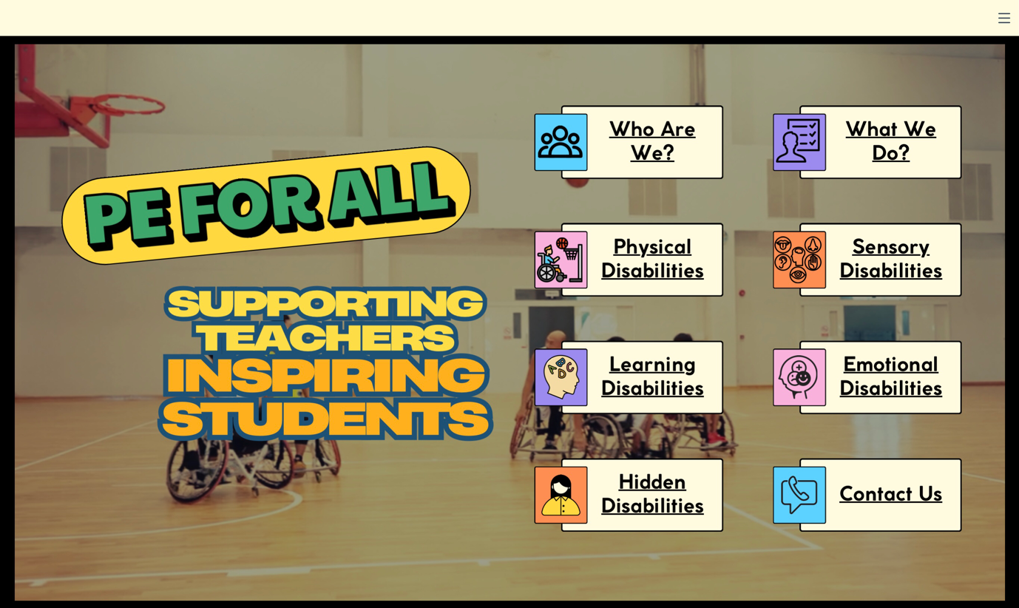
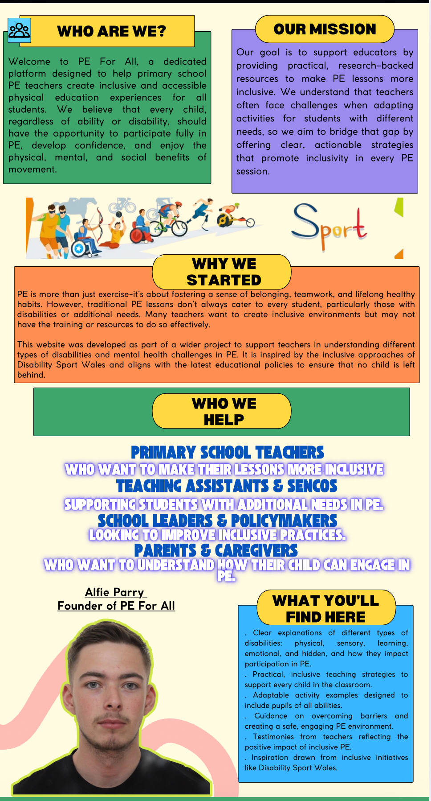
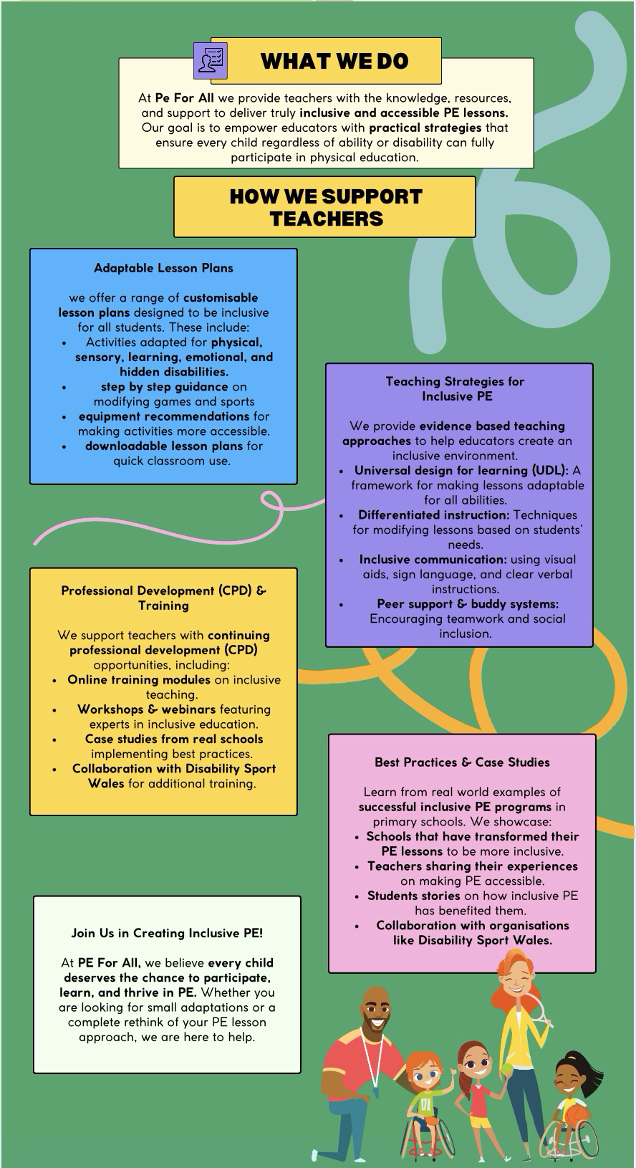
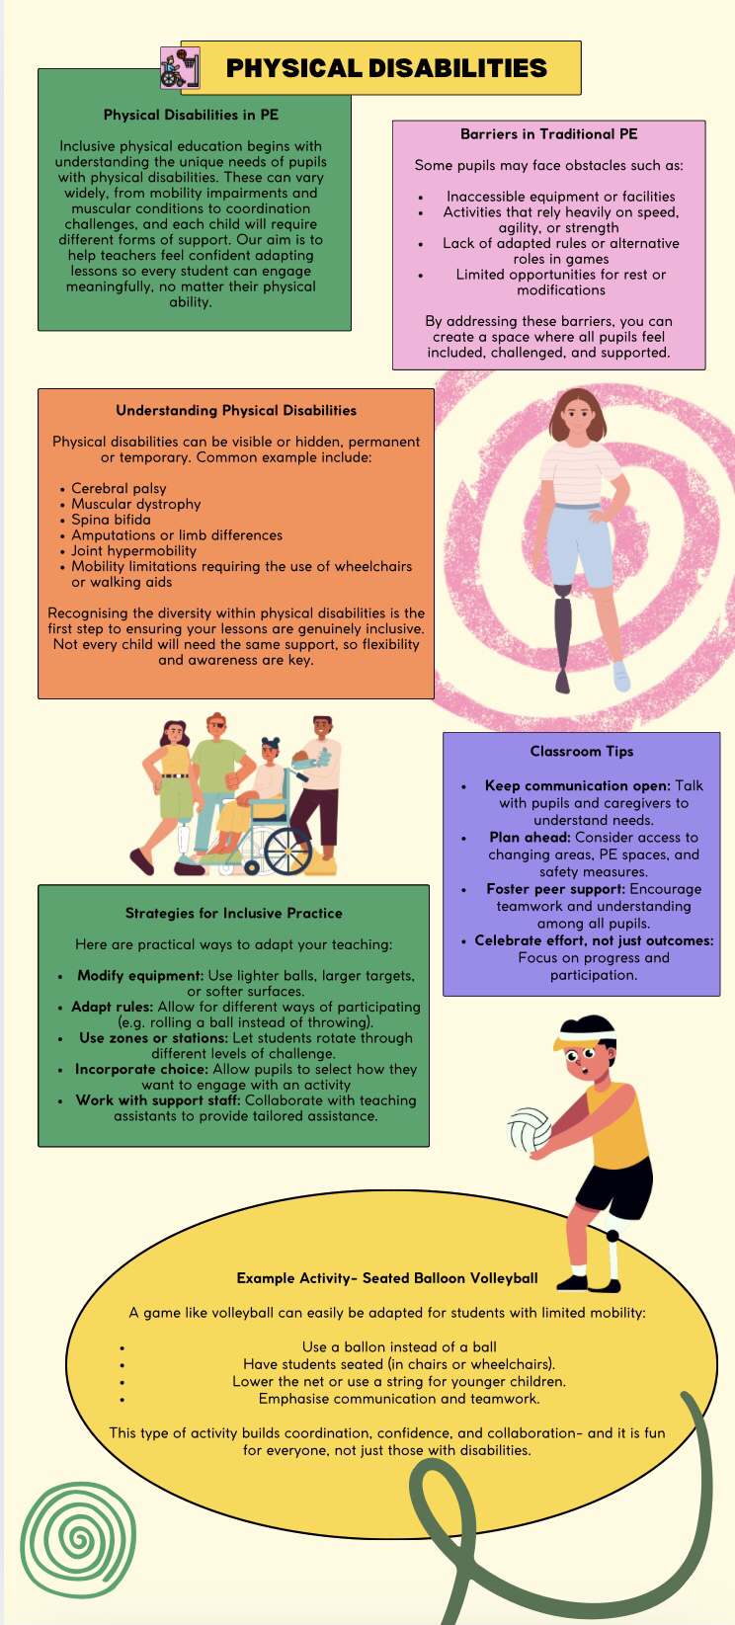
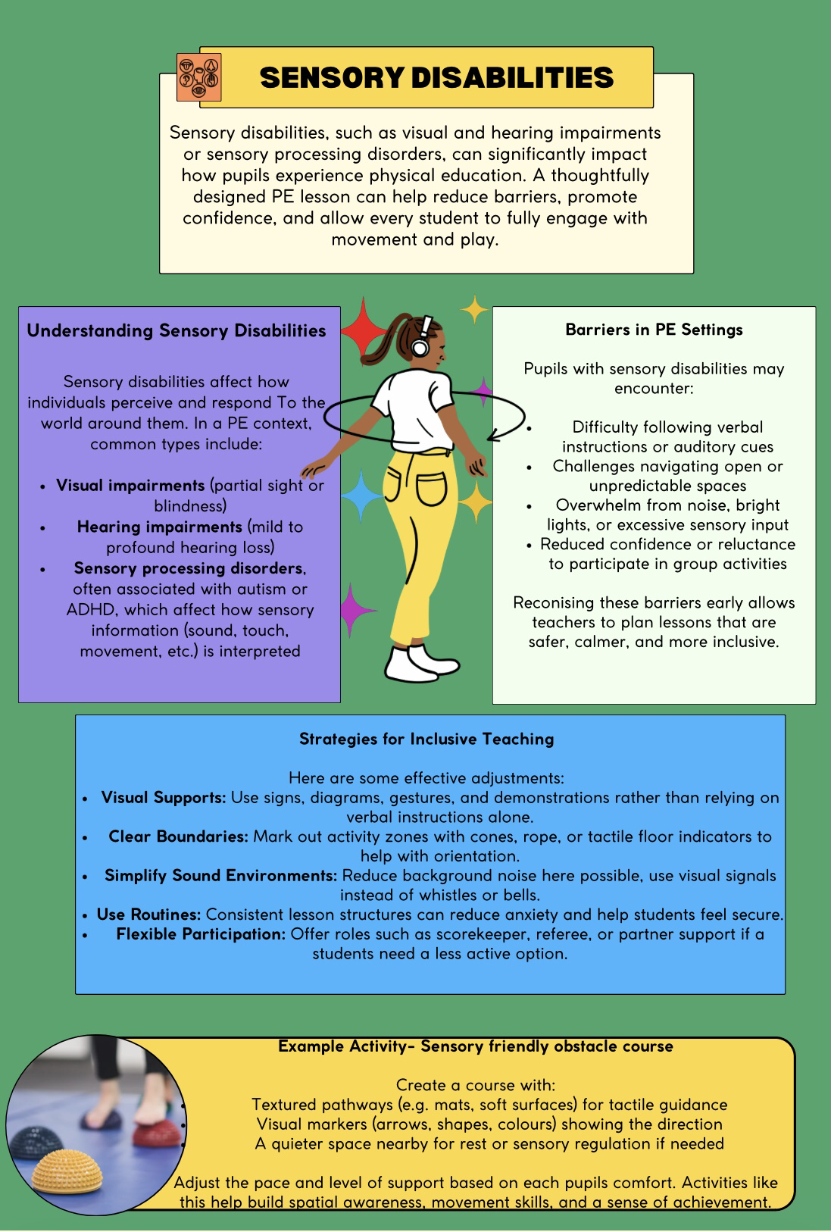
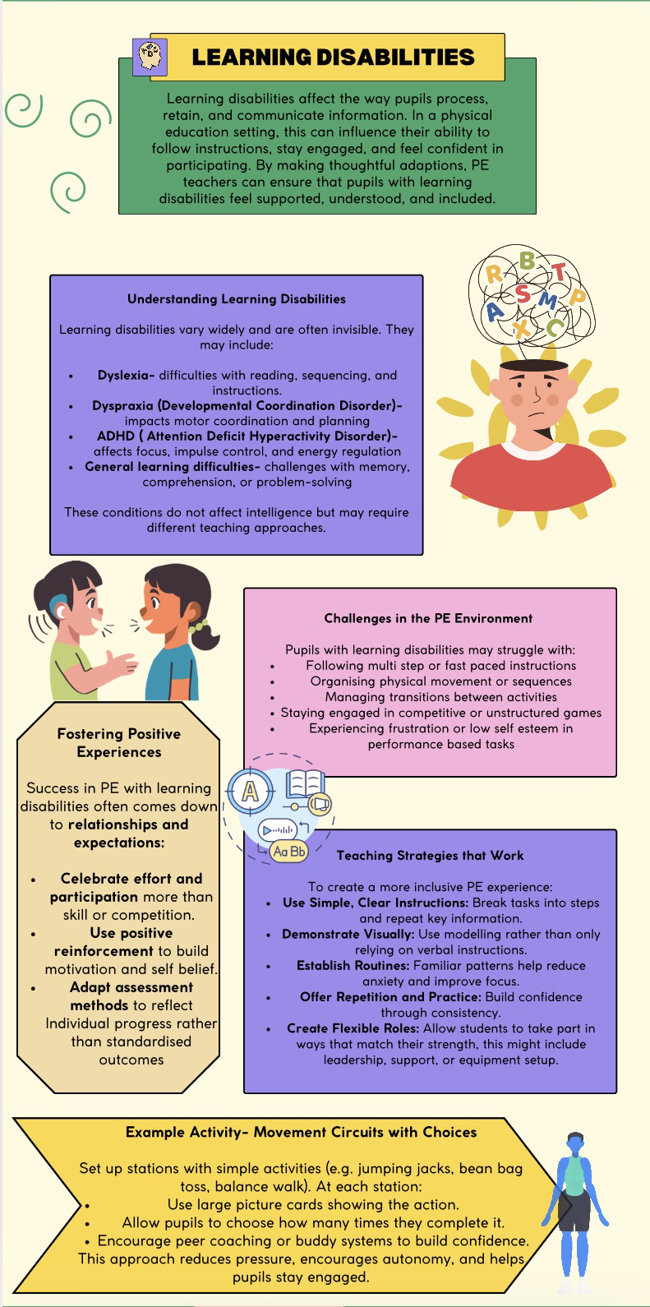
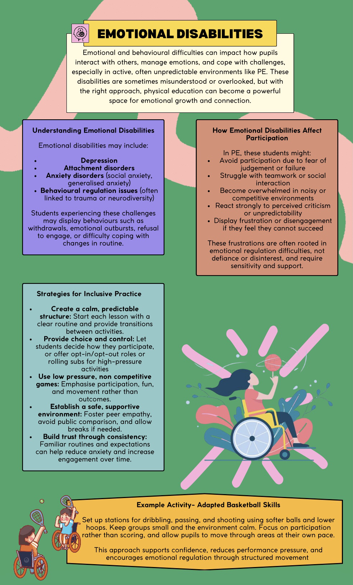
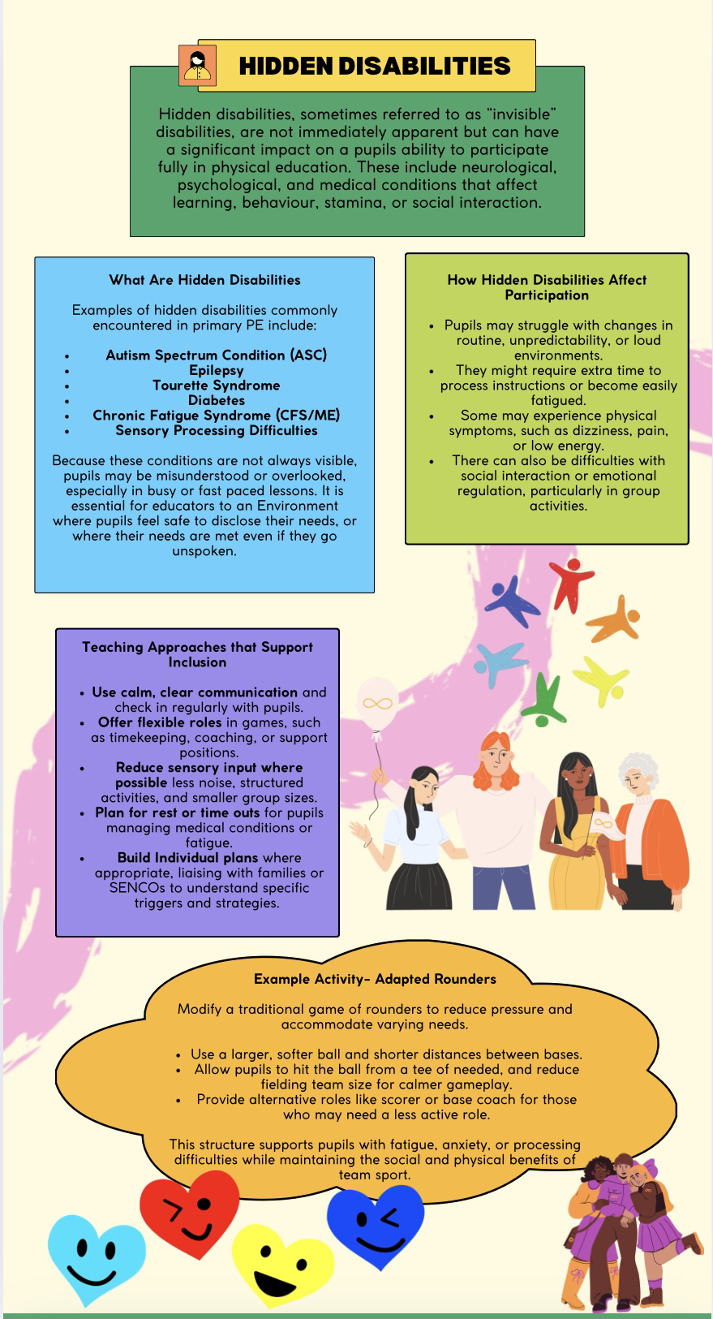
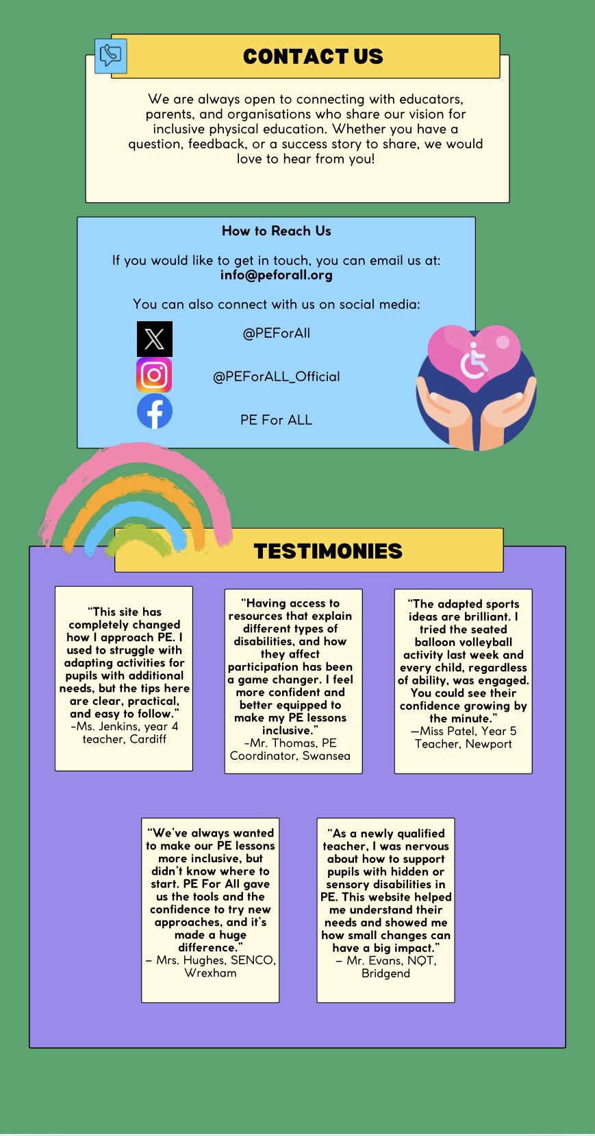

Reflection / Conclusion / Recommendations (key learning points)

Reflection
This dissertation has allowed me to explore the importance of inclusive physical education (PE) in primary schools, with a focus on supporting pupils with mobility difficulties. Throughout the research process, it became clear that inclusion goes beyond just allowing disabled pupils to participate; it’s about creating an environment where they are actively involved, challenged, and valued in the same way as their peers.
One of the key things I noticed is that many teachers want to do the right thing but aren’t always given the tools or confidence to deliver inclusive PE. There’s a gap between policy and practice—while the Curriculum for Wales promotes inclusion, some teachers are unsure how to put that into action in their lessons. This reinforced the idea behind my website project: creating an accessible online platform where teachers can easily find inclusive lesson plans, activity ideas, and resources to help them adapt PE for all learners
Learning about the work of Disability Sport Wales (DSW) also played a big part in shaping my thinking. Their commitment to inclusion and support for schools through training, partnerships, and equipment highlights what’s possible when organisations and schools work together. DSW has shown that inclusion isn’t just a theory—it can and should be part of everyday teaching practice.

Conclusion
Inclusive PE is not a luxury—it’s a fundamental right. All children, regardless of ability, should have equal access to physical activity, not just for their health and development, but for their confidence and sense of belonging. A well-designed, inclusive PE curriculum can help break down barriers, build friendships, and promote lifelong participation in sport.
However, inclusion doesn’t happen by accident. It needs planning, support, and a willingness to adapt. Through my research, I found that teachers often face challenges when trying to include pupils with mobility difficulties—these include lack of time, limited training, and not knowing how to modify games safely or effectively. That’s why my practical project—a website dedicated to inclusive PE—is designed to be a helpful, user-friendly space where teachers can access ready-to-use ideas and guidance.
The website aligns closely with the findings of this dissertation. It provides simple, inclusive lesson plans, showcases case studies of good practice, and shares information about working with external organisations like DSW. It is designed with busy teachers in mind, offering quick, practical advice they can apply straight away.

Key Learning Points and Recommendations
- Teacher Support and Training
One of the most important findings is that teachers need more training and support when it comes to delivering inclusive PE. Many want to be more inclusive but haven’t had specific training on how to adapt activities for different abilities. My website aims to fill this gap by offering practical tips, videos, and simple lesson plans that show how PE can be adapted without needing expensive equipment or specialist knowledge. I recommend that teacher training providers and schools prioritise inclusive PE in both initial teacher education and ongoing CPD.
- Listening to Pupils
Involving pupils with disabilities in planning PE lessons helps ensure their needs are properly met and that they feel seen and valued. Pupil voice is often overlooked, but it’s essential in developing activities that are genuinely inclusive. The website encourages teachers to speak directly with their pupils and includes example questions and checklists to help gather their feedback. This makes inclusion a collaborative process, rather than something imposed from above.
- Working with Organisations
External organisations like Disability Sport Wales offer invaluable support to schools. They provide coaching, adapted equipment, training, and resources that can make a real difference. However, not all schools are aware of what’s available. My website includes a directory of organisations, starting with DSW, to help schools find the help they need. I recommend that more partnerships are developed between schools and local sport bodies to improve the reach and impact of inclusive sport initiatives.
- Whole-School Approach
Inclusion works best when the whole school is involved—not just the PE teacher. Senior leaders need to prioritise inclusive practices and provide time, support, and resources to help them happen. The website includes materials aimed at school leaders, showing how inclusion fits into school values and how it can be supported across the curriculum. One of the learning points here is that successful inclusion in PE can help create a more inclusive culture throughout the school.
- Resources and Equipment
While some inclusive activities can be done with standard PE equipment, other situations require adaptations—such as softer balls, ramps, or seated options. Schools don’t always have access to these. The website suggests affordable alternatives and ideas for using everyday items in inclusive ways. It also signposts grant opportunities and support from charities like DSW. My recommendation is that local authorities provide better access to adapted equipment and funding to help schools become more inclusive.
- Tracking Progress
Inclusion should be reviewed regularly to make sure all pupils are benefiting. At the moment, many schools do not evaluate how inclusive their PE lessons really are. The website provides basic evaluation tools and teacher reflection sheets to help with this. I recommend that schools include inclusion in their regular self-evaluation processes, to ensure ongoing progress.
- Online Platform for Inclusive PE
Finally, a major learning point is that digital platforms can play a big role in improving inclusion. Teachers are busy and often rely on online tools for planning. My website is designed to be quick, accessible, and easy to use, so that even those with little experience in inclusive PE can find support. I recommend that similar digital resources be developed and shared at a national level to promote consistency and raise standards in inclusive practice.

Reference List (use relevant numbers of pages)

- Aaker, D.A. (1991) Managing Brand Equity: Capitalising on the Value of a Brand Name. Free Press.
- Activity Alliance. (2022). Inclusion 2024 Inclusive Education Hub. Available at: Activity Alliance.
- Armour, K.M. and Yelling, M.R. (2007) ‘Effective professional development for physical education teachers: The role of informal, collaborative learning’, Journal of Teaching in Physical Education, 26(2), pp. 177–200.
- Bailey, R., Collins, D., Ford, P., MacNamara, A., Toms, M. and Pearce, G. (2010) ‘Participant development in sport: An academic review’, Sports Coaching Review, 1(2), pp. 124–137.
- Balyi, I. and Hamilton, A. (2004) ‘Long-Term Athlete Development: Trainability in Children and Adolescents’, Sports Coach, 26(3), pp. 4–9.
- Blair, S.N., Cheng, Y. and Holder, J.S. (2012) ‘Is physical activity or fitness more important in defining health benefits?’, Medicine and Science in Sports and Exercise, 33(6), pp. S379–S399.
- Block, M.E. (2013) Inclusive Physical Education: A Teacher’s Resource. Champaign, IL: Human Kinetics.
- Burke, L.M., Loucks, A.B. and Broad, E.M. (2015) ‘Energy and carbohydrate for training and recovery’, Journal of Sports Sciences, 24(7), pp. 675–685.
- Casey, A. (2014) ‘Models-based practice: Great white hope or white elephant?’, Physical Education and Sport Pedagogy, 19(1), pp. 18–34.
- Conn, V.S. (2010) ‘Depressive symptom outcomes of physical activity interventions: meta-analysis findings’, Annals of Behavioral Medicine, 39(2), pp. 128–138.
- Cornwell, T.B. (2008) ‘State of the art and science in sponsorship-linked marketing’, Journal of Advertising, 37(3), pp. 41–55.
- Côté, J. and Gilbert, W. (2009) ‘An integrative definition of coaching effectiveness and expertise’, International Journal of Sports Science & Coaching, 4(3), pp. 307–323.
- Cushion, C., Armour, K.M. and Jones, R.L. (2003) ‘Coach education and continuing professional development: Experience and learning to coach’, Quest, 55(3), pp. 215–230.
- Daniels, K. and Thornton, E.W. (1992) ‘Stress and coping: The effects of coaching and fitness training on self-esteem and anxiety’, Journal of Sports Sciences, 10(4), pp. 345–359.
- Deci, E.L. and Ryan, R.M. (1985) Intrinsic Motivation and Self-Determination in Human Behaviour. Springer.
- Department for Education and Skills (2004) Removing Barriers to Achievement: The Government’s Strategy for SEN. Available at: https://dera.ioe.ac.uk/13804
- Disability Sport Wales (2023) insport Series: Education. Available at: https://www.disabilitysportwales.com
- Disability Sport Wales (2024) Disability Inclusion Training. Available at: https://www.disabilitysportwales.com
- Disability Sport Wales (2024) Philosophy of Inclusion. Available at: https://www.disabilitysportwales.com
- Dyson, B. and Casey, A. (2017) ‘Inclusive Physical Education: The Challenges and Opportunities of Supporting Students with Disabilities’, International Journal of Inclusive Education, 21(10), pp. 1077–1093.
- Dyson, L. (2015) ‘The Role of Digital Technology in Enhancing Inclusive Physical Education’, Computers & Education, 82, pp. 127–135.
- Equality Act 2010. Available at: https://www.legislation.gov.uk/ukpga/2010/15/contents
- Florian, L. and Black-Hawkins, K. (2011) ‘Exploring inclusive pedagogy’, British Educational Research Journal, 37(5), pp. 813–828.
- Gibala, M.J., Little, J.P., Macdonald, M.J. and Hawley, J.A. (2012) ‘Physiological adaptations to low-volume, high-intensity interval training in health and disease’, Journal of
- Physiology, 590(5), pp. 1077–1084.
- Goodwin, D.L. and Watkinson, E.J. (2000) ‘Understanding Inclusive Physical Education: A Guide for Teachers’, Journal of Physical Education, Recreation & Dance, 71(2), pp. 27–30.
- Goodyear, V.A. and Casey, A. (2015) ‘Innovation with digital technologies in physical education: Four key principles for teachers’, Sport, Education and Society, 20(1), pp. 1–18.
- Hall, E. and Shea, C. (2021) Inclusive Education for Children with Learning Difficulties: Supporting Learning through Differentiation and Universal Design. London: Routledge.
- Hoye, R., Smith, A.C.T., Nicholson, M., Stewart, B. and Westerbeek, H. (2015) Sport Management: Principles and Applications. Routledge.
- Humphrey, N. and Wigelsworth, M. (2016) Social and Emotional Learning: A Critical Appraisal. London: SAGE Publications.
- Inclusive Sport. (n.d.) Promoting Inclusion in Sport and Physical Activity. Available at: Inclusive Sport.
- Jones, R.L., Armour, K.M. and Potrac, P. (2003) ‘Constructing expert knowledge: A case study of a top-level professional soccer coach’, Sport, Education and Society, 8(2), pp. 213–229.
- Keller, K.L. (2013) Strategic Brand Management: Building, Measuring, and Managing Brand Equity. Pearson Education.
- Lakes, K.D. and Hoyt, W.T. (2004) ‘Promoting Social Inclusion Through Physical Activity: Strategies for Children with Disabilities’, Adapted Physical Activity Quarterly, 21(2), pp. 144–160.
- Lieberman, L. and Houston-Wilson, C. (2017) Strategies for Inclusion: A Handbook for Physical Educators. 3rd edn. Champaign, IL: Human Kinetics.
- Lyle, J. (2002) Sports Coaching Concepts: A Framework for Coaches’ Behaviour. Routledge.
- Macdonald, R. and Deacon, J. (2019) ‘Understanding and supporting pupils with hidden disabilities in physical education’, British Journal of Special Education, 46(2), pp. 203–216.
- Masterman, G. (2008) Strategic Sports Event Management. Routledge.
- Mullin, B.J., Hardy, S. and Sutton, W.A. (2014) Sport Marketing. Human Kinetics.
- Nash, C. and Sproule, J. (2011) ‘Coaches’ perceptions of coach education experiences’, International Journal of Sports Science & Coaching, 6(4), pp. 545–560.
- Olympics (2021). Best Paralympic Moments at Tokyo 2020!. YouTube. Available at: https://youtu.be/rf217HEhOO4?si=9KFTHj08p1LJhb1O
- PE Scholar. (2022). Inclusive PE Activity Cards. Available at: PE Scholar.
- Penney, D. (2008) ‘Playing a part: The impact of teachers’ practices on students’ learning in physical education’, European Physical Education Review, 14(2), pp. 153–165.
- Shilbury, D., Westerbeek, H., Quick, S. and Funk, D. (2008) Strategic Sport Marketing. Allen & Unwin.
- Slack, T. and Parent, M.M. (2006) Understanding Sport Organisations: The Application of Organisation Theory. Human Kinetics.
- Smith, A. and Stewart, B. (2010) ‘The special features of sport: A critical revisit’, Sport Management Review, 13(1), pp. 1–13.
- Smith, D. (2019) ‘Strategies for Successful Inclusion in Physical Education’, British Journal of Educational Studies, 67(1), pp. 56–73.
- Sport England (2016) Towards an Active Nation. Available at: https://www.sportengland.org
- Sports, D. (2010). About Disabled Sports USA. YouTube. Available at: https://youtu.be/jH8ARD0oBlM?si=KxrFB1zvwp2PZKHd
- Stevenson, P., Carter, L. and McQuaid, R.W. (2017) ‘Universal design and adaptive technology in sports’, Disability and Society, 32(4), pp. 564–579.
- Vella, S.A., Oades, L.G. and Crowe, T.P. (2016) ‘A coach-supported development programme for athletes: Theoretical background and practical applications’, International Journal of Sports Science & Coaching, 11(1), pp. 66–79.
- Warburton, D.E., Nicol, C.W. and Bredin, S.S. (2006) ‘Health benefits of physical activity: the evidence’, CMAJ, 174(6), pp. 801–809.
- Welsh Government. (2021). Guidance on Inclusive Education. Available at: Welsh Government.
- Williams, M.H. (2005) Nutrition for Health, Fitness and Sport. McGraw-Hill Education.
- World Health Organization (2018) Global Action Plan on Physical Activity 2018–2030: More Active People for a Healthier World. Geneva: WHO.
- Youth Sport Trust (2022) Inclusive Physical Education: A Guide for Teachers. Available at: https://www.youthsporttrust.org

Bibliography (use relevant numbers of pages)

- Black, D. (2017). Sport and Disability: A Global Perspective. London: Routledge. pp. 102–126
- Thomas, N. and Smith, A. (2009). Disability, Sport and Society: An Introduction. London: Routledge. pp. 58–85
- Department for Education. (2013). National Curriculum in England: Physical Education Programmes of Study. [online] Available at: www.gov.uk [Accessed 4 Jan. 2025].
- Coates, J. and Vickerman, P. (2016). Let’s Get Physical: Inclusive PE in Primary Schools. European Physical Education Review, 22(3), pp. 321–339.
- Kirk, D. (2010). Physical Education Futures. London: Routledge. pp. 30–61
- Sport Wales. (2021). Creating Inclusive Opportunities: Strategy for Disability Sport in Wales. Cardiff: Sport Wales Publications. pp. 15–42
- Haegele, J.A. and Sutherland, S. (2015). Perspectives of students with disabilities toward physical education: A qualitative inquiry. Review of Educational Research, 85(4), pp. 583–621.

Appendices (use relevant numbers of pages)
No appendices were required for this study.



Sports Management Portfolio

Independent Project

UWTSDSport

