HTML & CSS Web Development
ACCA4023 – Introduction to Web and Database Concepts
Student Name: Rami El Tayeb
Student ID: 2523863
Programme: BSc Computing (Computer Networks and Cybersecurity)
Module: ACCA4023
Date: 19th January 2026

Contents
1. Introduction ......................................................... 2
2. Requirements ......................................................... 3
3. Implementation ....................................................... 3
4. Validation ........................................................... 3
5. Evaluation ........................................................... 3
6. Conclusion ........................................................... 3
7. References ........................................................... 3
8. Appendices ........................................................... 3

1. Introduction

1.1 Abstract
This report outlines the design, development and evaluation of the Student Fitness Hub website. The site was created to help university students improve their fitness while balancing their academic commitments and budget. The platform provides straightforward gym routines and basic nutritional guidance for beginners.
The website was designed and coded by hand using HTML5 and CSS. The website follows web standards to ensure consistent presentation, accessibility and ease of navigation across pages. The completed site contains three linked pages: Home, Workouts and Nutrition pages.
This report sets out the design requirements, implementation steps and validation of the website code. It also assesses the final website with references to usability, accessibility, and search engine optimisation, and includes a comparison to existing live websites.

1.2 Introduction
University students often face challenges in maintaining a healthy lifestyle due to academic stress, time demands and financial limitations. Many students lack access to straightforward, reliable fitness guidance that is suitable for beginners while being manageable alongside their studies. As a result, students may feel discouraged from engaging in regular physical activity or taking steps to improve their everyday health habits.
The Student Fitness Hub was designed to address these challenges by providing a simple, accessible online resource that offers entry-level fitness guidance. Its aim is to reduce common obstacles to exercise by providing beginner-friendly gym workouts and affordable nutrition advice that reflects students' lifestyles. The content is organised and written clearly to support users with little or no prior fitness experience.
With a focus on simplicity and ease of use, the website is intended to encourage students to make small but sustainable changes that improve physical health over time. The following sections outline the requirements, implementation process, and evaluation of the Student Fitness Hub.

2. Requirements

2.1 Website Purpose
The purpose of the Student Fitness Hub website is to support university students with an accessible and beginner-focused fitness resource. It is designed for students who want to improve their physical health while managing common constraints such as limited time, limited finances, and a lack of previous fitness experience. Rather than providing advanced training programmes, the site focuses on entry-level guidance that can be understood and applied easily.
The website delivers simple gym workout routines and affordable nutrition guidance. Content is presented in a clear, structured format so users can access relevant information efficiently without confusion. Overall, the website aims to encourage students to take part in regular exercise by reducing barriers and presenting fitness in a more accessible manner.

2.2 Target Audience
The main target audience for the Student Fitness Hub website is university students, including those who are unfamiliar with gym-based training or have limited experience with fitness and nutrition. The website is intended for individuals balancing academic commitments with part-time work or other responsibilities, which can result in limited available time and disposable income.
The target audience is likely to view the website on laptops or mobile devices and may prefer clear, simple information that can be understood quickly. As a result, the content has been structured to be concise, easy to navigate, and free from unnecessary technical language. This approach ensures the website remains accessible and suitable for its intended users.

2.3 Functional Requirements
The functional requirements of the Student Fitness Hub website outline the key features and behaviours the system must support to meet user needs. The website must present fitness-related information clearly and provide efficient navigation between pages without difficulty.
The key functional requirements are as follows:
- The website must provide clear navigation between the home, workouts, and nutrition pages.
- The website must display beginner-friendly gym workout routines in an organised layout.
- The website must include basic and affordable nutrition guidance relevant to students.
- The website must load correctly in a standard web browser without requiring additional software.
- The website must allow users to access information without account creation or login functionality.
These requirements ensure the website delivers its intended content effectively while staying simple and accessible for the target audience.

2.4 Non-functional Requirements
The non-functional requirements of the Student Fitness Hub website define the quality standards required to ensure a strong user experience. The website must be simple to use and intuitive, enabling users to locate information quickly without unnecessary complexity.
The website should be accessible to a broad range of users, including those with limited technical skills. Content must be readable and logically structured, with appropriate font sizes and sufficient contrast. The website must also perform efficiently, with quick page load times on standard devices and typical internet connections.
Finally, the website must follow web standards by using valid HTML and CSS to ensure consistent performance across modern browsers. In addition, the code should be organised and maintainable to support future updates or content changes if required.

3. Implementation
The website was developed using HTML5 and CSS in accordance with recognised web standards. The final site includes three linked pages: a home page, a workouts page, and a nutrition page. The layout was kept consistent and the navigation simple so users can move between pages easily. The screenshots below show how the finished website looks and how the pages are structured, as shown in Figures 3, 4 and 5.
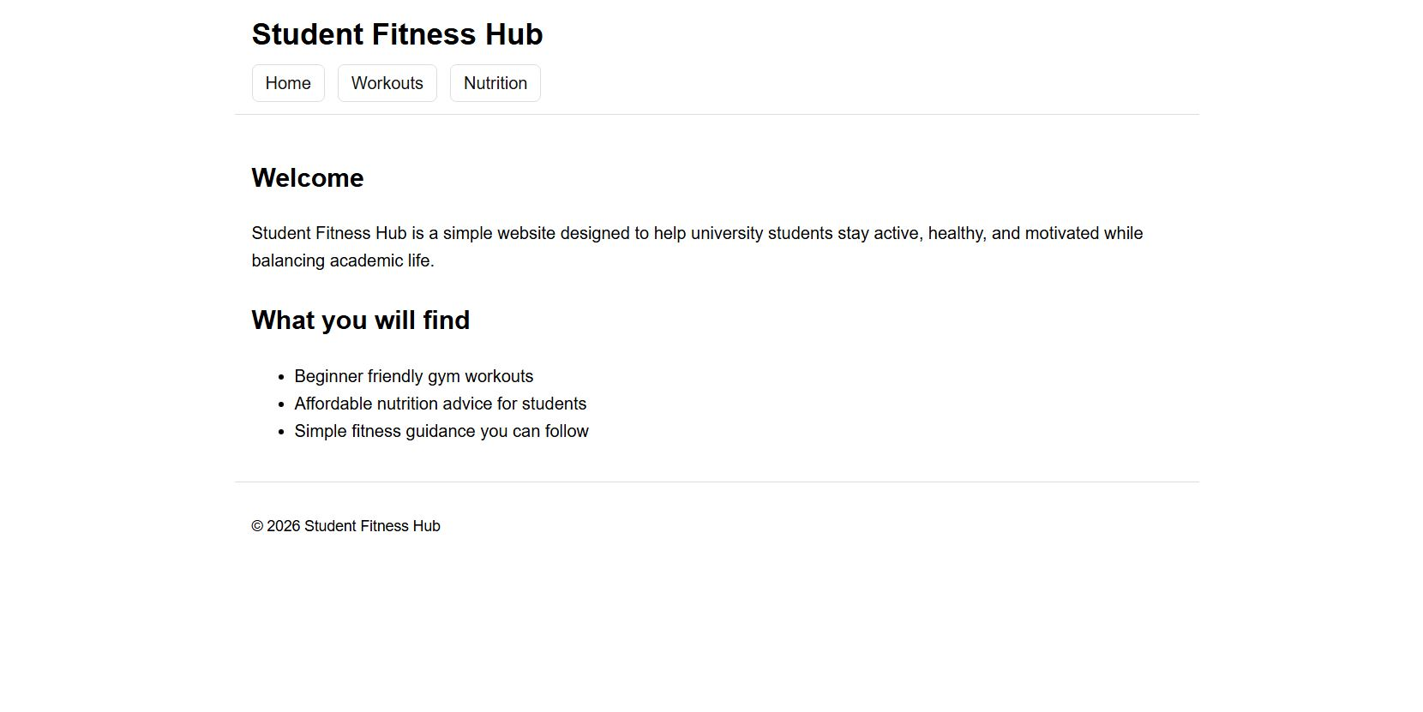
Figure 3: Home Page (Student Fitness Hub)
Screenshot showing the home page layout, including the site title, navigation menu, and introductory content.
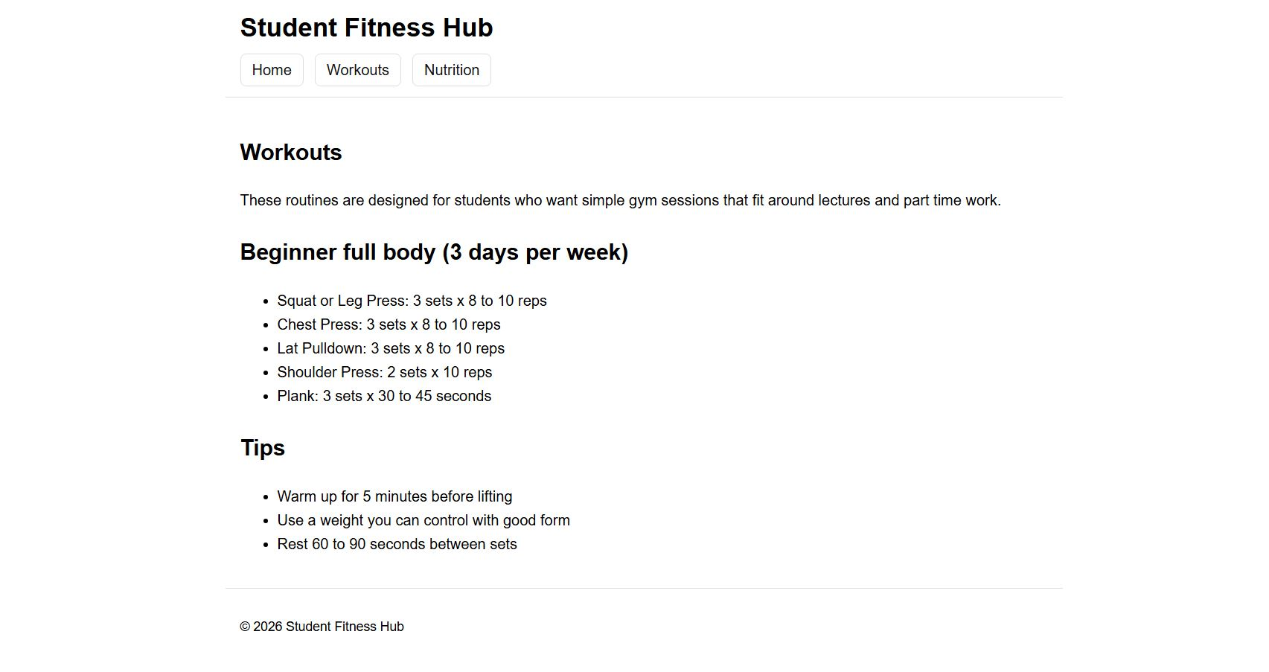
Figure 4: Workouts Page
Screenshot showing the workouts page with structured exercise routines and guidance designed for students.

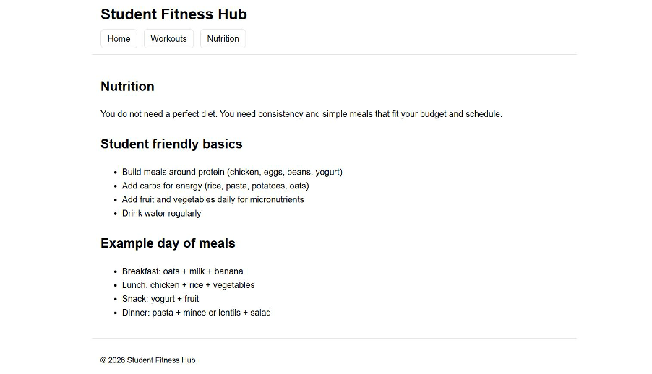
Figure 5: Nutrition Page
Screenshot showing the nutrition page with student-friendly dietary guidance and example meals.

4. Validation
I validated the website to check that the HTML and CSS were written correctly and followed web standards. The home page (index.html) was checked using the W3C HTML Validator. The main stylesheet (style.css) was checked using the W3C CSS Validator.
When the HTML file was validated, no errors or warnings were found. This shows that the page structure is correct and follows HTML5 rules. The CSS validation also returned no errors, which confirms that the styling was written correctly using CSS Level 3. Screenshots of both validation results are shown below.
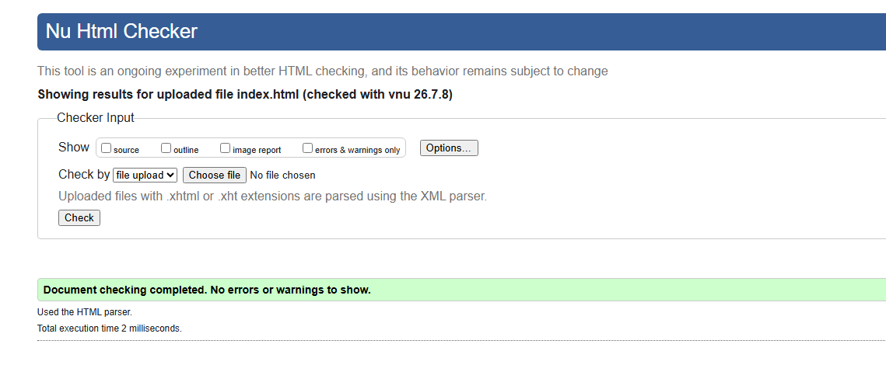
Figure 4: HTML Validation
Screenshot showing no errors being shown by validation checker for HTML

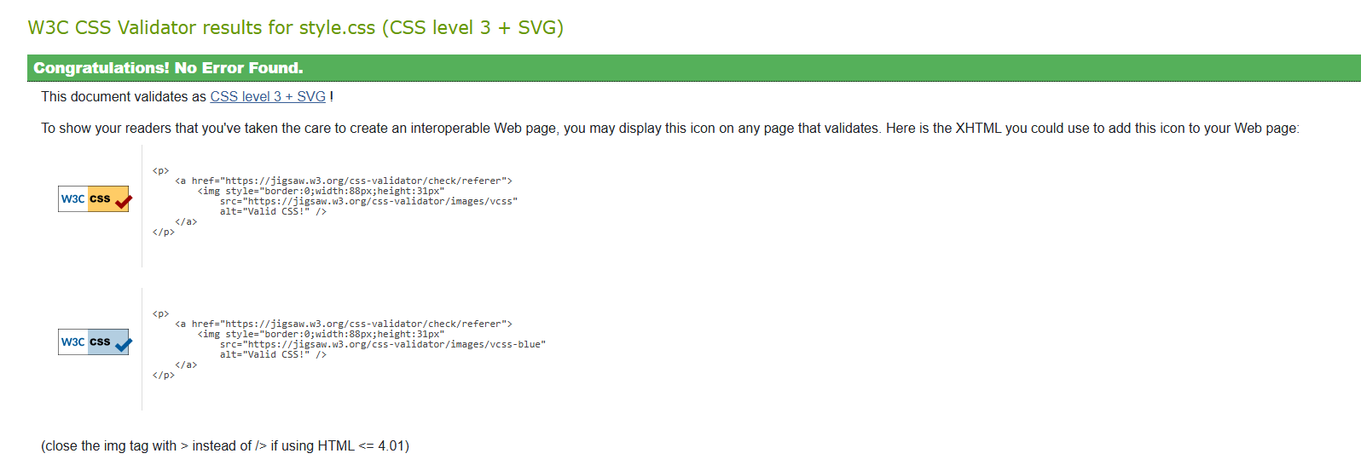
Figure 5: CSS validation
Screenshot showing no errors being shown by validation checker for CSS

5. Evaluation

5.1 Website Usability and Usefulness
Usability is widely defined as the extent to which users can interact with a website effectively and efficiently to achieve their goals. Studies frequently assess usability through effectiveness, efficiency, and satisfaction, with a focus on users with limited technical experience. Ugraş et al. highlight that usability supports both the completion of simple tasks and sustained user engagement, particularly when users require quick access to information with minimal effort [1]. This is especially important for websites designed for users with limited technical experience.
For the Student Fitness Hub website, usability is shown through a simple page layout and consistent navigation throughout the pages (see Figure 3). The home, workouts, and nutrition pages follow a standard layout which allows users to avoid confusion. The content presented on the website is in short paragraph format along with bullet points. This improves readability and reduces cognitive load for students who may be unfamiliar with fitness terminology.
The usefulness of the website is reflected in how well the content aligns with the needs of the target audience. This is achieved by providing users with beginner-friendly gym routines combined with affordable nutritional guidance that can be easily applied by students. Rather than overwhelming users with complex information and terms, the website focuses on practical advice that supports step-by-step improvements to physical health. Overall, this approach increases the likelihood that users will find the website relevant and continue to engage with it.
The quality of a website's content is displayed through clear language, logical organisation and how relevant it is to a student's day-to-day life. Accessibility for users with little or no prior fitness experience is ensured through concise information that avoids unnecessary detail. However, to further improve user experience, clearer section headings could help users identify their current location within the site.

5.2 Accessibility Evaluation (WCAG 2.1)
Web accessibility refers to designing websites so they can be used by as many people as possible, including users with disabilities or limited technical ability. WCAG 2.1 is commonly used to evaluate accessibility and is based on four principles: perceivable, operable, understandable, and robust [2].
By using readable headings, a consistent format and clear paragraphs, users can scan information easily, ensuring visual clarity throughout the Student Fitness Hub website. However, accessibility could be further improved by optimising colour contrast and including alternative text for any images used.

5.3 Search Engine Optimisation (SEO)
Search Engine Optimisation (SEO) involves improving a website so it can be found and interpreted more easily by both search engines and users. Google's Search Central documentation describes SEO as helping search engines understand content, while supporting users in finding relevant pages efficiently [3].
The Student Fitness Hub website uses basic SEO principles through its structured layout and clearly defined page topics (see Figures 4 and 5). Each page centres on a single theme, such as workouts or nutrition, which helps define the purpose and improve content relevance. Headings are used to structure information logically, supporting both readability and how search engines interpret page structure.
In addition, the website uses internal links and simple navigation across the pages, which supports how search engines discover and index content. The linking also improves the user experience by making it easier to move between different parts of the website. The use of relevant fitness terms and references to student lifestyles further improves clarity and relevance.
Despite this, SEO could be strengthened through more descriptive page titles and the addition of meta descriptions. These features would provide clearer context to search engines and improve how the pages are presented in search results. Implementing these improvements would improve visibility and increase the potential reach of the website.

5.4 Comparison with Live Websites
The effectiveness of the Student Fitness Hub website can be evaluated by comparing it with established fitness websites such as MyFitnessPal and Bodybuilding.com. These services provide extensive functionality, including interactive tools, personalised tracking, and detailed workout programmes that are designed to keep users engaged.
The Student Fitness Hub is simpler in comparison and offers fewer features, but it is more focused in purpose. While it does not include personalised plans or user accounts, the simplicity suits its audience of university students who may be new to fitness. The website prioritises clarity and ease of navigation, allowing users to access information quickly without unnecessary complexity.
In terms of usability, the Student Fitness Hub performs effectively through clear navigation and readable presentation. Websites such as Bodybuilding.com provide a large amount of content and products, which can be difficult for beginners to navigate. The Student Fitness Hub presents its content in a more structured and accessible way, making it easier for users with limited experience to follow the guidance.
However, the Student Fitness Hub lacks the same level of interactivity as MyFitnessPal, particularly in relation to nutrition tracking and personalised feedback. These tools can increase engagement and continued use, but they are not currently implemented within the Student Fitness Hub. Introducing these features in future versions would improve user engagement while maintaining the website's simple and accessible design.

6. Conclusion
The Student Fitness Hub website was created to provide university students with an accessible fitness resource designed for beginners. It meets its core objective by offering clear workout guidance and basic nutrition advice through a simple structure and simple, straightforward navigation.
The evaluation suggests the website performs well for usability, accessibility, and content clarity, which aligns with the needs of the intended users. Even so, further improvements could be made, especially by enhancing accessibility features, improving SEO practices, and increasing interactivity.
Overall, the website forms a solid foundation for a student-focused fitness programme with potential for future development that could boost engagement and broaden its reach.

7. References
[1] U. Ugraş, H. Yıldırım and E. Gülseçen, "Research Trends in Website Usability: A Systematic Review," International Journal of Computer Science and Information Technologies, vol. 7, no. 3, pp. 1435–1444, 2016.
[2] World Wide Web Consortium (W3C), Web Content Accessibility Guidelines (WCAG) 2.1, Jun. 2018. [Online]. Available: https://www.w3.org/TR/WCAG21/. [Accessed: 10-Jul-2026].
[3] Google, "SEO Starter Guide: The Basics," Google Search Central, Google for Developers, 2025. [Online]. Available: https://developers.google.com/search/docs/fundamentals/seo-starter-guide. [Accessed: 10-Jul-2026].

8. Appendices

Appendix A – HTML Source Code
The complete HTML source code has been included as a separate submission file.
Appendix B – CSS Stylesheet
The complete CSS stylesheet has been included as a separate submission file.
Appendix C – Validation Results
HTML and CSS validation screenshots are included within the report and demonstrate compliance with W3C standards.

