

Changemakers: Creativity and Value Creation
Professions (BMHP5014)

Component 2: Assignment (Report)

Student name: Busra Akter Rusi
Student number: 2413161
Lecturer’s name: Caroline Salami

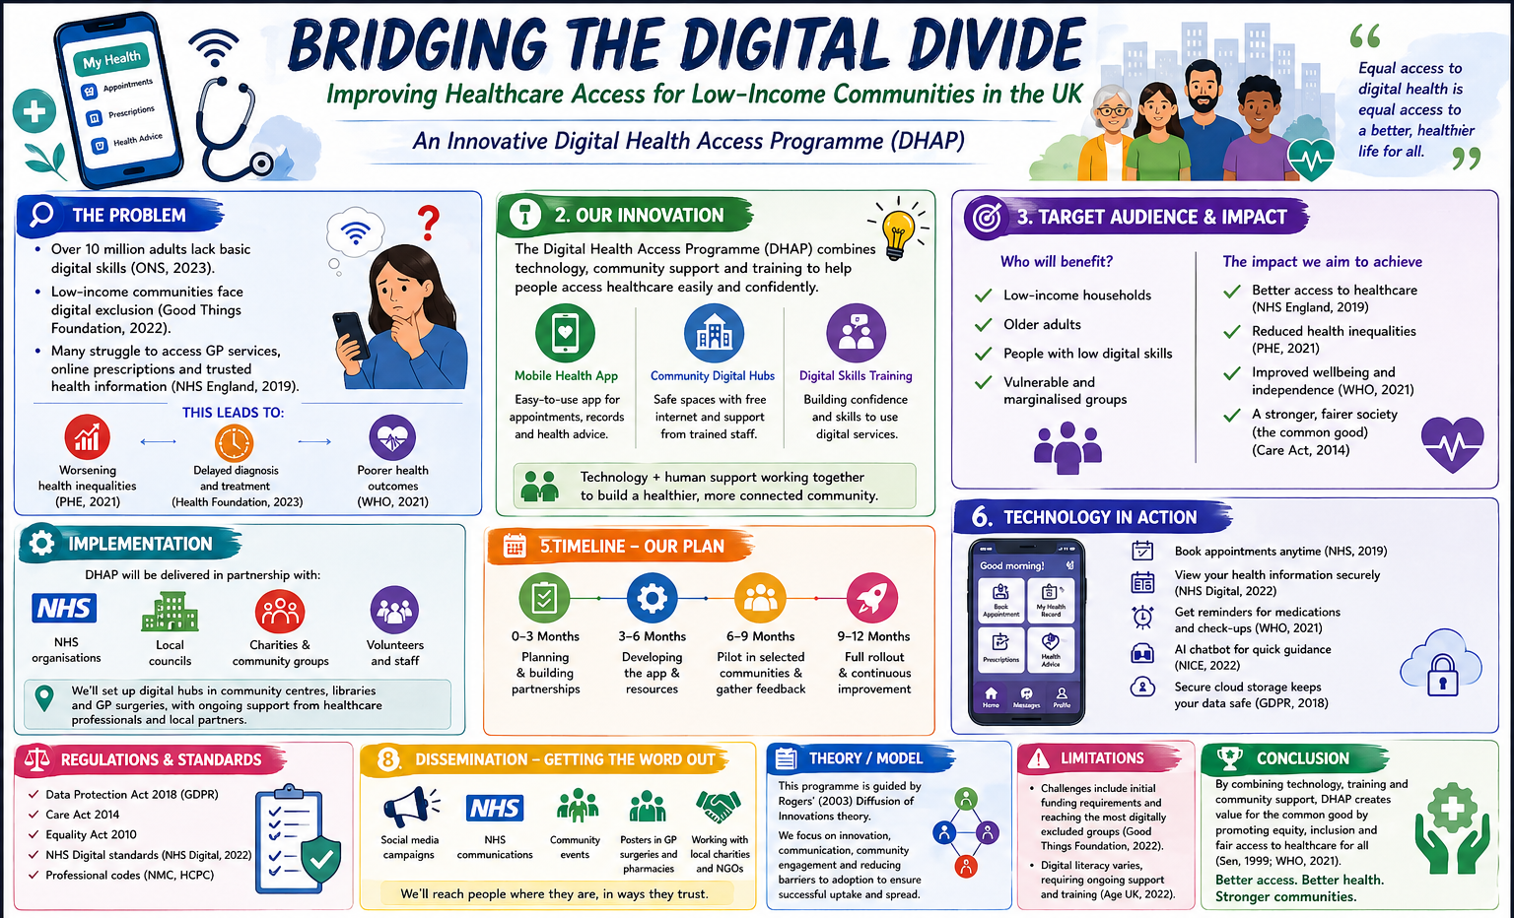

Introduction
Healthcare should be a right, however an enormous number of people are being failed by this in the UK due to a digital gap. A user-friendly mobile phone application, together with the integration of community-based digital health hubs, and the provision of relevant training has resulted in the formation of the Digital Health Access Programme (DHAP). This novel and community-based programme offers the digitally excluded population of low-income groups access to digital health.

The Problem: Digital Exclusion and Health Inequalities

Digital exclusion is a current, well-documented issue across the UK. The Office for National Statistics (2023) states that over 10 million adults lack the basic skills required to access health services online, in particular for low-income communities, the elderly and deprived groups. Lloyds Bank (2023) reports that almost 9 million UK adults do not use the internet independently.

Digital transformation is a crucial aspect of how health services will function going forward according to the NHS Long Term Plan (NHS England, 2019), yet if not managed in an inclusive manner these advancements may lead to exclusion of the communities who need support the most. (Good Things Foundation, 2022). This is confirmed by The Health Foundation (2023) who reported that those from poorer socio-economic areas are far less likely to access digital health technologies and consequently delays and inferior health outcomes will increase. The COVID-19 pandemic prompted a rapid acceleration of digitally delivering NHS services (NHS Digital, 2022), highlighting the urgent need for inclusive digital infrastructure.

The Innovation: DHAP

The three parts to DHAP were designed to tackle the system barrier. DHAP has an accessible mobile app on which patients can book GP appointments or retrieve their medical information, an accessible local digitally integrated community hub where anyone can access the internet for free and get one-to-one support, and digital literacy training to empower patients to gain digital confidence and become independent. The difference toDHAPis that it not only gives people the technology but also invests in skills and community relationships.

The framework for this design is rooted in Rogers (2003) diffusion of innovations theory: "The framework outlines five adopter categories and the influence of 'community champions' in overcoming barriers to diffusion of innovations" The step by step plan, from planning 0-3 months to pilot 6-9 months to full rollout 9-12 months, corresponds directly to this framework, targeting early adopters before moving on to early majority users. This also reflects the use of value for common good as suggested by NHS England (2022), and innovation is defined not in economic terms, but in terms of its impact on the wider society and social equity.

Impact on Health and Wellbeing

Those who will benefit are likely to be from a low-income demographic, elderly, and digitally excluded – all at-risk groups identified by Age UK (2022) and Public Health England (2021). It is anticipated that as access to health and care services via DHAP increases, diagnosis rates will increase (particularly in relation to serious and treatable illnesses); people will manage their chronic conditions with the support provided to self-manage; inappropriate A&E usage will fall. WHO (2021) acknowledges the global nature of digital health inequity and need for local/community based intervention to target excluded groups, confirming that DHAP has a valid rationale.

Sen's (1999) Capability Approach can also be applied – that it is not enough that health services are available; individuals need the true freedom and capability to utilize them; the DHAP directly enhances these capabilities by tackling both the technological and skills-based barriers.

Policy and Legislative Alignment

DHAP relies heavily on current UK policy and guidance. A statutory responsibility exists on Local Authorities to promote wellbeing by the Care Act 2014 (Department of Health and Social Care, 2014) with equal provision of services being enshrined in law via the Equality Act 2010 (UK Government, 2010), which the design of DHAP supports directly. It also builds on the requirement of a digital inclusion agenda through the UK Digital Strategy (DCMS, 2022), while the tools within DHAP will be designed with evidence-based advice from NICE (National Institute for Health and Care Excellence, 2022) on clinical effectiveness.

Regulatory Considerations

DHAP will be working under the scope of regulation regulated by the CQC (2023). All data handling will be within the terms of UK General Data Protection Regulation and the Data Protection Act 2018 which will mean that user's data will be securely managed. Healthcare professionals such as nurses and social workers and digitally supportive staff will all be adhering to the standards laid out by the NMC and HCPC.

Public and Stakeholder Involvement

The strength of DHAP will lie in the authenticity of its co-production: services co-design, not just services designed for communities. NHS providers, Local Authority partners, charities and most importantly, service users, will be at the heart of the design of all DHAP activities from the earliest stage. Volunteer digital champions will be drawn from within communities creating peer support and a long-term, sustainable approach that has been identified as one of the reasons for success in the context of the Good Things Foundation (2022). It is important for members of the public to not just be service users but also advocates and co-designers of DHAP.

Limitations and Challenges

However, when considering DHAP it is crucial to reflect critically on the limitations. Initial setup costs can be extremely high and targeting these most digitally excluded is a hurdle that can be difficult to overcome (Good Things Foundation, 2022). Digital literacy varies greatly depending on the demographic, this requires a consistent approach and on-going support (Age UK, 2022). Confidentiality can become an issue for a vulnerable user, and long-term sustainability in a project where initial funds run out can be an issue.

Conclusion

DHAP is an appropriate, evidenced and ethical response to digital exclusion within UK healthcare services. Theoretically grounded in Rogers (2003) Diffusion of Innovations and Sen (1999) Capability Approach, and aligned to current policy, DHAP seeks to tackles the root causes of health inequality, not the consequences, by providing a combination of technology and community support, coupled with co-production, generating real value for all members of society – equity, inclusivity and equal opportunities to healthcare (WHO, 2021; NHS England, 2022).

References
Age UK (2022) Digital inclusion and older people. Available at: https://www.ageuk.org.uk (Accessed: 25 April 2026).
Care Quality Commission (2023) Regulation of digital health services. Available at: https://www.cqc.org.uk (Accessed: 25 April 2026).
Department for Digital, Culture, Media & Sport (2022) UK Digital Strategy. Available at: https://www.gov.uk (Accessed: 26 April 2026).
Department of Health and Social Care (2014) Care Act 2014. Available at: https://www.gov.uk (Accessed: 20 April 2026).
Good Things Foundation (2022) Digital exclusion in the UK. Available at: https://www.goodthingsfoundation.org (Accessed: 23 April 2026).
Health Foundation (2023) Technology and health inequalities. Available at: https://www.health.org.uk (Accessed: 26 April 2026).
Lloyds Bank (2023) UK Consumer Digital Index. Available at: https://www.lloydsbank.com (Accessed: 23 April 2026).
National Institute for Health and Care Excellence (2022) Digital health technologies guidance. Available at: https://www.nice.org.uk (Accessed: 26 April 2026).
NHS Digital (2022) Digital transformation in health and care. Available at: https://digital.nhs.uk (Accessed: 21 April 2026).
NHS England (2019) The NHS Long Term Plan. Available at: https://www.longtermplan.nhs.uk (Accessed: 21 April 2026).
NHS England (2022) Inclusive digital healthcare strategy. Available at: https://www.england.nhs.uk (Accessed: 24 April 2026).
Office for National Statistics (2023) Exploring the UK’s digital divide. Available at: https://www.ons.gov.uk (Accessed: 22 April 2026).
Public Health England (2021) Health inequalities: digital access report. Available at: https://www.gov.uk (Accessed: 22 April 2026).
Rogers, E.M. (2003) Diffusion of Innovations. 5th edn. New York: Free Press.
Sen, A. (1999) Development as Freedom. New York: Anchor Books.
UK Government (2010) Equality Act 2010. Available at: https://www.legislation.gov.uk (Accessed: 20 April 2026).
World Health Organization (2021) Digital health and equity. Available at: https://www.who.int (Accessed: 24 April 2026).

