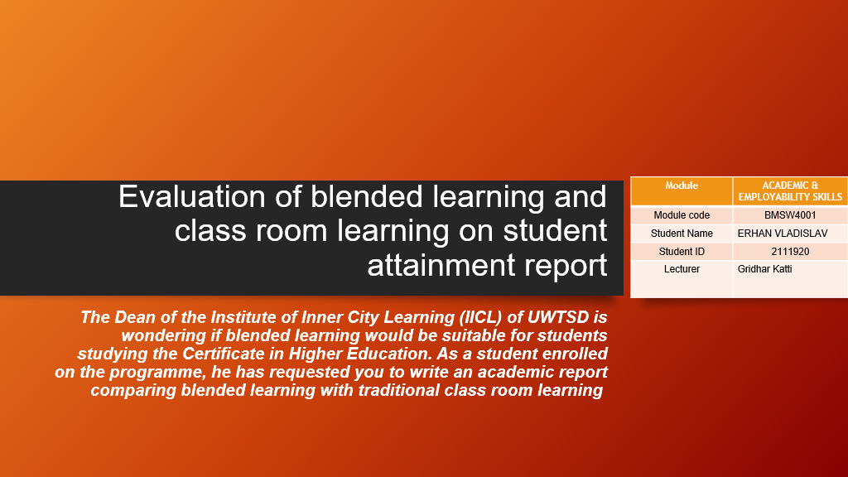

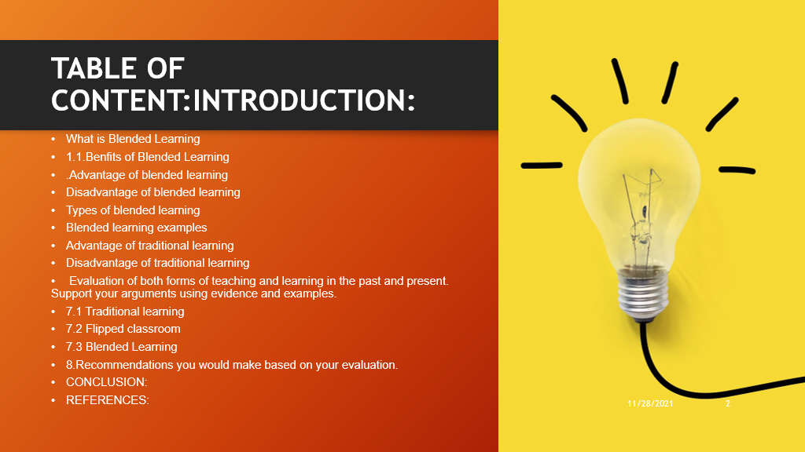

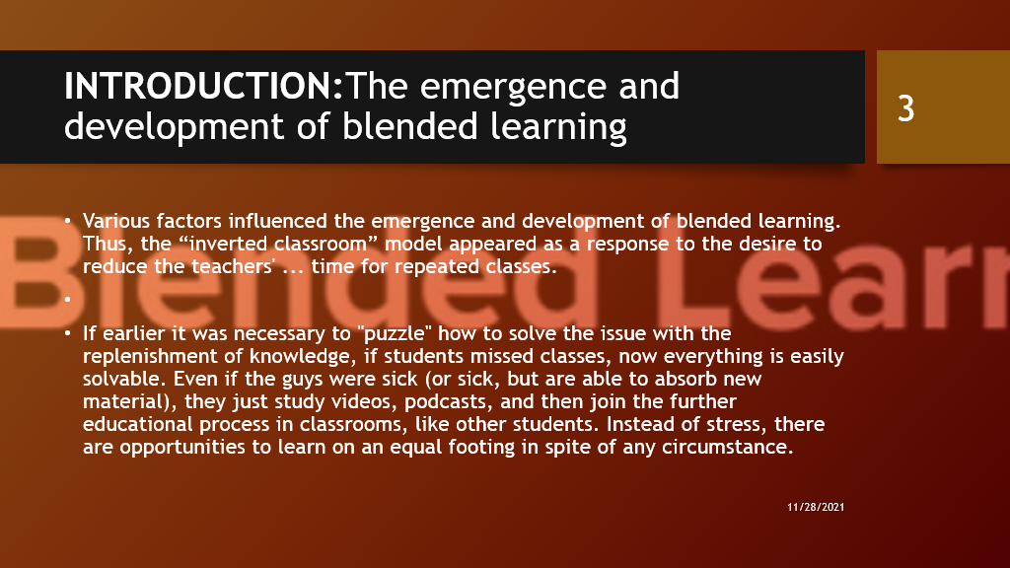

By the way, the same model is often taken up by training centers at companies where employees have irregular working hours and the rhythm of work depends mainly not on themselves, but on the number of clients at the moment. Even if today there is a sudden flurry of clients, the training material is again easy to catch up with the materials for self-study. But the popularization of the Flex model was especially promoted by the pandemic in 2020. Many educational institutions are faced with the fact that if they are able to transfer lectures and practical ones (especially if there are online simulators) to distance learning, then it is far from always possible to organize full-fledged online testing and exams.

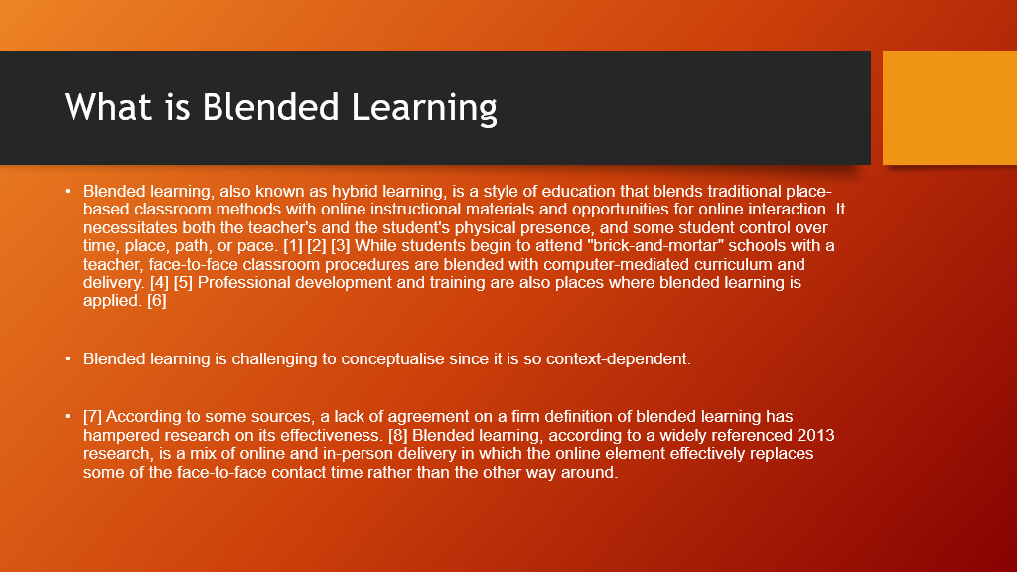

In addition, a 2015 meta-analysis found commonalities in defining blended learning as "a combination of traditional f2f [face to face] modes of instruction with online modes of learning, drawing on technology-mediated instruction, where all participants in the learning process are separated by distance some of the time." [10] This report also discovered that all of these evidence-based studies concluded that blended learning experiences resulted in higher student accomplishment than either totally online or completely face-to-face learning experiences. [11]

Sometimes the terms "blended learning," "targeted learning," and "differentiated teaching" are used similarly.

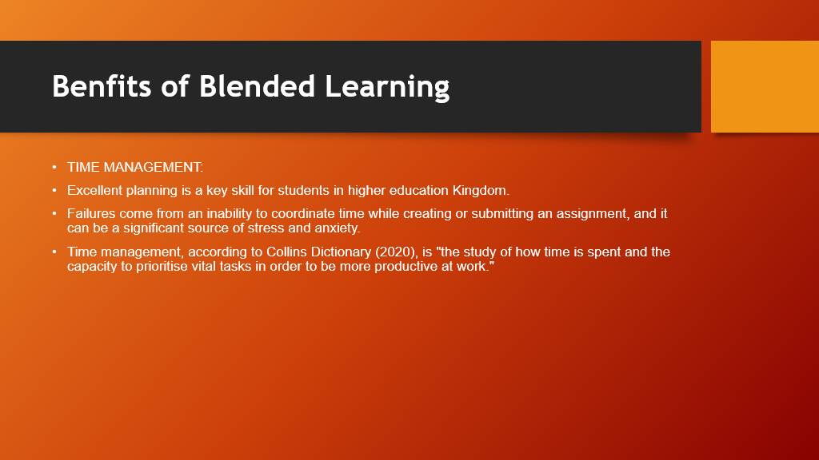

Its meaning can be applied even in higher education, meaning that it is critical for a student to understand how to manage the hours available to them in an organized way, as well as to have control over the way in terms of meeting all academic deadlines.
According Claessens, Eerde, and Rutte (2005), "time management is conceivable just through self-motivation and planning," which implies that in order to achieve the proposed goals, a student should make a list of the essential things and activities and prepare a "to do list" with a plan of action that takes account time stealers such as social media, work, romance, work, and friends.

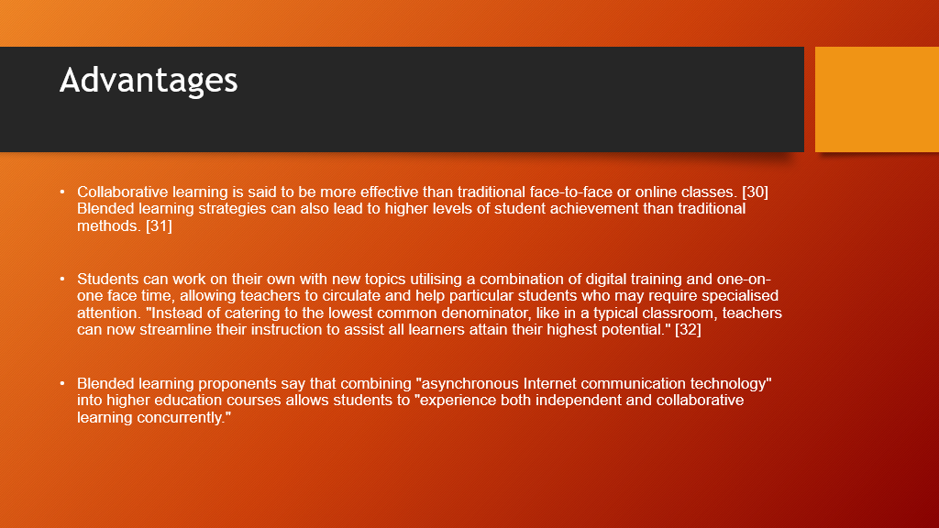

This is a significant predictor of student satisfaction and success in such classes. Student' attitudes toward learning have been demonstrated to improve when information and communication technologies are used. [34]

Communication between lecturers and part-time students has improved the quality of incorporating information technology into class projects, and students have really been able to better evaluate their understanding of course material through the use of "computer-based qualitative and quantitative assessment modules."[35]

Although some believe that blended learning is intrinsically less expensive than traditional classroom learning, it has the potential to reduce educational costs.

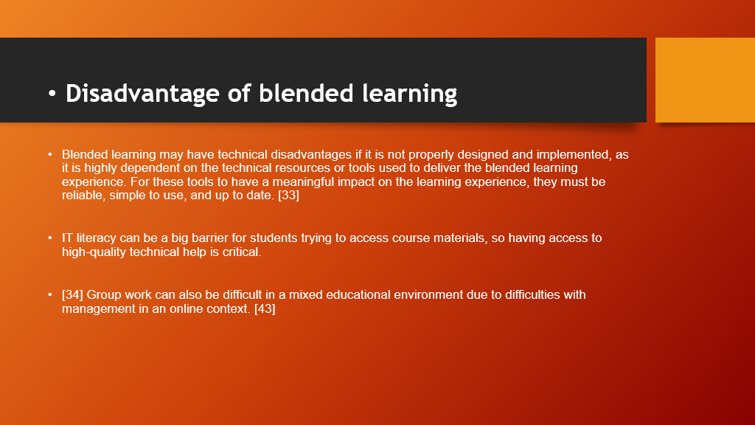

According to reports, using lecture recording devices can cause students to lag behind on their academics. Only half of students watched lecture videos on a regular basis, per a research conducted at four separate universities, while roughly 40% of students watched several weeks' worth of films in one session. [44] This has ramifications for the educator in terms of how much data about online resources must be revealed to students even while ensuring that it is at the appropriate level for the intended student.

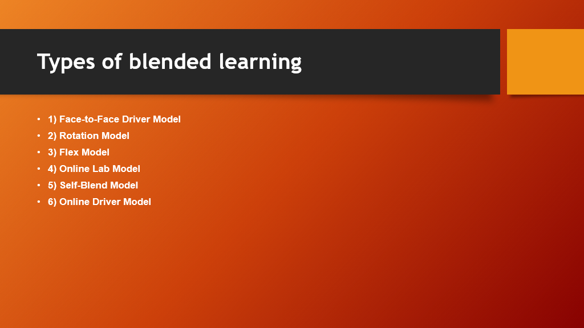

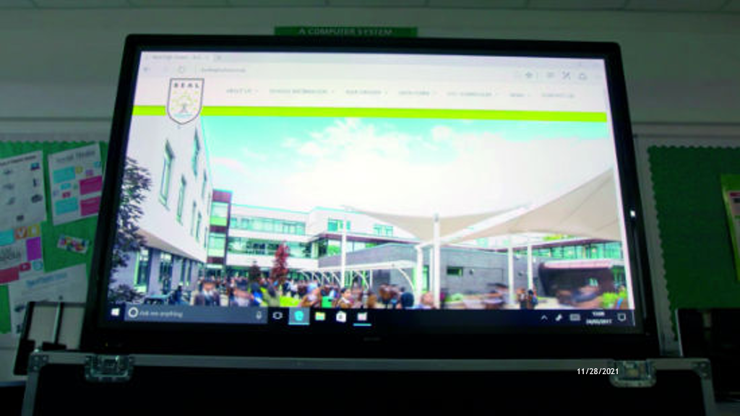

Example 1: Blended Learning at Beacon Academy Trust
Sharp has already been continuing to work with the Beacon Mega Trust to provide them with trying to cut technologies in the workplace (including such multifunctional photocopiers and interactive flat screen displays) to make the use of electronics in the teacher more common.

Tina Jacobs, a Beal High School teacher, is a firm believer in incorporating technology into classrooms. "One of the advantages is that I can use whatever software I want, whenever I want, and how I want," she says of helen use of technology in education. Its something I do in every class.

"Users can annotate on top of things you get from the internet or a PDF." Users don't even need a sharpie; just your fingertips will do. The clarity is magnificent, the colour scheme is breathtaking, and the children adore it. It's also bright sufficiently to use it as a light fixture.

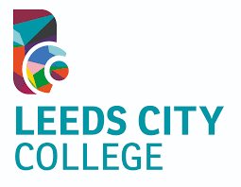

Example 2: Blended Learning at Leeds City College
Steven Hope is the supervisor of innovation education at Leeds City College. They've always used Google as portion of their blended learning approach, and he believes it's helped students know the topic better. He issued the following statement:

"University faculty can use the mixed method to provide reversed tasks that students can complete during class to obtain a greater understanding of themes." These really are highly valuable because they allow more time in traditional classrooms to expand students' knowledge and assisting people in achieving higher levels of learning, including such analyzing and assessing."

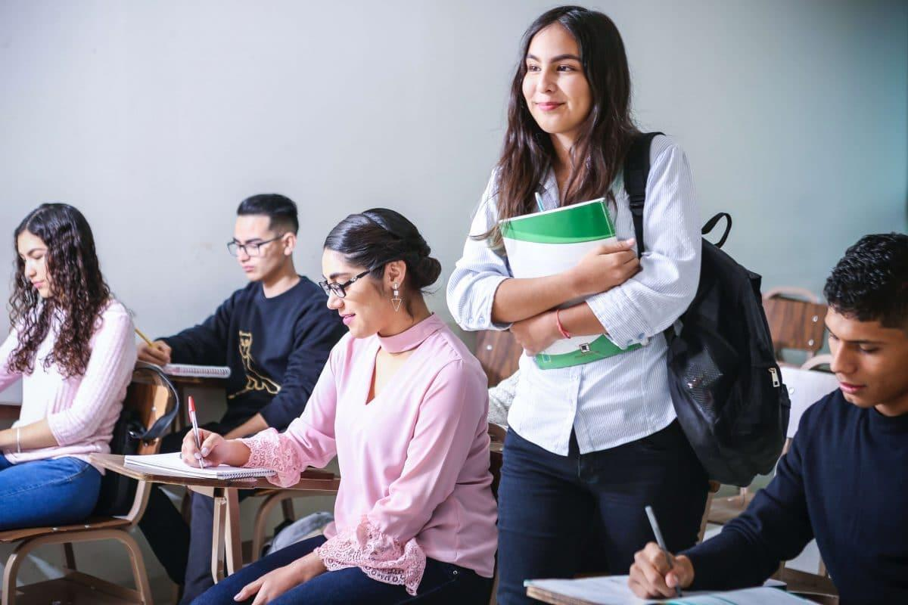

Traditional classrooms have started competing with the increasingly common online schools since the sunrise of information technology. Online classes are a suitable alternative classrooms for students who want to obtain a degree for less money and in less time. Students can earn a certificate within just a year or two even without having to know their Professors or classmates Many students, on either hand, believe that “ classrooms are a better way to learn and improve social skills.
There is indeed a learning timetable.
University officials timetable classes in such a way that all students can attend. Attending classes entails being on moment. In the this way, students can develop their possess regimen, which will genuinely make each other efficient and reprimanded. As those who start practicing promptness throughout their elementary grades, they will feel compelled that they will carry into adulthood.
Actions both curricular and co - curricular
There are a few school memories that you would not be able to acquire elsewhere. Excursions, graduations, and a variety of teams in which you can take part are just a few of the choices. Each of those activities will instruct you lessons that will advantage you in the future.


We can confidently assert that the feature of online learning that aren't its strong point are unmistakably those such as traditional classroom learning.
Face-to-face interaction is absent.
Although some may initially take into account the lack with one interaction with lecturers and coworkers to be an advantage, it might not be the case. Inside the long run, conversing with educators and coworkers online would then require far more effort. Although if email and social networks make the communication more convenient both for parties, they would never offer similar level of connection and affection as face-to-face communication.
Not many of the majors are accessible.
Numerous subjects can be researched online, however some cannot. Only those majors that require palm instruction or using any equipment fall into this category. To continue pursuing these major titles, you may well be obliged to visit classes.

Networking Difficulties
Online students may miss out on so many opportunities that even on students take for granted. On campus grounds, you'll encounter people who share your exuberance for the field you're going to study, attend conferences with guest speakers, and encounter lecturers from these other fields. Those conferences, no matter how brief, will yield a slew of career opportunities. Even though online learning has many advantages, this wasn't one of them.

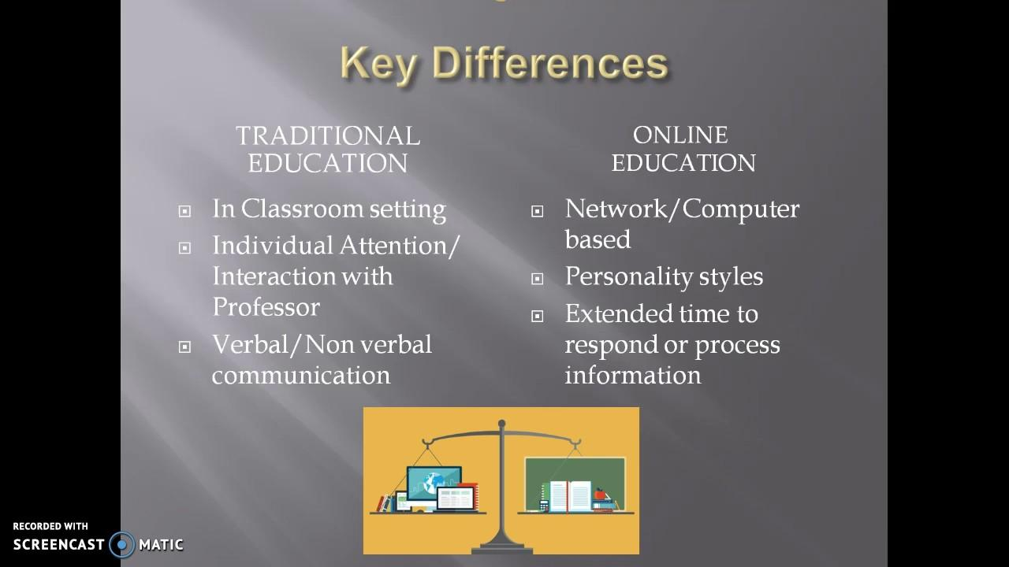
The Importance of Traditional Education
Before online learning, only one effective education format was really on learning. Conventional campus learning benefits students in a variety of ways that are not limited to academics. Students can development of social skills at school by having to interact both with one‘s lecturers and their peers. This sets up a regimen that the children must obey, which results in punctuality and self control.
Once trying to compare learning methods vs. e-learning, students may concentrate on the cost issue. While digital training may save user funds on tuition, it will deprive you of many of the benefits of formal instruction that we have debated. While 70percent of students believe that elearning is as good as, if not greater than, conventional teaching, it appears that particularly following is the best place to focus on underperforming students.

For thousands of years, traditional education has did exist. It it seems that due to its benefits, no other having to learn format will be able to fully replace it. However, as long because those two formats are "trying to compete," we'll view them bring the best in each other.
A flipped classroom is a type of blended learning that seeks to boost students' learning by having students complete readings at home whilst also focusing on live issue during class time. [1] The Soviet Union was the first nation to propose and implement a flipped classroom. This educational method utilizes activities that were initially thought homework into the classroom. In a flipped classroom, students attend online lectures, participation in online discussions, or conduct research at home while actually participating concepts in the teacher under oversight of a mentor.

Conclusion:
By supplying access to a wide range of flexible learning contexts, a blended learning strategy promotes expanded reading skills and learning.
Learning how to manage with a phone
Students who engage in blended learning will see one‘s reality mirrored in the programmes those who study, and they'll use critical thinking to participate in a culture that requires us all to create, work cooperatively, and interact through computer - mediated networks.
Adult academic institutions will collaborate responsively to ensure that teachers have had the resources and knowledge they need to make high, collaborative educational experiences in which abstract classes confidence and ability in using technologies in education, collaborate, and daily life by creating a support system that takes precedence people.

Recommendation:
Since some adult fundamental education have successfully implemented flipped classroom, teachers have few opportunity to network with and learn from one another, and also convey their governance, while conducting research, conducting experiments, and evaluating inventive blended learning methods. Literacy workers play an important role in the development and distribution of blended learning, and as one‘s roles change, they should be supplied with additional training, professional development, and recompense. Because technology is ever-changing, having continuing support for curriculum design, technology planning, and technology-related skills training will help make sure the game's long-term viability. This collaborative effort among service providers and organizations communicate must be enlarged in organising instructional leadership and boost programme capacity. To ensure this same evolution of instructor knowledge as well as the progression of the complex task, support should be given for the creation of communities of practise that meet regularly and engage in reflective practise.

Enhancing Students' Language Skills through Blended Learning". Electronic Journal of E-Learning. 14.
Jump up to:ª ^{b} Friesen, Norm (2012). "Report:Defining Blended Learning"
"Blended Learning (Staker / Horn – May 2012)" (PDF). Archived from the original (PDF) on 2013-08-21. Retrieved 2013-10-24.
Strauss, Valerie (22 September 2012). "Three fears about blended learning". The Washington Post.

Siemens, G., Gašević, D., & Dawson, S. (2015). Preparing for the Digital University: a review of the history and current state of distance, blended, and online learning. Pg. 71. Athabasca University. Retrieved from http://linkresearchlab.org/PreparingDigitalUniversity.pdf

Alexander, S. (2010). "Flexible Learning in Higher Education". In Penelope Peterson; Eva Baker; Barry McGaws (eds.). International Encyclopedia of Education (Third ed.). Oxford: Elsevier. pp. 441–447.
Alexander, S. & McKenzie, J. (1998). "An Evaluation of Information Technology Projects for University Learning". Canberra, Australia: Committee for University Teaching and Staff Development and the Department of Employment, Education, Training and Youth Affairs.

Wicks, David A; et al. (2015). "An investigation into the community of inquiry of blended classrooms by a faculty learning community". The Internet and Higher Education. 25: 53–62.
M. Gosper; D. Green; M. McNeill; R.A. Phillips; G. Preston; K. Woo (2008). Final Report: The Impact of Web-Based Lecture Technologies on Current and Future Practices in Learning and Teaching (PDF) (Report). Australian Learning and Teaching Council, Sydney.
Europass Teacher Academy| Flipped classroom; 2020 |url= https://www.teacheracademy.eu/course/flipped-classroom/

