

Ethical Hacking

ACCA7033

MSC Computer Networks and Cyber Security

University of Wales Trinity Saint David

Submitted By:

Pranjal Sinha

2220277

Date: January 8, 2024

Table of Contents

1. Introduction 4
2. Recent Cybersecurity Attacks: 5
2.1. WannaCry 5
2.2. UIWIX 6
2.3. Jaff Ransomware 7
3. Contingency Policy Implementation Prior to Pentest 7
3.1. Obtaining Initial Information 8
3.2. Enumeration 8
3.3. Choice of Pen-testing Framework 9
3.3.1. Kali Linux: 9
3.3.2. OWASP ZAP: 9
3.3.3. Acunetix: 9
3.3.4. Burp Suite: 10
3.4. Choice of Pen-testing Tools 10
3.4.1. Nessus 10
3.4.2. Nmap 11
3.4.3. Nikto 12
4. Types of Attacks Simulated with Diagrams 13
4.1. List of Vulnerabilities Targeted 13
4.2. Attack Tools Used 15
4.2.1. Metasploit 15
4.2.2. Password Cracking 17
4.2.3. Buffer Overflows 19
4.3. Protocols Involved in the Attack 20
4.3.1. Running Network or System Vulnerability Scanners 20
4.3.2. Web Application Scanners 20
4.3.3. Manual Tests / Specific Protocol 21
4.3.4. Vulnerability Databases 21
4.3.5. Analysis of Assurance Configuration Weaknesses 21
4.3.6. Exploitation 21
4.3.7. Post-Exploitation 21
4.4. How the Attack Was Launched 21
4.5. Results of Penetration Test 25
5. Recommended Solutions for the Threats Discovered 26
5.1. Configuration Changes to the System 26
5.2. Software and Hardware to Be Purchased 26
5.3. Defence Strategy to Avoid This Type of Attack in the Future 26
6. Cost of Solution 26
6.1. Upgrade to an Up-to-Date Joomla Content Manager 27
6.2. Install a New Digital Certificate on the CPC Website 27
6.3. Integrate the Updated Joomla Content Manager with a Captcha System 27
6.4. Configure Web Traffic Filter/Blocking Plugin with at Least Five Failed Attempts 27
6.5. Remove Obsolete Information Found on the Page 27
6.6. Conduct a Review of Visible Resources Within Websites 27
7. Execution Timetable 28
References 29

List of Figures

- Figure 1: WannaCry Model [1] 6
- Figure 2: UIWIX [2] 6
- Figure 3: Jaff Ransomware [4] 7
- Figure 4: Nessus Interface 10
- Figure 5: Nessus Network Scan 11
- Figure 6: Nessus Vulnerabilities 11
- Figure 7: nmap Scripts 12
- Figure 8: Nikto 13
- Figure 9: Metasploit nmap 16
- Figure 10: Metasploit Icecast 16
- Figure 11: Metasploit set 16
- Figure 12: Metasploit exploit 17
- Figure 13: Metasploit sysinfo 17
- Figure 14: Hydra 18
- Figure 15: SSH 18
- Figure 16: Hash Identifier 19
- Figure 17: John the Ripper 19
- Figure 18: John the Ripper - Result 19
- Figure 19: Memory Structure 20
- Figure 20: Scanning WordPress Content Manager 22
- Figure 21: Brute Force with BurpSuite at www.cpc.com 23
- Figure 22: Scanning with WPScan to www.cpc.com 23
- Figure 23: Scanning the Joomla Content Manager 24
- Figure 24: Metasploit Attack on Joomla 25
- Figure 25: Meterpreter Session Closed – Joomla 25

List of Tables

- Table 1. Consolidation of vulnerabilities 15
- Table 2. Cost of Solution 28
- Table 3. Execution Timetable 29

Introduction
Cureton Pharmaceutical Company (CPC) is diligently working to develop new cures for the latest respiratory viruses. As the company nears breakthroughs in various vaccines, it is imperative to ensure that its systems remain secure and resistant to hacking attempts. To achieve this, CPC has established an internal Red Team within its Cybersecurity Division. This team's role is to rigorously test the effectiveness of the company’s systems and infrastructure security controls.

In line with this objective, a penetration test was conducted on the company's primary domain, located at www.cpc.com. This evaluation focused solely on the main domain, utilizing the link: www.cpc.com/192.232.249.140/4. The CPC website utilizes two content management systems, WordPress and Joomla. No user credentials were provided for these tests, underscoring the importance of assessing the site's vulnerabilities from an external perspective.

Recent Cybersecurity Attacks
In the realm of cybersecurity, understanding recent attacks is crucial for developing effective defense strategies. This analysis focuses on three significant cyber attacks: the WannaCry ransomware attack, UIWIX, and the Jaff Ransomware. These incidents highlight various vulnerabilities and offer insights into preventive measures.

WannaCry Ransomware Attack
The WannaCry ransomware attack in May 2017 is a watershed moment in cybercrime history. It exploited a vulnerability in Microsoft's Windows operating system known as EternalBlue, which was allegedly developed by the U.S. National Security Agency. The attack affected over 230,000 computers in over 150 countries, with significant impact on the UK’s National Health Service[1], Spanish telecom giant Telefonica, and other major organizations globally.

Analysis: WannaCry’s rapid spread was due to its ability to self-propagate across networks using the EternalBlue exploit in unpatched Windows systems. The malware encrypted files on infected systems, demanding ransom payments in Bitcoin. The key failure was the lack of timely system updates and inadequate endpoint protection.

Preventive Measures: Regular software updates, effective endpoint security solutions, and robust backup strategies are critical. Organizations must prioritize patch management and employee awareness training to mitigate risks from phishing, a common ransomware entry point.
The WannaCry process flow model is illustrated in Figure 1 [2].
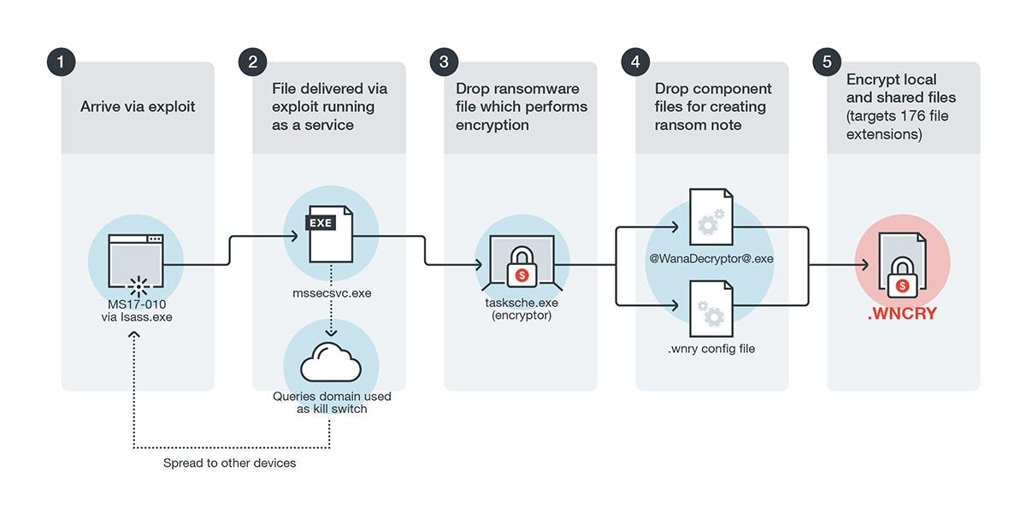

Figure 1: WannaCry Model [1]

WCry employs both the RSA and AES algorithms to encrypt files. It utilizes the Windows Crypto API for RSA encryption and for generating random keys. However, a third-party implementation of AES is integrated into the malware [2].

UIWIX
One of the most notable ransomware variants is UIWIX, identified by Trend Micro as RANSOM_UIWIX.A. UIWIX stands out as being more stealthy than WannaCry because it executes entirely in memory and leaves no traces on the infected system [3]. It has the capability to detect if it is operating in a virtual machine or sandbox environment. Unlike other ransomware that scans IP addresses, UIWIX connects to its control server using a different method. It reaches an .onion site through mini-tor.dll, which helps it evade detection. Additionally, UIWIX can steal personal credentials from the systems it infects. The operational model of UIWIX is depicted in Figure 2 [2], [3].
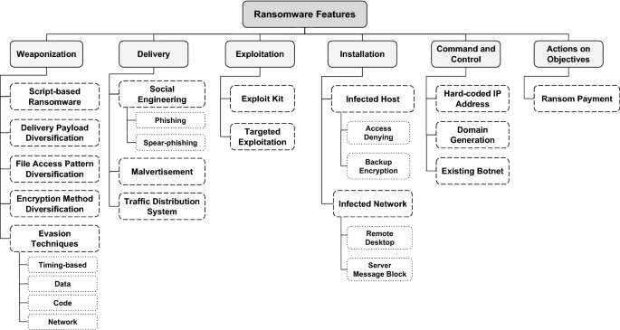

Figure 2: UIWIX [2]

As shown in Figure 2, UIWIX initially employs AES-256 encryption in Cipher Block Chaining (CBC) mode and subsequently applies RC4 encryption [39]. In contrast, Bucbi ransomware, another significant threat, uses a lesser-known encryption technique called GOST [3], [5].

Jaff Ransomware
Recently, a ransomware known as Jaff ransomware, or Ransom_CRYPJAFF, was identified. This was in addition to the ransomware that utilized the EternalBlue exploit [4].
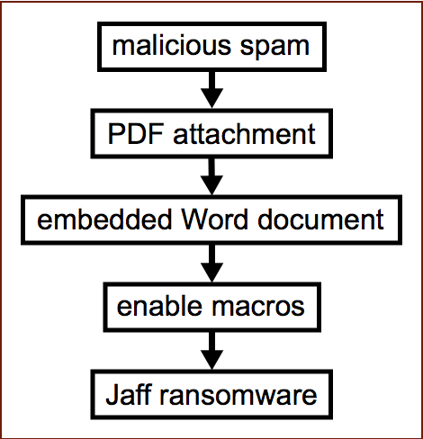

Figure 3: Jaff Ransomware [4]

Jaff operates via spam emails containing a harmful PDF document. When this PDF is opened, it prompts the opening of a Microsoft Word document, requesting user permission to enable editing – a tactic similar to another ransomware called Locky. Once the user enables editing, the Word document executes a macro which downloads the actual ransomware, leading to the infection of the computer. Jaff ransomware appends a .jaff extension to the encrypted files [4]. The payload also includes a ransom note in text form, and it alters the home screen to display this message [4], [5].

To mitigate cybersecurity threats, including Jaff, WannaCry, and UIWIX, businesses and institutions can employ cloud-based email gateway security, such as Hosted Email Security. This provides various protective features including behavior monitoring and real-time web reputation, which are effective in detecting and preventing ransomware attacks [1].

Contingency Policy Implementation Prior to Pentest
To effectively execute a pentesting audit, it is crucial to meticulously plan and methodically follow each phase. The process begins with gathering information from the client, gradually moving towards identifying vulnerabilities. After compiling a list of vulnerabilities, the focus shifts to the practical aspect of attempting to exploit these weaknesses. Successful breaches then lead to efforts in gathering additional information, which may be instrumental in accessing privileged documents or other systems within the same network. Finally, comprehensive documentation is prepared for the client, detailing the conducted audit tasks and providing recommendations to enhance the security of the analyzed systems. The subsequent sections will describe the main features of each of these phases in detail.

Obtaining Initial Information
In this first phase, the scope of the audit is agreed upon with the client. This includes defining the objectives to be achieved, the duration, the allowed methodology during the analysis, and what actions are permissible with the systems. All contractual documents reflecting the legal aspects related to the data that the auditor may access are also established [6]. It is particularly important to define the auditor's working hours and the IP address ranges to be analyzed. Based on the client-provided information, there are three types of tests that can be performed:

White Box
The client provides complete and detailed information on the network and systems to be audited.

Grey Box
The client provides limited information, such as IP address ranges, but not all details.

Black Box
The client does not provide any information, leaving the auditor with virtually no visibility of the working environment [7].
It is also crucial to specify the extent to which a vulnerability, once identified, can be exploited: Is it permissible to attempt accessing more privileged accounts? Is accessing and reading any type of document found during the access to other systems, not mentioned by the client, allowed? Therefore, before starting any pen-testing task, it is essential to have a signed contract where all these points are clearly specified. The explicit authorization from the company allowing access to the equipment, and the confidentiality agreement concerning the information the auditor may observe during the assignment, should not be overlooked.

Enumeration
Once the work contract is defined, the actual audit work begins. In this phase, various tools are utilized to gather much more detailed information about the systems being analyzed.

Initially, efforts are made to identify which IP addresses are accessible and which ports are open on each machine. Subsequently, a mapping of these machines or processes is created, including their operating systems and versions. After compiling a detailed list of all devices to be evaluated, it becomes necessary to determine which of these may harbor security vulnerabilities. For this purpose, various databases are available to search for known security flaws.

The following considerations must be taken into account by both parties before starting ethical hacking:

    - It is the responsibility of the ethical hacker to provide the necessary support, permissions, and authorizations required to execute each item contained in the methodology.
    - It is advisable to have backup copies of the data and configurations of the systems and devices within the project scope before the exercise begins.
    - The tests should ideally be conducted during a maintenance window to minimize the impact on services in the event of a potential restart.

Choice of Pen-testing Framework
Before starting the audit, it is crucial to have a computer equipped with the necessary pentesting tools. Although any operating system could theoretically be used, Kali Linux has become the preferred distribution within the hacker community. Hence, an introduction to this operating system is necessary.

Kali Linux:
Maintained by Offensive Security, Kali Linux is considered the most advanced, robust, and stable distribution dedicated to penetration testing. Its open-source nature has facilitated gradual evolution, thanks to contributions from numerous volunteers. This results in a constantly evolving distribution with tools that are updated in response to market demands and existing needs [7]. Kali Linux includes, by default, most tools required for a pentesting audit, making it extremely convenient as it is ready to use with minimal additional installation needed.

OWASP ZAP:
This open-source web security scanner is designed for use both as a security application and a professional penetration testing tool [8].

Acunetix:
An automated web application security testing tool, Acunetix audits web applications by checking for vulnerabilities like SQL Injection, cross-site scripting, and other exploitable vulnerabilities. It scans any website or web application accessible through a web browser and using the HTTP/HTTPS protocol [9].

BurpSuite:
A graphical tool for testing the security of web applications, BurpSuite offers a comprehensive solution for web application security checks. It provides basic functionalities such as a proxy server, scanner, and intruder, along with advanced options like a spider, repeater, decoder, comparator, extender, and sequencer [10].

Choice of Pen-testing Tools

Nessus
Nessus is known for its comprehensive network and web application scanning capabilities, and it helps organizations identify security vulnerabilities in their IT infrastructure. Nessus stands as the most widely used commercial tool in the vulnerability scanning application market. According to its corporate website, it boasts a database of more than 62,000 CVEs (Common Vulnerabilities and Exposures) and 157,000 plugins, with over 30,000 organizations worldwide utilizing it [11]. While Nessus is a commercial platform, it also offers a free version named Nessus Essentials. This version, although more limited, allows the analysis of up to 16 IP addresses. Upon installation, users can witness the power of this tool, which facilitates a broad spectrum of analyses.
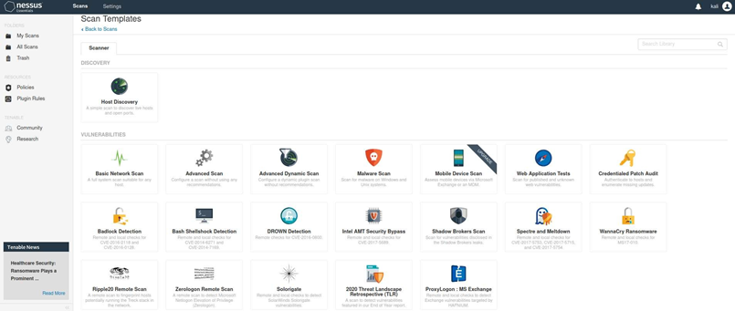

Figure 4: Nessus Interface
Nessus offers a range of scanning options, from discovering computers on a network to detecting malware and testing website vulnerabilities. An example of its capabilities can be seen in the results of a basic scan of the local network.
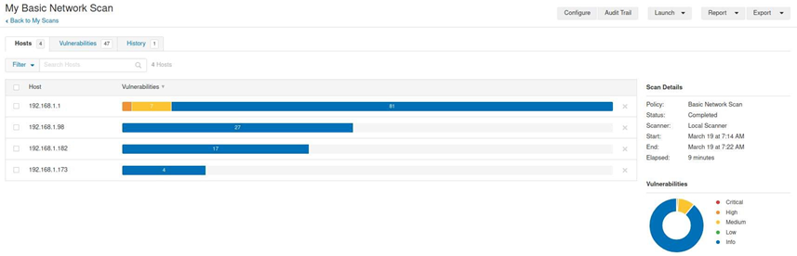

Figure 5: Nessus Network Scan
The scan results in a list of all devices found on the network, along with the number of vulnerabilities identified. Selecting the first device reveals a detailed report of all vulnerabilities discovered.
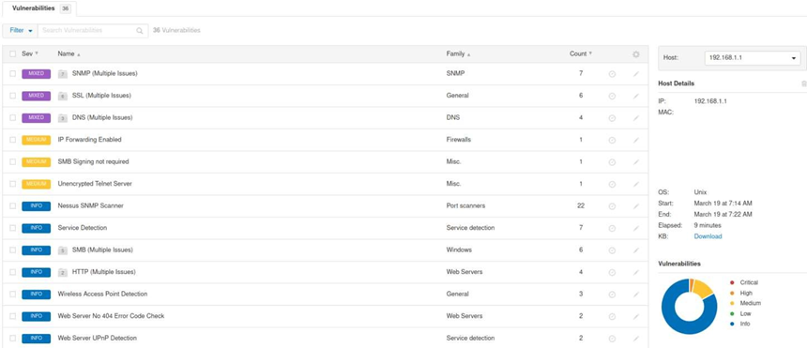

Figure 6: Nessus Vulnerabilities
Nessus not only lists the various vulnerabilities but also provides detailed information about their nature and possible remediation steps. For instance, selecting a vulnerability like "SMB Signing not required" offers further insights. Thus, Nessus is an application with an easy-to-use interface, yet it possesses powerful capabilities for detecting vulnerabilities in almost any working environment.

Nmap / Network Mapper
Nmap, short for "Network Mapper," is a widely used open-source tool for network discovery and security auditing. It is a powerful network scanning and reconnaissance tool that helps you discover devices on a network, identify open ports, determine which services are running on those ports, and gather various types of network information. Nmap is available for various operating systems, including Windows, Linux, and macOS.
Its vulnerability discovery mode merits additional mention due to its versatility. Thanks to the -script mode, nmap facilitates the use of various scripts written in the LUA programming language to automate numerous tasks. Notably, it includes several scripts capable of detecting vulnerabilities [12]. Among these, the 'vuln' script is particularly noteworthy for aggregating well-known vulnerabilities. When this script is executed against a vulnerable web server, the results are quite revealing.
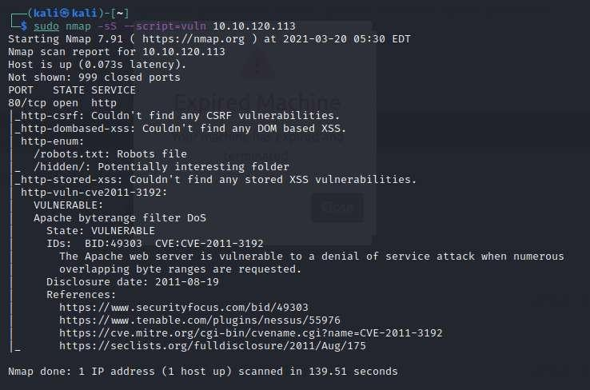

Figure 7: nmap Scripts
The output not only provides information about certain files and folders of interest but also identifies a vulnerability in the Apache web server. The results include a brief description of the vulnerability, along with links to further information.

Nikto
Nikto is an open-source tool that is specifically designed for the analysis of website vulnerabilities. It is equipped with a database that allows it to analyze around 7,000 potentially dangerous files. Additionally, Nikto checks for vulnerable versions of more than 1,000 types of web servers. It also scans through the website's structure to detect different indexing files, configuration options, and even the version of the web server. Its simplicity of use is evident in the following example:
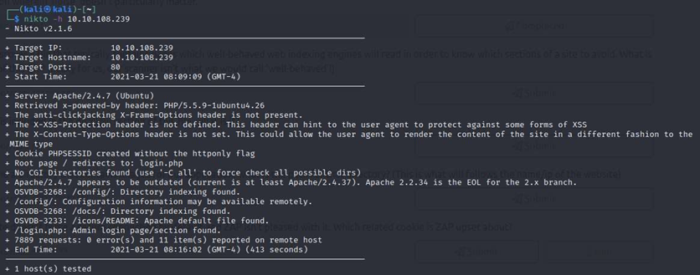

Figure 8: Nikto

The result demonstrates that the web server version is Apache 2.4.7, and it includes a comment indicating that this version is out of date. Other details are also revealed, such as the presence of a /config folder, the contents of which should not have been indexed. In this straightforward manner, Nikto successfully provides valuable information for subsequent analysis of the server's security.

Types of Attacks Simulated with Diagrams

List of Vulnerabilities Targeted
Regarding the data obtained from the tools used for the web scan of the domain www.cpc.com.
Tool | Vulnerability | Description
Nessus | Web Application Potentially Vulnerable to Clickjacking | Clickjacking, also known as a 'UI redress attack,' occurs when an attacker uses multiple transparent or opaque layers to deceive a user into clicking on a button or link on a different page than they intended. The attacker essentially 'hijacks' the clicks meant for one page and redirects them to another, possibly belonging to a different application, domain, or both. This technique can compromise user interactions with a webpage, leading to unintended actions or data exposures.
OWASP ZAP | X-Frame-Options Header Not Set | When the X-Frame-Options header is not set, it could allow attackers to embed the page within an iframe on another site, leading to clickjacking attacks. Clickjacking involves tricking users into clicking on something different from what they believe they are clicking on, potentially leading to unauthorized actions on the embedded page.
Acunetix | Clickjacking: X-Frame-Options header missing | In clickjacking, attackers trick users into clicking on elements of a different page than they think they are interacting with, which can lead to unauthorized actions. Without the X-Frame-Options header, a web page can be embedded in a frame or iframe of another website, making it vulnerable to such attacks.
Nitko | The anti-clickjacking X-Frame-Options header is not present | In the absence of the X-Frame-Options header, a web page could be embedded into a frame on another site. This vulnerability could allow an attacker to execute a clickjacking attack, where users are deceived into clicking on something different from what they perceive, potentially leading to unauthorized actions on the embedded page.
Nessus | Browsable Web Directories | This indicates that certain directories on the web server, like those containing 'robots.txt' or '/cgi/', are indexed and can be easily accessed by anyone using the web. This can pose several risks:  - Information Exposure  - Directory Traversal Attacks  - Attack Surface Expansion
Acunetix | HTML form without CSRF protection | The vulnerability arises when a web application's form lacks adequate CSRF protection. In such cases, an attacker could craft a malicious request that, if processed by a victim's browser while they are authenticated to a service (like email or online banking), could inadvertently perform actions on the user's behalf on the application or website.
Acunetix | File Upload | If files uploaded are not securely verified, an attacker could upload malicious files.
Acunetix | User Credentials Sent in Clear Text | When user credentials are transmitted over an unencrypted HTTP connection, they can be easily intercepted and read by a third party.

Table 1. Consolidation of vulnerabilities

Attack Tools Used
Once the list of computers and their potential vulnerabilities has been compiled, the next step is to try exploiting these security flaws using different methods. Among these, specific tools such as Metasploit stand out, which allows for the use of various exploits in a straightforward manner. Commonly, applications for password cracking are also used. Additionally, it's usual for penetration testers to create their own programs or modify existing ones for different purposes.

Metasploit
This tool is undoubtedly the most widely used by penetration testers due to its versatility and the range of options it offers. Primarily an open-source framework, Metasploit contains a database of exploits for attacking vulnerable systems [13]. It also facilitates the use of different modules for tasks like enumeration, vulnerability analysis, or integration with other external applications such as nmap or Nessus. Thus, almost any pentesting task can be performed from a single interface. From Kali Linux, Metasploit is directly accessible from the terminal using the 'msfconsole' command. After starting the application, users can enter different options or, if unsure, display the help menu using the question mark '?'.
For instance, to analyze and attack a vulnerable Windows machine, a port scan using nmap integration could be performed:
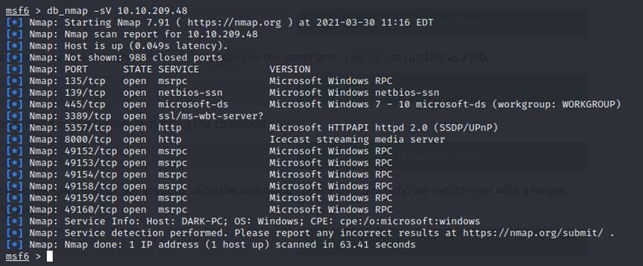

Figure 9: Metasploit nmap

Upon obtaining the results, it's observed that there is an Icecast server that could be vulnerable. A search within Metasploit might yield a matching result. The '0' option can be used, which corresponds to the number to the left of the name:
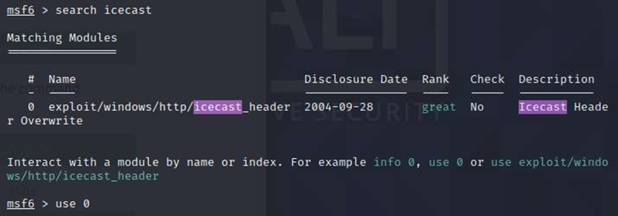

Figure 10: Metasploit Icecast
By selecting this exploit, it's then necessary to set the destination (Windows server) and source (local Kali Linux machine) addresses:
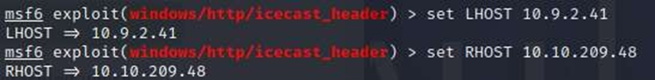

Figure 11: Metasploit set
After this setup, using the 'exploit' command allows direct access to the vulnerable machine:
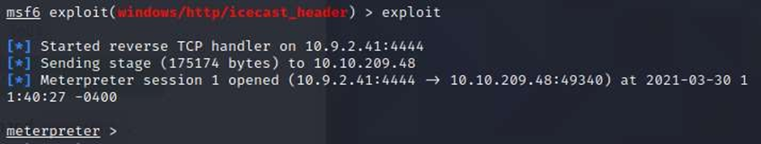

Figure 12: Metasploit exploit

This command prompt belongs to the vulnerable machine, enabling access to various resources, such as checking the operating system or displaying files in the current folder:
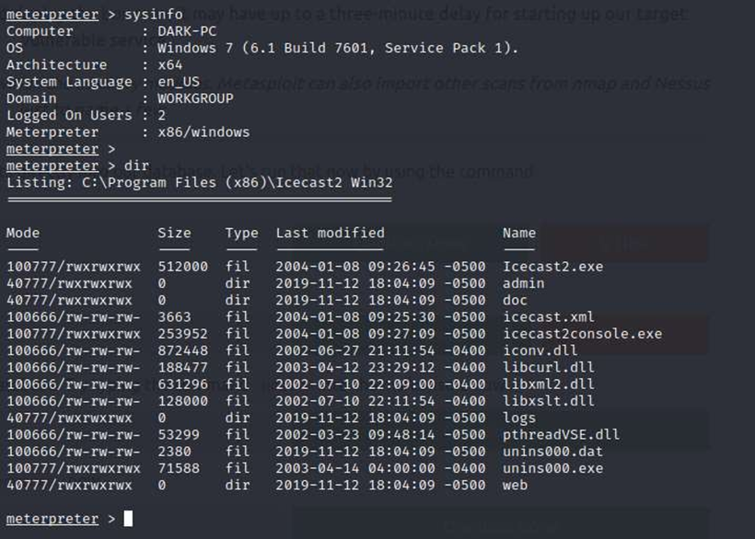

Figure 13: Metasploit sysinfo

This demonstration quickly shows how Metasploit facilitates enumeration, analysis, and attack tasks. However, it's important to note that not all vulnerabilities may be available in Metasploit.

Password Cracking
Password attacks can be categorized as either online or offline. For online attacks, tools like Hydra are common. This application tests different username and password combinations on various servers such as FTP, SSH, or web pages. For instance, to access an SSH server where the username is known (e.g., 'molly'), the following command can be used, specifying the username, password list, and server IP address:

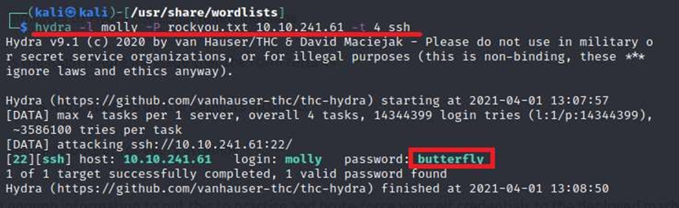
Figure 14: Hydra

After a few seconds, Hydra displays the result, indicating the password used by the 'molly' user. The tool then attempts to connect to the SSH server to verify the password's correctness and gain system access:

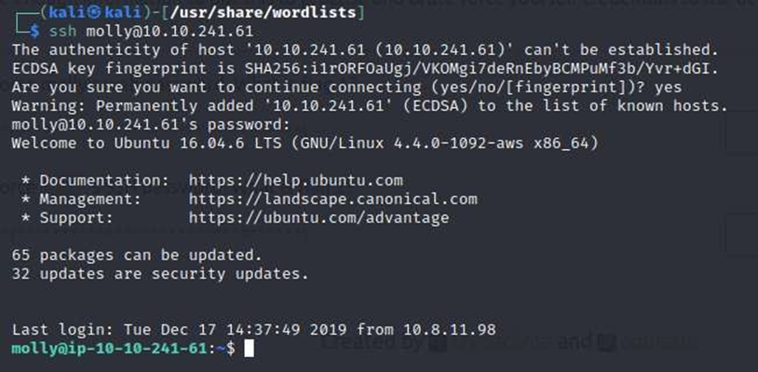
Figure 15: SSH

For offline password attacks, tools like John the Ripper are used. These attacks involve comparing a list of password hashes with a list of known passwords. Before using John the Ripper, it's necessary to identify the hashing algorithm used on the password. Tools like https://hashes.com/en/tools/hash_identifier can aid in determining the algorithm type for a found hash:

Figure 16: Hash Identifier

With this information, John the Ripper can be used to compare the hash with generated hashes from a password list. The hash is saved in a separate file (e.g., 'hash.txt'), and the following command is run:
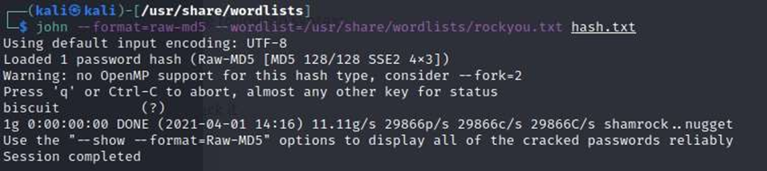

Figure 17: John the Ripper

Upon completion, the password can be displayed as follows:
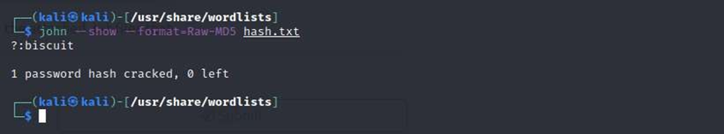

Figure 18: John the Ripper - Result

Buffer Overflows
One common technique to take control of a system is buffer overflow. Although not a tool but a technique, it's important to be aware of it, as it can be crucial in attack tasks. Before explaining this technique, it's necessary to understand how a program's memory is stored when executed. The memory structure of a standard C program can be divided into sections:

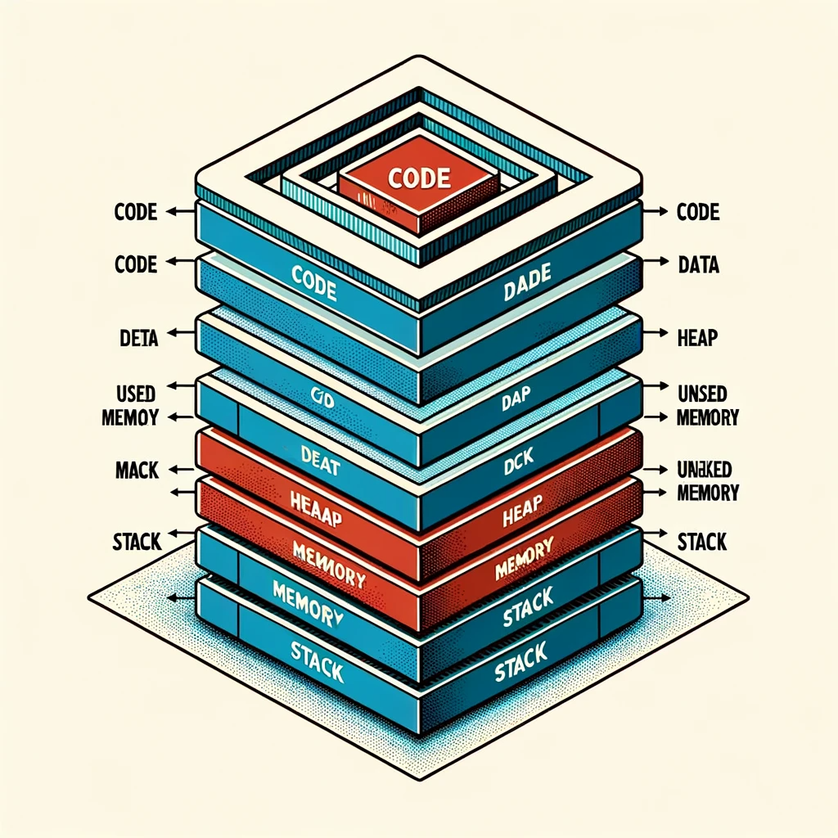

Figure 19: Memory Structure

Protocols Involved in the Attack
The process involves discovering flaws in CPC’s website or the entity's servers that can be exploited by an attacker. These flaws can range from host and service misconfiguration. The process used to find flaws varies and depends heavily on the specific component being tested, but some key principles are universally applicable.

Running Network or System Vulnerability Scanners
Automated port-based scanning determines what is available on the network or target host. For web server scanning, updated open-source tools like Nessus and Nmap are used. These tools are permissible at an educational level and inform us of the vulnerabilities found, enabling the company to rectify them.

Web Application Scanners
Tools like Nessus, OWASP ZAP, Nikto, and Acunetix are used to find vulnerabilities in the website. These tools, open-source or approved for educational use, assist in analyzing and diagnosing vulnerabilities so the company can address these potential security gaps. They identify versions of the web server, content manager, and components, which are then scrutinized for vulnerability. The web server is nginx/1.14.1, hosting two content management systems: Joomla version 1.5.15 from 2009 and WordPress version 4.5.17 from 2019.

Manual Tests / Specific Protocol
Manual testing is conducted for exploitation, confirmation, and potential controlled exploitation. Depending on the vulnerabilities found, penetration testing is performed manually or using Kali Linux exploitation tools.

Vulnerability Databases
These are used to check problems reported by tools or to manually verify vulnerabilities. Databases and frameworks are exploited for this purpose. There was no vulnerability found that allowed access to the database. After the scan findings, a brute force attack is performed, as content managers were identified, and one allowed listing administrator users to validate password strength.

Analysis of Assurance Configuration Weaknesses
Assurance information or validation of common bugs is sourced from vulnerability databases such as CVE, CWE - MITRE, and NVD. These sources provide clear data on the risks of vulnerabilities and how they should be remediated.

Exploitation
In this phase, according to the selected tools, the tester proceeds to carry out attacks to exploit the previously identified vulnerabilities. The tester identifies and defines attack vectors. No custom exploits are used; only pre-existing exploits in the Metasploit Framework database are executed for testing vulnerabilities.

Post-Exploitation
The goal at this stage is to maintain access to the systems, demonstrating the extent of the tester's control and access to information. Executive and technical reports are presented as a conclusion of the activities undertaken. During this phase, the tester attempts to obtain the highest level of privileges, network information, and access to as many systems as possible, identifying data and/or services and their levels of importance.

How the Attack Was Launched
Given the vulnerabilities identified, the next step was to perform a penetration test and make intrusion attempts on some of the website's weaknesses to see what information could be obtained.

Based on the vulnerability described in Table 1, which revealed the existence of a content manager authentication form, additional specialized validations and a brute force attack were performed. The lab conducted a scan of the WordPress content manager used for www.cpc.com.co using Kali's WPScan tool. By configuring the appropriate parameters for the scan, it identified the administrators and the application's version.
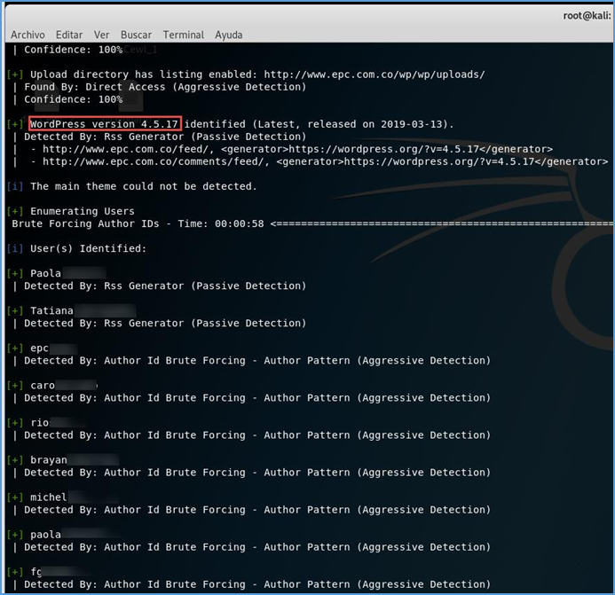

Figure 20: Scanning WordPress Content Manager

The test reviewed the WordPress version, and upon validating the vulnerabilities associated with it, it was found that this version, dated March 13, 2019, did not have any known weaknesses. Subsequently, knowing the users after performing the WPScan enumeration, the tester proceeded to perform a brute force attack to decipher the identified user passwords. This approach was chosen because manual testing of the login attempt revealed no blocking mechanism after a number of failed attempts. The tester used a dictionary containing a representative number of common passwords (14,350,000 words) for the brute force attacks, employing WPScan and BurpSuite, though without success.
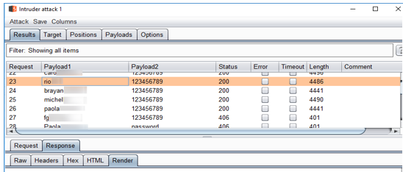

Figure 21: Brute Force with BurpSuite at www.cpc.com
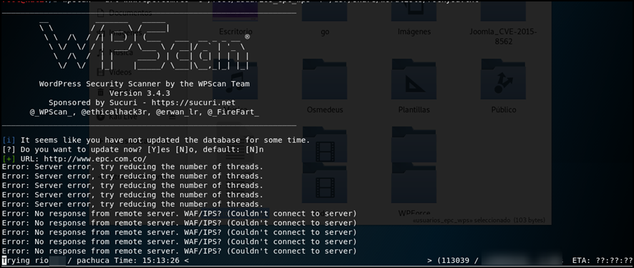

Figure 22: Scanning with WPScan to www.cpc.com

Based on the vulnerability described in Table 1 regarding the existence of a Login page for the Joomla content manager, the lab scanned the Joomla content manager, which was used years ago for www.cpc.com.co, with Kali's JoomScan tool. The scan, configured with the appropriate parameters, revealed the version and its vulnerabilities.
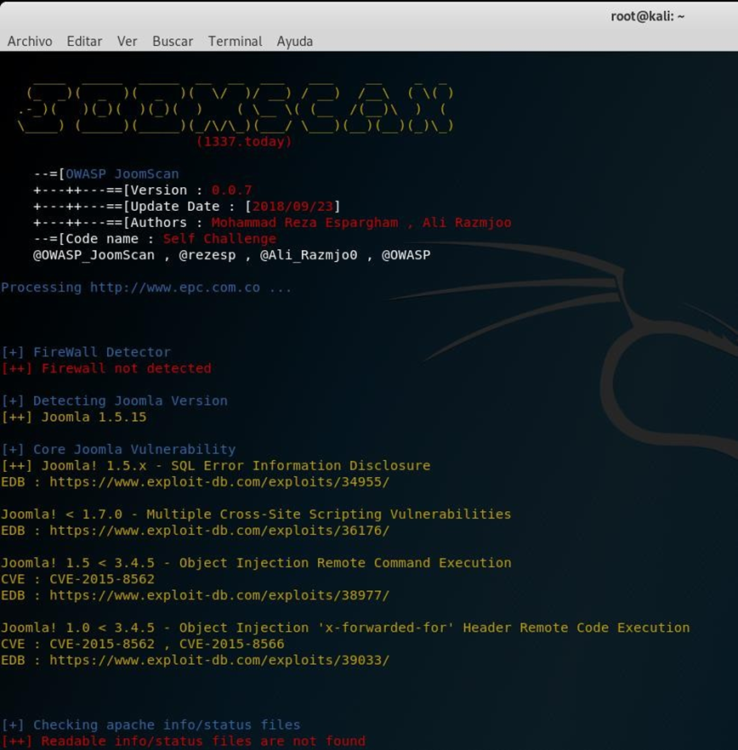

Figure 23: Scanning the Joomla Content Manager

After the scan, it was observed that the Joomla version was 1.5.15, dating back to November 4, 2009 – an outdated version compared to the latest 3.9.6 version as of May 7, 2019. This older version had vulnerabilities, including the potential for object insertion via a remote connection. The scan also revealed the absence of a Firewall detection, although the web server was Nginx/1.14.1, suggesting the possibility of a WAF/IPS that might block connection attempts.

Given this, there was an exploit allowing remote execution of PHP object injection into Joomla headers CVE-2015-8562 (NIST, 2015). The tester proceeded with the attack using Kali's Metasploit tool, performing the necessary pre configurations to execute the attack using the red-underlined exploit.
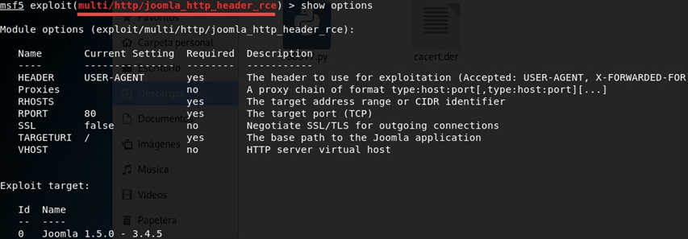

Figure 24: Metasploit Attack on Joomla

The result was a closed Meterpreter session, indicative of an unsuccessful attempt at opening a remote session due to various technical conditions, such as specific vulnerable versions and enabled protection systems, and possibly due to the NGINX server.
Meterpreter is a post-exploitation tool that is part of the Metasploit Framework, a widely used penetration testing and ethical hacking tool. It provides a powerful and interactive shell for controlling and managing compromised systems after a successful exploit. Meterpreter sessions are the interactive connections established with compromised hosts, giving the attacker full control over the target system.
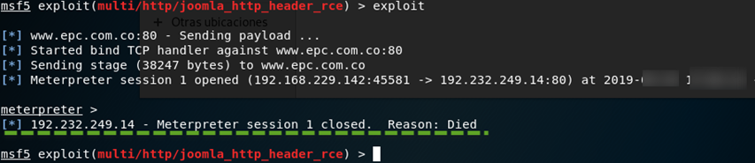

Figure 25: Meterpreter Session Closed – Joomla

Results of Penetration Test
The penetration test was successful. For instance, at the level of the CPC company's website, the following successes were noted: The WordPress content manager appears to be updated. Only a few vulnerabilities were observed, indicating that the servers are up-to-date, and their installations and configurations have appropriate security measures in place. It is evident that server administrators have prioritized securing the servers. The two vulnerabilities that were detected relate to configuration flaws. Although these flaws are not overly complex to resolve, they could cause significant damage if exploited.

Recommended Solutions for the Threats Discovered

Configuration Changes to the System
Given that the Joomla server does not contain representative information today, and considering that two web content managers are in use, it is advisable to decommission Joomla and transition all content definitively to WordPress, as it is more up-to-date.

Software and Hardware to Be Purchased
The Joomla content manager in use is significantly outdated and vulnerable. Additionally, the CPC website's digital certificate is nearing expiration and has not been properly implemented. Consequently, there is a need to design and implement a new, updated Joomla content manager, complete with a new digital certificate to thwart future attacks, such as buffer overflow attacks and PHP header object injection.

Furthermore, implementing a captcha system on authentication portals, as well as blocking login attempts after several failures, is recommended. This step is crucial as attackers can currently exploit this vulnerability. Generally, Captchas are effective in ensuring that login attempts are made by humans rather than automated applications or bots.

Defence Strategy to Avoid This Type of Attack in the Future
As evidenced in Figure 22, access to the content manager is vulnerable, and there is a risk of compromised administrator credentials. It is advisable to configure user blocking after a set number of failed attempts (e.g., five) to mitigate brute force attacks. Additionally, secure code creation in the organization’s applications and services is essential to reduce security incidents.

The CPC management should also remove obsolete information from the page, as these often appear as broken links. A thorough review of visible resources within websites is also recommended.

Cost of Solution
The above recommendations have identified a range of solutions to be purchased, designed, or implemented. Table 2 will present the possible cost implications for each solution, considering their procurement, design, or implementation needs, and associated labor costs.

Upgrade to an Up-to-Date Joomla Content Manager
Upgrade the existing Joomla content manager to a more current version for enhanced security and functionality.

Install a New Digital Certificate on the CPC Website
Implement a new digital certificate to ensure secure and encrypted communication on the CPC website.

Integrate the Updated Joomla Content Manager with a Captcha System
Add a captcha system to the updated Joomla Content Manager for improved security during user authentication processes.

Configure Web Traffic Filter/Blocking Plugin with at Least Five Failed Attempts
Set up a web traffic filtering and blocking plugin to lock user access after five unsuccessful login attempts, enhancing security against brute-force attacks.

Remove Obsolete Information Found on the Page
Delete outdated or irrelevant content from the website to improve user experience and website integrity.

Conduct a Review of Visible Resources Within Websites
Perform a thorough examination of all visible resources on the website to ensure they are current, relevant, and secure.
Solution | Type of cost | Cost (£)
Upgrade to an Up-to-Date Joomla Content Manager | Purchase fee | 710
Install a New Digital Certificate on the CPC Website | Labour fee | 420
Integrate the Updated Joomla Content Manager with a Captcha System | Purchase and labour costs | 890
Configure Web Traffic Filter/Blocking Plugin with at Least Five Failed Attempts | Purchase cost | 660
Remove Obsolete Information Found on the Page | Labour cost | 700
Conduct a Review of Visible Resources Within Websites | Input cost | 490

Table 2. Cost of Solution

Execution Timetable
Table 3 presents the estimated duration required to implement or execute the given recommendations.
Activity | Description | Estimated Start Date | Estimated Completion Date
Upgrade to Joomla | Upgrade Joomla content manager to the latest version | November 17, 2023 | November 23, 2012
Digital Certificate Installation | Install a new digital certificate on the CPC website | November 23, 2023 | November 24, 2012
Captcha System Integration | Add captcha to Joomla content manager | November 24, 2023 | November 25, 2012
Configure Web Traffic Filter | Set up a plugin for blocking after five failed login attempts | December 8, 2023 | December 12, 2023
Content Review and Removal | Remove obsolete information and review visible resources | December 12, 2023 | December 19, 2023

Table 3. Execution Timetable

References
- [1] Micro (2017). "Ransomware Recap: The Week of WannaCry" [Online]. Available at: https://www.trendmicro.com/vinfo/us/security/news/cybercrime-and-digital-threats/ransomware-recap-the-week-of-wannacry. Accessed Dec. 22, 2023.
- [2] Zimba, A. and Chishimba, M., 2019. "On the economic impact of crypto-ransomware attacks: The state of the art on enterprise systems." European Journal for Security Research, 4(1), pp.3-31.
- [3] Dargahi, T., Dehghantanha, A., Bahrami, P.N., et al., 2019. "A Cyber-Kill-Chain based taxonomy of crypto-ransomware features." J Comput Virol Hack Tech, 15, pp.277–305. https://doi.org/10.1007/s11416-019-00338-7
- [4] Brad Duncan. 2017. "Jaff ransomware gets a makeover" [Online]. Available at: https://isc.sans.edu/diary/Jaff+ransomware+gets+a+makeover/22446. Accessed Dec. 22, 2023.
- [5] Trend Micro. 2017. "After WannaCry, UIWIX Ransomware Follows Suit" [Online]. Available at: https://www.trendmicro.com/en_us/research/17/e/wannacry-uiwix-ransomware-monero-mining-malware-follow-suit.html. Accessed Dec. 22, 2023.
- [6] van der Linden, H., Kalra, D., Hasman, A., and Talmon, J., 2009. "Inter-organizational future proof EHR systems: A review of the security and privacy-related issues." International Journal of Medical Informatics, 78(3), pp.141-160.
- [7] Calacci, D., and Pentland, A., 2022. "Bargaining with the Black-Box: Designing and Deploying Worker-Centric Tools to Audit Algorithmic Management." Proceedings of the ACM on Human-Computer Interaction, 6(CSCW2), pp.1-24.
- [8] Abdullah, H.S., 2020. "Evaluation of open source web application vulnerability scanners." Academic Journal of Nawroz University, 9(1), pp.47-52.
- [9] Labiad, B., Tanana, M., Laaychi, A., and Lyhyaoui, A., 2022, May. "A Comparative Study of Vulnerabilities Scanners for Web Applications: Nexpose vs Acunetix." In International Conference on Advanced Intelligent Systems for Sustainable Development, pp. 107-117. Cham: Springer Nature Switzerland.
- [10] Thaqi, R., Vishi, K., and Rexha, B., 2023. "Enhancing burp suite with machine learning extension for vulnerability assessment of web applications." Journal of Applied Security Research, 18(4), pp.789-807.
- [11] Walkowski, M., Oko, J., and Sujecki, S., 2021. "Vulnerability management models using a common vulnerability scoring system." Applied Sciences, 11(18), p.8735.
- [12] Hwang, J., and Kim, M., 2019. "Effective Detecting Method of Nmap Idle Scan." Journal of Advanced Information Technology and Convergence, 9(1), pp.1-10.
- [13] Valea, O., and Oprişa, C., 2020, September. "Towards pentesting automation using the metasploit framework." In 2020 IEEE 16th International Conference on Intelligent Computer Communication and Processing (ICCP), pp. 171-178. IEEE.

