University of Wales
Trinity Saint David

MBA – HRM

Petya Slaveva
2014035

Marketing Management
Assessment 25%

LCMB7001

Tushara Balendran

Table of Contents
1.Introduction

2.History of Zara company

3.Pestel analysis

4.Porters Five Forces

5.SWOT analysis

6. Segmentation , Targeting and Positioning

7.Marketing mix strategies

8. Conclusion

9.Recomendations

10. References

1.Introduction

Every company's key aim is to expand and maximize its profitability to achieve
and retain a strategic edge over its competitors. Situational research is the first step to use tactics to increase revenue.

The report will analyze the Zara Company, including PESTEL, SWOT, and Porter's five forces. Also, Segmentation, Targeting, and Positioning, and marketing mix strategies of the company will be included. This report will focus on Zara's manufacture in the UK. Recommendations will be made in the end.

2 . History of the Zara Company
Zara is one of the major brands of fashion clothing and accessories. It was founded in 1975 by Amancio Ortega and Rosalia Mer. Zara is part of the Inditex company. It is famous for its ideal mix of high-end, chic clothes at affordable prices. This is the value of the brand that makes it a fashion brand for everyone. Its first store was opened in the coastal town of A Coruna in Spain, and Zara slowly spread to other cities in Spain, and then to Portugal. Zara entered the Indian market in 2010 and opened its first store in Delhi. Zara is present in every corner of the globe today. Zara is an environmentally conscious organization. It is one of the few brands known to make 100% free, toxic apparel. Zara is known for launching the newest fashion trends to the market. Zara reacts instantly to buyers' demands and changing preferences, which developed the idea of "fast fashion."(Inditex ,2010)

- Pestel Analysis

PESTLE Analysis of Zara analyses the brand's market strategies. Zara's PESTLE Analysis discusses the various external factors, such as political, economic, social, technological (PEST) factors, which have an impact on its company as well as legal and environmental factors. The PESTLE Analysis highlights the various extrinsic situations that have an impact on the brand's business.

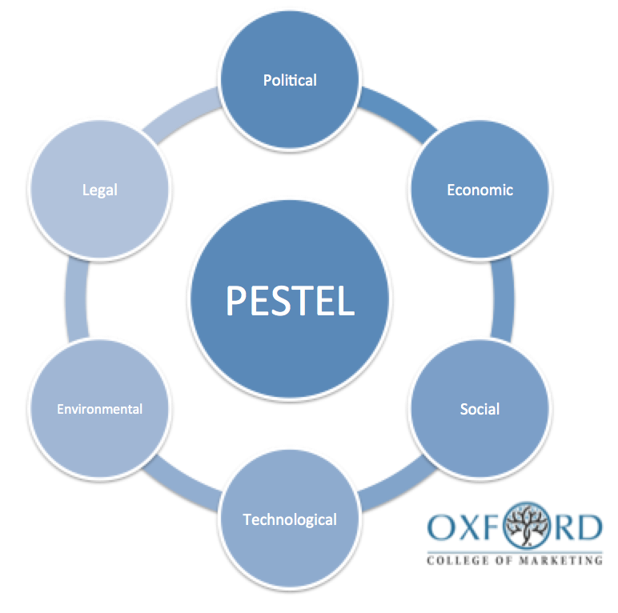
Figure1.

Political factors

Zara has successfully set up operations around the world. The country has a well-established framework with a comprehensive trade arrangement that lets Zara import raw materials and export goods already produced. The system also fixes Zara in shipping goods around the world with little effort and low cost. The EU was the main manufacturing market for textiles and garments in the United Kingdom. The industry accounted for 74% of total EU exports and therefore gave Zara access to a wider customer base in all European countries without paying extra border tariffs, which help to boost its sales. Financial regulations of the country also have a great impact on the smooth functioning of any business. Another major factor that affects the market is political disruption, as it affects the economy and disrupts the supply chain. Zara overcame this problem by limiting its supply chain operations in its home country and some neighboring nations.

Economic factors

Spain is experiencing slow economic growth. Zara is one of the most popular brands in the world. The willingness of the company to satisfy the needs of the majority of customers allows Zara to build a loyal customer base. Zara is a comparatively cheaper brand compared to other European brands, which provides Zara with a larger market share compared to its rivals. A dynamic network of low economic activity around the world will significantly damage the financial stability of the company. An increase in labor or total cost of production will place the business in financial distress. The British exit from the EU, also known as 'Brexit,' has contributed to a fall in the value of the pound resulting in high inflation rates and less discretionary money for households to spend on clothes. It has also decreased the sales of Zara and the total sales of the clothing industry.

Social factors

Variable market trends have a significant effect on the production and availability of the company's goods. It also has an immense effect on the availability and desire of individuals to work. Since Zara has a great demand and makes a range of goods, it is very doubtful that there will be a change in relation to these social factors. The company is not based on the niche market, but it caters its products to various segments, even though the company does not reach every new market without doing its preliminary analysis. Culture has an effect on consumer purchase decisions, especially in the apparel market. Any item that consumers cannot associate with does not find popularity in that specific cultural group. Zara makes her goods rhyme with local culture, though she doesn't believe much in experimenting. The brand frequently participates in a number of social projects. In order to save resources, Zara concentrated on environmentally sustainable approaches to operating its stores.
Technological factor

The brand has the money as well as the customer base to get the most out of the results. It spends massive sums of capital in order to learn and evaluate huge data sets in order to find effective ways to cater to its consumers. The business has a famous website from which it communicates with consumers from all over the world. The business connects with consumers via both online and personal contact points. Zara has formed a successful partnership with Toyota, incorporating the principles of JIT and Lean facilities in its manufacturing operations. The software also enhances the accessibility of the business to the customer.

Legal factors

Zara is a company that has given attention to integrity and sustainability. They aim to develop these values across the whole line of their operating company as well as the supply chain. Big brand names like Zara have to abide by those laws and regulations. The organization pays living wages to its employees for whom different laws have been established. Concurrence with the law is an increasing market for the brand, and the company has invested in the same through its supply chain management. In trying to put apparel into line with the current styles, the brand has encountered several problems with patent violations in the past. The company has been accused of copying patterns and apparel ideas from those of Adidas and Balenciaga. Present legal doctrines are one of the reasons why brands are capable of copying each other without having to suffer any major consequences. At the same time, such brands as H&M, Zara still need to strictly follow copyright regulations, as apparel that they introduce on the market entails spending time, effort, and resources.

Environmental factors

The whole world of fashion is falsely synonymous with wastefulness when customers change styles and desires quickly. This could be a crucial aspect for a fast-fashion company like Zara to be under the influence of the consumer. When today's consumers are more eco-conscious than ever, retailers like Zara need to follow sustainable approaches to prevent harmful impacts. Zara has been training & aiming to make its shops 100% eco-efficient. The plan outlines the different policies by which the brand focuses on reducing its energy and water consumption. The brand has strongly displayed its contribution to climate change and energy, sustainability, renewable products, animal rights, and other environmental concerns in depth. The organization has maintained that it excludes all forms of toxic waste from its supply chain system. Inditex has agreed to join the deal to reduce its carbon footprint. They have agreed to reach 17 sustainable development goals in order to solve the climate change crisis. Issues relating to poverty and inequality are also addressed by these targets.

Zara's PESTLE Review highlights the different elements that have an impact on its market performance.

- Porter’s 5 Forces model

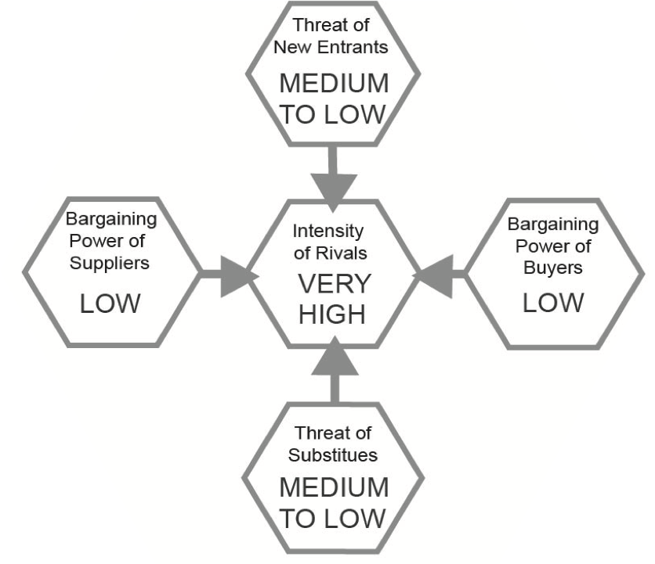

Figure 2. Porter’s Five model applied to Zara

Porter's Five Forces is a business analysis model that helps illustrate why different sectors are capable of maintaining various sorts of profitability. The model was published in the book "Competitive Strategy: Techniques for Analysing Industries and Competitors" by Michael E. Porter in 1980.1. The Five Forces model is commonly used to evaluate the company's manufacturing environment as well as its organizational strategy. Porter described, with some caveats, five undeniable powers that play a role in shaping every market and industry in the world. Five forces are also used to calculate the level of competition, the attractiveness, and performance of the industry or the market (Porter,1980).

Treats of new entrants

The strength of new entrants is strong as the textile and retail market is very competitive due to its uniqueness and profitability. Retaliation by established main players in the fashion industry, such as the start of a price war, often provides new competitors an edge. However, the high costs of starting up a company, distribution, advertising, etc., make it very difficult for potential entrants. A new player must have sufficient capital to enhance the creation of new fashion lines. Zara also has the advantage of economies of scale and a market name that makes it difficult for new entrants to join.

Treats of substitute

Clothing now serves not only as a critical necessity but also as a representation of the socio-economic community in order to show personal identification. Buyer's tendency to replace is strong with a range of rivals to pick from, such as H&M, GAP, and Armani. Duplicate fashion can pose a major risk to sales in certain countries, such as India, China, and Indonesia, due to lower purchaser switching costs. However, successful substitutes are not available since they are made expensive with cheap quality. Zara's goods are more economical and made from excellent raw materials of high quality. Often, the substitution of shopping online poses a challenge to department stores like Zara.

Buyers power

Zara's clients typically range from the lower class to the upper class, who have considerable purchase power when they tend to have more income at their hands. There are also other clothing stores that sell Zara substantially the same range of items, but there is a poor level of consumer satisfaction with the company's products, which puts more focus on creativity. There is also a major struggle for the sellers, provided that the buyer has comparatively more leverage to determine whether to purchase. However, Zara's approach to launching the latest fashion trends at quicker and more affordable rates makes it better than its rivals.

Supplier powers

As global trade liberalization continues, the influence of the seller is reduced by competition between suppliers at low wage prices, such as China. Suppliers' influence is considerably strong as they expend more time forming quality relationships. Supplier bargaining power is better as members of the industry face increased prices by going to a different supplier, so the manufacturers are well familiar with safety and quality requirements. As a result, Zara organizes the different licenses given to all suppliers and, thus, under the current licensing contract, the control of the suppliers is further reduced as they are forced to abide by clear requirements that minimize duplication or modification of designs.

Rivalry

Due to its segmentation, the fashion sector has a worldwide allowance for smaller companies. While Zara has many direct competitors, such as Gap and H&M, its brand still has significant loyal customers. Zara sits on the side-lines with its rivals. The purchaser's odds of moving to other products are reasonably high in the event that they do not like the price setting. (Inditex,2019)
They are more worried about the brand's reputation. The buyers purchase in limited amounts, which means that they have little ability to compromise on the basis of small quantities. In fact, increased demand provides competition for the seller, which transfers the negotiating power to the seller. As a result, a business such as Zara delivers a service that makes it difficult for consumers to find any other close options.

5.SWOT analysis

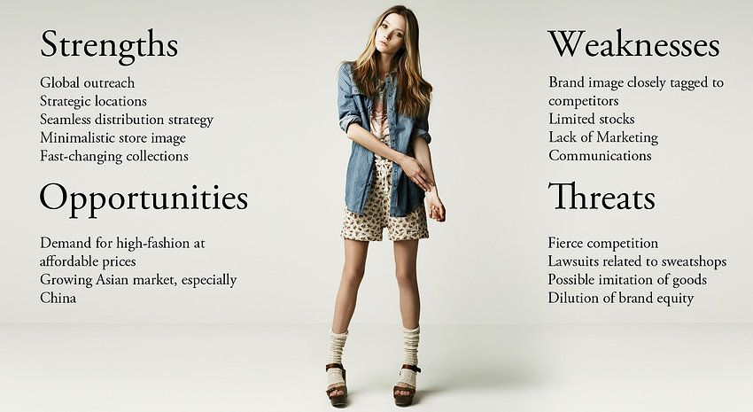

Figure 3. SWOT analysis of Zara

Strengths

Pioneer Advantage: Fast-fashion focuses on designing, manufacturing, and distributing clothes as soon as a theme is established. Traditionally, the process takes months, but Zara completes it in three weeks. As pioneers, Zara has the most innovative approach and management techniques for handling the supply chain.
Stores: Zara shops in 202 markets and has outlets in 96 of them. With a total of 2249 stores, Zara has the highest number of fashion outlet stores in the country. The number of retail outlets is almost double that of Nike, which has the second-highest number of retail stores.
Supply Chain: Zara refreshes its online and store range twice a week. Zara's ten distribution centers can be shipped to every place in the world within 48 hours. Inditex also has an in-house team that develops tools to double the speed at which orders are dispatched by the organization.
Design Team: Inditex has a team of 700 professional designers who turn the customer's needs into designs. The production team creates 50,000 creatives a year. And it only takes them three weeks to get the models from the drawing board to the shops.
Turn to Web: Inditex is spending £3 billion to boost its online revenue. The investment focuses on creating an immersive online shopping environment and incorporating current physical infrastructure. By 2022, the organization plans to achieve a fifth of its revenue from online transactions.

Weaknesses

Fast-Fashion: Surprisingly, the pattern that helped push Zara to the top is the cause of its most pressing disadvantage. With a rising vision to promote among consumers and policymakers, Zara's difficulty is combining sustainability with fast-fashion.
Reliance on Physical stores: The pandemic accelerated Zara's efforts to minimize the number of physical stores. Online purchases helped Zara out of a huge decline in sales due to COVID-19-related events. However, even with online sales up, sales are just 89% of what they were in 2019.
AI-Enabled Prediction: Inditex is actively partnering with AI and Big Data companies to develop an AI-enabled platform that forecasts customer behavior. However, the new system is still in its testing stages. When such a device officially launches, Zara would have the unbeatable ability to understand and satisfy the demands of the client.

Opportunities

Rapid Delivery Cycle: Consumers visit Zara's stores on average 17 times a year. This is because Zara is reacting to patterns as soon as they appear. Right now, Zara is delivering a pattern from start to finish in just 2 to 3 weeks. However, in the future, the intervals may be further shortened by Zara.
Personalization: collects information and segmenting the customer base after reviewing the data is made simpler than ever before thanks to AI. This makes it easier to provide consumers with customized tips. Zara is expected to build on this technology.
Eco-Friendliness: According to the Sourcing General, more than 1/3 of Millennials and Gen Z are searching for "sustainable" and "environmentally friendly" logos on their clothing. Together, the two communities make up 50% of the population. So, Zara needs to listen and respond to this growing need.
Resale: The resale industry, currently worth £28 billion, is expected to rise to £64 billion in five years. Integrating a resale plan on their existing site will encourage consumers to buy more with less waste. This supports consumerism and, at the same time, encouraging sustainability.
Influencer Marketing: Unbox Social claims that influencer marketing is the most successful tactic to support lifestyle brands. Zara's popularity with the #DearSouthAfrica initiative, involving 60 micro-influencers, has reached 8 million people. This is meant to be a model for the future.

Threats

Competition: China's fast-fashion giant, Shein, is the world's largest fashion retailer with a complete online presence. The Shein app had 10.3 million downloads in September. With just 2 million downloads at the same time, Zara must look out for its competitors in the digital arena.
Price War: Easy fashion, Zara's main niche, takes the newest styles from ramp to consumers easily and at low cost. However, the market is vulnerable to imitators fighting price wars leaching off Zara's line.
COVID-19: In the first quarter of 2020, Inditex announced a 44% decrease in revenue. Inditex's study reports that the closing of 88% of its stores due to Coronavirus lead is the central cause for a decline in revenue.
Government Regulations: Inditex has 13 factories based in Spain. In the early months of the pandemic, only 3 of the 13 factories worked due to the lockdown policies of the Spanish government. As Europe heads into a second surge, the organization should expect similar steps.
Sustainability: The use-and-throw mentality that people have towards fashion is changing. People are aware of the effect of fashion on the world and on people. Thus, Zara will have to press for a fast-moving sustainable business – economically and ecologically.

6.Segmentation, targeting, and positioning

Zara has a wide range of target markets, from kids to teenagers to women and men. Anyway, the core customer tends women between the age of 15 and 35. One Zara customer is a person that is looking for trendy and awesome outfits at a good price. Zara is a European fashion brand, and its consumers are guided by European fashion. Apart from that, the consumer may belong to either the social stratum or demo-graphic category as Zara caters to a wide variety of tastes. The market segmentation strategy is based on demographic and psychographic factors like gender, age, generation, and lifestyle. The company also targets clients based on their fashion and style. Zara's stores are in very good locations, and that provides customers with turnover time five times a week to catch the latest collection. Along with the brand identity and quality clothes at good prices attracts the target market to Zara stores.
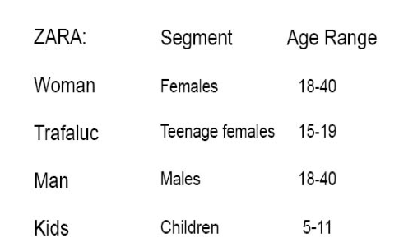
Positioning

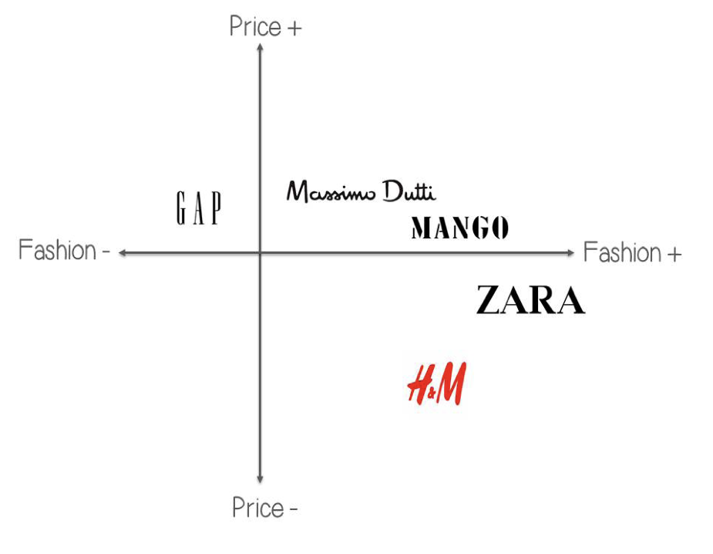
Figure 4. Zara Market Position

This positioning chart offers Zara an analysis of its role in comparison to that of rival brands on the market. There is a very strong competition between rivals, as companies must compete for market share. Zara is regarded as slightly more trendy than its rivals. Zara has become a world-class brand, but Zara's popularity does not depend on the designer's name to produce iconic or famous, but it is due to the close relationship of Zara's brand positioning to "fast fashion."

7. Marketing mix strategies

Zara Marketing Mix analyses the brand/company that covers 4Ps (Product, Price, Location, Promotion) and describes the Zara marketing approach. As of 2020, a variety of marketing initiatives, such as product/service innovation, marketing growth, customer engagement, etc., have allowed the company to expand. Marketing strategy helps businesses meet strategic goals and objectives, and the marketing mix (4Ps) is a commonly used method for identifying strategies.
Product strategy

Zara's goods are available for men, women, and children. It offers shorts, jackets, tops, knitwear, t-shirts, sneakers, bags, and accessories. These are the commodity approach in the Zara marketing mix. It's a one-stop solution for everybody if they want to buy formals or causals. One can choose from the various designs that Zara has to give. It launches at least 10,000 new prototypes a year. The products of Zara are a success for both the high-end fashionistas and the masses. The taste of the target market determines the availability of the product line. Zara is now teaming up with local talent to bring the best fashion trends.
Zara believes in sustainable growth and is committed to reducing waste generation. It recycles its hooks and protection tags. Zara makes its products available in paper or biodegradable plastic bags. Zara uses recycled cotton materials, such as organic cotton, to make some of their products. These goods have a distinctive and distinct mark that can be easily recognized.

Price strategy

Zara offers the latest fashion at much lower prices in all its regional outlets relative to other rival international brands. Zara is pursuing a low price policy. It can continue to do so, as it does not waste an incredible amount of money on advertising and raw materials. It has a low total cost profile according to its rivals. The prices of Zara are country-specific. The marking of their goods is made locally in each respective market. Zara sets out a market-based pricing plan that sets the target price that customers are able to pay. The production budget is based on the target price. This fixes the profit margin they gain on - item. This provides insight into Zara's marketing mix pricing strategy.
The brand uses different schemes as a method of encouraging sales. Zara has a low degree of discounts across the year and clearance offers of 50 percent or more twice a year, which customers are actively waiting for.

Place and distribution strategy

Zara has an incredible reach of stores in 88 countries, with more than 6,500 branches. Zara also operates from an online shop. Many of these cover the marketing mix of the brand's position and sales strategy. The supply chain of Zara is what gives them a strategic edge. It uses its innovative business model to introduce new goods and fashion to the market in the shortest possible time. Store managers give orders to headquarters twice a week on the basis of the store's sales results and the shopper's expectations. The commercial staff compiles the order and then delivers it to the manufacturing center. The commercial team is now working with the in-house designers to identify emerging developments and to create new products. New goods are manufactured in very limited batches that tend to give them exclusivity.

Promotion and advertising strategy

Zara rarely spends any money on advertising. It's popular for being shy of the media. And the owner never gives any press interviews. Unlike its rivals, Zara is not involved in any flashy advertisement. This is why Zara's ads are not available on tv. Zara's unique selling proposition is its short delivery time, a wide range of models, and competitive prices. It depends more on word of mouth and social media than on costly marketing techniques. The scope of Zara's social media is very extraordinary. It's got 2.5 million followers on Facebook and 15 million followers on Instagram.

This completes Zara's marketing mix.

8. Conclusion

Zara's current goal is to return from the COVID-19 crisis and improve its online presence. Inditex's finances show signs of recovery, and management is positive about improving online revenue. Zara's business model cannot be easily reproduced by its rivals until their supply chain model has been introduced. The supply chain model is based on several variables such as participants, technologies, processes. Their success is strongly connected to the way they perceive the customer's needs and how they address them with the use of the right methods and tactics. It is a popular international retailer, which in 30 years has turned itself from a local Spanish brand into a genuinely global business.

9. Recommendation

9.1 Ansoff matrix

Present product New products
New markets
Present markets
Market penetration | Product development
Market extension | Diversification

Choice | Rationale | Advantage | Disadvantage | Implementation
Market  Penetration  Strategy | The world is in a financial crisis, and the situation keeping existing customers is more relevant from the financial point of view in likeness to invest in the new market. | This will low the risk of producing unnecessary fashion material and risking to invest in an unknown market. | This will not only reduce market variegation for the company but will grant a chance to rivals to imitate Zara's value chain integration. | Zara has to motivate UK customers to buy more from them. This will be a good step against the weak marketing strategy of rivals. Faster integration of the value chain will grant Zara the opportunity to accumulate new stocks.
New  Product  development | Creating a new fashion line for an already existing market will pare down the risk by taking a chance in a new market. | Rivals like the low-cost retailer will not easily copy the varied product line of Zara. | It has limited market dilatation. | Strategic co-partnership with different designers will help the company launch in the new UK market.

Diversification

Zara Home Decor is the result of a diversification strategy of a business that is not connected to the fashion and clothing industry. The corporation has developed an unrelated diversification plan in order to bring more growth to the increasing enterprise in terms of market and product innovation.

Market development
This market growth provided a stable basis for the business and established the reputation of a popular multinational brand. The popularity of the business in Asian markets is partly attributed to its reputation as a popular European brand.

10.References

- Berthon, P. R., Pitt, L. F., Plangger, K., & Shapiro, D. (2012). Marketing meets Web 2.0, social media, and creative consumers: Implications for international marketing strategy. Business horizons, 55(3), 261-271.
- Lopez, Carmen, and Ying Fan. "Internationalisation of the Spanish fashion brand Zara." Journal of Fashion Marketing and Management: An International Journal (2009).
- Gockeln, Lisa. Fashion industry analysis from the perspective of business model dynamics. BS thesis. University of Twente, 2014.
- Oliveira, Carolina Lago Barbosa Ortigão de. Zara: marketing in fast fashion: a case-study. Diss. 2014.
- Zozi, Jelena, and Radmila Janicic. "CREATIVE MARKETING STRATEGIES H&M VS ZARA." INCITING PHYSICAL ACTIVITY AMONGST YOUTH USING MODERN TECHNOLOGIES 1729(2014): 1766.
- Cortez, Michael Angelo, et al. "Fast fashion quadrangle: An analysis." Academy of Marketing Studies Journal 18.1 (2014): 1.
- Tokatli, Nebahat. "Global sourcing: insights from the global clothing industry—the case of Zara, a fast fashion retailer." Journal of economic Geography 8.1 (2008): 21-38.
- KAPUSTINA, Larisa, Mushfig AGABABAEV, and Andrei DREVALEV. "COMPETITIVE POSITION OF THE ZARA BRAND IN THE CLOTHING MARKET." Challenging the Status Quo in Management and Economics: 779.
- Inditex.com

- Forbes.com

