
NAME : MOHAMMED ABRAR
STUDENT ID : 2213718
MODULE NAME : INTERNATIONAL MARKETING
MODULE CODE : LCMB7006

Table of Contents
Introduction 4
Background information about Company 4
Macro Environment 5
McDonald’s India 5
McDonald’s Japan 7
Hofstede cultural dimensions Model 9
McDonald’s India 9
McDonald’s Japan 9
Porter’s five forces Model 10
McDonald’s India 10
McDonald’s Japan 11
SWOT Analysis 12
McDonald’s India 12
McDonald’s Japan 12
STP 13
McDonald’s India 13
McDonald’s Japan 14
Marketing mix Elements (7Ps) 15
McDonald’s India 15
McDonald’s Japan 16
Directional Development Strategy 18
McDonald’s India 18
McDonald’s Japan 19
Conclusion 19
Recommendations 20
References 21

Table of Figures
Figure 1: Revenue of McDonald's worldwide from 2005 to 2022, Source: (Statista, 2022) 5
Figure 2; Corporate tax rate of India, Source: (Trading economics, 2022) 6
Figure 3: GDP growth rate of India, Source: (Trading economics, 2023) 6
Figure 4: Inflation rate of Japan, Source: (Trading economics, 2022) 7
Figure 5: GDP growth rate of Japan, Source: (Statista, 2022) 8
Figure 6: SWOT analysis of McDonald's in India, Source: Author 12
Figure 7: SWOT analysis of McDonald's in Japan, Source: Author 13

Introduction
The term, international marketing, refers to the procedure of marketing products or services to consumers in the global market. Such type of marketing has created a buzz in the contemporary business environment for various reasons, especially globalisation, technology and competition (Czinkota, et al., 2022). Enterprises now face a heightened level of rivalry from competitors that are also entering worldwide marketplaces, organisations must be able to keep up with these adversaries in global markets if they are to succeed (Tien, et al., 2019). In this report, the international marketing of the famous fast-food chain McDonald's will be critically evaluated thoroughly. The chosen two markets for the analysis are the USA and Japan. The marketing strategies employed by McDonald's in these two nations are evaluated considering STP, the 4Ps of marketing and directional development. Further, compare and contrast of these marketing strategies will be drawn. It will be followed by their relation to the organisational approaches and strategies of McDonald’s. Lastly, the likelihood of agreeing to the approach being used by McDonald’s will be discussed referring to appropriate marketing or business performance measurements. All these aspects have covered not only cultural and human aspects but also market structures, economic and political aspects and social demographics throughout the report.

Background information about the Company
McDonald’s is an American multinational fast food chain that was founded in the year 1940 having its headquarters situated in California, United States (Mcdonalds, 2022). The country serves their customers through their 40,000 outlets as of the year 2021. The fast food restaurant is known among its customers for offering hamburgers, cheeseburgers and french fries. The food menus are customised based on the choices and preferences of the customers which helps McDonald's in attracting a large number of customers and grow their profitability. Revenue earned by McDonald’s during the year 2022 is $ 23.18 billion and operating income earned by McDonald’s during the same year was $ 10.98 billion (Statista, 2022).

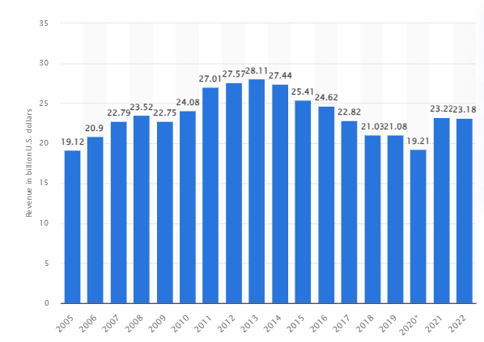
Figure 1: Revenue of McDonald's worldwide from 2005 to 2022, Source: (Statista, 2022)

Macro Environment

McDonald’s India
Political
The corporate tax rate in India stands around 34.94% which is making it difficult for McDonald’s to operate their business successfully in India (Trading Economics, 2022). Whereas, the inflation rate in India stands around 4.25% which is also turning out difficult for McDonald's to establish their business in the Indian context (Forbes, 2022).
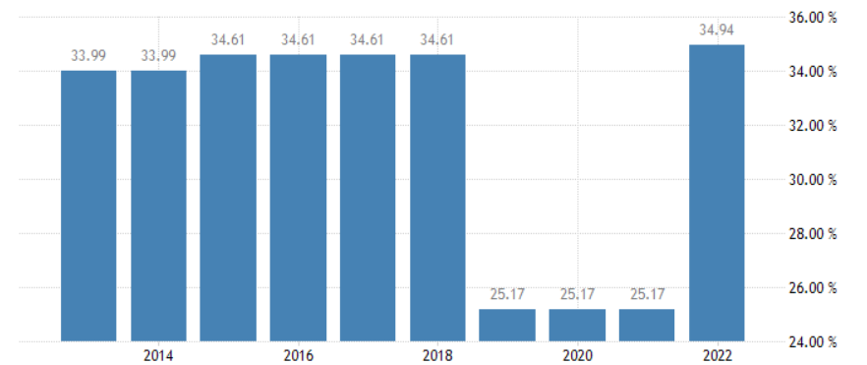
Figure 2; Corporate tax rate of India, Source: (Trading economics, 2022)

Economic
The GDP growth rate of India is predicted to grow at a rate of 7.2% in the year 2023 opening up the door of opportunities for McDonald’s to set up their corporate in India (Trading Economics, 2023). The viability for McDonald's to operate their business in India is that of its growing FDI investment which is rising at a rate of $ 70.97 billion (Ibef, 2022).
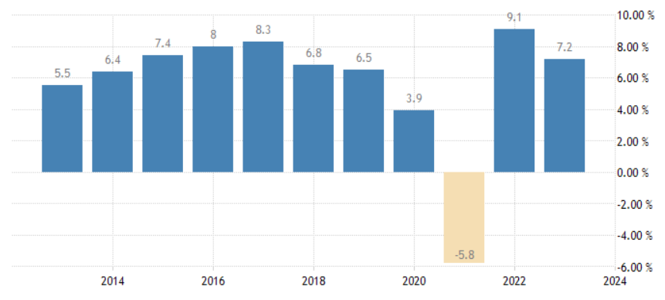
Figure 3: GDP growth rate of India, Source: (Trading economics, 2023)
Social
Society of India is multicultural where people accept change and prefers to accept new products and services with open arm. India's per capita net national income in the year 2023 is INR 172,000 annually (India-briefing, 2023). The growing purchasing capability of Indian people contributes towards organisational development.
Technological
The technological growth rate of India is set to slow down by 8.4% to $ 254 billion in the year 2023 (Economictimes, 2023). The decreasing technological growth will create hindrances towards the path of development for McDonald's to operate their business in India.
Legal
MacDonald's work in India complies with The Factories Act 1948, Contract Labour Act 1970 and Regulation of Employment and Conditions of Service Act 1996 (Icsi, 2022). Complying with the legal laws helps out the organisation to follow all guidelines and policies to set out their business in India.
Environment
MacDonald’s while operating in India complies with The Environment Protection Act 1986 to protect the environment and contribute to organisational development (Indiacode, 2022). Complying with the environmental law enables the firm to maintain long-term sustainability for achieving business.

McDonald’s Japan
Political
The corporate tax rate in Japan stands around 15% and the inflation rate within the country is 2.50% in the year 2023 (Trading Economics, 2022). The suitable political situation for McDonald’s benefits in setting out their business in Japan to grow their business and earn profitability.
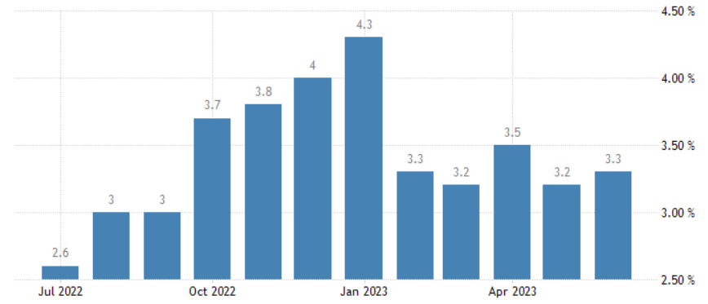
Figure 4: Inflation rate of Japan, Source: (Trading economics, 2022)
Economic
The GDP growth rate of Japan is growing at a rate of 1.3% annually and the FDI investment received by Japan during the same year is 32.53% (Statista, 2022). The economic growth of Japan also opens up the door of business opportunities for MacDonald’s to operate their business in the country.
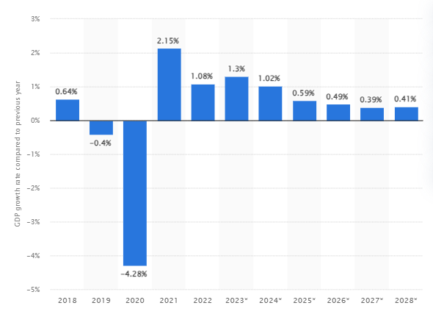
Figure 5: GDP growth rate of Japan, Source: (Statista, 2022)
Social
The social status of Japan is rapidly increasing due to the rise in the purchasing capability of the people. The median salary in Japan in the year 2023 stands at around 471,000 JPY per month (Tokyoportfolio, 2022). People in Japan are open towards accepting change hence enabling MacDonald’s to grow their business.
Technological
The technological growth rate recorded in Japan during the year 2023 is 30% which has made it easier for MacDonald's to invest capital within the organisation to grow its business operations (National Academies, 2022). Technological investment also encourages MacDonald’s to introduce new products and services that increase the speed of service delivery to the organisation.
Legal
MacDonald's in Japan complies with Employment & labour laws and regulations in Japan 2023 where better employment and job opportunities are being provided to the employees to grow their loyalty and trust towards the organisation (Iclg, 2023). Earning the trust and loyalty of employees also help in growing the business of the organisation.

Environment
MacDonald's operating business in Japan needs to comply with the Environmental Law 2022 so that it can protect the environment along with reducing the issues of growing wastage and carbon emission (Practiceguides, 2022). Protecting the environment helps McDonald's in growing its brand reputation in the competitive business environment.

Hofstede cultural dimensions Model

McDonald’s India
Hofstede cultural dimensions model for India explained its social factor that explains the power distance score of India is 77 indicating an gratitude of hierarchy and top-down structure in society (Hofstede-insights, 2023). India’s society is highly collectivist where the country scores 48, India has a society with both collectivist and individualist traits. The collectivist society of India opens up teamwork and creative thinking among the individual that contributes to organisational development. India scores 56 on the masculinity index that explains the country is highly masculine in terms of graphic exhibition of success and power (Hofstede-insights, 2023). Examining the Hofstede cultural dimension model it has also been identified that India scores 40 on this dimension and thus has a medium-low preference for evading hesitation (Hofstede-insights, 2023). This kind of society believes nothing has to be perfect nor has to go exactly as intentional. India in the dimension of long-term orientation scores 51 which explains its dominant culture. India obtains a low score of 26 in Hofstede cultural dimensions meaning that the society is restrained. A society with a low score in this dimension shows cynicism and pessimism.

McDonald’s Japan
Hofstede cultural dimension model for Japan explains about power distance matrix that explains the intermediate score of Japan is 54 explaining about borderline hierarchical society. The country maintains a high hierarchy in their business operations. The society of Japan in individual scores of 46 indicates the country is highly collectivist where people prefer to work together in a group (Hofstede-insights, 2023). In a collectivist society operating a business turns out to be easier as it opens up a new door of opportunities for the organisation to contribute to their overall development. With a score of 95, Japan is a highly masculine society in the world where competition is high among the people. The society of Japan scores 92 in uncertainty avoidance which explains the country is threatened by natural disasters from earthquakes and tsunamis making them vulnerable to natural disasters (Hofstede-insights, 2023). The society of Japan scores 88 in a long-term orientation where the people enjoy their life and keep their faith towards their gods (Hofstede-insights, 2023). With a score of 42 in the indulgence dimension Japan is shown to have a culture of restraint that explains people within the society do not prefer to waste their time and control the satisfaction of their wishes.

Porter’s five forces Model

McDonald’s India
The threat of new entrants
New business entrant threat level in India is low because it turns out to be difficult for them to appoint new experts, arrange for resources and make investments in different segments to grow the business (Fuertes, et al., 2020). The threat level of new entrants in India is also high due to changing business nature and dynamism that puts up barriers for new business entrants to operate their business within the country.
Bargaining power of suppliers
The power of suppliers is low because organisations such as MacDonald's tie up with different local and international suppliers who help the organisation in procuring the resources and use it to develop innovative food items that match the expectations of customers (Hitt, et al., 2019). The availability of suppliers in India decreases their bargaining power.
Bargaining power of buyers
Buyers' bargaining power is high for McDonald's as the taste and choices of clients change very frequently making it hard for the firm to retain the trust and loyalty of the organisation towards the organisation (Henry, 2021). Buyers' power is also high because of the low switching cost enabling them to purchase products at a low price range.
Threat of substitute
The threat of substitute is high because of the availability of different high street shopping centres, cafes and restaurants that offers almost similar services and food items half the price of McDonald's. The availability of substitute products and services decreases the business opportunities for McDonald's.

Competitive rivalry
Competitive rivalry for McDonald’s in India is high as they face high and intense competition from both local and international brands such as Subways, Wow Momo, Starbucks and Café Coffee Day. Growing competition for McDonald’s India decreases the profitability for the organisation followed by limiting their growth opportunities for the organisation (Johnson, et al., 2020).

McDonald’s Japan
The threat of new entrants
The threat of new entrants for McDonald's is low as the organisation puts up barriers in the form of innovation that make it challenging for the new business entrants to set out their business in Japan. The huge requirement for financial and skilled manpower also turns out to be a threat as Japan is considered to be the world's oldest population.
Bargaining power of suppliers
Suppliers' power for McDonald's is low as the organisation sets up their manufacturing plant in the country along with acquiring small firms and tying up with local and international suppliers (Grant, 2021). High investment of capital for McDonald's in introducing a new food menu is also a challenging aspect and also grows the bargaining power of suppliers.
Bargaining power of buyers
The bargaining power of buyers is high because their switching cost is low enabling them in purchasing food items at less prices. The bargaining power of buyers is also considered to be high because accessibility to product information and services makes it easier for the organisation to grow their business (Rosenbaum-Elliott, 2020).
Threat of substitute
The threat of substitutes for McDonald's is high due to the presence of fast food chains operating globally such as Subway, Domino's, Pizza Hut and KFC. All of the substitute provides similar experiences to the customers which grows the power of substitute in the competitive business environment.
Competitive rivalry
Competitive rivalry for McDonald’s is high such as facing intense competition from Domino, KFC, Pizza Hut and Papa Jones (Businesschronicler, 2022). The growing competition for McDonald’s decreases their ability to operate their business successfully in Japan. The competition also decreases the opportunity for the organisation to scale up their business and maintain organisational productivity.

SWOT Analysis

McDonald’s India
Strength  The strength of McDonald's in India comprises of their quality means and product innovation that allows the organisation to tap into the customers and earn their trust and loyalty towards the organisation (Benzaghta, et al., 2021). Strong marketing and promotional advertisement and a quick and fast delivery system also help McDonald's to grow their business in India. | Weakness  The limitation of McDonald's operating their business in India comprises of the low number of outlets makes it challenging for the organisation to reach out to their customers in no time (Puyt, 2020). Operational difficulties and franchise-related issues are also considered a weakness for McDonald’s while operating their business in India.
Opportunity  The opportunity that lies in front of McDonald's comprises introducing a new menu that will be low in calories and high in taste. Mid-range food items can also be introduced by McDonald's which will be helping the firm to raise their business in India and earn high effectiveness. | Threat  The threat that McDonald's face while operating its business in India comprises growing competition from both local and international competition that decreases the growth opportunities. High cost of operations and regulated pressure is also considered to be a threat to the organisation (Minsky & Aron, 2021). Moreover, the lack of long-term contracts with the suppliers is also considered to be a threat to the organisation.
Figure 6: SWOT analysis of McDonald's in India, Source: Author

McDonald’s Japan
Strength  McDonald's in Japan enjoys high brand recognition as they cater to different customer segments allowing them to enjoy success. Diverse revenue models and market leadership position is also considered to be the strength of McDonald's while operating their business in Japan. High margins and talent management of employees are also considered to be the strength of McDonald's. | Weakness  Low investment in their Japanese customer-oriented services as a result of which it makes it challenging for the organisation to gain the kindness of customers and make them loyal to the firm (Phadermrod, et al., 2019). The cost associated with building a new supply chain and logistics network is also considered a weakness for McDonald’s to operate their business in Japan.
Opportunity  The rapid expansion of the economy and technological boost for McDonald's in Japan opens up the door of opportunities for the organisation to scale up their business along with achieving growth potentiality (Deepak & Jeyakumar, 2019). Developing local collaboration also helps McDonald's to maintain the speed of services and sufficing the needs of customers. | Threat  Growing competition for McDonald’s is a challenge that limits the growth opportunities for the organisation along with decreasing their capabilities to earn growth potentiality. Changing demographic is also considered a threat for McDonald's as they have to shell out money to introduce new products matching the requirements of the customers (Park, 2020).
Figure 7: SWOT analysis of McDonald's in Japan, Source: Author

STP
Segmentation is the process of separating the customers into smaller sections in terms of dividing the customers grounded on their selections and preferences making it easier for the firms to appeal the devotion of customers (Hutt & Speh, 2021). Segmentation helps McDonald's in offering products and services that help them in growing their sales and revenue.

McDonald’s India
Demographic segmentation: In India, McDonald's positions itself as an affordable, convenient and family-friendly fast-food restaurant which provides high-quality food and beverages. The company also stresses its commitment to social responsibility and innovation. Some campaigns distinguish McDonald's from its competitors like KFC in the Indian market which has been discussed below.
Geographic segmentation: McDonald's while operating their business in India comprises operating in tier 1 and tier 2 cities. The campaign of “I’m Lovin’ It campaign" is to date one of the major and successful marketing campaigns in history (Adgully, 2022). Due to this, McDonald’s has become a household name in India by positioning itself as a fun and family-oriented brand.
Behavioural segmentation: McDonald's targets its customers based on their consumption habits and eating nature allowing them to attract the attention of customers towards the organisation. McDonald’s is famous for its “Breakfast All Day” campaign which was launched in 2015 so that the company can be appealing for breakfast-loving customers. By doing so, it was able to its breakfast sales by 10% (Campaign India, 2022).
Psychographic segmentation: McDonald’s in India has taken up the initiative of introducing new products that are customised fitting to the choices and preferences of customers. McDonald’s carries out market research in India that allows the organisation to know about the choices and preferences of customers helping them to attract the attention of customers towards the organisation.
Targeting: The target customers for McDonald's operating business in India comprises 10 years to 40 years old, people who prefer to eat tasty and unique snacks are the target customers for the organisation.
Positioning: The positioning strategy of McDonald's comprises of differentiation strategy where they offer a wide range of high-quality food items to gain the attention of customers and grow business opportunities.

McDonald’s Japan
Geographic segmentation: Starting in 2023, Japan is expected to have about 2,975 McDonald's restaurants. About 1,000 of them are situated in remote regions (Yahoo, 2022). This implies that McDonald's is a fairly typical sight in rural Japan and is frequently a sought-after tourist destination.
Demographic segmentation: McDonald's Japan targets customers based on their age, income, gender and occupation. However, a huge part of McDonald's sales in Japan can be considered as an outcome of its special menus and tourist attraction. Happy Meals for Children, McCafe and Family Meals are common, however, meals such as teriyaki burgers and bacon-lettuce burgers are what that is loved by not only Japanese consumers but also tourists (Web-japan, 2022).
Behavioural segmentation: McDonald's Japan offers working professionals a breakfast set which includes hamburgers, hash browns and coffee. This service is available from 6.00 AM to 10.30 AM. Also, kids receive happy meals like any other Mcdonalds' but with different toys which are mostly educational and interactive (Mcdonalds, 2022). For helping families with kids, it offers high chairs and even changing tables.
Psychographic segmentation: In Japan, the company tries to even tap into customers who do not invest in fast-foods or refrain from investing a lot of money in something that they can get at a cheaper cost from local sellers, especially coffee. Thus, McDonald's is offering this market 100 yen coffee which is available from 10.00 AM to 5.00 PM and also one cup is sold to each customer. Besides that seasonal menu items from McDonald's Japan include the McShake Sakura and the Shaka Shaka Potato with Sakura Salt which engages customers that enjoys seasonal offers in general.
Targeting: Targeting for McDonald's in Japan is 10 years to 45 years old working professionals, students and casual people. Identifying the right target customers contribute to their growth.
Positioning: McDonald's in Japan undertakes a focused differentiation strategy where they introduce regional-based products to meet the growing expectations of the customers.

Marketing mix Elements (7Ps)
In marketing 7Ps signifies product, price, place, promotion, physical evidence, people and process. The 7Ps force businesses to undertake the desires and requirements of the target market and create a marketing plan that addresses those demands. Because the 7Ps are interrelated, businesses can foster a better coordinated and successful marketing strategy by addressing all 7Ps (Lim, 2021). Companies can determine which components of their marketing mix are effective and which components need to be improved by monitoring the results of their marketing initiatives.

McDonald’s India
Product
Burgers, fries, chicken, breakfast dishes, desserts, and beverages are just a few of the many goods that McDonald’s India sells. The restaurant also provides a selection of combo meals and value meals. The Egg McMuffin and Hash Browns are some of the new items that are being provided by McDonald’s served with Spicy chilli Sauce are just a couple of the new items that McDonald's India has just added to its menu (Mcdonaldsindia, 2023). McDonald's in recent times while operating in India has launched several new products aimed at appealing to health-conscious people. The Egg White Delight McMuffin, the Grilled Chicken Sandwich, and the Fruit & Yoghurt Parfait are some of these items.
Price
McDonald's India offers competitive pricing to its consumers by offering them a range of combo deals and value meals. In addition to these, coupons and discounts through its website and mobile app make the products affordable to the majority of its target market (Gallego & Topaloglu, 2019).
Place
McDonald's India has a vast network of outlets spread all over the nation. Additionally, the business provides delivery and takeaway services. McDonald's in India continually widens its geographic footprint by opening new restaurants there. Additionally, the organisation has set up shop in unconventional places like airports and college campuses.
Promotion
McDonald's while operating their business in India reaches its target population through a variety of promotional avenues such as print, radio, television, and online advertising. Additionally, it supports other events related to culture and sports. Jr NTR the South Indian superstar is a celebrity endorsing McDonald's in India (Campaignindia, 2022). Celebrity endorsement helps the organisation to grow their business along with earning business profitability.
People
The total number of employees working in Indian McDonald’s as of the year 2022 is 150 thousand, the skilled and qualified employees help the organisation to grow their business followed by earning profitability (Mcdonaldsindia, 2023). The company also invested $ 5 million in employee development to make them loyal and satisfied.
Process
Different processes are being undertaken by McDonald's during their food preparation that is transparent for the customers ensuring that the customers are being made satisfied and loyal. Transparent business processes for McDonald's help them in growing their business in the competitive landscape.
Physical evidence
Physical evidence for McDonald’s India is its packaging, cleanliness and quality of services that grow its reputation among the customers and make them attracted towards the organisation.

McDonald’s Japan
Product
The menu of Japan includes some staple items of McDonald's, but McDonald's Japan specialises in Teriyaki burgers, Ebi Filet-O-Fish, McChicken, Shake Shake Potato, Fruit Pie and Sakura Burgers (Mcdonalds, 2022).
Price
Pricing for McDonald's is typically a little bit more in Japan than they are in India. This is brought on by a variety of elements, such as the increased price of living in Japan, the strength of the Japanese yen decreasing due to a major political factor, inflation, and the business's goal to keep profit margins high (Foodgressing, 2022). McDonald's Japan does, however, also provide several value meals and combo offers that lessen the price of its goods. For instance, the daily special "Set of the Day" is 500 yen and includes a burger, fries, and a drink.
Place
In Japan, McDonald's has more than 3000 stores which are all over the country. However, there are a few areas in Japan where McDonald's are famous such as Harajuku, Shibuya, Shinjuku in Tokyo, Osaka and more.
Promotion
Television advertising for McDonald's Japan is broadcast on several platforms, including cable television channels, regional television stations, and national television networks. The commercials for the corporation frequently use well-known Japanese celebrities like Japanese singer and actor Takuya Kimura and are made to be entertaining and amusing (Japantoday, 2022). Print advertisements for McDonald's Japan are published in a range of publications, such as national magazines, regional magazines, and newspapers.
People
The total number of McDonald's employees working in Japan is 2,272 as of the year 2022, the employees are being provided with knowledge and required skill development training (Datanyze, 2022). Through training the focus is towards growing the competitiveness of employees towards the organisation.
Process
McDonald's undertakes different process strategies such as cost minimisation and quality improvement in terms of offering a high-quality food menu to the customers at the most affordable price so that their attention towards the organisation can be grown. Maintaining a highly structured process also benefits the organisation to minimise resource wastages and take control of the activities that contribute to organisational development.
Physical evidence
McDonald’s while operating their business in Japan holds to the psychical evidence of keeping packaging of the food items, designing their logo and introducing new food menus based on the preferences of customers to gain their attention.
Investigation of the 7Ps in respective India and Japan has identified the internal operational activities of the firm in two different countries based on the choices and preferences making it easier for the organisation to tap into target customers. Furthermore, it has also been noticed that analysing the 7Ps also helps McDonald's in determining the taste and preferences of two different customers which made them aware of the strategies they need to undertake to grow the overall organisational effectiveness.

Directional Development Strategy
The directional strategy helps businesses maintain the highest level of strategic focus while continuing to expand consumer offerings for both goods and services as well as revenue. They achieve this by ensuring that each department collaborates to achieve the company's objectives rather than working independently (Johnson, et al., 2020). Directional development can be a useful tool for businesses looking to expand. Companies can increase their market share and client base by locating and focusing on new market segments. The development of new products to sell to your base or focusing on current customers to expand how much they spend on a company's goods and services are both examples of vertical expansion.

McDonald’s India
In India, McDonald's is growing its menu in recent years to tap into the customers and grow their loyalty. To appeal to a larger spectrum of customers, the business is expanding its menu with additional items. McDonald’s while operating in India undertakes market development strategy. Undertaking market development strategy allows McDonald’s to introduce new products while operating in India such as McSpicy and Piri-Piri chicken, McSpicy Paneer Burget, Piri-Piri McSpicy Chicken Burget and Piri-Piri Big McSpicy Chicken Wrap are a few of the new things that McDonald's has added to its menu (Mcdindia, 2022). All of these new products that have been added to the menu list of India by McDonald’s show that the company is focusing on this vision of being the most loved and trusted restaurant brand around the nation. Expanding new menus will be allowing the company to tap further into the new customer base showing that McDonald's India is staying true to its mission of being well-known for its delicious and high-quality food (Mcdonaldsblog, 2022). Unique product offerings such as Egg McMuffin and the Shamrock Shake are being added to McDonald's menu. Additionally, the business is trying fresh products at a few restaurants, including the Deluxe Chicken Sandwich and the McSpicy Chicken Burget Sandwich (Mcdindia, 2022). Based on the growing range of products, it can be said that the fast food giant is ensuring vertical growth. Further, such a range of options shows that the company has understood the changing customer demands in the Indian market and offering them products that match their expectations.

McDonald’s Japan
McDonald's while operating their business in Japan undertakes a diversification strategy where the firm introduces new food menus based on the choices and preferences of customers. McDonald's in Japan has developed a new menu such as Teriyaki burgers, spaghetti, and other prevalent Japanese foods available at McDonald's Japan (Japantoday, 2022). High-quality ingredients are another speciality of McDonald's Japan. When achievable, it employs foods that are locally produced and fresh. The diversification strategy has contributed to McDonald's Japan's reputation for serving sophisticated cuisine. McDonald’s has customised its menu for the Japanese palate, McDonald's Japan's food is distinct from that of other McDonald's locations (Jw-web magazine, 2022). The diversification strategy that McDonald's Japan is following is also to enhance its growth vertically. For companies aiming to broaden their customer base and boost economic viability, vertical development in marketing can be an effective approach. Before implementing a diversification strategy, it is crucial to thoroughly analyse the needs of the target market and the capabilities of the company. Considering the new product launches and offers that allow children to learn from interactive games and also enjoy themselves in the kids' areas, provided to the Japanese market, McDonald's Japan has successfully achieved its vision of being an enjoyable and convenient food service in Japan (Reuters, 2023). The diversification strategy has helped McDonald's in introducing new products based on the choices and preferences of customers helping the organisation to earn their trust and reputation contributing to their overall development. Hence, the diversification strategy for McDonald's helps them in expanding their business in a challenging business environment.

Conclusion
Analysis of the overall report has explained international marketing strategies used by McDonald's in India and Japan. Investigation of the report has helped in explaining about macro environmental analysis of the Indian and Japanese markets. Examining them helped in knowing about the viability of operating their business in the respective nation. Hofstede cultural dimensions for India and Japan have been explained as related to social factors. Porter's five forces model has also been examined within the report helping in determining the micro-environmental analysis of respective nations. SWOT analysis of McDonald's in India and Japan has been examined determining the strengths and weaknesses of operating the business in the nations. STP of McDonald's in the Japanese and Indian market has also been explained helping out the research scholar to determine target customers for the organisation. The 7Ps of the marketing mix for McDonald's for the Indian and Japanese market has also been examined within the report. Differences are especially shown in terms of pricing, place and advertising or offers in general. Prices of the same products differ in both nations, where the Japanese market asks for more cost compared to India. Finally, the Directional development strategy related to the ansoff matrix has been subsequently discussed within the report.

Recommendations
Recommendations for the report have been underlaid based on the analysis of the overall report.
- Competition is a major challenge that McDonald's faces while they operate their business in both the Indian and Japanese markets. To eliminate the competition McDonald's can look forward to developing region-specific menu options that will be allowing the organisation to satisfy the taste and experiences of the customers and make them loyal towards the organisation. Offering a region-specific food menu will also be helping McDonald's to grow their revenue and profitability contributing to their overall development.
- McDonald’s to develop their brand reputation need to undertake word-of-mouth marketing as it will be allowing the organisation to attract new customers without spending a huge amount on advertisement and promotional activities. Customer retention and favourable word-of-mouth marketing are encouraged by the focus on providing excellent customer service. Word-of-mouth marketing will also be allowing the organisation to tap into a large customer base that will be contributing to the growth of organisational development.
- While operating in both India and Japan McDonald’s can undertake a standardisation process that allows the firm to also create economies of scale and a consistent customer experience. The business's innovation initiatives and menu alternatives tailored to certain regions draw in new customers, which helps increase sales.

References
Adgully,2022.Mcdonaldsimlovinitlivetopremiereinindia.[Online]Availableat:https://www.adgully.com/mcdonald-s-i-m-lovin-it-live-to-premiere-in-india-130680.html[Accessed 7 August 2023].
Benzaghta, M. et al., 2021. SWOT analysis applications: An integrative literature review. Journal of Global Business Insights, 6(1), pp. 55-73.
Businesschronicler,2022.Mcdonaldscompetitorsanalysis.[Online]Availableat:https://businesschronicler.com/competitors/mcdonalds-competitors-analysis/[Accessed 7 August 2023].
Campaignindia,2022.Mcdonaldskicksoffglobalmediareview.[Online]Availableat:https://www.campaignindia.in/article/mcdonalds-kicks-off-global-media-review/440656[Accessed8 August 2023].
Campaignindia,2022.Mcdonalds-launches-mcspicyfriedchickenwithntrjrasbrandambassador. [Online] Available at: https://www.campaignindia.in/video/mcdonalds-launches-mcspicy-fried-chicken-with-ntr-jr-as-brand-ambassador/483220[Accessed 8 August 2023].
Czinkota, M., Ronkainen, I. & Cui, A., 2022. International marketing. London: Cengage Learning.
Datanyze,2022.Mcdonaldsjapan.[Online]Availableat:https://www.datanyze.com/companies/mcdonalds-japan/425861574[Accessed 7 August 2023].
Deepak, R. & Jeyakumar, S., 2019. Marketing management. London: Educreation Publishing.
Economictimes, 2023. Indian tech sector growth slows in FY23, CEOs cautiously optimistic about future: Nasscom. [Online]Availableat:https://economictimes.indiatimes.com/tech/information-tech/indian-tech-sector-growth-slows-in-fy23-ceos-cautiously-optimistic-about-future-nasscom/articleshow/98334842.cms?from=mdr[Accessed 7 August 2023].
Foodgressing,2022.Mcdonalds-japan-menu-price-calories-in-english.[Online] Available at: https://foodgressing.com/mcdonalds-japan-menu-price-calories-in-english/[Accessed8 August 2023].
Forbes,2022.Inflationrateinindia.[Online]Availableat:https://www.forbes.com/advisor/in/personal-finance/inflation-rate-in-india/[Accessed 7 August 2023].
Fuertes, G. et al., 2020. The conceptual framework for the strategic management: a literature review—descriptive. Journal of Engineering, 3(1), pp. 1-21.
Gallego, G. & Topaloglu, H., 2019. Revenue management and pricing analytics (Vol. 209). London: New York: Springer.
Grant, R., 2021. Contemporary strategy analysis. London: John Wiley & Sons.
Henry, A., 2021. Understanding strategic management. London: Oxford University Press.
Hitt, M., Ireland, R. & Hoskisson, R., 2019. Strategic management: Concepts and cases: Competitiveness and globalization. London: Cengage Learning.
Hofstede-insights,2023.India.[Online]Availableat:https://www.hofstedeinsights.com/country-comparison-tool?countries=india%2Cjapan[Accessed 8 August 2023].
Hofstedeinsights,2023.Japan.[Online]Availableat:https://www.hofstedeinsights.com/country-comparison-tool?countries=india%2Cjapan[Accessed 7 August 2023].
Hutt, M. & Speh, T., 2021. Business marketing management: B2B. London: South-Western, Cengage Learning.
Ibef,2022.Foreigndirectinvestment.[Online]Availableat:https://www.ibef.org/economy/foreign-direct-investment[Accessed 7 August 2023].
Iclg,2023.Employmentandlabourlawsandregulations.[Online]Availableat:https://iclg.com/practice-areas/employment-and-labour-laws-and-regulations/japan[Accessed 7 August 2023].
Icsi,2022.LABOURLAWS&PRACTICE.[Online]Availableat:https://www.icsi.edu/media/webmodules/LabourLaws&Practice_June_2020.pdf[Accessed 7 August 2023].
India-briefing, 2023. India’s Per Capita Income for 2022-23 Doubles from 2014-15, but Wealth UnevenlySpread.[Online] Available at: https://www.india-briefing.com/news/indias-per-capitaincomedoublessince201415butwealthunevenlyspread27325.html/#:~:text=India's%20per%20capita%20net%20national,National%20Statistical%20Office%20(NSO).[Accessed 7 August 2023].
Indiacode,2022.The_environment_protection_act.[Online]Availableat:https://www.indiacode.nic.in/bitstream/123456789/6196/1/the_environment_protection_act%2C1986.pdf[Accessed 8 August 2023].
Japantoday,2022.McDonald'sstarts-new-japan-campaign-featuring-burgers-from-itsoverseas-restaurants.[Online]Availableat:https://japantoday.com/category/features/food/mcdonald%E2%80%99s-starts-new-japan-campaign-featuring-burgers-from-its-overseas-restaurants
[Accessed 8 August 2023].
Japantoday,2022.Sakuraseasonarrivesatmcdonald.[Online]Availableat:https://japantoday.com/category/features/food/sakura-season-arrives-at-mcdonald%E2%80%99s-japan-with-new-range-of-exclusive-menu-items-1[Accessed 8 August 2023].
Johnson, G. et al., 2020. Exploring strategy. London: Pearson UK.
Jw-webmagazine,2022.Unique-japanese-mcdonalds-menus.[Online] Available at: https://jw-webmagazine.com/unique-japanese-mcdonalds-menus/[Accessed 8 August 2023].
Lim, W., 2021. A marketing mix typology for integrated care: the 10 Ps. Journal of Strategic Marketing, 29(5), pp. 453-469.
Mcdindia,2022.Menu.[Online]Availableat:https://mcdindia.com/[Accessed 8 August 2023].
Mcdonalds,2022.Home.[Online]Availableat:https://www.mcdonalds.com/us/en-us.html
[Accessed 7 August 2023].
Mcdonalds,2022.Japan.[Online]Availableat:https://www.mcdonalds.co.jp/en/menu/[Accessed 8 August 2023].
Mcdonalds,2022.Menu.[Online]Availableat:https://www.mcdonalds.co.jp/en/menu/[Accessed 8 August 2023].
Mcdonaldsblog,2022.New-launch/.[Online] Available at: https://mcdonaldsblog.in/tag/new-launch/[Accessed 8 August 2023].
Mcdonaldsindia,2023.Home.[Online]Availableat:https://www.mcdonaldsindia.com/[Accessed 7 August 2023].
Minsky, L. & Aron, D., 2021. Harvard Business Review. Are you doing the SWOT analysis backwards, 21(1), pp. 1-8?
Nationalacademies,2022.JAPAN'SUNIQUEINNOVATIONCAPABILITY.[Online] Available at: https://nap.nationalacademies.org/read/2030/chapter/14[Accessed 8 August 2023].
Park, S., 2020. Marketing management. London: Seohee Academy.
Phadermrod, B., Crowder, R. & Wills, G., 2019. Importance-performance analysis based SWOT analysis. International journal of information management, 44(1), pp. 194-203.
Practiceguides,2022.EnvironmentalLaw2022.[Online]Availableat:https://practiceguides.chambers.com/practice-guides/environmental-law-2022/japan/trends-and-developments[Accessed 8 August 2023].
Puyt, R. L. F. D. G. F. a. W. C., 2020. Origins of SWOT analysis. In Academy of Management proceedings . In: London: Briarcliff Manor, NY 10510: Academy of Management, p. 17416.
Reuters,2023.mcdonalds-japan-hikes-prices-city-centres-costs-bite.[Online] Available at: https://www.reuters.com/business/retail-consumer/mcdonalds-japan-hikes-prices-city-centres-costs-bite-2023-06-19/[Accessed 8 August 2023].
Rosenbaum-Elliott, R., 2020. Strategic advertising management. London: Oxford University Press.
Statista,2022.Gross-domestic-product-gdp-growth-rate-in-japan.[Online]
Available at: https://www.statista.com/statistics/263607/gross-domestic-product-gdp-growth-rate-in-japan/[Accessed 7 August 2023].
Statista,2022.Revenue-of-the-mcdonalds-corporation-since-2005.[Online] Available at: https://www.statista.com/statistics/208917/revenue-of-the-mcdonalds-corporation-since-2005/#:~:text=McDonald's%20generated%20a%20total%20revenue,for%209.42%20billion%20U.S.%20dollars.[Accessed 7 August 2023].
Tien, N., Phu, P. & Chi, D., 2019. The role of international marketing in international business strategy. International journal of research in marketing management and sales, 1(2), pp. 134-138.
Tokyoportfolio,2022.AverageSalaryinJapanfor2023.[Online]Availableat:https://tokyoportfolio.com/averagesalaryinjapan/#:~:text=The%20median%20salary%20in%20Japan,the%20other%20half%20earn%20less.[Accessed 7 August 2023].
Tradingeconomics,2022.Corporatetaxrate.[Online]Availableat:https://tradingeconomics.com/india/corporate-tax-rate[Accessed 7 August 2023].
Tradingeconomics,2022.Inflationcpi.[Online]Availableat:https://tradingeconomics.com/japan/inflation-cpi[Accessed 7 August 2023].
Tradingeconomics,2023.IndiaFiscalYearGDPGrowth.[Online]Availableat:https://tradingeconomics.com/india/fullyeargdpgrowth#:~:text=Full%20Year%20GDP%20Growth%20in,India%20Full%20Year%20GDP%20Growth.[Accessed 8 August 2023].
Web-japan,2022.Happymeal.[Online] Available at: https://web-japan.org/kidsweb/cool/13-07/index.html#:~:text=It's%20called%20the%20%22Okosama%20Lunch,like%20a%20car%20or%20train.[Accessed 7 August 2023].
Yahoo, 2022. Fmc-donalds-japan-is-one-of-the-most-popular-placesonfacebooK. [Online]
Availableat:https://www.yahoo.com/?err=404&err_url=https%3a%2f%2ffinance.yahoo.com%2fnews%2fmcdonaldsjapanisoneofthemostpopularplacesonfacebook131211479.html%3fguce_referrer%3daHR0cHM6Ly93d3cuZ29vZ2xlLmNvbS8%26guce_referrer_sig%3dAQAAAENY-5Nr0fMOAv8X-VrnLPt6[Accessed 8 August 2023].

