

Assessment 1: Comparative report
Student Name: Shalma Begum
Student ID: 1813709
Module Name: Living with Care: The Older Person
Module Code: BMHP6009
Lecturer Name: Dr Edward Goka
Due: 10/01/22

Table of contents
Introduction………………………………………………………………….3
Definition of old age………………………………………………………...4
Statistics…………………………………………………………………..5/67
Theories of loneliness and isolation………………………………………………………………………7
The impact of loneliness and isolation on an older person living within a care setting……………………………………………………………………….….8/9
Legislations and policies…………..…………………………………………………………..10/11
The prospective future of care for the elderly…………………………….11/12
Recommendations…………………………………………………………...….12
Conclusion………………………………………………………………………..13
References………………………………………………………………….14/15/16

Introduction
This comparative report will be looking at the definition of old age in the UK and the USA. An analysis of statistics of the ageing population in both countries will be provided, as well as looking at the theories of loneliness and isolation among older people. Policies and legislation in both countries will be discussed as well as looking at the future of care for the elderly using technology such as AI.

Definition of old age in the UK
According to the NHS, (2021), a person above the age of 65 may be deemed an older individual. Though, it is not straightforward to employ a precise meaning as individuals can biologically age at separate times. A person aged 75 could be physically fit than a person who is aged 65, (NHS, 2020). The Office of National Statistics (2021) says the reason that age 65 is used to define old age could be because it was the formal withdrawal age from employment for males and the age they were able to receive State Pension.
Developments in health care have assisted individuals in the UK to survive longer than they did in the past. Consequently, the amount of older individuals in the UK is rising drastically and this degree of increase is estimated to rise even faster in the next twenty years. This may be a positive view for all, but it creates a challenge for the NHS, as people get older chronic conditions rises and therefore the demand for more health and social care, (NHS,2020).

Definition of old age in the USA
In the USA similarly to the UK old age is defined from the age of 65. Traditionally, the elderly is defined as a chronological age of 65 years or more, whereas people aged 65-74 years are described as early elderly and individuals above 75 years old are classed as elderly. According to the Census Bureau US (2020), 2030 will mark a demographic changing moment for the country. At the start of 2030, people born in the 1960s will be above the age of 65. This will increase the amount of the older populace meaning 1 in 5 Americans will be predicted to be retirement age, Furthermore, by 2034, it is estimated that the older population will in fact outstrip young children for the first time in American history. Regardless of decelerating growth, the U.S. populace is still estimated to expand. This continued growth lies in the fact that the U.S has more migrants coming into the country than the UK, (Goodkind and Kowal 2015). The amount of mortalities is expected to increase significantly, in 2060 the U.S. populace is estimated to total 500,000 people by natural increase, while international migration is anticipated to increase over twice this figure to the population.

Statistics and changes
The UK populace is ageing, this is the outcome of the blend of decreasing fertility levels and an increase in life expectancy. And it is estimated to carry on ageing; estimates say that when we reach 2050, one in four individuals in the UK will be aged 65 years or over, (The Office for National Statistics, 2019). A rise in the older population has repercussions for the financial system in relation to delivering facilities and state pensions; though, this financial effect will be influenced by individuals live better lives for longer and rises in monetary movement at mature years.
According to The Office for National Statistics (2021), there are 15.5 million individuals aged sixty and over in the UK, this is 23% of the population. The amount of ageing individuals is on the rise, and it is estimated by 2041 there will be more than 3 million people aged 85+. This is more than twice the amount that currently exists. Through the later part of the twentieth century, the UK populace gradually aged hence why development is expected to go on in the time to come. They also state that five years ago, there were 11.8 million UK citizens aged 65 years and beyond, making up 18% of the overall population, this is a stark difference to 25 years before when there stood 9.1 million, ageing citizens.
Declining fertility and death rates are both long-term trends that are contributing to the world`s ageing population. In England and Wales, the total fertility rate was 1.83 children per woman in comparison to a high of 2.93 in 1964. The long-term drop in mortality rates has been especially high among the oldest age groups, (Harper and Warpool 2020). Long-term declining death rates among the over-65s are also driving rising life expectancy, a trend that is likely to continue.
Historically, advances in life expectancy have been driven by a decrease in mortality. However, declining mortality is now the most important determinant in newborn and child mortality rates among those over the age of 65. High fertility rates in the past are also a factor in the UK's demographic transformation – but this is a temporary consequence of an elevated amount of births following World War II, and a lengthier surge in people having babies in the 1960s also known as the 'baby boom' saw the introduction of huge cohorts of people of comparable ages into the UK population. The Individuals born straight after World War II are already into the late 60s and may live into their 70s and are also estimated to be in their 90s in 2040.

The UK population pyramid for the year 2021 is shown below, which estimates by 2100 elderly population will account for 29.91% of UK population, (Population Pyramid, 2021).

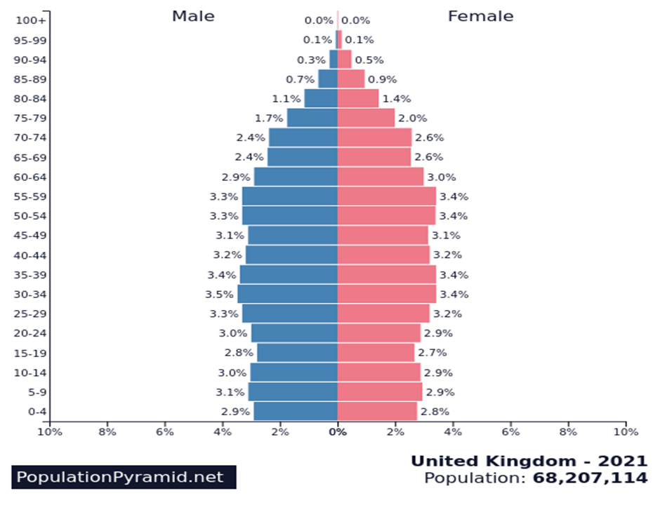

Looking at the statistics of the ageing in the USA, similarly like the UK the number of American citizens aged 65 above is estimated to be more than twice the number there is now in the coming 40 years, totalling nearly 80 million in 2040. The amount of older people aged 85+ which is also the band requiring the most assistance with necessary personal care may almost increase fourfold from 2000 and 2040, (Census Bureau US, 2021). The demographic pyramid for the USA is shown below where it reveals that by the year 2100 the ageing populace will account for 27.80% of the countries population, (Population Pyramid, 2021).
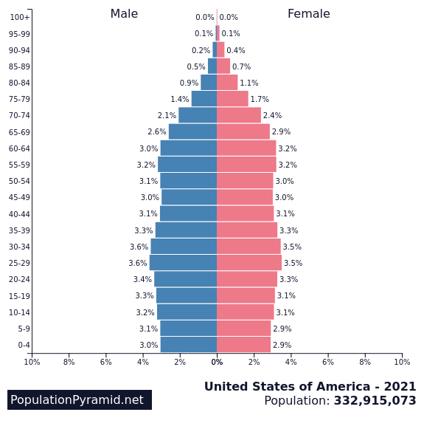

Theories of loneliness and isolation
An increasing quantity of empirical studies has incorporated a variety of definitions of loneliness during the last few decades. There are distinctions between loneliness and social isolation, as well as loneliness and solitude. Many experts agree that loneliness and social isolation are distinctive conceptions. Yet, this theoretical distinction is not usually completely represented in loneliness studies, (Bolmsjo et al 2018). Interventions aimed at increasing social connections are based on the notion that loneliness is synonymous with social isolation because they give social exposure in response, as a result, the generally accepted difference between loneliness and social isolation is weakened.
People ageing has long been a source of contention. According to the disengagement theory of ageing, as people age, they withdraw from interaction and communication with the many networks to which they belong. According to the notion, this disengagement is unavoidable and reciprocal. It is one of three primary psychosocial theories that describe how people develop as they age. The Activity Theory of Ageing and the Continuity Theory of Ageing are the other two theories. The notion, which was first advocated in 1961, was that older persons should feel it normal, if not natural, to withdraw from society. The primary shift in contact amongst the elderly and the rest of society, corresponding to Cumming and Henry's conception, take place when older people are more self-conscious of their decreasing physical and cognitive functions, as well as mortality, (Mabry and Bengtson, 2005). They contend that this leads to disengagement from social networks, both deliberately and instinctively. Similarly, society removes oneself from the elderly, along with the tasks and obligations of the elderly being transmitted down to the younger generations. From a sociological standpoint, it has been proposed that disengagement offers theoretical advantages (Asiamah, 2017). Disengagement permits the elderly to steadily retreat from society whilst preserving social harmony. Because ageing reduces older people's capacity to act as nurturers, professionals, or working representatives of the population, it promotes self-reflection.
Both the disengagement theory and the activity hypothesis are diametrically opposed. The activity theory contends that to limit the dangers associated with disengagement, ageing individuals must remain mentally and socially active. According to Teater and Chonody, (2020), doing so will delay the ageing process and improve quality of life. When the elderly stay socially engaged and keep active with a filled round of everyday tasks and maintain a positive attitude toward life, they will feel healthier and much more capable.

The impact of loneliness and isolation on an older person living within a care setting
Loneliness is the sense of being on your own, irrespective of the extent of social contact. Social isolation is a shortage of social links. Social isolation may head to loneliness in several individuals, although others can feel lonely devoid of being socially separated.
In the present state of social care, merely the extremely reliant individuals are being provided with support and this has preceded several older individuals who reside on their own to grow to be socially isolated. They are the people who require minimum assistance to retain a decent condition of life but if they do not have family/friends to offer them the help or confidence to be active they simply come to be confined in their own residences. The Social Care Institute for Excellence (2018) says social isolation and loneliness place a damaging effect on health and well-being. In the UK, loneliness is a lot more frequent in long-term care establishments. The incidence of acute loneliness amongst elderly individuals residing in care residences is at minimum twice that of neighbourhood-residence populaces, 22% to 42% of elderly people, (Simard and Volicer, 2020). Socially isolated older individuals can rapidly come to be withdrawn and at the same time be depressed. Loneliness in elderly individuals residing in care residences in the UK is linked with very high rates of restrictions in daily activities, poor self-informed health, incapacity, issues with mobility, depression, deprived psychological health which can then also increase the risk of mortality, (Jannson, et al. 2017). According to Martin, (2022), Britain will face a pandemic of loneliness amongst the ageing population. The reason for this down to a vast increase in individuals looking after their spouses without support from the government. About 3.6 million seniors are also unpaid carers, this figure has surged by almost 1.5 million since the beginning of COVID-19.
There appears to be a common belief that residing in a care home means a person will have company at all times. Nevertheless, having individuals around has no assurance that a person will not feel lonely or socially isolated, countless individuals move into care homes due to a decline in health but have resided without help for years, The reality of living with complete strangers may not sit well with older people and could be one of the reasons why they do not leave their rooms as they consider it their safe space.
In the USA 44% of people who were born in the 1960s known as the baby boomers stated that they occasionally or always feel lonely, (Census bureau US 2019) and 16% of Baby Boomers have no close friends. Like the UK, the USA states that loneliness and social isolation in elderly people remains a significant public wellbeing threat impacting a substantial amount of individuals in the USA and placing them at stake for dementia as well as additional severe medical conditions. Corresponding to the Centres for Disease Control and Prevention, (2019), that more than 1/3 of people age 45 plus have feelings of loneliness in care homes, and nearly twenty-five per cent of people age 65 and above are thought to be socially isolated. Elderly individuals are at a heightened possibility for loneliness and social isolation, they can be prone to encounter issues like absence of family, residing by themselves as well as chronic conditions.

Legislations and policies
Currently, there are acts and legislations that are set out to protect individuals such as the ageing. The Mental Capacity Act 2005 UK permits individuals to communicate their inclinations regarding care and treatment and to employ a trustworthy individual to make choices on their side if they do not have the ability to in the time to come. The Act also says that individuals must also be offered unbiased support, who will assist the individual in making decisions in some circumstances, such as vital treatment or when the person may have substantial limitations laid on their independence and rights to support their best interests, (NHS, 2021). The Equality Act 2010 is a law that safeguards individuals from being discriminated against. It implies that discrimination or unethical behaviour because of individual attributes, like age, is currently contrary to the law. Older people who are employed or seeking employment cannot be discriminated against due to their age, (Legislation GOV UK, 2021).
In the USA there are also acts in place to protect the ageing. One of these is The Older Americans Act, which pays for a selection of home environment and neighbourhood centered facilities, involving lunches/dinners and additional diet packages, in-home environment support, mobility, legal assistance, elderly neglect avoidance, and support for caregivers. These programmes assist elders in staying as independent as feasible in their residences and neighbourhoods. Furthermore, OAA services support elderly people in avoiding admittance to hospitals and nursing home care, thus conserving national and government cash that would be expended on this form of care. The OAA's objective is to support the respectability of elderly people by delivering services as well as support that enables them to remain independent and involved citizens in their communities, (Ujvari et al, 2019).
Age discrimination is an extremely significant issue, and the USA State law forbids age discrimination systems and strategies. Employers and organisations cannot legitimately publicise, impose retirement, strike back, or employ a member of staff just because of their age. The Age Discrimination in Employment Act of 1967 says it is illegal to victimise individuals aged 40 or over. Thus, employers cannot differentiate based on age.
Charities such as Age UK, are constantly looking at ways to help the elderly. Age UK, (2021) has revealed that 1/3 of elderly carers who are not paid felt lonely. The charity wants the state to more to support more pensioners who are also carers and are finding it difficult to manage alone. They are also a part of late MP Jo Cox’s Loneliness Commission. It entails a string of commitments to assist people of any age to create connections and tackle loneliness and isolation in older people. They wanted the Government to look at these areas, a wide strategy for loneliness across all ages, measure progress, and finance to aid measure and layout encouraging methods to deal with loneliness. This was set up as the Governments Loneliness Strategy 2018. The strategy allows GPs throughout England to refer patients who are lonely to activities in their community such as cooking workshops, walking clubs, as well as arts and crafts workshops by the end of 2023, (GOV, UK 2018). This is known as ‘social prescribing' and implies that GP’s can aim to better their patients' welfare and health via activities instead of through medication.
Age UK (2019) says that over 25,000 older individuals frequently go for a week with no conversation with others and more than six million older individuals stated just a couple of moments of chatting to someone creates a huge impact on their week. Programmes such as befriending services are available where the elderly can pick up the phone just to speak to someone or befriending service can provide someone to come and sit down with them and just chat. Community-based social activities can also help the elderly to retain social relationships as well as decrease feelings of loneliness, it is also an excellent path to discover new skills or return to a hobby that was once enjoyed. In the UK as well as the USA, policies such as meals on wheels, money management and medication aid are available for the elderly, (NIA, 2017).

The prospective future of care for the elderly
Corresponding to a United Nations estimate, the amount of people aged 60 and more is predicted to rise from 962 million in 2017 to 2.1 billion in 2050 and 3.1 billion in 2100. The healthcare business employs nearly 4.5 million nursing assistants, care assistants, and personal care assistants in the United States. In addition to an ageing population and a scarcity of competent workers, governments throughout the world may be seeking to hire senior care machines to fill the gap. Though the implementation of senior care robots is currently modest in contrast to other service robot marketplace sectors, the trade has made strides in terms of elderly care robots coupled with artificial intelligence (AI), (Corbyn, 2021). For example, it may assist in filling the caregiving absence in the USA, it is having been estimated that by 2030, just 4 possible family caregivers will be on hand for everyone in need of care, and this figure will drop to 3 by midway-century. The impact of this development is intensified by the statistic that 90% of elderly people wish to remain at home.
According to Taber et al, (2017) studies carried out in 2015 discovered that 40% of care providers declare that home-based care is demanding. Hence, the objective is to enhance the individuality, excellence of life expectancy, and well-being for the elderly and care providers, AI has an increasing prospect to deal with matters from cost to tailored health proposals. It has been stated that AI could lower or relieve the duty of care workers. It may also assist individuals to reside at home for an extended time with speaking devices, measuring devices that sense movement and more. The digital invention has even now streamlined difficult responsibilities, which have headed to a fundamental prospect for AI, the industry of ageing. These technologies have the ability to avert acute deteriorations or major injuries by giving not just accurate information but additionally automatic alarms to assist early and safe care, therefore postponing or eliminating the requirement of expensive hospitalisation, (McMurray et al, 2017).
People are getting more connected at home in the long run. In-home video communication will not only be simple to use and widely available among the elderly by 2030, but it will also be inexpensive. Home-monitoring and biometric alert and alarm systems will undoubtedly become more common by 2030. Technologies for caregivers are brimming with new ideas. However, these technologies can only supply infrastructure; the main difficulty will be to develop human engagement around future technology. Smarter homes and biometric monitoring systems have the potential to improve the security and connection of elderly persons in the UK. This promise will be realised only if it is supported by the development of wide-ranging and community strategies to provide services for the elderly, (Ho, 2020).

Recommendations
Given that there is no specific method that suits all older people in resolving loneliness or social isolation, treatments must be tailored to the requirements of people, particular groups or the degree of loneliness encountered. Although an approach may work for one individual in one situation, it may fail miserably in another. Moreover, individuals often react differently depending on certain situations. When planning and procuring services targeted at individuals, a 'holistic approach is essential. Personal tastes, expectations, and goals must be addressed through solutions that are adjustable.

Conclusion
To summarise this report, the main issue is that the UK, as well as the USA’s population, is ageing. Population pyramids for 2021 look drastically different compared to past years. One of the reasons for this is that healthcare is extremely better than in past years hence why people are living for longer as well as low fertility rates.
The use of technology can be useful in this day and age for the elderly, however, when AI replaces human interaction this could potentially see older people spiral into the depths of loneliness. Some older people long for interaction with others, they can go for days or even months without speaking to someone.
As discussed legislation and policies in the UK and USA to tackle loneliness and isolation in older people has been implemented to make sure that older people are not discriminated due to their age, they are allowed to make choices regarding treatment and be treated with dignity and respect.
Despite funding limits and government cutbacks, the health and social care sector remains a massive and critical organisation in caring for our aged. Healthy older persons who are isolated must have access to services and assistance. Daycare centres, for example, are useful for the solitary elderly because they provide them with services such as socialisation, meals, bingo, card playing, and adult learning. Another part of decreasing elderly loneliness is the provision of home help. This includes assisting with excellent housekeeping. Taking care of the elderly or the old involves a variety of factors. Having a comprehensive understanding of the diverse needs and wants of the elderly is critical for those who care for them. This sort of aid and help that old people frequently require, as well as a few senior unique needs, is critical in reducing or easing isolation. The HSC sector tries to support and deliver age-friendly initiatives for all seniors, regardless of where they live. They aim to enhance mobility, accommodation, social equality, community engagement, as well as health services. Furthermore, actively listening to someone who is socially isolated can make a difference. Spending a day with someone might also influence their outlook on life.

References
Age UK (2019) Almost 5 million older people claim to have felt lonely in later life [Online] Available at: https://www.ageuk.org.uk/latest-press/articles/2019/september/almost-4.5-million-older-people-claim-to-have-felt-lonely-during-later-life/. (Accessed: 6th January 2022).
Age UK (2021) Campaigning Jo Cox Commission [Online] Available at: https://www.ageuk.org.uk/our-impact/campaigning/jo-cox-commission/. (Accessed: 6th January 2022).
Age UK (2021) Policy positions health and wellbeing [Online] Available at: https://www.ageuk.org.uk/globalassets/age-uk/documents/policy-positions/health-and-wellbeing/ppp_loneliness_and_isolation_uk.pdf. (Accessed: 6th January 2022).
Asiamah, N., (2017). Social engagement and physical activity: Commentary on why the activity and disengagement theories of ageing may both be valid. Cogent Medicine, 4(1), p.1289664.
Bolmsjö, I., Tengland, P.-A. and Rämgård, M. (2019) ‘Existential loneliness: An attempt at an analysis of the concept and the phenomenon’, Nursing Ethics, 26(5), pp. 1310–1325. Available at: https://journals.sagepub.com/doi/10.1177/0969733017748480. (Accessed: 6th January 2022).
Census Bureau US (2019) Prepare for the Incoming Wave of Aging Boomers [Online] Available at: https://www.census.gov/library/stories/2019/12/by-2030-all-baby-boomers-will-be-age-65-or-older.html. (Accessed: 6th January 2022).
Census Bureau US (2020) Demographic Turning Points for the United States: Population Projections for 2020 to 2060 [Online] Available at:https://heartlandcua.org/common/Uploaded%20files/DEI/Census_projections.pdf (Accessed: 6th January 2022).
Census Bureau US (2021) Population [Online] Available at: https://www.census.gov/topics/population/older-aging.html. (Accessed: 6th January 2021).
Centres for Disease Control and Prevention, (2019) [Online] Lonely older adults Available at: https://www.cdc.gov/aging/publications/features/lonely-older-adults.html#:~:text=Loneliness%20and%20social%20isolation%20in%20older%20adults%20are,risk%20for%20dementia%20and%20other%20serious%20medical%20conditions. (Accessed: 6th January 2022).
Corbyn (2021).Eldercare artificial intelligence software [Online] Available at: https://www.theguardian.com/us-news/2021/jun/03/elder-care-artificial-intelligence-software. (Accessed: 6th January 2022).
Gladence, L.M., Anu, V.M., Rathna, R. et al. (2020) Recommender system for home automation using IoT and artificial intelligence. J Ambient Intell Human Comput [Online] Available at: https://doi.org/10.1007/s12652-020-01968-2. (Accessed: 3rd January 2022).
GOV UK (2018) A strategy for tackling loneliness [Online]Available at: https://www.gov.uk/government/publications/a-connected-society-a-strategy-for-tackling-loneliness. (Accessed: 6th January 2022).
Ho, A., (2020). Are we ready for artificial intelligence health monitoring in elder care?. BMC Geriatrics, 20(1).
Jansson, AH, Muurinen, S, Savikko, N, Soini, H, Suominen, MM, et al. (2017). Loneliness in nursing homes and assisted living facilities: prevalence, associated factors and prognosis. Journal of Nursing Home Research, 3: 43–49.
Kowal, P., Goodkind, D. and He, W. (2016) An Aging World: 2015, International Population Reports. U.S. Government Printing Office, Washington DC. Available at: http://www.census.gov/library/publications/2016/demo/P95-16-1.html/ (Accessed: 6th January 2022).
Legislation GOV UK, (2021). Legislations 2010 [Online] Available at: https://www.legislation.gov.uk/ukpga/2010/15/contents. . (Accessed: 6th January 2022).
Mabry, J.B. and Bengtson, V.L., 2005. Disengagement theory. Encyclopedia of ageism, pp.113-117.
McMurray, J., Strudwick, G., Forchuk, C., Morse, A., Lachance, J., Baskaran, A., Allison, L. and Booth, R., (2017). The Importance of Trust in the Adoption and Use of Intelligent Assistive Technology by Older Adults to Support Aging in Place: Scoping Review Protocol. JMIR Research Protocols, 6(11), p.e218.
NHS (2020) Improving care for older people [Online] Available at: https://www.england.nhs.uk/ourwork/clinical-policy/older-people/improving-care-for-older-people/. (Accessed: 6th January 2022).
NHS (2020) Improving care for older people, [Onlline] Available at: https://www.england.nhs.uk/ourwork/clinical-policy/older-people/improving-care-for-older-people. (Accessed: 6th January 2022).
NHS (2021) Mental Capacity Act [Online] Available at: https://www.nhs.uk/conditions/social-care-and-support-guide/making-decisions-for-someone-else/mental-capacity-act/. (Accessed: 5th January 2022)
NIA,( 2017) Growing older home [Online] Available at: https://www.nia.nih.gov/health/aging-place-growing-older-home. (Accessed: 6th January 2022),
ONS (2019) Living longer and old-age dependency what does the future hold [Online] Available at:https://www.ons.gov.uk/peoplepopulationandcommunity/birthsdeathsandmarriages/ageing/articles/livinglongerandoldagedependencywhatdoesthefuturehold/2019-06-24. (Accessed: 5th January 2022).
Population pyramid (2021) United Kingdom Available at: https://population-pyramid.net/en/pp/united-kingdom. (Accessed: 6th January 2022).
Population pyramid (2021) United States of America [Online] Available at: https://population-pyramid.net/en/pp/united-states-of-america. (Accessed: 6th January 2022).
Scie, (2018) Tackling Loneliness and Social Isolation: the Role of Commissioners. Available at: https://www.scie.org.uk/prevention/connecting/loneliness-social-isolation?utm_campaign=10193621_scieline%2015%20january%202019&utm_medium=email&utm_source=scie&utm_sfid=003g000002xcjzdiax&utm_role=communications&dm_i=4o5(Accessed: 5th January 2022).
Simard, J., & Volicer, L. (2020). Loneliness and Isolation in Long-term Care and the COVID-19 Pandemic. Journal of the American Medical Directors Association, 21(7), 966–967. Available at: https://doi.org/10.1016/j.jamda.2020.05.006. (Accessed: 6th January 2022).
Taber, J. M., Leyva, B., & Persoskie, A. (2015). Why do people avoid medical care? A qualitative study using national data. Journal of general internal medicine, 30(3), 290–297. Available at: https://doi.org/10.1007/s11606-014-3089-1. (Accessed: 6th January 2022).
Teater, B. and Chonody, J.M., (2020). How do older adults define successful ageing? A scoping review. The International Journal of Aging and Human Development, 91(4), pp.599-625.
The Office of National Statistics How population is changing and why it matters [Online] Available at:https://www.ons.gov.uk/peoplepopulationandcommunity/birthsdeathsandmarriages/ageing/articles/livinglongerhowourpopulationischangingandwhyitmatters/2018-08-13#how-is-the-uk-population-changing. (Accessed: 6th January 2022).
Ujvari, K., Fox-Grage, W., Houser, A., Dean, O. and Feinberg, L.F., (2019). Older Americans Act. Washington, DC: AARP Public Policy Institute.. (Accessed: 6th January 2022).

