Name of report: The Ritz London
Name of the student: Ioana-Alexandra Varlan
Student’s ID: 2219850
Name of the company: Kenvoro Consultancy
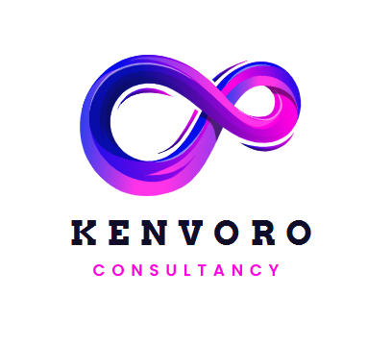
Contents
Executive summary 3
Introduction 5
Background of The Ritz London 5
Background of Kenvoro consultancy 5
Overview of theories and frameworks to be used 6
Analysis 6
Description of the issue identified by the hotel 7
STEEPLED analysis 8
SWOT analysis 12
TOWS matrix 13
Recommendations and Change Management 15
Costs associated with the strategy implementation 20
Action plan 20
Conclusion 23
References 25

Executive summary
The development of the tourism and hospitality industry has been significant over the years specifically after the COVID-19 Pandemic. There have been a number of organisations who have been experiencing issues in developing their hospitality businesses post-pandemic and they require consultancy services to develop strategic approaches for acquiring better competitive advantages. The focus of this report has been on providing consultancy services and strategic recommendations to The Ritz London which is one of the iconic hotels operating in Mayfair in London. Kenvoro consultancy has focused on identifying the specific issues that are being experienced in the organization post-pandemic which has resulted in the high employee turnover rate and the decline of the quality of the services that are being offered to the guests in The Ritz.
The presentation of the business report has been divided into two major segments where the first segment has analysed the issue by understanding the internal and the external business environment. The different factors that are resulting in the causes of the issues experienced by the Ritz have been identified in this specific section. The report has focused on using the STEEPLED analysis, SWOT analysis and TOWS matrix analysis. It has been used to understand the different opportunities and challenges that are present in the internal and external business environment of The Ritz in the hospitality industry of the United Kingdom. It has been identified that the social changes and economic fluctuations in the United Kingdom are resulting in major challenges for the organisation. However different aspects are providing numerous opportunities for growth to the company that can be effectively capitalized and used as an opportunity for growth for the organisation in the industry. This specific section has presented the reasons why different strengths can be used for using the opportunities available in the market and the reasons why the weaknesses can be addressed with the opportunities. Furthermore, it has also focused on identifying the ways in which the strengths can be used to eliminate the threats that are present in the market while identifying the challenges that can be further experienced because of the weaknesses that align with the threats in the industry.
On the basis of the different aspects of opportunities and challenges that are present in the market that have been identified in the previous sections the primary section of recommendation and change management have provided strategic recommendations for the business. It has been identified that The Ritz can focus on personalizing the services to the customers with the help of data collection and artificial intelligence. This can offer exclusive services that align with the needs and requirements of the consumers in the market and promote their satisfaction level with the company. It has also been identified that the company needs to focus on investing in digital technologies that can help increase accuracy and provide predictive analytics for the business. The application of Kotter's eight-step change management model has been recommended to the organisation, which can contribute to efficient change management facilities with maximum transparency with the employees. The report has presented the ways in which this can help to reduce the level of resistance that the hotel has been experiencing in terms of modernization. The study has presented the significance of the sustainable initiative that needs to be incorporated in the hospitality industry and further growth of companies like The Ritz. Furthermore, the views in which the organisation can focus on using employee development and employee engagement for reducing the increasing level of Employee turnover rate has been identified in the study. The different ways in which it is expected that the organisation can focus on using marketing campaigns to attract more stakeholders and address the increasing losses over the years have been identified in the study. The overall cost that would be required to incorporate the changes within the organisation has been presented for a clear understanding to the management of The Ritz. Along with these, the study has presented an action plan to identify the different strategic activities that can be incorporated to address specific problems within the organisation. The visual representation of the action plan has been developed in a way that it is possible to understand the desired outcomes for the specific problems and the strategies that are being incorporated. The time frame that will be required for achieving individual goals has been presented in the visual representation along with the estimated cost that would be required for incorporating the changes. The study is a complete evaluation of the major problems that are being experienced by The Ritz and proper consultancy to promote the strategic opportunities available for the business by using market resources. It presents the significant factors that would determine the long-term growth of an iconic hotel in London that has been experiencing a major loss in the past few years because of the pandemic. A number of organisations have been able to capture the market growth opportunities that are currently present in the hospitality industry when tourism is developing again after the stagnant growth during the pandemic. It is believed that the consultancy recommendations for the business will play a very important role in the long-term development.

Introduction
The hospitality industry in the contemporary business environment is becoming highly competitive with more organisations offering high-quality services. The margin of errors present for organisations in the hospitality industry is therefore constantly reducing and companies are identifying ways to improve their service qualities. The focus of this specific report will be to evaluate the issues that are being experienced in the business operations of The Ritz London, a luxury five-star hotel operating in Mayfair, London. It has been observed that the employee turnover rate in the organisation has increased post-pandemic along with a strong decline in the quality of the services. This is resulting in a number of problems for the organisation internally and externally that can negatively influence the competitive advantages of the organisation in the highly competitive hospitality industry.

Background of The Ritz London
The Ritz London operates not only as a five-star luxury hotel in London but it is also a symbol of high society and luxury. It is one of the world’s most prestigious and best-known hotels that is currently operating at 150 Piccadilly in London, England (The Ritz London, 2025). The hotel was founded in 1906 by Caesar Ritz who was a Swiss Hotelier. The hotel gained its recognition during the end of World War I when politicians and different high society individuals started visiting different areas of London. Over the 119 years of its operation, the hotel is known for the quality of hospitality services that appeal to people coming to London all across the globe. It is currently offering 111 rooms along with 23 suites and 3 restaurants.
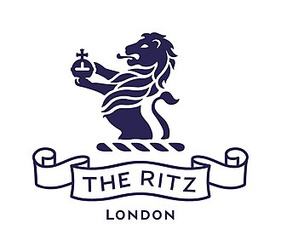
Figure 1: Logo of The Ritz London
(Source: The Ritz London, 2025)

Background of Kenvoro consultancy
Kenvoro Consultancy is a London-based consultancy service that offers businesses with strategic evaluation of their organisations by supporting them in identifying opportunities for growth. The company is known for its expertise in understanding the market environment of the United Kingdom and the factors due to which different organisations have been experiencing a lack of growth in recent years specifically after the COVID-19 pandemic. It is a dynamic consultancy company delivering strategic solutions to corporate organisations all across the globe specifically in the United Kingdom. The company focuses on business transformation, digital innovation and operational excellence to ensure maximum competitive advantages for the clients. The mission of Kenvoro Consultancy is to empower organisations across the globe with data-driven insights and strategic expertise that can promote and facilitate positive changes with sustained growth and better performance.

Overview of theories and frameworks to be used
In order to analyse the issue that has been negatively impacting the growth opportunity of The Ritz London, the following theories and frameworks will be used in this specific report.
STEEPLED analysis
STEEPLED analysis will be used as a strategic planning tool for identifying the different external factors that have been influencing the business operations of The Ritz London. It stands for Social, Technological, Economic, Environmental, Political, Legal and Demographic factors that are present in a specific business environment (Cherunilam, 2021).
SWOT analysis
SWOT analysis is one of the most effective strategic planning tools that helps in identifying different elements that are present in the microenvironment and can influence the internal and the external business environment of a company. SWOT analysis helps in identifying the internal strengths and weaknesses that influences the business along with the opportunities and threats that are present in the external business environment (Pasaribu et al., 2023).
TOWS matrix
TOWS Matrix is also one of the most effective strategic planning tools that expands from the SWOT analysis framework which identifies the relationship between the internal strengths and weaknesses with the external threats and opportunities present in the business environment (Revina, 2021).

Analysis

Description of the issue identified by the hotel
The primary issue that has been identified in the business operations of The Ritz London is the high staff turnover rate that the company has experienced after the covid 19 pandemic and the negative reviews regarding the decline of the quality of the hospitality services (City A.M., 2025). The following is the critical description of the different aspects of the issue that is negatively influencing the growth opportunities of the company in the hospitality industry:
High turnover rate: It has been identified that the turnover rate among the employees in the hotel has been constantly increasing in recent years, especially after the pandemic. There are a number of causes that are resulting in this specific issue and one of the major causes is the dissatisfaction among the employees regarding the culture and the internal environment. In 2023 a major acquisition was faced by the hotel in terms of discrimination when a job applicant was not permitted due to the Afro-style hair which the applicant declined the final interview (BBC News, 2025). The discrimination has been influencing the motivation and the satisfaction of the employees working in the organisation which eventually resulted in choosing other competing companies over The Ritz London. It has also been studied that the dress code enforcement which is highly strict in the HRM of the organisation is being inconsistently enforced and overly strict.
Financial losses: In recent years it has been observed that the hotel has experienced major losses in its financial capabilities and resources specifically after the pandemic. According to the statistics, a pre-tax loss of around £10 million was experienced by The Ritz London in 2023. In 2020 the company experienced a loss of £27.3 million which increased to £32 million in 2021 (City A.M., 2025). Although the losses were reduced £16.5 million loss in 2022 was still a very significant negative figure for the organisation. According to the reports of the organisation and the interviews conducted among different managers it has been observed that the primary reason behind the losses incurred by the organisation is the Covid 19 pandemic (Ntounis et al., 2022). Similar to many other organisations the company has not yet been able to recover the major losses that it experienced in the fiscal year of 2020 and 2021 where travel restrictions were imposed all across the globe.
Dissatisfaction among the guests: There have been a number of factors that have resulted in the issue which is negatively influencing the reputation of the hotel at present. It has been observed that a very significant number of guests have found that the services and the quality do not live up to the reputation of the iconic The Ritz and they have been dissatisfied with the services in comparison to the expectations that they had from the hotel. There has been a number of instances of poor services mentioned in the reviews presented by guests such as being assigned to a wrong room or having a hotel key that can easily work in another room's lock (TripAdvisor, 2025). The issues regarding noise from the street traffic especially at night have also been a major cause of dissatisfaction that can be observed from the feedback provided by the guests. The dress code enforcement that is not only strict for the employees but also for the guests have been criticized especially for the individuals who do not wear formal attire.
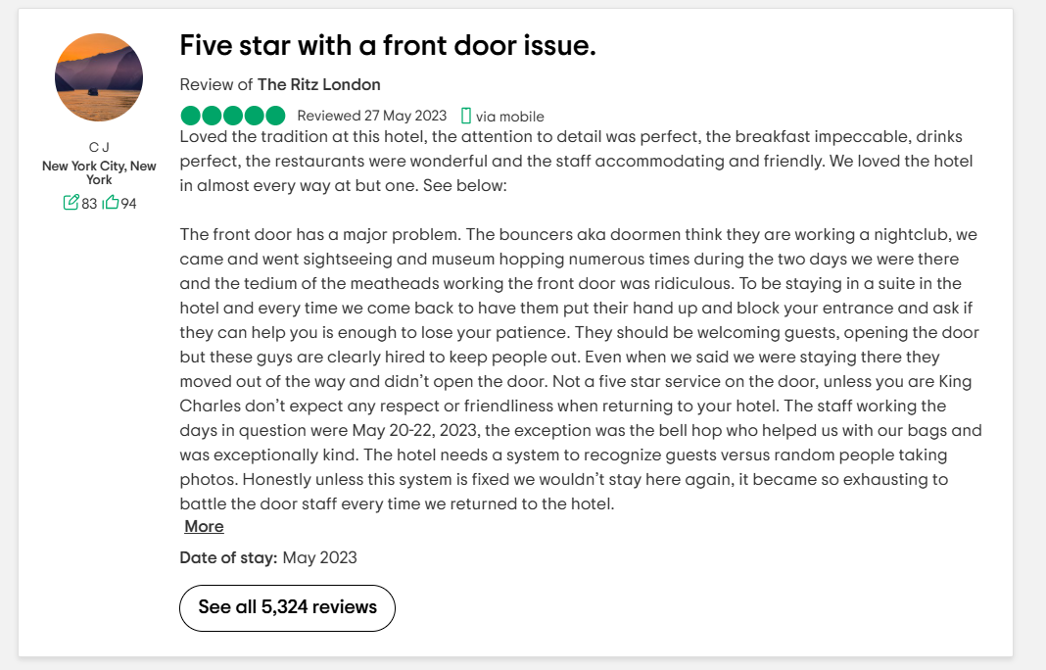
Figure 2: Review provided by a guest at The Ritz London
(Source: TripAdvisor, 2025)

STEEPLED analysis
Social factors | The travel preferences of the communities and the tourists are constantly changing and different trends as ecotourism and staycations are growing in the hospitality industry. This can be an important factor that is influencing the lack of growth for The Ritz London as it operates in the heart of London rather than in an ecological spot that can promote ecotourism activities (Tan and Despotis, 2021). The expectations of consumers for authentic experiences and personalized travel experiences are also a major trend. It can be an influential factor for the hotels in London where customers from the global tourism industry expect to be provided with personalized approaches and services to address their demands. Cultural diversity is an important factor in the hostile industry and the strict regulations regarding the dress codes of formal attires in The Ritz London might become a potential issue in the long run in attracting tourists from different cultural backgrounds (Ioannou and Dukes, 2021).
Technological factors | The development of online booking systems through technology has become a major factor in the growth of the hospitality industry. If the opportunities are available to book the hotel suites and rooms online it influences the satisfaction level and makes the consumers engage more with the hotels (Franzoni et al., 2021). The presence of brands in the digital markets is also a very critical factor that can influence the companies. The presence of digital marketing campaigns for The Ritz London can therefore be a determining factor for the success of the company. In addition to this Gen Z customers prefer companies with strong operational technologies such as the Internet of Things as they believe That the presence of technology will reduce the chances of errors and improve the quality of the services.
Economic factors | The economic stability of a country can influence the hospitality industry in significant ways. According to the data, the economic outlook of the United Kingdom is mixed with a growth forecast of 1% with different risks such as inflation and trade disruptions (Campos et al., 2022). This makes the possibility industry volatile in nature which can result in vulnerabilities for the business operations of different hotels including that of The Ritz London. The high inflation rate in London which is around 3.5% at present is becoming a major challenge for the company in acquiring stability in terms of economic growth.
Environmental factors | The sustainability practices are one of the most important factors in the business environment of the hospitality industry. The majority number of tourists prefer to book their stays in hotels that provide sustainable business practices and services (Nazarian et al., 2024). In addition to this, the local weather of the destination also plays an important role for the tourists to choose the hotels. Since it is known that Mayfair London has proper weather in terms of urban areas it provides an opportunity for growth for the company. However, the increasing level of carbon footprint in the area might influence the tourists to choose hotels that are located in destinations that are free of carbon footprint (George, 2025).
Political factors | The stability of the government is one of the most important political factors that can influence companies such as The Ritz London. The tourism policies in the United Kingdom are in benefit to the tourism industry which is an opportunity for growth for the organisation. However, the regulations and compliances are strict in the UK and failure to comply with these can result in repetitional damages for the organisation in the long run (Sann et al., 2022). In recent years, the company has been experiencing issues because of the problems the UK has been experiencing in international relations. The influx of tourists some certain destinations has reduced after the political distress between the UK and Ukraine.
Legal factors | The different types of laws present in the United Kingdom make it possible for the company to portray a safe tourism environment for tourists. The strong customer protection laws that are being abided by different organisations in the hospitality industry including The Ritz London contribute to the safety measures for tourists (Kichuk et al., 2023). The straight employment laws that are present in the United Kingdom are important to be constantly complied with as noncompliance can result in reparational damages that The Ritz London has already experienced in 2023.
Ethical factors | The code of conducting the hospitality industry is becoming an important factor influencing the tourists. It has been observed that the ethical use of data that is being provided by the customers and the guests must be consistently ensured and the brands are expected to be transparent with the customers regarding the different aspects of the services to maintain ethical standards (Ioannou and Dukes, 2021).
Demographic factors | The demographics in the hospitality industry are constantly changing and with Gen Z consumers, it will be important for companies to focus on being flexible with their approaches and adopt the latest technologies (Ben Youssef and Zeqiri, 2022).
Table 1: STEEPLED analysis
(Source: As created by the author)

SWOT analysis
Strengths | Weaknesses
S1: The iconic brand reputation that it has developed since 1906.  S2: Operating in a central London location in Mayfair with strong landmarks (The Ritz London, 2025).  S3: Affiliated with the membership in the leading hotel Consortia.  S4: The high staff-to-guest ratio helps in maintaining the service level for every guest (Limna, 2023). | W1: High cost of operations and maintenance of high level of staff.  W2: Resistance to the modernisation and incorporation of technology (Ghani et al., 2022).  W3: High dependency on international guests with limited market diversification.  W4: Increasing employee turnover rate along with reducing satisfaction and motivation among employees due to strict and traditional policies (Achmad and Yulianah, 2022).
Opportunities | Threats
O1: Development of sustainable luxury initiatives that promote business opportunities for luxury hotels and hospitality companies (Tanveer et al., 2024).  O2: Increasing preferences of tourists for exclusive and private travel after the pandemic.  O3: Expansion in digital technologies and digital services for better service quality (Crespí-Cladera et al., 2021).  O4: Consistent growth of domestic travel. | T1: High turnover rate along with staff shortage post Brexit.  T2: Increasing economic uncertainties in the UK along with a high inflation rate (Majeed et al., 2022).  T3: Strong competition from boutiques experiential hotels and ecotourism hospitality companies.  T4: Constantly changing guest expectations with changes in the demography (Jawabreh et al., 2022).
Table 2: SWOT analysis of The Ritz London
(Source: As created by the author)

TOWS matrix
 | Strengths (S) | Weaknesses (W)
Opportunities (O) | S1-O2: The Ritz can focus on using its iconic brand reputation to invest in different aspects of exclusive and private travel that are gaining traction in the contemporary tourism environment.  S2-O4: The strength of the organisation in operating in a core and central area of London can help the company attract domestic tourists along with international tourists (Nikopoulou et al., 2023).  S3-O1: The affiliation of the brand with the membership in the leading hotel Consortia can help the organisation in developing different sustainable initiatives that will be recognized by other partnering brands and potential tourists in London.  S4-O3: The high and efficient staff that is present in the organisation can be used for leveraging the digital expansion within the organisation and using technology for the benefit of the business (Djajasinga et al., 2021). | W1-O1: The high cost of operations in the organisation can be efficiently addressed by focusing on developing sustainable initiatives that can reduce the cost of operations in the long run (Burton and Dickinger, 2025).  W2-O3: Focusing on developing digital technologies within the organisation can help in reducing the manual and the traditional operations which tends to resist the modernization approaches.  W3-O4: The weakness of high dependency of the international tourists can be effectively addressed by focusing on the opportunity of increasing significance of domestic travel where domestic tourists are attracted towards the company (Ozturkcan and Kitapci, 2025).  W4-O3: The employee turnover rate can be effectively reduced by making sure that individuals in the organisation are being motivated through digital technologies and their performances are being evaluated with big data ensuring that there are no biases in the employee management.
Threats (T) | S1-T3: The Ritz can focus on using its iconic brand reputation in order to address the issue of competitive threats that it is experiencing from ecotourism hospitality and boutiques. It can use its brand reputation to attract tourists over these competing companies (Zahidi et al., 2024).  S2-T3: The central location in which the companies currently operate can also be used to develop our operating advantage over the other brands. It can make the consumers aware of the high accessibility that they would be enjoying when choosing The Ritz London.  S4-T1: The threat of a high turnover rate and the staff shortage can be effectively addressed by using its high staff-to-guest ratio. By focusing on improving the motivation of these employees the company will be able to obtain a competitive advantage over other companies who are experiencing the challenge of staff shortage (Hayes et al., 2021).  S4-T4: Constantly changing expectations of the guests with the changes in the demography can be addressed by ensuring that the high guests-to-staff ratio can be used to cater to the different types of needs of the guests. | T1-W4: The challenges for the organisation might further increase because of the staff shortage post-Brexit the reduction in employee motivation and the increasing Employee turnover rate that it is currently experiencing.  T2-W1: Due to the economic uncertainties and the high inflation rate the company might experience further challenges in terms of the increasing cost of operations (Varga et al., 2021). This can result in making it difficult for the organisation to acquire effective profit margins.  T3-W3: The strong competition can increase the challenges due to the high dependency of the organisation on international guests and the limited market diversification. It will therefore be important for the organisation to focus on diversifying further and acquiring better growth (Sakas et al., 2022).  T4-W2: Technology has the capability to address the changing guest expectations but the resistance of the organisation to modernization and incorporation of technology can increase the challenges further (Zhu et al., 2023).
Table 3: TOWS matrix of The Ritz London
(Source: As created by the author)

Recommendations and Change Management
In relation to the different aspects of the evaluation that have been considered for The Ritz, the following are some of the major recommendations that can help in addressing the issues it is currently experiencing.
Investing in personalised exclusive services:
It is recommended that the organisation focus on personalising the services that are being provided in its luxury hospitality portfolio. This is because the demographic aspects of the market are constantly changing at the current generation prefers personalised experiences over traditional experiences. It will be important for the organisation to focus on open-mindedly identifying the different ways of becoming flexible in their operations and providing autonomy to the employees in offering personalized services (Ruel and Njoku, 2021). The ethical standards of the market are one of the most important factors that the company will have to consider in relation to the external business environment that has been evaluated. It is therefore recommended that the organisation focus on identifying the needs and requirements of the consumers by obtaining data and feedback. It is also important for the business to ensure that this sensitive information is being protected thoroughly through the incorporation of big data and other types of artificial intelligence (Citak et al., 2021). The presence of information regarding the consumers will help in understanding the preferences of the consumers and thereby promote the opportunity for personalised services that are being offered to them.
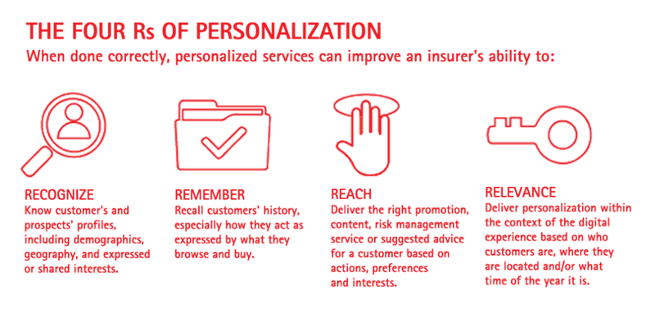
Figure 3: Elements of service personalisation
(Source: Citak et al., 2021)

Investing in digital technologies:
It will be important for the organisation to focus on addressing its resistance to modernising and incorporating digital technologies. It is recommended that the organisation focus on investing in different types of artificial intelligence and big data analytics along with predictive analytics. This will help in providing the business with an opportunity to understand the market with more accuracy in a minimum amount of time (Elkhwesky et al., 2022). This will also promote the opportunity available for The Ritz to personalize the services as per the data obtained from the market environment. In addition to this, digital technologies will promote the opportunities of the organisation to make themselves more visible and accessible to the customers. This is because Digital technologies promote the opportunities of digital marketing. Since it has been identified that the market dynamics and the demographics are changing because of Gen Z consumers, The Ritz will have to focus on investing in digital marketing. It will help in attracting a greater number of potential customers and also diversify its revenue streams from domestic tourists (Gursoy et al., 2022). It will therefore help the organisation in making sure that it is able to address its weakness of over-dependency on international tourists and tap into the market opportunities. Digital technologies will also help in making sure that the evaluation of the performances of individual employees is being considered efficiently in an unbiased way (El Hajal and Rowson, 2021). This will promote their satisfaction with the jobs and will thereby help in reducing the employee turnover rate that the company has been experiencing.
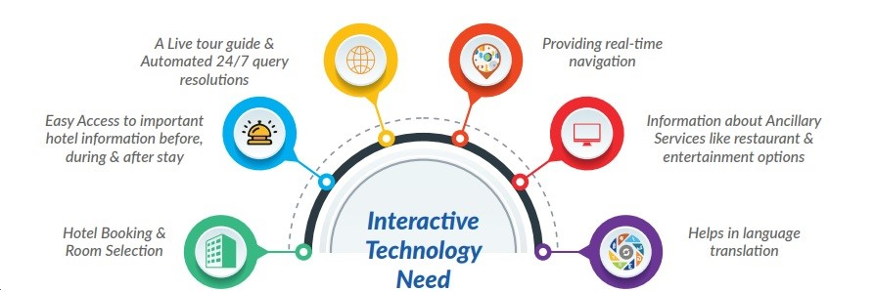
Figure 4: Digital technologies in hospitality industry
(Source: El Hajal and Rowson, 2021)
Application of Kotter's 8-step change management model:
It has been identified that the resistance that is experienced in the internal business operations regarding the change or modernization is a major issue. In order to address this properly the management of the hotel will have to properly communicate the changes that could be incorporated to address the problems (Palrão et al., 2023). The application of the eight-step change management model will provide a chronological framework to the organisation in making sure that the changes are being properly communicated in a transparent way. It will thereby make the individual employees understand the significance of the changes that are being incorporated and make them resist the changes less. The framework will also help in making sure that the changes are being incorporated in an evidence-based approach which would eliminate any chances of experiencing assumptions or presumptions (Elkhwesky et al., 2022).
Investing in sustainable initiatives:
It is recommended that the hotel focus on investing more in sustainable initiatives in the modern hospitality industry. It has been studied from the analysis that consumers are attracted towards organisations and brands that promote sustainable services in their hotels. Therefore, if the company progresses in modernizing its operations with the help of sustainable initiatives it will not only promote the ESG aspects of the business but it will also help in attracting one number of potential consumers (Lensen et al., 2025). This specific strategy approach will be of great benefit to the organisation in the long run as it will reduce the cost of operations without compromising the quality. The application of sustainable initiatives can be considered along with the cost leadership strategy approach that will help introduce the high overhead cost and the operational costs that reduce the proper margins of the business. It will therefore help the organisation in making sure that the percentage of loss that it has been experiencing over the years due to the negative impact of the pandemic can be efficiently addressed.
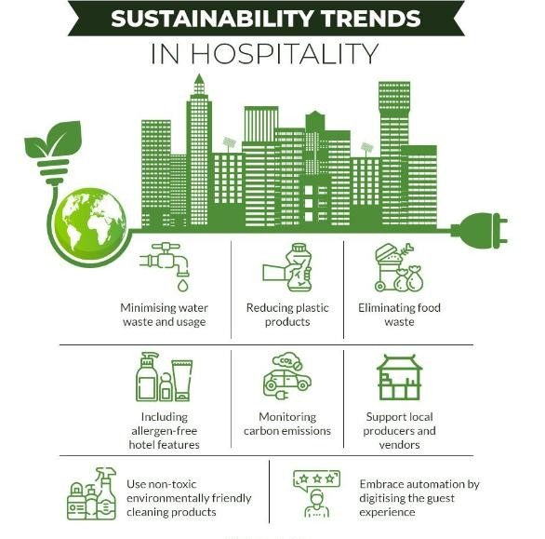
Figure 5: Sustainability trends in hospitality industry
(Source: Lensen et al., 2025)
Employee development and engagement:
It is recommended that the organisation focus on the consistent development of the employees within the organisation and engaging them with operational strategies with different approaches. Identifying the areas of skill development that are required among the employees will not only help in improving the level of service quality but will also promote motivation among the employee base (Gajić et al., 2024). The presence of development opportunities intrinsically motivates the employees in different ways as has been observed in different cases of other organisations. Motivating the employees will address the high turnover rate that it has been experiencing and the lack of job satisfaction. It is also important for the organisation to consider the application of different technologies for identifying the performance of the employees and providing them with different types of rewards that can keep them engaged and motivated within the organisation.
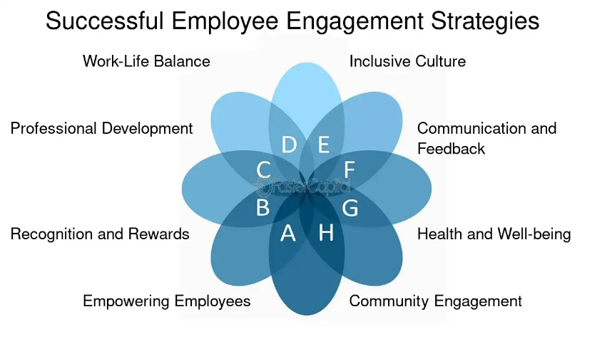
Figure 6: Employee engagement strategies
(Source: Gajić et al., 2024)
Leveraging the brand image:
It has been observed that there are different aspects of the brand image that have been negatively impacted because of the reputational damages it experienced in the issues and scandals in the past few years. It will be important for the organisation to focus on regaining the trust of the tourists regarding the brand value and the positive approaches that are being focused on by the organisation (Parvez, 2021). This will also be of significant value for the organisation to address the competitive disadvantage that it has been experiencing from different organisations operating as per the needs and requirements of the consumers. It is important for the organisation to focus on developing different types of marketing campaigns that can help in leveraging the brand and making the consumers aware of the new changes that have been incorporated. It will also be of critical significance in increasing the revenue of the organisation by increasing the flow of tourists when the tourism industry is experiencing a post after the pandemic to recover the losses.
Diversifying the revenue streams:
It is recommended to The Ritz to focus on diversification of the continuous streams for focusing on expanding the services in the tourism industry. It can focus on catering to the specific needs of environmentally conscious domestic tourists by offering them tailored ecotourism services that not only include stays but also other types of tourism across London. Since the company is operating in one of the core areas of London that has strong accessibility it could be a major opportunity for the organisation to utilize the strengths as well as the market opportunity (Deng and Zhou, 2022). It will help the organisation make sure that it can reduce its dependency on international tourists while using the growing interest of tourists in eco-tourism activities. The package tours that can be obtained by the guests when they choose The Ritz over other organisations can be measured unique selling proposition or value proposition for the organisation. The brand image will play a major role where the majority of the tourists will prefer The Ritz over other small-scale businesses that do not have the experience of operating in the hospitality industry in comparison to that of The Ritz.

Costs associated with the strategy implementation
Strategy | Estimated Cost (GBP)
1. Personalized Exclusive Services | £100,000 – £150,000
2. Digital Technologies Investment | £200,000 – £300,000
3. Kotter’s 8-Step Change Management | £30,000 – £50,000
4. Sustainable Initiatives | £250,000 – £500,000
5. Employee Development and Engagement | £80,000 – £120,000
6. Marketing campaigns | £40,000 – £60,000
7. Diversification of revenue streams | £70,000 – £100,000
Total | £770,000 – £1,280,000
Table 4: Estimated cost of strategic implementation
(Source: As created by the author)

Action plan
Number | Problem | Solution | Desired outcome | Time scale | Completion date | Planned budget
 | Dissatisfaction among customers | To provide personalized exclusive services that can cater to different needs. | It will provide better satisfaction to the customers by improving the quality of the services that are being offered by the hotel. | 6 months | 15.11.2025 | £100,000 – £150,000
 | Lack of digital technologies | To invest in digital technologies that align with the needs and requirements of the business. | It will promote the opportunity to reduce the chances of errors and improve accuracy as well as the quality of the services. | Three months three months | 10.10.2025 | £200,000 – £300,000
 | Resistance to change | To implement the 8-step change management model and obtain effective as well as transparent change management. | It will reduce the chances of experiencing resistance to modernisation and technological changes that can promote opportunities for growth for the hotel. | Three months | 12.09.2025 | £30,000 – £50,000
 | Lack of sustainable initiatives | To invest in sustainable initiatives that can promote the ESG positioning of the business and attract stakeholders. | It can improve the ESG positioning of the organisation which will reduce the cost of operations and attract potential stakeholders to the business for better profit margins. | 8 months | 15.02.2026 | £250,000 – £500,000
 | High employee turnover rates and employee dissatisfaction | To incorporate employee development and engagement strategies that will promote their motivation and satisfaction in the jobs in The Ritz | It will reduce dissatisfaction among the employees and retain them more efficiently in the organisation while motivating them to achieve the strategic goals of the business consistently, | 5 months | 10.11.2025 | £80,000 – £120,000
 | Reduction in the inflow of guests | To develop effective marketing campaigns in traditional and digital platforms for reaching consumers from different ethnicities and demographics. | It will increase the visibility of the brand in the market and attract more potential guests from domestic as well as international markets. | 6 months | 20.12.2025 | £40,000 – £60,000
 | Over-dependency on international tourists as the only revenue stream | To diversify the revenue streams and focus on different areas of business development for the needs and requirements of the market. | It will reduce the dependency of the hotel on international tourists and focus more on the domestic and other areas of tourism operations. | 10 months | 05.04.2026 | £70,000 – £100,000
Table 5: Action plan for the strategic implementation in The Ritz London
(Source: As created by the author)

Conclusion
From the overall analysis of the report, it can be stated that the contemporary hospitality industry is ever-changing and different factors contribute to the dynamics of the market environment. The critical evaluation of the external business environment shows that there are a number of opportunities available for businesses that have strong footholds in the industry to acquire consistent growth in the long run along with strong competitive advantages. It can be concluded from the analysis of the study The Ritz London needs to focus on its development in different areas to address the high employed all over rate and the decline in the quality of the services that it has been experiencing post-pandemic. The inefficiency of the organisation in modernizing itself as per the needs and the development of the market that is cost because of the high level of internal resistance is one of the primary causes of the issue. It will be important for the business to focus on developing itself with the latest technology such as artificial intelligence and big data that has been identified in the study. These will help the organisation increase accuracy and efficiency in boosting the quality of the services that it is offering to the consumers in the market. It can also be concluded that the employees are also an important part of the stakeholder group that the company needs to focus on. It will be necessary for the business to improve the motivation level and the satisfaction level of these employees who are known to be one of the primary factors contributing to the growth of the business. Promoting their satisfaction with the help of proper performance evaluation that includes the application of the technologies can develop a stronger engagement level among the employees. The biases and the discrimination that has been experienced in the organisation has been one of the primary factors that negatively impacted the reputation. The incorporation of technology that focuses on evaluating the capabilities of the individuals working in the business will therefore help in addressing the discrimination issues that it has experienced over the years. It can also be concluded from the analysis that the overhead costs and the operational costs are becoming a reason for the organisation to acquire profit margins. Hence, it can be concluded that the recommendation of sustainable initiatives and cost leadership strategy would help the business in reducing the overall cost of operations without compromising the quality of the services that it provides to the guests. Therefore, it can be concluded that in the contemporary hospitality industry organisations are expected to focus on aligning themselves with the growing trends of digital technologies and the changing consumer demographics. It is important for businesses to ensure that they are able to align themselves with sustainable initiatives and focus on the positive development of the environment in order to attract more potential consumers towards the brands and make them feel a part of the positive changes. It can also be concluded that organisations must focus on developing the employees and their motivation in the business by providing them with flexibility and refraining from restricting them with strict policies. These factors can contribute to the competitive advantages of the organisations operating in the market and promote their capabilities of acquiring better growth.

I confirm that I have not used any AI tools in the research and creation of this assignment. I confirm that I have not presented any AI generated materials as my own work. I confirm I have copies of my drafts, notes, and other resources I used, which I may be asked to provide in evidence.

References
Achmad, W. and Yulianah, Y., (2022). Corporate social responsibility of the hospitality industry in realizing sustainable tourism development. Enrichment: Journal of Management, 12(2), pp.1610-1616.
BBC News, (2025). UK England London News: The Ritz London. Available at: https://www.bbc.com/news/uk-england-london-65242398 (Accessed: 10 June 2025).
Ben Youssef, A. and Zeqiri, A., (2022). Hospitality industry 4.0 and climate change. Circular Economy and Sustainability, 2(3), pp.1043-1063.
Burton, A.M. and Dickinger, A., (2025). Innovation in Crisis. The role of leadership and dynamic capabilities for a more innovative hospitality industry. International Journal of Hospitality Management, 124, p.103946.
Campos, F., Lima Santos, L., Gomes, C. and Cardoso, L., (2022). Management accounting practices in the hospitality industry: a systematic review and critical approach. Tourism and Hospitality, 3(1), pp.243-264.
Cherunilam, F., (2021). Business environment. Himalaya Publishing House Pvt. Ltd.
Citak, J., Owoc, M.L. and Weichbroth, P., (2021). A note on the applications of artificial intelligence in the hospitality industry: preliminary results of a survey. Procedia Computer Science, 192, pp.4552-4559.
City A.M., (2025). The Ritz losses continue at iconic London hotel. Available at: https://www.cityam.com/the-ritz-losses-continue-at-iconic-london-hotel/#goog_rewarded (Accessed: 10 June 2025).
Crespí-Cladera, R., Martín-Oliver, A. and Pascual-Fuster, B., (2021). Financial distress in the hospitality industry during the Covid-19 disaster. Tourism Management, 85, p.104301.
Deng, F. and Zhou, C., (2022). Sustainable development of corporate governance in the hospitality and tourism industry: the evolution and the future. Sustainability, 14(7), p.4286.
Djajasinga, N.D., Sulastri, L., Sudirman, A., Sari, A.L. and Rihardi, E.L., (2021, June). Practices in human resources and employee turnover in the hospitality industry. In 2nd Annual Conference on blended learning, educational technology and Innovation (ACBLETI 2020) (pp. 113-117). Atlantis Press.
El Hajal, G. and Rowson, B., (2021). The future of hospitality jobs: The rise of the gig worker. Research in Hospitality Management, 11(3), pp.185-190.
Elkhwesky, Z., Salem, I.E., Ramkissoon, H. and Castañeda-García, J.A., (2022). A systematic and critical review of leadership styles in contemporary hospitality: a roadmap and a call for future research. International Journal of Contemporary Hospitality Management, 34(5), pp.1925-1958.
Franzoni, S., Sarwar, H. and Ishaq, M.I., (2021). The Mediating Role of HRM in the Relationship between CSR and Performance in the Hospitality Industry. Sustainability, 13(24), p.13699.
Gajić, T., Ranjbaran, A., Vukolić, D., Bugarčić, J., Spasojević, A., Đorđević Boljanović, J., Vujačić, D., Mandarić, M., Kostić, M., Sekulić, D. and Bugarčić, M., (2024). Tourists’ willingness to adopt AI in hospitality—Assumption of sustainability in developing countries. Sustainability, 16(9), p.3663.
George, R., (2025). Marketing tourism and hospitality: Concepts and cases. Springer Nature.
Ghani, B., Zada, M., Memon, K.R., Ullah, R., Khattak, A., Han, H., Ariza-Montes, A. and Araya-Castillo, L., (2022). Challenges and strategies for employee retention in the hospitality industry: A review. Sustainability, 14(5), p.2885.
Gursoy, D., Malodia, S. and Dhir, A., (2022). The metaverse in the hospitality and tourism industry: An overview of current trends and future research directions. Journal of Hospitality Marketing & Management, 31(5), pp.527-534.
Hayes, D.K., Hayes, J.D. and Hayes, P.A., (2021). Revenue management for the hospitality industry. John Wiley & Sons.
Ioannou, G. and Dukes, R., (2021). Anything goes? Exploring the limits of employment law in UK hospitality and catering. Industrial Relations Journal, 52(3), pp.255-269.
Ioannou, G. and Dukes, R., (2021). Anything goes? Exploring the limits of employment law in UK hospitality and catering. Industrial Relations Journal, 52(3), pp.255-269.
Jawabreh, O., Shniekat, N., Saleh, M.M.A. and Ali, B., (2022). The strategic deployment of information systems attributes and financial performance in the hospitality industry. Information Sciences Letters, 11(5), p.110504.
Kichuk, Y., Filipishyna, L., Ivanov, A., Hopkalo, L., Konarivska, O. and Soloviova, O., (2023, November). Innovation management in the hospitality industry. In IOP Conference Series: Earth and Environmental Science (Vol. 1269, No. 1, p. 012007). IOP Publishing.
Lensen, J., IJsselmuiden, J. and Westerlaken, R., (2025). The future of hospitality management: adapting to Generation Z’s values and preferences. Research in Hospitality Management, 15(2), pp.98-101.
Limna, P., (2023). Artificial Intelligence (AI) in the hospitality industry: A review article. International Journal of Computing Sciences Research, 7, pp.1306-1317.
Majeed, M., Asare, C., Fatawu, A. and Abubakari, A., (2022). An analysis of the effects of customer satisfaction and engagement on social media on repurchase intention in the hospitality industry. Cogent Business & Management, 9(1), p.2028331.
Nazarian, A., Shabankareh, M., Ranjbaran, A., Sadeghilar, N. and Atkinson, P., (2024). Determinants of intention to revisit in hospitality industry: A cross-cultural study based on globe project. Journal of International Consumer Marketing, 36(1), pp.62-79.
Nikopoulou, M., Kourouthanassis, P., Chasapi, G., Pateli, A. and Mylonas, N., (2023). Determinants of digital transformation in the hospitality industry: Technological, organizational, and environmental drivers. Sustainability, 15(3), p.2736.
Ntounis, N., Parker, C., Skinner, H., Steadman, C. and Warnaby, G., (2022). Tourism and Hospitality industry resilience during the Covid-19 pandemic: Evidence from England. Current Issues in Tourism, 25(1), pp.46-59.
Ozturkcan, S. and Kitapci, O., (2025). A sustainable solution for the hospitality industry: The QR code menus. Journal of Information Technology Teaching Cases, 15(1), pp.2-7.
Palrão, T., Rodrigues, R.I., Madeira, A., Mendes, A.S. and Lopes, S., (2023). Robots in tourism and hospitality: the perception of future professionals. Human Behavior and Emerging Technologies, 2023(1), p.7172152.
Parvez, M.O., (2021). Use of machine learning technology for tourist and organizational services: high-tech innovation in the hospitality industry. Journal of Tourism Futures, 7(2), pp.240-244.
Pasaribu, R.D., Shalsabila, D. and Djatmiko, T., (2023). Revamping business strategy using Business Model Canvas (BMC), SWOT analysis, and TOWS matrix. Heritage and Sustainable Development, 5(1), pp.1-18.
Revina, A., (2021). Business process management: Integrated data perspective. A framework and research agenda.
Ruel, H. and Njoku, E., (2021). AI redefining the hospitality industry. Journal of Tourism Futures, 7(1), pp.53-66.
Sakas, D.P., Reklitis, D.P., Terzi, M.C. and Vassilakis, C., (2022). Multichannel digital marketing optimizations through big data analytics in the tourism and hospitality industry. Journal of Theoretical and Applied Electronic Commerce Research, 17(4), pp.1383-1408.
Sann, R., Lai, P.C., Liaw, S.Y. and Chen, C.T., (2022). Predicting online complaining behavior in the hospitality industry: Application of big data analytics to online reviews. Sustainability, 14(3), p.1800.
Tan, Y. and Despotis, D., (2021). Investigation of efficiency in the UK hotel industry: A network data envelopment analysis approach. International Journal of Contemporary Hospitality Management, 33(3), pp.1080-1104.
Tanveer, M.I., Yusliza, M.Y. and Fawehinmi, O., (2024). Green HRM and hospitality industry: challenges and barriers in adopting environmentally friendly practices. Journal of Hospitality and Tourism Insights, 7(1), pp.121-141.
The Ritz London, (2025). The Ritz London. Available at: https://www.theritzlondon.com/ (Accessed: 10 June 2025).
TripAdvisor, (2025). User review of The Ritz London. Available at: https://www.tripadvisor.in/ShowUserReviews-g186338-d187591-r892196951-The_Ritz_London-London_England.html (Accessed: 10 June 2025).
Varga, S., Mistry, T.G., Ali, F. and Cobanoglu, C., (2021). Employee perceptions of wellness programs in the hospitality industry. International Journal of Contemporary Hospitality Management, 33(10), pp.3331-3354.
Zahidi, F., Kaluvilla, B.B. and Mulla, T., (2024). Embracing the new era: Artificial intelligence and its multifaceted impact on the hospitality industry. Journal of Open Innovation: Technology, Market, and Complexity, 10(4), p.100390.
Zhu, J.J., Liu, Z., Huang, T. and Guo, X.S., (2023). Roboethics of tourism and hospitality industry: A systematic review. Plos one, 18(6), p.e0287439.

