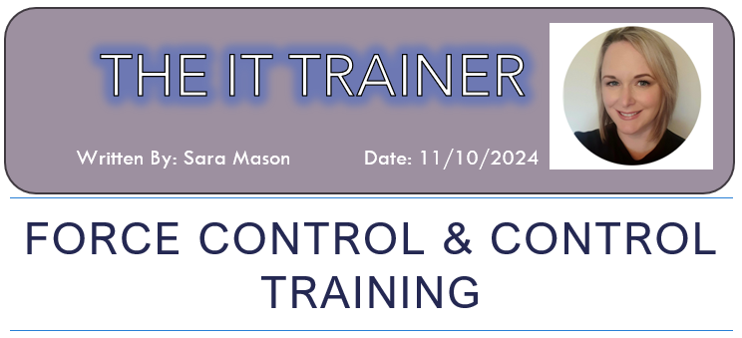

I joined Gwent Police in 2012, having spent almost ten years as an operational Police Community Support Officer (PCSO) and two years as a PCSO Trainer, I only knew how to listen to the police radio, follow instructions from dispatchers and bounce between 999 and 101 calls, and that was in between visiting community groups (and filling up on copious amounts of tea and cake), litter picks, community projects, and producing fifteen long-winded reports for my local community councils every month. I had no idea what went on ‘behind the scenes’ in the control room, and how those ‘heroes in headsets’ were juggling hundreds of calls, and tens of officers 24 hours a day, 7 days a week. It was something I took for granted…
I transferred to the IT Training team in January 2024, initially to develop training packages for (and deliver) the STORM logging system and the NICHE data management system, and it became apparent straightaway that my new colleagues had all started their Gwent Police careers years before in the Force Control Centre as Call Handlers and Dispatchers. They knew all the processes, buzz words, and acronyms, so delivering training on STORM and NICHE was a breeze for them. I however sat there trying to understand what they were talking about along with what needed to be done, and quietly regretting my move as imposter syndrome slowly started to creep in. This feeling became more prominent on a visit to the South Wales Police Headquarters, and Cheshire Police Headquarters when meeting new people and other trainers, all of whom, again, came from a Call Centre background. Thankfully my supervisor noticed me quietly hiding in the corner and knowing that I do experience extreme anxiety very often, she sat me down to have a one-to-one chat, which allowed me to open up about how I was feeling, and my concerns over the role. The importance of doing this can be found here.
Anxiety at work: 6 steps to supporting employees
At the end of our discussion, my supervisor suggested that I join the next cohort for the Call Handling training so that I could familiarise myself with the processes, and most importantly with STORM – the system that I was moved to the IT training department to develop and train.
The website for the system can be found here: https://www.soprasteria.co.uk/technology/storm
At the beginning of September 2024, I made my way to Headquarters to meet the group that I would be training with. I had missed the first three days of training (as it was an induction for new staff) so the group had already met each other, learned names, backgrounds and developed a bond. As I walked into the classroom on day four with my files and coffee cup, I clocked a PCSO colleague who I had worked with previously, it was also her first day due to not having to attend the induction. It was at this point I thought that the trainer should have at least done an icebreaker as both of us were entering the ‘Forming’ phase of the group dynamic (Tuckman 1965), instead a quick introduction explaining how I was an IT Trainer who would be observing the course to familiarise myself with the Control Room processes seemed to be enough, which on reflection affected my relationship with the group as I was seen as ‘another trainer’.
As the weeks went on, I started to become more confident in understanding the role. Processes and acronyms started to become clearer, and I was finally able to understand what my team were talking about all those times previously. A variety of topics was covered including grading calls, making decisions (which is not my strong point), dealing with traffic collision reports, domestic violence reports, to name a few, but also how they linked into NICHE, which was a programme that I was already familiar with and had already been delivering the training for to new staff. I was given a brand-new headset, and we proceeded to take ‘pretend’ calls from each other and creating ‘mock’ incidents on the STORM training system – I started to think that this could be a new career path for me as the adrenaline kicked in and my incident creation list creeped up. This feeling of a possible career move gained traction as we headed into the Force Control Centre to listen in to live calls that were coming in, this included both 999 and 101 calls. After sitting with different Call Takers and Dispatchers, and having the opportunity to share advice and my own experiences of being a PCSO, I felt that my confidence had soared, and I would soon be ready to take my own live call.
During the final week of classroom training, we all sat in anticipation as we all took in turns to be ‘hooked into’ the live system. Soon enough it was my turn. The idea is to make sure that everyone’s first live call is a 999, so that the anxiety of taking one is dealt with straightaway. I anxiously waited for my first call, another student who had transferred from a different force so was already experienced sat next to me listening in and waiting to jump on and offer advice if I required it. Expecting it to be a 999 my first call was a diverted 101, so very quickly I had to remember the different greeting (which includes speaking Welsh) and listen carefully to what the caller was saying. The call was about a member of the public who was causing a nuisance, and I managed to take enough information to transfer the call to dispatch quickly. It was a relief to see a PCSO call sign had been allocated and was updating the log before I finished my own update. My sense of relief was short lived as my phone rang again, this time a 999 call about a Road Traffic Collision.
Now, having taken these calls, and the worry that comes with ensuring you have taken all the correct details and locations, I soon realised that maybe Call Handling was not for me for the time being – however, the training was very beneficial as I now have a much better understanding of the system which I have already implemented into my training plans and lesson material for the new SmartSTORM system that is coming in January 2025.
References:

Benstead, S. (2023) Anxiety at work: 6 steps to supporting employees. Available at: https://www.breathehr.com/en-gb/blog/topic/mental-health/6-steps-to-supporting-an-employee-with-anxiety#:~:text=Anxiety%20at%20work%3A%206%20steps%20to%20supporting%20an,...%206%20Champion%20a%20mental%20health-friendly%20culture%20 (accessed: 17th October 2024)
Hughes, M. (2020) Forming, Storming, Norming and Performing. Available at: https://www.mindtools.com/abyj5fi/forming-storming-norming-and-performing (accessed: 17th October 2024)
Imaged sourced from: https://pixabay.com/illustrations/call-center-headset-woman-service-8643476/ (https://pixabay.com/users/geralt-9301/) (Accessed: 22nd November 2024)
Sopra Steria (2024) STORM Available at: https://www.soprasteria.co.uk/technology/storm (Accessed: 5th December 2024)

(1070 words)

