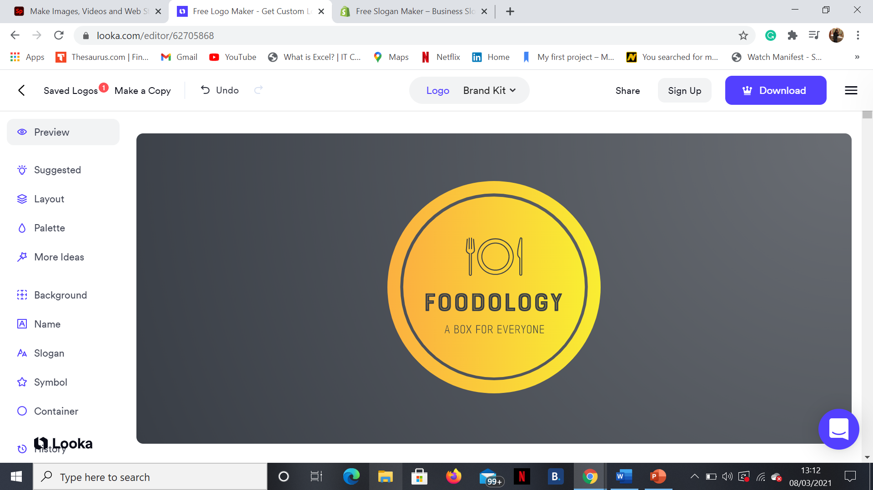

Marketing in Practice
  - Assignment 2 – Vegan Food box campaign proposal
Lareesa Young | 1901947 | 12/05/21

Executive summary
In this report we will discuss different type of channels that we are going to use in a campaign to promote our new vegan subscription box. In this campaign we need to achieve 5,000 new members in one month. We will achieve this by using different type of communication channels such as social media, Public Relations and Billboards. We will ensure we stay within our £50,000 budget by creating a budget list where all our out goings will be written down. We found that the total cost of all social media channels cost around £1,570 this will include a Tiktok in feed ad and an Instagram feed advertisement along with influencers. We then found that a Google Search advert will cost us roughly, £25,000. This is the most expensive channel for us however, we believe it is going to be the most effective where it draws in the most customers at around 20%. We then have offers on our vegan boxes where we have offered the first 1,500 customers 20% and 10% off one food box. This channel is looking quite strong for us as it is found that many individuals love an offer, and it is the pushing point for them to purchase. The next out channels are billboard and flyer where we will spend £5,116. This is quite a high price range as we are going to have our advertisements on bus stops and billboards in London and Bristol. These will be effective as the footfall past these places will be very high and we hope people will be intrigued by what they see. Finally, our last channel is hiring a public relations freelancer/ agency which will cost us £600. To conclude, to be successful with our campaign all these channels need to work together to advertise our new box to get the word out and to maximize the efficiency of them all.

Contents
Executive summary 1
Vegan Food Box proposal 2
Our Objective 2
Target Audience 2
Channels and campaign ideas 2
Tiktok 3
PR 3
Instagram 4
Billboard 4
Offers and Flyers 5
Google marketing 5
measuring the performance 6
Budgeting Chart 6
Conclusion 7
recommendations 7
Reference list 8

Vegan Food Box proposal

OUr Objective
Our objective for our new vegan food subscription box is to achieve 5000 new members in one month with a £50,000 budget.

Target Audience
Foodology has developed a new vegan-friendly range and we wish to produce a campaign to promote it. We have a budget of £50,000 and we need to have 5,000 new members. According to the website finder,1,545,899 people in the UK follow a vegan diet and is set to increase to 3,589,629 by the end of 2021. Studies also show that Generation z is currently leading the way for people who are intending to adopt a meat-free lifestyle in 2021, with 25% planning to ditch meat in the previous new year (Johnson, 2021). This means this is a huge market that is continuously growing. From this information, we had decided to target 16–24-year old’s. The message we want to show is how quick and easy these vegan boxes are to make as well as emphasizing how tasty and fresh all the ingredients are. We also know how hard it is for vegans to find a suitable meal as some companies do not accommodate vegans, so we also want to emphasize how our box is suitable for everyone. In all of our advertisements, we want to show how easy it is to sign up for our subscription and how doing this it will solve the problems of not knowing what to eat or no time to go out food shopping. Our Buyer Persona is Sophie a 19-year-old Vegan, she is a full-time student studying at university. Sophie is always extremely busy with all her university work. At 10pm every night Sophie has time to scroll through her social media platforms such a Tiktok and Instagram, where she can look at all her favourite social media influencers. She notices her favourite influencer has posted a video on a Foodology vegan food box, she continues to watch the video and extremely intrigued. Sophie knows this would be much cheaper and a lot easier for her to make quickly.

Channels and campaign ideas
The majority of our customers are already using social media therefore it is the most convenient way to advertise our vegan box. According to Digital Report, (2019), there are 45 million UK social media users which are roughly 67% of the population and every day the average UK based user spends 1 hour 50 minutes scrolling through their social media site. Social media’s two-way dialogue allows e-commerce businesses to build online communities and brand ambassadors from their customers which increases positive visibility of their brand. By using two-way dialogue, it will enable Foodology to show off our brand personality, as we will be able to show off our “cultural humor” by posting about our Vegan box on our platforms for customers to interact with (Trek Marketing, 2018). If we share high-quality content on our platforms with user-generated content and customer reviews it will build customer trust and brand authority which will enable our new customers to trust us and either engage with us or place an order with us (McGrath, 2021).

Tiktok
One social media channel to focus on currently is Tiktok, as there are currently 3.7 million users in the UK, and it is the 7th most active social media app in the world. The largest share of users in the UK is the age group 18-24 (26%) which means we have a good chance of reaching our target audience by using this app (Bendix, 2020). We could use Tiktok to create videos about our vegan meal boxes, perhaps videos on how to prepare and make the food in a step-by-step guide to show how easy it is to put together. We would then use Hashtags to reach a wide-scale audience and from which we will then hopefully appear on users foryou pages.
We would also like to do an In-Feed-Ad where we will use a friendly, fun, and exciting tone of voice for our customers to notice that we are a fun and exciting brand and hopefully they will be intrigued and what to try our brand out. We will even post-call to actions to help gain engagement with our vegan box by encouraging users to shop now or visit our website right from Tiktok. This will hopefully give our target audience the push they need to visit our website to place an order. We do understand that Infeed ads can be ignored, which means we need something eye-catching in the first 2-3 seconds of the ad popping up (Jessica worb, 2020). We will also try to send a vegan box to social media influencer Fearne Cotton with 3.3 million followers to target a bigger audience as our influencer (Cotton, 2021).
Tiktok ads pricing starts at £8 per CPM (Cost per 1000 views). In addition to this, the platform will ask us to throw a minimum of £354 on a campaign. This means the total for this could cost roughly £1,000 This campaign may not be the cheapest option for Foodology, however it is the platform that is going to reach our target audience the quickest (Tiwari, 2021). We will be able to measure how effective the Tiktok ad has been by following the number of clicks onto the website via the Tiktok website link. We will also measure the number of likes and comments on the videos to see what individuals have said, to see how many people our ad has reached. We believe this will bring in roughly 10% of our visitors.

PR
Along with the other channels, public relations are another crucial way to reach our target audience, build our brand awareness and create a positive business image. Instead of competing without marketing efforts, our public relations could supplement and support our other initiatives in a way advertising cannot. Our PR would have to consider developing a PR campaign and try to know and empathize as much as possible with our target audience and provide us with something valuable. If we are successful and have a good PR it will prevent our problems, as one of the key parts of being a PR is to stay on top of what’s being said about our business and they can make sure that information being spread about Foodology is accurate (Mossevelde, 2018). For our campaign I would like to send a press release to some vegan publications, this will cost us roughly £300-£500 for a small agency freelancer. I would like to send these to “vegan Food & Living”, “Simply Vegan”, “Vegan Life” and “Plant-based” (Ravanelli, 2021). We hope this will bring in around 8% of our members.

Instagram
We would like an advertisement on Instagram, as 80% of users on Instagram follow a business or a brand, which shows us that people tend to use Instagram to look at updates from businesses. 42% of the UK’s population are on Instagram, with 54% Female and 46% Male (Battisby, 2019). Instagram charges somewhere around £1.42 per click on an Instagram campaign or if running an ad on cost per mile, then it is likely that we will pay around £3.55 per 1,000 visitors on average. This will cost roughly £550 per ad (Influencer Marketing Hub, 2019). For our Instagram ad, we should have an image or a short video of our vegan box, with some different meals around the picture of the box. It would also be very beneficial if we could get Matt Pritchard’s presenter of “Dirty Vegan” who has 104K followers. As he promotes a vegan lifestyle majority of his followers would perhaps follow in his footsteps. I would like him to perhaps post a couple of images to his Instagram story and feed for his followers to see how good our vegan box is (Pritchard, 2021). We will also measure our Instagram ad through the number of likes and comments made and also the number of clicks on our website link via the Instagram images or video.

Billboard
We will also put a couple of billboard adverts out, the typical standard billboard in the UK costs £600 for 2 Weeks. We would like to have 2 big billboards in close proximity to a local vegan shop or café in London. This will cost me roughly £1,453 for a large-scale billboard of 96 sheets. A huge billboard like this holds greater value to us as it is likely to gain more impressions and have a greater impact. The total for 2 will be £2,906. I would also like to add on 3 smaller bus stop advertisements, which cost £240-£270 for 2 Weeks (Giles, 2016). This will cost us £810, making the total £3,716. We believe this will be a very good type of advertisement as certain Locations in London have a very large number of footfall who pass these billboards all the time. We should perhaps try to look at having the bus shelter advertisements near train stations such as London Piccadilly or even in universities such as Bristol. We would again like to have an image of our vegan subscription box, with some little images surrounding to show what meal options are available to customers who pass by.

Offers and Flyers
We want to provide users with a 20% off offer for the first 500 members that sign up. We have averaged the price of one Vegan box to £4. This means the new price will be £3.20. We will need to budget £400 for the discount boxes. We will then do a further 10% off for the next 1,000 members after the 500 orders, which will mean. The discounted budget for this will also be £400. By giving people a discount, it might be just the thing to draw them in and become a new customer (Valk, 2016).
We would also like to distribute flyers across universities in the Uk. We would like 20,000 leaflets to be distributed between certain universities. To design a flyer, roughly costs £60. We would like the leaflet to be A5 size and double-sided this will cost around £55 per 5,000 leaflets. We would then need to pay for them to be distributed which costs £55 per every 1,000 flyers. The total cost for this would be roughly £1,400. We believe this will gain about 10% of our visitors (Editorial Staff, 2019).

Google marketing
As Google is the world’s most-visited website we should consider using Search Marketing. It is a tactic used to gain online presence and traffic via paid and unpaid strategies on search engines such as Google. When you type text into the search box, you get directed to the Search engine results page. The higher we are on this page the more likely we are to gain traffic to our website. We need to ensure we are one of the top results. Search Marketing is divided into two main categories, 1. SEO-(Search engine Optimization)-which is gaining search engine listings via unpaid tactics and 2. PPC-(Pay-Per-Click or paid advertising)–Gaining search engine listings via paid tactics. There are several things as a company we can do to increase our chances of being ranked organically, this includes rewriting content to match keywords, writing meta tags to match keywords, create more quality content to build authority, get other websites to link onto our website and we need to maintain an active presence on social media to help create external links (wordstream, 2021). The keywords we need to focus on are “Easy to Prepare Vegan Subscription Meal Box”.
We should also try to get a paid search, so when a customer types into Google and is presented with the SERP page. The result we would have paid for will come up with a green box with the word “AD” next to the listing and place us on the top of the listing. An advantage of using this we will be able to measure the ad completely, it will enable us to see how many people have seen the ad and how many people are clicking through the ad to our website (Google, 2019). There are 3.5 billion Google searches made every day (Internetlivestats, 2009) and 35% of product searches start on google (Garcia, 2018), this will mean we achieve at least 20% of our visitors to our website who will go on to sign up to the box. As we plan to spend £25,000 on google ads as we know we have got to get more members to sign up to our service and this is the most targeted way of doing so. If we had 20,000 searches from it, we then will have £1.25 to play with per click.

measuring the performance
We will measure the campaign performance via google analytics, as it will allow us to track many important metrics, which will cover all aspects. We can monitor the effectiveness of our online marketing strategies, onsite content, user experience and device functionality. All these statistics will tell us as a company what is working well and what isn’t. This means once we identify an issue, we can create a solution promptly. The advantages of us using Google Analytics includes that it is completely free, therefore we will not be using any of our budget for this. We will also be able to identify which pages and links our visitors clicked on the most to see which advert was the most effective. Google Analytics also provides visitor segmentation, so with this we can know what number of new visitors that our search engine optimization campaign brings to us, we can then segment our analytic results by categorizing new and returning visitors and referral sources (Seo Yield Voiue, 2021). It will however be hard to measure the effectiveness of the billboards and flyers, however we will try to use the hashtag #Foodologyvegan. We can then use this hashtag to check on different social media platforms to see its effectiveness (Gadek, 2020).

Budgeting Chart
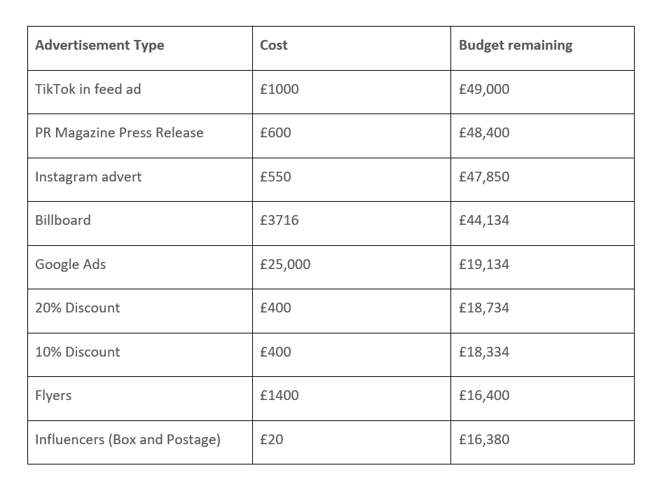

Conclusion
To conclude, we believe to get the best out of this campaign we need to advertise as much as possible to achieve our 5,000 new members with our £50,000 budget. We believe that all the channels we have listed and budgeted for need to be used to maximize the efficiency of the campaign. If all channels work to our expected standard, we will reach our target goal within one month of carrying this out.

recommendations
We personally recommend that you use all the given marketing channels to achieve the best out come and to see the full potential of the campaign. If all are used correctly the success of the campaign will be apparent and our objective of reaching the 5,000 members will be met and we would have stayed within our budget.

Reference list
Battisby, A. (2019). The Latest UK Social Media Statistics for 2019 - Avocado Social. [online] Avocado Social. Available at: https://www.avocadosocial.com/latest-social-media-statistics-and-demographics-for-the-uk-in-2019/.
Bendix, T. (2020). TikTok UK Statistics (2021) | Everything you need to know. [online] Social Films. Available at: https://www.socialfilms.co.uk/blog/tiktok-uk-statistics#:~:text=How%20many%20active%20users%20does.
Cotton, F. (2021). Login • Instagram. [online] www.instagram.com. Available at: https://www.instagram.com/fearnecotton/?hl=en [Accessed 12 May 2021].
Editorial Staff (2019). How much does leaflet advertising cost? - Leaflet Distribution Team. [online] Leaflet Distribution Team. Available at: https://leafletdistributionteam.co.uk/blog/how-much-does-leaflet-advertising-cost/.
Gadek, C. (2020). How Do You Calculate OOH Impressions? [online] Out of Home (OOH) Advertising Blog - AdQuick. Available at: https://www.adquick.com/blog/how-do-you-calculate-ooh-impressions/#:~:text=Hashtag%20Metrics [Accessed 12 May 2021].
Garcia, K. (2018). More Product Searches Start on Amazon. [online] eMarketer. Available at: https://www.emarketer.com/content/more-product-searches-start-on-amazon.
Giles, A. (2016). How much does billboard advertising cost? [online] Bubble. Available at: https://bubbleoutdoor.com/how-much-does-billboard-advertising-cost/#:~:text=Billboard%20rental%20costs%20in%20the.
Google. (2019). What is paid search? | Google Ads | Google UK. [online] Available at: https://ads.google.com/intl/en_uk/home/resources/what-is-paid-search/.
Influencer Marketing Hub. (2019). How Much Does it Cost to Advertise on Instagram? [online] Available at: https://influencermarketinghub.com/how-much-does-it-cost-to-advertise-on-instagram/.
Internetlivestats. (2009). Google Search Statistics - Internet Live Stats. [online] Available at: https://www.internetlivestats.com/google-search-statistics/.
jessicaworb (2020). Everything You Need to Know About TikTok Ads. [online] Later Blog. Available at: https://later.com/blog/tiktok-ads/.
Johnson, G.-R. (2021). UK diet trends. [online] Finder UK. Available at: https://www.finder.com/uk/uk-diet-trends.
McGrath, L. (2021). 10 Surefire Ways to Build Trust on Social Media. [online] www.socialpilot.co. Available at: https://www.socialpilot.co/blog/10-surefire-ways-to-build-trust-on-social-media.
Mossevelde, C.V. (2018). 6 Reasons Why PR is Essential for All Small Businesses. [online] Mention. Available at: https://mention.com/en/blog/why-small-businesses-must-do-pr/#:~:text=PR%20loves%20marketing [Accessed 11 May 2021].
Pritchard, M. (2021). Login • Instagram. [online] www.instagram.com. Available at: https://www.instagram.com/pritchardswyd/?hl=en [Accessed 11 May 2021].
Ravanelli, G. (2021). Vegetarian & Vegan Magazines. [online] magazine.co.uk. Available at: https://www.magazine.co.uk/lifestyle-magazines/vegetarian-and-vegan [Accessed 11 May 2021].
Seo Yield Voiue. (2021). 5 Benefits of using Google Analytics for your SEO campaign. [online] Available at: https://seoyv.com/benefits-using-google-analytics-seo-campaign/.
Tiwari, A. (2021). TikTok Advertising: How to Advertise On TikTok & How Much Do TikTok Ads Cost? [online] Rankon Technologies. Available at: https://www.rankontechnologies.com/tiktok-advertising-guide/amp/.
Trek Marketing. (2018). Social media marketing: The importance of two-way dialogue. [online] Available at: https://trek.marketing/2018/07/17/social-media-marketing-the-importance-of-two-way-dialogue/.
Valk, T. de (2016). The psychology of discounts • Yoast. [online] Yoast. Available at: https://yoast.com/psychology-discounts/.
We Are Social (2019). Global Digital Report 2019 - We Are Social. [online] We Are Social. Available at: https://wearesocial.com/global-digital-report-2019.
wordstream. (2021). What Is Search Marketing? Beginner’s Guide to Marketing through Search | WordStream. [online] Available at: https://www.wordstream.com/search-marketing#:~:text=Search%20Marketing%20is%20a%20tactic [Accessed 11 May 2021].

