University of Wales Trinity Saint David
London campus

3/24/2025
E-Portfolio Link: https://account.portfoliobox.com/pb4/admin/#/assignment-1-lde-all-doc
Module Name: Learning In the Digital Era
Module Code: ACCA 4025

Student Name: Ikechukwu Victor Osigwe
Student ID: 2530991
Group: 2

Lecturer’s Name: Koushik Modak

LDE Assignment 1
E-Portfolio
Table of Contents
Introduction 2
Main Body 2
Task 1: Essential Academic and Employment Skills for the future career Path 2
Task 1 (a): Report on Essential Academic and Employment Skills 2
Task 1 (b): Evaluation of Task 1 (a) based on Similarity report 2
Task 2: Collaborative Mind Map and Individual Poster 2
Mind Map (Collaborative) 2
Poster (Individual) 2
Task 3: Virtual Collaboration and RefWorks 2
Report on Virtual Collaboration 2
Step-by-step process of using RefWorks with visuals 2
Task 4: E-Portfolio Creation and Evaluation 2
Task 4 (a): E-Portfolio Creation 2
Task 4 (b): Illustrative Review of E-Portfolio tool Selection 2
Conclusion 2
References 2
Task 1 References: 2
Task 3 References: 2

Introduction

Main Body

Task 1: Essential Academic and Employment Skills for the future career Path

Task 1 (a): Report on Essential Academic and Employment Skills
Learning is the very best way for every student to study in any academic institution and could create fundamental Academic skills by their self to enable them to progress into the future about the career they choose. Furthermore, to explore the nature of Learning at University for a deep approach to knowledge and the ability to think critically and learn independently by becoming more aware of what we think learning is. What kind of Learning is required and how learning occurs. Everybody has the power to atter and develop how they learn and so doing increases their chances to become successful [1].

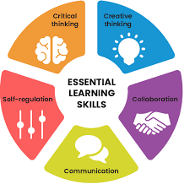

the content. But in some extrinsic factor (outside of the task) they may, for example be aiming just to pass to obtain employment or they may be studying because their parent expects it. As a result of lack of interest and motivation these students do not aim to understand the content but to reproduce it. They learn as if they were filling information Knowing the step by step some of the department that are there to support student on the basic skills needed to complete each learning tasks importantly to keep consistency and encourage well as support student to stretch their skill in Learning. The Aim is to help students become the best learner that can be successful both at the University and in the future career path in Life. [1] To succeed at University, Student need to upgrade their approaches to learning developed a theory of learning and named two broad approaches surface and deep. These describe patterns in the intention the student has in learning and the strategies employed as a means of fulfilling that intention. The aim of the University Education is to help student reach a deep approach to Learning Student with a surface approach to learning are not interested in the content. But in some extrinsic factor (outside of the task) they may, for example be aiming just to pass to obtain employment or they may study

Task 1 (b): Evaluation of Task 1 (a) based on Similarity report
plan and watch the subsequent execution. Ongoing development can be vital, and helpful, but pursuing this in a busy time in your career is challenging. As you become more senior, and more skilled, you can buy time and take courses or take a personal or group retreat to recharge. Most of us do not do this enough, and this can be very helpful. Time is the most precious commodity we have, and generally urologists do not lack for in a computer. Each new file is given a name and place. However, the file is not linked. Such students also have a poor search function. while they can easily retrieve a particular file. They find it difficult or impossible to think about ideas that occur in different files.

. Developing Transferable skills
. Making Use of Lectures and Seminars
. Using Libraries and the internet
. Note taking, essays, Seminars and Presentations
. Revision and Examinations

Task 2: Collaborative Mind Map and Individual Poster

Mind Map (Collaborative)
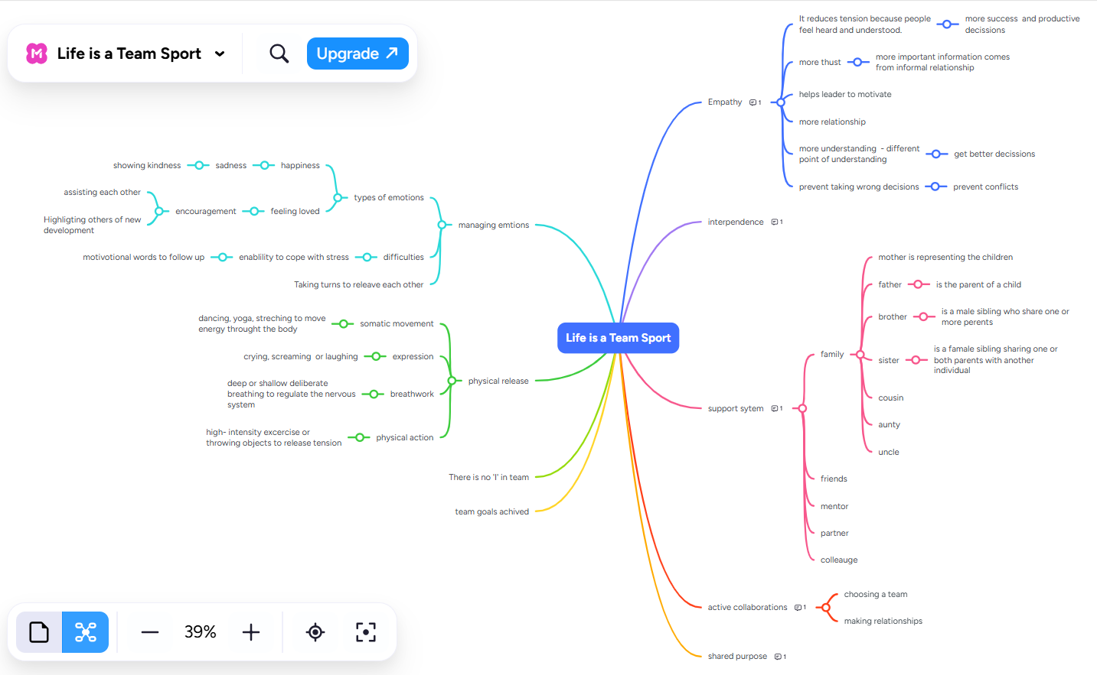

Poster (Individual)


Illustrated with some examples
[3] [3]

A review of the problem-solving literature related to design-thinking processes revealed that the problem-solving framework utilised by novice designers is missing some significant aspects when compared to the design-thinking framework utilised by expert designers. The central theme of this paper focuses on an early phase of the design process, more specifically, problem analysis and thinking tools that assist in problem analysis. Drawing on educational constructivist theory and concept mapping research found within the domain of cognitive psychology, this paper empirically investigates and discusses why non-hierarchical mind mapping tools are useful as design tools when introduced to a group of first year industrial design students. It illustrates how non-hierarchical mind mapping techniques can guide novice designers (students) in adopting the design problem-solving processes/framework of expert designers. Further, the experiments revealed statistically significant correlations and relationships between the analysis phase and the resultant creative output [3].

Task 3: Virtual Collaboration and RefWorks

Report on Virtual Collaboration

Step-by-step process of using RefWorks with visuals

Task 4: E-Portfolio Creation and Evaluation

Task 4 (a): E-Portfolio Creation

Task 4 (b): Illustrative Review of E-Portfolio tool Selection

Conclusion

References

Task 1 References: [1].

Task 3 References: [3].

