

Student Name: Mit Ahir
Student ID: 2513323
Module Name: Social Epidemiology and Public Health Development (LCHS7000)
Assignment Title: Ethnicity and Health Inequalities: A Social Epidemiological Analysis of South Asian Communities in the UK.
Programme/Course: Msc In Public Health And Social Care In Practice
Instructor/Supervisor: Dr. Hamdi Hussain
Date of Submission: 23/03/2026

Table of Contents
Task 1: Social Epidemiological Analysis 3
1.1 Title 3
1.2 Introduction 3
1.3 Contextual background and underlying factor 3
1.3.1 Three diseases or illness 3
1.3.2 Three social issues 5
1.4 National response to reduce health inequalities among South Asian population in the UK 6
1.5 Organisations that support South Asian population in the UK 7
1.6 Conclusion 7
Task 2: Epidemiological Analysis 7
2.1 Introduction 7
2.2 Main body 8
2.2.1 Public health measures and prevention, protection, promotion 8
2.2.2 Key determinants or risk factors 9
2.2.3 Epidemiological studies and health needs assessment 9
2.2.4 Monitoring and surveillance systems 10
2.2.5 Public health impact 10
2.2.6 Intervention programme and evaluation 10
2.2.7 Strengths and weaknesses of epidemiological approach 12
2.3 Conclusion 12
List of References 13
Task 1 13
Task 2 14

Task 1: Social Epidemiological Analysis

1.1 Title
Ethnicity and Health Inequalities: A Social Epidemiological Analysis of South Asian Communities in the UK.

1.2 Introduction
Health inequalities are essentically described as avoidable as well as systematic disparities in health status among various populations. Ethnicity has been a major contributor in terms of health inequalities in the UK especially among the South Asian populations that significantly including the people of Indian, Pakistani, and Bangladeshi descent.
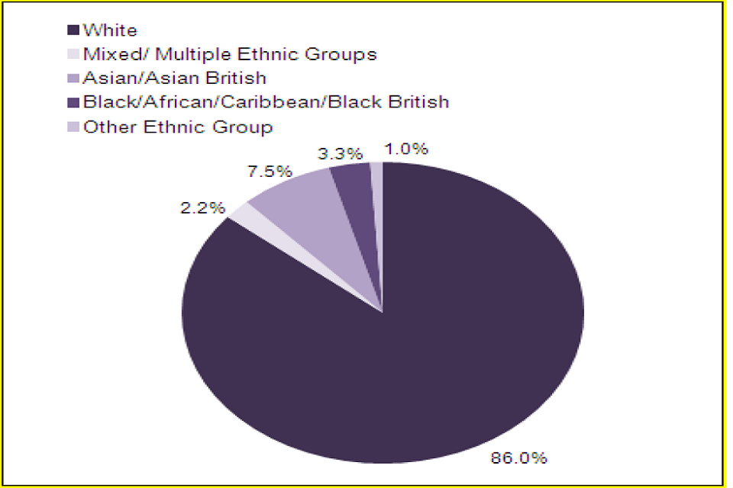
Figure 1: South Asian Population in the UK
(Source: UK GOV, 2022)
This population category is estimated to constitute 7.5% of the UK population, yet faces a disproportionately higher burden of disease (Raleigh, 2025). South Asians are 2 to 6 times more susceptible to Type 2 diabetes and their cardiovascular risks are remarkably higher (van Niel et al., 2021). The presence of these disparities is predetermined by a complex of genetic, socioeconomic, cultural, and structural factors, and this population group is especially susceptible to health inequity.

1.3 Contextual background and underlying factor

1.3.1 Three diseases or illness
Type 2 Diabetes
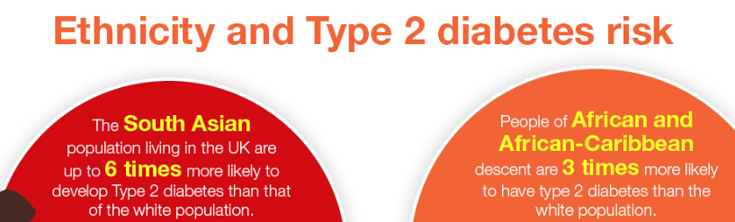
Figure 2: South Asian and Type 2 diabetes
(Source: UK GOV, 2020)
The prevalence of Type 2 diabetes is much larger among South Asians, who are 2 to 6 times more inclined to develop Type 2 diabetes in comparison with populations of the White British (Prinjha et al., 2020). In UK, around 400,000 to 420,000 South Asians live with diabetes which is a disproportionate number considering that they are a minority (Asianleader, 2024). The causes of this inequality are genetic predisposition, earlier age, and lifestyle. This demonstrates a clear ethnic disparity in both prevalence and age of diagnosis. The solutions are earlier screening, diet interventions that are culturally sensitive, and specific NHS prevention programmes (Taylor, 2022).
Cardiovascular Disease (CVD)
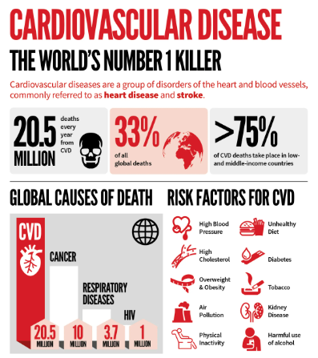
Figure 3: CVD
(Source: Pedamallu et al., 2026)
South Asians are disproportionately at risk of cardiovascular conditions, being nearly twice as prone to developing coronary heart disease than White Europeans. Moreover, the South Asian populations are 1.5 times more prone to stroke. CVD is essentially accounts for 27% of all UK deaths, but it is important to note that South Asians are overrepresented due to higher rates of diabetes as well as hypertension (Pedamallu et al., 2026). This disparity is based on the biological and social risk factors. Addressing it requires specific screening, early intervention, and culturally-specific cardiovascular health education (Saeed et al., 2020).
Mental Health Inequalities
South Asians have not been reporting mental health issues because of stigma and cultural barriers. It has been proven that there is less access to mental health services when required, and South Asian women experience depression more often than the general population. The language barrier influences more than half of the South Asians who cannot speak English freely hence restricting access to services (Sultana et al., 2026). This represents a disparity in the diagnosis as well as treatment and not merely prevalence. Solutions include culturally competent services along with multilingual support as well as community-based mental health awareness programmes (Hieke et al., 2025).

1.3.2 Three social issues
Socioeconomic Inequality
Health disparities are largely due to socioeconomic inequality, and this is evidential as around 40% of Pakistani and Bangladeshi households live in relative poverty which is in comparison to approximately 20% of White British households (Dotsikas et al., 2025).
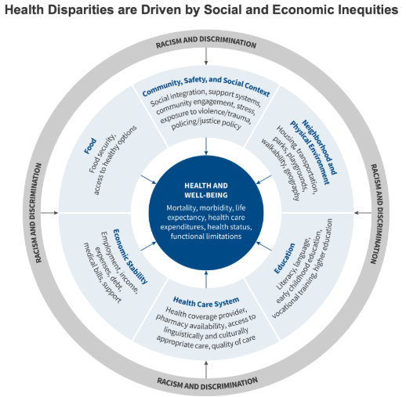
Figure 4: Socioeconomic Inequality
(Source: VCU, 2025)
This disparity in income results in disparity in having access to healthy food, health care, and healthy living conditions. More importantly, poverty is closely associated with an increased prevalence of chronic illnesses like diabetes or CVD. This illustrates the existence of a structural inequality in health. Through employment assistance, special welfare policies, and lessening income disparity amongst the ethnic minorities, solution can be got. (Cheshmehzangi, 2022).
Housing and Overcrowding
The inequality in housing is seen in the fact that 24% of the households in Bangladesh live in overcrowded houses in comparison to 2% of the White British households (Gov UK, 2024). This inequality adds the risk of an infectious disease, respiratory conditions, and mental health deterioration. The issue of overcrowding aggravates the situation even in the case of a public health crisis like COVID-19. This reflects environmental inequality linked to ethnicity and income. To solve this, there needs to be investment in affordable house, better living conditions, and special housing policies on high-risk communities (Panovska-Griffiths et al., 2021).
Barriers to Healthcare Access
South Asians have big challenges of in accessing healthcare, contributing to health inequalities. As per the asseration of Khan (2024), ethnic minorities have reduced chances to receive preventive care including screening programmes. Moreover, the minority populations treated with advanced diabetes technology were only 5.3% of some minority groups which in contrast with 17.5% of well-serviced areas demonstrating the inequality in the treatment (Thomas, 2026). This disparity is caused by language, cultural differences, and systemic bias. The interpreter services, inclusive healthcare policies, and enhancing a sense of trust between the healthcare providers and the ethnic communities are some of the solutions (Khan, 2024).

1.4 National response to reduce health inequalities among South Asian population in the UK
NHS Health Check Programme
The “NHS Health Check” programme detects cardiovascular disease and diabetes early risks in adults aged 40 to 74 years (Tanner et al., 2022). It particularly focuses on high-risk groups, such as the South Asians, by encouraging early detection and prevention, which can be applied to decrease health disparities in the long run.
Change4Life Campaign
The “Change4Life” campaign promotes healthy eating and physical activity. It involves culturally specific messages to be used to reach the South Asian communities, aiming to reduce obesity and prevent chronic diseases that disproportionately affect this group (NSMC, 2025).

1.5 Organisations that support South Asian population in the UK
South Asian Health Foundation (SAHF)
“South Asian Health Foundation” undertakes a major role in enhancing awareness of inequalities on health among the South Asians in the UK (NHS, 2026). It carries out research and shapes the health policy to counter the disparities.
British Heart Foundation (BHF)
“British Heart Foundation” assists the individuals of cardiovascular disease, which developed among the South Asians to a significant fraction, by providing funds to research and conducting awareness programs (BHF, 2026).
Support for the Community
These organisations not only offer culturally relevant education but also they facilitate early diagnosis and enhance access to healthcare using outreach programmes.
Goals
Their goals significantly include reducing disease prevalence along with improving early detection as well as supporting research at the same time addressing systemic health inequalities within South Asian communities.

1.6 Conclusion
South Asian population in the UK is highly inequitable in health terms as indicated by increased disease rate and poor socioeconomic status. The differences are vividly demonstrated through statistical data in comparison with the general population. To deal with these disparities, culturally sensitive healthcare, specific policies, and long-term high-level efforts in the field of the popular health should help to enhance the health outcomes.

Task 2: Epidemiological Analysis

2.1 Introduction
Diabetes type II is a non-communicable disease that is chronic, insulin-resistant, and in which blood sugar is raised. It is a significant public health issue globally and in the UK because it is linked with severe complications like heart disease, kidney failure, and early death (NCBI, 2026). Globally, approximately 537 million adults were living with diabetes in 2021 which projected to rise to 643 million by 2030 and in the UK, over 4.3 million people are diagnosed with diabetes, with Type 2 accounting for around 90% of cases (DRWF, 2026).
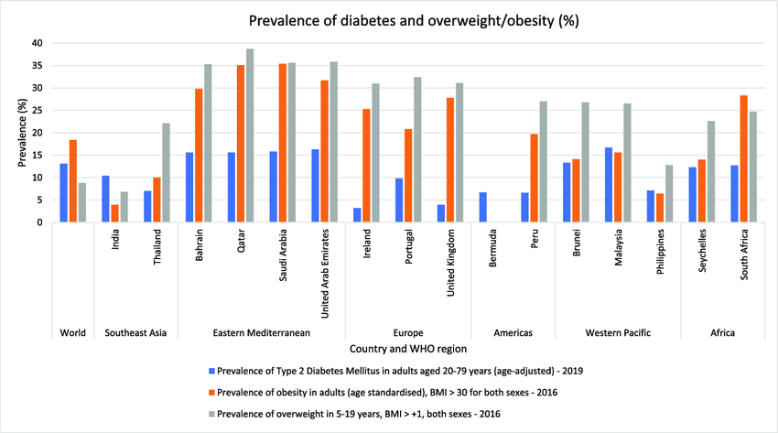
Figure 5: Diabetes type II in globally
(Source: MClinExPhys et al., 2022)
The burden is disproportionately higher in populations of South Asians as they are 2 to 6 times more likely to develop the condition and at an earlier age than in White British populations. In Tower Hamlets, London, where the population of Bangladeshi residents is the largest, the estimated level of diabetes prevalence is 9%, which is much higher than the estimated national rate of approximately 6 to 7% (Tower Hamlets, 2024). The social and cultural impacts of this disease are severe such as decreased quality of life, high expenses of healthcare and restrictions in self-management by use of language, diet, and cultural practices (Khan and Russell, 2025). This discussion will examines the epidemiological processes that are applied to identify, evaluate, and control Type 2 diabetes among this high-risk group.

2.2 Main body

2.2.1 Public health measures and prevention, protection, promotion
The public health interventions to manage Type 2 diabetes in Tower Hamlets are designed on the three P’s that includes prevention, protection and promotion to have a comprehensive reaction to the disease burden (Nathwani and Rahman, 2021).
Prevention: Prevention is aimed towards prevention of Type 2 diabetes by preventing its incidence. The “NHS Diabetes Prevention Programme (NDPP)” targets individuals at high risk, especially South Asians, who are earlier screened at the age of 25, rather than 40 because of increased risk (Ravindrarajah et al., 2023). It has been proved that lifestyle interventions are capable of reducing the risk of diabetes by as much as 58% (Komi et al., 2024). In Tower Hamlets, diet modification programmes that are culturally specific to the South Asian diet have been used which is characterized by high proportion of refined carbohydrates and saturated fats.
Protection: Protection involves reducing complications among those already diagnosed. Periodic screening in terms of ‘HbA1c,’ blood pressure checking, and retinal screening helps to avoid developing complications like blindness and kidney disease. In Tower Hamlets, the proportion of diabetic patients receiving annual health checks is above the national average, over 70% of diabetic patients in the locality receive health checks annually (Tower Hamlets, 2024). Vaccination programmes also protect vulnerable diabetic patients from secondary complications.
Promotion: Health promotion is aimed at creating awareness and promoting behavioural change. Campaigns target South Asian communities through multilingual education, community centres and religious organizations (Kumar, 2025). In one instance, local programs facilitate exercise and nutritious dieting in accordance with the cultural norm. Research indicates that culturally sensitive education enhances the involvement and compliance to treatment by more than 30% (Sanad, 2025).
Despite these efforts, challenges remain. Low health literacy, cultural beliefs and socioeconomic deprivation lead to poor effectiveness of interventions. Consequently, community leaders need to be integrated, and culturally competent care should be improved to improve the health outcomes of the population. It is important to mention that, the combined approach of prevention as well as protection and promotion is critical in managing diabetes within this high-risk population.

2.2.2 Key determinants or risk factors
The high prevalence of Type 2 diabetes among South Asians is influenced by multiple determinants. Genetically, South Asians have higher insulin resistance and central adiposity, even at lower “body mass index (BMI)” levels. Obesity levels are high and approximately 60% of South Asian adults in the UK classified as overweight or obese (Caleyachetty et al., 2021).
There is also a role of socioeconomic factors as in Tower Hamlets, the rate of poverty is more than 40%, restricting the access to food and physical activity (Tower Hamlets, 2024). Dietary habits that are high in fats and carbohydrates also contribute to the risk. There is a high prevalence in physical inactivity and South Asian adults are less likely to achieve the recommended levels of activity than the general population. Also, health awareness as well as cultural barriers intervene with diagnosis and treatment, slowing it down.

2.2.3 Epidemiological studies and health needs assessment
The epidemiological research carried out in Tower Hamlets and the UK as a whole indicates that the prevalence of diabetes in the South Asians especially in the Bangladeshi communities is higher. According to the local health needs assessment, the prevalence rates are 8 to 9%, which is compared to the UK average rate of approximately 6 to 7% (NICE UK, 2025). Research studies like the cohort and cross-sectional studies indicate a premature onset and higher complication rates in the population. Cultural beliefs, socioeconomic deprivation, and language are also the barriers to health needs identified during the health needs assessment.
Middle-aged adults, obese people, and those whose family has a history of diabetes are considered to be high-risk groups. The South Asian communities may be especially susceptible to women because of lack of physical activity (Fatema et al., 2021). These results indicate the significance of both specific screening and culturally relevant interventions in the assessment of the particular needs of the given population and minimization of health disparities.

2.2.4 Monitoring and surveillance systems
Monitoring of diabetes in Tower Hamlets is based on various epidemiological surveillance systems. “Quality and Outcomes Framework (QOF)” collects primary care data on diabetes prevalence and management (Xiao et al., 2025). “National Diabetes Audit (NDA)” is the source of information on outcomes and complications of treatment (Holman et al., 2021). The population-level data is used by “Public Health England” and local authorities to monitor trends and recognize high-risk groups. Such screening programmes as NHS Health Check play a role in early detection (Tanner et al., 2022). Such systems enable constant monitoring of incidence and prevalence, and make it possible to take specific actions. Nevertheless, the lack of accuracy may be caused by underreporting and gaps in data among the minority groups, thus the need to advance data collection and inclusion.

2.2.5 Public health impact
Impact Type | Short-Term Effects | Long-Term Effects
Health Impact | Fatigue, high blood sugar, increased infections | Cardiovascular disease, kidney failure, blindness
Economic Impact | Increased GP visits, medication costs | Long-term healthcare costs, loss of productivity
Social Impact | Reduced daily functioning | Disability, reduced quality of life
Health System Impact | Increased demand for services | Strain on NHS resources
Table 1: Public health impact of Type 2 diabetes
(Source: Self-developed)
Type 2 diabetes imposes an important burden on patients and the health care systems. The increased prevalence in Tower Hamlets creates demand on the services and emphasis should be made on appropriate prevention and management strategies (Tower Hamlets, 2024).

2.2.6 Intervention programme and evaluation
Programme Name: “Healthy Living for South Asians (HLSA) Programme”
Designing the health intervention programme
“Healthy Living for South Asians (HLSA) Programme” is a community-based intervention program that is targeted at lowering the risk of Type 2 diabetes in South Asian communities in Tower Hamlets. The programme focuses on early detection, lifestyle modification, and long-term behaviour change. Persons above 25 years are registered in GP and requested to screen HbA1c and risk assessment. The intervention includes a 12-week structured education programme that is going to be delivered within the community settings which are GP practices, community centres, and faith-based centres (Ahmad et al., 2022). The sessions are centred around culturally tailored dietary recommendations that can be decreasing sugar and refined carbohydrates in traditional diets, increasing active approach to life, and increasing health literacy. Bilingual educators as well as translated materials ensure accessibility. Adherence as well as self-management are improved with the help of digital support, such as mobile apps and SMS reminders (Ahmad et al., 2022). The integration of family engagement is an intervention to strengthen behaviour change at the family level.
Evaluate the impacts of any proposed intervention
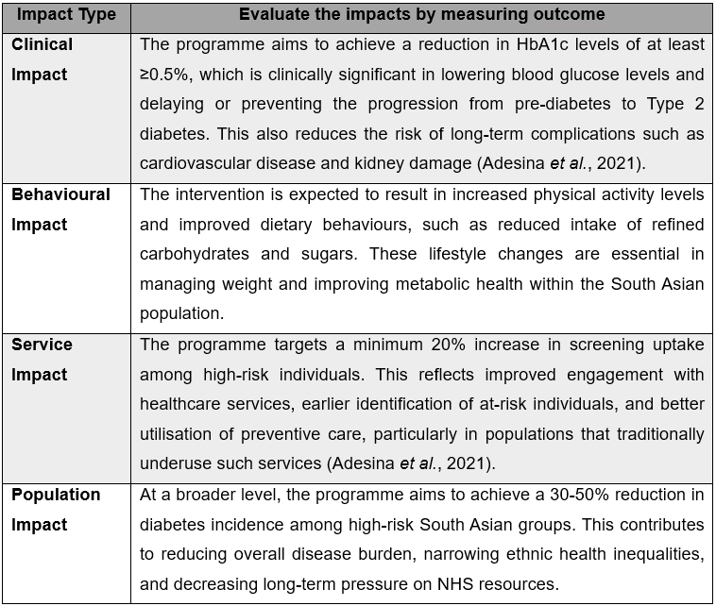
Table 2: Intervention programme and evaluation impact
(Source: Self-developed)

2.2.7 Strengths and weaknesses of epidemiological approach
Epidemiology can be useful in terms of offering understanding of the patterns of diseases ath the same time their risks and population demands, which can be used to make specific interventions (Volkow and Blanco, 2023). Therefore, it aids in evidence-based decision making and effective resource distribution. Nevertheless, there are such limitations as gaps in data, underreporting and possible research bias (Volkow and Blanco, 2023). Quantitative data might not adequately be able to capture cultural factors. Also, the results might not be applicable to other groups of people. Despite these limitations, epidemiology is indispensable in the appreciation and resolution of the communal health issues.

2.3 Conclusion
Type 2 diabetes is a serious health problem to the population of South Asians in Tower Hamlets. The epidemiological analysis shows evident disparities in prevalence, risk factor and outcome. To counter this, there is a need to manage this through specific culturally relevant interventions that are backed with effective surveillance mechanisms to curb the effects of this in the long run.

List of References

Task 1
Asianleader, (2024). 420,000 South Asians live with Type 2 Diabetes in UK. https://asianleader.co.uk/420000-south-asians-live-with-type-2-diabetes-in-uk/
BHF, (2026). What we do. https://www.bhf.org.uk/what-we-do
Cheshmehzangi, A., 2022. Vulnerability of the UK’s BAME communities during COVID-19: The review of public health and socio-economic inequalities. Journal of Human Behavior in the Social Environment, 32(2), pp.172-188.
Dotsikas, K., McGrath, M., Osborn, D.P.J., Walters, K. and Dykxhoorn, J., 2025. Exploring the impact of ‘hostile environment’policies on psychological distress of ethnic groups in the UK: a differences-in-differences analysis. Social Psychiatry and Psychiatric Epidemiology, 60(1), pp.139-148.
Gov UK, (2024). English Housing Survey 2022 to 2023: housing quality and condition. https://www.gov.uk/government/statistics/english-housing-survey-2022-to-2023-housing-quality-and-condition/english-housing-survey-2022-to-2023-housing-quality-and-condition
Hieke, G., Black, G.B., Yargawa, J., Vindrola-Padros, C., Gill, P., Islam, L., Williams, E.D., Braun, S. and Whitaker, K.L., 2025. South Asian patient experiences of professional interpreting service provision in general practice in England: a qualitative interview study. International journal for equity in health, 24(1), p.104.
Khan, N., 2024. Barriers to access palliative care for ethnic minorities, particularly south asians in the UK: A systematic review. PQDT-Global.
NHS, (2026). South Asian Health Foundation. https://www.nhs.uk/services/service-directory/south-asian-health-foundation/N10496919
NSMC, (2025). Change4Life. https://www.thensmc.com/resources/showcase/change4life
Panovska-Griffiths, J., Ross, J., Elkhodair, S., Baxter-Derrington, C., Laing, C. and Raine, R., 2021. Exploring overcrowding trends in an inner city emergence department in the UK before and during COVID-19 epidemic. BMC emergency medicine, 21(1), p.43.
Pedamallu, H., Aghabazaz, Z., Lancki, N., Rodriguez, L.A., Siddique, J., Moorthy, M., Shah, N.S., Allen, N.B., Kanaya, A.M. and Kandula, N.R., 2026. Prevalence and Trends in Cardiovascular Risk Factors Among Middle‐Aged South Asian Adults Compared With Other Racial and Ethnic Groups in the United States: A Longitudinal Analysis of 2 Cohort Studies. Journal of the American Heart Association, 15(4), p.e41221.
Prinjha, Suman, et al. "British South Asian patients’ perspectives on the relevance and acceptability of mobile health text messaging to support medication adherence for type 2 diabetes: qualitative study." JMIR mHealth and uHealth 8.4 (2020): e15789.
Raleigh, V. (2025). The health of women from ethnic minority groups in England. https://www.kingsfund.org.uk/insight-and-analysis/long-reads/the-health-of-women-from-ethnic-minority-groups-england
Saeed, S., Kanaya, A.M., Bennet, L. and Nilsson, P.M., 2020. Cardiovascular risk assessment in South and Middle-East Asians living in the Western countries. Pakistan Journal of Medical Sciences, 36(7), p.1719.
Sultana, R., Husain, N., Allen, O. and Taylor, P., 2026. Barriers and facilitators for Help-Seeking behaviors in British South Asian women who have experienced domestic violence: A qualitative study. Families in Society, 107(1), pp.90-110.
Tanner, L., Kenny, R.P.W., Still, M., Ling, J., Pearson, F., Thompson, K. and Bhardwaj-Gosling, R., 2022. NHS Health Check programme: a rapid review update. BMJ open, 12(2), p.e052832.
Taylor, R., 2022. Type 2 diabetes: the problem and the solution. British Journal of Diabetes, 22(Supplement 1), pp.S55-S58.
Thomas, T. (2026). Ethnic minorities in England less likely to have access to diabetes tech – study. https://www.theguardian.com/society/2026/jan/01/ethnic-minorities-in-england-less-likely-to-have-access-to-diabetes-tech-study?hl=en-US
UK GOV, (2020). Health matters: preventing Type 2 Diabetes. https://www.gov.uk/government/publications/health-matters-preventing-type-2-diabetes/health-matters-preventing-type-2-diabetes
UK GOV, (2022). Trend Deck 2021: Demographics. https://www.gov.uk/government/publications/trend-deck-2021-demographics/trend-deck-2021-demographics
van Niel, J., Geelhoed‐Duijvestijn, P.H., Numans, M.E., Kharagjitsingh, A.V. and Vos, R.C., 2021. Type 2 diabetes in South Asians compared to Europeans: Higher risk and earlier development of major cardiovascular events irrespective of the presence and degree of retinopathy. Results from The HinDu The Hague Diabetes Study. Endocrinology, diabetes & metabolism, 4(3), p.e00242.
VCU, (2025). Social Determinants of Health. https://guides.library.vcu.edu/sdoh

Task 2
Adesina, N., Dogan, H., Green, S. and Tsofliou, F., 2021. Effectiveness and usability of digital tools to support dietary self-management of gestational diabetes mellitus: a systematic review. Nutrients, 14(1), p.10.
Ahmad, E., Lim, S., Lamptey, R., Webb, D.R. and Davies, M.J., 2022. Type 2 diabetes. The Lancet, 400(10365), pp.1803-1820.
Caleyachetty, R., Barber, T.M., Mohammed, N.I., Cappuccio, F.P., Hardy, R., Mathur, R., Banerjee, A. and Gill, P., 2021. Ethnicity-specific BMI cutoffs for obesity based on type 2 diabetes risk in England: a population-based cohort study. The lancet Diabetes & endocrinology, 9(7), pp.419-426.
DRWF, (2026). Number of people living with diabetes in UK hits 5 million. https://www.drwf.org.uk/news-and-events/news/number-of-people-living-with-diabetes-recorded-at-5-million-in-uk/#:~:text=Record%20figures%20as%20diabetes%20diagnoses,making%20up%20the%20remaining%202%25.
Fatema, S.R., East, L., Islam, M.S. and Usher, K., 2021. Health impact and risk factors affecting south and southeast Asian women following natural disasters: a systematic review. International journal of environmental research and public health, 18(21), p.11068.
Holman, N., Knighton, P., Wild, S.H., Sattar, N., Dew, C., Gregg, E.W., Khunti, K., Valabhji, J. and Young, B., 2021. Cohort profile: national diabetes audit for England and Wales. Diabetic Medicine, 38(9), p.e14616.
Khan, U.R. and Russell, D.A., 2025. Diabetes‐Related Foot Disease in South Asians Living in Western Countries: Burden, Outcomes, and Gaps in the Literature—A Scoping Review Protocol. International Wound Journal, 22(11), p.e70772.
Komi, L.S., Mustapha, A.Y., Forkuo, A.Y. and Osamika, D., 2024. Lifestyle Intervention Models for Type 2 Diabetes: A Systematic Evidence-Based Conceptual Framework. ICONIC Research and Engineering Journals, 7(8), pp.511-513.
MClinExPhys, M., Boelsen-Robinson, T., Pesantes, M.A., MA, M. and MPubPol, A.M.T., 2022. A comparative policy analysis of the adoption and implementation of sugar-sweetened beverage taxes (2016-2019) in 16 countries.
Nathwani, S. and Rahman, N., 2021. The 3 P’s model enhancing patient safety during the COVID‐19 pandemic. Oral Surgery, 14(3), pp.246-254.
NCBI, (2026). IDF DIABETES ATLAS [Internet]. 10th edition. https://www.ncbi.nlm.nih.gov/books/NBK581940/
NICE UK, (2025). CKS via NICE is only available to eligible users within the UK. https://cks.nice.org.uk/topics/diabetes-type-2/background-information/prevalence/
Ravindrarajah, R., Sutton, M., Reeves, D., Cotterill, S., Mcmanus, E., Meacock, R., Whittaker, W., Soiland-Reyes, C., Heller, S., Bower, P. and Kontopantelis, E., 2023. Referral to the NHS Diabetes Prevention Programme and conversion from nondiabetic hyperglycaemia to type 2 diabetes mellitus in England: a matched cohort analysis. PLoS medicine, 20(2), p.e1004177.
Tanner, L., Kenny, R.P.W., Still, M., Ling, J., Pearson, F., Thompson, K. and Bhardwaj-Gosling, R., 2022. NHS Health Check programme: a rapid review update. BMJ open, 12(2), p.e052832.
Tower Hamlets, (2024). Tower Hamlets Borough Profile: Corporate Strategy and Improvement Team. https://www.towerhamlets.gov.uk/Documents/Borough_statistics/Tower-Hamlets-Borough-Profile-2024.pdf
Volkow, N.D. and Blanco, C., 2023. Substance use disorders: a comprehensive update of classification, epidemiology, neurobiology, clinical aspects, treatment and prevention. World Psychiatry, 22(2), pp.203-229.
Xiao, M., Núñez-Elvira, A. and Kristensen, S.R., 2025. How does the quality of outcomes framework impact on the quality of life of adult patients with diabetes? A cross-section study in England using GP Patient Survey data. BMC Primary Care, 26(1), p.327.

