Construction Materials
Module: Material Science and Building Services
Lecturer: Allan Nantel
Institution: University of Wales Trinity Saint David
Date of submission: 14/01/2020
Word count: 2214 nr

Contents
Building Case Studies 3
Durability and Climatic Resistance 4
Effect of Moisture on Steel and Concrete 4
Effect of Forces on Steel and Concrete 6
Impact of the Production Process on the Environment 8
Ease of Assembly and Adaptation 10
List of References 11

Building Case Studies
The Steel frame building I’ll be reporting on is the Taipei Tower 101 which is located in the country of Taiwan, in Xinyi District, Taipei. The building is classified as a supertall skyscraper due to it’s once world record holding height of 509 meters. It’s architectural style comes under the category of Postmodernism because of the tendencies belonging to the era in which it was designed. Completion of the construction works was on the 31st of Decemeber 2004, some five and a half years later to when construction began.
It’s impressive height which puts it at the 11th spot on the list of the worlds tallest building, consists of 101 floors, with a floor area of 412,500m2. Steel is the primary material of the buildings massive structural frame, and this report will explain why this was the chosen material.
Marina City is the Concrete framed building which I will be comparing and contrasting with the above structure. This building is situated on the North bank of the Chicago River in Chicago. Marina City stands at a height of 179 meters, which when thought of subjectively to many people , is a very tall building. This height however isn’t enough to classify it as a ‘supertall building’ according to the ‘Council of Tall Buildings and Urban Habitat’. This organization proposes that “supertall is a tall building 300 meters (984 feet) or taller” (CTBUH, 2019). This leaves Marina City 121 meters below the threshold, which means when compared to Taipei Tower 101, this building is well inferior in terms of height status.

Durability and Climatic Resistance
Taipei Tower 101 and Marina City are located in Taipei, Taiwan and Chicago, USA respectively. These citys are on different conintents, with a distance of 11,984 km between them. Due to this, it is expected that they have differing climates…and so they do. ‘Sub tropical’ climate is the category of climate which Taipei falls under with it being situated in the north of Taiwan. This ‘sub tropical’ climate means that Taipei sees a large amount rainfall, with “about 2574 mm of precipitation falling annuanly.” (CD.O, 2019). Chicago’s climate is known as ‘Hot summer humid continental’. Although it has pleasantly warm summers, the winter months can see some extreme weather. The temperature drops to a minimum of -20 degrees practically every year “and to -30.6 degrees in January 2019.” (CTTWCG, 2019). These differing climates present they’re own stresses and strains on structures in their area, and can particularly have an effect on the framing material of the building. This means that framing materials need to be fit for purpose.

Effect of Moisture on Steel and Concrete
Moisture and water plays a factor in the cases of both buildings with it coming from the typhoons in Taipei to the above average humid air of Chicago. The effect of inside moisture and also leakage and dampness are causes of corrosion. Corrosion is in fact a natural process, which basically results in the deterioration of the material, by being converted to a more stable state like it’s sulphide, hydroxide, or oxide state. Steel is very much more susceptible to corrosion than concrete is as steel may corrode when water comes into contact with it. Whereas with concrete, effective constrution and care will see the material water resistant. This means that the concrete framing of the Marina City towers is climatically resistant in this sense, to the humid environment that Chicago presents upon it.
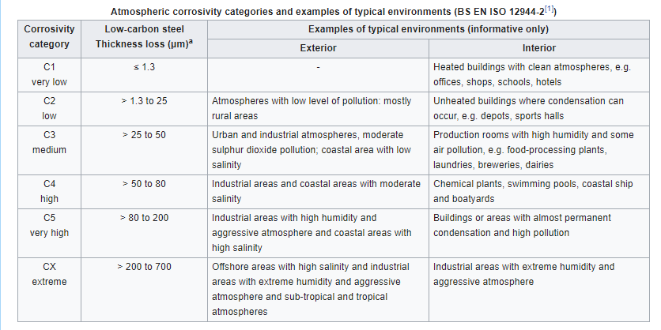
Figure 1
BS EN ISO 12944-2, 2017
Figure 1 shows the potential loss in thickness of low carbon steel due to corrosion. This is the type of Steel wich is likely to be used for the structure as it is less brittle, more easily welded, and more malleable than high carbon steel. It is also as strong in compression, tension and shear strength. The corrosivity category which ranges from very low to extreme, determines the loss in thickness of the steel which ulitimately may affect the safety and securtiy of the structure. Taipei is a very large city with many industries and large scale buildings, which results in a lot of low quality atmospheric conditions. It’s sub tropical climate along with it’s tendency to see typhoons results in a humid environemt also. This general overhall of it’s typical environment sees Taipei fall under the corrosivity categories of ‘C4 high’ to ‘C5 very high’. These categories may reuslt in a thickness loss of 50 to 200 µm3. This information extrapolated from figure 1 shows the kind of of damage that corrosivity could cause to the strucutre of Taipei Tower 101 in it’s environment. The application additional water reistant seals and paint care will help limit corrosion. In the sense of moisture and water, Steel may not be the most climatic resistant material for the framing however it makes up for this elsewhere.

Effect of Forces on Steel and Concrete
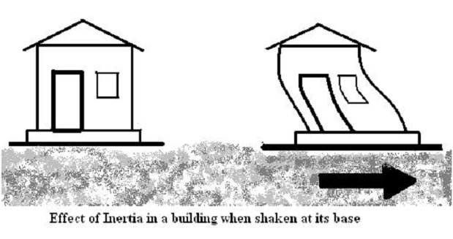
Both Taipei Tower 101 and Marina City experience forces brought upon them by the climate in which they are situated in. Taipei, Taiwan see itself on the ‘Pacific Ring of Fire’ which makes the area a seismically active zone. The most destructive earthquakes originate beneath the country itself even though the larger ones occur off the east coast. Only five years ago Taipei experienced it’s own earthquake at a magintude of 5.3 on the Richter scale. The forces that earthquakes cause are lateral forces, as their main effect is to apply horizontal loads to a building.
Figure 2

TCCEH, 2019

Figure 2 demonstrates the manner in which horizontal loads are applied to a building and the effect it may have if not constructed in a suitable manner.
Chicago presents it’s own problems in relation to forces. As mentioned previously Chicago’s temperature drops below -20 degrees every winter, and on the 30th of January 2019 fell to -31 degrees due to a polar vortex. Due to these sub zero temperatures in the winter and warmer summers, ‘freeze thaw’ action may occur. This process can have an adverse affect on concrete as it involves water seeping into ingresses and cracks that can occur in concrete. When temperatures fall below freezing, the water molecules expand beyond the volume constraints of the cracks and lateral forces damage the structure of the material.
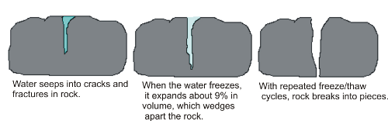
Figure 3
GC, 2014

Figure 3 demonstrates the process of freeze thaw action on a rock. It will have the same effect on concrete, if it has cracks and faults.
Steel is considered as a durable construction material, and with Taipei Tower 101 being constructed to withstand earthquakes, it’s not a surprise that it was the chosen framing material for the structure. One important factor when considering forces from earthquakes is flexibility. Steel frames are flexible because they are comprised of steel beam members bolted together which allows that bit of flexibility along the frame that’s so importantly needed. Also with Steel frames, bracing can be added to provide rigidity to the exterior of the building. These bracings regularly come in the form of ‘X’ or ‘K’ braces which resist external lateral forces to due earthquakes. This factor and Steels high tensile strength contributes to it being a very durable and climatic resistant material when using it for the frame of Taipei Tower 101.
When considering durability in terms of resistance to forces, Concrete is inferior to Steel at the site in which each structure is situated. This is because Concrete frame construction is more subjective and prone to human error. Factors such as aggregate size, particle size, amount of water in the mix, and amount of time the concrete is left to dry all have an affect on the durability of the final product. Therefore there are many more things to consider when constructing concrete frames, which gives more opportunity for errors and things to go wrong. Cracks may occur in the concrete due to shrinkage caused by excess water in the mix evaporating. Likewise not leaving the concrete to set for long enough may cause the same cracking effects.

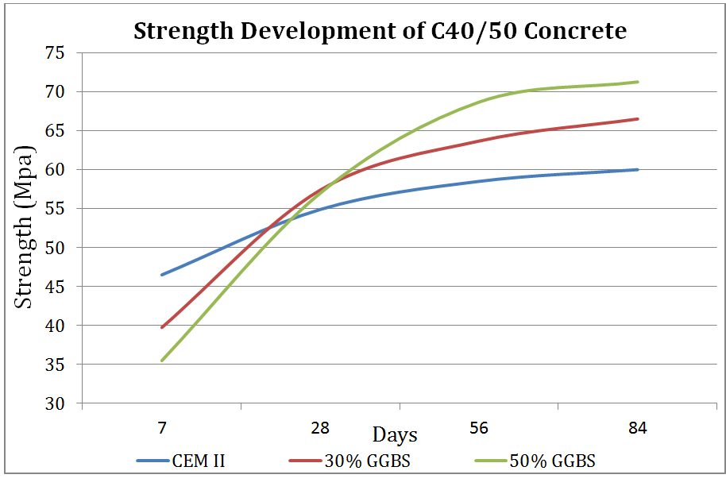
Figure 4

JR, AF, 2016
Figure 4 demonstrates the fact that the concrete not having enough time to dry may cause cracks to form. The graph shows a positive correlation between number of days left to set and increased strength of the resulting concrete. This is the case for each one of the three types of concrete shown. For example the 30% GGBS concrete is a strength of 40Mpa when left to set for 7 days, whereas it has a strength of 63Mpa when left for 84 days.

Impact of the Production Process on the Environment
The production process of Steel involves the conversion of coke, which is a high carbon content fuel derived from the baking of low ash coal. This coke is converted in the blast furnace to Carbon Monoxide which in turn reduces the iron oxide to iron. Iron then collects in the bottom of the furnace, and Limestone forms a liquid slag which floats on top. This slag is important as it absorbs the impurities from the Iron. The pure Iron is then drawn into ladles and taken to the Oxygen vessel, where molten iron is added to scrap steel. High pressure oxygen is then blown into the mix using a lance, forming molten steel.
The production process of Concrete involves practically mixing the fundamental components of it which are cement, aggregates, and water. The production of the cement in the concrete is the element of concrete production which has the most impact on the environment. Fundamental materials utilized to produce cement include chalk, shells, shale, clay, slate , silica sand, limestone, iron ore. When these items are heated together with high temperatures in a blast furnace cement is produced. The production process of cement is not totally dissimilar to steel as that also involves heating iron ore and limestone in a blast furnace. It is because of this, the both materials production industries release very similar amounts of fossil fuel emissions.
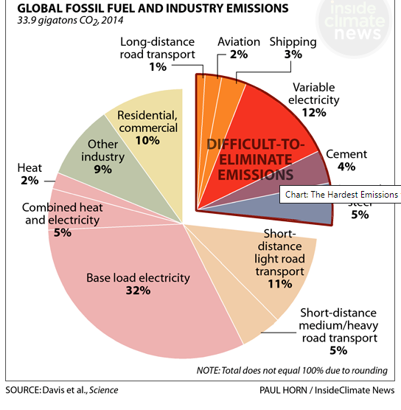
NK, 2018
Figure 5

Figure 5 shows that out of the 33.9 gigatons of CO2 produced in 2014, Cement production accounted for 4% of it whereas Iron and Steel production accounted for 5% of it. This obviously shows that Steel production does have a bigger impact on the environment overall, however this could be because there is more Steel being produced in 2014. For the same amount produced of each material, Cement production may emit more CO2. One thing for sure, is that Concrete production and Steel production each have a very large carbon footprint. According to figure 5 Steel and Iron production emitted 1.695 gigatons of fossil fuels in 2014 and cement emitted 1.356 gigatons. The amount of steel and cement produced resulting in these emissions obviously differed, however Steel and Iron production plays a bigger factor in the impact on the environment, sustainability wise.

Ease of Assembly and Adaptation
Due to the nature of Steel and Concrete they both have different methods of assembly and construction. Steel frame refers to the skeleton frame of a building formed from structural steelwork. This steelwork typically comes in the form of horizontal beams and vertical columns which are welded or bolted together to form a grid. In order to do this heavy plant machinery and man power is required. The components of the steel frame are lifted into position by be cranes or occasionally by the method of jacking. Once in place, steel erectors will secure the structure with bolted connections left slightly loose. This is done to ensure that the column bases are lined and level, and columns are plumb. It is after this, that frame may gain it’s rigidity by ‘bolting up’ which means to tighten the bolts fully.
The concrete frame includes a network of connecting beams and columns that form the skeleton of the structure. This frame will typically be constructed on a concrete foundation which will support the building. The concrete in the frame may need to be reinforced using rebar as the material itself has low tensile strength. This rebar is basically reinforced steel in the form of mesh steel wires, which strengthens the structure. This type of frame is typically constructed on site. This is done by using a formwork in where the concrete is poured in to. Once the concrete has set after a certain amount of time, the formwork is raised up, and more concrete is poured on top, resulting in the structure raising in height. Both steel and concrete frames are similar in the way that they comprise of beams and columns that are practically joined together.
In terms of ease of assembly the both types of frames do differ. The erection of a Steel Frame tends to be a quicker process than the erection of a concrete frame. This is because the steel columns and beams can be bolted together almost instantly one after the other. Whereas once the concrete is poured, it needs time to set and dry before commencement of the erection can take place.
Over the life cycle of a building, the shape of the structure may alter slightly to the original planned design. Steel frames can adapt to a different shape comparatively easier to concrete frames. For example during the construction of the ‘Cheese Grater’ building in London, steel spacers were added between some of the beams in the building to allow the structure to be able to adapt to change in shape. These spacers can be added or taken away to correspond with the change in shape.

List of References
In Text Reference | Full Reference
CTBUH, 2019 | Council of Tall Buildings and Urban Habitat 2019, Tall, Supertall, and Megatall Buildings.  https://www.ctbuh.org/resource/height
CD.O, 2019 | Climate-Date.org 2019, Taipei City Climate.  https://en.climate-data.org/asia/republic-of-china/taipei-city/taipei-city-5817/
CTTWCG, 2019 | Climate to Travel 2019, World Climate Guide, Climate – Chicago.  https://www.climatestotravel.com/climate/united-states/chicago
(Figure 1) BS EN ISO 12944-2, 2017 | British Standard 2017, Paints and Varnishes. Corrosion Protection of Steel Structures by Protective Paint Systems. Classification of Environments. BS EN ISO 12944-2.
(Figure 2) TCCEH, 2019 | The Constructor Civil Engineering Home 2019, Calculate Earthquakes Forces on Buildings and Structures.  https://theconstructor.org/structural-engg/calculate-earthquake-forces-on-buildings-and-structures/8466/
(Figure 3) GC, 2014 | Geography Classroom 2014, Weathering and Erosion., GCSE.  https://geographyclassroom2014.weebly.com/weathering.html#
(Figure 4) JR, AF, 2016 | John Reddy and Aidan Fogarty 2016, Assessing Concrete Strength and the Use of Temperature Matching Curing, Engineers Journal.
(Figure 5) NK, 2018 | Nicholas Kusnetz 2018, These are the Toughest Emissions to Cut and a Big Chunk of the Climate Problem, Inside Climate News.

