The Global Business Environment
LCBB4005

Volvo

Name: Cornel Valentin Gabriel Bondor
Id: 1813451
Lecturer: Dr Amare Desta
Table of Contents
Introduction: 3
Research informed literature: 3
Knowledge and understanding of subject: 4
Analysis: 6
Supporting safer driving: 7
Practical Application and deployment: 8
Skills for professional practice: 9
Product manager: 10
Supply chain manager: 10
Business executive: 11
Client or account vice president: 11
Conclusion: 12
References: 13

Introduction:
The term “Global Business” denotes the effective activity throughout countries over the years. It also achieves profit from time to time. Global business plays a pivotal role to increase prosperity, growth and forecasting of a country. An organization and allowance is needed to perform and continue a business through the members of organization and carried it out among various people of a nation. Under global business environment “Electric vehicles in Australia” is mainly described and a research work also included. Many theories, concepts and ideas are also explained in detail. Various conceptual descriptions are described by several stages. Professional practice and deployment also described and an evaluation of it’s also analyzed. The procedure should be taken to spread out rapidly of global business internationally is also used. Effect on economy globally is also designed. For an example Volvo Cars are created a new designation to the international market. It switches on the movement in the moving world. Electrified Volvo Cars are the brand new invention and plug in hybrid cars are the world’s first diesel cars. Depends on sustainable movement and reduction of fume emissions a natural but competitive movement has progressed.

Research informed literature:
Customers and consumers are proficient source of any business environment. Based on good and effective service, durability of a market research depends. The sustainability of a business is increased through research oriented procedure (Nieuwenhuis et al. 2017, p.114). Organization fix and targets to achieve exact goal from time to time servicing also done to discover demand of the market. Keep obtained data based on interest to a product of a customer. Sometimes it is also done by overall survey on the available products.
Much cheaper and quality product need to bring on that occasion so that it increases the keen interest of people. With the help of demographic criteria and others effective procedure professionally and scientifically sound question should be maintained as a format (O'brien and Marakas, 2015, p.599). Correct and verified ideas need to take and execute decisions as early as possible. There are several factors which enhances global business:
- statistics on relevant data
- Forecasting
- Trends and demands
- Economy
The business organization needs finding of several internal and external activities to elaborate rapidly growth throughout the planet. Strength and weakness analysis is done for internal health and performance appraisal of that organization. Identification of challenges, threats and opportunities are analyzed among overall activity and to create an impression in upcoming days on global market. Competitors and customers analysis should be done for the sake of outgrowth in market globally (Hill, 2015, p.24). In terms of Volvo Cars from 2019 launched their electrified motor. It is performing a lead role through cleaner mobility and less impact on the environment by the products. Volvo Company upgrades their technology by implementing T8-T6 twin engine plug in hybrid power trains, improving the quality of battery and also using plug-in option in each model. A rage of mild hybrids based on kinetic energy recovery technology is introduced from the start of this year (Berggren and Kågeson, p.230).

Knowledge and understanding of subject:
The subject regarding globalisation of business is described into several stages. Multidimensional activities including political risks, legal and taxation issues, cultural differences, regulatory and tax keep up the global business. There are several theories to discuss the world trade systems.
- Modern firm based theories: Excepting the ancient theories this modern firm based theory creates its remark largely all over the world at short time (Nieuwenhuis et al. 2017, p.114). Multinational companies (MNC) rapidly growth depends on that theory. The procedure of working of this theory acts as dealing with two organization of goods production of same industry. For an example: Australia exports Volvo cars to Japan and imports Toyota from Japan (Marginson, 2016, p. 409).
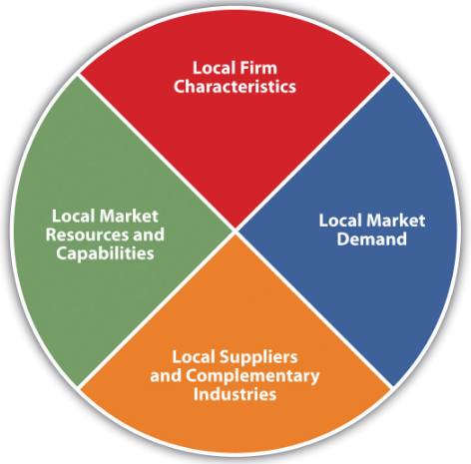
Figure 1: Modern firm based theory.
(Source: Marginson, 2016).
- Product life cycle theory: The life cycle of a product depends on its quality and performance over time. Depends on invention and manufacturing of goods it can describe lightly of the advanced business growth. For development of the business and marketing highly skilled labors and advanced resources should be needed. As a result more cheaper and useful product could be made for the society. Product life cycle curve denotes sales with respect to time (Pitt et al. 2006, p. 610). Sales increases with increasing of time and after certain time reach the stage of maturity. In this stage the rate of selling is maximum and after that declination comes with increasing time.
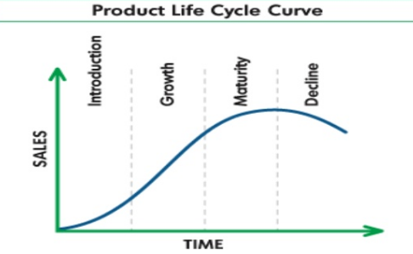
Figure2: Product life cycle curve.
(Source: Pitt et al. 2016)

These useful theories are maintained by the multinational companies all over the world because of they helped promoting, managing and regulating an organization. Economic growth is increased by the effect of these theories. Any particular theory is not dominant over another. Each and every theory is the important from their functions to raise and increase rating of business. For that reason organization use a compile of these theories to develop their strategy and quick procedure to complete of work at a time.
In terms of Volvo Electrified Motor Cars a new project strategy named “Volvo way to market” is created. Sales and service, dealerships, digital leaderships and moreover scientific marketing tools has been looked after under this strategy.

Analysis:
Analytical and logical thinking creates an impression over several issues regarding resolution of purpose of the global business environment. The decision making procedure is to be maintained carefully and implement through the experiments. The organization needs to accurate their ideas and planning of business and evaluate them so that inherent assumptions and effective ideas find out easily. Logical thinking can be explained by continuous formulation of statements and systematic evaluation for standardization. Global economic and business climates are modified by the global business. The world economy is increased by studying international business. There are seven most prefer advantages on international business environment to expand the flow of business very quickly (Lewis et al. 2017, p.191). They are described as:
- New revenue potential: It denotes the overturn income of an organization over a year.
- Diversifying company markets: Companies invest different types of property reducing the investment risk to avoid the poor performance of the organization.
- Greater access to talent: The experts are introduced who helps to increase the growth of business to an international level.
- Exposure to foreign investment opportunities: The organization have to trustworthy to the international level so that it can gain any type of investment and increase the financial growth for the organization.
- Improving reputation of company: Time to time prestige, prosperity and reputation will be increased.
- Ability to help more people: The main objectives of any organization in international level have to help the surrounding people as well as taking care of the environment. So that it will be beneficial for all.
- Learning a new culture: In terms of culture and heritage of any organization learning ability also gained the members and employees throughout their work and performance.
Global business spread out rapidly by the following procedure:
- Close relationships set up with local business.
- Preparation of tax and finance.
- A deep jump Is needed for diligence.
- Final budget preparation has to prepare.
- Market going activities required to increase..
- Lagan preparation.
- Organizational readiness.
- Product arrangements required.
- Establish a beachhead team.
- Develop a well defined strategy and business plan.
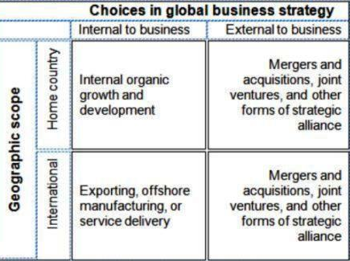
Figure3: Global business strategy.
(Source: Lewis et al. 2017)
Future of global business basically based on regarding categories: compliance rules, tax laws and global regulations trustworthy sources on tax regulatory changes all over the world. International business organizations want to achieve the platform in the present century, they should maintain several trends needs to follow:
- Interoperability.
- Compliance.
- High flexibility and fast adaptation.
- Customer experience.
- Complexity.
- Co-creation.
The product of Volvo Electrified Motor Cars is preferred due to several internal and external reasons as well as safety and security purpose. Three challenging for road safety: speeding, intoxication, distraction which has to overcome by several alerting strategies.

Supporting safer driving:
The three challenging of road safety is required b y the advanced safety innovation that supports drivers. They improve the technology to find dangerous spot and take corrective action with respect to the situation. Beside this there are also facilities of care key, geo fencing and in car cameras which are effective to avoid the accident and fluently driving.

Practical Application and deployment:
Every new trustworthy business wants to acquire success after certain times by their specific skills and effective performance throughout the world. In practical application global business achieve its success by some of unique market planning and specific decision and become one of the most renowned businesses globally.
The management of that business is quite similar with local business. Proper planning, leadership skills, well defined strategy and their effective execution make the business to reach another upward stage in the world. Global business manager follows some procedure to execute the application of the environment of global business (Newson, and Deegan, 2002, p. 183). The characteristics are described below:
- A global mindset: It is the proper planning and execution of work from the prospect.
- Cultural awareness: Depends upon various cultural beliefs and ideas need to recognize of involvement of the using process.
- Comfort with uncertainty: There are several discomforts situations and uncertain future have to face while execution of the marketing plans.
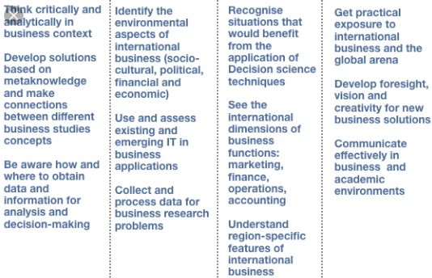
Figure 4: Practical application of global business
(Source: Newson, and Deegan, 2015)

Skills for professional practice:
Ability, Craftsmanship and proficiency are main factors of any well established business. Suppose a small family business is started. Owner of that business always wants to spread out his business through people in locality market to national market and international market (Noe et al. 2017, p.58). So, a plan needs to arrange previously. No of proficient and experienced employers are employed to expand business quickly in the international market of multinational company (MNC). Theoretical knowledge is not enough for employers but a field work experience and professional practice is also needed to improve their skills for that field of business (Epstein, 2018, p.547). Career of many employee enhanced by management, trade and international business which is conducted with respect to global business scale (Mounce et al. 2019, p. 154). There are several types of professional practice implemented by multinational companies:
- Logistics management.
- Export-Import management
- Brand management
- Compliance management
- Key account management
- Finance and forex management
- Marketing
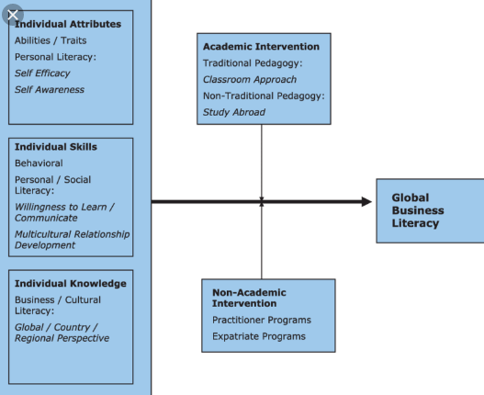
Figure 5: Skills for professional practice
(Source: Mounce et al. 2019)
Training is performed to improve the skills of employers. On the basis of global business oriented topic which uplift the organization in international market. Trainees have to focus on the following topics and subjects:
- Economic aspects
- Legal aspects
- Import management
- Export management
- Accounting practices
- International trade finance
- Trade agreement
- International capital management
- Foreign trade policy
- Foreign exchange
- Communication skills
- International labor laws
Beside these there are five types of scopes on global business are:

Product manager:
The field of product manager is very common for holders for getting chance. About the details of the product and marketing of that have to understand about plans, managing in controls, review and creation of it. In order to equate the best of the approaches for positioning in the market and competitive analysis are researched previously while planning. The profitability of potential product and recommended enhancements are also determines. At last some of the product managers and consultant reviewed labeling and materials are created to use regarding sales terms (Muratori, 2018, p. 121).

Supply chain manager:
Managers control the logistics curve of the international markets. Regional managers, senior sketch holders and board of directors of any company are supervised the products (Evans et al. 2017, p.95). Supply chain managers are the pivotal part of any organization because they are responsible for the lean logistics, cost negotiation and moreover management expertise.
Sales directors: Sales directors are responsible for the creation of budget of the product, evaluation of product financial impacts and control the budget and track it. They have the ability to maintain the sales and marketing collaboration of any particular day. They analyze and develop internal and external validate data from data sources. Based on these Activities a final report related to market share, sales, price tag and customers review has to submit after analyze (Rupp, 2015, p.58). Global business market and trade center organized the strategies and tactics to advertise the international events and shows. Sales directors look after the performance of business and different types of duties.

Business executive:
Preparing and running projects several activities has been needed which is performed by the business executives. They supervise different functions and duties like financial goals reviewing, setting budget achievements and set up the budget of any region. They collect the performance data and create the financial budget of upcoming days. They suggest overall data on production and operational activities changes (Young, 2018, p.45).

Client or account vice president:
Increase customer satisfaction and leverage resources are constructed and defined solutions by the vice president or client’s performance management, process formworks and product or service management is reviewed by them. All the managerial decisions, developing process, driving the successful outcomes, transparency and influencing strategies are also taken by the client and help the executives. The vice president helps to achieve values, ethics and moral activities, implicity, user friendliness and Effective collaboration programs of effective regions to the members of the organization. The procedures ensures professional skills improvement and development the quality of the business organizations (Pereirinha et al. 2018,p. 601).
Volvo Electrified Motor Cars has spread out globally with their new invented electrified cars.2300 dealers are working under Volvo Company. The dealers are responsible for the sales growth of Electrified Motor Vehicle of Volvo from last few years. 642253 no of cars have been sold out among 100 countries in 2018.

Conclusion:
It can be concluded that all the commercial transactions happens beyond the political boundaries between two or more nations. There are some advantages and disadvantages over global business environment. Human resource advantages are lies on the improvement of working culture and conditions, increase labor productivity and also better understanding within the employees. Production advantages are stands for rate of large scale production, using global resources and natural resources. Increase sales and profits, optimum uses of resources and scale of economics the factors enhancing the growth of the business.
Depends on overseas marketing, business expansion and use of new strategies the development of the business has been increased. There are some drawbacks created regarding global business. Competition of the domestic business organization, difference in cultural and language barriers, corruption, political stability, war and terrorism and bureaucratic practices by host countries pulls back the development of the organization.
In terms of the privacy of technology, tariffs, quotas and trade barriers the declination of growth of the company mostly affected. International business environment helps in mutual growth and investment in infrastructure. In terms of Volvo Electrified Modified Cars has already launched electrified, plug in hybrid and mild hybrid and now Volvo proposed to launch three fully electrified cars and two high performance electric cars from polyester. It also said petrol and diesel supplemented cars by mild hybrid and plug in hybrid with 48volt in all model.

References:
Adekola, A. and Sergi, B.S., (2016). Global business management: A cross-cultural perspective. Routledge.
Berggren, C. and Kågeson, P., (2017). Speeding up electro-mobility: How to electrify half of new car sales by (2030). Transport and Environment.
Epstein, M.J., (2018). Making sustainability work: Best practices in managing and measuring corporate social, environmental and economic impacts. Routledge.
Evans, S., Vladimirova, D., Holgado, M., Van Fossen, K., Yang, M., Silva, E.A. and Barlow, C.Y., (2017). Business model innovation for sustainability: Towards a unified perspective for creation of sustainable business models. Business Strategy and the Environment, 26(5), pp.597-608.
Katzev, R., (2003). Car sharing: A new approach to urban transportation problems. Analyses of social issues and public policy, 3(1), pp.65-86.
Mounce, R. and Nelson, J.D., 2019. On the potential for one-way electric vehicle car-sharing in future mobility systems. Transportation Research Part A: Policy and Practice, 120, pp.17-30.
Muratori, M., (2018). Electrification Opportunities in the Transportation Sector and Impact of Residential Charging (No. NREL/PR-5400-71102). National Renewable Energy Lab. (NREL), Golden, CO (United States).
Nieuwenhuis, P., Vergragt, P. and Wells, P., (2017). The business of sustainable mobility: from vision to reality. Routledge.
Noe, R.A., Hollenbeck, J.R., Gerhart, B. and Wright, P.M., (2017). Human resource management: Gaining a competitive advantage. New York, NY: McGraw-Hill Education.
Pereirinha, P.G., González, M., Carrilero, I., Anseán, D., Alonso, J. and Viera, J.C., (2018). Main trends and challenges in road transportation electrification. Transportation research procedia, 33, pp.235-242.
Rupp, M.Y., Engelman, G.H., Miller, A.M., Zwicky, T.D., Tellis, L. and Stephenson, R.L., Ford Global Technologies LLC, 2015. Autonomous control in a dense vehicle environment. U.S. Patent 9,079,587.
Uhl, A. and Gollenia, L.A. eds., (2016). A handbook of business transformation management methodology. Routledge.
Young, M.S.C. ed., (2018). The emergence of ecological modernisation: integrating the environment and the economy? Routledge.

