

Name : Deepa Sureshbhai Suthar
Student ID : 2523541

Subject Name : Strategic Management
Module Code : (LCMB7003)

Lecturer’s Name : Ghulam Mujtaba

Ford Motor Company: Strategic Analysis of the Ford F-150 in Alberta, Canada
Table of Contents
Section 1 (a): Organizational Context and Overview 4
Organizational Background 4
Business Model, Industry and Market Position 4
Section 1 (b): External and Internal Analyses 6
External Analysis (PESTEL) 6
Internal Analysis Using the VRIO Framework 10
SWOT Analysis 12
Section 1 (c): Comprehensive and Holistic View of the Organization 15
Corporate Social Responsibility (CSR) Strategy 15
The Balanced Scorecard 16
Section 1 (d): Strategic Choices and Implementation 18
Strategic Choices Available to Ford Motor Company 18
Recommended Strategy 19
How the Recommended Strategy Delivers Competitive Advantage 20
Implementation Challenges and Mitigation Strategies 21
Section 2: Reflective Account Using Kolb's Reflective Cycle 22
Concrete Experience 22
Reflective Observation 23
Abstract Conceptualization 23
Active Experimentation 24
Conclusion 24
References 25

Executive Summary
The report examines the strategic position of Ford Motor Company specifically with respect to the Ford F-150 in the Alberta, Canada market to analyze how competitive the company is and what strategies there are to maintain their growth over the long-term. Existing business analysis models are used to analyze the external business environment in conjunction with Ford's internal business capabilities - PESTEL analysis, the VRIO model, the SWOT model, the Balanced Scorecard and Ansoff’s matrix. The results show that Ford has a competitive edge by its market leading F-150 brand, technological innovation, broad dealer networks and focus on sustainability. But the company is not without its problems stemming from competition, rapid technological advances, ever-changing environmental rules and the forthcoming vehicle electrification movement. Based on the analysis, a differentiation marketing strategy embracing continuous innovation, advanced vehicle technologies in the form of added value for the customer and sustainable mobility is recommended. By adopting this approach, Ford will be able to more effectively compete in Alberta, better meet customer expectations, maintain high customer loyalty, and perform better over time even in the face of market uncertainty.

Section 1 (a): Organizational Context and Overview

Organizational Background
Established in 1903 by Henry Ford, Ford Motor Company is one of the largest automotive companies in the world, manufacturing passenger and commercial vehicles, as well as pickup trucks, and mobility solutions in over 100 countries (Ford Motor Company, 2026). Ford has long been acknowledged as a pioneer in mass automobile production – with the moving assembly line of the early 1900s revolutionizing global manufacturing practices. In the last ten years, the company moved away from just being an automotive manufacturer, and became a mobility and technology company by investing massively in provided connected vehicles, electrification, software services and advanced driver assistance technologies.
According to Ford Motor Company (2026), the company's corporate purpose is "to help build a better world, where every person is free to move and pursue their dreams," while its aspiration is "to become the world's most trusted company." With these pronouncements, Ford has clearly outlined its vision of growth from a product company to customer-focused mobility and sustainability. In order to compete in rapidly changing business environments, contemporary strategic management is recognized as a strategic approach that has to combine systems thinking with innovation (Kunc, 2024); this is very similar to Ford's current strategic approach.
This report does not look at Ford's global sales and business, only the Ford F-150 specifically focused on the Alberta automotive market. The geographical area chosen is Alberta which is one of the top pickup truck markets in Canada because of its expanding forestry, agriculture, construction and oil/gas operations, which speak to the continued demand for full-size pickups. Mousa et al. (2024) stress the need for organizations to grasp the unique characteristics of each market and call broad national plans to the task to be replaced with in-depth strategic planning.

Business Model, Industry and Market Position
Ford has a diversified business model which includes vehicle manufacturing, financial services, after-sales services, connected vehicle technologies and commercial fleet management. The company's business is segmented into four strategic segments: Ford Blue (internal combustion engine and hybrid vehicles, including the F-150), Ford Model e (electric vehicles), Ford Pro (commercial customers), and Ford Credit (automotive financing solutions). The diversified structure helps ensure Ford is able to sell its products in multiple complementary businesses, offering it less dependence upon the vehicle business. In 2025, Ford claimed approximately 15.2% of the national automotive industry's market share which indicates that Ford is one of the top automotive manufacturers in Canada (Ford Motor Company 2025 Annual Report).
Table 1: Competitive Analysis
Vehicle | Key Competitive Strengths
Ford F-150 | • Strong brand loyalty  • Advanced technology (BlueCruise & ADAS)  • High towing capability  • Extensive dealer network
Chevrolet Silverado | • Powerful engine options  • Strong towing capacity
GMC Sierra | • Premium interior  • Advanced technology features
Ram 1500 | • Comfortable ride  • Luxury cabin and refinement
Toyota Tundra | • High reliability  • Excellent resale value

In Alberta (from the table above), the Ford F-150 is only up against the Chevrolet Silverado, GMC Sierra, Ram 1500 and Toyota Tundra. Price isn't all one should consider: efficiency, durability, and towing cubicles, advanced safety features, resale value and after-sales support are all playing a part in competition. The competitive pressure in the pickup can market has been strengthening as a result of various new technologies that have emerged in recent years, such as hybrid vehicles, connected car services and Advanced Driver Assistance Systems (ADAS). In automotive continuously evolving competitive advantage, Kim et al. (2026) suggest that ADAS technologies are further commercialized to improve automotive products' safety, convenience and value for customers. To remain competitive in Alberta, continuous innovation, along with operational excellence and value creation from today's customers, will be key.

Section 1 (b): External and Internal Analyses

External Analysis (PESTEL)
Political Factors
One of the biggest external influences impacting on Ford's operations in Alberta is the Government Policy. Canada has further improved its regulations to help lower GHGs and increased investments in EV, low- or improved manufacturing options (Speer, 2026). Alberta's resource-based economy for many years now has demanded bigger and bolder gasoline-powered pick-up trucks, but national environmental policy will begin to impact purchasing habits and manufacturer investments over time.
Canada and the United States also continue to play a significant strategic role in relation to trade as Ford's North American supply chain is heavily reliant on the movement of vehicle parts and finished goods between the two countries. Recent political uncertainty about tariffs on Canadian and Mexican imports highlights the impacts it can have on automotive manufacturing production costs, pricing and profitability decisions for companies that operate across North America. To integrate sustainability into strategic management, Ali (2026) asserts that companies can better manage the changing regulatory requirements and improve financial results in the long run.
Economic Factors
In Alberta, economic conditions play a significant role in the demand for full-size pickup trucks due to the close relationship between them and activities related to employment, disposable income, fuel prices, interest rates and the oil and gas industry generally (see Figure 1 below). As Alberta makes use of pickups extensively in agriculture, construction, transportation and energy, it consistently has more on the road than many Canadian provinces. (Speer, 2026) But prices for financing cars have gone up with than the interest rates, with inflation being an increasingly important competitive factor.
Figure 1 Alberta's Trucking Labor Demand Rises Implying High Truck Purchases
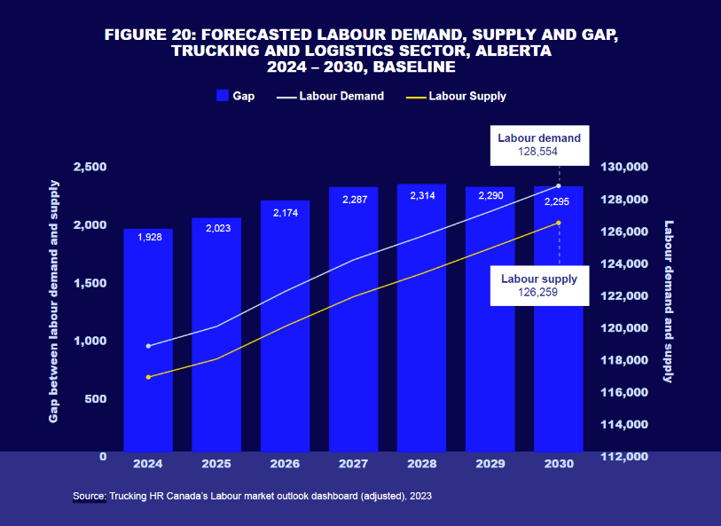
Source: Shchedrina (2024)
In spite of the macro-economic pressures, Ford held on to leading positions in 2025, with national market share up 5.44% and the F-Series vehicle sales dominating the Canadian market for the 16th year in a row. Kunc (2024) explains that companies that are able to strategically adjust to the economic climate by being flexible in their business models will be less vulnerable to maintaining their competitiveness in times of economic uncertainty. Ford Motor Company (2026) in turn, said that although the economy has been tough on some of the company's other models, the continued success of the F-Series was largely due to customer demand from both commercial and retail customers.
Social Factors
Social developments in Alberta remain very favorable for the Ford F-150 market position. The economy in Alberta is heavily reliant on industries like oil and gas, agriculture, forestry, construction, and transportation in which durable and high-capacity pickup trucks are crucial, making for one of the highest pickup truck rates in Canada (Grahn et al., 2013). But more than just work vehicles, many users appreciate the versatility, towing power, 4x4 functionality and premium comfort of pickup pickups, making them true lifestyle vehicles. This change has broadened the F-150 to be appealing to both commercial vehicle operators and families and recreational users.
Technological Factors
Artificial intelligence is one of the main factors that gives auto makers competitive edge in the industry. To counter this, Ford has poured vast sums into a connected car agenda, over-the-air software updates, digital customer services, autonomous driving research and artificial intelligence, as well as electrification. The Ford F-150 has repleted many advanced features, such as the infotainment SYNC system, the Ford Focus Assistant, BlueCruise hands-free driving system and several different Advanced Driving Assistant Systems (ADAS) features. All of this enables them to deliver innovations that create value for the customer, and help Ford's transition to a mobility and technology company. As manufacturers become more competitive in how they create vehicles and their software capabilities and digital environments, it is especially critical to invest technological resources on an ongoing basis. Boston and Werthman (2016) show that valuable information in real-world data from Ford's electrified vehicles can help inform the future development and innovation of products.
Environmental Factors
Given the increasing expectations of governments, investors and consumers that automotive manufacturers reduce greenhouse gas emissions and be more resource efficient, environmental sustainability has emerged as a key strategic consideration for the auto sector. As a response, Ford has made new announcements to mitigate carbon footprints, allocate more resources to EVs, make legal commitments to further integrate renewables in their plants, and enhance the sustainability of supply chain. The principles of the circular economy help increase the use of resources and thus also the sustainability performance in the automotive industry, as described by (Nechita et al. 2025).
The hybrid variants of the Ford F-150 and the Ford F-150 Lightning, which is designed as a zero-emissions vehicle, mark Ford's efforts to give socially responsible customers the opportunity to lead the way in the pickup segment without compromising on product leadership. Environmental laws also push manufacturers to increase the efficiency in fuel use, minimize waste levels during the production of vehicles and implement the circular economic principles during the vehicle manufacturing. According to Polighet et al. (2023), automotive companies need to integrate carbon management into operational and strategic decision making in order to achieve successful decarbonization strategies.
Legal Factors
The automotive industry is subject to a complex and well-regulated legal landscape with regard to vehicle safety, emissions standards, product quality, consumer protection, labor, cyber security, and data privacy (Speer, 2026). Ford has a responsibility to make sure that all Alberta-sold F-150s meet both Canadian federal and Alberta requirements for vehicle safety and environmental performance. The additional requirements for legal regulation of connected vehicles, autonomous driving systems, software and cyber security further increase manufacturers' compliance obligations.
Product recalls, another major legal and financial threat, can cause a loss of trust and brand reputation and costs to business operations. It's for this reason that it is crucial to have stringent quality management processes in place to support customer confidence and regulatory requirements. By using systematic approaches to planning quality and to problem solving, the significant gains in improving operational performance and reducing quality failures in automotive manufacturing are shown by Cirtina et al. (2025).

Table 2: Summary of PESTEL Analysis
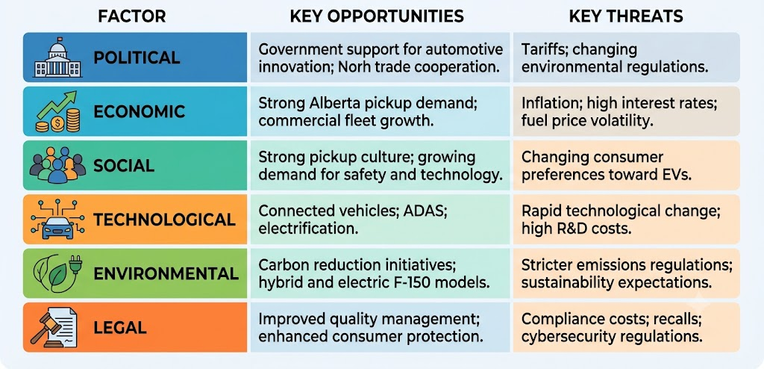

Internal Analysis Using the VRIO Framework
Valuable Resources
Ford has some important strategic assets and components that help in their direct impact on competitive strengths in Alberta. Ford F-150 has a legacy of decades of reliability, excellent resale value, a network of dealers, and ongoing innovative technology making the brand a top choice for customer loyalty. Ford is aided by its all-in-one manufacturing processes, extensive research & development spending, advanced supply chain management and a considerable amount of funds to continually improve its product. Th compagnie has the ability to deal with market changes quickly while ensuring high levels of operational efficiencies.
In addition to the connected vehicle technologies, electrification, and digital services, the company has invested in, these technologies offer customers greater safety, convenience, and ownership experience, further improving their value. For organizations with valuable strategic resources, strategic planning is more likely to help them achieve higher organizational performance, according to Mousa et al., (2024). Likewise, Braidy et al. (2025) highlight how innovation is one of the most important assets towards long-term competitiveness in the automotive sector, noting that change is happening continuously within it.
Rare Resources
Some of Ford's strategic resources may be considered rare in the full-size pickup industry. It has won the best-selling truck for 6 decades in a row for Canada – a truly high degree of brand equity that not many brands would be able to rival. The long-term partnerships with commercial customers, dealerships, suppliers, and fleet operators are key strategic assets that enhance Ford's market leadership in Alberta. According to Kunc (2024), those that have strategic capabilities to be unique among firms are likely to be more competitive and resilient to those conditions.
Inimitable Resources
Ford's many competitive strengths are far from easy to emulate because they have been built up over decades through built-up investment, organizational knowledge and customer relationships. Over the years, customer satisfaction has further cemented the Ford F-150's reputation for durability, reliability, and innovation (Ford Motor Company, 2026). It would take heavy investment in money and time for competitors to build up this brand image, and earn the same trust from consumers. Ford's manufacturing experience, relationships with suppliers, proprietary technologies and engineering are also factors that create strength in protecting its product from being copied.
Organization
Having valuable, uncommon, and hard-to-copy resources isn't enough on its own without a well-designed organization to use these resources effectively. Ford exhibits high-level organizational ability, defined as the ability to form strategy-based business divisions, operate a worldwide manufacturing network, manage integrated research and development (R&D), conduct digital transformation, and implement performance management. A restructuring has brought the company into three segments: Ford Blue, a business segment focused on People and Ford Model e, a business segment focused on Planet, and Ford Pro, a business segment focused on Profit.
Ford also invests a high degree into developing its employees, integrating new technologies, strengthening its supply chain’s reliability, managing its customer relationship, and more. Through these organizational skills, the company can leverage strategic resources into competitiveness in Alberta's pickup truck market over the long-term. According to Ali (2026) engaging sustainability in organizational strategy has added benefit in terms of enhanced financial performance, as well as future competitiveness.
Table 3: VRIO Summary
Resource/Capability | V | R | I | O | Competitive Implication
F-150 brand reputation | ✓ | ✓ | ✓ | ✓ | Sustained Competitive Advantage
Dealer and service network | ✓ | ✓ | ✓ | ✓ | Sustained Competitive Advantage
R&D and innovation capability | ✓ | ✗ | ✗ | ✓ | Competitive Parity
BlueCruise & ADAS technology | ✓ | ✓ | ✗ | ✓ | Temporary Competitive Advantage
Ford Pro commercial solutions | ✓ | ✓ | ✓ | ✓ | Sustained Competitive Advantage

SWOT Analysis
Strengths
Ford Motor Company has several strategic strengths that help the Ford F-150 to maintain its foothold as a competitor in Alberta. One of the most notable amongst these is the longstanding reputation the F-Series have for durability reliability, towing capabilities, and resale value (Ford Motor Company, 2026). These qualities have helped the F-Series truck reignite the best-selling position it held for decades in Canada and build Ford's brand recognition and customer loyalty. Ford enjoys a large network of dealerships and maintenance facilities in Alberta, providing easy vehicle sales, parts, service, and warranty services to both dealership and private customers.
Moreover, Ford has made its way on the competitive path by way of continuous investments in innovation – from hybrid technology to connected vehicle services, BlueCruise hands-free driving technology and advanced driver assistance systems. All the technological advancements add value to F-150 for the customers and make it stand out from the competitive pickup industry. According to Bridley et al. (2025), innovation is a continuous process that can help a company to maintain its competitive edge in a rapidly changing market.
Weaknesses
While it has some advantages, the company has a number of internal weaknesses that could impact the long-term competitiveness of the F-150 in Alberta. Predictable, variable fuel prices, fluctuating environmental law and consumer demand for electric vehicles can affect the company's reliance on pick-up truck sales (Ford Motor Company, 2026). The production of large pickup trucks, like other vehicles, consumes a lot of raw materials and does not benefit from commodity price stability.
Opportunities
There are a number of external options that could further bolster Ford's foothold in Alberta over the next few years. As long as the province continues to invest in infrastructure, construction, agriculture and energy projects, the durable pickup trucks will continue to sustain high demand for commercial users. However, as environmental awareness rises among consumers, the F-150 PowerBoost Hybrid and the F-150 Lightning offer Ford some opportunities for greater uptake of the two new hybrid and electric power solutions (Grahn et al., 2013). Advances in digital connectivity, predictive maintenance, fleet management software, and autonomous driver assistive systems also offer opportunities for added value for customers beyond a car or as a car. In addition, alliances between the charging infrastructure, renewable energy and smart mobility can enhance Ford's long-term competitiveness even more. Boston and Werthman (2016) show that driver behavior can be used for deriving knowledge about drivers' behavior from real world driving for future development of electrified vehicles.
Threats
Ford is dealing with a more challenging, competitive outside world. Even that, or perhaps because of that, established manufacturers like Chevrolet, GMC, Ram, Toyota and Nissan are investing substantial resources into bettering the products, products electrification and customer experience. At the same time, new to the EV market, and developing EV companies are changing the expectations of consumers around software integration, battery technology and connected mobility (Ali, 2026). Specifically, emissions reduction, fuel economy, and vehicle safety regulations are becoming increasingly stringent, thus driving up compliance costs in the industry. Other challenge risks include supply chain disruption, shortage of semiconductors, inflation and geopolitical uncertainty, all at the global level. Nechita et al. (2025) claim that as the automotive industry moves to a circular economy, major shifts must occur across the various links in the chain, which brings even more strategic challenges for automotive manufacturers.
Figure 2 SWOT Analysis Summary
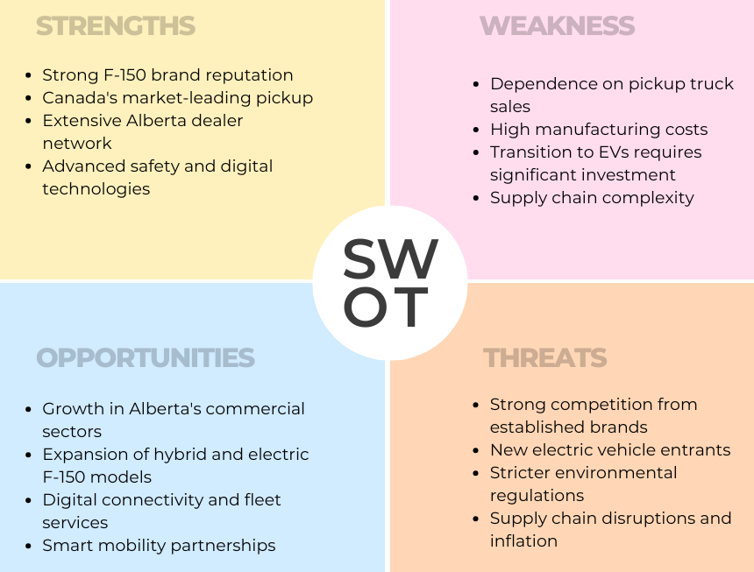

Section 1 (c): Comprehensive and Holistic View of the Organization

Corporate Social Responsibility (CSR) Strategy
Ford's Current CSR Strategy
Ford's CSR is part and parcel of the firm's corporate strategy and sustainability. Ford's CSR efforts are not limited to compliance with regulations, but also focus on environmental sustainability, responsible manufacturing, and ethical supply chain management, employee wellness, diversity and inclusion, community engagement and technological innovation. The firm has announced plans to move towards carbon neutrality for all its worldwide activity, in addition to boosting its investment in renewable energy, battery technology, EVs and sustainable manufacturing practices. As part of its F-150 product line, Ford has launched hybrid and fully electric versions, as well as models that aid emission reduction without compromising customers' expectations for performance. Polighet et al (2023) state that a successful decarbonization strategy involves embedding sustainability in the organization's overall strategy and not limited to a CSR project.
Alignment of CSR with Business Objectives
The CSR strategy is well aligned with Ford's business goals as sustainability is a major source of competitive advantage in the automotive sector. Better technologies, electrification, responsible sourcing and advanced energy efficiency measures help Ford meet changing customer expectations and anticipate the future of regulations. They also help build investor confidence, improve corporate reputations and mitigation of long-term operating risks due to climate change and resource scarcity.
Ford's increased focus on sustainability does not detract from profitability, but rather enables innovation, operational efficiency and market differentiation. This alignment allows the company to create value for the shareholder, its customer, the employee and society at the same time. According to Ali (2026), integrating sustainability into strategic management has a positive impact on the company's financial results and sustainability. Similarly, Mousa et al. (2024) state that strategic planning is the process of aligning the resources of the organization with the expectations of the stakeholders in the long-term and thus supporting sustainable competitive advantage.

The Balanced Scorecard
Financial Perspective
Financially, Ford's goal is to remain profitable and a leader in the extremely competitive Alberta pickup truck market. Some examples of KPIs are sales revenue, operating profit margin, market share, return on investment (ROI) and growth in F-150 sales in Alberta. In order to meet these goals, Ford needs to keep investing in high-end variant of the F-150, sales to fleets, hybrid technology and after-sales services that provide repeat business.
Competitive pricing and operational efficiency gains brought on by advanced manufacturing technologies will also help to drive financial gains. The financial perspective is directly aligned to Ford's mission as it helps shape long-term value for shareholders by supporting innovation and sustainability programs. According to Ali (2026), sustainability in strategic management enhances the financial performance and long-term competitiveness. Similarly, Zhang and Saadé (2025) state that optimal use of strategic resources facilitates organizations to maintain competitive advantage while accomplishing the financial goals.
Customer Perspective
The F-Series' success in Canada has been largely due to its focus on customer satisfaction, which is a key component of Ford's competitive strategy. Ford's goals are to boost customer satisfaction and repeat sales, build brand loyalty, and offer a better ownership experience with digital services and quality after-sales support (Foote, 2026). Key metrics that can be measured are customer satisfaction scores, customer retention rates, Net Promoter Score (NPS), warranty claim frequency and dealership service ratings.
Internet connectivity, BlueCruise technology, maintenance support and dealer relationships will continue to expand and add to customer value with strategic initiatives throughout Alberta. Keeping customers' confidence in the brand is especially crucial in the face of the continued influx of technologically sophisticated pickup trucks from rival brands. According to Kim et al. (2026), advanced driver-assistance technologies have a significant impact on customer satisfaction by improving the safety and convenience of vehicles. Likewise, Braidy et al. (2025) state that ongoing innovation boosts customer value propositions and enables long-term market competitiveness.
Internal Business Processes Perspective
Ford's internal processes should aim to increase manufacturing efficiency, product quality, the ability to innovate, supply chain's ability to bounce back from adversity, and sustainability performance. The goals are to lower production costs, enhance the manufacturing quality, limit warranty defects, increase flexibility in the supply chain, and move product innovation along more quickly (Automotive Anonymous, 2026). Production efficiency, manufacturing defect rates, recall rates, supply chain lead times, and research and development effectiveness are pertinent KPIs. Digital manufacturing technologies, predictive maintenance systems, supplier collaboration, and constant quality improvement programs are all areas that should be part of a strategic initiative. Enhancing operational efficiency enables Ford to respond more rapidly to changing market conditions while maintaining product quality. Cirtina et al. (2025) present that structured quality planning and systematic problem-solving can substantially contribute to manufacturing performance improvement in the automotive industry.
Learning and Growth Perspective
The learning and growth perspective is about building the organizational capacity for its future. The goals that Ford aims to achieve include improving employee skills, promoting innovation, improving digital skills, and promoting constant organizational learning (Automotive Anonymous, 2026). Key performance indicators are employee training hours, investment in research and development, employee engagement, innovation output, and the adoption of technology. Strategic targets include placement of more staff on the workforce training program focused on electrification, artificial intelligence, software engineering, sustainability management and advanced manufacturing techniques. By investing in staff, Ford can continue to innovate and successfully navigate the ever-changing automotive sector. Kunc (2024) believes that organizational learning is a core competence for strategic adaptability in complex business environments.
Table 4: Balanced Scorecard for the Ford F-150 in Alberta
Perspective | Objectives | KPIs | Targets | Strategic Initiatives
Financial | Increase profitability | Revenue, ROI, operating margin, market share | Increase F-150 sales and profitability | Expand fleet sales, improve operational efficiency
Customer | Improve customer satisfaction | Customer satisfaction, retention, NPS | Higher customer loyalty | Enhance dealership service, digital connectivity
Internal Business Processes | Improve operational efficiency | Defect rates, production efficiency, recall rates | Reduce defects and production costs | Digital manufacturing, quality improvement
Learning & Growth | Strengthen innovation capability | Employee training, R&D investment, engagement | Increase innovation and workforce capability | Employee development, technology investment

Section 1 (d): Strategic Choices and Implementation

Strategic Choices Available to Ford Motor Company
There are multiple strategies Ford could pursue to enhance the position of the F-150 in Alberta. Cost leadership is the first approach, which Ford aims at lowering the production and operating costs, but not at raising prices. Manufacturing automation, economies of scale, optimization of supply chain and better operational efficiency can lead to cost leadership. Reducing production costs would enable Ford to offer a competitive product against its competitors while maintaining profit margins. But if your competitive strategy is simply price, it can be difficult because people who buy full-sized pickup trucks may care more about how long they'll last, the reliability of the truck and the technology it offers, and reputation than the total price of the truck. Mousa et al. (2024) suggests strategic planning should not be a one-way approach of reducing costs but should take into account value creation over the long term. Likewise, Kunc (2024) reports that organizations that bridge the gap between systems thinking may be inclined to 'optimize for the bottom line' which can be a sign of sacrificing innovation and future competitiveness.
Differentiation is the second strategic option, in which Ford differentiates the F-150 even further with the use of superior technology, product quality, customer experience, innovation and sustainability. The approach is well suited to the present market with customers placing greater emphasis on advanced driver-assistance systems, connected vehicle systems, electrification, high quality interior and after-sales service. Differentiation will allow Ford to charge higher prices and increase customer loyalty and decrease direct price competition. The continued investment in hybrid technologies, digital services and intelligent mobility solutions will further strengthen Ford's position in Alberta's pickup market. Braidy et al. (2025) suggest that continuous innovation is important for companies to remain different even when faced with greater competition. Similarly, Kim et al. (2026) point out that technological leadership is one of the most important factors to competitive advantage in the automotive industry.

Recommended Strategy
The best strategy for Ford is to differentiate and continue investing in innovation and sustainable mobility. Alberta buyers of pickup trucks are concerned with reliability, towing power, durability and the use of the latest technology and most importantly ownership experience, not just a low acquisition price. Ford will reinforce customer loyalty and keep their premium position in the market by strengthening technological leadership and through connected vehicle services, hybrid powertrain, intelligent safety systems and superior after-sales service. This approach aligns with Ford's overall transformation as a mobility company that is centered on technology. According to Ali (2026), sustainability-based innovation also leads to improved financial results and competitiveness. In the same vein, Poligkeit et al. (2023) find that embedding sustainability in strategic decisions enhances the resilience of an organization in the long term and its competitiveness.
Figure 3 Ansoff's Growth Matrix Ford F-150 in Alberta Canada
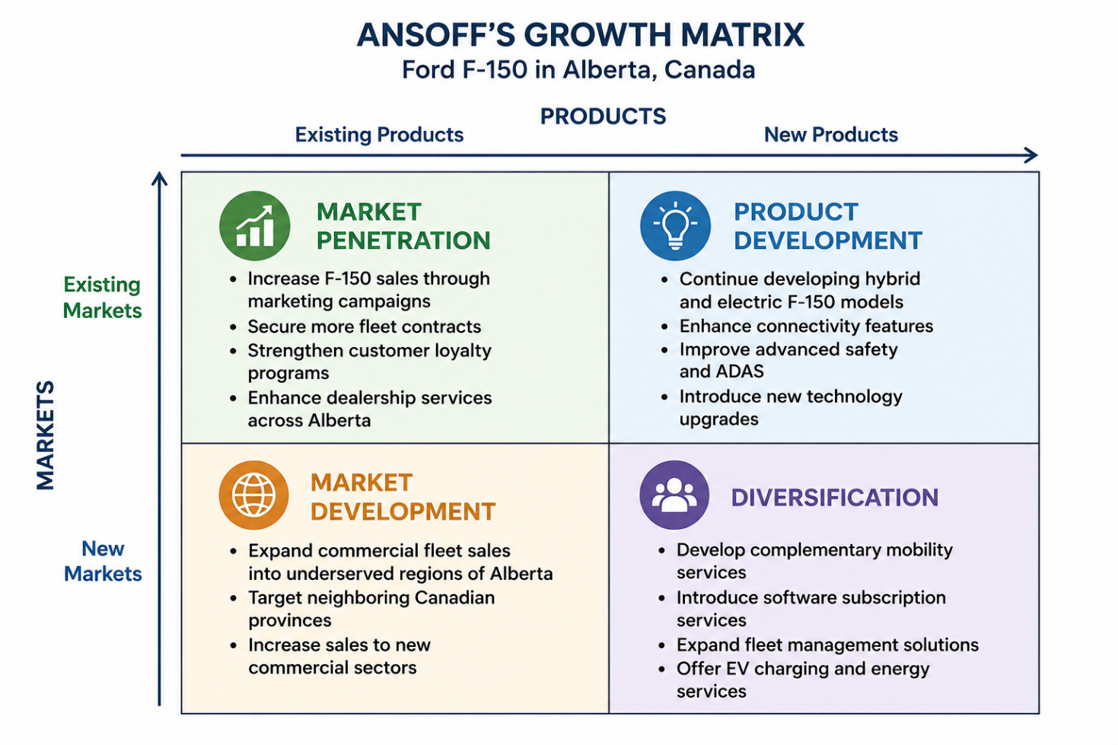

How the Recommended Strategy Delivers Competitive Advantage
Differentiation allows Ford to offer value that can be difficult for competitors to duplicate. Advanced engineering, high brand value, extensive dealer support, connected car technologies, and ongoing product development enhance customer loyalty and mitigate price sensitivity. When buying the F-150 customers frequently think of lifetime ownership value, and not just the price of the vehicle. So, differentiating further makes Ford more capable of holding premium prices and ensuring long-term profitability. Zhang and Saadé (2025) say that the organizations which have unique strategic competences have more chances to gain long-term competitive advantage. Likewise, Kunc (2024) asserts that an organization that has the capability to coordinate strategic capabilities in several organizational systems will have more persistent resilience.

Implementation Challenges and Mitigation Strategies
- High investment costs: The value of advanced technologies, electrification and connected mobility solutions are not fully understood. Ford should continue its strategic partnerships and focus on investing in technologies that will provide the highest value to customers and continue to be disciplined with their capital allocation (Ali, 2026; Braidy et al., 2025).
- Increasing competitive pressure: Rival companies keep on releasing technologically advanced pickup trucks and electric vehicles. Ford needs to speed up the innovation process, improve customer relationships through better after-sales service, and build on the reputation of the F-150 to continue to be the leader in the market (Kim et al., 2026; Pohl & Karlström, 2023).
- Supply chain disruptions: Chip, battery and critical raw material shortages could impact production timelines and profitability. To reduce the risks and vulnerabilities in their supply chain, Ford should diversify their suppliers, improve their strategic sourcing and build supply chain resilience with digital monitoring and collaborative supplier management (Poligkeit et al., 2023; Cirtina et al., 2025).

Section 2: Reflective Account Using Kolb's Reflective Cycle
Figure 4 Summary Diagram of my Kolb's Reflective Cycle
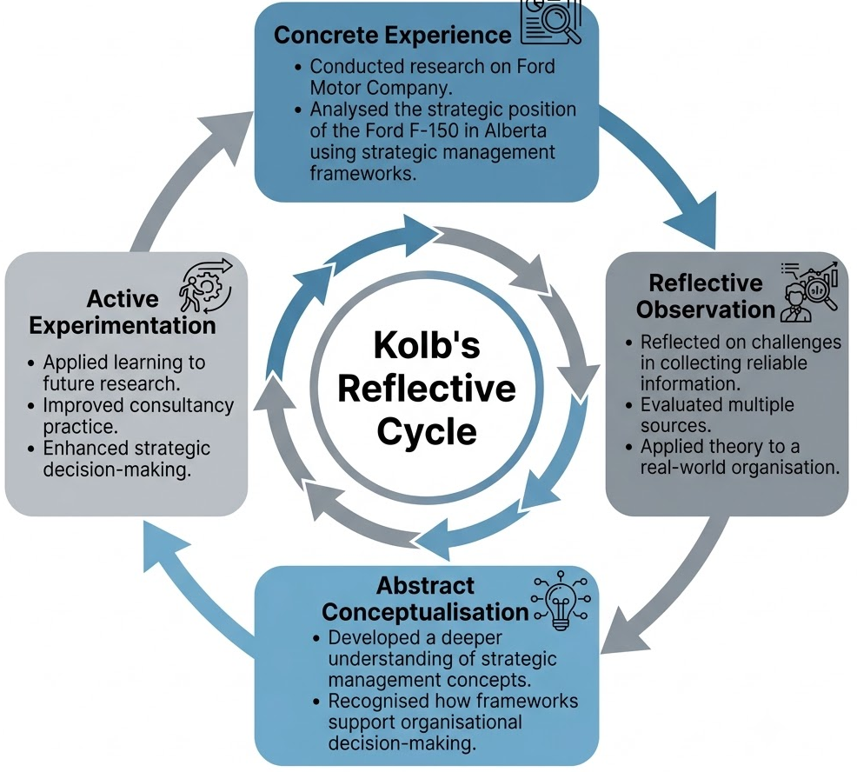

Concrete Experience
This strategic report proved to be an opportunity to test theories in an actual organization in the competitive business world. As opposed to analyzing the whole Ford Motor Company, the report concentrated on Ford's F-150 in Alberta, Canada, making it simpler to analyze the company's strategic placement in that market. I used the framework of strategic management in my research from the beginning to the end to analyze Ford's context, industry, competitive position, capabilities, corporate social responsibility initiatives, and strategic options, as well as using the following well-known strategic management frameworks: PESTEL, VRIO, SWOT, Balanced Scorecard, and Ansoff's Matrix. This required integrating scientific theories and business data from company literature, industry reports and scholarly publications. This experience showed that in order to be effective in strategic management, the organization must assess both their own resources and the external environment before making strategic decisions for the long term.

Reflective Observation
When thinking about the research process, I realized that strategic analysis is not a description of what an organization does, but rather a critical examination of the process with supporting, believable evidence. An important hurdle was finding reliable information that was related to the Ford F-150 in Alberta, not Ford in general. Ford has a lot of information out there about their business, but they did have to be careful to interpret a number of sources to make it relevant if you focused in on a single product and geographical market. The other learning experience was the appraisal of various strategic management frameworks and their contribution of unique insights that would help understand the performance of an organization. For instance, physical conditions were brought by PESTEL and internal capabilities and resources were emphasized by VRIO. Likewise, the Balanced Scorecard showed that there is no single measure of organizational success as customer satisfaction, operational efficiency and organizational learning contribute to long-term competitiveness as well.

Abstract Conceptualization
This report helped me to improve my understanding of the application of strategic management theories in real business scenarios to a great level. Prior to doing this analysis, I thought of strategic management as a process of choosing competitive strategies. The report showed however, that strategy development is an ongoing process which involves continuous interaction between organizational resources, stakeholder expectations, market situation, technological innovation, sustainability, and organizational abilities. The VRIO framework reiterated the significance of valuable, rare, inimitable and organized resources for securing sustainable competitive advantage.

Active Experimentation
This learning experience will have a positive impact on the way in which I will conduct myself as a strategist and professional in the future. In my future academic research, I will be more focused on combining several strategic management frameworks since they offer different aspects of organizational performance and competitive positioning. I now understand that using only one analytical tool for the development of recommendations for organizational improvement is not sufficient, and that it is essential to use external analysis, internal resource evaluation, performance measurement and implementation of the strategy. I will also use evidence-based decision making, providing support for strategic recommendations with reliable, and sound data from credible academic and industry sources as a future management professional. In addition, I have come to understand the significance of sustainability, technological innovation and the involvement of stakeholders in today's strategic management. My judgement of complex business issues will be enhanced and I will be able to offer sound, realistic suggestions that will help with the long-term success of the organization.

Conclusion
This report explores the strategic landscape of Ford Motor Company, and more specifically the Ford F-150 in the Alberta, Canada market. The study found that Ford still has considerable competitive benefits in terms of its brand reputation, technological innovations, dealership network and market share in the Canadian pickup truck market. However, the company is faced with a rapidly changing environment, with technology advancing rapidly, competition becoming more formidable, customers becoming more demanding and sustainability demands rising. Ford's differentiation strategy, based on continuous innovation, digital technology, electrification and value creation for the customer, will bolster the organization’s competitive position and help in the long-term.

References
Ali, A.A. (2026) 'Impact of Integrating Sustainability into Strategic Management on Financial and Sustainability Performance—Literature Review,' Sustainability, 18(8), p. 4137. https://doi.org/10.3390/su18084137 .
Automotive Anonymous. (2026, March 27). 2026 Ford F-150 (RCSB 5.0 V8) | Honest review and 0-60 [Video]. YouTube. https://www.youtube.com/watch?v=pE-knVaQIxw
Boston, D. and Werthman, A. (2016) 'Plug-in Vehicle Behaviors: An analysis of charging and driving behavior of Ford plug-in electric vehicles in the real world,' World Electric Vehicle Journal, 8(4), pp. 926–935. https://doi.org/10.3390/wevj8040926.
Braidy, A., Pokharel, S. and ElMekkawy, T.Y. (2025) 'Research perspectives on innovation in the automotive sector,' Sustainability, 17(7), p. 2795. https://doi.org/10.3390/su17072795.
Cirtina, L.-M. et al. (2025) 'Eight-Disciplines Analysis Method and Quality Planning for Optimizing Problem-Solving in the Automotive sector: a case study,' Processes, 13(10), p. 3121. https://doi.org/10.3390/pr13103121.
Foote, B. (2026, July 10). Ford F-150 among top 10 “Forever” vehicles. Ford Authority. https://fordauthority.com/2026/07/ford-f-150-among-top-10-forever-vehicles/
Ford Motor Company. (2026). 2026 Ford F-150 Support Information | Ford Owner Support. Ford.com. https://www.ford.com/support/vehicle/f150/2026/?srsltid=AfmBOoo4xKmtON3mNUZ5Zwovph1neOgo6pPkV79lCD5t_MRnYvo1nhx5
Grahn, M. et al. (2013) 'Sustainable mobility: Using a global energy model to inform vehicle technology choices in a decarbonized economy,' Sustainability, 5(5), pp. 1845–1862. https://doi.org/10.3390/su5051845.
Kim, Y. et al. (2026) 'Comparative Review of Commercialized Advanced Driver Assistance System (ADAS) Technologies,' Electronics, 15(10), p. 2015. https://doi.org/10.3390/electronics15102015.
Kunc, M. (2024) 'The Systems Thinking Approach to Strategic Management,' Systems, 12(6), p. 213. https://doi.org/10.3390/systems12060213.
Mousa, K.M., Ali, K.A.A. and Gurler, S. (2024) 'Strategic Planning and Organizational Performance: An empirical study on the manufacturing sector,' Sustainability, 16(15), p. 6690. https://doi.org/10.3390/su16156690.
Nechita, R., Deselnicu, D., Istriţeanu, S., & Băjenaru, V. (2025) 'Analyzing critical factors for the automotive industry’s transition to a circular economy: a Multi-Attribute Decision-Making Analysis approach,' Applied System Innovation, 8(5), p. 150. https://doi.org/10.3390/asi8050150.
Pohl, H. and Karlström, M. (2023) 'Academic and corporate vehicle electrification research,' World Electric Vehicle Journal, 14(3), p. 71. https://doi.org/10.3390/wevj14030071.
Poligkeit, J., Fugger, T. and Herrmann, C. (2023) 'Decarbonization in the automotive sector: A holistic status quo analysis of original equipment manufacturer strategies and carbon management activities,' Sustainability, 15(22), p. 15753. https://doi.org/10.3390/su152215753.
Shchedrina, K. (2024, November 25). Alberta’s drivers out-earn national average, but province struggles with retention, input costs: THRC. Truck News. https://www.trucknews.com/transportation/albertas-drivers-out-earn-national-average-but-province-struggles-with-retention-input-costs-thrc/1003191563/
Speer, S. (2026) 'The rest of Canada has a lot to learn from Alberta,' The Hub, 12 June. https://thehub.ca/2026/06/12/the-rest-of-canada-has-a-lot-to-learn-from-alberta/.
Zhang, X. and Saadé, R.G. (2025) 'Towards a deeper understanding of strategic management factors in international Non-Governmental organizations,' Administrative Sciences, 15(2), p. 34. https://doi.org/10.3390/admsci15020034.

