BMSP6007: Economics of Sustainability
Assignment Title: World Economic Forum Report
Lecturer: Anthony Burns
Student: Peter Todorov
Student ID Number: 1705088

Economics of Sustainability Assignment Two – World Economic Forum Report

Introduction

Climate change can have a negative impact on the planet in a number of different ways which include rising temperatures and food production. As one of the global risks given by the World Economic Forum for 2033 was climate change with the failure to mitigate the effects of it (World Economic Forum, 2023). Researchers have stated that the global warming threshold of 1.5 °C would be surpassed in 2027 with the Intergovernmental Panel on Climate Change (2018) also stating Global temperatures between 2030 and 2052 will continue to increase by 1.5 °C globally (McGrath, 2023). The negative effects which climate change can have can affect large areas of the world such as the Mediterranean as rising temperatures, food production issues, flood and droughts can have a negative impact on the way of life in the Mediterranean. With temperatures rising in the Mediterranean, it has been estimated that in the past three decades the temperatures has increased between 0.6 °C and 1 °C (López García, 2021). Other effects of climate change will be given in this report with potential solutions to these issues will be discussed.

World Economic Forum Global Risks

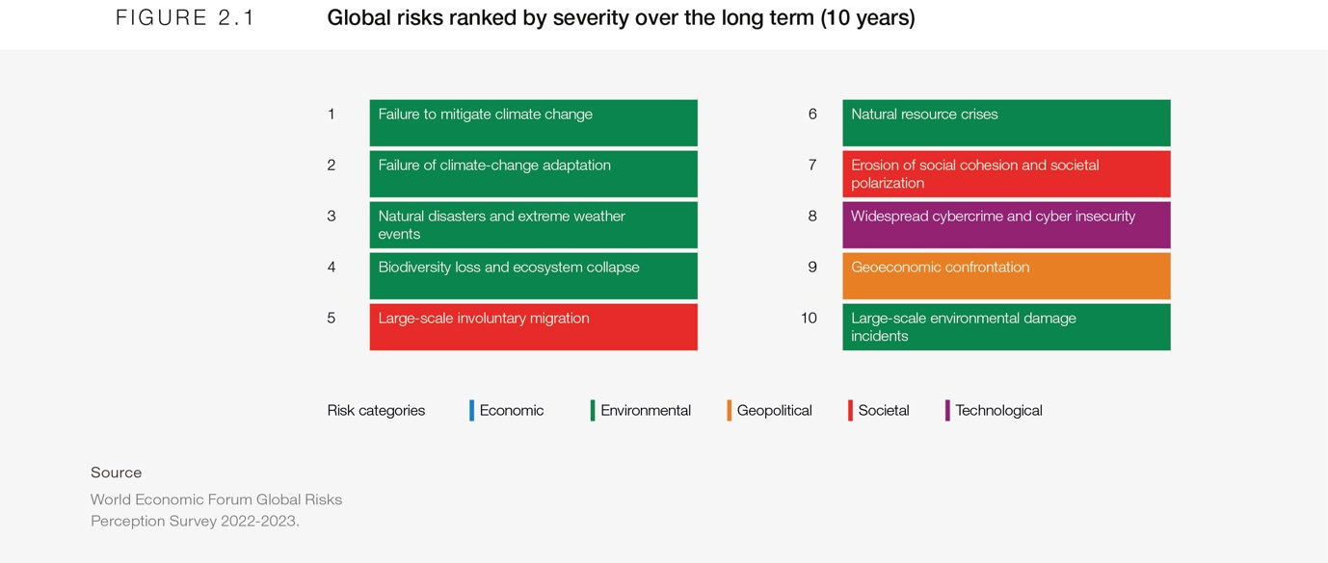
Figure One: World Economic Forum: Global Risks Ranked by Severity Over The Long Term (10 Years) (World Economic Fund, 2023)

The World Economic Forum risk outlook for the global risks in 2033 outlines ten risks ranging from environmental, economic, technological and societal (World Economic Forum, 2023). The risk that will be discussed in this report is climate change and the failure to mitigate it as it is the highest ranked risk based on severity (World Economic Forum, 2023). If climate change and the effects it has on the planet are not stopped it can lead to potentially disastrous effects for the planet in a number of different ways which may not be reversible. The risk of not achieving sustainable development can have a negative effect on the environment through the effects that climate change will have on it. Not stopping the effects of climate change would result in not achieving one of the seventeen United Nations Sustainable Development Goals (goal thirteen) which is to prevent climate change and the impacts it will have on the environment (United Nations, No Date). For climate change the United Nations has set five goals with eight indicators on how progress is being made to achieve this Sustainable Development Goal (Ritchie et al., 2018). These goals include increasing knowledge, incorporating measures into planning and policies and reinforce resilience and capacity to disasters from climate change (Ritchie et al., 2018). Achieving this Sustainable Development Goal set by the United Nations can help in reducing the climate change risk outlined by the World Economic Forum. By achieving it can have a knock on effect of other risks given by World Economic Forum and other goals set by the United Nations. The knock on effects it would have for the risks that are given by the World Economic Forum would be that reduced risk of natural disasters, biodiversity loss and damage to the environment (World Economic Forum, 2023).

Malthus Model

Thomas Robert Malthus in 1798 published his model in the book, An Essay on the Principle of Population as It Affects the Future Improvement of Mankind (Hussen, 2012). The Malthusian model states that population will double as it increases (2, 4, 8, 16, etc.) however supply of food will increase singularly (1, 2, 3, 4, etc.) (Hussen, 2012). The imbalance over time would increase so the population growth rate or supply of food would need to be solved through different methods. These methods may include abstinence, marriage postponement, one child policy, etc. (Hussen, 2012; Zhang, 2017). If the population does continue to grow without any restrictions, then the risk of the standards of living will decrease to a level where living standards are not sustainable due to the supply of food not providing enough for the growth in population with this being called the ‘dismal doctrine’ of Malthus (Hussen, 2012). If living standards do become unsustainable whether it is from drought, flood or other natural events it can mean issues for food production as an increase in the regularities of floods and droughts that can be challenging for production of food is predicted to be caused by climate change (Mar et al., 2018). Floods can be prevented through the maintaining of wetlands and forests (IUCN World Conservation Congress, 2021). Droughts can affect plant growth as it can be hampered at all stages from heat stress which therefore can reduce food crops production (Hussain et al., 2019). A solution to droughts would be increasing photosynthesis efficiency or growth enhancements have the potential for intrinsic yields to be improved (Ambavaram et al., 2014). Identifying new molecules and implementing them into plant breeding can quicken production of the improved crops, which can be more resistant to droughts and other environmental issues (Pareek et al., 2020). Additionally, Melandri et al., (2020) discussed drought induced losses of crops and found that malondialdehyde levels and dehydroascorbate reductase activity can be biomarkers for crop tolerance to drought.

In the Mediterranean the effects of global warming would affect sea temperatures, fire seasons and supply of food amongst others. In the Mediterranean fire seasons are expected to become more frequent, severe and longer due to heatwaves, drought and change of land use (Duguy et al., 2013; Turco et al., 2014; Ruffault et al., 2016).

Sea temperatures rising have been linked to numerous different species having enlarged events of mass deaths in the Mediterranean (Garrabou et al., 2009; Rivetti et al., 2014; Marbà et al., 2015) Since 1999 events of mass deaths regarding different species every year has been reported but it is affecting fewer species and more restricted in range geographically in the Mediterranean (Rivetti et al., 2014). With temperatures rising in the Mediterranean, it has been estimated that in the past three decades the temperatures has increased between 0.6 °C and 1 °C (López García, 2021). The effects it has made for the summers is they have become longer, more intense with June and July having the highest rates of temperature increases with 0.6 °C for each decade for the previous thirty years (López García, 2021). These increases in temperature can have a negative effect on human health for people who do live in the Mediterranean that currently have health issues. Royé (2017) conducted an analysis in Barcelona, that found the mortality risk increased as a result of cardiovascular, respiratory and natural causes for hot nights that have temperatures which are higher than 23°C. This means young children, older adults and people with chronic and pre-existing medical conditions are especially vulnerable to any diseases or illnesses and they are at a high risk for heat related mortality (CDC, 2015).

Research shows this as in 2014 91% of fish stocks assessed in the Mediterranean were overfished, though fish stocks are vulnerable and sensitive to the climate the future of the fisheries in the Mediterranean are also undermined by overfishing (European Commission, 2014; Coll et al., 2012). This means that there is a high risk of other food supplies and products becoming in short supply if the population continues to grow at a fast rate. For example, 20% of exploited fish that are presently found in the Eastern Mediterranean may become locally extinct because of climate change, with models projecting this to happen between 2040-2059 (Jones & Cheung, 2015; Cheung et al., 2016).

As research shown by Schneider et al., (2011) it investigated the impact of population growth on global food production and consumption it found that agricultural land globally would increase by 14% between 2010 and 2030. Restrictions on deforestation impact the price of water and land resources strongly but there is little effect on the food prices and food production levels globally. If water resources do become in short supply, it can affect the production of food supplies such as rice as to produce 1 kg of rice a considerable quantity of water is required as 2497 litres of water is needed in the production process (Rahaman et al., 2016). A method which may be help if water resources become restrict as Melandri et al., (2020) reported a low canopy temperature is a beneficial indicator during droughts for access to moisture for rice. In terms of drought usage of low canopy temperatures can be beneficial for rice production and if it is used for other food supplies it can assist in producing them even if a drought is or is not currently happening in hot temperature countries (Melandri et al., 2020). Using moisture instead of water resources can allow for less water to be used in food production and to be used in other vital aspects of life where water resources are required.

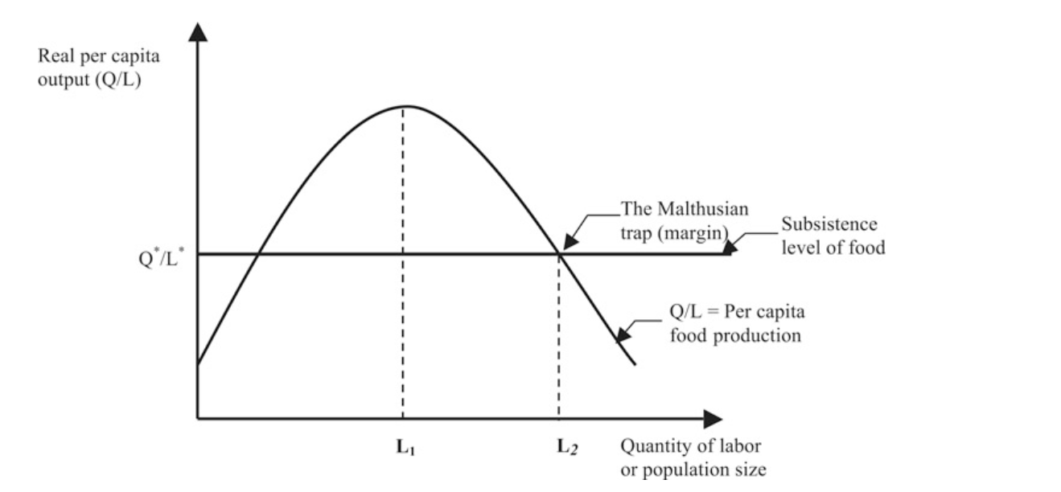

Figure Two: Malthusian Model (Hussen, 2012)

Increasing Resource Scarcity

Increasing resource scarcity is shown in the figure below as the availability of natural resources decreases over time due to the lack of replaceability for certain natural resources such as coal, oil and/or gas (Hussen, 2012). Scarcity can increase when to retrieve the same resource more labour hours are required to retrieve said resource (Hussen, 2012). Changing the reliability of resources that are not easily replaceable such as coal, oil and/or gas to ones that are like wood will assist in avoiding a situation like this (Hussen, 2012). If resources are used that do not have good replaceability or are of a lesser quality then the price of that resource will increase over time as the supply of it becomes less and less (Hussen, 2012). If a resource is used which can be replaced easily such as wood, then the price of it should stay constant (Hussen, 2012). But if it is easily replaceable but of a lower quality the price will increase over time as the quality of the product improves (Hussen, 2012).

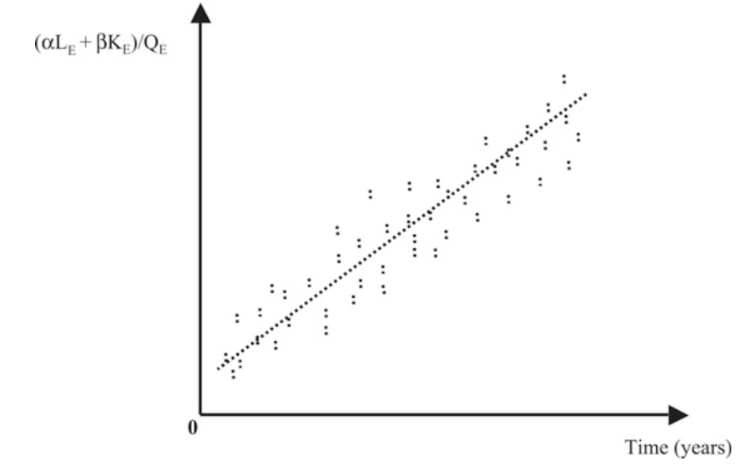
Figure Three: Increasing Resource Scarcity (Hussen, 2012)

Kuznets Curve

Kuznets curve shows that at a certain point the living standard of a country can be attained by growth in the economy as it can allow for the quality of the environment to be improved as extra money can be spent on these improvements (Hussen, 2012). As the economy increases there will initially be a decrease in the conditions of the environment, and there will then be an increase in the conditions of the environment afterwards (Hussen, 2012). This point of increasing environmental conditions will happen at the income turning point (Hussen, 2012). However, Özokcu and Özdemir (2017) conducted a study into Kuznets curve and investigated twenty-six high income level countries and fifty-two emerging income countries, and it was found that the results does not support Kuznets theory which means that economic growth does not prevent decline to the environment. This means that growing the economy will not help in improving the environment, but initiative solutions will be necessary.

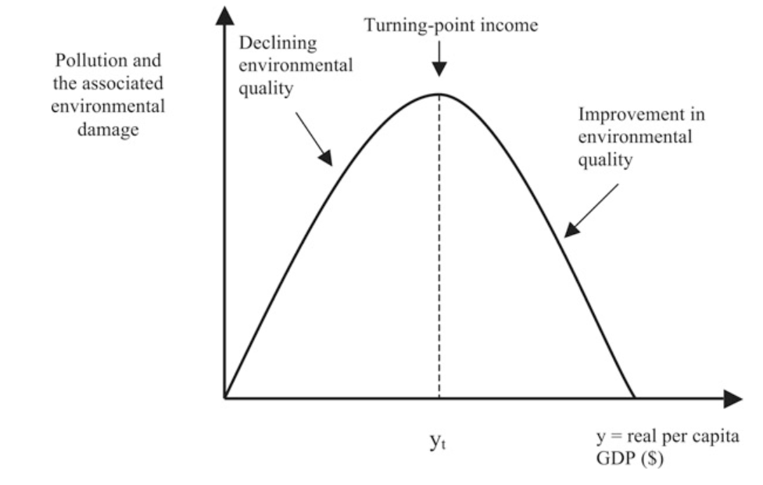
Figure Four: Kuznets Curve (Hussen, 2012)

The amount of natural resources that are currently in use has grown since the 1970s when 27 billion tonnes of global materials were used to present day being 92 billion tonnes (Oberle et al., 2019). To maintain the current rate of materials that are used globally by 2060, extraction of materials would have to double to 190 billion tonnes, and emissions from greenhouse gases would increase by a total of 43% (Oberle et al., 2019). Other effects would include land used for pasture needing to increase by 25%, cropland increasing by 20%, forests decreasing by 10% and other natural habitats decreasing by 20% (Oberle et al., 2019). Reducing the need to use natural resources such as fossil fuels like oil or coal that the use of which has grown from 6.2 billion to 15 billion tonnes, can help in reducing greenhouse gas emissions which can be done through the increasing usage of renewable energy sources such as wind power. By 2030 Spain aims to have 27% of their power being supplied by renewable energy sources, with 31 GW of it being energy produced from wind and in the next ten years an extra 8 GW is needed to be produced by wind to meet this aim (de Simón-Martín et al., 2019). Increasing the usage of renewable energy can reduce the liability of people feeling price increases from fossil fuels like oil which reached their highest known prices in 2022 (Bolton, 2023). Switching to renewable energy sources can help reduce the reliability on fossil fuels which means reducing the greenhouse gas emissions that are produced and will be beneficial to the environment and to battling climate change.

Conclusion

This report has given numerous different effects that climate change will have on the planet from rising temperatures and food production. In terms of drought usage of low canopy temperatures can be beneficial for rice production and if it is used for other food supplies it can assist in producing them even if a drought is or is not currently happening in hot temperature countries (Melandri et al., 2020). In terms of drought usage of low canopy temperatures can be beneficial for rice production and if it is used for other food supplies it can assist in producing them even if a drought is or is not currently happening in hot temperature countries (Melandri et al., 2020). Implementing of wind power instead of using fossil fuels can reduce the greenhouse gas emissions that are produced and will be beneficial to the environment and to battling climate change. Reduction of greenhouse gas emissions can assist in reducing the risks set out by the World Economic Forum and achieve the goals set by the United Nations. If greenhouse gas emissions are not reduced, then global temperatures may exceed the global warming threshold of 1.5 °C which would be disastrous for the planet due to the effects it would have overall.

Word Count: 2299

Reference List

Ambavaram, M. M., Basu, S., Krishnan, A., Ramegowda, V., Batlang, U., Rahman, L., Baisakh, N., & Pereira, A. (2014). Coordinated regulation of photosynthesis in rice increases yield and tolerance to environmental stress. Nature communications, 5(1), 5302.

Bolton, P. (2023). Petrol and Diesel Prices. Retrieved from: https://commonslibrary.parliament.uk/research-briefings/sn04712/

CDC. (2015). Heat Stress. Retrieved from: http://www.cdc.gov/niosh/topics/heatstress

Cheung, W. W., Jones, M. C., Reygondeau, G., Stock, C. A., Lam, V. W., & Frölicher, T. L. (2016). Structural uncertainty in projecting global fisheries catches under climate change. Ecological Modelling, 325, 57-66.

Coll, M., Piroddi, C., Albouy, C., Ben Rais Lasram, F., Cheung, W. W. L., Christensen, V., Karpouzi, V. S., Guilhaumon, F., Mouillot, D., Paleczny, M., Palomares, M. L., Steenbeek, J., Trujillo, P., Watson, R., & Pauly, D. (2012). The Mediterranean Sea under siege: spatial overlap between marine biodiversity, cumulative threats and marine reserves. Global Ecology and Biogeography, 21(4), 465-480.

de Simón-Martín, M., de la Puente-Gil, Á., Borge-Diez, D., Ciria-Garcés, T., & González-Martínez, A. (2019). Wind energy planning for a sustainable transition to a decarbonized generation scenario based on the opportunity cost of the wind energy: Spanish Iberian Peninsula as case study. Energy Procedia, 157, 1144-1163.

Duguy, B., Paula, S., Pausas, J. G., Alloza, J. A., Gimeno, T., & Vallejo, R. V. (2013). Effects of climate and extreme events on wildfire regime and their ecological impacts. Regional Assessment of Climate Change in the Mediterranean: Volume 2: Agriculture, Forests and Ecosystem Services and People, 101-134.

Ekins, P., & Zenghelis, D. (2021). The costs and benefits of environmental sustainability. Sustainability Science, 16, 949-965.

European Commission. (2014). Maritime Affairs and Fisheries: On the State of Fish Stocks. Retrieved from: https://go.nature.com/2OWQJHr

Garrabou, J., Coma, R., Bensoussan, N., Bally, M., Chevaldonné, P., Cigliano, M., Diaz, D., Harmelin, J.G., Gambi, M.C., Kersting, D.K., Ledoux, J.B., Lejeusne, C., Linares, C., Marschal, C., Pérez, T., Ribes, M., Romano, J.C., Serrano, E., Teixido, N., Torrents, O., Zabala, M., Zuberer, F., & Cerrano, C. (2009). Mass mortality in Northwestern Mediterranean rocky benthic communities: effects of the 2003 heat wave. Global change biology, 15(5), 1090-1103.

Hussain, H. A., Men, S., Hussain, S., Chen, Y., Ali, S., Zhang, S., Zhang, K., Li, Y., Xu, Q., Liao, C., & Wang, L. (2019). Interactive effects of drought and heat stresses on morpho-physiological attributes, yield, nutrient uptake and oxidative status in maize hybrids. Scientific reports, 9(1), 3890.

Hussen, A. (2012). Principles of environmental economics and sustainability: an integrated economic and ecological approach. Routledge.

Intergovernmental Panel on Climate Change. (2018). Summary for policymakers. In: Masson-Delmotte V, Zhai P, Pörtner H-O, et al., eds. Global warming of 1.5 °C. An IPCC special report on the impacts of global warming of 1.5 °C above pre-industrial levels and related global greenhouse gas emission pathways, in the context of strengthening the global response to the threat of climate change, sustainable development, and efforts to eradi- cate poverty. Geneva, Switzerland: World Meteorological Organization, 32.

IUCN World Conservation Congress. (2021). Mediterranean Solutions: Innovating and collaborating for a greener region. Retrieved from: https://www.iucn.org/sites/default/files/content/documents/2021/brochure_med_stand_iucn_congress_2021_low_1.pdf

Jones, M. C., & Cheung, W. W. (2015). Multi-model ensemble projections of climate change effects on global marine biodiversity. ICES Journal of Marine Science, 72(3), 741-752.

López García, M. J. (2021). How much warmer is the Mediterranean becoming? Thirty-five years of satellite observations. Metode Science Studies Journal, (11), 193-199.

Mar, S., Nomura, H., Takahashi, Y., Ogata, K., & Yabe, M. (2018). Impact of erratic rainfall from climate change on pulse production efficiency in lower Myanmar. Sustainability, 10(2), 402.
Marbà, N., Jordà, G., Agustí, S., Girard, C., & Duarte, C. M. (2015). Footprints of climate change on Mediterranean Sea biota. Frontiers in Marine Science, 2, 56.
McGrath, M. (2023). Global warming set to break key 1.5C limit for first time. Retrieved from: https://www.bbc.co.uk/news/science-environment-65602293

Melandri, G., AbdElgawad, H., Riewe, D., Hageman, J. A., Asard, H., Beemster, G. T., Kadam, N., Jagadish, K., Altmann, T., Ruyter-Spira, C., & Bouwmeester, H. (2020). Biomarkers for grain yield stability in rice under drought stress. Journal of Experimental Botany, 71(2), 669-683.

Melandri, G., Prashar, A., McCouch, S. R., Van Der Linden, G., Jones, H. G., Kadam, N., Jagadish, K., Bouwmeester, H., & Ruyter-Spira, C. (2020). Association mapping and genetic dissection of drought-induced canopy temperature differences in rice. Journal of experimental botany, 71(4), 1614-1627.

Oberle, B., Bringezu, S., Hatfield-Dodds, S., Hellweg, S., Schandl, H., Clement, J., Cabernard, L., Che, N., Chen, D., Droz-Georget, H., Ekins, P., FischerKowalski, M., Flörke, M., Frank, S., Froemelt, A., Geschke, A., Haupt, M., Havlik, P., Hüfner, R., Lenzen, M., Lieber, M., Liu, B., Lu, Y., Lutter, S., Mehr, J., Miatto, A., Newth, D., Oberschelp, C., Obersteiner, M., Pfster, S., Piccoli, E., Schaldach, R., Schüngel, J., Sonderegger, T., Sudheshwar, A., Tanikawa, H., van der Voet, E., Walker, C., West, J., Wang, Z., Zhu, B. (2019). Global resources outlook: 2019. International Resource Panel, United Nations Envio, Paris, France. Retrieved from: https:// www.resourcepanel.org/reports/global-resources-outlook

Özokcu, S., & Özdemir, Ö. (2017). Economic growth, energy, and environmental Kuznets curve. Renewable and Sustainable Energy Reviews, 72, 639-647.

Pareek, A., Dhankher, O. P., & Foyer, C. H. (2020). Mitigating the impact of climate change on plant productivity and ecosystem sustainability. Journal of Experimental Botany, 71(2), 451-456.

Rahaman, M. M., Shourov, M. R., & Akram, M. N. (2016). Production of rice versus groundwater depletion in Bangladesh during 1988–2014. In Proceedings of Conference on Water Security and Climate Change: Challenges and Opportunities in Asia, Asian Institute of Technology, Bangkok, Thailand.

Ritchie, Roser, Mispy, Ortiz-Ospina. "Measuring progress towards the Sustainable Development Goals." SDG-Tracker.org, website (2018). Retrieved from: https://sdg-tracker.org/climate-change

Rivetti, I., Fraschetti, S., Lionello, P., Zambianchi, E., & Boero, F. (2014). Global warming and mass mortalities of benthic invertebrates in the Mediterranean Sea. PloS one, 9(12), e115655.
Royé, D. (2017). The effects of hot nights on mortality in Barcelona, Spain. International journal of biometeorology, 61(12), 2127-2140.

Ruffault, J., Moron, V., Trigo, R. M., & Curt, T. (2016). Objective identification of multiple large fire climatologies: an application to a Mediterranean ecosystem. Environmental Research Letters, 11(7), 075006.

Schneider, U. A., Havlík, P., Schmid, E., Valin, H., Mosnier, A., Obersteiner, M., Böttcher, H., Skalsky, R., Balkovic, J., Sauer, T., & Fritz, S. (2011). Impacts of population growth, economic development, and technical change on global food production and consumption. Agricultural Systems, 104(2), 204-215.

Turco, M., Llasat, M. C., von Hardenberg, J., & Provenzale, A. (2014). Climate change impacts on wildfires in a Mediterranean environment. Climatic Change, 125(3-4), 369-380.

United Nations. (No Date) Goal 13 – Take urgent action to combat climate change and its impacts. Retrieved from: https://sdgs.un.org/goals/goal13

World Economic Forum. (2023). Global Risks Report. Retrieved from: https://www.weforum.org/reports/global-risks-report-2023/in-full/2-global-risks-2033-tomorrow-s-catastrophes#2-global-risks-2033-tomorrow-s-catastrophes

Zhang, J. (2017). The evolution of China’s one-child policy and its effects on family outcomes. Journal of Economic Perspectives, 31(1), 141-160.

