University of Wales Trinity Saint David
School of Engineering

Engine Performance Characteristics
Sami Naas
2203564

Motorsport engineering
26/03/2023
Motorsport Technology
ACHA4004


Contents
1 Introduction 3
2 Methodeology 4
2.1 Equiptment 4
2.2 Method 5
3 Results 7
3.1 Specific fule consumption Vs Engine speed. 8
3.2 Torque vs engine speed 9
3.3 Corrected power vs engine speed 9
4 Conclusions 11
5 Evaluation 12
6 References 13

List of Tables
Table 1: data produced by dyno and calculated data 7
List of figures
Figure 1: the Schenck WS230 dyno 4
Figure 2: a third gen civic that uses the tested engine 5
Figure 3: the honda 1.6 SOHC engine on the dyno 5
Figure 4: graph of SFC Vs engine speed 8
Figure 5: graph of torque vs engine speed 9
Figure 6: graph of the corrected power vs engne speed 9

Introduction
This report is about a engine dynamometer test that was completed to find the power, specific fuel consumption and overall thermal efficiency of a 1600cc Honda v-tec engine would produce. The test was completed by using an eddy current engine dynamometer to generate the load and engine speed data. the engine dyno would applied a load to the engine which would increase causing the engine to speed up to increase the torque produced. The data for all the mentioned variables would change and could be plotted on a graph which would show how the engine acts over the rev range.

Methodology
This section will look at the different equipment, methods and results that will be found.

Equipment
Dynamometer.
The dyno that was used was the Schenck WS230 which is an eddy current dyno. It works by the engine spinning a magnet in the dyno which will send the data to a computer. As the magnet spins the load on the engine can be increased by the controls. Due to the increasing load from the dyno the engine has to rev higher in order to produce the torque necessary to stop it from stalling. To calibrate the dynamometer some additional equipment is also needed.(Schenck,2001)
- calibration arms: two of these were used on either side of the dyno with a specific measurement of the edge of the arm to the pivot point of the dyno. A mass that could then be hung of the end of it which would produce a torque on the dyno. As the length of the arm was 0.815776 m a mass of 2 Newtons will create a torque of 1.63 Nm on the dyno. This would then be compared to the data provided from the dyno to ensure the readings are accurate.
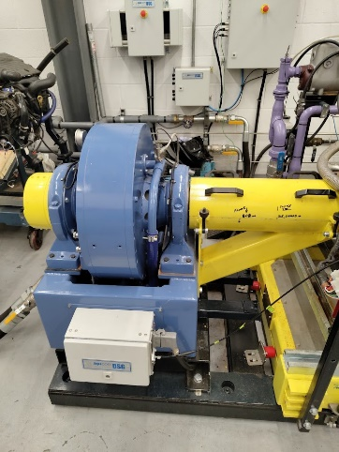
Figure 1: the Schenck WS230 dyno
Engine
The engine used in the test was the Honda 1600cc v-tec engine. the engine is attached onto an engine rig to keep it stable as it runs on the dyno. A fuel supply system that is part of the dyno cell could then be attached. The engine is connected to the dyno using a driveshaft which is surrounded in a protective casing. The engine uses a stock air intake and exhaust manifold.

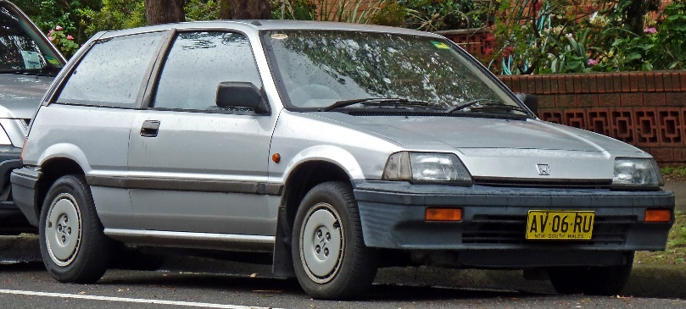
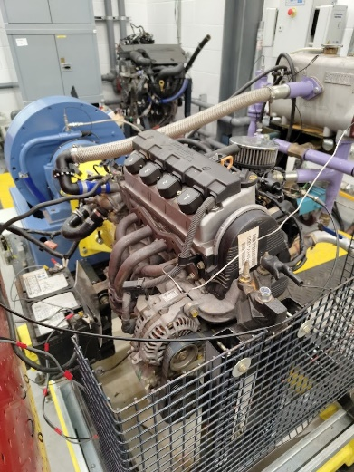
Figure 2: a third gen civic that uses the tested engine (wikipedia.org,2023)
Figure 3: the Honda 1.6 SOHC engine on the dyno

Method
To complete the test a sweep method was used where the dyno load was increased as the engine speed increases. the dyno would then output the data onto a graph which could then be exported onto a excel table. Both the engine speed and dyno load would be found from the dyno. In addition to these variables both the fuel flow rate and lambda was measured during the sweep test. this would allow for the calculation of the other variables. The calculated variables are:
Torque: this can be calculated using the load from the dyno and the length of the calibration arm using the equation(engineer.org,2023):
$T=force×raidus$
Power: this is the vale for the engine power output and is calculated by using the values for dyno speed and torque in the equation (engineer.org,2023):
$power=\frac{2πNT}{60}$
Corrected power: the corrected power is calculated to allow for the test to be repeatable as different factors such as air temperature and pressure could affect the results. This was calculated using the European standard DIN Standard 70020. The equation used:
$$\frac{p_{s}}{p}=\frac{1.01325}{p_{a}}\sqrt{\frac{T_{a}}{239}}$$
Brake Mean Effective Pressure (BMEP): the BMEP is a mean sum of all the pressure in the cylinder that forces the piston down. it allows for different sized engines to be compared as it shows the force that is produced in the combustion process that is used effectively after frictional losses (roadandtrack.com,2020). The equation for BMEP is:
$BMEP= \frac{p_{s}×120}{stroke×bore×engine speed×no. cylinders}$

Specific Fuel consumption (SFC): this shows the engines efficiency in producing power. It relates to the amount of fuel used in Kg/sec per kWh of power produced. It is found in the equation:
$SFC=\frac{M^{,}}{BP}$
Overall thermal efficiency: this shows how efficient, and engine is in using the chemical energy stored in the fuel and turning that into power. It takes into account the losses from friction and other inefficiencies in the engine. It is calculated using the equation:
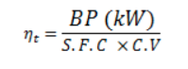

Results
The table below shows the raw data that was obtained during the sweep test that was completed. The table includes the vales that were calculated from the data. With this data it was translated into graphs which would better represent the data for analysis
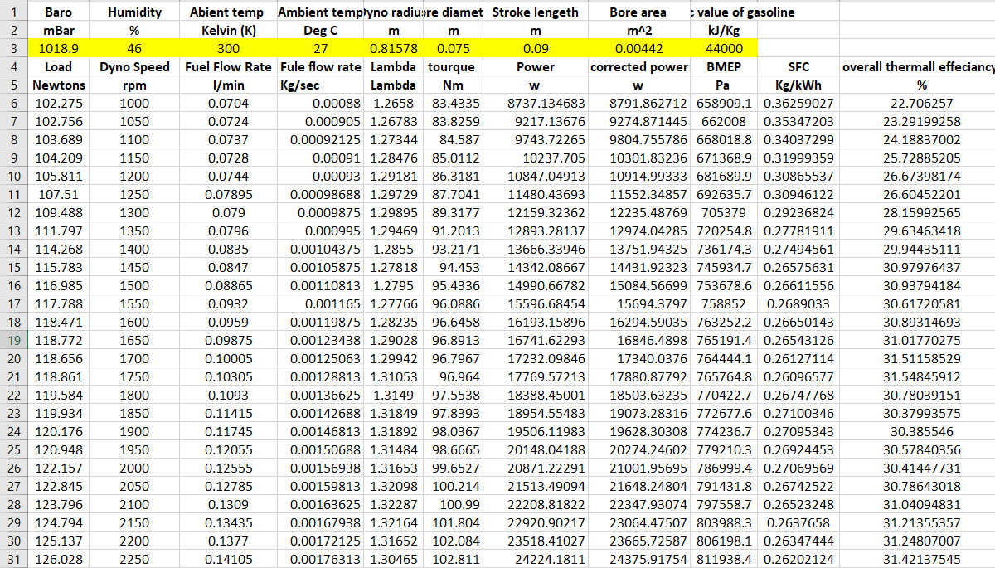

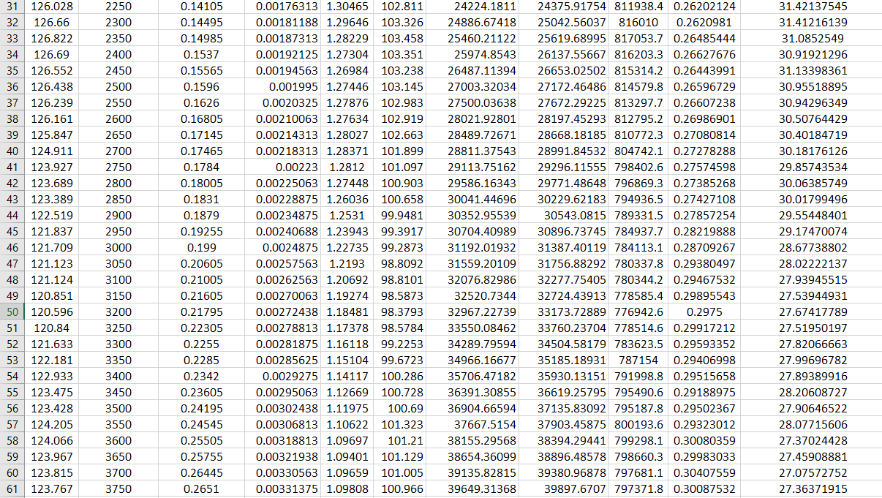

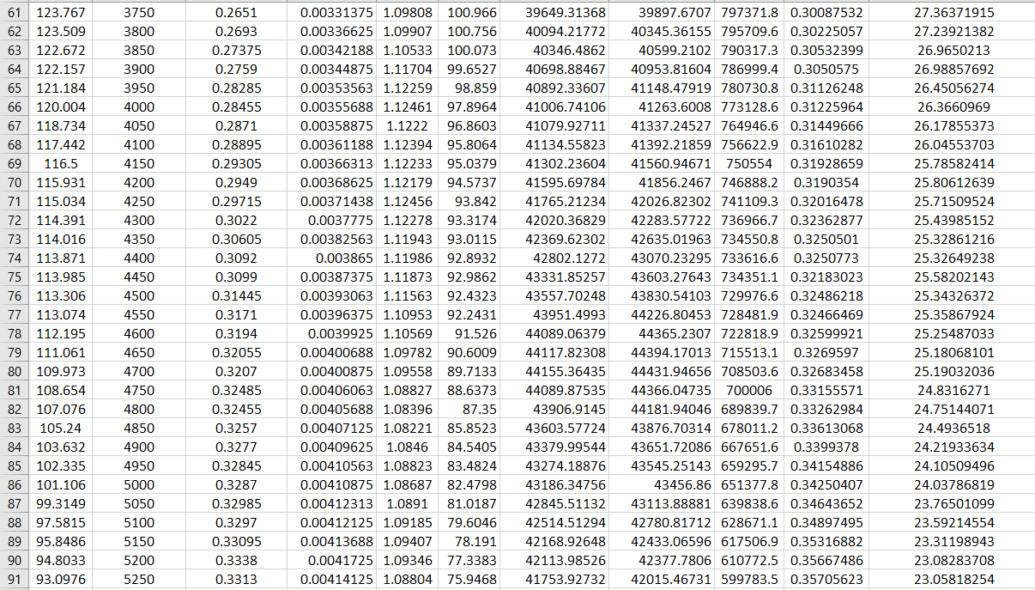

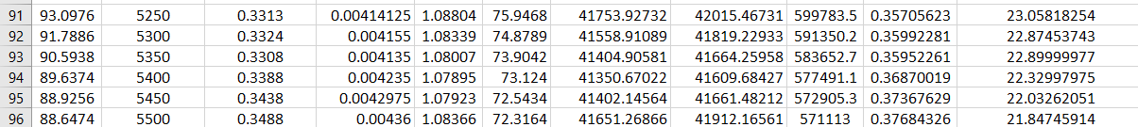
Table 1: data produced by dyno and calculated data.

Specific fuel consumption Vs Engine speed.
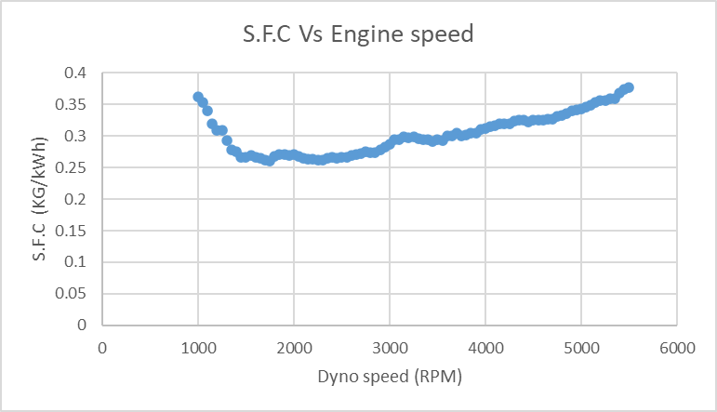
Figure 4: graph of SFC Vs engine speed
This graph shows how the Specific fuel consumption (S.F.C) changes as the engine speed was increased. The graph show that with increasing RPM from 1000 to 2000 there is a negative trend in the results. This shows that the fuel consumption reduces therefore increasing the economy of the engine. Above 2000 RPM the S.F.C increases until it reaches its maximum value of 0.38 Kg/kWh. This graph shows the efficiency of the engine is a peak at 1750 RPM at 0.26 kg/kWh. This shows that keeping the engine running near this value by changing gear will keep it at its highest efficiency.
The S.F.C varies due to frictional losses in the engine, at lower rpms the engine needs to create allot of power to get the engine moving. As the RPM increases the engines efficiency increases as torque output increases as well. As the engine RPM increases past 3000 RPM the torque decreases and so does the engines efficiency. This is shown in the graph as the S.F.C increase. This is due to the increasing frictional losses from the engine that increase with higher engine speeds. Table 1 shows values for the thermal efficiency which peaks at 31.5% at 1750 RPM and falls to 21.8% at 5500 RPM. Which proves the increasing frictional losses as the engine speed increases.

Torque vs engine speed
Figure 5: graph of torque vs engine speed
this graph shows how torque varies over the engine speed. The trend shows that torque increases to 103.35 Nm at 2400 RPM and then decreases to 72.32 Nm 5500 RPM. The reason why the torque output decreases as the engine speed increases is due to the increasing frictional losses. Thes frictional losses can be found in allot of different areas in the engine. The friction between the piston and the engine block, friction at bearings and the friction from the valves are some of the main ones.
Another reason for the decrease in engine efficiency and therefore torque is due to the air intake and exhaust system restrictions. As the engine spins faster it requires more air to meet the stoichiometric value of around 14.7:1. As the intake system is a fixed size there is a maximum amount of air that the engine can take in per revolution. If this is not enough to meet the air to fuel ratio the efficiency, power and torque will all decrease.

Corrected power vs engine speed
this graph shows how the corrected power varies with engine speed. There is a positive trend that shows that the corrected power increase with RPM from 8791.86 W at 1000 RPM until 44366.05 W at 4750 RPM. At this point the corrected power drops to 41912.17 W at 5500 RPM, this is due to the engine not being able to receive enough air so the power out put drops. In the dynamometer cell the air pressure, temperature and humidity will all effect the power output of the engine. Using the corrected power value instead will produce results that are repeatable no matter what time or where the engine is tested.
Figure 6: graph of the corrected power vs engine speed
Another factor that could affect the corrected power, torque and S.F.C could also be the exhaust system. like the intake the exhaust is a fixed sized and can only remove a certain volume of combusted gas from the cylinder. Due to this some combusted gas can remain in the cylinder which will reduce the air fuel ration and therefore the energy output by the combustion process.

Conclusions
To see the accuracy of the results and to compare the engine to others in production looking at values from other engines could provide this.
The peak thermal efficiency of the Honda engine in the test was 31.42%. for street cars on the market the benchmark is 30% so the results reflect the trend in other street cars(actualidadmotor.com,2021). This is due to how the engine works and the friction losses all ICE will experience from the bearings to the amount of substance combusted in the chamber. As the combustion process isn’t instant the flame has to travel. Due to this not 100% of the material can be combusted and turned into power. This is reflected in the SFC data.
For an engine connected to a gear box to operate properly the power curve and torque curve have to complete each other.at low engine speeds torque is more important then power to get the car moving, figure 5 shows this. Once the car is moving power becomes more important to gain speed which is shown in figure 6 as the power increases with rpm. as an engine is connected to a gear box each gear limits the speed of the car. when you change gear to go faster RPM drops and the torque would increase. This allows for the engine to not stall with a higher gear ratio. Once the rpms increase the power can take over again. Figures 5 and 6 show this trend which proves that the results match what needs to happen in a car. (BMW,2021)

Evaluation
To improve to results that were found different steps could have been taken. An example of this is to run the engine for a longer period of time to allow it to get up to operating temperature. This will allow for the engine to be running in the temperature range it was designed for. This would reflect in the results as possible increase in power, SFC, BMEP and overall efficiency. To improve the accuracy of the results the test could have been repeated multiple times and average results could be obtained.

References
Bmw (2022) Technology explained, simply: Torque in Cars, Technology explained, simply: Torque in cars | BMW.com. BMW. Available at: https://www.bmw.com/en/performance/torque-in-cars-explained.html (Accessed: March 19, 2023).

Honda Civic (third generation) (2023) Wikipedia. Wikimedia Foundation. Available at: https://en.wikipedia.org/wiki/Honda_Civic_%28third_generation%29 (Accessed: March 20, 2023).

Honda motor co. (ed.) (1987) CRX workshop Manual . Tokyo : Honda motor co. .

Isaac (2021) Thermal efficiency: What is it, Diesel vs. gasoline and how much does your engine have, Actualidad Motor. Actualidad Motor. Available at: https://www.actualidadmotor.com/en/eficiencia-termica-rendimiento-termico-motor/ (Accessed: March 203, 2023).

Marc et al. (no date) Home, x. Available at: https://x-engineer.org/power-vs-torque/ (Accessed: March 20, 2023).

SCHENCK PEGASUS GmbH (ed.) (2001) Technical SpecificationEddy-Current DynamometerW Series. Munich .

Silvestro, B. (2020) Here's why the Mustang's 5.0-liter V-8 is more impressive than Ferrari's V-12, Road &amp; Track. Road &amp; Track. Available at: https://www.roadandtrack.com/car-culture/a32157287/bmep-engine-performance-measurment-explained/#:~:text=Brake%20Mean%20Effective%20Pressure%20(BMEP,is%20pretty%20easy%20to%20grasp. (Accessed: March 20, 2023).

