Student Name: Biplob Das
Student ID: 2424763
Programme: Master of Business Administration
Module: International Business Concepts
Module code: LCMB7034
Title: International Business Strategies and Cultural Adaptation of Procter & Gamble

Table of Contents
1. Introduction 3
2. Benefits and challenges of International operations 3
2.1 Justification as an MNC/TNC 3
2.2 P&G’s Global Value Chain 4
2.3 Entry modes used by P&G 5
2.4 Benefits of P&G’s global operations 6
2.5. Challenges of Internationalisation 7
3. OLI Eclectic Paradigm Analysis 7
3.1 Ownership Advantages (O) 8
3.2 Location Advantages (L) 9
3.3 Internalisation Advantages (I) 10
3.4 Resulting Entry Mode Decision 11
4. Cultural Distance & Its Implications 12
4.1 Cultural Profile Comparison 12
4.2 Impact on Entry Strategy 16
4.3 Impact on Success Potential 17
4.4 Mitigation Strategies 17
5. Recommendations and Strategic Adjustments for India 18
Adjustment 1: Localised management and HR systems 18
Adjustment 2: Market-specific product and marketing adaptation 19
Adjustment 3: Supply chain and local sourcing strategy 20
6. Conclusion 22
References 23

1. Introduction
Procter & Gamble (P&G) is a prodigious American multinational customer goods corporation established in 1837. It creates and markets trusted brands in beauty, grooming, and health care, fabric & home care and baby care and serves billions in over 180 countries with products such as Tide, Pampers, Gillette and Crest along with operating globally with innovation and market leadership as a key drivers (careers, 2025). It employs around 109,000 people worldwide. Procter & Gamble's annual revenue for 2025 was $84.284B, a 0.29% increase from 2024 (Macrotrends, 2023). This company operates through focused portfolio strategy, centering on 65 leading brands across 10 product categories. The purpose of this consultancy report is to evaluate how P&G balancing its international operations and how these strategies can be employed to its activities in India, one of the world’s most emerging economic region. This report also assesses P&G’s global benefits, operational challenges, and strategic decisions through using various frameworks such as OLI (Ownership-location-internationalisation) factors, Hofstede dimensions, and SOP adaptation. This report aims to evaluate P&G’s competitiveness in India and deliver operational reconciliation for assisting in sustaining development.

2. Benefits and challenges of International operations

2.1 Justification as an MNC/TNC
P&G (Procter & Gamble) is designated as a Multinational corporation or Transnational corporation as its business operations extend beyond its country of origin through the network of industries and marketing operations in various other countries (Xu, 2024). This organisation has operations in nearly 70 countries. It operates via subsidiary offices, branches and manufacturing plants located in international regions. It can be stated that this organisation is mainly considered as a “Transnational Corporation (TNC)” for its comprehensive global footprint, diverse product portfolio and high level of centralised collaboration with subsidiaries (Tuselmann et al., 2020).P&G's total FY 2025 revenue was ~$84.3 billion, with strong North American performance noted in early 2025 (4% sales growth)(pginvestor, 2025).Procter & Gamble (P&G) generated approximately $18.489 billion in net sales from its Europe segment. However, in Asia, Procter & Gamble (P&G) posted record results for its fiscal year ending June 30, 2025, with net sales rising 2.92% YoY to 84.28 billion euros (Daily, 2025). P&G leverages a hybrid organisational structure, which is described as a front-back matrix that integrates Global Business Units with Market Development Organisations. This structure allows P&G to balance global scale and efficiency with local market responsiveness. This structure enables P&G to balance global scale and efficiency with local market responsiveness.
This organisation uses a vast portfolio of well-known global brands such as Ariel, Tide, Pampers, Gillette, Whisper, Oral-B, Head & Shoulders, Always Olay, Pantene, Vicks and Downy, spanning categories such as Fabric & home care, Beauty, Health care and Baby & Feminine Care made it a leading customer goods organisation globally(pg, 2025). This organisation obtains smooth coordination of its supply chains across regions such as US, Europe, Asia, and Latin America through an incorporated, end-to-end digital strategy. It also persistently involves significant foreign direct investment across the globe, developing strong international networks for manufacturing, R&D, and distribution. It operates and is managed through wholly owned subsidiaries.

2.2 P&G’s Global Value Chain
P&G’s global value chain is a tremendous and integrated network concentrated on efficiency, resilience and sustainability, expanding from strategic sourcing such as sustainable palm oil, advanced manufacturing such as Integrated Work Systems (IWS methodology), automation and sophisticated logistics and digital platforms such as cloud computing for real-time data(Brice, 2021). Its global value chain mirrors high level of functional specialisation and international corporation. P&G’s major R&D hubs are concentrated on its massive Cincinnati area presence (Mason, West Chester), key centers in Beijing (China) and Singapore and the Reading & Newcastle sites in the UK, extending global innovation pipeline. This organisation sources an extensive range of raw materials globally, such as chemicals, packaging and natural ingredients and incorporates suppliers through long-term contracts and digital supply-chain systems. This context highlights responsible sourcing and collaboration with external business partners.
P&G operates a global supply network with manufacturing and sourcing abilities over five regions such as Americas, Europe, Asia-Pacific, Africa, and the Middle East. Its strategy includes tackling global scale with local market focus.P&G’s distribution system is a sophisticated, technology-driven network using an intensive distribution model for fast-moving consumer goods, moving from factories to distribution centres and then via stockists and distributors to retailers by using a mix of large-scale partners and improved networks (Obara et al, 2025). P&G uses a strategic marketing strategy which incorporates a spontaneous global brand identity with localised communication mainly depending on consumer insights collected by its country teams. Procter & Gamble’s global value chain finance operations include treasury management and shared services which are incorporated into its overarching global business model that standardizes procedures to drive productivity and efficiency over the organisation’s global operations.

2.3 Entry modes used by P&G
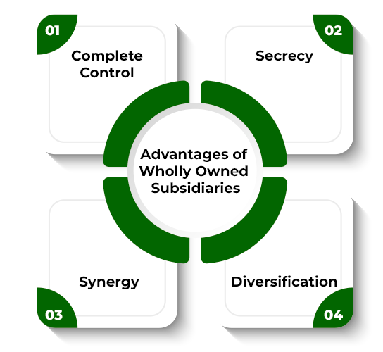
Figure: Wholly owned subsidiaries
Source: (geeksforgeeks, 2025)
P&G mainly enters foreign markets through wholly owned subsidiaries, enables it to safeguard proprietary technologies and maintain persistent quality standards (geeksforgeeks, 2025). This FDI-driven strategy incorporates its global strategy of high control and direct oversight. In India, P&G follows a similar pattern by developing a subsidiary and later investing in manufacturing and distribution facilities. Procter & Gamble India to invest $244 million to set up a manufacturing facility (Reuters, 2023). Over time, this company enlarged through tactical mergers and local investments, highlighting a preference for full ownership rather than licensing or joint ventures. This persistently mirrors both P&G’s organisational focus and India’s conducive regulatory setting of FDI. In 1964, P&G primarily entered through using joint venture and later transformed into a structure that consists of wholly owned and listed subsidiaries.

2.4 Benefits of P&G’s global operations
P&G’s global operations provided various key advantages that deliver a strong competitive advantage, mainly centred around economies of scale, high-volume production and improved global R&D efforts. Operating on a global scale enables P&G to centralise key functions and pool resources. This allow them to purchase raw materials in much larger quantities, securing favourable pricing and mitigating overall procurement costs (Maron, Maron and Kazmina, 2024). Accessing engineering and R&D talent in Asia is effectively more cost-efficient, mitigating operational expanses for critical innovation functions. Access to lower-cost, highly skilled talent in regions such as Asia is a key advantage of P&G’s global operations, allowing cost-efficiency in innovation, development and support functions, enhancing their global talent pools and connect-and-develop strategies to drive competitive advantage and market-relevant product creation. P&G’s global operations also get advantages from obtaining new markets such as India, using its large, developing middle class for significant sales opportunities, driving mid-single growth through localisation, local production and R&D and becoming a key component of P&G’s enterprise markets strategy (Arunachalam et al., 2020). Moreover, P&G’s global operations allow powerful, two-way knowledge transfer which enable innovations from the US and EU to be adapted for India while local Indian insights such as consumer needs, market specifics, inform global strategy, promoting faster, cost-efficient, customer-cenric development improved financials and improved quality and safety through shared best practices and a unified global framework. P&G can use worldwide reputation for developing customer trust and loyalty over diverse markets (Fatmawati and Fauzan, 2021). The persistence in product quality and spontaneous innovation in one regions can translates into anticipated advantages and faster adoption in another. Through developing multiple production bases globally, P&G reduces the risk associated with localised disruptions such as natural disasters or geopolitical issues. As of its Fiscal Year 2024 reporting, P&G has a total of 106 manufacturing facilities globally (esg, 2025). This robust diversified manufacturing footprint assures greater resilience and efficiency on providing products to market globally (Aheleroff et al., 2022). Global operations deliver access to the dynamic markets, enable P&G to tap into new customer bases and revenue streams. This diversification mitigates dependence on any single market and enable to balancing growth opportunities.

2.5. Challenges of Internationalisation

P&G’s global operations can face challenges such as managing complex, costly supply chains, navigating diverse and dynamic regulatory environments such as trade, privacy and environmental, and intense competition from local and global players. These prospects are increasingly changing customer needs and the need to innovate sustainably while tackling geopolitical disruptions and currency fluctuations (Nikonenko et al., 2025). The key issues consist of input costs, supply chain bottlenecks, shifting tax/trade policies and balancing global scale with local market needs for agility. It can face regulatory and geopolitical risks from adapting to the transforming government policies on taxes, trade, and privacy and through navigating the environmental regulations and scrutiny over sourcing (Rasshyvalov et al., 2024). Moreover, P&G can face challenges from changing customer behaviour while operating globally, as changing customer preferences towards value, sustainability and personalised products can provide risks. They need to decentralise to recognise and quickly respond to particular local customer requirements (Rasshyvalov et al., 2024). Moreover, while operating internationally, P&G can face internal and structural issues from the risk of rigidity for the large size and preventing shifts to the developing markets. Effectively balancing global brand consistency with local market relevance can helps in mitigating this risk.

3. OLI Eclectic Paradigm Analysis
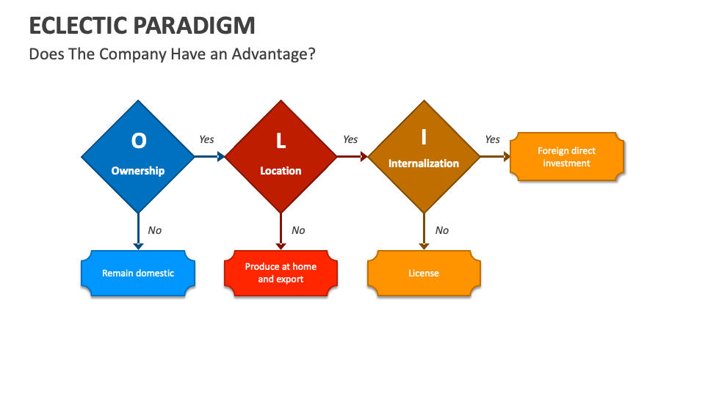
Figure: OLI Framework)
(Source: Collidu, 2023)

3.1 Ownership Advantages (O)
Strong Brands: Procter & Gamble in India can explore its ownership advantages with the help of its strong brands like Tide, Gillette, and Olay. This company offers some global popular brands like Ariel, Pampers and other brands which fosters a very strong brand equity in India (Aithor, 2024). P&G’s these brands also offer significant potential revenue growth in terms of the different consumer segments.
Technology and Innovation: This company also combines global R&D and advanced technology, especially in product innovation for the Indian Market (Aithor, 2024). Its new product plans or formulas foster its global innovation plans which is provided by the global structure for the Indian market.
Management Expertise: This company highlights its Central distribution centres in the key locations of India such as Mumbai, Kolkata with various manufacturing herbs in Baddi, Goa and others (Procter & Gamble, 2025). This company also fosters its local mile in rural and urban India with specific examples such as OM Associates in Odisha and Amazon Distributors in Karnataka.

Figure : The Brands of P&G
(Source: Bella, 2018)

3.2 Location Advantages (L)
Market Potential: India offers significant advantages in terms of location with various segments like urban to rural with different categories of products such as detergent, personal care, hygiene care, and dental care. India is presenting its GDP as approximately $3.57 trillion with around 8.2% GDP growth (Pib.gov, 2025). Growing market of India especially in FMCG sector which highlights its market share in India approximately 2.5% (Srivastava and Maxwell, 2024). This company also offers significant revenue growth in different consumer segments.
Competition: P&G faces extreme competition with the company called “Hindustan Unilever" which is larger than P&G in size.
Skilled workforce and local R&D: P&G offers a local skilled workforce by engaging with the local R&D which provides the company significant advantages. This company also customized the products and adopted the market strategies for the Indian customers' preferences (Siddhartha, 2025). This company uses local resources for its premium categories which signifies its labor cost advantages compared to other global markets. This company also collaborated with local retailers, e-commerce platforms and many more. This company also launched another brand called “Olay Total Effects" with the help of the " Wella Salon” platform (The Economic Times, 2007).
Infrastructure: P&G and other FMCG industries of India face poor infrastructure which creates significant challenges such as affecting logistics, distribution, and overall operational costs. The key infrastructure deficiencies are road connectivity and transportation, inadequate warehousing and storage, lack of gold chain facilities, unreliable power supply, and lastly Limited digital connectivity (Kumar et al., 2023).
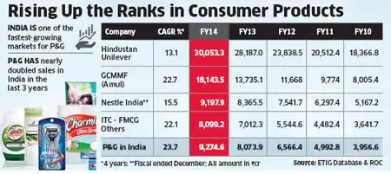
Figure : Ranks of Consumer Products
(Source : Malviya, 2014)

3.3 Internalisation Advantages (I)
P&G adopts a strategy which combines global efficiency with its local responsiveness (P&G, 2025). P&G also can ensure compliance with its global standards and value by managing other risks. This company fosters its degree of autonomy to manage and stay in the Indian market which helps it to elevate its growth and value of creation. It also helps to combine the Global Innovation and supply plans of this company (P&G, 2025). It also operates dual structure regarding “Focus Markets” of USA and Europe by implementing a decentralized model and “Enterprise Markets" of India with centralised model. In terms of the Indian market, the global divisions provide innovation and strategy frameworks. This company also focuses on its innovation to fit for the Indian market and its practices which helps to maintain the quality of the products. This brand also offers different approaches in different segments like premium v/s economy. Its brand “Tide Naturals” addresses the local needs by targeting the economy segments while " Olay” targets the premium consumers in India (P&G, 2025). P&G’s strategic partnership involves with the organized retailers for its premium products and supports some platforms like “Wella Salon" to promote ‘Olay’. This brand also promotes local manufacturing and supply chain which can effectively serve the Indian market and react to local dynamics. P&G maintains control over the supply chain from manufacturing to distribution segments which focuses on its product quality and consistency.
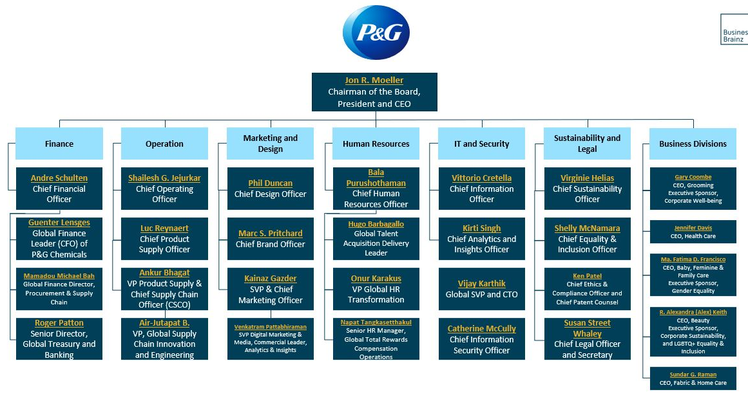
Figure: Organizational Structure of P&G in India
(Source: Business Brainz, 2024)

3.4 Resulting Entry Mode Decision
Advantages - Procter & Gamble has some key advantages in the Indian market. These advantages may include in different segments like business and market advantages, operational and strategic advantages. The business and market advantages may include strong brand recognition, high market share, significant investment, and agile operations. The operational and strategic advantages may include manufacturing and supply chain, export hub, investment in innovation and lastly IT and technology. This brand has many popular brands in the Indian market such as Tide, Pantené, Pampers, Gillette and many more which foster strong presence and customer loyalty. This company has invested more than twenty thousand crore rupees in India since the past two decades (Malviya, 2025). This brand also represents a network of eight manufacturing facilities all over India. P&G also focuses on its 180 years of experience with a startup-like entrepreneurial spirit in its innovation to grow more in the future market (P&G, 2025). P&G in India fosters 8 state-of-the-art manufacturing facilities and more than 95% of the sales in business has been produced domestically (P&G, 2025).
Disadvantages - P&G in India also faces some disadvantages. These disadvantages may involve three segments. The business and market disadvantages can include intense competition, price sensitivity, rural market penetration, regulatory scrutiny, supply chain, and infrastructure issues. The employee and internal disadvantages involve work-life balance and long hours, bureaucracy and slow decision making, internal politics and management issues and lastly challenges for experienced hires. On the other hand, environmental and ethical concerns may face difficulties in sustainability and supply chain with the product safety concerns (Abraham, 2025). The company also faces a lawsuit about green washing which is related with the products like “Charming toilet paper" and “Puffs tissues" (Vinyard, 2025).

4. Cultural Distance & Its Implications

4.1 Cultural Profile Comparison
Hofstede's Cultural Dimensions refers to a framework which analyses how the cultures are affecting the values and behaviours across different cultures. This framework involves six dimensions, and these are Power Distance, Individualism v/s Collectivism, Masculinity v/s Femininity, Uncertainty Avoidance, Long-Term v/s Short-Term Orientation and lastly Indulgence v/s Restraint (Wale, 2025).
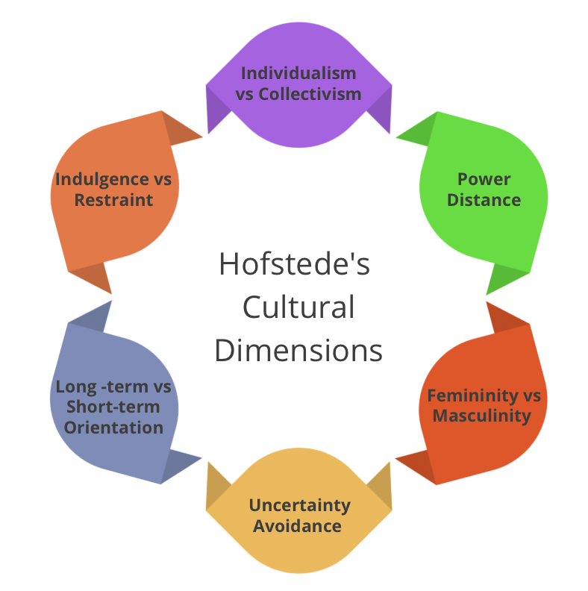
Figure: Hofstede’s Cultural Dimensions
(Source: Culture in the workplace, 2024)
Dimensions | USA | India
Power Distance | The USA's power distance score is 40. It means the USA focuses on equal rights in different aspects of society and government. | India’s power distance score is 77. It indicates that India believes in acceptance of people with inequality.
Individualism v/s Collectivism | The USA’s score in individualization is 60. It presents an individualistic culture in the USA. The country promotes the independent degree in society with “I’ or " We.” | India fosters collectivist society with a score of 24 in individualism. It means the group is prioritized too much over the individuals in India.
Motivation Towards Achievement and Success | The USA also promotes high motivation towards achievement and success with a score of 62. | India scores 56 in this domain which indicates low scores in this domain highlights the decisive society which shows visual display about the success and power.
Uncertainty Avoidance | The USA also presents a low score of 46. It believes that their behaviour plays pivotal rather than its culture. The society of the USA promotes new ideas and innovation. | India scored 40 which indicates low. India is considered as India accepts the imperfections and believes that “nothing has to be perfect.”
Long-Term v/s Short-Term Orientation | The USA scores 50 in the dimension of long-term orientation. This country measures its performance on a short-term basis where the USA also promotes a society with very practical mindsets. | India scored 51 in this dimension of long-term orientation. This country measures its performance on a short-term basis. India also has a great tolerance for its religious views.
Indulgence v/s Restraint | The USA scores 68 in the dimension of Indulgence. The society of the USA represents lack of control in the impulses and desires as in the UK. | A score of 26 in the dimension of the Indulgence which indicates corruption. religious culture with various languages. The society of India does not promote leisure time and controls its needs and impulses.
Table: Comparison between USA v/s India
(Source: The Culture Factor, 2025)
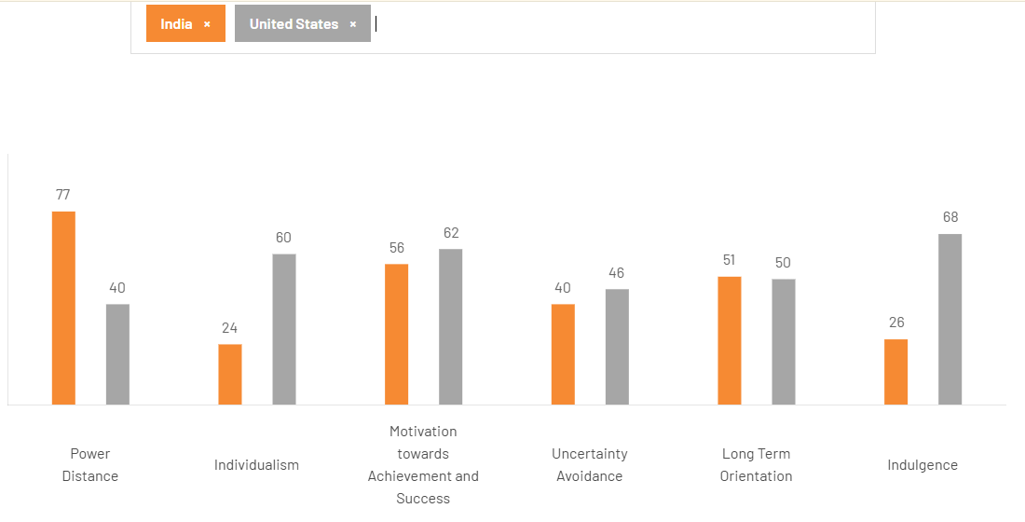
Figure: USA v/s India
(Source: The Culture Factor, 2025)
Power Distance (High) - India’s power distance score is 77. It indicates that India believes in acceptance of people with inequality (The Culture Factor, 2025).
Individualism (Low) - India fosters collectivist society with a score of 24 in individualism. It means the group is prioritized too much over the individuals in India (The Culture Factor, 2025).
Motivation Towards Achievement and Success (Low) - India scores 56 in this domain which indicates low scores in this domain highlights the decisive society which shows visual display about the success and power (The Culture Factor, 2025).
Uncertainty Avoidance (Low) - India scored 40 which indicates low. India is considered as India accepts the imperfections and believes that “nothing has to be perfect” (The Culture Factor, 2025).
Long-Term Orientation (Low) - India scored 51 in this dimension of long-term orientation. This country measures its performance on a short-term basis. India also has a great tolerance for its religious views (The Culture Factor, 2025).
Indulgence (Low) - A score of 26 in the dimension of the Indulgence which indicates corruption. religious culture with various languages. The society of India does not promote leisure time and controls its needs and impulses (The Culture Factor, 2025).
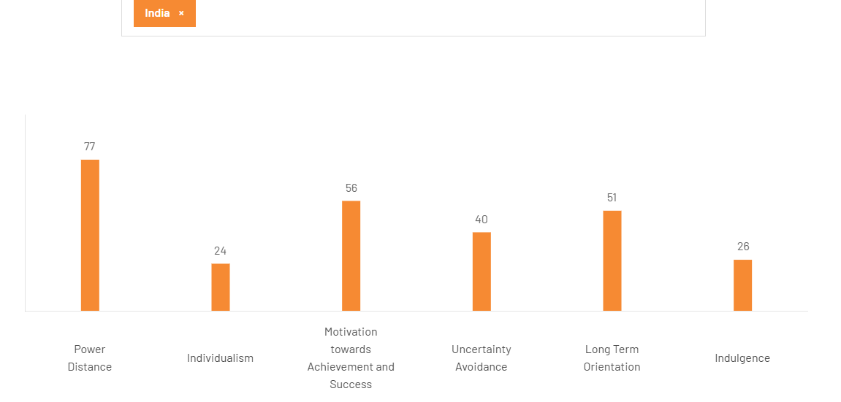
Figure: Hofstede’s Cultural Dimensions of India
(Source: The Culture Factor, 2025)

4.2 Impact on Entry Strategy
Procter & Gamble’ entry strategy for India involves an initial joint venture in 1964. The evolution of the entry strategy in recent models may involve local production, R&D, product innovation and adaptation. This brand started its joint venture with Richardson Hindustan Limited in 1964. This company also initially focused on personal care products such as ‘Vicks’ and in future it expanded into hygiene care to home care products like ‘Pantené’, ‘Head & Shoulder’, ‘Pampers’, ‘Tide’ and ‘Ariel’ (Torane, 2025). The key strategic impacts of this brand may involve localization and product innovation, distribution and market access, brand and market strategies and lastly, market presence and leadership. This brand also personalized the products for the Indian market to fit in the Indian practice such as developing an affordable razor which is designed for a lack of hot running water. Its brand and marketing strategies may include purpose-driven marketing, digital focus and push marketing (Rodney, 2025).

4.3 Impact on Success Potential
This company is shaped by its strong market position, strategic innovation which focuses on the local consumer needs. This company also supports its significant investments in local manufacturing and distribution. The factors driving the success potential of this company in India may involve market leadership, strategic product innovation, investment in local manufacturing, strong distribution network, corporate social responsibility (CSR), cost management and productivity. This company has set its leadership in hygiene categories like sanita napkins, diapers and in different categories like blades (Tandon, 2025). This company also exceeded its two-billion-dollar profit in FY24 (Nataranjan, 2025). P&G also personalized its products according to the local consumer preferences in different segments like hair care (Pantené, Head & Shoulder) and laundry (Ariel liquid detergents and Tide detergent). This company also invests in its initiative for the educational sector which is called as “P&G Shiksha" (P&G, 2023).

4.4 Mitigation Strategies
P&G’s some integrated strategies for mitigating the disadvantages in India may be classified into three main strategies. These strategies may include operational and financial mitigation strategies, market and innovation strategies and lastly environmental and social (ESG) strategies. The operational and financial mitigation strategies involve cost optimization and productivity, supply chain efficiency, supplier relationship management, pricing strategy and lastly tax efficiency (Mittal, 2023). The market and innovation strategies involve market segmentation and localization, digital transformation and lastly continuous innovation (Gadhwal et al., 2025). The environmental and social (ESG) strategies involve climate and waste management, water stewardship and community impact (P&G, 2023).

5. Recommendations and Strategic Adjustments for India

Adjustment 1: Localised management and HR systems
P&G’s sustaining and long-term success in India is heavily reliant on substantially focusing on revisiting its HR and Management SOPs (standard operating procedures) for incorporating with cultural expectations and workplace behaviour which can form Indian organisations. This company presently operating by using global HR framework which highlighted equal communication individual performance measurement and relevant informal managerial relationships (Bandyopadhyay and Srivastava, 2021). Moreover, these practices can resulted in conflict with Indian employees’ demand of structured guidance, visible leadership authority and relationship-focused business environment. Providing localised leadership training can be considered as an important prospect where managers both the local and professionals, need to be able to deliver the transparent guidance, regular feedback and supportive communication that can fully align with employees' preference for a guiding figure (Azhari et al., 2024). Moreover, Indian employees prefer to value mentorship, clarity and reassurance along with a leadership style which can align with these components for improving workplace harmony. P&G’s HR policies also need to mirror the significance of seniority loyalty and team collaboration(Azhari et al., 2024). Developing a recognition system for organisational service can help in enhancing team-based reward structure and make bonding-focused boarding sessions, which can help employees to feel valued and unified. These practices can make a sense of belonging, which is particularly significant in a cultural relationship as the epicentre of work motivation. The rationale for this HR and management adjustment is focused on the requirement for robust organisation incorporation (Bristol-Alagbariya, Ayanponle and Ogedengbe, 2022). When leadership behaviour and HR system align cultural expectations, employees become more involved and loyal with the organisation. Operationally, these transformations can mitigate employee turnover mainly in middle management levels, where retention is crucial for continuity. Moreover, a robust culturally accustomed onboarding system can improve employee retention by reducing the time needed for new recruits to extend productivity. Team-based rewards effectively assist collaboration and mitigate internal competition in organisations that can create friction in a relationship-oriented work culture. Moreover, robust employee-manager collaboration also enhance morale and mitigate conflict resulting in enhanced overall efficiency (Suknunan and Bhana, 2022). Additionally, if P&G does not employee this HR adjustment, various challenges can arise. Employees in India may obtain management as insensitive which can lead to disengagement and dissatisfaction into the organisation. Additionally, the misalignment between global management style and local expectation can make confusion, mitigate trust and the team collaboration (Suknunan and Bhana, 2022). On the other hand, high turnover mainly among skilled staff can result it to rising recruitment and training costs while evacuating institutional knowledge. Lastly, it can be said that without strong HR localisation, P&G can risk developing an internal culture that feels disconnected from its Indian employees, that can mitigate both operational performance and sustaining stability.

Adjustment 2: Market-specific product and marketing adaptation
The strategic adjustment for P&G in India focused on the localisation of product development and marketing standard operating procedures for confronting the innovative and diverse requirements of Indian customers. India's wide ranges market demonstrated significant diversity across climate zones, languages, skin tone, water conditions (Kumar, 2024). The standard global formulations often underperform in this environment. It can be observed that hard-water conditions in many Indian households needs specially tailored detergents which produce effective results even with high mineral content. Moreover, shampoos need to be delivered as thicker, as most of the oilier hair textures observed commonly in the region, while skin care products must align with the climate that ranges from humid to arid, depending on the location of India (Kumar, 2024). Moreover, reforming the product to incorporate these requirements ensures that they deliver performance that customers can trust and improve brand credibility. However, marketing standard operating procedures also need to be incorporate with India's linguistic and cultural challenges (Malik et al., 2021). Indian customers can respond strongly to emotional advertisements which is focused on storytelling, family values and everyday life. Creating marketing content in regional languages rather than depending only on national-level communication can improve this prospect. The emotional narratives in Tamil, Telugu, Bengali, Marathi and other languages can make robust customer connections and enhance the influence of the campaign. Moreover, the other crucial component is the persistent inclusion of micro-pack formats at a lower price. These small packs are not only a marketing strategy, but they serve as an essential affordability prospect for the low-income groups and rural customers who often make small-scale purchases (Sharma et al., 2025). P&G need to ensure that SOPs mandate the production and distribution of these smaller packs is important for enhancing the reach of the brand and maintaining competitiveness in the price-sensitive segment of India.
Additionally, the operational influence of this adjustment is considerable. Localised product formulations can enhance customer satisfaction and mitigate negative feedback regarding the product, which can be caused by the climate or water variation in the region. Regional language marketing can enhance brand recall and emotional involvement that can enable P&G to develop dominance in areas where local competitors are in control (Xu, 2024). Lastly, it can be said that these adaptations can solidify brand perception and improve the organisation's relevance over India's many consumer submarkets. Additionally, if P&G fails to make this adjustment, it can deliver risk of losing out in an increasingly competitive FMCG environment. However, local and regional organisations which have sustaining dependency on deep localisation can continue to attract customers by confronting their requirements more accurately (Bohnenkamp, Schiele and Visser, 2020). However standardised global products can be obtained as foreign suited for everyday which can mitigate brand trust. However, the marketing messages which do not align culturally can fail to involve customers that can limited market penetration. Moreover, it can lead to mitigating market share despite India being one of the world’s most promising FMCG growth markets.

Adjustment 3: Supply chain and local sourcing strategy
This effective adjustment needs P&G to include ethical local sourcing, enhancing supply chain integration and last-mile distribution network for assisting deeper perception into the emerging market of India. Whereas India provides cost advantages for organisations which willing to sourcing raw materials and packaging inputs locally (Shanker et al., 2023). Through increasing the proportion of inputs gathered from Indian suppliers, P&G can mitigate its dependent on imports, mitigate transportation cost and volatility for the global supply disruption. The local sourcing can assist with increasing production cycles and enhance the responsiveness to fluctuation in requirements. Additionally, the Indian government actively assist the multinational organisations to manufacturer mode domestically through the initiative such as Make in India (indianembassywarsaw, 2025). This prospect can deliver regulatory and financial incentives for organisations that intend to in large they are local procurement and manufacturing activities. By incorporating local sourcing, P&G can improve collaboration with Tier 2 and Tier 3 logistics providers. These regional logistic organisations often consist of detailed knowledge of local prospect, retail network and distribution types mainly in smaller town and rural areas (Haag and Sandberg, 2020). Through aligning them into SOPs, P&G can effectively enhance the delivery persistency and improve its reach to market, which are challenges for large logistics organisations to service effectively. By improving the last mile distribution strategy in rural India can help in enhancing the share in FMCG sector (Haag and Sandberg, 2020). It is highly important to assure that products remain consistently affordable mainly for the essential products such as detergent, so and shampoos that can enable P&G to secure development in the rapidly growing market landscape.
Transparent SOPs for distributor management and product customisation cycle can help in balancing the continuous supply and mitigating stock out. The operational advantages of robust localisation in the supply chain also consist of mitigating cost, shorter delivery time and enhancing supply chain resilience (Katsaliaki, Galetsi and Kumar, 2022). Additionally local sourcing can improve ability during the higher demand, which can medicate the risk of delay caused by international shipping issues or currency fluctuations. However effective local logistic network also encourages trustworthy product affordability that can allow these organisations to complete effectively also in the remote regions of India. Furthermore, accessibility of micropacks in rural distribution area also can encourage wider implementation among low-income customers which promotes brand presence. However, if these strategies are not followed by P&G, various challenges can arise such as increasing production cost, vulnerability to global destruction and mitigating time to market for new or replenish products. The competitors who have already improved local sourcing and manage the regional distribution network can obtain various advantages (Sudirjo, 2023). Moreover, the weak rural penetration can prevent the access of P&G for becoming the largest distributor of the FMCG sector. Lastly, it can be highlighted that failing to improve supply chain and local sourcing for standard operating procedures can mitigate the effectiveness of the operation and limit competitiveness, which can prevent its long-term capability in the emerging market of India.

6. Conclusion
In conclusion, it can be added that P&G’s position in India highlights the advantages and barriers for operating as a global customer goods leader in the world's most culturally and economically emerging market. The above evaluation has highlighted that while P&G advantages from robust ownership values such as global brand, innovative abilities and management expertise, its long-term competitiveness in India is highly reliant on how effectively it adapts operations to local conditions. Moreover, India's cultural comparison with the United States mainly in hierarchy, collectivism and communication style creates various operational difficulties that need to be recognised by implementing HR localisation, culturally focused leadership practices and an effective relationship-centred management system. Similarly, the customer diversity and robust regional differences need market-specific product customisation, emotional marketing strategies and accessibility-based packaging solutions. Additionally, the cost structure of India, regulatory initiatives and increasingly expanding rural market require supply chain destructuring, enhancing local sourcing and a suitable last-mile delivery network. However, these adjustments are practically important as failing to adapt these strategies can give risk to P&G regarding meeting customer relevance, enhancing operational efficiencies and weakening its competitive position in the FMCG sector, which is controlled by local players of India. Through incorporating SOPs with India's cultural, economic and infrastructure prospects, P&G can maintain the long-term market leadership by improving resilience and securing growth in the economically emerging market.

References
pginvestor (2025). P&G Announces Fourth Quarter and Fiscal Year 2025 Results. [online] Pginvestor.com. Available at: https://www.pginvestor.com/news/news-details/2025/PG-Announces-Fourth-Quarter-and-Fiscal-Year-2025-Results/default.aspx.
Daily, J. (2025). Jing Daily. [online] Jing Daily. Available at: https://jingdaily.com/intels/2025-07/31/procter-and-gamble-hits-usd84b-revenue-asia-surges [Accessed 11 Dec. 2025].
Reuters (2023). Procter & Gamble India to invest $244 million to set up manufacturing facility. [online] Moneycontrol. Available at: https://www.moneycontrol.com/news/business/procter-gamble-india-to-invest-244-million-to-set-up-manufacturing-facility-10877041.html [Accessed 11 Dec. 2025].
esg (2025). Environmental Footprint Metrics for P&G Operations. [online] Available at: https://s204.q4cdn.com/332108499/files/doc_downloads/esg/Environmental-Footprint-Metrics-for-PG-Operations-FY2425-v3.pdf [Accessed 2025].
Abraham, M. (2025). P&G Case Solutions. [online] Scribd. Available at: https://www.scribd.com/document/242782347/P-G-Case-Solutions [Accessed 17 Nov. 2025].
Aheleroff, S., Huang, H., Xu, X. and Zhong, R.Y., 2022. Toward sustainability and resilience with Industry 4.0 and Industry 5.0. Frontiers in Manufacturing Technology, 2, p.951643.https://www.frontiersin.org/journals/manufacturing-technology/articles/10.3389/fmtec.2022.951643/pdf
Arunachalam, S., Bahadir, S.C., Bharadwaj, S.G. and Guesalaga, R., 2020. New product introductions for low-income consumers in emerging markets. Journal of the Academy of Marketing Science, 48(5), pp.914-940.https://papers.ssrn.com/sol3/Delivery.cfm?abstractid=3460736
Azhari, A., Iswardhani, I., Macenning, A.R.A.D., Nasir, S.A. and Ridha, A., 2024. Improving leadership capacity of local leaders through effective communication and conflict management training. Celebes Journal of Community Services, 3(2), pp.345-360.https://ojs.stieamkop.ac.id/index.php/celeb/article/download/1893/1264
Bandyopadhyay, C. and Srivastava, K.B., 2021. HR signals in the context of HRM-firm performance relationship: development of a conceptual framework. International Journal of Productivity and Performance Management, 70(2), pp.376-390.https://www.researchgate.net/profile/Kailash-Srivastava-3/publication/340462055_HR_signals_in_the_context_of_HRM-firm_performance_relationship_development_of_a_conceptual_framework/links/601299e1299bf1b33e2def85/HR-signals-in-the-context-of-HRM-firm-performance-relationship-development-of-a-conceptual-framework.pdf
Bella, R. (2018). P&G Brands. [online] Pinterest. Available at: https://www.pinterest.com/pin/5277724553879684/ [Accessed 17 Nov. 2025].
Bohnenkamp, T., Schiele, H. and Visser, M.D., 2020. Replacing global sourcing with deep localisation: the role of social capital in building local supply chains. International journal of procurement management, 13(1), pp.83-111.https://research.utwente.nl/files/279986211/ijpm.2020.105200.pdf
Brice, J. (2021). Procter & Gamble: How IWS Is Driving Operational Excellence. [online] manufacturingdigital.com. Available at: https://manufacturingdigital.com/company-reports/procter-and-gamble-how-iws-driving-operational-excellence.
Bristol-Alagbariya, B., Ayanponle, O.L. and Ogedengbe, D.E., 2022. Developing and implementing advanced performance management systems for enhanced organizational productivity. World Journal of Advanced Science and Technology, 2(1), pp.39-46.https://www.researchgate.net/profile/Latifat-Ayanponle/publication/386348208_Developing_and_implementing_advanced_performance_management_systems_for_enhanced_organizational_productivity/links/67a1c97a645ef274a46662dc/Developing-and-implementing-advanced-performance-management-systems-for-enhanced-organizational-productivity.pdf
Business Brainz. (2024). P&G Organizational Structure 2024. [online] Available at: https://businessbrainz.com/reports/org-charts/pandg-organizational-structure/.
careers (2025). Our Locations. [online] Procter & Gamble - China. Available at: https://careers.pg.com.cn/cn/en/our-locations.
Collidu (2023). Eclectic Paradigm. [online] Collidu.com. Available at: https://www.collidu.com/presentation-eclectic-paradigm.
Culture in the workplace (2024). About Prof. Geert Hofstede - Culture In The WorkplaceTM. [online] Culture in the workplace. Available at: https://cultureinworkplace.com/about-prof-geert-hofstede/.
Fatmawati, I. and Fauzan, N., 2021. Building customer trust through corporate social responsibility: The Effects of corporate reputation and word of mouth. The Journal of Asian Finance, Economics and Business, 8(3), pp.793-805.https://www.researchgate.net/profile/Nizar-Fauzan-2/publication/353982182_Building_Customer_Trust_through_Corporate_Social_Responsibility_The_Effects_of_Corporate_Reputation_and_Word_of_Mouth/links/6178d898eef53e51e1f0d906/Building-Customer-Trust-through-Corporate-Social-Responsibility-The-Effects-of-Corporate-Reputation-and-Word-of-Mouth.pdf
Gadhwal, A., Ab, A., Aggarwal, A. and Poddar, P. (2025). An Analysis of Procter & Gamble’s Market and Price Discrimination Strategies in Relation to Whisper. ResearchGate. [online] doi:https://doi.org/10.13140/RG.2.2.17260.07049.
geeksforgeeks (2025). Redirect Notice. [online] Google.com. Available at: https://www.google.com/url?sa=i&url=https%3A%2F%2Fwww.geeksforgeeks.org%2Fbusiness-studies%2Fwholly-owned-subsidiaries-meaning-advantages-and-disadvantages%2F&psig=AOvVaw1bnugiMwjJQ_YjzsNfgdnq&ust=1763474705323000&source=images&cd=vfe&opi=89978449&ved=0CBgQjhxqFwoTCPC4_qyt-ZADFQAAAAAdAAAAABAE [Accessed 17 Nov. 2025].
Haag, L. and Sandberg, E., 2020. Exploring key logistics characteristics supporting embeddedness in retailers’ geographical expansion. The International Review of Retail, Distribution and Consumer Research, 30(1), pp.1-26.https://www.tandfonline.com/doi/pdf/10.1080/09593969.2019.1683052
indianembassywarsaw (2025). Embassy of India, Poland & Lithuania: Make in India Campaign. [online] www.indianembassywarsaw.gov.in. Available at: https://www.indianembassywarsaw.gov.in/page/make-in-india-campaign/.
Katsaliaki, K., Galetsi, P. and Kumar, S., 2022. Supply chain disruptions and resilience: a major review and future research agenda. Annals of operations research, 319(1), pp.965-1002.https://link.springer.com/content/pdf/10.1007/s10479-020-03912-1.pdf
Kumar, R., Arora, S.K., Bhatia, B. and Mittal, K. (2023). Issues and Opportunities of the FMCG Sector in the Indian Rural Market. [online] 8(1), pp.306–316. Available at: https://www.researchgate.net/publication/367204783_Issues_and_Opportunities_of_the_FMCG_Sector_in_the_Indian_Rural_Market.
Kumar, Y., 2024. Climate Justice in India: Addressing the Impact of Climate Change on Vulnerable Populations. ldealistic Journal of Advanced Research in Progressive Spectrums (IJARPS) eISSN–2583-6986, 3(11), pp.148-157.https://journal.ijarps.org/index.php/IJARPS/article/download/474/441
Macrotrends (2023). Procter & Gamble Revenue 2010-2023 | PG. [online] Macrotrends.net. Available at: https://www.macrotrends.net/stocks/charts/PG/procter-gamble/revenue.
Malik, A., Budhwar, P., Patel, C. and Laker, B., 2021. Holistic indigenous and atomistic modernity: Analyzing performance management in two Indian emerging market multinational corporations. Human Resource Management, 60(5), pp.803-823.https://discovery.dundee.ac.uk/files/139383231/201012_Revised_Manuscript_HRM.pdf
Malviya, S. (2014). P&G pips Nestle, ITC to become India’s third largest consumer-products maker. The Economic Times. [online] 29 Oct. Available at: https://economictimes.indiatimes.com/industry/cons-products/fmcg/pg-pips-nestle-itc-to-become-indias-third-largest-consumer-products-maker/articleshow/44965726.cms?from=mdr.
Malviya, S. (2025). India has solid opportunities, but volatile in terms of growth: P&G. [online] The Economic Times. Available at: https://economictimes.indiatimes.com/industry/cons-products/fmcg/india-has-solid-opportunities-but-volatile-in-terms-of-growth-pg/articleshow/120628454.cms?from=mdr.
Maron, A.I., Maron, M.A. and Kazmina, A.A., 2024. An optimal raw material procurement strategy that minimizes enterprise price risks. Бизнес-информатика, 18(2 (eng)), pp.67-77.https://cyberleninka.ru/article/n/an-optimal-raw-material-procurement-strategy-that-minimizes-enterprise-price-risks
Mittal, S. (2023). P&G leverages data science to stay ahead of the curve - ET CIO. [online] ETCIO.com. Available at: https://cio.economictimes.indiatimes.com/news/case-studies/pg-leverages-data-science-to-stay-ahead-of-the-curve/97595663.
Nataranjan (2025). P&G’s Growth Strategies in India for FY24. [online] Glottis Limited. Available at: https://glottis.global/2025/04/28/pgs-growth-strategies-in-india-for-fy24/ [Accessed 17 Nov. 2025].
Nikonenko, U., Chornenka, O., Mandzinovska, K. and Struk, N., 2025. Innovation and new challenges in the world: proposals to redesign food supply and production chains to resist geopolitical and climate disruptions in a forward-looking way. Clío. Revista de Historia, Ciencias Humanas y Pensamiento Crítico., (10), pp.187-212.http://ojs.revistaclio.es/index.php/edicionesclio/article/download/274/522
Obara, S.A.O., Mboya, T., Maendo, D. and Owino, E., 2025. Distribution Strategies, Tracking Technology and Quality Service Delivery in Kenya’s Courier Sector. European Journal of Business and Management Research, 10(4), pp.49-60.https://ejbmr.org/index.php/ejbmr/article/download/2740/2053
P&G (2023). Environmental sustainability. [online] in.pg.com. Available at: https://in.pg.com/environmental-sustainability/.
P&G (2025). P&G Spotlight 2025 - Season 3 | Procter & Gamble. [online] Procter & Gamble. Available at: https://www.pgcareers.com/in/en/p-g-spotlight-2025---season-3 [Accessed 17 Nov. 2025].
P&G (2025). Procter and Gamble corporate structure. [online] in.pg.com. Available at: https://in.pg.com/structure-and-governance/corporate-structure/.
pg (2025). Brands | Procter and Gamble. [online] in.pg.com. Available at: https://in.pg.com/brands/.
Pib.gov (2025). 8.2% GDP: India’s Growth Story Strengthens. [online] Pib.gov.in. Available at: https://www.pib.gov.in/PressReleasePage.aspx?PRID=2195990®=3&lang=1.
Procter & Gamble (2025). India. [online] Procter & Gamble. Available at: https://www.pgcareers.com/global/en/locations/india.
Rasshyvalov, D., Portnov, Y., Sigaieva, T., Alboshchii, O. and Rozumnyi, O., 2024. Navigating geopolitical risks: Implications for global supply chain management. Multidisciplinary Reviews, 7.https://www.malque.pub/ojs/index.php/mr/article/download/3809/1688
Rodney, C. (2025). Project-case_study 1 (4) (1). [online] Scribd. Available at: https://www.scribd.com/document/533491982/Project-case-study-1-4-1 [Accessed 17 Nov. 2025].
Salunke, N., 2023. Resilient Sourcing: An Effective Strategy to Mitigate Supply Chain Disruptions. Indian Journal of Economics and Business, 22(4).https://www.ashwinanokha.com/resources/3.%20Resilient%20Sourcing-%20An%20Effective%20Strategy%20to%20Mitigate%20Supply%20Chain%20Disruptions%20V1.4.1.pdf
Shanker, R., Khan, D., Hossain, R., Islam, M.T., Locock, K., Ghose, A., Sahajwalla, V., Schandl, H. and Dhodapkar, R., 2023. Plastic waste recycling: existing Indian scenario and future opportunities. International Journal of Environmental Science and Technology, 20(5), pp.5895-5912.https://link.springer.com/content/pdf/10.1007/s13762-022-04079-x.pdf
Sharma, V., Bhardwaj, S., Farheen, V., and Agarwal, P.K., 2025. Rural consumer behavior in developing economies: A review of social and marketing interventions. Journal of Marketing & Social Research, 2, pp.313-328.https://jmsr-online.com/article/rural-consumer-behavior-in-developing-economies-a-review-of-social-and-marketing-interventions-278/
Siddhartha, S. (2025). Gillettes expansion to india through the lens of porters diamond model and dunnings eclectic paradigm| International Journal of Innovative Science and Research Technology. [online] Ijisrt.com. Available at: https://www.ijisrt.com/gillettes-expansion-to-india-through-the-lens-of-porters-diamond-model-and-dunnings-eclectic-paradigm [Accessed 17 Nov. 2025].
Srivastava, R., and Maxwell, A. (2024). AN OVERVIEW OF THE FAST-MOVING CONSUMER SECTOR OF INDIA. ResearchGate, [online] XXVIII (No. 32), pp.265–270. Available at: https://www.researchgate.net/publication/385654399_AN_OVERVIEW_OF_THE_FAST-MOVING_CONSUMER_SECTOR_OF_INDIA.
Sudirjo, F., 2023. Marketing strategy in improving product competitiveness in the global market. Journal of Contemporary Administration and Management (ADMAN), 1(2), pp.63-69.https://journal.literasisainsnusantara.com/index.php/adman/article/download/24/39
Suknunan, S. and Bhana, A., 2022. Influence of employee-manager relationship on employee performance and productivity. Problems and Perspectives in Management, 20(3).https://papers.ssrn.com/sol3/Delivery.cfm?abstractid=4164625
Tandon, S. (2025). P&G Hygiene sees rebound in rural demand, but urban stress persists. [online] mint. Available at: https://www.livemint.com/companies/news/pg-hygiene-earnings-p-g-hygiene-rural-demand-fmcg-india-consumer-demand-hul-itc-11749726978075.html [Accessed 17 Nov. 2025].
The Culture Factor (2025). Country Comparison Tool. [online] Theculturefactor.com. Available at: https://www.theculturefactor.com/country-comparison-tool?countries=india%2Cunited+states.
The Economic Times (2007). P&G launches Olay in India. [online] The Economic Times. Available at: https://economictimes.indiatimes.com/industry/cons-products/fmcg/pg-launches-olay-in-india/articleshow/2228705.cms?from=mdr [Accessed 17 Nov. 2025].
Torane, R. (2025). How Global FMCG Players Are Entering India. [online] Linkedin.com. Available at: https://www.linkedin.com/pulse/how-global-fmcg-players-entering-india-rahul-torane-5kk4f.
Tuselmann, H.J., McDonald, F., Gammelgaard, J. and Dörrenbächer, C., 2020. How TNC subsidiaries shine in world cities: policy implications of autonomy and network connections. Transnational Corporations, 27(1), pp.35-62.https://e-space.mmu.ac.uk/626196/1/TNC%20paper%20World%20Cities.pdf
Vinyard, S. (2025). Procter & Gamble Doubles Down on Forest Degradation. [online] Nrdc.org. Available at: https://www.nrdc.org/bio/shelley-vinyard/procter-gamble-doubles-down-forest-degradation.
Wale, H. (2025). Hofstede’s Cultural Dimensions Theory. [online] Corporate Finance Institute. Available at: https://corporatefinanceinstitute.com/resources/management/hofstedes-cultural-dimensions-theory/.
Xu, L., 2024. Research on the Referential Significance of Procter & Gamble's Diversified Brand Strategy to Chinese Local Enterprises. Asia Pacific Economic and Management Review, 1(6), pp.107-115.https://ojs.apspublisher.com/index.php/apemr/article/download/112/113
Xu, L., 2024. Research on the Referential Significance of Procter & Gamble's Diversified Brand Strategy to Chinese Local Enterprises. Asia Pacific Economic and Management Review, 1(6), pp.107-115.https://ojs.apspublisher.com/index.php/apemr/article/download/112/113

