Software Solutions for Business
Assignment

Module Name Software Solution for Business
Module Code: ACCA 4025

Student Name: Paul Ycossie
Student ID: 2510890
Group: 4

Lecturer’s Name: Rajeev Nath
University of Wales Trinity Saint David
LONDON CAMPUS

Table of Contents
Introduction 1
Task 1. e-Commerce Website builders or software solutions 2
1.1 Shopify 2
1.2 Wix 3
Task 2. Mind-map of contemporary software applications 4
a. Mind mapping and explain the benefits of using mind mapping in business operations 4
b. Create a mind map of contemporary software applications 6
Task 3. Office Applications 7
a. Four office software solutions for business operations 7
MS Word 7
MS PowerPoint 8
MS Excel 9
MS Access 11
b. Practical demonstration of Two Office Features 12
Mail Merge 12
Pivot Table 13
Task 4. Communication and Collaboration applications 14
a. One contemporary Communication and one Online Collaboration applications/tools 14
MS Outlook 14
Zoom 15
b. One feature of a freely available Communication (1) and one feature of a Collaboration (1) application 17
MS Outlook 17
Zoom 18
Conclusion 19
References 19

Introduction
In today’s fast-paced digital world, technology plays a key role in helping us stay organized, productive, and connected. Microsoft Office applications such as Word, Excel, PowerPoint, Access, Outlook, and Teams, serve as essential tools for everyday work. Word helps create professional documents, Excel facilitates data analysis, PowerPoint brings ideas to life with presentations, Access manages databases, Outlook organizes emails and schedules, and Teams supports real-time collaboration. On the business side, e-commerce platforms like Shopify, WooCommerce, Squarespace, and Wix make it simple to set up and manage online stores, offering tools for product management, secure payments, and marketing. Mind mapping, meanwhile, is a powerful way to visualize ideas, plan projects, and make better decisions. Together, these tools and techniques improve efficiency, creativity, and communication, whether in personal, academic, or professional settings.

[1] Shopify Inc., What is Shopify and How Does It Work? Shopify, 2024.
[2] Investopedia, Shopify: Meaning, Overview, and How It Works, Investopedia, 2024.

Task 1. e-Commerce Website builders or software solutions

1.1 Shopify

Shopify is a leading cloud-based e-commerce platform that allows individuals and businesses to create, manage, and scale online stores efficiently. Founded in 2006, Shopify has become one of the most widely used e-commerce solutions worldwide due to its ease of use, reliability, and comprehensive built-in tools. The platform is designed for entrepreneurs, small businesses, and large enterprises that want to sell products and services online without requiring advanced technical skills [1]
One of Shopify’s major strengths is its all-in-one e-commerce solution. The platform includes web hosting, security, website design, and store management tools within a single subscription. Users can quickly set up professional-looking online stores using customizable themes and an intuitive interface. Shopify also provides strong product and inventory management features, allowing businesses to add unlimited products, organize them into collections, and track inventory levels in real time. It supports both physical and digital products, making it suitable for various business models [2] .
Shopify offers secure payment and checkout integration by supporting multiple payment gateways such as Shopify Payments, PayPal, and Stripe. This flexibility enables businesses to accept a wide range of payment methods, improving customer convenience and trust. Additionally, Shopify includes built-in marketing and analytics tools, including discount codes, search engine optimization (SEO), abandoned cart recovery, and sales reporting. These tools help businesses monitor performance and make informed decisions. Furthermore, Shopify supports multi-channel selling through social media platforms, online marketplaces, and physical point-of-sale (POS) systems, all managed from a single dashboard.

1.2 Wix


Wix is a cloud-based website development platform that allows individuals and businesses to create professional websites without requiring advanced technical or coding skills. Founded in 2006, Wix has become one of the most popular website builders globally due to its ease of use, flexibility, and wide range of design features. It is suitable for personal websites, small businesses, freelancers, and even larger organizations seeking an online presence [3]
One of Wix key features is its drag-and-drop website editor, which enables users to design and customize websites visually. Users can choose from hundreds of professionally designed templates and modify layouts, colors, text, and images to suit their needs. Wix also provides reliable web hosting, security, and domain management as part of its service, making it an all-in-one website solution .
Wix supports e-commerce functionality through Wix Stores, allowing businesses to sell physical and digital products online. The platform includes product management, secure payment processing, inventory tracking, and order management tools. Additionally, Wix integrates with multiple payment gateways, making online transactions convenient and secure for customers [4]
Another important feature of Wix is its built-in marketing and analytics tools. These include search engine optimization (SEO) features, email marketing, social media integration, and performance analytics. Wix also offers an App Market where users can add extra functionalities such as booking systems, live chat, and customer support tools. Overall, Wix provides a flexible and user-friendly platform that enables users to build, manage, and grow their online presence effectively [5]].

Task 2. Mind-map of contemporary software applications

Mind mapping and explain the benefits of using mind mapping in business operations

Mind mapping is a visual thinking technique used to organize information, ideas, and concepts around a central topic. It involves creating a diagram that branches out from a main idea into related subtopics, using keywords, symbols, colors, and images. Mind mapping is widely used in business operations to support planning, problem-solving, decision-making, and knowledge management. By presenting information visually, mind maps help individuals and teams understand complex information more easily and identify relationships between ideas [6].
In business operations, mind mapping plays an important role in strategic planning and project management. Managers can use mind maps to outline business goals, define objectives, allocate resources, and track progress. By visually breaking down large projects into smaller tasks, mind mapping improves clarity and ensures that responsibilities are clearly assigned. This approach reduces confusion and enhances coordination among team members, leading to improved operational efficiency [7].
Another major benefit of mind mapping is enhanced creativity and innovation. During brainstorming sessions, mind maps encourage free thinking by allowing ideas to flow naturally without rigid structure. This is particularly valuable in marketing, product development, and process improvement, where generating new ideas is essential. The flexible nature of mind maps enables businesses to explore alternative solutions and identify opportunities that may not emerge through traditional linear note-taking methods [8].
Mind mapping also improves communication and collaboration within organizations. Visual representations make it easier for employees from different departments to understand shared goals and processes. Mind maps can be used during meetings and presentations to communicate ideas clearly and concisely, reducing misunderstandings. Additionally, collaborative digital mind-mapping tools allow multiple users to contribute ideas in real time, supporting teamwork in both physical and virtual work environments [9].
Furthermore, mind mapping supports decision-making and problem-solving in business operations. By visually organizing information such as risks, costs, benefits, and alternatives, decision-makers can analyze situations more effectively. Mind maps help identify cause-and-effect relationships and highlight gaps in information, leading to more informed and balanced decisions. They are also useful for documenting business processes, training employees, and managing knowledge within the organization.
mind mapping is a powerful tool that enhances efficiency, creativity, communication, and decision-making in business operations. Its visual and flexible structure makes it especially effective for managing complex information and supporting collaborative work. As businesses continue to operate in dynamic and competitive environments, mind mapping remains a valuable technique for improving organizational performance.

Create a mind map of contemporary software applications
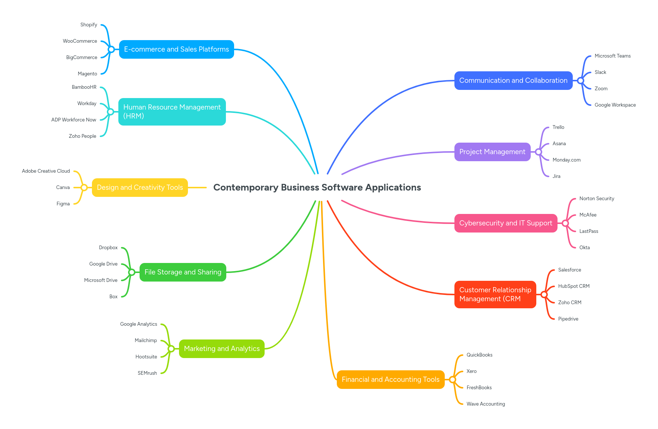

Task 3. Office Applications

Four office software solutions for business operations

MS Word

Microsoft Word is a widely used word processing application developed by Microsoft as part of the Microsoft Office suite. It is designed to help users create, edit, format, and share text-based documents efficiently. Microsoft Word is commonly used in education, business, and professional environments for tasks such as writing reports, letters, resumes, proposals, and official documents. Its popularity is largely due to its user-friendly interface, reliability, and extensive range of features that support both simple and complex document creation [10].
One of the major features of Microsoft Word is its advanced document creation and formatting tools. Users can apply various fonts, styles, headings, tables, images, and page layouts to produce professional-quality documents. The software includes built-in spelling and grammar checking, autocorrect, and formatting suggestions, which help improve writing accuracy and presentation. Microsoft Word also provides ready-made templates for documents such as reports, resumes, and letters, saving users time and effort. Additionally, Word supports referencing tools, footnotes, and citations, which are particularly useful for academic writing.
Another important feature of Microsoft Word is collaboration and document sharing. Through cloud integration with OneDrive, multiple users can work on the same document simultaneously. Features such as comments, track changes, and version history allow users to review edits and provide feedback efficiently. This makes Microsoft Word suitable for team projects, business reports, and group assignments where collaboration is required.
The benefits of using Microsoft Word are significant. It enhances productivity by simplifying document creation, editing, and formatting processes. The software is easy to use, making it accessible to beginners, while still offering advanced tools for experienced users. Microsoft Word also integrates seamlessly with other Microsoft Office applications such as Excel and PowerPoint, allowing users to insert charts, tables, and data easily. Its wide compatibility ensures that documents can be opened and shared across different devices and operating systems, reducing file-format issues.
Despite its many advantages, Microsoft Word has some limitations. Full access to all features requires a paid subscription, which may be expensive for some individuals or small organizations. Large or highly formatted documents may occasionally experience performance issues, especially on older devices. In addition, some advanced features require training or experience to use effectively.
In conclusion, Microsoft Word remains a powerful and essential word processing tool. Its strong features, productivity benefits, and widespread compatibility make it a preferred choice for document creation, despite a few limitations.

MS PowerPoint
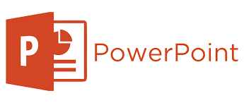
Microsoft PowerPoint is a widely used presentation software developed by Microsoft as part of the Microsoft Office suite. It enables users to create, edit, and deliver professional presentations for educational, business, and professional purposes. PowerPoint is designed to help users communicate ideas effectively through a combination of text, visuals, charts, and multimedia elements. Its popularity stems from its user-friendly interface, extensive design tools, and seamless integration with other Microsoft Office applications, making it a key tool for educators, business professionals, and students [11].
Oe of the major features of Microsoft PowerPoint is its slide-based design structure, which allows users to organize information into individual slides. Each slide can include text, images, charts, tables, and multimedia elements such as audio and video, enabling dynamic presentations. PowerPoint provides a wide variety of professionally designed templates and themes, which help users create visually appealing presentations quickly and consistently. Animations and slide transitions allow users to add motion to content, emphasizing important points and enhancing audience engagement. PowerPoint also offers SmartArt graphics, which simplify the visualization of complex information, as well as tools for embedding tables, charts, and diagrams to present data clearly and effectively.
Collaboration and sharing are additional strengths of PowerPoint. Through cloud integration with OneDrive, multiple users can work on a presentation simultaneously, enhancing teamwork and productivity. Features such as comments, track changes, and version history allow for efficient review and feedback, which is particularly useful for group projects, corporate presentations, and academic assignments. PowerPoint presentations can be shared digitally, exported as PDFs, or converted into video formats, improving accessibility and convenience for different audiences.
The benefits of using Microsoft PowerPoint are extensive. The software enhances communication by presenting information visually, making it easier for audiences to understand and retain content. PowerPoint improves productivity by offering ready-made templates and easy-to-use formatting tools. Its integration with other Microsoft Office applications such as Word and Excel allows users to incorporate charts, graphs, and data seamlessly into slides. PowerPoint’s multimedia capabilities, including audio narration, video embedding, and animation effects, help engage audiences more effectively than static text alone, making it ideal for lectures, workshops, business meetings, and conferences.
Despite its advantages, Microsoft PowerPoint has some limitations. Overreliance on text, excessive animations, or crowded slides can reduce audience engagement and clarity. Some advanced features, such as custom animation paths, multimedia embedding, and interactive elements, may require training or experience to use effectively. Additionally, the full version of PowerPoint requires a paid subscription, which may be costly for some users, and very large or media-rich presentations can sometimes lead to performance issues on older devices.
In conclusion, Microsoft PowerPoint is a versatile and essential tool for creating professional presentations. Its extensive features, productivity benefits, multimedia capabilities, and collaborative functions make it an indispensable application for effective communication, learning, and professional engagement, despite certain limitations.

MS Excel
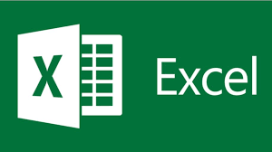
Microsoft Excel is a powerful spreadsheet application developed by Microsoft as part of the Microsoft Office suite. It is widely used in business, education, finance, and professional environments for data analysis, calculation, visualization, and reporting. Excel allows users to organize, manipulate, and analyze large amounts of data efficiently, making it an essential tool for decision-making and operational management [12].
One of the major features of Microsoft Excel is its ability to create and manage spreadsheets. Users can enter data into rows and columns, apply formulas and functions for calculations, and perform complex mathematical, statistical, and financial analyses. Excel provides a wide range of built-in functions such as SUM, AVERAGE, IF, VLOOKUP, and pivot tables, which simplify data management and help extract meaningful insights from raw data. Conditional formatting and data validation tools enhance the organization and presentation of information, making it easier to identify trends and outliers.
Another important feature of Excel is its data visualization capabilities. Excel allows users to create charts, graphs, and dashboards to represent data visually. These visual tools help communicate information effectively, enabling managers, analysts, and teams to interpret results quickly. Excel also supports data import and export from various sources, including databases, text files, and online services, ensuring flexibility in data handling and integration across different systems.
Collaboration and sharing are additional strengths of Excel. With cloud integration through OneDrive and SharePoint, multiple users can work on the same spreadsheet simultaneously. Features such as comments, track changes, and version history allow for real-time collaboration and review, improving productivity and accuracy in group projects or corporate reporting.
The benefits of using Microsoft Excel are significant. It enhances productivity by simplifying data entry, analysis, and reporting processes. Its advanced calculation and visualization tools enable users to make informed decisions, identify patterns, and optimize business operations. Excel integrates seamlessly with other Microsoft Office applications such as Word and PowerPoint, allowing data and charts to be shared or presented efficiently. Its widespread adoption and compatibility across devices and operating systems ensure that spreadsheets can be accessed, edited, and shared easily.
Despite its advantages, Microsoft Excel has some limitations. Advanced features, such as pivot tables, macros, and complex formulas, may require training or experience to use effectively. Large spreadsheets with extensive data or complex calculations can slow performance and increase the risk of errors. Additionally, full access to all features requires a paid Microsoft Office subscription, which may be costly for some individuals or small organizations.
In conclusion, Microsoft Excel is a versatile and essential tool for data management, analysis, and visualization. Its comprehensive features, productivity benefits, and collaborative capabilities make it indispensable for business operations, financial analysis, and academic purposes, despite certain limitations.

MS Access
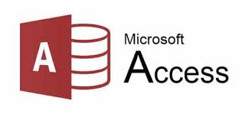
Microsoft Access is a database management system (DBMS) developed by Microsoft as part of the Microsoft Office suite. It allows individuals and businesses to create, manage, and analyze relational databases efficiently. Access is widely used in business, education, and professional environments to store large volumes of structured data, generate reports, and support decision-making processes [13].
One of the major features of Microsoft Access is its ability to create relational databases. Users can design tables, define fields, set primary keys, and establish relationships between tables to ensure data integrity. Access supports various data types and validation rules, which help maintain accurate and consistent records. The software also provides a user-friendly interface with forms that simplify data entry and retrieval, enabling users without extensive technical knowledge to interact with databases effectively.
Another important feature is query and reporting capabilities. Access allows users to create queries using Structured Query Language (SQL) or the graphical Query Design tool to extract specific information from one or multiple tables. This is particularly useful for generating meaningful insights from large datasets. Access also provides robust reporting tools, enabling users to design and produce professional reports, charts, and summaries that can be shared with stakeholders or integrated into other Office applications such as Word and Excel.
Collaboration and integration are additional strengths of Microsoft Access. Databases can be shared over networks, allowing multiple users to access and update data simultaneously. Integration with other Microsoft Office applications enables seamless import and export of data, improving workflow efficiency. Additionally, Access supports automation through macros and VBA (Visual Basic for Applications), allowing repetitive tasks to be streamlined and customized according to business needs.
The benefits of using Microsoft Access are significant. It provides a structured and organized way to store and manage data, enhancing productivity and data-driven decision-making. Access reduces the likelihood of data redundancy and errors by enforcing relationships and validation rules. Its reporting and querying tools help users analyze data effectively and communicate insights clearly. Access is also scalable for small to medium-sized databases, making it suitable for a variety of business operations and academic projects.
Despite its advantages, Microsoft Access has some limitations. It may not be ideal for very large or complex databases with high transaction volumes, as performance can be affected. Advanced features such as macros, VBA programming, and SQL queries require training or experience to use effectively. Additionally, full access to the software requires a paid Microsoft Office subscription, which may be costly for some users.
In conclusion, Microsoft Access is a powerful database management system that provides comprehensive tools for data storage, management, analysis, and reporting. Its features, productivity benefits, and integration capabilities make it a valuable tool for businesses and educational institutions, despite certain limitations.

Practical demonstration of Two Office Features

Mail Merge

click on Mailings found in the ribbon, then select start mail merge, a drop down will appear, select letters.

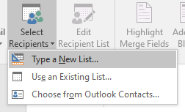
I Select Recipients, after selecting that, I select on ‘Type a new list

Pivot Table

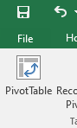
Select the data,Go to insert tab and select PivotTable
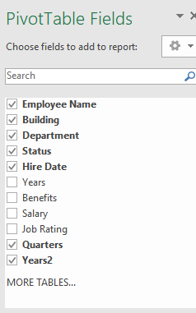
I choose from the fields to start creating my Pivot Table

Task 4. Communication and Collaboration applications

One contemporary Communication and one Online Collaboration applications/tools


MS Outlook
Microsoft Outlook is a personal information manager and email client developed by Microsoft and included in the Microsoft Office suite. It is designed to manage emails, calendars, contacts, tasks, and notes efficiently, making it a vital tool for both personal and professional communication. Outlook is widely used in businesses, educational institutions, and organizations to enhance communication, organization, and productivity.
One of the major features of Microsoft Outlook is its email management system. Users can send, receive, and organize emails into folders, apply rules for automatic sorting, and flag important messages. Advanced search capabilities allow users to locate specific emails quickly, improving efficiency.
Outlook also provides calendar and scheduling tools. Users can create appointments, schedule meetings, set reminders, and share calendars with colleagues. This feature is particularly useful for coordinating team activities, managing deadlines, and improving time management.
Another key feature is its contact and task management. Outlook stores contact information and allows users to track communication history, set up task lists, and assign priorities. Integration with emails and calendars ensures that tasks and meetings are organized and monitored effectively.
Microsoft Outlook supports integration and collaboration. It integrates seamlessly with other Microsoft Office applications such as Word, Excel, and Teams, allowing users to share information across platforms. Shared mailboxes, calendar sharing, and group scheduling enhance team collaboration and streamline workflow.
Outlook also includes security and organizational features. It provides spam filtering, virus protection, encryption options, and customizable rules to safeguard sensitive information and reduce inbox clutter.
Despite its advantages, Microsoft Outlook has some limitations. Its interface and wide range of features can be overwhelming for new users. Large mailboxes and extensive attachments can affect performance, and certain advanced features may require technical knowledge to configure. Additionally, full functionality often requires a Microsoft 365 subscription, which may be costly for some users.
Overall, Microsoft Outlook is a comprehensive communication and organizational tool that enhances email management, scheduling, and collaboration. When used effectively, it improves productivity, streamlines communication, and supports efficient business operations.

Zoom

Zoom is a cloud-based video conferencing platform that allows individuals and organizations to meet virtually, host webinars, and collaborate online. Since its launch in 2011, Zoom has become one of the most widely used tools for remote communication due to its reliability, high-quality video and audio, and user-friendly design. It is commonly used in businesses, educational institutions, healthcare, and social settings, helping people connect and collaborate without being in the same physical location [14].
One of Zoom’s most notable features is its high-definition video and audio conferencing. Users can host meetings with large groups, depending on the subscription plan, and interact through chat, polls, or reactions without interrupting the flow of the meeting. Screen sharing, annotation tools, and virtual backgrounds enhance presentations and make discussions more engaging. Breakout rooms allow participants to split into smaller groups, which is particularly useful for workshops, brainstorming sessions, or focused team discussions. Zoom also supports features like hand-raising and recording, which add flexibility and interactivity to meetings. [15]
Another significant feature is its integration with other software. Zoom connects seamlessly with tools like Microsoft Outlook, Google Calendar, Slack, and Learning Management Systems. This integration allows users to schedule, join, and manage meetings efficiently. Meetings can be recorded locally or in the cloud, enabling participants to review sessions, share them with absent colleagues, and keep accurate records. Zoom also provides security measures such as password protection, waiting rooms, authentication controls, and end-to-end encryption to ensure that meetings remain private and secure.
The benefits of Zoom are numerous. It reduces the need for travel, saving time and costs, and allows teams to collaborate effectively from different locations. Its ease of use means that even beginners can participate in meetings without technical difficulties. Zoom’s cross-platform compatibility allows it to be used on computers, tablets, and smartphones, making it accessible in various settings. Features like recording, transcription, and note-taking help capture important points and ensure follow-up actions are clear. Overall, Zoom makes remote communication efficient and accessible, supporting both professional and educational needs.
Despite its advantages, Zoom does have some limitations. Free accounts limit meetings to 40 minutes and restrict the number of participants, which can be challenging for large groups. Technical issues such as poor internet connections, audio or video lag, and bandwidth limitations may affect meeting quality. Additionally, while Zoom has enhanced its security features, concerns about privacy and unauthorized access have been raised, so users need to follow best practices for safe usage.
In conclusion, Zoom is a versatile and essential platform for modern remote communication. Its features, ease of use, and accessibility make it invaluable for business, education, and personal use. However, users should be mindful of limitations like meeting restrictions, potential technical issues, and security considerations to ensure effective and secure communication.

One feature of a freely available Communication (1) and one feature of a Collaboration (1) application

MS Outlook

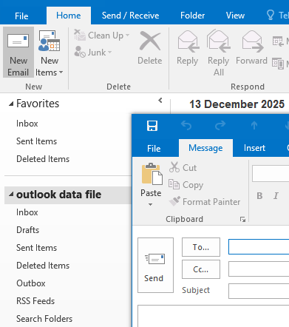
Select New Email add recipients TO,Cc, Bcc, type message.

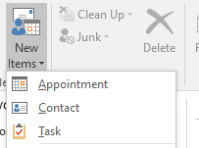
I can create an Appointment, set details like time and location

Zoom


Click Join icon and enter a meeting ID that you have been provided
When viewing shared, you can often right-click the shared screen and look for zoom options.

Conclusion
In conclusion, digital tools such as Microsoft Office applications, e-commerce platforms, and mind mapping techniques are essential for improving productivity, organization, and decision-making. Microsoft Word, Excel, PowerPoint, Access, Outlook, and Teams enhance document creation, data analysis, communication, collaboration, and project management. E-commerce platforms like Shopify, WooCommerce, Squarespace, and Wix empower businesses to establish and manage online stores effectively. Mind mapping adds value by organizing ideas visually, improving planning, and supporting better decisions. Together, these tools and techniques help individuals and organizations work smarter, communicate efficiently, and adapt to the demands of modern professional, academic, and business environments.

References
[1] Shopify Inc., What is Shopify and How Does It Work? Shopify, 2024.
[2] Investopedia, Shopify: Meaning, Overview, and How It Works, Investopedia, 2024.
[3] Wix.com Ltd., About Wix, Wix, 2024.
[4] Investopedia, Wix: What It Is and How It Works, Investopedia, 2024.
[5] T. Buzan and B. Buzan, The Mind Map Book, BBC Active, London, 2010.
[6] M. Eppler and R. Platts, “Visual strategizing: The systematic use of visualization in the strategic-planning process,” Long Range Planning, vol. 42, no. 1, pp. 42–74, 2009.
[7] Microsoft, Microsoft Word Overview, Microsoft, 2024.
[8] Microsoft, Microsoft PowerPoint Overview, Microsoft, 2024.
[9] Microsoft, Microsoft Excel Overview, Microsoft, 2024.
[10] Microsoft, Microsoft Access Overview, Microsoft, 2024.
[11] Zoom Video Communications, Zoom Overview, Zoom, 2024.

