Burberry – Marketing Management
University Trinity Saint David London Campus
Marketing Management(LCMB7001)

Student: Marius Ionut Saiz 1605685
Lecturer: Tushara Balendran

Executive Summary
Marketing management is considered as an essential parameter in terms of defining the success of an organisation in the competitive market. The present report has paid attention to evaluate critically the marketing management aspects of a renowned global fashion service provider Burberry PLC. In this concern, the report has included a brief background of the company along with the importance of communication in the business. Followed by this the communication model diagram is evaluated on behalf of the company along with integrated marketing communication. Moreover, the promotional strategy and competitor analysis is also conducted in this aspect. Apparently, the brand equity and branding are defined for Burberry PLC along with providing the theoretical consideration of Keller's brand equity model. However, the customer journey is also defined in this aspect along with the customer touch point by defining its advantages and drawbacks. Lastly, the report has also included a recommendation in the context of marketing management welfare for Burberry PLC.

Table of Contents
Introduction 4
Company background 4
Importance of communication in business 5
Channels of communication diagram 6
Integrated Marketing Communication of Burberry 8
Promotional strategy 8
Promotional strategy recommendation’s 9
New promotional strategy 9
Brand equity and branding 9
Keller’s Brand equity model 10
Advantages and disadvantages 11
Customer journey along with touch point 12
The customer journeys 12
References 17
Appendix: Burberry global revenue from 2005 to 2020 21

Introduction
Marketing management plays a significant role for any business organisation as it helps to perform all the managerial activities in marketing. Thus, this report aims to provide an in-depth analysis of effectiveness about marketing management by considering UK based leading luxury fashion brand Burberry. Importance of communication in business will be outlined by considering model concepts and Integrated Marketing Communication (IMC) utilized by aforementioned companies will be outlined in this report. Present promotional strategy of Burberry will be highlighted based on which new promotional strategy will be developed. Brand equity of the mentioned organization and the customer touch point utilized by the mentioned organisation will also be demonstrated in this report.

Company background
Burberry is recognized as one of the leading luxury fashion brands in the UK that presently distributes and designs ready to wear products including footwear, trench coat, eyewear, leather goods, fashion accessories and others. With an effective and strong brand image, the company is able to establish their business operation in 59 other countries. Having employee strength of 9,892, in 2020, the company is able to obtain revenue of £2.63 billion with a net operating income of £433 million respectively. Provision of diversified products the company also obtain a net income of £122 million and keep their market competition in the UK fashion industry (burberryplc.com, 2020).
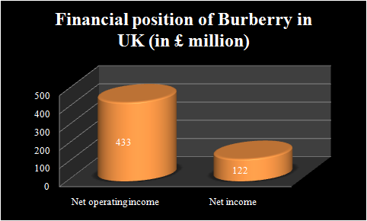
Figure 1: Financial position of Burberry in UK
(Source: burberryplc.com, 2020)
In the UK, the company holds a market share of 281bn EUR along with 33.3bn EUR in online sales. In order to sustain competitiveness, Burberry continuously launched new products (statista.com, 2020). However, in China, Burberry was found to be criticized for the advertisement as their advertising for marketing products navigate the local sensibilities. In this context, it can be mentioned that the advertising concept they are followed for their global marketing serves as effective for their brand image and business prosperity. This generates the need for changing marketing strategy for sustaining customer satisfaction level and brand equity in the UK along with the global market (Halliday, 2019). From the next adjoining section, evaluation about the importance of communication in business will be outlined by utilization of suitable models in relation to the aforementioned organisation.

Importance of communication in business
An effective and suitable marketing management allows an organization to sustain their market competitiveness and long-run business success. Other than this, marketing management also helps to improve product distribution process and profitability. In this revelation, building an effective interaction or communication flow with target audiences allows any business organisation to fulfil their needs and meet their exception by identifying them accurately. As mentioned by Mari et al. (2020), having an effective knowledge of the customer demands and their perspectives towards particular brands, service or company, and enterprise can be able to change their operational strategy and can provide customer-oriented services facilities sustaining sustainability in business growth. In this regard, the concept of Voice over Marketing (VOM) can be aligned to evaluate the effectiveness of marketing management.

Figure 2: Voice of Marketing
(Source: Mari et al. 2020)
Considering the mentioned figure, it can be mentioned that VOM plays a crucial role for an organization to engage, analyse, recognize and capture the external as well as internal stakeholders and maximizes their chance towards long-run business success. As mentioned by Umeozor et al. (2020), it is important to recognize the needs, exceptions, and priority of the target customers based on which the components of VOM that is strategy building, marketing, branding and other can be executed in an accurate and synchronized manner.
However, in the case of Burberry, it is identified that with the change in market trends, customer’s behaviour and market trends, and rising expectation of customers, the company is experiencing challenges in terms of communication and marketing. Additionally, they were also accused of unethical marketing practices in China as they negatively affected the local sensibilities. As mentioned by Murphy and Sashi (2018), digital communication is recognized as the key channel for reaching maximum number of target audience within minimum time of span. Other than this, it also enables an organization to recognize the perspective and expectation of their target customers over particular brands closely. In this point, the concept of Shannon and Weaver Model of Communication can be interlinked to highlight the key importance behind increasing customer’s satisfaction. Evaluation of this statement will be outlined in the next adjoining section.

Channels of communication diagram
Shannon and Weaver Model of Communication refers to the systematic process of communication in a linear form including one-way communication between sender and receiver. As mentioned by Talukdar (2017), this model concept is associated with six specific factors such as information source, transmitter, channel, receive, destination and noise source respectively. Utilization of this model concept helps to eliminate the intermediate noise in the path of communication flow.
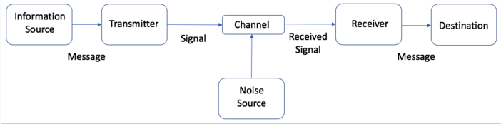
Figure 3: Shannon and Weaver Model of Communication
(Source: Talukdar 2017)
In relation to the above figure, it can be mentioned that digital communication systems can be considered as the process related to the concept mentioned in this model. The reason behind this statement is that maximization of online presence helps any business organization to eliminate intermediaries that create issues while interacting with target customers or audience (Soter, 2017).
In relation to Burberry, it is identified that the company took the digital media channel for marketing and maximized their presence on social media platforms. Burberry utilizes social media as their effective branding strategy to sustain their business growth and competitiveness within the UK as well as target market. They spend their marketing budget by 60% on digital media and most of the luxury brands in the UK preferred social media as an effective communication channel to identify customers' touch points and minimize the issues in relation to customer-end-journey (Lechimia, 2016).
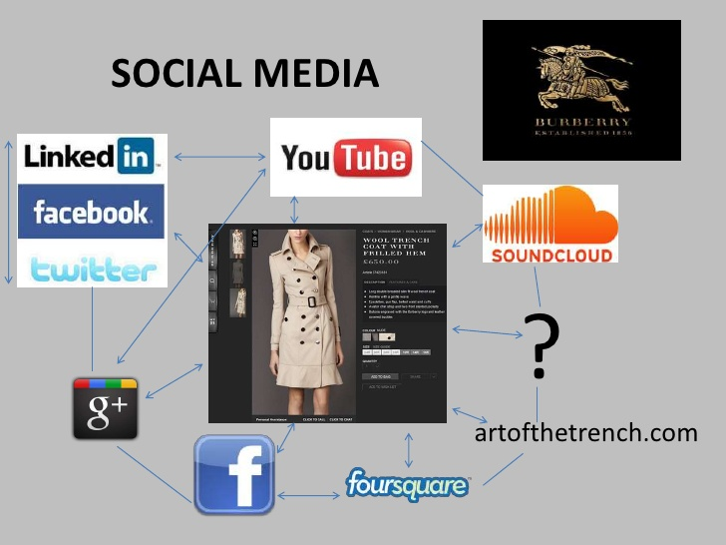
Figure 4: Online presence of Burberry
(Source: burberryplc.com, 2020)
Considering the above figure, it has been identified that the mentioned organization has established their presence in different social media platforms such as Facebook, YouTube, Instagram and others. Burberry maximizes its popularity in Facebook by reaching 17 million viewers; however, they failed to compete against other top most fashion brands such as Louis Vuitton with 18 million and Chanel by 17 million of viewers respectively. Adding to this, they have 7.5 million of viewers on Instagram. They organized their content through a combination of videos and images for gaining attention from their target customers (Lechimia, 2019). Here, it can signify that the company identifies the touch-point of their target customers to maximize its presence in the UK as well as global market.

Integrated Marketing Communication of Burberry
The term IMC or Integrated Marketing Communication found to be a systematic and suitable process that can be considered by any business organization that is willing to draw attention from their target customers. In the context of Burberry, it has been identified from the above section that the company has taken the advantages of IMC through establishing their presence on different social media such as Facebook, YouTube, Instagram, LinkedIn and others. However, the company failed to determine and acknowledge the demographic and psychographic factors in different regions like China due to which they failed to obtain success through their exciting promotional strategy in the China market. In this context, it can be mentioned that “Viral Marketing Strategy'' can be utilized by the organisation to strengthen their promotional activities in a more effective and synchronized manner (Zhai, 2017).

Promotional strategy
Promotion can be considered as the key pillar for an organization that helps to obtain benefits in terms of presenting specific products or services and interacting with the target customers in a more effective and suitable manner. With the advent of technology, every business organization tries to transform its marketing strategy or promotional activities to digital campaigning or increasing followers in social media channels. As mentioned by Yasa et al. (2020), digital marketing helps enterprises to identify new market trends, change in customers' elections and preferences in a global context. This helps to sustain global competitiveness and long-run business success. In the context of Burberry, it is identified that they consider the social media marketing strategy as their branding strategy due to maximizing presence of UK based top most fashion enterprises in the mentioned social media platforms. However, this strategy did not serve as effectively for their global marketing plan as they involved in the advertising scandal in China. In this regard, it can be articulated that the company requires to improve their promotional strategy to minimize their present advertising issues in the future (Kim, 2018).

Promotional strategy recommendation’s
In relation to the above discussion, it can be mentioned that Burberry can adopt the concept of email marketing, content marketing, and optimization of search engine strategy. The key reason behind this statement is that utilization of any one of the mentioned promotional strategies would help the company to provide product or service related information in a personalized manner. It would further help them to change their marketing content according to the demographic and psychographic factors in respect to the different country and region.

New promotional strategy
With respect to the current market trends, Burberry PLC is also noted to focus on transforming their operations under the shape of digital touch. In this context, the company has initiated to switch their focus of marketing and promotion from glossy print advertising into digital investment. However, the company is also noted to focus on digital promotion throughout different social media channels such as Facebook and others in terms of promoting the launch of their new products.
Apart from that, Burberry has also been initiating to provide attractive and expensive promo codes for their consumers under the form of Burberry Black Friday deals (burberry.knoji.com, 2020). In this concern, the company is also providing lucrative offers and discounts for their online consumers. Apparently, specific coupon codes and promo codes are also available from the company perspective towards their consumers in order to avail the discount.
Because of this, the company has been experiencing rising growth of their sales and profitability in the UK market. However, the company is notified to achieve a promising sales growth based on which their full year revenue in this current year is amounted to £ 2.63 billion (retail news.asia, 2020). On the other hand, the company had to deal with the closure of around 60% of the retail stores in order to comply with the lockdowns and social distancing measures due to the ongoing Covid-19 pandemic.

Brand equity and branding
In terms of justifying the brand recognition for Burberry PLC, it can be notified that the company has been operating in the UK market with different brand awareness. For example, it can be stated that Burberry PLC was able to undertake their position as the world's most popular fashion brands on Instagram ahead of the renowned market players like Nike, Jimmy Choo, Topshop and others (Santamaria, 2017). This statistic reflects on the significance of the organisational brand across the UK market. Moreover, Burberry PLC was able to hold their first position as the top British brands on Instagram for the second consecutive year during 2017.
Apart from that, the digital appliances of Burberry PLC reflect on providing personalized luxury services for their consumers under the lights of seamless omnichannel experiences (burberryplc.com, 2020). This attribute has been acting in favour of enlarging the organisational reputation in the competitive market. For example, it can be noted that the company was able to confirm gradual growth in their revenue generation throughout the last 10 years (refer to appendix). This gradual growth reflects on the organizational ability of performing with extensive brand recognition in both the UK and global market. In order to develop brand equity furthermore, Burberry PLC should focus on the conceptualization of a total quality management framework, which can also increase their product and service quality largely. However, the company is notified to depend on commencing a program in order to re-energise the brand (burberryplc.com, 2020). Moreover, the concept of creative transition is also managed by the company due to which Burberry PLC able to confirm attractive brand awareness in the global market.
However, the company was criticized in the Chinese market due to having the inability of maintaining a cultural relationship with the current market trends and requirements. In this concern, the company had to experience criticism in China (Halliday, 2019). Due to this reason, the company should focus on establishing a strong cultural Bond with the expanded market in order to obtain consumer attraction furthermore.

Keller’s Brand equity model
Keller’s brand equity model is segmented on four distinctive levels including brand identity, brand meaning, brand response and resonance.
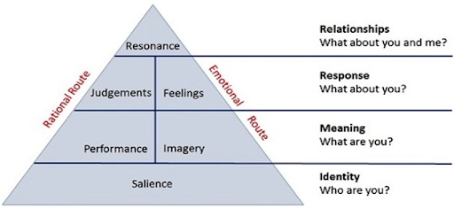
(Source: free-management-ebooks.com, 2020)

Brand identity
Brand identity is created when consumers are generally unaware of organisational products and services (Yousaf et al. 2017). Burberry PLC had initiated to position their brand in the consumer's mind under the shape of a functional luxury brand from the start of their operations. Moreover, the company also maintains a product line with reference to their diversified products in two main categories including fashion and continuity.
Brand meaning
This level reflects on providing good customer service in order to make the customer familiar with an organisational brand. In the case of Burberry PLC, the brand performance for the company was noted to be attractive and excellent throughout the years. Due to this aspect, the company had announced their plan for establishing their position firmly in luxury brands during 2017 (cpp-luxury.com, 2020). Moreover, the company also initiated to sharpen their brand positioning in order to influence positively the consumer purchasing behaviour.
Brand response
Extensive response was notified among the consumer's mind regarding the brand of Burberry PLC. Because of this, the company was able to secure the top position according to the British brands report ahead of the leading and renowned market players in the UK (Santamaria, 2017). Moreover, this attribute also supported the company with increasing revenue and sales growth in the market.
Brand resonance
A proper balance between judgement and feelings is significant for any brand in terms of creating brand equity. Burberry PLC had conceptualized the new strategy of positioning their brand with the luxury tagline. Because of this, the company witnessed 4% rise in their revenue. Moreover, the adjusted operating profit for Burberry PLC also increased by 17% underlying and 28% reported to £ 185 million during 2017 (cpp-luxury.com, 2020).

Advantages and disadvantages
Several positive instincts can be notified with regards to the services and products offered by Burberry PLC in the competitive market. In this concern, the prime attention is reflected on extensive brand recognition under the preference of a luxury brand. In this concern, the company has utilised social media like Facebook in order to provide there are offers and promotional codes to their online consumers. Apart from that, the company has also been utilising artificial intelligence and big data in order to achieve market success (Marr, 2017). Because of this, their sales growth is boosted along with customer satisfaction.
However, the company is also having a disadvantage in this context by transforming their strategy of positioning their brand into luxury form. Because of this, the company has been lacking from offering products for the lower and middle class consumers with cost optimisation.

Customer journey along with touch point
In terms of defining the customer journey for Burberry PLC, it can be noted that the company has been able to confirm a decent brand image in the competitive market based on which the customer satisfaction aspect has been higher for them. The company had recorded 12 million people in their database as per November 2016 (Trotter, 2018). Moreover, the company is also noted to focus on complete full brand transformation including alignment of distribution and growth acceleration as their strategy (burberryplc.com, 2020). However, the prime concern behind this initiative reflected to foster creativity in order to enlarge and support their luxury brand positioning in the market.
On the other hand, the company is adequately missing from having a different product portfolio for the middle and lower class customers. In this aspect, the customer journey for Burberry PLC has been only limited with the luxury brand uses.

The customer journeys
Problem awareness was the topmost concern for Burberry PLC in terms of empowering their customer journey in the competitive market. In this concern, the company initiated to digitalise their operations along with promotional activities throughout online channels according to the current market trends. Moreover, the utilisation of artificial intelligence and big data has acted in favour of increasing service effectiveness for Burberry PLC. For example, it can be noted that the investment of Burberry PLC in their personalized customer management programs had resulted in a 50% increase in repeating custom (Marr, 2017). Moreover, the company with reference to their luxury branded products in the market provides a firm commitment. Along with this Facebook, the company also conceptualizes chatbots in order to share information and updates on new products (Marr, 2017). Because of this, the company has retained a decent customer satisfaction rate in the global market.

Total Engagement Model
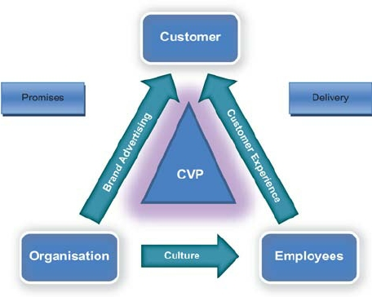
Figure 5: Total engagement model
(Source: Grover and Kar, 2020)
The total engagement model is a value proposition model that defines the role of the organisation responsible for engaging the employees as well as the customers of the company. The role of the organisation is most important, as it is responsible for creating a brand advertisement, which increases the value of the products they are selling in the market. It also serves as a promising factor to the customers. Such advertisements are necessary to engage the customers, furthermore this also attracts the attention of the customers towards the products and services the company is providing (Demangeot and Broderick, 2016). On the other hand, the organisation is also responsible for developing a holistic working environment and working culture in the organisation to develop their workforce. This enables the company and its workforce to expand their consumer base as well as maintain a stable relationship with all the existing and prospect customers. Moreover, it is the responsibility of the employees to make sure that they deliver as per the promises made by the company to the customers. It is essential for the organisation to train their workforce in a manner, which can serve the requirements and demands of the customers, and only then, the value propositions can be met. Additionally doing so also increases the engagement of the customers as it helps in creating a solid bond with the existing customer and increases the customer loyalty rate.
Therefore based on the activities carried out by the organisation in order to generate total engagement the company needs to effectively advertise and promote the products in the market (Grover and Kar 2020). Adding to that the company also needs to develop a workforce, which can serve to the expectation of the customers, which is generated after the advertisement is done.
Customer touch points
There are several customer touch-points of Burberry that the company utilizes in order to increase their engagement with customers as well as improve their brand recognition in the market. There are touches points before the sale of the product, there are also touch points when the customer decides to purchase the product and finally there are touch points after the sale of the product (Rosenbaum et al. 2017). Among the most important and widely used touch points of Burberry are
- Touch point before the purchase
  - Social media
  - Online advertisements
  - Advertisements in newspapers magazines
  - Hoardings
  - The company website
- Touch points during the purchase
  - Retail stores
  - Product catalogue
  - Website
  - Point of sale
  - E-Commerce platforms
- Touch points after the purchase
  - Sponsored events
  - Online reviews
  - Subscription emails and messages
  - Customer service
  - Refund and return policies
  - Invoices and thank you letters
It is necessary for the organisation to maintain the maximum amount of touch points it can create in the customer journey map. The higher the number of customer touches points the higher is the chances of sales. Furthermore, touch points also increase the engagement rate of the customers with the company's products and services. Hence, the more effective and interactive touch point a company can create the higher is the chances of engaging with new customers who can end up buying the company's products and services (Rudkowski et al. 2020).
Advantages and disadvantages
Based on the list of the above touch points in the different stages in which the touch points change in the customer journey map there are several advantages as well as disadvantages of these touch-point supplies by the organisation. Primary the most effective forms of test points are the one that the customer comes across before the purchase of the product. This is why companies extensively focus upon advertising and promoting the product in the market so that consumers can get more familiar and accustomed with their brand image. It has been seen that companies and brands that are more familiar and popular among consumers have a higher chance of succeeding in the market compared to products that are not advertised all promoted by their respective companies (von Briel, 2018). On the other hand, touch point also increases the competitiveness of an organisation in the market therefore if Burberry increases their touchpoints they have a higher chance of internet in engaging the customers, which can end up in a successful sale.
On the other hand, excessive use of touch points can cost the company many financial resources. Moreover the distribution of these touch points is also time consuming and can reduce the company's productivity and engagement rate in the long run. Additionally excessive use of touchpoint also dilutes the credit percentage of the products (Vannucci and Pantano, 2019).
Recommendation
The company already has a successful social media presence and online promotion strategy however in order to meet their online promotion is more effective the primary need to analyse the consumer behaviour patterns. Additionally, the consumer decision making greatly depends upon the effectiveness of the online promotional strategies therefore the company needs to study the current market trends based on which there online promotional strategies need to be changed from time to time. Additionally a quality management framework needs to be installed by the company in terms of the products and services provided by the company. Having a quality management structure would ensure that the company stands up to the demands and expectations of the customers.
Conclusion
Based on the bus the rate can be concluded that Burberry has been successfully conducting their business in the markets for several years. As a result, the marketing management of the organisation can be termed as a successful operation conducted by the company over these years. The above study also discusses different forms of business communications that are utilised by the organisation and their importance for the company's growth and competitiveness in the market. Furthermore, the different promotional strategies that are adopted by the organisation as well as recommendations to improve further their existing promotional strategies have also been discussed in the above study. The customer journey map along with the different touch points that are utilised by the organisation has also been briefly evaluated and analysed. Hence, based on all these findings, recommendations have also been provided which can help the organisation to further improve that overall marketing strategy.

References
Anselmsson, J., Burt, S. and Tunca, B., 2017. An integrated retailer image and brand equity framework: Re-examining, extending, and restructuring retailer brand equity. Journal of retailing and consumer services, 38, pp.194-203. Available at: http://dspace.stir.ac.uk/bitstream/1893/25566/1/Integrated%20Retail%20Image%20%20Brand%20Equity%20Framework%20%28with%20authors%29.pdf
burberry.knoji.com, 2020. Burberry Promo Codes | Burberry Black Friday Deals Available at: https://burberry.knoji.com/promo-codes/ [Accessed 19th November 2020]
burberryplc.com, 2020. Annual Report of Burberry for year 2020. Available at: https://www.burberryplc.com/en/investors/results-reports.html [Accessed on 10 November 2020]
burberryplc.com, 2020. STRATEGY Available at: https://www.burberryplc.com/en/company/strategy.html#item-undefined [Accessed 19th November 2020]
cpp-luxury.com, 2020. Burberry shifts strategy towards ultra-luxury positioning Available at: https://cpp-luxury.com/burberry-shifts-strategy-towards-ultra-luxury-positioning/ [Accessed 19th November 2020]
keller's brand equity model, 2020. http://www.free-management-ebooks.com/news/kellers-brand-equity-model/ [Accessed 19th November 2020]
Demangeot, C. and Broderick, A.J., 2016. Engaging customers during a website visit: a model of website customer engagement. International Journal of Retail & Distribution Management, 26(2), pp.7-11. Available at: https://repository.uel.ac.uk/download/43f1c247e56e5725d89540b03004ef93579195138c8590d04f771f48baf21d2f/1012424/Engaging%2520customers%2520during%2520a%2520website%2520visit.pdf
Grover, P. and Kar, A.K., 2020. User engagement for mobile payment service providers–introducing the social media engagement model. Journal of Retailing and Consumer Services, 53. Available at: https://www.sciencedirect.com/science/article/pii/S0969698918307501
Halliday, S., 2019. Burberry ad criticised in China for lack of festive cheer Available at: https://uk.fashionnetwork.com/news/Burberry-ad-criticised-in-china-for-lack-of-festive-cheer,1053497.html [Accessed 19th November 2020]
Halliday, S., 2019. Burberry ad criticised in China for lack of festive cheer. Available at: https://uk.fashionnetwork.com/news/Burberry-ad-criticised-in-china-for-lack-of-festive-cheer,1053497.html [Accessed on 10 November 2020]
Kim, K.W., 2018. Smart offering system using marketing strategy and digital promotional brochure. International Information Institute (Tokyo). Information, 21(2), pp.679-686. Available at: http://search.proquest.com/openview/f82f128a4dd6e707c91cb7df508742c4/1?pq-origsite=gscholar&cbl=936334
Lechimia, Q., 2016. Case Study: Is Burberry’s Social Media Use the Best Amongst Luxury Brands?. Available at: https://socialwall.me/en/burberry-social-media-use-luxury-brands/ [Accessed on 10 November 2020]
Mari, A., Mandelli, A. and Algesheimer, R., 2020, July. The evolution of marketing in the context of voice commerce: A managerial perspective. In International Conference on Human-Computer Interaction (pp. 405-425). Springer, Cham. Available at: https://www.researchgate.net/profile/Alex_Mari2/publication/342822343_The_Evolution_of_Marketing_in_the_Context_of_Voice_Commerce_A_Managerial_Perspective/links/5f0dc708458515129998c8e5/The-Evolution-of-Marketing-in-the-Context-of-Voice-Commerce-A-Managerial-Perspective.pdf
Marr, 2017. The Amazing Ways Burberry Is Using Artificial Intelligence And Big Data To Drive Success Available at: https://www.forbes.com/sites/bernardmarr/2017/09/25/the-amazing-ways-burberry-is-using-artificial-intelligence-and-big-data-to-drive-success/?sh=12cc812d4f63 [Accessed 19th November 2020]
Murphy, M. and Sashi, C.M., 2018. Communication, interactivity, and satisfaction in B2B relationships. Industrial Marketing Management, 68, pp.1-12. Available at: https://www.researchgate.net/profile/Micah_Murphy/publication/320446158_Communication_interactivity_and_satisfaction_in_B2B_relationships/links/5a5112b8458515e7b72c3bf6/Communication-interactivity-and-satisfaction-in-B2B-relationships.pdf
retailnews.asia, 2020. Burberry sales growth was promising and stable Available at: https://www.retailnews.asia/burberry-sales-growth-was-promising-and-stable/ [Accessed 19th November 2020]
Rosenbaum, M.S., Otalora, M.L. and Ramírez, G.C., 2017. How to create a realistic customer journey map. Business Horizons, 60(1), pp.143-150. Available at: https://isidl.com/wp-content/uploads/2017/08/E4735-ISIDL.pdf
Rudkowski, J., Heney, C., Yu, H., Sedlezky, S. and Gunn, F., 2020. Here Today, Gone Tomorrow? Mapping and modeling the pop-up retail customer journey. Journal of Retailing and Consumer Services, 54. Available at: https://www.sciencedirect.com/science/article/pii/S0969698918302686
Santamaria, B., 2017. Burberry tops Instagram UK brand ranking Available at: https://uk.fashionnetwork.com/news/burberry-tops-instagram-uk-brand-ranking,895288.html [Accessed 19th November 2020]
Soter, M., 2016. Theoretical Modelling of Intercultural Communication Process. Journal of Advocacy, Research and Education, (2), pp.87-92. Available at: http://www.kadint.net/journals_n/1473284978.pdf
statista.com, 2020. Burberry - Statistics & Facts Available at: https://www.statista.com/topics/3458/burberry/
statista.com, 2020. Burberry - Statistics & Facts. Available at: https://www.statista.com/topics/3458/burberry/ [Accessed on 10 November 2020]
Talukdar, H., 2017. The Different Models of Communication-Their Differences, Lacks and Integrity, and their Association to Real Life Communication. Asian Journal of Research in Social Sciences and Humanities, 7(8), pp.36-50. Available at: http://www.indianjournals.com/ijor.aspx?target=ijor:ajrssh&volume=7&issue=8&article=004 Trotter, C., 2018. Inside the retail strategy of Burberry Available at: https://www.insider-trends.com/inside-retail-strategy- [Accessed on 10 November 2020]
burberry/#:~:text=Perhaps%20most%20interesting%20though%20is,million%20people%20in%20its%20database. [Accessed on 11 November 2020]
Umeozor, S.N., 2020. Information Retrieval: A Communication Process in the 21st Century Library. International Journal of Knowledge Content Development & Technology, 10(2), pp.7-18. Available at: http://www.ijkcdt.net/xml/22689/22689.pdf
Vannucci, V. and Pantano, E., 2019. Digital or human touchpoints? Insights from consumer-facing in-store services. Information Technology & People, 12(7), pp. 32-51. Available at: https://www.emerald.com/insight/content/doi/10.1108/ITP-02-2018-0113/full/html
von Briel, F., 2018. The future of omnichannel retail: A four-stage Delphi study. Technological Forecasting and Social Change, 132, pp.217-229. Available at: https://www.sciencedirect.com/science/article/pii/S0040162518302026
Yasa, N., Giantari, I.G.A.K., Setini, M. and Rahmayanti, P., 2020. The role of competitive advantage in mediating the effect of promotional strategy on marketing performance. Management Science Letters, 10(12), pp.2845-2848. Available at: http://m.growingscience.com/msl/Vol10/msl_2020_120.pdf
Yousaf, A., Amin, I. and Gupta, A., 2017. Conceptualising tourist-based brand-equity pyramid: an application of Keller brand pyramid model to destinations. Tourism and hospitality management, 23(1), pp.119-137. Available at: https://hrcak.srce.hr/file/266535
Zhai, M., 2017. The Generation Mechanism of Internet Rumors—Based on Consideration of Information Philosophy. Multidisciplinary Digital Publishing Institute Proceedings, 1(3), p.114. Available at: https://www.mdpi.com/2504-3900/1/3/114

Appendix: Burberry global revenue from 2005 to 2020
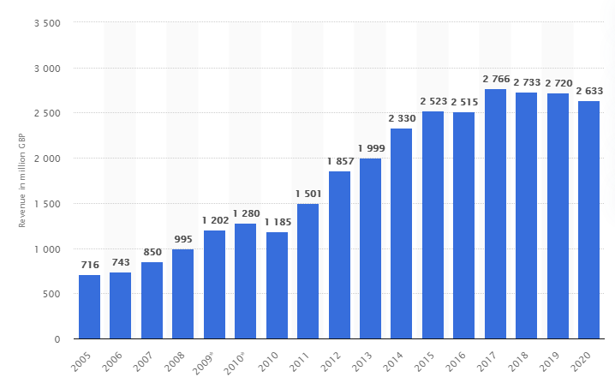
(Source: statista.com, 2020)

