

Changemakers: Creativity and Value Creation
Professions (BMHP5014)
Component 1: Online portfolio of set exercises
Student’s name: Michael Njuguna Muroki
Student number: 2423546
Lecturer’s name: Laila Surani

Task 1: Key Concepts in Health and Social Care: Innovation, Creativity, Value Creation, and Change 4
Task 2. Mind Map: Staff Burnout in Health & Social Care 5
Task 3: Self Reflection using Gibb’s Model 6
Task 4: Case Study Analysis of a UK Innovation 7
Task 5: Research Task 8
Task 6: Exploring Digital Innovation in Health and Social Care 8
Task 7: Understanding the NHS Leadership Framework and the Role of Leadership and personal Creativity and value creation development 9
Task 8: Self Reflection Journal 11
References 12

Task 1: Key Concepts in Health and Social Care: Innovation, Creativity, Value Creation, and Change

Innovation, creativity, value creation, and change are central to improving quality and effectiveness in health and social care. These concepts help practitioners respond to evolving needs, policy pressures, and organisational challenges. Understanding them supports safe, person-centred, and efficient practice.
  - Innovation
Innovation involves developing and implementing new ideas, technologies, or methods that improve outcomes. Tidd and Bessant (2021) define innovation as the “successful exploitation of new ideas,” highlighting that it requires both creation and application. Rogers’ Diffusion of Innovations theory supports this by explaining how new practices spread within organisations. Innovation is vital in health and social care because services must adapt to rising demand, complex conditions, and technological advances. For example, the introduction of telehealth consultations has improved access for people with mobility issues or those living in remote areas.
  - Creativity
Creativity refers to generating original and useful ideas. Amabile (1996) describes creativity as producing ideas that are both novel and appropriate. Guilford’s Structure of Intellect model emphasises divergent thinking as a key element of creative problem-solving. Creativity is important in health and social care because practitioners often face unpredictable situations requiring flexible, person-centred responses. For instance, a social worker supporting a young person with autism may use creative communication tools—such as visual prompts—to help them express emotions and participate in decision-making.
  - Value Creation
Value creation involves generating meaningful benefits for service users and organisations. Porter (1985) defines value creation as delivering services that meet needs more effectively than alternatives. Porter and Teisberg’s Value-Based Healthcare framework emphasises improving outcomes relative to cost. In health and social care, value creation ensures resources are used efficiently while enhancing wellbeing. An example is the use of multidisciplinary teams (MDTs) in mental health services, which improves coordination and reduces duplication, creating greater value for service users.
  - Change
Change refers to altering organisational structures, behaviours, or systems. Lewin’s (1951) Change Management Model outlines three stages; unfreezing, moving, and refreezing to support effective transitions. Change is essential in health and social care because services must respond to new evidence, policies, and population needs. Implementing electronic health records (EHRs) is a common example, requiring staff training and workflow redesign to improve accuracy and patient safety.

Task 2. Mind Map: Staff Burnout in Health & Social Care
  - Explanation
Staff burnout is a major issue in health and social care because exhausted workers cannot maintain safe, compassionate practice. Using the Social Determinants of Health model, burnout is shaped by poor working conditions, limited resources, and organisational pressures (Marmot, 2020). High workloads and emotional strain reduce staff resilience, leading to mistakes and lower care quality (West et al., 2018). In practice, overwhelmed nurses and carers struggle to communicate effectively, increasing risks for patients. If burnout remains unaddressed, turnover rises, waiting times increase, and vulnerable people, especially those with complex needs experience poorer outcomes. Frontline staff are most affected, facing chronic stress and reduced wellbeing. Solutions require systemic change: improved staffing, supportive leadership, and redesigned workflows that reduce unnecessary strain. Addressing burnout protects both workers and the individuals who rely on them, ensuring sustainable, high-quality care.
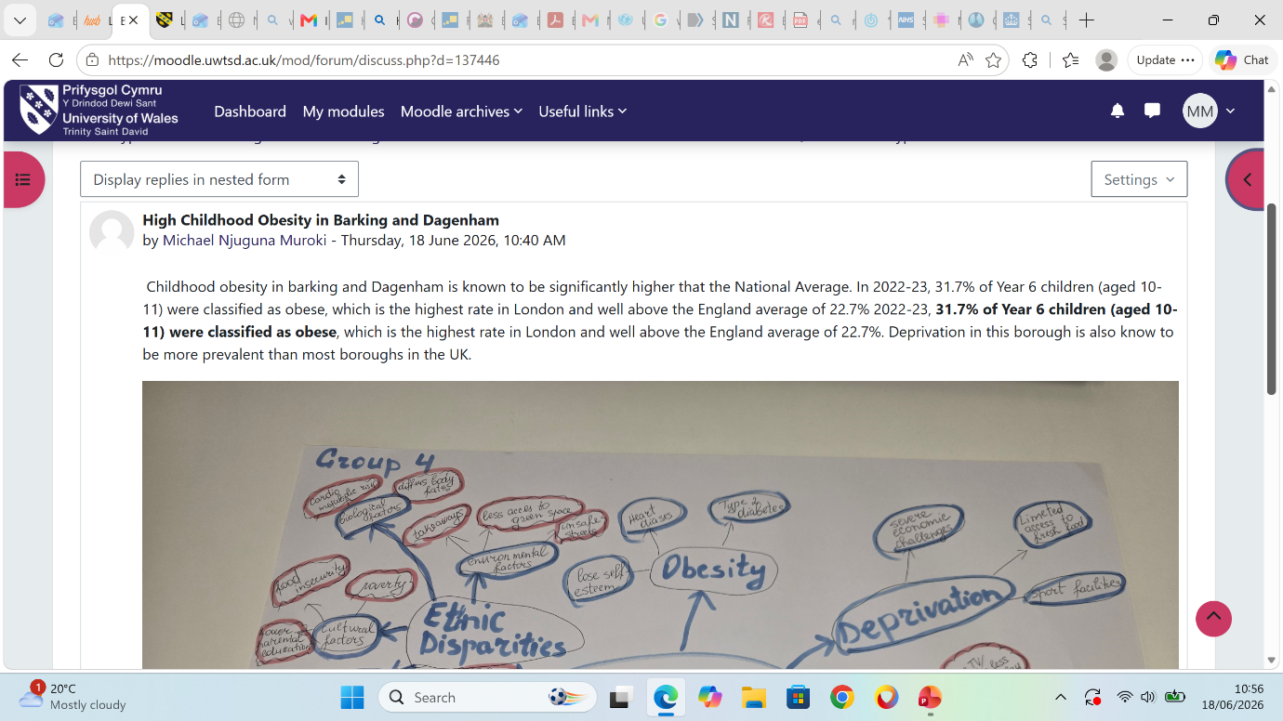

Task 3: Self Reflection using Gibb’s Model
In our class activity, we practised divergent thinking, which involves generating multiple creative ideas, and convergent thinking, which focuses on evaluating options to reach a single solution. Using Gibbs’ Reflective Cycle, I reflected on how I engaged with both styles.
Description: During the brainstorming stage, our group produced many ideas quickly. When we became stuck, I suggested using a pros and cons list, which helped us shift from divergent to convergent thinking and make a clearer decision.
Feelings: I felt confident during the divergent phase because idea generation feels natural to me. However, I became more hesitant during the convergent stage, worrying that rejecting ideas might create tension.
Evaluation: My contribution helped organise the discussion, but I realised I sometimes avoid challenging suggestions, which slowed our decision-making.
Analysis: According to Kolb (1984), learning develops through active experimentation, and this activity highlighted that while I am strong in creative thinking, I need to improve my evaluative confidence. I also learned that structured tools, like listing pros and cons, support teamwork effectively.
Conclusion & Action Plan: Next time, I will be more assertive during convergent thinking and take a clearer leadership role in guiding the group toward decisions.
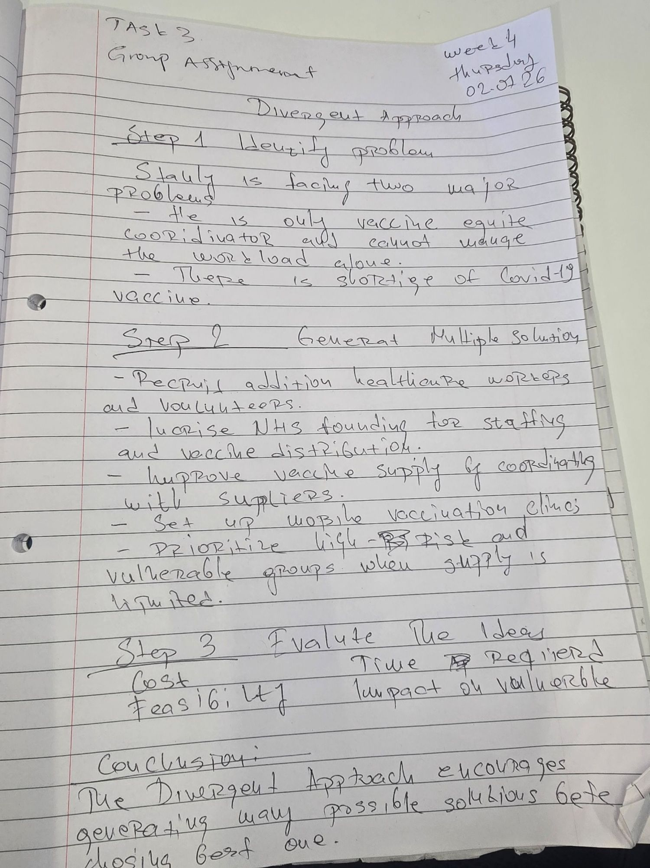

Task 4: Case Study Analysis of a UK Innovation

Virtual wards were developed in the NHS to reduce pressure on hospitals caused by rising demand, limited bed capacity, and increasing numbers of people with long-term conditions. They allow clinically stable patients to receive hospital-level care at home using remote monitoring tools, daily clinical reviews, and rapid escalation pathways. This creative approach combined digital technology with multidisciplinary teamwork, enabling clinicians to track symptoms and vital signs in real time while keeping patients in familiar home environments.
The innovation created value by improving patient comfort, reducing infection risk, and supporting independence. Staff benefited from clearer triage information and reduced strain on acute wards. System-level value included fewer avoidable admissions and more efficient use of resources. National evaluations report high patient satisfaction (94% rating care as good or excellent) and positive clinical outcomes, including low readmission rates and stable patient acuity (NHS England, 2023). An evaluation in Northwest England found an annualised net benefit of £10.4 million through reduced bed days and improved flow (Health Innovation Manchester, 2023).
Virtual wards illustrate Rogers’ Diffusion of Innovation Theory: they spread rapidly because they were seen as useful, compatible with existing practice, and easy to adopt. Their success suggests they could be replicated across other community-based care pathways.
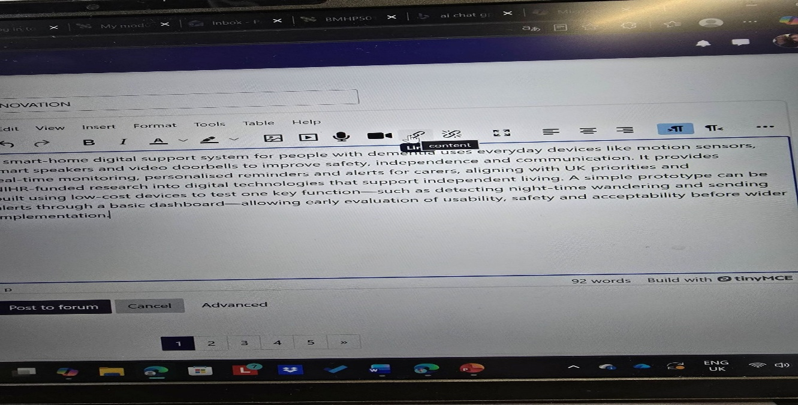

Task 5: Research Task

Staff stress in health and social care is strongly shaped by emotional exhaustion and high job demands. Two recent peer-reviewed studies help explain why this issue persists and how theory deepens understanding.
A scoping review by Dall’Ora et al. (2020) identifies chronic workload pressure, inadequate staffing, and emotional demands as core causes of burnout in nurses, with Maslach Burnout Theory used to explain how emotional exhaustion develops when demands consistently exceed resources. The review shows that stress emerges systemically, not just individually, highlighting how organisational factors, such as understaffing create conditions for exhaustion.
Qiao et al. (2026) similarly find that occupational stress arises from a mismatch between job demands and workers’ capacity, with emotional exhaustion acting as the central pathway linking stress to depression. Their network analysis reinforces burnout structural theory, showing how emotional exhaustion and cynicism mediate the impact of stress.
Both articles agree that emotional exhaustion is the key driver of staff stress, though Dall’Ora et al. emphasise organisational workload, while Qiao et al. highlight psychological pathways. In real care settings, this appears as staff fatigue, reduced empathy, and increased errors are clear indicators of systemic strain.

Task 6: Exploring Digital Innovation in Health and Social Care

Wearable Health Technologies and Chronic Conditions
Wearable health technologies such as smartwatches provide a major benefit for people managing chronic conditions by enabling continuous, real-time monitoring. Devices that track heart rate, oxygen saturation, sleep quality or physical activity allow early detection of deterioration, helping individuals and clinicians intervene sooner. For example, people with cardiovascular disease can use wearables to identify abnormal heart rhythms and share this data with their GP or specialist. Evidence shows that continuous monitoring improves self-management and supports behaviour change because users receive instant feedback, increasing perceived usefulness and ease of use, as explained by the Technology Acceptance Model (Davis, 1989). A study by Piwek et al. (2016) found that wearables enhance patient engagement and can reduce hospital admissions by identifying problems earlier. Overall, wearables strengthen personalised care and empower people to take an active role in managing long-term conditions.
Electronic Health Records and Provider Communication
Electronic Health Records (EHRs) improve communication and collaboration by giving healthcare professionals instant access to accurate, up-to-date patient information. Instead of relying on paper notes or fragmented systems, clinicians can view medication histories, test results and care plans in one shared digital record. This reduces duplication, prevents errors and supports safer decision-making. For example, in the NHS, integrated EHR systems allow GPs, hospital teams and community services to coordinate treatment for patients with complex needs. Research shows that EHRs enhance multidisciplinary teamwork because information flows more easily between services (Kruse et al., 2018). When professionals trust that digital systems are reliable and easy to use, adoption increases, reflecting the Technology Acceptance Model (Davis, 1989). Ultimately, EHRs streamline communication, reduce delays and ensure that every provider involved in a patient’s care has access to the same essential information.
Digital Technology in Preventative Care and Health Promotion
Digital technology supports preventative care by helping people identify risks early and adopt healthier behaviours. Mobile health apps, online screening tools and AI-driven risk calculators can guide users to make informed lifestyle changes. For example, a diabetes-prevention app might analyse activity levels and diet, then provide personalised goals, reminders and educational content. This encourages behaviour change by making health promotion accessible, convenient and tailored to the individual. Public health teams also use digital platforms to deliver targeted campaigns, such as smoking-cessation support or vaccination reminders. Evidence shows that digital interventions can significantly improve preventative outcomes when users perceive them as useful and easy to navigate, aligning with the Technology Acceptance Model (Davis, 1989). According to WHO (2023), digital health tools strengthen population health by expanding access to preventative advice and empowering individuals to manage their own wellbeing.

Task 7: Understanding the NHS Leadership Framework and the Role of Leadership and personal Creativity and value creation development

Effective leadership is fundamental to delivering safe, compassionate and innovative health and social care. The NHS Leadership Framework provides a structured set of behaviours and competencies expected of leaders across all levels of the NHS. Its purpose is to promote a consistent leadership culture that supports high-quality, person-centred care. The framework is organised around several behavioural domains, including inspiring shared purpose, leading with care, evaluating information, connecting our service, sharing the vision, engaging the team and holding to account (NHS Leadership Academy, 2013). These behaviours emphasise ethical practice, evidence-based decision-making and collaborative working. Strong leadership is closely linked to improved patient outcomes, staff wellbeing and organisational resilience. West et al. (2015) argue that compassionate and inclusive leadership enables staff to feel valued, motivated and empowered to innovate within complex care environments.
One behaviour within the framework, inspiring shared purpose is particularly effective for encouraging creativity and improving patient care. Leaders who communicate a clear and meaningful vision help staff understand the broader significance of their work. This shared purpose motivates teams to challenge outdated practices, contribute new ideas and collaborate on creative solutions. Bass and Avolio’s (1994) transformational leadership theory support this view, suggesting that leaders who inspire and support their teams foster innovation, engagement and improved performance. In practice, inspiring shared purpose can lead to more personalised care planning, enhanced communication with service users and a culture where staff feel confident proposing new approaches to improve care quality.
Reflecting on my learning throughout this module, my understanding of creativity and value creation in health and social care has developed significantly. Initially, I viewed creativity as simply generating new ideas or improving existing processes. However, I now recognise creativity as a collaborative, reflective and patient-centred practice that emerges from understanding service-user needs, challenging assumptions and working across professional boundaries. Activities such as analysing leadership theories, exploring case studies and participating in group discussions helped me appreciate that innovation often arises from small, thoughtful changes rather than large-scale transformations. This learning will shape my professional development by encouraging me to adopt a proactive, reflective and collaborative approach to improving care.

Task 8: Self Reflection Journal

I have realised that creativity and innovation are not spontaneous sparks but structured processes that deliberately generate value. Using Gibbs’ Reflective Cycle, I reflected on our design-thinking workshop, where repeated prototyping and user feedback reshaped my understanding. The task where we reframed a problem three different ways was pivotal, t showed me that innovation begins with questioning assumptions rather than jumping to solutions. This shifted my perspective from seeing creativity as personal expression to recognising it as a disciplined, user-centred practice.
Professionally, this will push me to adopt an iterative mindset, grounding decisions in evidence rather than intuition. In future placements, I plan to use techniques like empathic interviewing and rapid prototyping to test ideas early and reduce risk. The key concept I’ll carry forward is that meaningful innovation emerges when creativity is paired with structured experimentation and a clear focus on real user needs.

References
Amabile, T. (1996) Creativity in Context. Westview Press. Lewin, K. (1951) Field Theory in Social Science. Harper & Row. Porter, M. (1985) Competitive Advantage. Free Press.
Bass, B.M. and Avolio, B.J., 1994. Improving organisational effectiveness through transformational leadership. Sage.
Davis, F.D. (1989) ‘Perceived usefulness, perceived ease of use, and user acceptance of information technology’, MIS Quarterly, 13(3), pp. 319–340.
Kruse, C.S., Stein, A., Thomas, H. and Kaur, H. (2018) ‘The use of electronic health records to support population health: A systematic review’, Journal of Medical Systems, 42(11), p. 214.
Kolb, D.A. (1984) Experiential Learning: Experience as the Source of Learning and Development. Englewood Cliffs: Prentice Hall.
Marmot, M. (2020) Health Equity in England: The Marmot Review 10 Years On. London: Institute of Health Equity.
NHS Leadership Academy, 2013. The Healthcare Leadership Model. NHS England.
Piwek, L., Ellis, D.A., Andrews, S. and Joinson, A. (2016) ‘The rise of consumer health wearables’, PLOS Medicine, 13(2), e1001953.
Porter, M. and Teisberg, E. (2006) Redefining Health Care. Harvard Business School Press. Tidd, J. and Bessant, J. (2021) Managing Innovation. Wiley.
Qiao, Y. et al. (2026) Occupational stress, burnout, and depression: a network analysis perspective. Psychological Medicine.
Rogers, E.M. (2003) Diffusion of Innovations. 5th ed. New York: Free Press.
West, M., Bailey, S. and Williams, E. (2018) The Courage of Compassion. London: The King’s Fund.
West, M. et al., 2015. Leadership in healthcare: A review of the evidence. Faculty of Medical Leadership and Management.
World Health Organization (2023) Global digital health strategy. WHO.

