Assignment 1 (Worksheet 1)

Kalan Hughes
1902299

Higher National Diploma: Computing (Web Development)
Networking Operating Systems and Services
12 March 2021

Table of Contents
Practical Work: 3
Task 1: 3
Task 2: 24
Observational Work: 32
Task 3: 32
References 35

Practical Work:

Task 1:

Server 1 Creation:
A new virtual machine was created. It was given a name, a destination for where the virtual machine would be saved, a type which determines what operating system it would run, and then a version that the virtual machine would run.
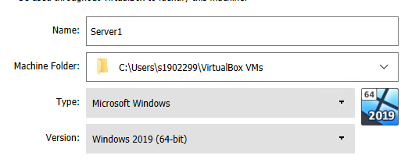

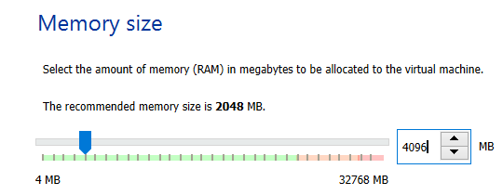
The virtual machine was then given RAM. The virtual machine was given 4096MB of RAM which is equivalent to 4GB of RAM.

The virtual machine presented the option for a hard disk. It was chosen that a virtual hard disk would be created now.
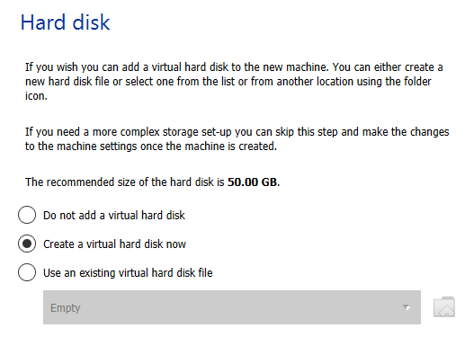

The hard disk file type that was chosen was VDI which means VirtualBox Disk Image.
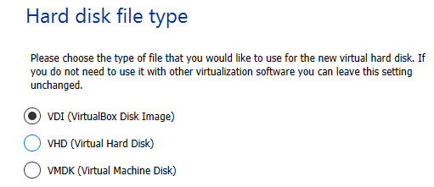

The storage on the physical hard disk was chosen to be dynamically allocated.
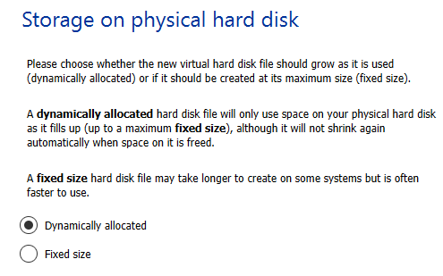

The location of the virtual hard disk was selected, and the size of the hard disk was chosen to be 25GB.
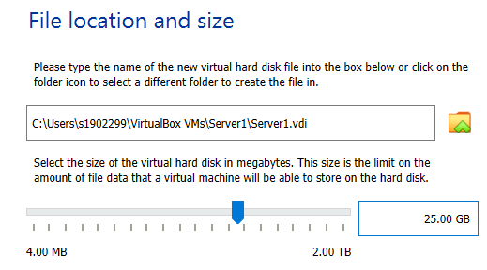

The server 1 virtual machine was then created. This process was repeated to create a second server.


Client 1 Creation:
A new virtual machine was created. It was given a name, a destination for where the virtual machine would be saved, a type which determines what operating system it would run, and then a version that the virtual machine would run.
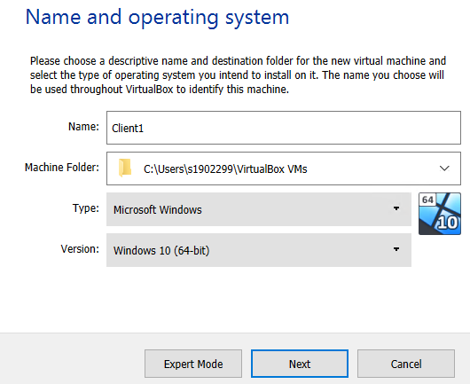

The virtual machine was then given RAM. The virtual machine was given 4096MB of RAM which is equivalent to 4GB of RAM.
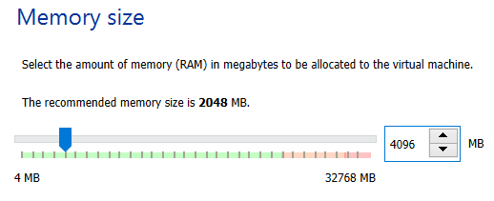

The virtual machine presented the option for a hard disk. It was chosen that a virtual hard disk would be created now.
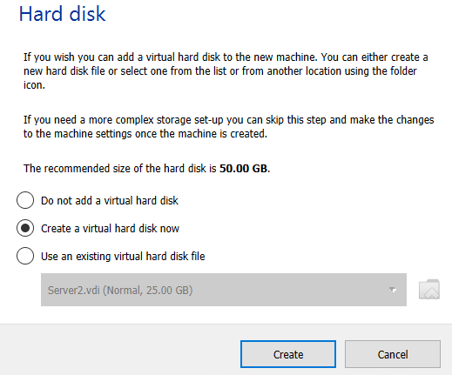

The hard disk file type that was chosen was VDI which means VirtualBox Disk Image.
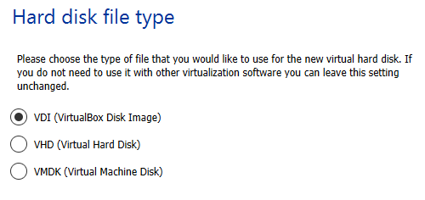

The storage on the physical hard disk was chosen to be dynamically allocated.
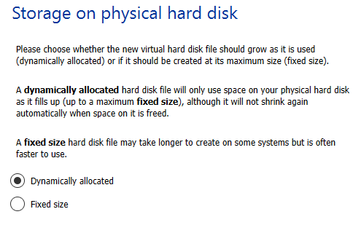

The location of the virtual hard disk was selected, and the size of the hard disk was chosen to be 20GB.
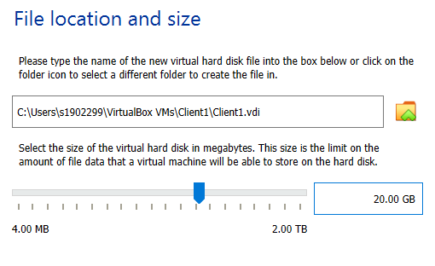

The client 1 virtual machine was then created. This process was repeated to create a second client.

Server 1 Operating System:
After the servers had been created, they were given an operating system. The operating system that was chosen for the servers was Windows Server 2019.
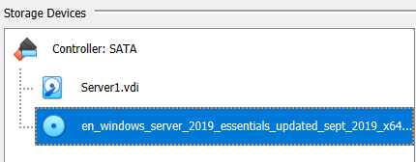

Client 1 Operating System:
After the clients had been created, they were given an operating system. The operating system that was chosen for the clients was Windows 10.
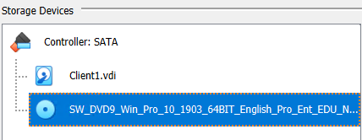

Server 1 Optimization:
The servers were then optimized to help improve performance. First, PAE/NX was enabled on the servers. The video memory was then set to 128MB. Finally, the number of processors was increased from 1 to 2.
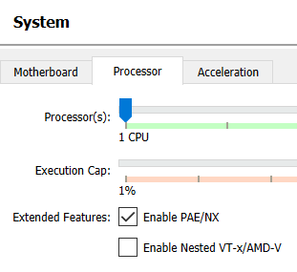

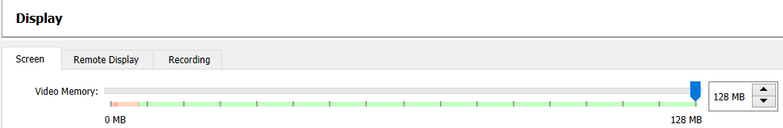

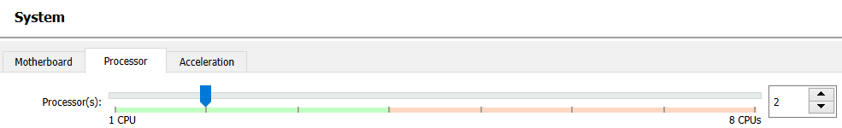

Client 1 Optimization:
The clients were then optimized to help improve performance. First, PAE/NX was enabled on the clients. The video memory was then set to 128MB. Finally, the number of processors was increased from 1 to 2.

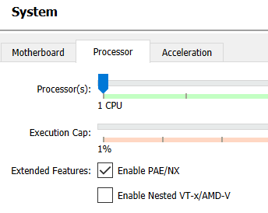

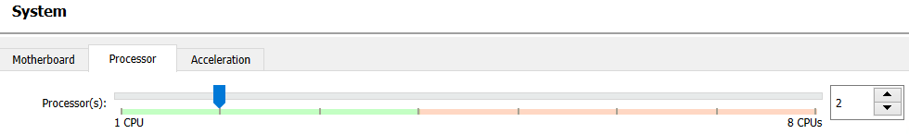
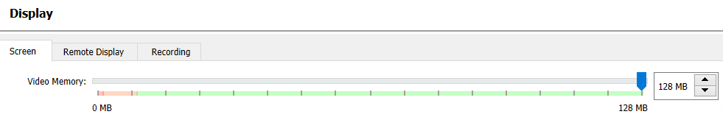
Server 1 Installing Server:
After the servers had been optimized, the operating systems were installed. The time and currency format, and the keyboard were both set to United Kingdom.
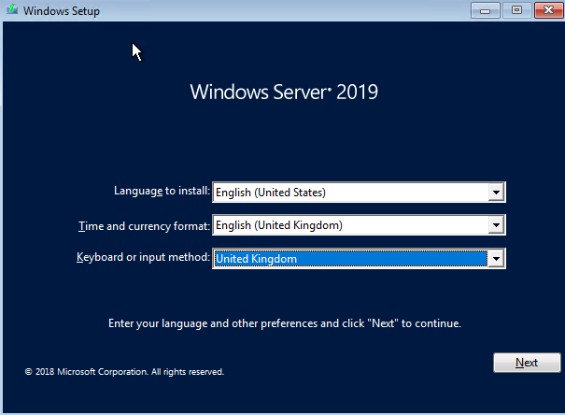

It then asked for a product key, ‘I don’t have a product key’ was the chosen option. The Next button was then clicked.
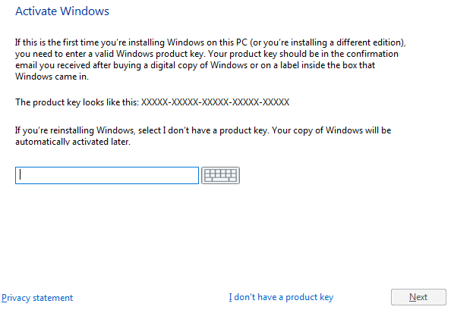

The license terms were accepted and then the Next button was clicked.
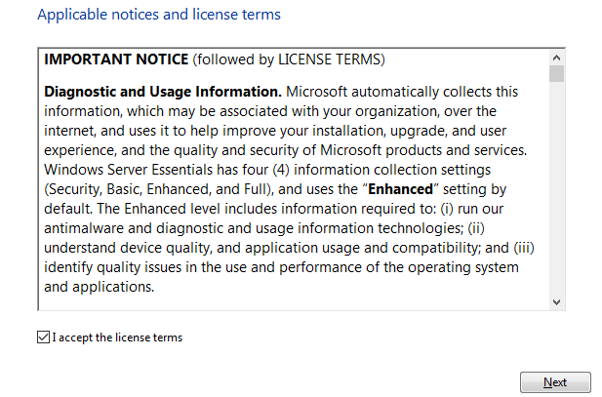

It then asked what type of installation was wanted. Custom was the option that was chosen.
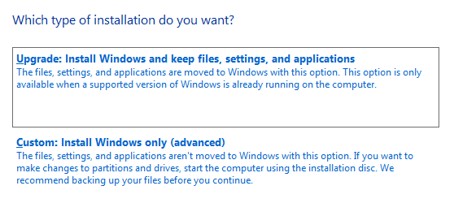

The hard drive which Windows would be installed on was chosen. The primary drive was chosen.
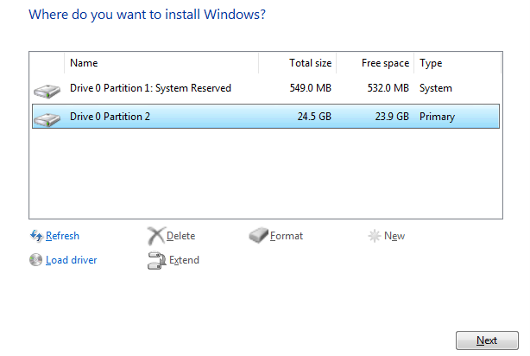

Windows was now beginning to install.
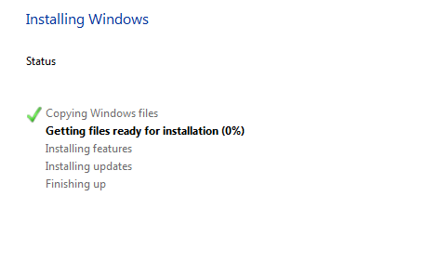

After installing, Windows asked for a password for the built-in administrator. The password that was chosen was ‘P@ssw0rd’.
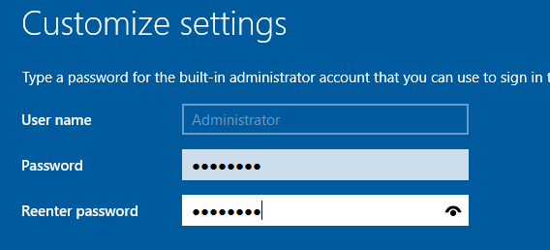

The login screen was then displayed. The password was then entered, and the administrator was logged in.
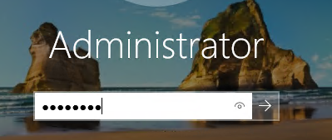

The server then opened. This process was repeated for server 2.

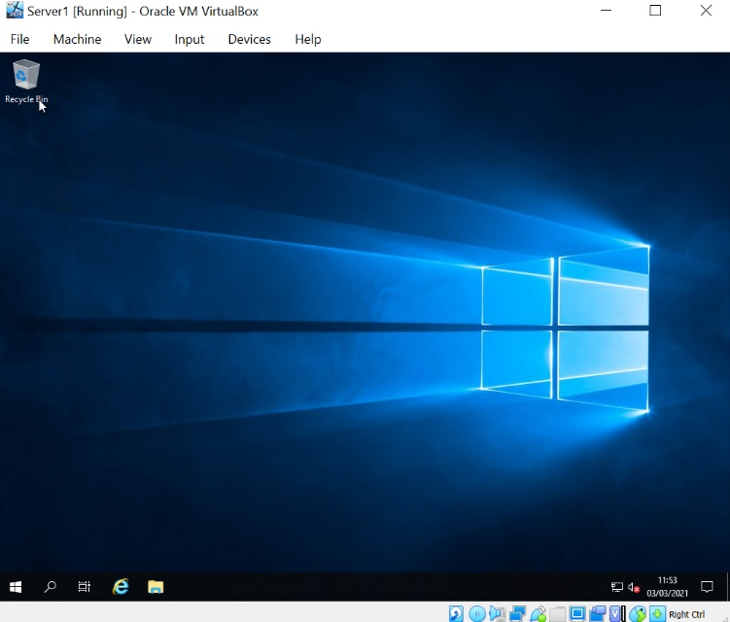

Client 1 Installing Windows:
After the clients had been optimized, the operating systems were installed. The time and currency format, and the keyboard were both set to United Kingdom.
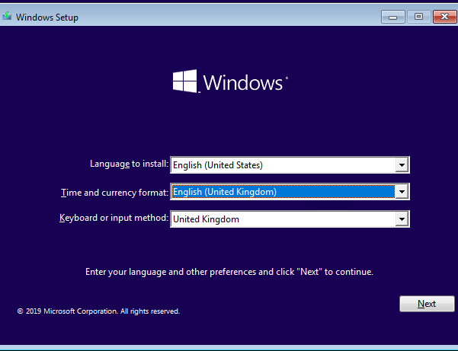

The Install now button was then clicked.
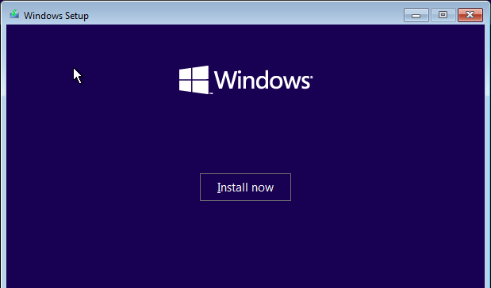

It then asked which operating system was going to be installed. Windows 10 Education was selected.
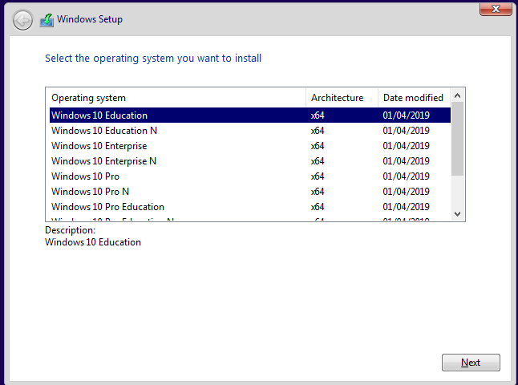

The license terms were then accepted, and the Next button was clicked.
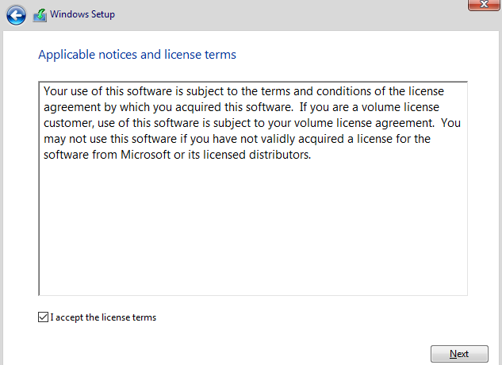

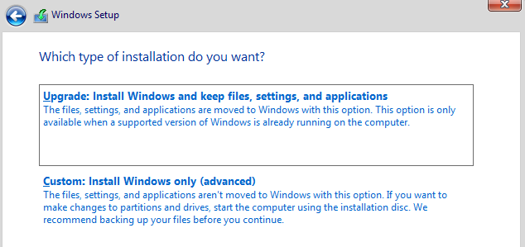
It then asked what type of installation was wanted. Custom was the option that was chosen.

The hard drive which Windows would be installed on was chosen.
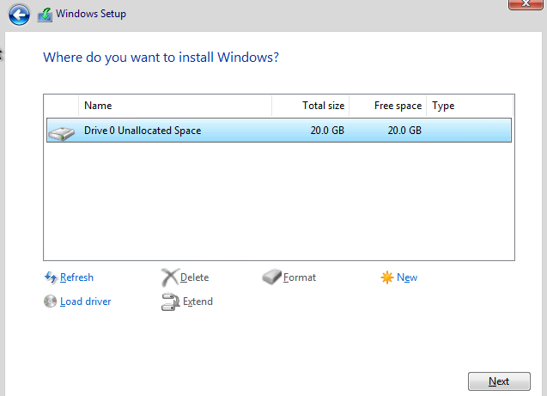

Windows was now beginning to install.
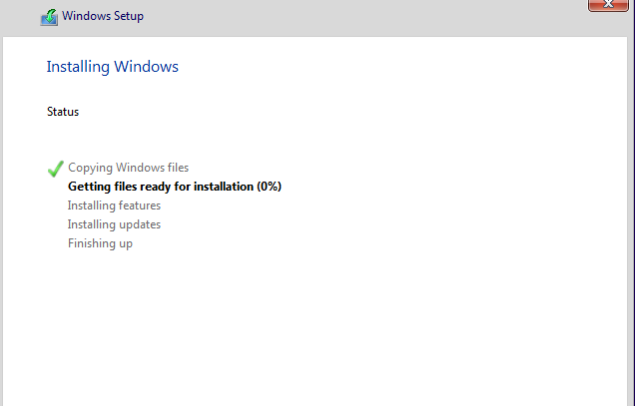

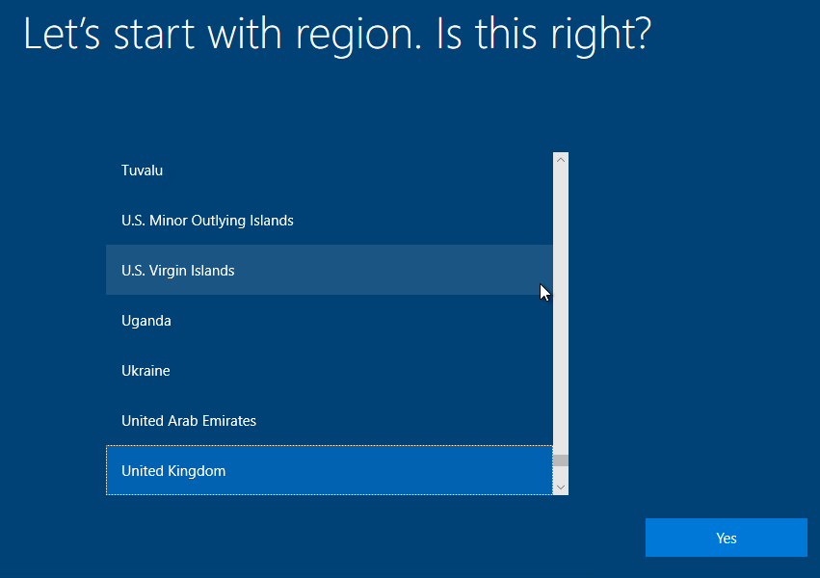
It then asked for the region. United Kingdom was selected.

It then asked for the keyboard layout. United Kingdom was selected.
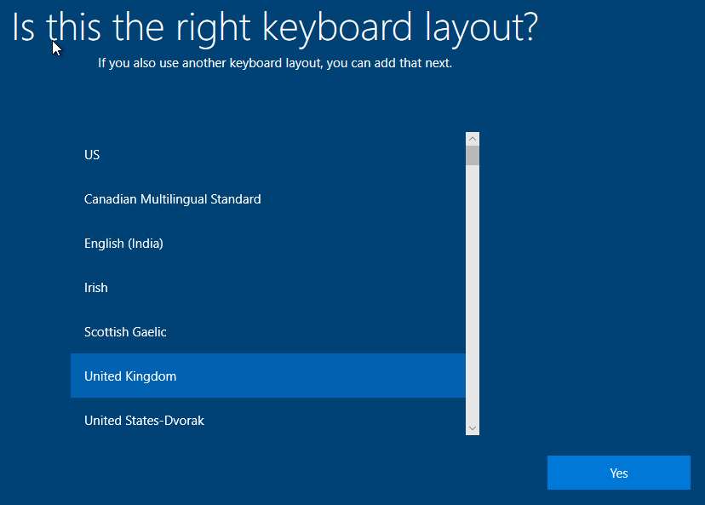

It then asked for who was going to use the PC. The name of the user was entered.
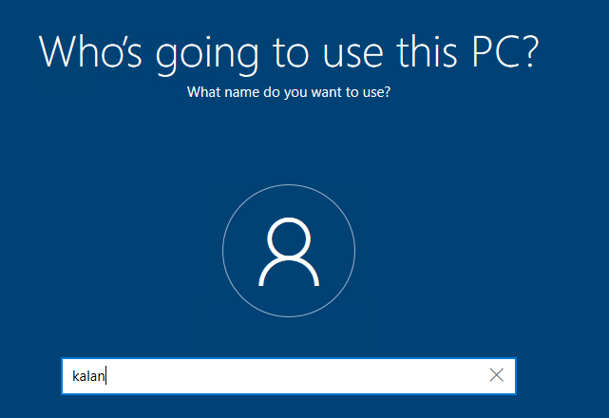

The password for the user was then entered. The password was ‘P@ssw0rd’.
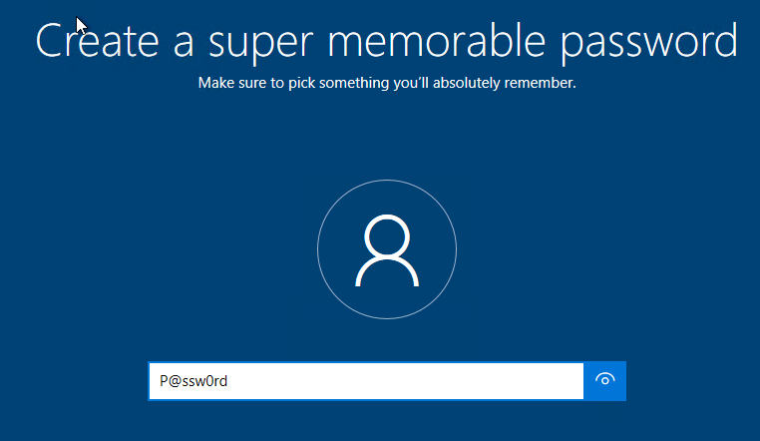

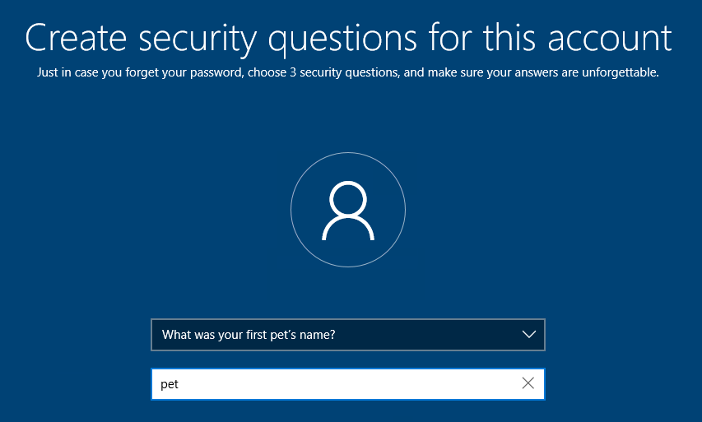
It then asked for a security question. The security question that was picked was the name of a first pet. ‘pet’ was the answer that was entered.

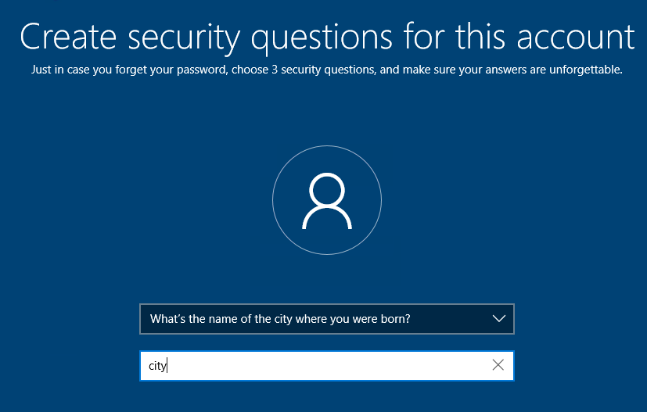
A second security question was asked which asked for the city where the user was born. ‘city’ was the answer that was entered.

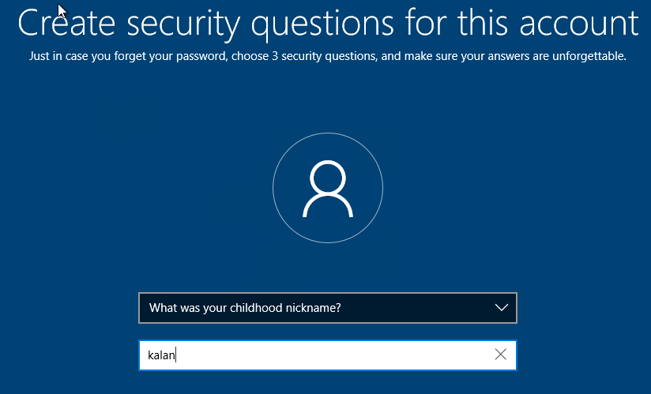
A third security question was asked which asked for the users childhood nickname. ‘kalan’ was the answer that was entered.
The client then opened. This process was repeated for client 2.

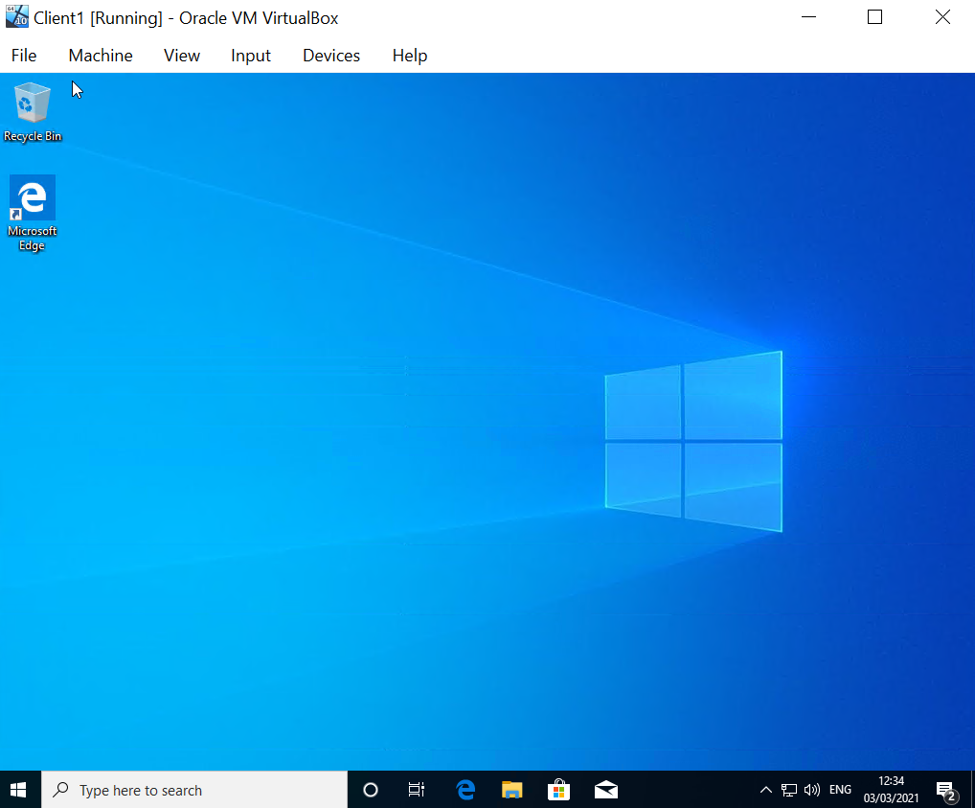

Task 2:

Server 1 IP:

In the server 1 network settings, the first network adapter was enabled. It was attached to an internal network called ‘PublicNet’.
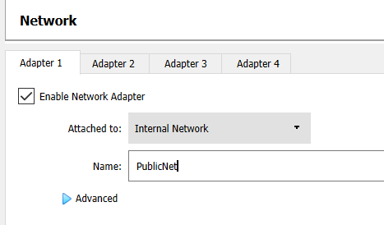

Server 1 was then started. In the Network Connection settings, the network connection was renamed from Ethernet to ‘PublicNet’.

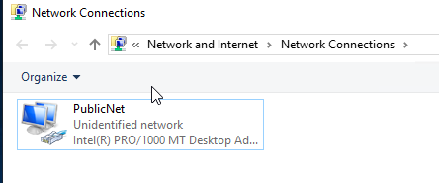

The IP address was then assigned. The IP address that was entered was 192.168.1.100. The subnet mask automatically populated with the value of 255.255.255.0.
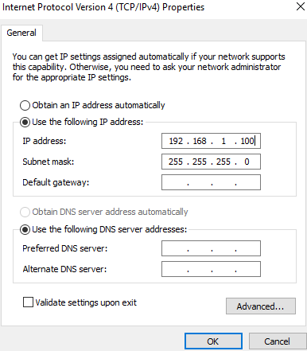

In the server 1 network settings, the second network adapter was enabled. It was attached to an internal network called ‘PrivateNet1’.
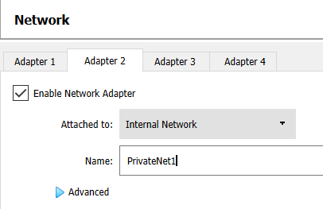

Server 1 was then started. In the Network Connection settings, the network connection was renamed from Ethernet to ‘PrivateNet1’.
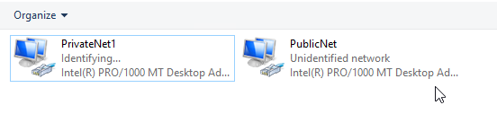

The IP address was then assigned. The IP address that was entered was 192.168.100.1. The subnet mask automatically populated with the value of 255.255.255.0. This process was then repeated for server 2.
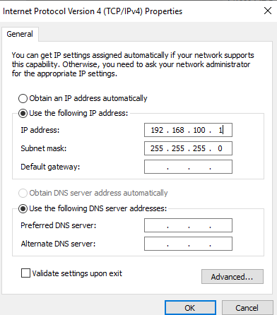

Client 1 IP:
In the client 1 network settings, the first network adapter was enabled. It was attached to an internal network called ‘PrivateNet1’.

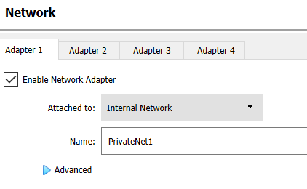

Client 1 was then started. The network connection was renamed from Ethernet to ‘PrivateNet1’.
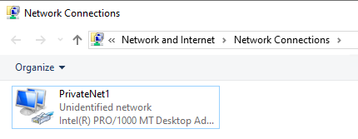

The IP address was then assigned. The IP address that was entered was 192.168.100.2. The subnet mask automatically populated with the value of 255.255.255.0. This process was then repeated for client 2.
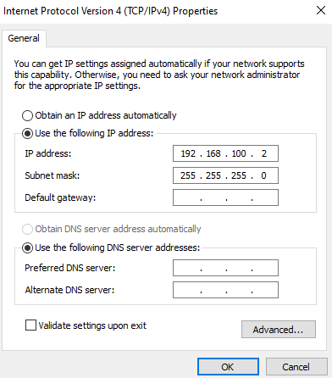

Server 1 Firewall:
The firewall settings for server 1 were changed. Windows Defender Firewall was turned off on the private network settings and the public network settings.
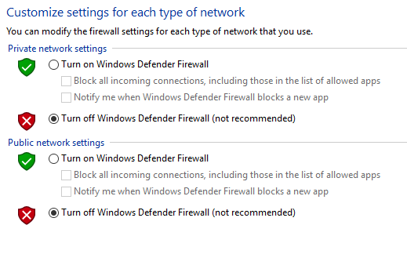

Client 1 Firewall:
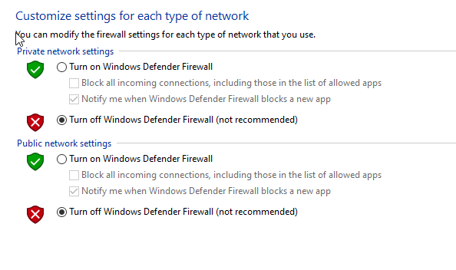
The firewall settings for client 1 were changed. Windows Defender Firewall was turned off on the private network settings and the public network settings.

Server 1 To Client 1 Ping:
On server 1, the command prompt was opened.
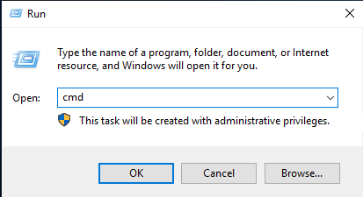

In the command prompt “ping 192.168.100.2” was entered. This command would verify if server 1 was properly connected to client 1. 4 packets were sent, and 4 packets were received which means that they were properly connected.
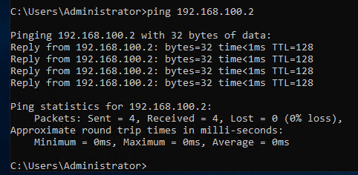

Server 2 To Client 2 Ping:
On server 2, the command prompt was opened.
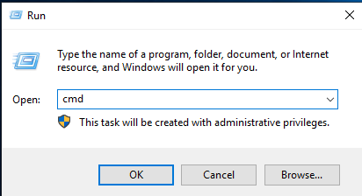

In the command prompt “ping 192.168.101.2” was entered. This command would verify if server 2 was properly connected to client 2. 4 packets were sent, and 4 packets were received which means that they were properly connected.

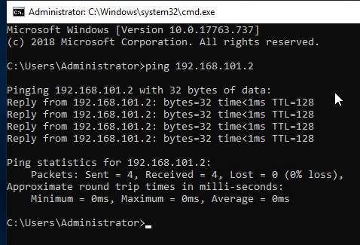

Observational Work:

Task 3:

a) Describe the main differences between Type 1 and Type 2 Hypervisors. Identify benefits and drawbacks of both and provide some example Vendors.
There are many differences between type 1 and type 2 hypervisors. A type 1 hypervisor is software which is installed on top of a physical server and its hardware. A type 1 hypervisor is typically referred to as a bare-metal hypervisor. This is because no operating systems or software is installed between the physical software and its hardware. Type 1 hypervisors do not run inside of operating systems. This is because they are operating systems themselves, which allows for better performance and stability as they do not have to rely on another operating system. One benefit of type 1 hypervisors is that they only use the necessary amount of resources to be functional. This means that you can allocate as much resources as you want without having to worry about the physical amount of resources that you have. One drawback of type 1 hypervisors is that they do not offer a lot of functions because they are very simple. Another drawback of type 1 hypervisors is that they can only be used for virtualization purposes due to the physical machines that they run on. Some type 1 hypervisor vendors are VMware vSphere, Oracle VM, Microsoft Hyper-V, and Citrix Hypervisor [1].
A type 2 hypervisor is typically referred to as a hosted hypervisor. This is because it runs on a physical host machine inside an operating system unlike type 1 hypervisors which are directly on the hardware. One benefit of type 2 hypervisors is that they are typically used for smaller projects which can be very useful for individuals. They also allow for a lot of functions which can be very useful. One drawback of type 2 hypervisors is that you need to be careful when assigning resources to the virtual machines. This is because the virtual machines use the total amount of resources that are assigned to it. This means that if the host machine does not have a lot of RAM, it may be difficult to run multiple virtual machines as they require a lot of RAM. This may result in the host machine crashing which can be a big problem. Some type 2 hypervisor vendors are Windows Virtual PC, Oracle VM VirtualBox, and Parallels Desktop [1].

b) What is the significance of the subnet mask in IPv4 addressing?
The subnet mask in an IPv4 address is very important. This is because it allows for smaller networks to be created within a large network. This can help to make the network more secure because the subnet mask can help to increase the efficiency of the routing in the network [2]. The subnet mask identifies the network id and the host id in an IP address. Subnet masks are able to identify all of the machines on a network. Subnets masks are important when a host communicates with another system. This is because the subnet mask will try to find the address on the local link if the system is on the same network as the host. If the system is not on the same network, the packet will be sent to a gateway. Once the packet is on the gateway it will be directed to the destinations IP address [3]. One reason why the subnet mask is important is because when data travels over networks, it is more secure. This can help to prevent sensitive information like personal and financial data from being stolen. If the data is stolen, it can have serious consequences. This is why subnet masks are important. This is the significance and importance of the subnet mask in an IPv4 address.

c) Cloud computing has revolutionised the way that enterprise networks are hosted. Describe the use of cloud computing including its benefits and drawbacks and identify example vendors within the industry.
Cloud computing is used in enterprise networks as it allows businesses to gain access to different types of services through contracts [4]. One benefit of cloud computing in enterprise networks is that businesses can gain access to software programmes by having the programmes delivered over the internet [4]. This is a benefit for many reasons. One reason is that you would not have to wait for the software to be delivered because it is delivered over the internet. This means that the business would have access to the software the moment they purchase it. Another reason why this is a benefit is because it will be easier to install the software on the businesses devices. This is because the software will already be on the devices which means that the IT department would not have to manually install it on every device. This will help to save a lot of time and effort which could be better spend doing more productive work. An additional benefit is that it can help to reduce costs. This is because the businesses do not have to pay people to install the software on their devices. This could save them a lot of money which they could spend on other parts of the business [4]. One drawback of cloud computing is downtime [5]. This is because if the business is using internet-based services, the services may go down for maintenance. This would have a negative impact on the business because all of the employees would be unable to use the software until the maintenance has finished. This means that employees would be unable to work which could result in the business losing a lot of money. Some cloud computing vendors are Amazon, Microsoft, HP, and IBM. These are some of the advantages, disadvantages, and vendors of cloud computing.

d) Give an in-detail description about the different terminologies and its purposes (like (not limited to) Ping, Server Management, Firewall, PAE/NX, OOBE etc) you came across during the Task 1 and Task 2. Compare your list of terminologies in the aspect of their operations/functionality with other Network Operating Systems. (For example: If you select Windows Firewall and describe the operations/functionality of Windows Server 2019 Firewall, you have to compare these features with the operations/functionality of other Network Operating Systems like Linux, Mac)
There are many different terminologies which have many different purposes. The first terminology that will be talked about is ping. Ping is used to test whether or not your computer is connected to other devices on the network [6]. You can use ping to send packets of data to another device on the network. The device will then send the packets back to your computer. If your computer sends and receives the packets, it means that there is a connection between the devices. If the packets are lost, it means that there is not a connection between the devices. You can use ping to test how fast of a connection you have by looking at how long it takes for the packets to be sent and received. Ping can be used on many different operating systems. Ping has the same functions on Windows, Linux, and MacOS [6].
The second terminology is server management. Server management is used to allow administrators to manage and access all of the servers. The administrators are able to do many things with the server management. For example, they can use server management to setup, install, and update new software on certain servers on the network [7]. One benefit of server management is being able to manage multiple servers in one place. This can help save a lot of time as the administrators do not have to go to each individual server to make changes to it. Server management can be used on many different operating systems. Windows server management and Linux server management both do the same things. However, Linux server management allows for servers to be more easily managed than Windows server management [8].
Another terminology is firewall. Firewall is used to monitor networks. It does this by managing all of the traffic that goes in and out of the network. It does this to try and find and block any threats. Firewall is also used to prevent unauthorised access to a network [9]. One benefit of firewalls is that they can help to keep networks secure. This is because they prevent any threats from accessing the network. This helps to stop data from being corrupted or ending up in the wrong hands. Firewalls can be used on many different operating systems. Firewalls work the same on Windows, Linux, and MacOS.
An additional terminology is PAE/NX. The Physical Address Extension (PAE) allows for the CPU to access more than 4GB of RAM. The No-Execute bit (NX), allows the CPU to separate certain areas of the memory [10]. PAE/NX can be accessed on many different operating systems. It Works the same on Windows, Linux, and MacOS.
The final terminology is OOBE. Out-of-box experience (OOBE) is the set of screens that the user sees when first setting up their computers in Windows [11]. This is used to make the user accept the licensing agreements. It is also used to allow the user to setup Windows to fit their needs. For example, it allows the user to choose their language, keyboard layout, and more. OOBE can be used in many different operating systems. It works the same on all of the operating systems.

References

[1] | S. Simic, “What Is A Hypervisor? Types Of Hypervisors 1 & 2,” 24 January 2019. [Online]. Available: https://phoenixnap.com/kb/what-is-hypervisor-type-1-2. [Accessed 6 March 2021].
[2] | “Subnetting: What is Subnet Mask?,” [Online]. Available: https://www.guru99.com/subnetting-subnet-mask.html#1. [Accessed 6 March 2021].
[3] | “Subnet masks (IPv4) and prefixes (IPv6),” [Online]. Available: https://www.ibm.com/support/knowledgecenter/en/STCMML8/com.ibm.storage.ts3500.doc/opg_3584_IPv4_IPv6_prefix_subnet_mask.html. [Accessed 6 March 2021].
[4] | “Enterprise Cloud Computing,” [Online]. Available: https://www.techopedia.com/definition/29865/enterprise-cloud-computing#:~:text=Enterprise%20cloud%20computing%20is%20the%20provision%20of%20cloud,vendors%20to%20outsource%20different%20types%20of%20IT%20services.. [Accessed 6 March 2021].
[5] | A. Larkin, “Disadvantages of Cloud Computing,” 7 August 2019. [Online]. Available: https://cloudacademy.com/blog/disadvantages-of-cloud-computing/#:~:text=Disadvantages%20of%20cloud%20computing%20explained.%201%201).%20Downtime.,and%20flexibility.%205%205).%20Vendor%20lock-in.%20More%20items. [Accessed 6 March 2021].
[6] | B. Gavin, “How to Use the Ping Command to Test Your Network,” 21 June 2018. [Online]. Available: https://www.howtogeek.com/355664/how-to-use-ping-to-test-your-network/#:~:text=On%20a%20computer%20network,%20a%20ping%20tool%20is,that%20device,%20and%20then%20waits%20for%20a%20response.. [Accessed 7 March 2021].
[7] | S. M. Kerner, “What is Server Management?,” 4 November 2020. [Online]. Available: https://www.serverwatch.com/servers/server-management/#:~:text=At%20its%20core,%20server%20management%20is%20about%20having,is%20operating%20to%20help%20improve%20and%20optimize%20performance.. [Accessed 7 March 2021].
[8] | “Linux vs Windows Server,” [Online]. Available: https://www.educba.com/linux-vs-windows-server/. [Accessed 7 March 2021].
[9] | B. Lutkevich, “firewall,” [Online]. Available: https://searchsecurity.techtarget.com/definition/firewall. [Accessed 7 March 2021].
[10] | “How do I enable PAE in BIOS?,” 26 February 2020. [Online]. Available: https://findanyanswer.com/how-do-i-enable-pae-in-bios#:~:text=What%20is%20PAE%20NX%20and%20sse2?%20For%20your,Windows%20and%20is%20a%20prerequisite%20for%20NX%20.. [Accessed 7 March 2021].
[11] | “What is OOBE or Out-Of-Box Experience in Windows 10?,” 27 October 2019. [Online]. Available: https://www.thewindowsclub.com/oobe-out-of-box-experience-in-windows. [Accessed 7 March 2021].

