GLOBAL TOURISM DESTINATION MGT: Lecture 1

GLOBAL TOURISM TRENDS:

- GLOBAL TOURISM IS AN INDUSTRY THAT HAS GROWN IN EXPONENTIAL GROWTH IN CONTEMPORARY SOCIETY.

- NB: ITS ROOTS DATE BACK TO HISTORICAL TIMES – GRAND TOUR 17 TH CENTURY.................

- TOURISM CAN BE SEEN ESTABLISHED IN MANY DIFFERENT COUNTRIES BOTH RICH AND POOR.

- NB: COUNTRIES VARY AS TO HOW THEY ESTABLISH THEMSELVES FROM A TOURISM PERSPECTIVE ....................(LARGELY RELATED TO AVAILABLE WEALTH / FUNDS).

- BASED ON A COUNTRY’S WEALTH - THIS OFTEN DETERMINES WHETHER A COUNTRY IS CLASSED AS AN ‘EMERGING TOURISM MARKET’ OR AN ‘ESTABLISHED TOURISM MARKET’
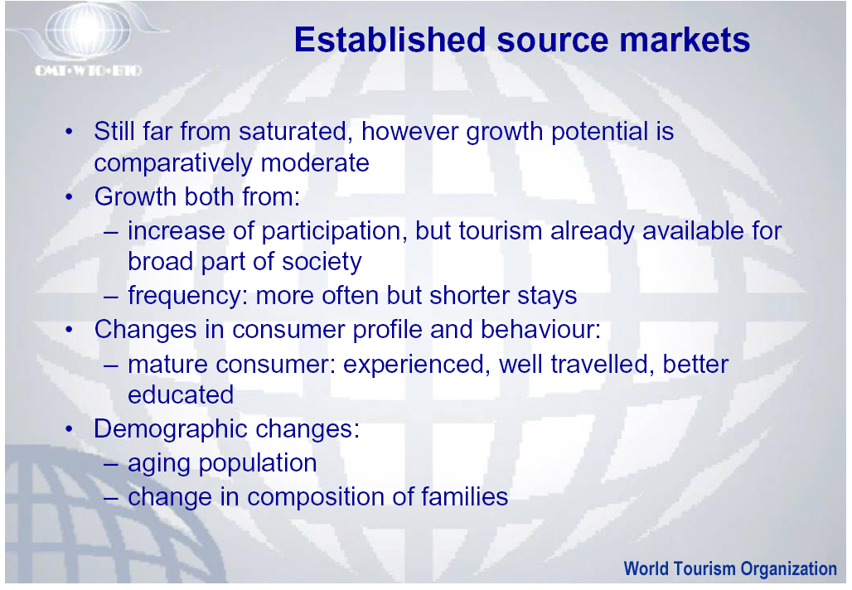

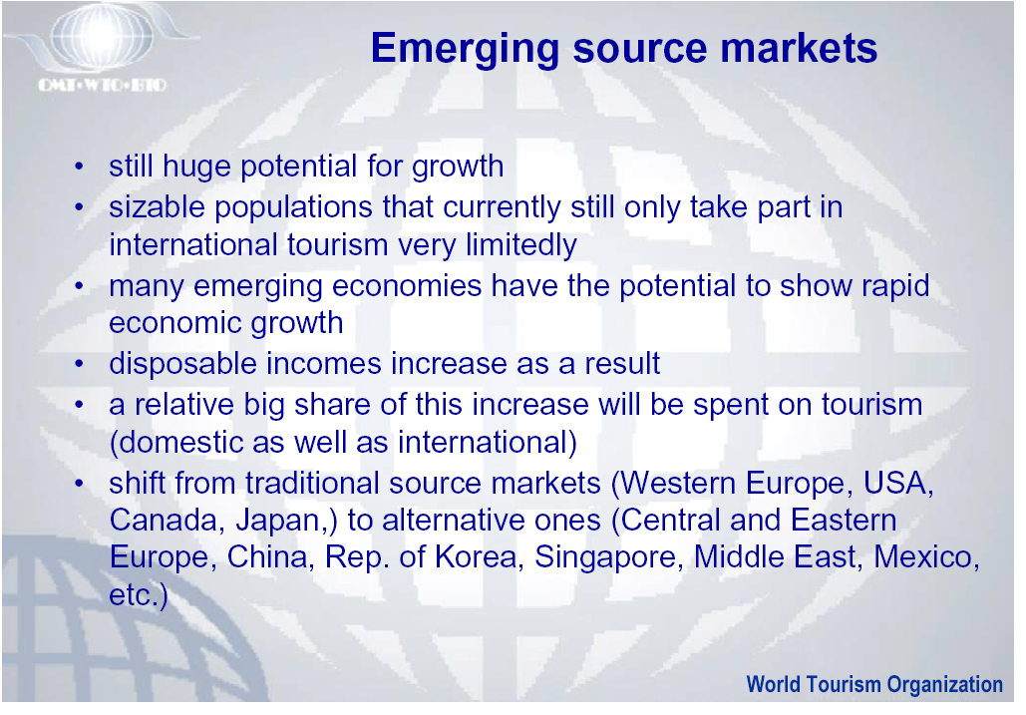

- DUE TO PAST RAPID GROWTH OF TOURISM THIS IS PREDICTED TO CONTINUE FOR THE FUTURE - - --- PARTICULARLY WITH EMERGING MARKETS DEVELOPMENT .

- NB: THE TOURISM INDUSTRY IS SUBJECT TO MANY ISSUES AND CHALLENGES WHICH CAN STRONGLY INFLUENCE DEVELOPMENT – EG; WEATHER PATTERNS / SEASONALITY / SECURITY / RECESSION / POLITICAL CONDITIONS / HEALTH ........................

- SOME OF THE MORE NOTEWORTHY AND SERIOUS ISSUES HAVE BEEN EXPERIENCED GLOBALLY SINCE 2001.

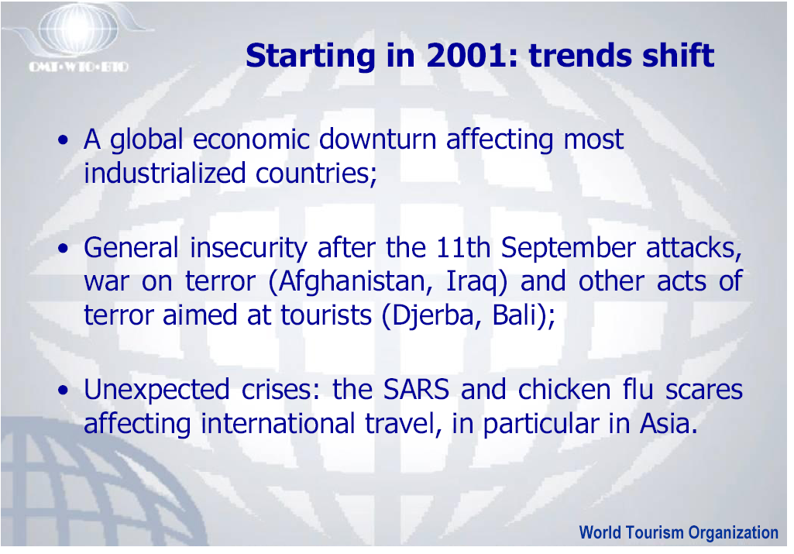

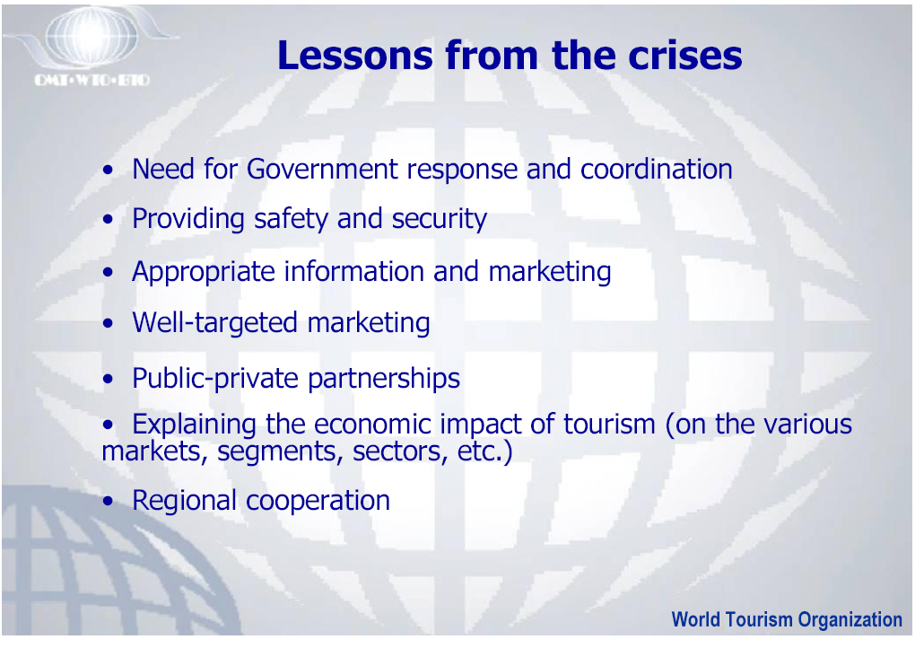

Recent factors influencing THE tourism industry:

- Terrorism (Isis….)
- Russian Conflicts (Russia)
- Zika Virus / Ebola….. (Africa) / SARS (Asia)
- Climate Change / Weather Conditions
- Malaysian Air Controversies
- Israel Conflicts
- North Korea concerns and potential conflicts
- Politics – USA?
- Brexit
- COVID 19
- ………………

______________________________________

