Module Title: Contemporary Themes in the Hotel and Hospitality
Module Code:BMIH6001
Student name: Aurel-Constantin Lature
Student number:2208733
Lecturer name: Antoinette Milne

I confirm that I have not used any AI tools in the research and creation of this assignment. I confirm that I have not presented any AI generated materials as my own work. I confirm I have copies of my drafts, notes, and other resources I used, which I may be asked to provide in evidence.

Abstract
Sustainability is focused on the hospitality sector, and there is also the implementation of a net-zero strategy. There are positive impacts, such as the incorporation of sustainable sources and eco-friendly products in the business. Conservation of waste and water is effective due to sustainability protocols, and which have developed the business. The secondary data collection method was followed to collect data about sustainability protocols in the hospitality sector. There is also a focus on using PEST analysis, as that helps in giving the strengths and limitations of the companies in the external environment. Strategies such as automated services and eco-friendly protocols need to be followed in the hospitality industry.

Table of Contents
1. Introduction 4
2. Literature Review 5
3. Method 8
4. Theme impact analysis 8
5. Conclusion 11
6. Recommendations 12
References 14

Option Two: Sustainability and net-zero in the hotel industry

1. Introduction
Outline and importance.
Sustainability and eco-friendly practices are implemented in the hotel and hospitality sector. In the industry, they are focused on designs and technologies related to energy-efficient buildings and waste reduction strategies. Renewable sources are incorporated in industry, such as solar panels and geothermal systems, which become beneficial for power operations. Sustainability became important in the hotel sector as it helped with cost savings, water and energy conservation and carbon footprint and waste reduction. Between 2019-2025, there were many travellers who chose eco-friendly practices for the reduction of environmental impact, and in 2025, almost 35% of travellers also focused on eco-friendly hotels (Statista, 2025).
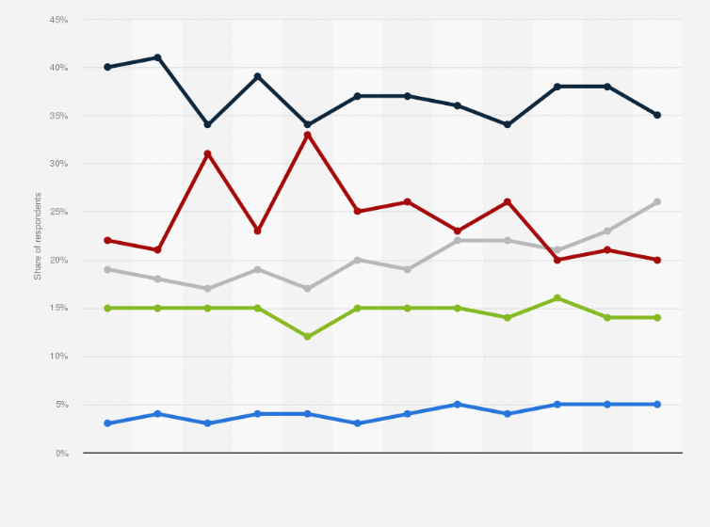
Figure 1: British travellers' choice of green hotels
(Source: Statista, 2025)
Background
The UK hospitality sector focuses on contributing almost £40 billion to the economy of the UK. The sector employed 1.8 million Britons, and 93% of the companies focused on sustainability strategy. 66% of SMEs in the hospitality sector focused on the food waste measure sustainable waste management process is followed (Roberts, 2204). Sustainability in this industry becomes helpful for reducing waste and carbon footprint, and for business development. The study is going to focus on the analysis of the theme and detergent, and the limitation analysis of this practice within the industry.

2. Literature Review
Impact of sustainability and net-zero strategy in the hospitality industry
Sustainability and net-zero strategy are followed in the current time in the hospitality industry as they become beneficial in reducing the negative environmental impact. As per the comment of Han (2021), consumer behaviour has become an important aspect in tourism and sustainability. Most countries' governments are planning to achieve net-zero emissions by 2030 and focus on the reduction of carbon emissions. The sustainable hospitality industry has become effective for the carbon footprint reduction, and natural and cultural heritages are protected through it. As argued by Legrand et al. (2022), there are environmental and social issues in the hospitality industry in the modern day. Waste conservation and water, and food waste management are also ensured through sustainability. The brand image of the hotels is developed, and that becomes beneficial to ensure the success of the business.
Challenges of sustainability implementation in the hotel industry
In the adoption of sustainable protocols in the hospitality industry, there are a variety of challenges. Energy consumption and efficiency are becoming serious issues that are confronted by the hospitality industry at present. As opined by Khatter (2023), global warming and biodiversity reduction remain two key challenges. Water management and conservation also become crucial issues for the hospitality industry as water sources are impacted through this sector, such as surface water becoming polluted and natural ecosystems becoming disrupted. A large amount of waste is created by this industry from different sources, such as packaging and plastics. These impact negatively on the environment as they enhance emissions of greenhouse gas and soil contamination. As opposed to Ghani et al. (2022), sustainable HR becomes a key strategy for the better condition of the hospitality industry. Climate change has also become a serious threat, as there are rising levels of sea and extreme weather that affect sustainable initiatives.
Strategies for easily implementing sustainability and net-zero protocols.
The hospitality sector has focused on sustainability and net-zero protocols, which has become helpful for the development of the business. According to Ben Youssef and Zeqiri (2022), Industry 4.0 could be effective for combating climate change issues so in the hospitality industry should use this enhanced technology. Waste management has been a focus for companies in the hospitality sector to implement sustainable protocols. Many hotels focused on the elimination of single-use plastics as a sustainable protocol. Biodigesters are used to help process food waste. Many hotels focused on the towel reuse program and hotel automation embarrassment, as these ensure sustainability. Plastic usage cuts and water preservation strategy focus have become useful strategies. On the other hand, Ozturkcan and Kitapci (2025), stated that QR code menus also become a sustainable strategy for the hospitality sector. Food waste reduction and rethinking transportation will become beneficial to implement sustainability in the hotel sector.
Theoretical framework
Triple Bottom Line theory (TBL)
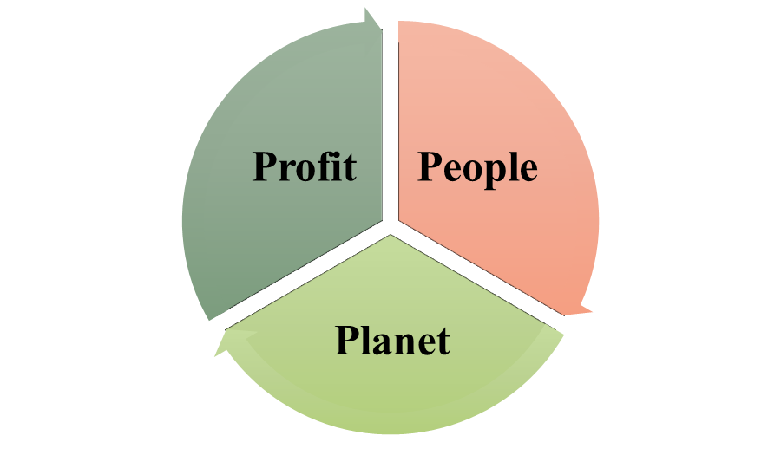
Figure 2: TBL components
(Source: Self-created)
TBL becomes an important theory to enhance sustainability and CSR in the business. Hotel companies, by following this theory, could be able to do better things for the planet, its people and earn better profit. As mentioned by Grădinaru et al. (2022), TBL has become a sustainability standard in every domain and business models and ways of thinking are changing. This theory becomes helpful for the hotels to reduce waste generation and carbon footprint easily reduced through it. People are managed easily as they are given equal opportunities in the business, and discrimination is reduced. This theory becomes effective in generating better profit for the hotels as consumers are attracted towards sustainable practices in hotels. As argued by Liute and De Giacomo (2022), TBL also analysed the environmental performance. On the other hand, this theory is criticised for not explaining the people and planet aspects in detail. Hotels and other companies mainly focused on their profit approach instead of investing in the planet and people.
Three-pillar model of sustainability
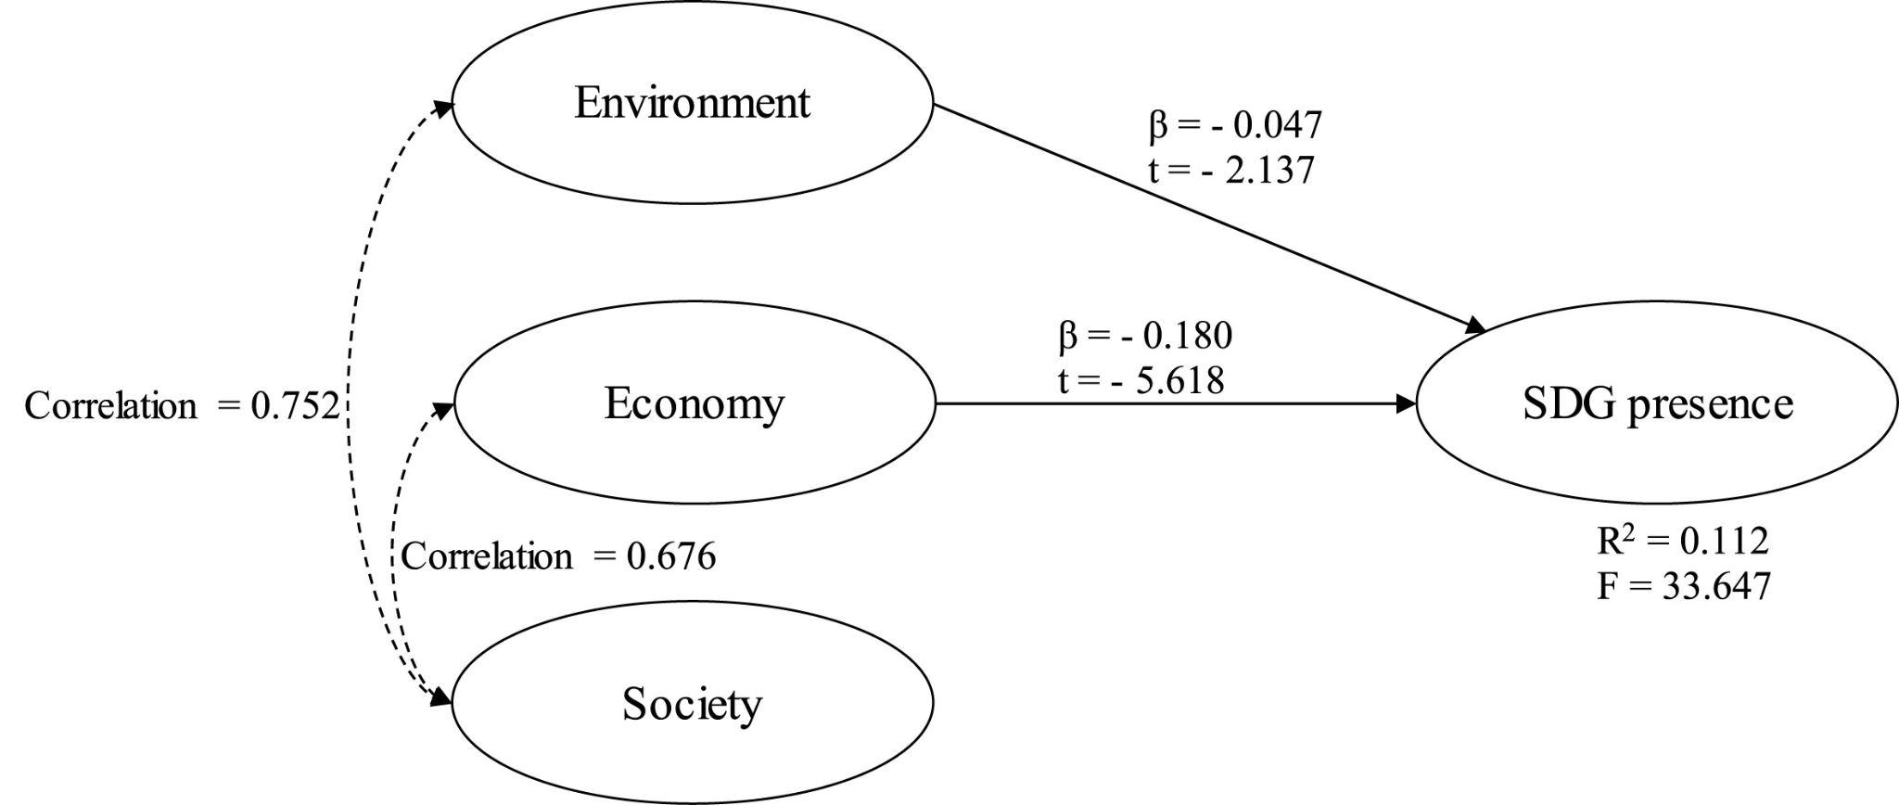
Figure 3: Three sustainability pillars
(Source: Surman and Böcskei, 2023)
As per this model, three sustainability pillars are environmental, social and economic. This model application in the hospitality business becomes effective in ensuring GHG emission reduction and the prevention of air and soil pollution. According to Díaz et al. (2021), this model is able to enhance economic profitability awareness. Fair business practices could be easily emphasised by the hospitality sector through following this model, and that could be beneficial for the employees and the community. Responsible sources are also encouraged, and environmental social costs are considered by this model. As argued by Surman and Böcskei (2023), the three-pillar sustainability and the SDGs are presented in SMEs. Due to the theoretical development and universality, this theory faces criticism. It also faced criticism due to explicit economic sustainability exploration.
Literature gap
Sustainability evidence based on the hospitality sector is lacking in the study and which creates a gap in the study. The study also lacked information about the net-zero protocols from the literature, and that gap would be mitigated through further research.

3. Method
Data collection procedure
The study focused on the secondary data collection and use of journals, articles and books used for collecting data about the sustainability information in the hospitality industry. The hotel sector and hospitality industry data have been focused, and Google Scholar and industry reports have been used for collecting data. Data before 2018 was excluded, and the inclusion of authentic sources made this research process authentic. Secondary data was collected by previous researchers and is published in books and journals (Mazhar, 2021). Qualitative data follows as there is no survey analysis to collect data, and numerical information was avoided due to complexity.
Analytical techniques
Thematic analysis has focused on the data analysis process, as there is an evaluation of collected data in a thematic manner to understand sustainability importance and issues in the hotel industry. Thematic analysis has been a key method of qualitative data analysis, and it also helped in the conceptual model development in research (Naeem et al. 2023).
Tools used.
There has been a focus on using PEST as a key tool for the research. It becomes beneficial to give information about political, economic, social and technological factors and understanding about contemporary issues and strategies for solving the issues. Theories such as TBL and the Three Pillar model are also used for the issues analysis related to sustainability.

4. Theme impact analysis
Factors | Description | Impact
Political | - UK employment law limiting UK hospitality and catering (Ioannou and Dukes, 20221)  - Government regulation changes affected the business of the hospitality sector | Negative
Economical | - Hospitality contributed almost £54 billion in tax receipts to the Treasury (UK Hospitality, 2023)  - Generation of £20 billion in exports and attracted £7 billion.  - 90% of UK hospitality businesses followed sustainable protocols (Roberts, 2024) | Positive
Social | - 3.5 million people are employed by this sector.  - Between 2009-2019, around 17% of UK employment growth was accounted for by hospitality (UK Hospitality, 2023)  - Waste minimisation, food waste reduction and waste recycling | Positive
Technological | - Robotic technologies adopted by the companies in hotels (Pizam et al. 2022)  - Green technology is adopted in the hotels | Positive
Table 1: PEST
Political
The political condition of the UK has not always been favourable for the hotel companies as has affected the business performance. There are strict regulations in the business that affect the overall business. Businesses faced strictness such as taxes and other regulations that affected the business performance of the companies in the hospitality sector. There are employment laws in the UK that are responsible for the catering and hospitality industry in the UK (Ioannou and Dukes, 2021). The government, on the other hand, pushed companies to maintain sustainable protocols, which became beneficial for the positive environmental impact. Communities and the environment are both supported by the hotel as they become helpful for the company to develop its overall business. For example, Marriott focused on community empowerment through CSR maintenance and business ethics are also valuable in the business (Marriott, 2025). As per the LR section, the hospitality sector focuses on sustainability, maintenance and net-zero emissions. The government is also responsible for supporting the net-zero strategy.
Economical
As per the collected data, it has been understood that this sector is responsible for making a significant impact on the business performance. The hospitality sector focuses on giving a positive contribution and which becomes effective for the companies to develop their business. The sector focused on the contribution of almost £54 billion in taxes and which positively impacted the UK economy. There is a generation of almost £20 billion in exports, and that also becomes helpful for the development of business. In the UK, 90% of companies in the hospitality sector are focused on sustainable protocols in the business (Roberts, 2024). The LR section describes that there are issues presented in the business of the hospitality sector, such as waste generation, which affect the business performance of the company. It has been understood that companies, through sustainable development protocols, have developed economic impact development. For example, IHG hotels focused on sustainable commitment and no fossil fuels, and the installation of solar panels is effective in the business (IHG, 2025).
Social
Sustainability protocols of the company are useful for the development of business, and many people get an advantage from it. There is a focus on the benefits of the people, as almost 3.5 million people in the UK are able to get a job in the hospitality sector. 17% of job opportunities in the UK sectors have been contributed by the hospitality sector and which becomes beneficial for the business (UK Hospitality, 2023). Minimisation of waste and waste reduction are part of sustainable protocols, and the LR section describes that strategies such as waste management and technology integration are helpful for business development. People aspect has been followed by the company in the hotel sector, and that has helped in the business. People get job opportunities and are able to achieve success in the business, which helps the company's success. Triple Bottom Line theory focuses on the company that plays an effective role in ensuring success in the business. For example, climate action and destination stewardship are helpful initiatives that become beneficial for the sustainable future of the business of Hilton (Hilton, 2025).
Technological
They are focused on technological development in hotels, and that becomes helpful for the hotels to achieve success in the business. Robotics are used as automation, and its adoption becomes helpful for the company to achieve success in the business (Pizam et al. 2022). There is also a focus on the adoption of green technology as that becomes beneficial for business development. The LR section focused on strategies such as technology integration that become helpful for the better business of the hospitality sector. In modern times, hospitality technologies are developed and ensure success in the business. Most companies followed automation and probiotics applications, which reduced human-generated waste in the business. The three sustainability pillars become effective in the success of business and environment, and society both are followed. The economy has also become developed, and the application of this model by companies is useful in profitability development (Díaz et al., 2021).

5. Conclusion
It has been concluded that sustainability and net-zero emissions are useful in the hospitality sector as they ensure the reduction of harmful environmental impact. The hospitality sector focused on ensuring a net-zero strategy, as that became useful for the success of the business. The political condition of the UK gives difficulty to the business of hotels, while the hospitality industry gives positive continuity to the overall economy. People also benefit as they have gotten job opportunities to get a better lifestyle. Issues such as excessive waste generation and the use of fossil fuels are responsible for creating threats in the business of the hospitality sector.

6. Recommendations
- Automated hotel operations: In the hotel industry, there needs to be a focus on the automation of the hotel business. Hospitality management is necessary to achieve an excellent experience for guests (Ford and Sturman, 2020). Automation could be responsible for giving a good experience to the guests. There could be a reduction in the use of harmful environmental protocols with automation. Robotics could be helpful for the reduction of waste that is generated by humans. Errors could also be reduced through the application of automated services, and that would be beneficial for the hospitality sector. Technological advancement is useful for the sustainable challenges and managing hospitality management (Batabyal and Das, 2019).
- Plastic avoidance and renewable energy: Avoidance of the use of plastics could be helpful for dealing with the issue of sustainability in the business of the hospitality industry. Bamboo or other suitable materials need to be used instead of plastic for the packaging in the industry. During the pandemic crisis, sustainability adoption became beneficial for the business of hotels (Costa and Costa, 2022). Renewable energy needs to be followed in the business, and that becomes useful for the reduction of negative environmental impact. The use of solar panels and wind energy is going to be used instead of fossil fuels, as that could be helpful for a better and sustainable hospitality business. Innovation and regenerative trends are used in the tourism sector, and which becomes helpful for the development of the hospitality industry business (Sharma et al. 2024).
- Eco-friendly protocols: Hotels in the sector need to focus on the eco-friendly protocols to ensure better sustainability. Efficient lighting needs to be followed, and there should be a focus on the use of single-use plastic. Contemporary tourism in the world became popular in the developed countries and helped in the economic development (Cooper, C. and Hall, 2019). Linens need to be reused, and waste generation needs to be limited. Cleaning supplies in the hotels have to be eco-friendly, and that could be effective for business development. Green teams need to cultivate and water preservation, and food waste reduction could also be followed as eco-friendly practices. Sustainable protocols are useful for the philosophical issues in tourism and hospitality (Tribe, 2009).

References
Batabyal, D. and Das, D.K. eds., (2019). Global Trends, Practices, and Challenges in Contemporary Tourism and Hospitality Management. IGI Global.
Ben Youssef, A. and Zeqiri, A., (2022). Hospitality industry 4.0 and climate change. Circular Economy and Sustainability, 2(3), pp.1043-1063. Link: https://link.springer.com/content/pdf/10.1007/s43615-021-00141-x.pdf
Cooper, C. and Hall, M. (2019) Contemporary Tourism: An International Approach, 4th Edn. Goodfellows, Oxford.
Costa, V. and Costa, C., (2022). Challenges in Times of Crisis and Pandemics in the Hospitality Industry: A Systematic Literature Review. Sustainability and Competitiveness in the Hospitality Industry, pp.1-22. Link: https://www.igi-global.com/chapter/challenges-in-times-of-crisis-and-pandemics-in-the-hospitality-industry/305921
Díaz de Otálora, X., Del Prado, A., Dragoni, F., Estellés, F. and Amon, B., (2021). Evaluating three-pillar sustainability modelling approaches for dairy cattle production systems. Sustainability, 13(11), p.6332. Link: https://www.mdpi.com/2071-1050/13/11/6332?trk=public_post_main-feed-card-text
Ford, R.C. and Sturman, M.C., (2020). Managing hospitality organizations: Achieving excellence in the guest experience. SAGE Publications.
Ghani, B., Zada, M., Memon, K.R., Ullah, R., Khattak, A., Han, H., Ariza-Montes, A. and Araya-Castillo, L., (2022). Challenges and strategies for employee retention in the hospitality industry: A review. Sustainability, 14(5), p.2885. Link: https://www.mdpi.com/2071-1050/14/5/2885
Grădinaru, C., Obadă, D.R., Grădinaru, I.A. and Dabija, D.C., (2022). Enhancing sustainable cosmetics brand purchase: a comprehensive approach based on the sor model and the triple bottom line. Sustainability, 14(21), p.14118. Link: https://www.mdpi.com/2071-1050/14/21/14118
Han, H., (2021). Consumer behavior and environmental sustainability in tourism and hospitality: A review of theories, concepts, and latest research. Sustainable consumer behaviour and the environment, pp.1-22. Link: https://www.tandfonline.com/doi/pdf/10.1080/09669582.2021.1903019
Hilton (2025) Travel with purpose: Environmental, social and governance at Hilton, Travel With Purpose | Hilton TWP. Available at: https://esg.hilton.com/environment/ (Accessed: 20 May 2025).
IHG (2025) Sustainability at IHG Hotels & Resorts: Options to support a more sustainable stay experience, IHG. Available at: https://www.ihg.com/content/us/en/sustainability-low-carbon (Accessed: 20 May 2025).
Ioannou, G. and Dukes, R., (2021). Anything goes? Exploring the limits of employment law in UK hospitality and catering. Industrial Relations Journal, 52(3), pp.255-269. Link: https://onlinelibrary.wiley.com/doi/pdfdirect/10.1111/irj.12329
Khatter, A., (2023). Challenges and solutions for environmental sustainability in the hospitality sector. Sustainability, 15(15), p.11491. Link: https://www.mdpi.com/2071-1050/15/15/11491
Legrand, W., Chen, J.S. and Laeis, G.C., (2022). Sustainability in the hospitality industry: Principles of sustainable operations. Routledge.
Liute, A. and De Giacomo, M.R., (2022). The environmental performance of UK‐based B Corp companies: An analysis based on the triple bottom line approach. Business Strategy and the Environment, 31(3), pp.810-827. Link: https://onlinelibrary.wiley.com/doi/pdfdirect/10.1002/bse.2919
Marriott (2025) Home - CSR, marriott. Available at: https://serve360.marriott.com/ (Accessed: 20 May 2025).
Mazhar, S.A., Anjum, R., Anwar, A.I. and Khan, A.A., (2021). Methods of data collection: A fundamental tool of research. Journal of Integrated Community Health, 10(1), pp.6-10. Link: https://www.researchgate.net/profile/Syeda-Ayeman-Mazhar/publication/356269289_Methods_of_Data_Collection_A_Fundamental_Tool_of_Research/links/61fe7e23870587329e943cd1/Methods-of-Data-Collection-A-Fundamental-Tool-of-Research.pdf
Naeem, M., Ozuem, W., Howell, K. and Ranfagni, S., (2023). A step-by-step process of thematic analysis to develop a conceptual model in qualitative research. International journal of qualitative methods, 22, p.16094069231205789. Link: https://journals.sagepub.com/doi/pdf/10.1177/16094069231205789
Ozturkcan, S. and Kitapci, O., (2025). A sustainable solution for the hospitality industry: The QR code menus. Journal of Information Technology Teaching Cases, 15(1), pp.2-7. Link: https://journals.sagepub.com/doi/pdf/10.1177/20438869231181599
Pizam, A., Ozturk, A.B., Balderas-Cejudo, A., Buhalis, D., Fuchs, G., Hara, T., Meira, J., Revilla, M.R.G., Sethi, D., Shen, Y. and State, O., (2022). Factors affecting hotel managers’ intentions to adopt robotic technologies: A global study. International Journal of Hospitality Management, 102, p.103139. Link: http://eprints.bournemouth.ac.uk/36954/3/Pizam%20RobotsManuscript%20Revised.pdf
Roberts, I. (2024) The UK hospitality sector and Sustainability in 2024, UKHospitality. Available at: https://www.ukhospitality.org.uk/the-uk-hospitality-sector-and-sustainability-in-2024/ (Accessed: 20 May 2025).
Sharma, M., Singh, A.K. and Tyagi, P. (2024) Proceedings of the International Conference on Innovation and Regenerative Trends in Tourism and Hospitality Industry (IRTTHI 2024). 1st ed. Dordrecht: Atlantis Press Zeger Karssen.
Statista (2025) Share of travelers choosing eco-friendly Hotels GB 2025, Statista. Available at: https://www.statista.com/statistics/1340780/travelers-choosing-ecofriendly-hotels-uk/ (Accessed: 20 May 2025).
Surman, V. and Böcskei, E., (2023). The SDG relevance-presence map of Hungarian SMEs-The relationship between the SDGs and the three pillar model. Cleaner Environmental Systems, 11, p.100144. Link: https://www.sciencedirect.com/science/article/pii/S2666789423000387
Tribe, J. ed., (2009). Philosophical issues in tourism (Vol. 37). Bristol: Channel view publications.
UK Hospitality (2023) Economic contribution of hospitality, UKHospitality. Available at: https://www.ukhospitality.org.uk/insight/economic-contribution-of-hospitality/#:~:text=Hospitality%20contributed%20%C2%A354%20billion,to%20the%20Treasury%20last%20year.&text=The%20sector%20generated%20%C2%A320%20billion%20worth%20of%20exports%20in%202022.&text=Hospitality%20attracted%20%C2%A37%20billion%20worth%20of%20business%20investment%20last%20year. (Accessed: 20 May 2025).

