

Student Name: Shyam SatishKumar Patel

Student ID: 2520602

Module Name: Marketing Management

Module Code: LCMB7024

Lecturer’s Name: Dr Laila Maazouz

Word Count: 2700

Term 1

Contents
1. Introduction 3
2. STDP Analysis 3
2.1 Market Segmentation 3
2.2 Targeting Strategy 4
2.3 Differentiation Strategy 5
2.4 Positioning Strategy 6
3. Marketing Mix (7Ps) 7
3.1 Product 8
3.2 Price 9
3.3 Place (Distribution) 9
3.4 Promotion 10
3.5 People 10
3.6 Process 11
3.7 Physical Evidence 11
4.Reflection 12
References 14
Appendix 16

1. Introduction
Urbanisation and environmental concerns have significantly influenced urban travel patterns, increasing demand for sustainable alternatives. Electric mobility, particularly e-bikes, has gained momentum due to its efficiency and flexibility (International Energy Agency, 2023). The e-bike market is expected to grow rapidly, reflecting strong demand (Statista, 2024).
Tesla, Inc. is a global leader in electric vehicles and clean energy, with a strong brand image centred on innovation, performance, and sustainability (Tesla, 2024). Brand extension involves using an existing brand to introduce new products, leveraging established reputation and customer trust (Aaker, 1990).
The proposed Tesla E-Bike aims to address urban mobility challenges through a smart, energy-efficient transport solution aligned with growing interest in sustainable and technology-driven products (McKinsey & Company, 2022). This report evaluates the Tesla E-Bike as a brand extension, focusing on its market relevance, target audience, and contribution to sustainable mobility.

2. STDP Analysis

2.1 Market Segmentation
Market segmentation is a key step in developing an effective marketing strategy, as it allows firms to divide a broad market into smaller, more manageable groups based on shared characteristics (Kotler et al., 2024). For the Tesla E-Bike, segmentation can be analysed using geographic, demographic, psychographic, and behavioural variables. This segmentation approach is illustrated in Figure 1.
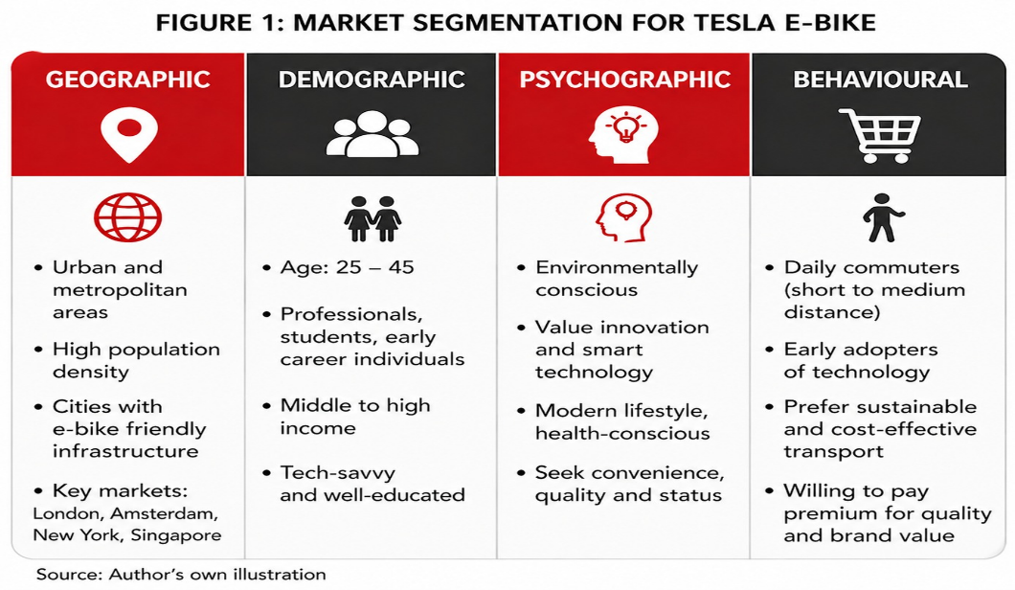
Figure 1: Market Segmentation for Tesla E-Bike (Source: Author’s own illustration)
Geographically, the target market focuses on urban and metropolitan areas characterised by high population density and transport challenges such as congestion and limited parking. This is particularly relevant as micro-mobility solutions are expanding rapidly, with the global micro-mobility market valued at approximately $40.6 billion in 2024 and projected to grow significantly due to increasing urban congestion (Statista, 2024; McKinsey & Company, 2022; Eccarius and Lu, 2020). Cities such as London, Amsterdam, and New York are therefore ideal markets due to infrastructure and policy support for sustainable transport.
From a demographic perspective, the primary segment includes individuals aged 25–45, particularly students and urban professionals. This group is more likely to adopt innovative mobility solutions and has the financial capacity to invest in premium products. The growth of the global e-bike market, expected to expand from around $65.8 billion in 2026 to over $193 billion by 2034, reflects increasing adoption among this economically active segment.
Psychographically, the Tesla E-Bike targets consumers who value sustainability, innovation, and convenience. This aligns with broader environmental trends, as e-bikes are increasingly recognised for reducing car dependency, with studies suggesting that around 44% of e-bike trips replace car journeys. Consumers are increasingly motivated by sustainability considerations in their purchase decisions (White et al., 2019).
Behaviourally, the focus is on individuals who commute short to medium distances and seek efficient, cost-effective alternatives to traditional transport. Increasing fuel costs and urban congestion are key drivers of this shift, encouraging consumers to adopt e-bikes as practical daily transport solutions. These users are typically early adopters and demonstrate a willingness to pay a premium for innovative and high-quality products, reflecting attitude–behaviour relationships in consumer decision-making (Fishbein and Ajzen, 1975; Eccarius and Lu, 2020)

2.2 Targeting Strategy
Based on the segmentation analysis, Tesla can adopt a differentiated targeting strategy focusing on urban professionals and students who are environmentally conscious, technology-oriented, and value convenience. This segment aligns with Tesla’s existing customer base, allowing the firm to leverage brand loyalty and reputation. A representative customer persona is presented in Figure 2.
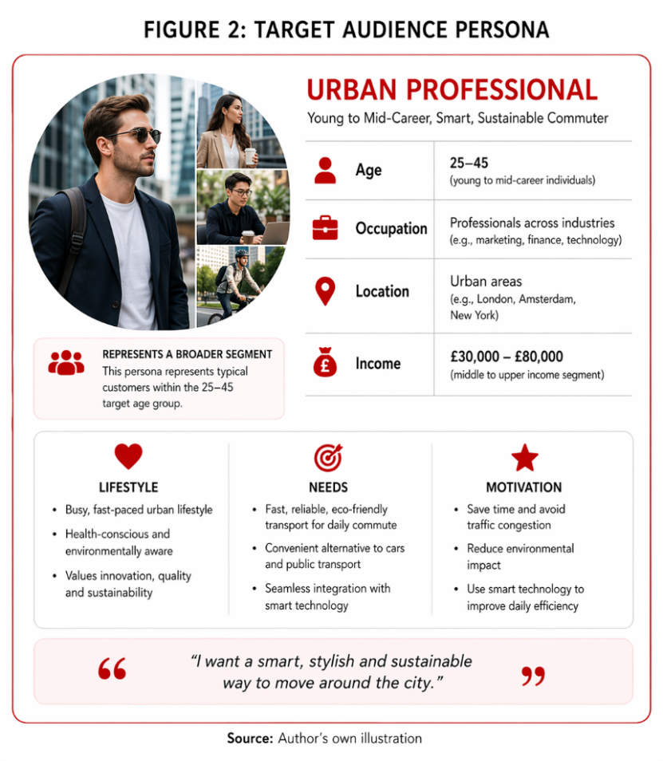
Figure 2: Target Audience Persona for Tesla E-Bike (Source: Author’s own illustration)
This group is particularly attractive due to its strong willingness to adopt sustainable solutions and sensitivity to innovation and brand perception (International Energy Agency, 2023). Rising fuel costs and urban congestion further increase demand for alternative mobility, making this segment both relevant and profitable (McKinsey & Company, 2022; Shaheen and Cohen, 2019). However, focusing on this niche may limit accessibility for more price-sensitive consumers.

2.3 Differentiation Strategy
Differentiation is essential in a competitive market, particularly within the growing e-bike industry where many brands offer similar products. The Tesla E-Bike can differentiate itself through a combination of technology, brand value, design, and sustainability.
The Tesla E-Bike can differentiate itself through technology, brand value, design, and sustainability. Tesla’s expertise in battery technology offers potential advantages such as longer range and faster charging, addressing key concerns for urban users (Tesla, 2024).
In comparison to brands such as VanMoof (VanMoof, 2024) and Cowboy (Cowboy, 2024), which focus on design and usability, Tesla’s advantage lies in integrating advanced battery systems with digital connectivity. While other brands offer affordability and performance, they lack Tesla’s technological ecosystem and brand prestige.
Additional differentiation can be achieved through smart features such as app connectivity, GPS tracking, and performance analytics, enhancing user experience. However, as competitors invest in similar innovations, maintaining this advantage may be challenging (Deloitte, 2023).
Thirdly, brand value plays a crucial role in differentiation. Tesla is widely perceived as a premium and innovative brand, which allows it to position the e-bike as a high-quality and aspirational product rather than a basic transportation tool. Strong brand equity enhances perceived value and influences consumer preferences (Keller, 1993). This perception can justify a higher price point and attract customers who are willing to pay for quality and status.
Finally, sustainability remains a key differentiator. The Tesla E-Bike supports zero-emission transportation and contributes to reducing carbon footprints, aligning with global sustainability goals and increasing consumer expectations for environmentally responsible products (World Health Organization, 2021).

2.4 Positioning Strategy
Positioning refers to how a product is perceived in the minds of consumers relative to competitors (Kotler et al., 2024). The Tesla E-Bike can be positioned as a premium, technology-driven, and sustainable urban mobility solution.
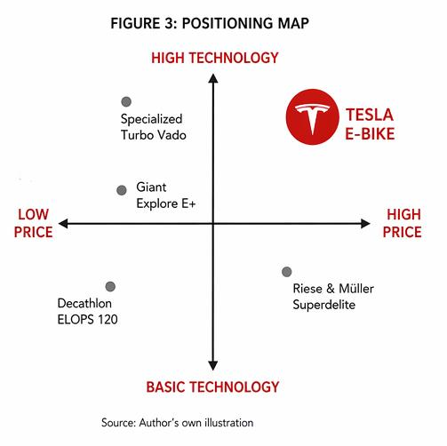
Figure 3: Positioning Map of Tesla E-Bike in the E-Bike Market (Source: Author’s own illustration)
Unlike many traditional e-bikes that mainly focus on affordability and basic functionality, the Tesla E-Bike would aim to stand out by offering a combination of advanced technology, strong performance, and a premium design. As shown in the positioning map (Figure 3), Tesla is placed in the high-price and high-technology segment, which clearly separates it from most competitors in the market.
The intended positioning of the product can therefore be summarised as: the Tesla E-Bike is designed for urban individuals who are looking for a smart, reliable, and environmentally friendly way to travel, while also valuing design and technological advancement. This aligns closely with Tesla’s existing brand image, which is strongly associated with innovation and sustainability. This reflects a differentiation strategy focused on superior value rather than cost leadership (Porter, 1985).
By positioning itself in this way, Tesla is able to differentiate from competitors by focusing on quality and technological leadership rather than price competition. This approach not only strengthens the brand’s premium image but also supports its wider objective of promoting sustainable mobility solutions in urban environments (Kotler et al., 2024).

3. Marketing Mix (7Ps)
The marketing mix provides a structured approach to implementing the proposed brand extension in a practical context. By applying the 7Ps framework, this section examines how each element supports the Tesla E-Bike’s positioning and target market. The overall marketing mix strategy is summarised in Figure 4. As noted by Kotler et al. (2024) and Booms and Bitner (1981), an integrated marketing mix is essential for delivering consistent value and reinforcing brand positioning.
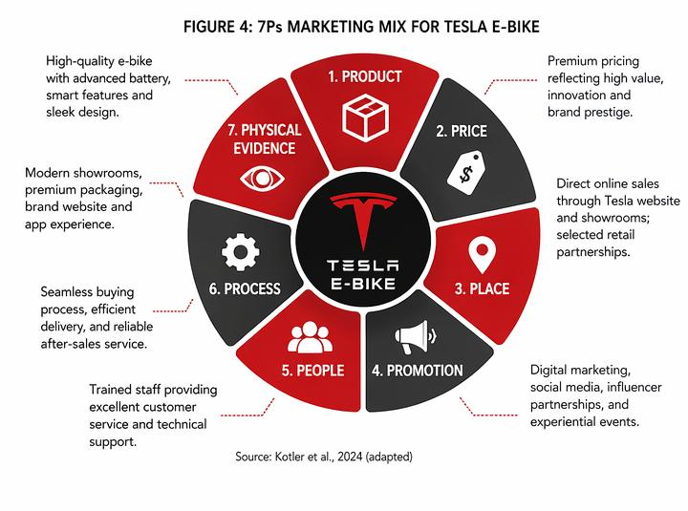
Figure 4: 7Ps Marketing Mix Framework for Tesla E-Bike (Source: Author’s own illustration, adapted from Kotler et al., 2024)

3.1 Product
The Tesla E-Bike offers efficient and sustainable transportation as its core benefit. The actual product includes advanced battery performance, smart connectivity, and modern design, while the augmented product may involve after-sales services, software updates, and ecosystem integration.
A key strength of this product lies in Tesla’s existing expertise in battery technology, which can provide a longer range and faster charging compared to competitors. In addition, integrating features such as GPS tracking, mobile app connectivity, and performance analytics enhances the overall customer experience and aligns with the increasing demand for smart products (Kotler et al., 2024).
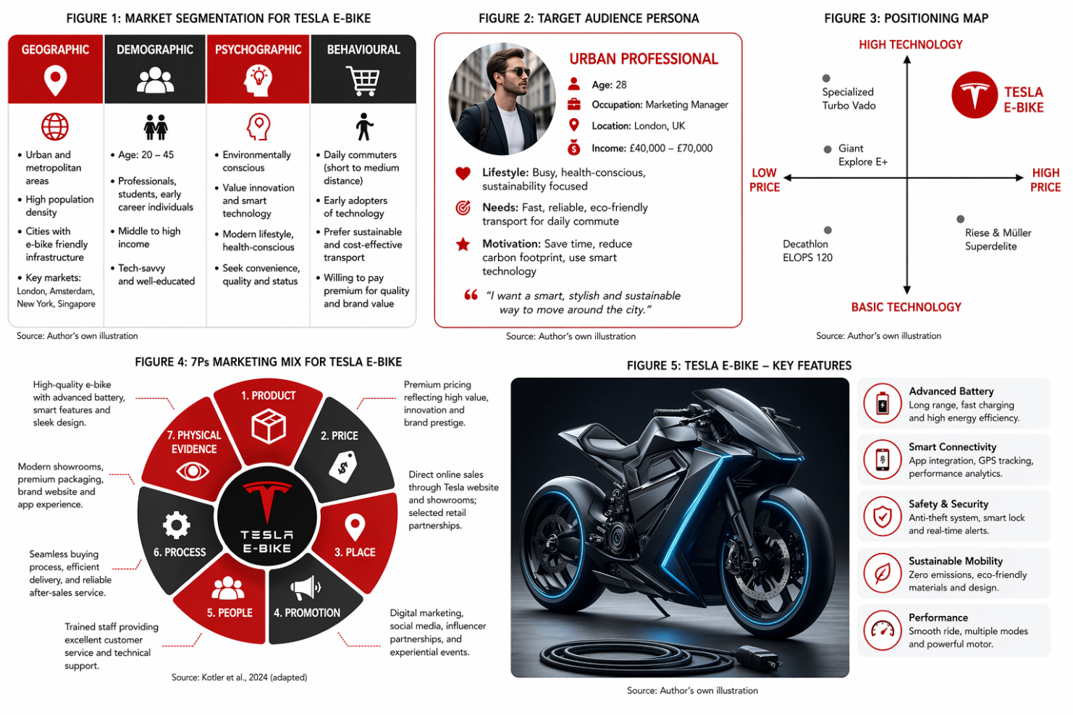
Figure 5: Tesla E-Bike Concept Design (Source: Author’s own illustration)
From a strategic perspective, the Tesla E-Bike supports brand extension by maintaining consistency with Tesla’s core values of innovation and sustainability. Whereas, the challenge lies in ensuring that the product meets the high expectations associated with the Tesla brand, as any failure could negatively impact brand perception. However, this technological advantage may be difficult to sustain in the long term, as competitors within the e-bike industry are also investing heavily in battery innovation and smart features. This increases competitive pressure and may reduce Tesla’s differentiation over time.

3.2 Price
Pricing plays a crucial role in reinforcing the premium positioning of the Tesla E-Bike. A value-based pricing strategy is most appropriate, where the price reflects the perceived value of the product rather than simply the cost of production.
Given Tesla’s brand image, the e-bike would likely be priced higher than standard e-bikes in the market. This premium pricing strategy helps maintain brand exclusivity and signals high quality and advanced technology. Research suggests that consumers often associate higher prices with better quality, particularly in technology-driven products (Kotler et al., 2024).
However, a critical consideration is price sensitivity within the target market. While urban professionals may be willing to pay a premium, students or lower-income segments may find the product less accessible. To address this, Tesla could consider flexible payment options such as instalment plans or leasing models. This creates a potential trade-off between exclusivity and market penetration.
Overall, the pricing strategy must balance profitability with market accessibility, while ensuring alignment with Tesla’s premium positioning.

3.3 Place (Distribution)
The distribution strategy for the Tesla E-Bike should focus on selective distribution, ensuring that the product is available through channels that reflect its premium positioning.
Tesla’s existing direct-to-consumer model, primarily through its official website and showrooms, can be extended to include the e-bike. This approach allows Tesla to maintain control over the customer experience and brand image. In addition, selling through Tesla stores creates opportunities for cross-selling and brand reinforcement.
Online distribution is particularly important, as the target audience is digitally active and comfortable purchasing products online. Furthermore, partnerships with selected urban mobility retailers or experience centres could increase accessibility without diluting the brand.
From a strategic perspective, the distribution approach aligns with Tesla’s focus on innovation and efficiency. However, relying primarily on a direct-to-consumer model may restrict physical accessibility in certain regions, particularly where Tesla does not have a strong retail presence. Overall, the company must ensure that logistics, delivery, and after-sales support are effectively managed, as these factors significantly influence customer satisfaction.

3.4 Promotion
Promotion is essential for communicating the value of the Tesla E-Bike and creating strong brand awareness. The promotional strategy should focus on digital marketing, experiential marketing, and brand storytelling.
Tesla traditionally relies less on conventional advertising and more on brand reputation and word-of-mouth. This approach can be applied here by leveraging social media platforms, influencer collaborations, and user-generated content to create organic engagement.
Digital campaigns can highlight key features such as sustainability, smart technology, and convenience, while also emphasising how the product fits into modern urban lifestyles. Additionally, experiential marketing, such as test ride events in major cities, can allow potential customers to directly experience the product’s benefits.
However, Tesla’s limited use of traditional advertising may reduce its ability to reach new customer segments who are not already familiar with the brand. Therefore, a more balanced promotional approach, combining digital engagement with broader communication channels, may be necessary to maximise overall market reach.

3.5 People
The people element refers to all individuals involved in delivering the product and shaping the customer experience. For the Tesla E-Bike, this includes sales staff, customer service teams, and technical support personnel.
Given Tesla’s premium positioning, it is essential that all customer interactions reflect professionalism, product knowledge, and efficiency. Employees must be well-trained to communicate the product’s features and benefits clearly, particularly its technological aspects.
Customer service also plays a critical role in building trust and long-term relationships. Quick response times, effective problem resolution, and personalised support can significantly enhance customer satisfaction.
From a strategic perspective, strong human interaction supports brand loyalty and reinforces Tesla’s reputation for quality and innovation.

3.6 Process
Process refers to the systems and procedures involved in delivering the product to the customer. For the Tesla E-Bike, this includes the purchasing process, delivery, and after-sales service.
Tesla’s digital-first approach allows for a streamlined purchasing process, where customers can easily browse, customise, and order the product online. This convenience aligns with the expectations of modern consumers.
In addition, efficient delivery systems and reliable after-sales services, such as maintenance and software updates, are essential for ensuring a positive customer experience. Customer experience plays a critical role across all touchpoints in shaping satisfaction and loyalty (Lemon and Verhoef, 2016). The inclusion of app-based support or service tracking can further enhance efficiency.
From a critical perspective, any inefficiencies in these processes could negatively impact customer satisfaction, especially given the premium expectations associated with the brand.

3.7 Physical Evidence
Physical evidence refers to the tangible aspects that influence customer perception of the brand. For the Tesla E-Bike, this includes product design, packaging, retail environments, and overall brand presentation.
The design of the e-bike is particularly important, as it must reflect Tesla’s futuristic and premium image. High-quality materials, sleek aesthetics, and attention to detail can reinforce perceptions of innovation and quality.
In addition, Tesla’s showrooms and online platforms serve as important touchpoints where customers form impressions about the brand. A clean, modern, and technology-focused environment can enhance the overall brand experience.
From a strategic perspective, strong physical evidence supports brand positioning and helps differentiate the product from competitors in a crowded market.

4.Reflection
Developing the Tesla E-Bike brand extension has been a valuable learning experience, as it allowed me to apply theoretical marketing concepts in a practical and creative way. At the beginning of the project, I found it challenging to translate ideas into a structured marketing strategy, particularly when trying to align the concept with real-world market trends. However, as I progressed, I developed a clearer understanding of how marketing frameworks such as segmentation, targeting, positioning, and the marketing mix can be used to support business decisions.
One of the key insights I gained from this project is the importance of understanding the target audience in detail. Initially, my approach was quite general, but through the STDP analysis, I realised that effective marketing strategies require a much deeper understanding of customer needs, behaviours, and preferences. This helped me to think more critically about why a product would succeed in the market, rather than simply focusing on its features.
Another important learning point was the role of brand consistency. While developing the Tesla E-Bike, I had to ensure that the product aligned with Tesla’s existing brand image of innovation, sustainability, and premium quality. This made me realise that brand extensions are not just about introducing new products, but about maintaining a strong and consistent brand identity across all offerings.
The process of designing and presenting the poster also contributed to my skill development. I improved my ability to communicate ideas clearly and visually, which is an essential skill in marketing. However, I found it slightly challenging to simplify complex ideas into a short presentation format, as it required careful selection of key points. Despite this, the experience helped me become more confident in presenting and explaining my ideas in a structured way.
In addition, this project enhanced my research and analytical skills. I learned how to use academic sources to support my arguments and how to integrate them effectively into my writing. At the same time, I became more aware of the importance of referencing and maintaining academic integrity.
Looking back, one area I could improve is time management. At certain stages, I spent too much time refining small details instead of focusing on the overall structure. In future projects, I would aim to plan my work more effectively and allocate time more efficiently across different sections. In addition, I also recognise that my analysis could have been strengthened by incorporating more real-world market data and competitor benchmarking, which would improve the depth and reliability of the strategy.
Overall, this project has contributed significantly to my understanding of marketing strategy and brand development. It has also helped me develop practical skills such as critical thinking, research, and communication, which will be useful for my future academic and professional career.

References
Aaker, D.A. (1990) ‘Brand extensions: The good, the bad, and the ugly’, Sloan Management Review, 31(4), pp. 47–56.
Booms, B.H. and Bitner, M.J. (1981) ‘Marketing strategies and organisation structures for service firms’, in Donnelly, J.H. and George, W.R. (eds.) Marketing of Services. Chicago: American Marketing Association, pp. 47–51.
Cowboy (2024) Smart electric bikes. Available at: https://www.cowboy.com (Accessed: 31 March 2026).
Deloitte (2023) Smart mobility trends 2023. Available at: https://www2.deloitte.com (Accessed: 31 March 2026).
Eccarius, T. and Lu, C.C. (2020) ‘Adoption intentions for micro-mobility—Insights from electric bike users’, Transportation Research Part D, 82, pp. 1–12.
Fishbein, M. and Ajzen, I. (1975) Belief, attitude, intention and behavior: An introduction to theory and research. Reading, MA: Addison-Wesley.
International Energy Agency (2023) Global EV outlook 2023. Available at: https://www.iea.org/reports/global-ev-outlook-2023 (Accessed: 31 March 2026).
Keller, K.L. (1993) ‘Conceptualizing, measuring, and managing customer-based brand equity’, Journal of Marketing, 57(1), pp. 1–22.
Kotler, P., Keller, K.L., Chernev, A. and Brady, M. (2024) Marketing management. 16th edn. Harlow: Pearson.
Lemon, K.N. and Verhoef, P.C. (2016) ‘Understanding customer experience throughout the customer journey’, Journal of Marketing, 80(6), pp. 69–96.
McKinsey & Company (2022) The future of micromobility. Available at: https://www.mckinsey.com (Accessed: 31 March 2026).
Porter, M.E. (1985) Competitive advantage: Creating and sustaining superior performance. New York: Free Press.
Shaheen, S. and Cohen, A. (2019) ‘Shared micromobility policy toolkit’, Transportation Sustainability Research Center, pp. 1–40.
Statista (2024) Electric bicycle market growth statistics. Available at: https://www.statista.com (Accessed: 31 March 2026).
Tesla, Inc. (2024) About Tesla. Available at: https://www.tesla.com/about (Accessed: 31 March 2026).
VanMoof (2024) Electric bikes overview. Available at: https://www.vanmoof.com (Accessed: 31 March 2026).
White, K., Habib, R. and Hardisty, D.J. (2019) ‘How to SHIFT consumer behaviors to be more sustainable’, Journal of Marketing, 83(3), pp. 22–49.
World Health Organization (2021) Sustainable transport and health. Available at: https://www.who.int/publications/i/item/WHO-HEP-ECH-AQH-2021.6 (Accessed: 31 March 2026).

Appendix
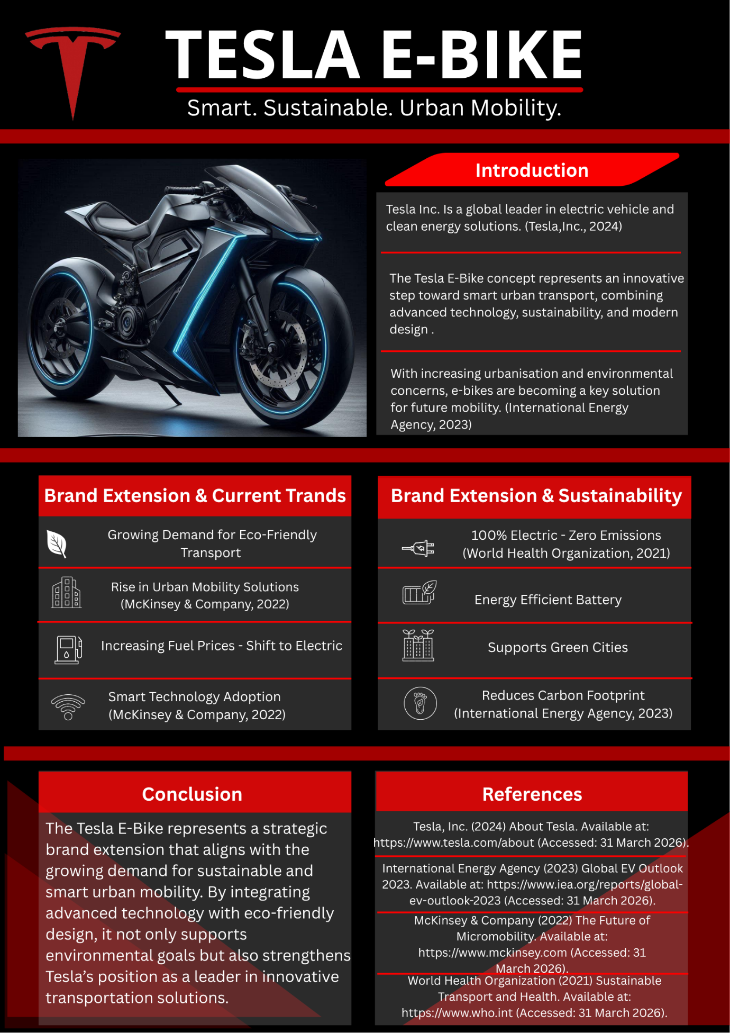
Appendix A: Tesla E-Bike Poster

