Assignment 2: Personal Development Plan (PDP)

Module name: Learning in the Digital Era (ACCA4025)
Assignment title: Assignment 2: Personal Development Plan (PDP)
Student name: Robert Iwan Jamieson
Student number: 2004728
Course title: BSc Computing (Software Engineering)
Date of submission: 04/01/2020

Video link: https://youtu.be/_Ckhzi5tPUc
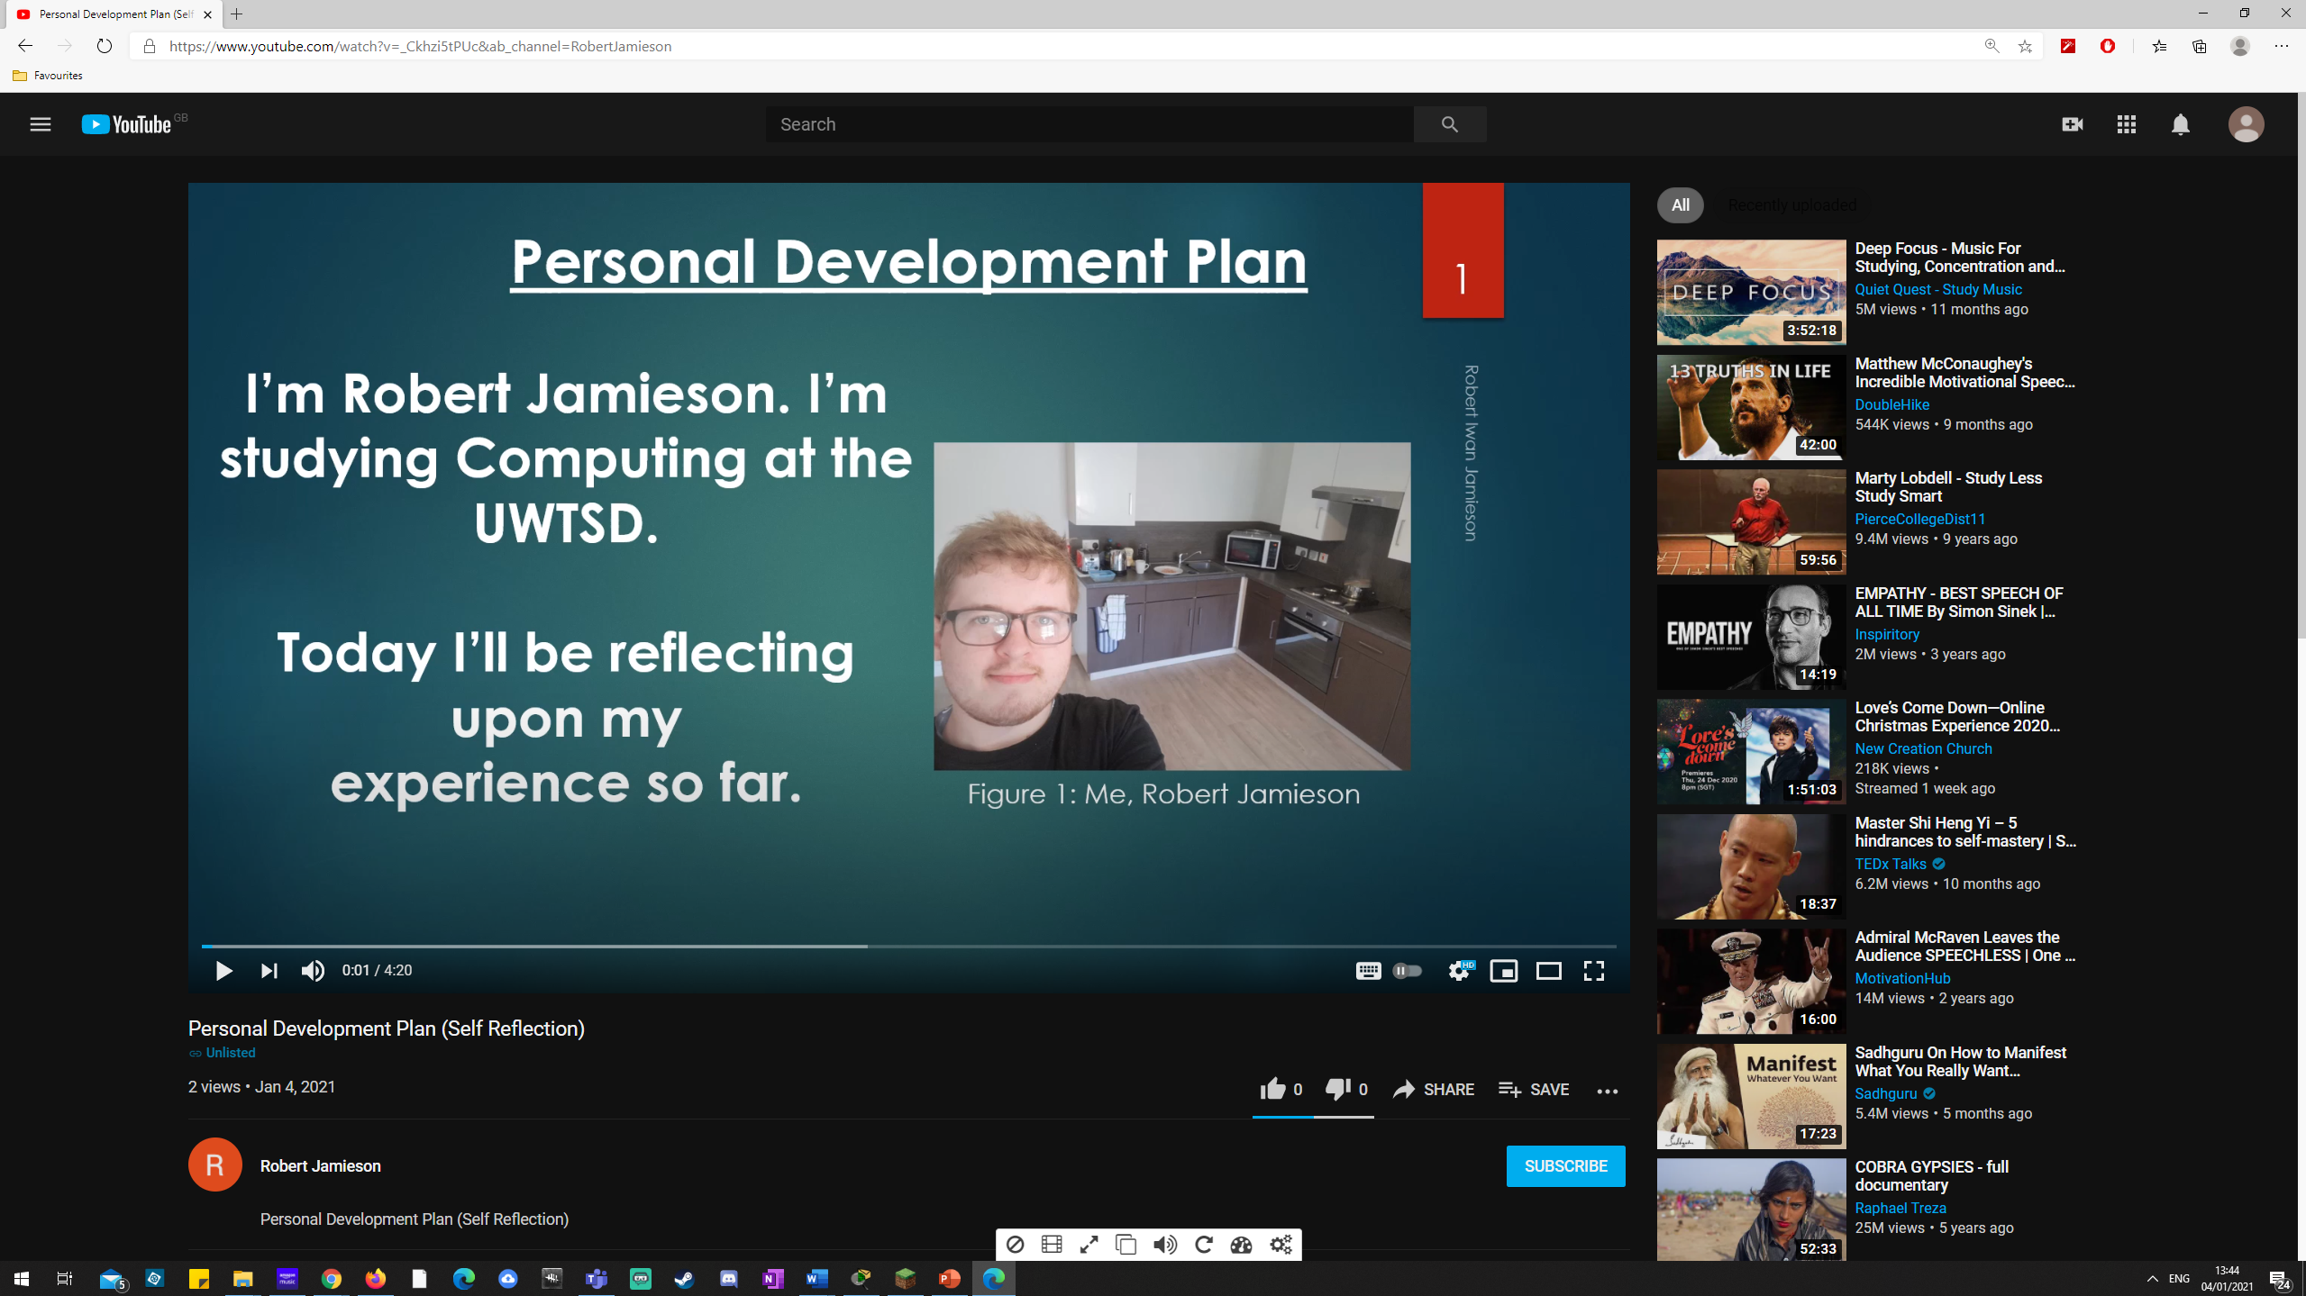
Screenshot:

