Networking Worksheet 2
Task 1
This first task of worksheet 2 was to use the ARP (Address Resolution Protocol) to figure out what the physical and logical network information is.
The first part of this task was to use the command window and type ARP -A, the command window outputted various information about the network such as, the interfaces of the network (NIC’s), the MAC or Physical address of the preceding NIC and the internet addresses of the network interfaces.
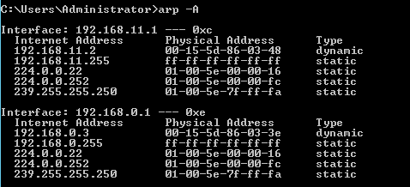
Here is a screenshot of the command window using the ARP protocol from the Cardiff server: -
As you can see there is only two interfaces, these are the interfaces of the 11 and 0 networks.

Task 2
Task 2 was to use the routing and remote access services to filtering data packets within the network, this is done with the TCP (Transmission Control Protocol) and the ICMP (Internet Control Message Protocol) processes.
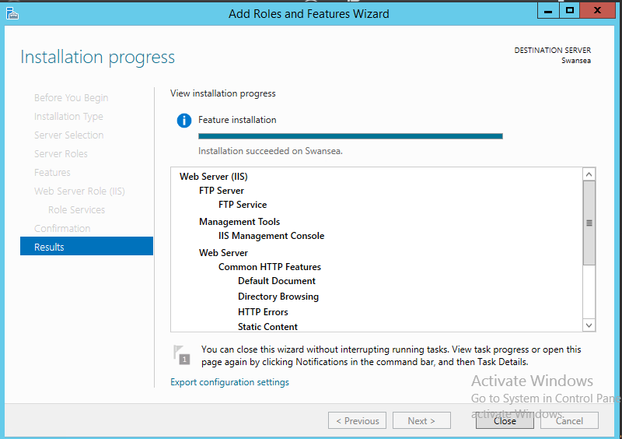
The first part of task 2 was to add the web server (IIS) or FTP (File Transfer Protocol) service within the server manager dashboard, below is a screenshot of the FTP service and web server being installed:-

The second part of task 2 was to add a new user to the FTP service within the computer management of the Swansea server, the name of the new user was called ftpuser.
Below is a screenshot with the new user added to the local users and groups: -
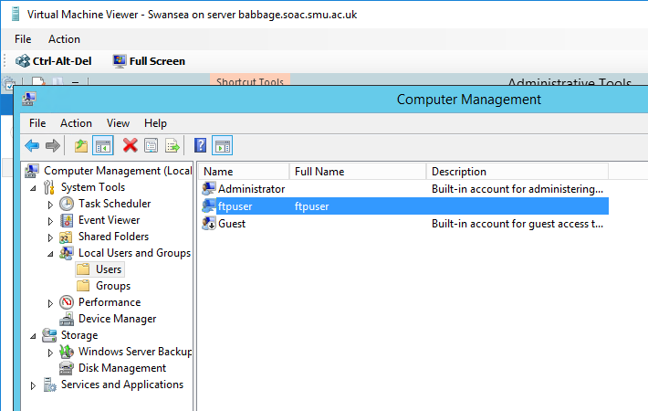

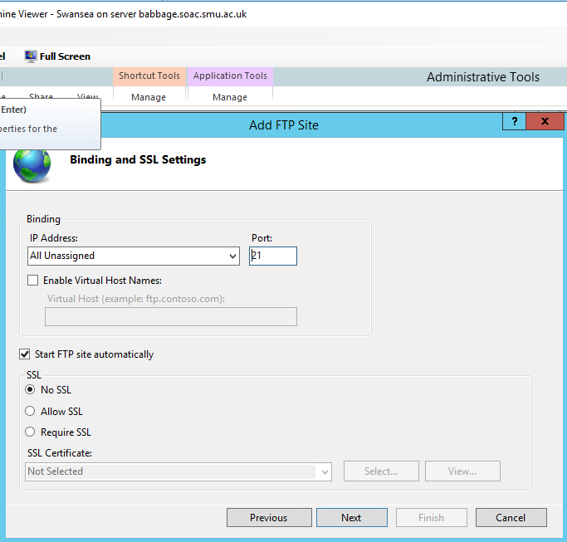
The next step of task 2 was to test the ftp service by adding a FTP site this was done by going into the content directory and selecting the C root drive (C:\lnetpub\ftproot) , after the directory is opened the binding and SSL settings were opened and a port number had to be chosen which was port 21 (as seen in the screenshot below) this will be used later for the TCP service.

After the ftp user had to be named after server that was being used (Swansea Server), so the user name was Swansea\ftpuser.
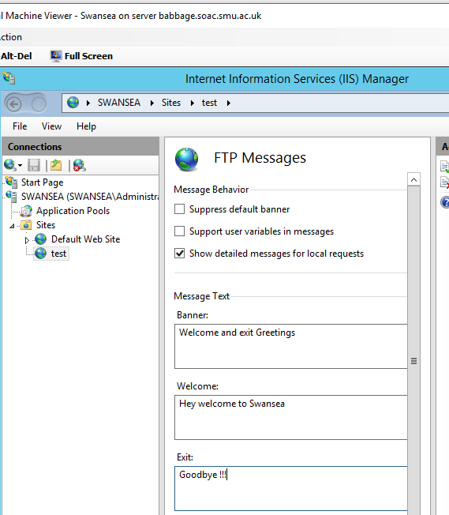
The next part of task 2 was to set up the banners that all the users of the FTP server will see when they log into it or log out of it this was done by using the IIS (Internet Information Services) manager, below is a screenshot of this being set-up on the Swansea server :-

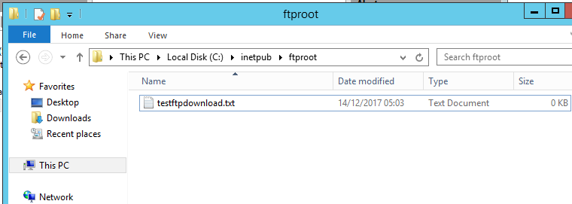
The next step of task 2 was to create a text file within the file directory C:\lnet\ftproot (as shown by the screenshot below), once this was carried out the FTP server was running within the Swansea server.

The next part of task two was to attempt to upload to or download from the FTP server which will be carried out on the Cardiff server, there was a few steps that led to the downloading of a file these steps included:-
Logging into the FTP server using the command window on the Cardiff server the command of ftp and the IP address of the Swansea server, this connected the Cardiff server with the FTP server, then the login in details of the user were inputted so the username was Swansea\ftp and the password was entered.
Once the user had logged in the command dir was used to give a readout of what is stored within a host directory, once this was completed the host directory had to be changed so that the FTP server knows where to download any new files to.
This was done by using the command lcd and the filename of c:\ftpdownloads, then when prompted another command get testftpdownload.txt, after this is entered the FTP server came up with a message saying the process had been completed.
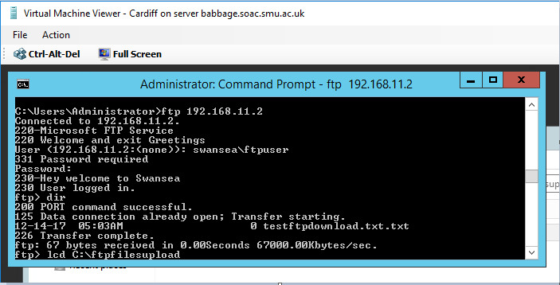
then a file had to be created for the uploading of files, this was done in the C:\ file directory of the Cardiff server, the file was named ftpfilesupload, a text file was also created in the file called testftpuploads.txt, below is a screenshot of the file being uploaded/transferred to the ftpfilesupload file.

The last part of this task was to prove that the file had been uploaded to the c:\inetpub\ftproot folder within the Swansea server.
Task 3
Task 3 was used to restrict specific ICMP processes, this was achieved by using by using the routing and remote accesses service on the Cardiff server to filter IP data Packets.
The first part of this task was concerned with stopping the windows client from pinging the Swansea server by employing an inbound filter, this was done from the Cardiff server and involved the next steps.
Going into the routing and remote access console within the administrative tools, going into the IP routing section and clicking on the ‘general’ tab and this is one of the networks had to be picked to be filtered, as the 0 network was being used to filter, it was the network picked and then a new inbound rule was created using the following details (shown in the screenshot below).
The source IP was 192.168.0.3 (The windows client on the 0 network).
The destination was 192.168.11.2 (The Swansea server on the 11 network).
The Subnet for both IP’s was 255.255.255.255.
The protocol that was used was the ICMP protocol.
And the ICMP type and code were left blank meaning the usual value of 255 were inserted into those boxes.
And the filters option was set to ‘Receive all Packets, except those that meet the criteria below’.
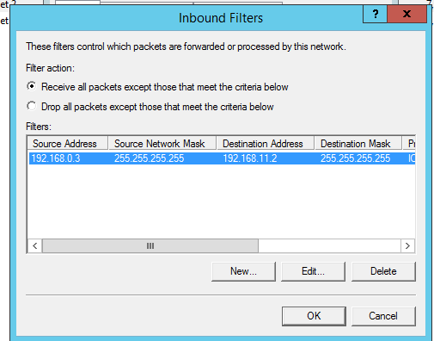

The next step of task 3 was to test the filter by trying to ping the Swansea server from the windows 7 client, this is shown in the screenshot below: -
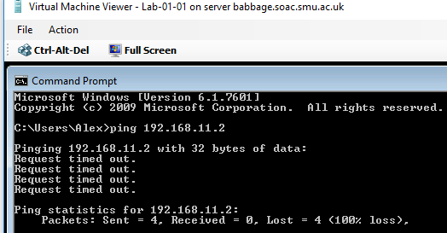

As was expected the ping failed, showing a 100% loss of the data packets.

Then the part of the Cardiff server on the 11 network was pinged from the windows 7 client, here is a screenshot of that ping attempt: -
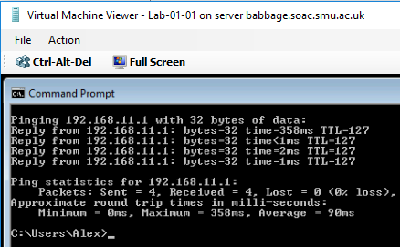

This was successful with a 0% loss in the data packages, which was what was expected.
This shows that it was possible to speak to the 11 network from the windows client but not the Swansea Server part which means that the inbound rule worked.
Task 4
This task is the opposite of the last as an outbound filter was created using the routing and remote access service of the Cardiff server to filter IP data Packets.
The first step of task 4 was to delete the inbound filter rule from task 3, this task is concerned with filtering out all traffic coming out of the Cardiff server (the router) and specifically stop all of the servers/networks from accessing the FTP service which at the moment is running on the Swansea Server.
The same steps were followed above to get to the IP routing tab on Cardiff. This time the new outbound filter option was pressed within the 11 Network tab, but the following settings were applied: -
The source IP was left blank.
The destination IP was left blank.
The protocol that was picked was TCP protocol.
The destination port was 21 (This is the Port that the FTP service was defined on earlier).
And the filters option was set to ‘Receive all Packets, except those that meet the criteria below
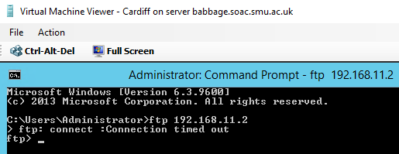
Once these settings were applied the filter had to be tested so the command box was opened in the Cardiff server and the command ftp followed by the Swansea address 192.168.11.2.

The screenshot above shows that the Cardiff server couldn’t connect to the FTP service which means that the outbound filter was successful.
The next part of task 4 is to create an inbound filter that only allows network traffic from the Cardiff Server (router) through, but filters out all other network traffic from getting to the FTP service.
Firstly the other outbound filter rule had to be deleted, then the steps from the beginning of task 4 are followed to get to the IP routing tab, interface of the 0 network was chosen and a new inbound filter rule was created and these were the settings: -
The source IP address was left blank.
The Destination IP was left blank.
The protocol chosen was the TCP protocol.
The Destination Port was 21.
And the filters option was set to ‘Receive all Packets, except those that meet the criteria below’.
The next part of this task was to test the filter from the Cardiff server, so the command box was opened, the command ftp followed by the Swansea (11 network) address 192.168.11.2 was typed.
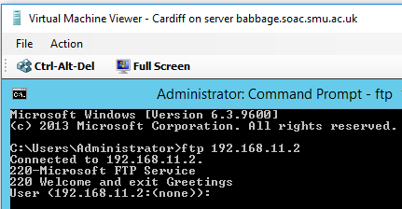
This resulted in the screenshot to the left showing that the filter works showing that the Cardiff server was successful at reaching the FTP server.

This also had to be tested to show that the other network (The 0 network) cannot reach the FTP server so the command ftp was followed with the two 0 network addresses 192.158.0.1 and 192.168.0.3.
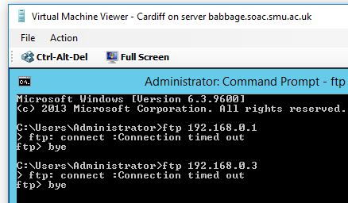
This resulted in the screenshot to the left showing that neither address could connect to the FTP server.

This shows that the inbound filter rule worked by letting only the Cardiff (11 network) through and disallowing the 0 network to get through to the FTP server.
The last part of this task was to create an outbound filter on the Cardiff server to let all network traffic through, apart from the Cardiff network when trying to connect to the FTP server.
This part of the task was started by deleting the preceding inbound filter rule, then all the steps were taken to get to the IP routing tab in the network where the 11 Network was chosen, a new outbound filter rule was created and these were the settings: -
The source IP address was 192.168.11.1 and its subnet mask was 255.255.255.255
The Destination IP was 192.168.11.2
The protocol chosen was the TCP protocol.
The Destination P And the filters option was set to ‘Receive all Packets, except those that meet the criteria below’.
ort was 21.
Once these setting were set the outbound filter rule was tested by typing ftp followed by the Cardiff (11 network) IP address of 192.168.11.1.
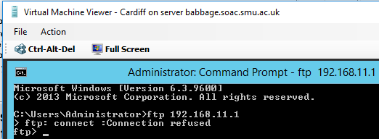
Here is a screenshot of the command window showing that the router (Cardiff server) on the 11 network cannot connect to the FTP server, which means that the outbound filter has worked.

Observation Tasks
Task 1
ARP or Address Resolution protocol can be defined as a was of effectively mapping IP (internet Protocol) addresses to a devices MAC address (this is an address given to a device by its manufacturer and so can be described as its physical address), when the networks IP addresses and MAC addresses are mapped they are put into a ARP table, this way it is easy for a network to link both types of addresses together, so that when data is sent over a network it can use this table as a type of reference and send the data packet to the correct device depending on the IP address within the ARP table.[1]
Appendix 1 shows a simple diagram of how the ARP protocol works, a request is sent from one device within a system to another device with requests going back and forth asking for each other’s information such as each other’s IP addresses and each devices MAC address, this information can then be kept within the networks ARP table.
Task 2
Task 2 is concerned with the use of packet filtering within a given network system, packet filtering is a less complex version of a firewall, the operation of a Packet filter is to receive a data packet and decide on whether the data should be sent through to a specified IP address , it also takes into account which port is being used to send and which port is receiving the Packet, the filter must stick to the protocols that have been defined by a user such as in the worksheet above the TCP (transmission Control Protocol) was used.[2]
Packet filtering can be called IP Packet filtering, this is because it is the process of stopping IP addresses either from “speaking” to a server via data Packets, this a good for stopping unwanted packets from being sent to a server from IP addresses that are trying to send undesirable traffic through the network.[3]
There are a couple of advantages to using Packet filtering such as that as it is less complex that other types of filters like firewalls they use up less network resources, IP filters are better at being implemented in smaller networking systems and Packet filters are generally more low cost to use within a network.[4]
Task 3
Contradictory Filters within packet filtering happen when filter rules that have been placed on interfaces of a network system conflict with each other, an example of this would be when a network has a inbound filter rule on a specific network interface that permits the flow of data packets through the network and an outbound filter rule has been created to block the same traffic flowing though, this can result in the sending of data packets across the network not occurring.[5]
References
[1] M. Rouse, “What is Address Resolution Protocol (ARP)? - Definition from WhatIs.com,” 2005. [Online]. Available: http://searchnetworking.techtarget.com/definition/Address-Resolution-Protocol-ARP. [Accessed: 12-Feb-2018].
[2] J. R. Vacca, “Firewalls,” in Computer and information security handbook, Burlington: Elsevier, 2009, p. 360.
[3] E. Cole, R. L. Krutz, and R. Reese, Network security fundamentals. Hoboken, NJ: Wiley, 2008.
[4] Router Switch Limited, “Tutorial of Firewall Types and their Advantages and Disadvantages,” Router-Switch.com, 2013. [Online]. Available: http://nhprice.com/tutorial-of-firewall-types-and-their-advantages-and-disadvantages.html. [Accessed: 13-Feb-2018].
[5] Microsoft, “IP PACKET FILTERING,” IBM i5/OS information center, version5 Release 4, 2011. [Online]. Available: https://technet.microsoft.com/en-gb/library/cc957881.aspx. [Accessed: 13-Feb-2018].
[6] D. Gibson, Microsoft Windows networking essentials, 1st ed. Indianapolis, IN: Wiley Pub, 2011.

Appendices
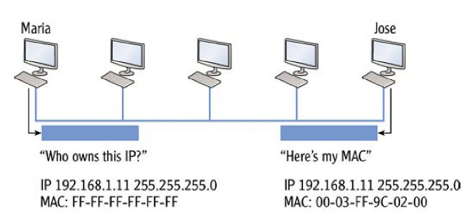
Appendix 1-
Appendix 1- ARP protocol [6]

