Abstract

This essay examines the relationship between Yayoi Kusama, Edmund De Wall and repetition through the theories of Henri Bergson and Martin Heidegger. Examined is the linkage between the artists and how they each interpret repetition visually through their work and how they both incorporate it into the actual process of creating the respective works. Also how both artists portray repetition in different ways either by using it to represent people, items and places that no longer exist or to represent an abundance of anxieties, emotions and thoughts which are present in the artist and how these come out through the use of repetition out of the mind and into the physical world. Investigated is the ways in which both artist’s link with repetition affects themselves mentally and how it has a strong power to in a way improve the lives of the artists by means of bringing out what's held in their minds and out of themselves and into the wider world for all to see and experience. The way Henri Bergson and Martin Heideggar both see repetition and how their theories relate to the way that both Kusama and De Wall incorporate repetition into their work. Lastly the comparisons and contrasts between how each artist uses repetition are explored.

Time, Memory and the Archive
2204133
MA Glass
4000 words
Steven Shears

How does Yayoi Kusama and Edmund De Wall reimagine time in relation to the Bergson and Heidegger theories and how is it portrayed through repetition?
Contemporary artists and designers reimagine time in a multitude of ways with repetition being one of these ways. Within this essay is studied the relationship between two well-known artists, Yayoi Kusama and Edmund De Wall and their relationship with repetition. This is through the theories of Henri Bergson and Martin Heidegger. The link between the artists and how they each interpret repetition visually through their work is explored and how they both incorporate it into the actual process of creating the respective works.
To begin with, the link between Edmund De Walls work in relation to time theory is explained. Edmund De Walls practice is linked to Henri Bergson's theory of time. In the theory Rethinking times arrow, by Bergson and Deleuze it states “Temporalizing practices are viewed as a dimension of the exercise of power, as temporality is a hinge that connects subjects to wider social horizons, and control over pasts and futures that are temporalized also influence action in the present”. (Hodges 2008). This quote suggests that by engaging in practices that are involved with time and governed by its movements then the person who is practicing those activities can gain a power through the process and that also by linking temporal qualities into the activities, then the time aspect has the ability to influence the actions of and increase the productivity of that person. When this is linked to Edmund De Wall when he is crafting his ceramic repetitively then it is clear to see that by De Wall using repetition which is linked to time, then that repetition can bring power to De Wall whilst he is crafting his work. That power that is gained by repetition is broadcast through the conceptual meaning of De Walls work or visually by the aesthetic qualities of the numerous and repeated ceramic pieces. Overall, time is heavily linked to and influences Edmund De Walls work.
A further quote strengthens this by stating "Control over time is not just a strategy of interaction; it is also a medium of hierarchic power and governance”. (Hodges 2008). This quote also suggests that by utilising time, for example by physically repeating processes within the art of making, then the artist is bringing the element of power to their work and themselves. This then can lead to a greater sense of achievement or satisfaction from the artist in themselves and their work.
As repetition is a major element in De Walls work it is interesting to see what Henri Bergson thinks of repetition and the following quote shows this as “Pure repetition is an abstraction that reduces reality to its material dimension and ignores the creative force that underlines this material dimension”. (Bergson's philosophy of repetition in dance, n.d.) This quote implies that repetition is an act that is purely materialistic. This suggests that for De Wall to be using repetition by crafting his ceramic vessels endlessly, that he, by doing this, is doing so purely in a physical realm and that there is nothing more surrounding him, no spiritual energy or influence affecting his work in that moment. If Bergson's idea was true then it would imply that for example, De Wall using repetition is nothing more than a factory worker churning out an endless array of products without perhaps any deeper linkage with what he is creating, no deeper connection, nothing more than a production line in process.
Although De wall is physically creating a production line as he is making time and time after, similar items, there is however a deeper, more spiritual connection involved which comes from within De Wall himself and is the main reason as to why he uses repetition as mentioned earlier.
Now investigated is how Yayoi Kusama's work is linked with time theory. Kusama's work is linked with time theory also but to begin with is how pain within Bergson's time theory affects and influences Kusama's work. In the book Living in Time: The philosophy of Henri Bergson it talks about how mental states and pain holds influence on a person's actions. This is heavily linked to Kusama due to herself suffering from mental illnesses throughout her life. Within the book is the following quote which states “We do not have to have pain for an organism to respond adaptively to damage, so why the sensation at all? Bergson thinks it indicates the evolutionary emergence of choice. What we feel as an intensity of pain is consciousness of involuntary reactions under preparation, providing an opportunity to suppress, select, or modulate them. Feeling the sensation, one is aware of the looming requirement to act. There is an interval during which memory comes to bear and a preferable response can be selected from alternatives remembered or imagined. Here is the humble beginning of the feeling of freedom” (Allen 2023). What this quote suggests is that pain whether physical or psychological is a reaction in which the body provides in times of choice. The pain then helps the sufferer to select their corresponding choices accordingly. In the section of the quote “Feeling the sensation, one is aware of the looming requirement to act”. This relates to Kusama and how the majority if not all her work is created as per this quote. For Kusama, pain is the initial factor which brings about her reactive response which then in turn governs the visual aesthetics and the physical processes of creating her artwork. For Kusama her pain influences how her art involves such a great amount of repetition, which is her visual response to the pain in which she experiences. As a result, it can be noted that Kusama's art is a timely response and reaction to pain and that pain, repetition and art are three factors which come together for her life.
Another way in which Kusama's work has relation to time theory is through Martin Heidegger's book Being and Time which goes and states “Heidegger's idea is not that human beings necessarily exist in time, but rather that they exist as temporality, that human existence most fundamentally is temporality”. (Mulhall 2013). This quote suggests that there is no man-made time which governs the world and everyone with it but instead every person has their own personal time associated with them. This suggests that for every person time operates differently and passes at different tempos all within a general idea of time which is man-made time which is set by the clock. This in relation to Kusama is that for Kusama, time evolves to the rhythm of repetition. It could be said that without repetition for people like Kusama, Edmund De Wall and also myself that without repetition time is nothing altogether for there is nothing solid or grounding that could be perceptually held on to whilst we flow through the period of time what we call life. So, for Kusama, with her repetitive process that she creates her art is her own unique and personal version of time. As mentioned earlier Kusama uses her art to calm the chaos within her mind and that repetition is her way to calm it. As a result, For Kusama repetition and time or her own temporality are the main elements in her life that keep her going and thus gives her purpose.
Next is explored the relationship between Yayoi Kusama and repetition. Kusama's relationship with repetition is not just a mere visual interest of hers in which she finds the visual aesthetics appealing, but her use of repetition is far more a deeper, personal and in many cases, unknown affair. The following quote emphasises on her relationship with repetition further by stating “As a child, she hallucinated sweeping fields of dots, using art to calm the chaos in her mind.” (Wakim 2017). This quote emphasises that for Kusama, repetition plays a profound and important role within her life as the repetition enables a sense of calm to enter her life whilst the particular forms that are repeated, again to begin with in her mind, then become transferred from her mind and brought out into the physical world. one of her most well-known art pieces is her infinity mirrors (fig.1) in which she placed thousands of her creations within a grid form of mirrors including several hundred phallic protuberances, sewn from red-and-white polka-dot fabric and stuffed with wadding to create the image of the type of visuals that were appearing within her mind. She then invites the public to travel through her creation to further physically be within her work and importantly get an idea of what it is like to be her within her mind.
According to the founding director of the Broads in Seattle USA, Joanne Heyler, she states, "In the infinity rooms you have the sensation of feeling tiny and vast.” and continues, "There's something about that paradox that resonates.” (Wakim 2017). This clever way by using mirrors and large spaces emphasises the face that for Kusama who has suffered from neurosis her whole life, feels small within the vastness of her mind.
It is not just her infinity mirrors that incorporate repetition within her work as the following quote emphasises, “Kusama had been working with the idea of repetition for several years, at first with her Infinity Net paintings: vast canvases filled with interlocking flicks of paint that expanded, mesh-like, over the surface of the canvas and later onto the floor, walls, tables and chairs that surrounded her”. (Anonymous, 2021). this quote clearly highlights that for Kusama, repetition is everything and it has appeared within numerous other instillations of hers including mirror room 1991 and Kusama world 2012. A further quote highlights the reason why repetition is of immense importance to Kusama. “The theme of endless repetition has personal significance for the artist. Since childhood, Kusama has experienced episodes involving hallucinations and intense anxiety, which she describes as 'dissolution and accumulation. Proliferation and fragmentation. The feeling of myself obliterating.” (Anonymous, 2021). This quote showcases that throughout her life Kusama has been in a way attacked by repetition through hallucinating various pictures and visions within her mind. Also, this quote shows what Kusama's life is like in general and how the need for a solid structure to bring control, meaning and purpose to her life is very much needed. The use of repetition as a result has been able to combat these issues as by herself spending hours of her life focusing on larger and larger patterns and instillations then she is no longer able to experience to such an extent the previous feelings of dissolution or herself obliterating in which she felt. Overall, it's clear that repetition plays a major role in Kusama's life and as a result, impacts her art so profoundly.

Another way that repetition is used and why is shown further through the quote that states “French writer Roger Caillois wrote two essays on insects in the 1930s describing the psychological and physiological process of camouflage in the animal world. He compared an anxious, obsessive-compulsive condition to certain animals and insects merging into their surroundings to become ‘invisible’ at the first sign of danger. According to art critic Jo Applin, this is the condition of Kusama’s self-obliteration.” (Applin 2012, Cited in Ching Yi Ling 2017 p36). This quote highlights how Kusama uses her polka dot and other repetitive camouflage devices through her work to morph herself into her surrounding whilst blending into her art pieces and this is linked to her condition and how she uses the comfort and safety of her form of art to express herself. This is interesting as by the use of repetition in this way of creating a camouflage for herself then she is able to both get herself seen in the wider world which is of importance due to enabling herself to gain success from her art, whilst being hidden enough that she feels comfortable whilst being in the public eye all over the world.
Alongside the fact that repetition through Kusama's work represents the way she can disappear into her surroundings and the fact that repetition is who she is by what she sees within her mind, repetition is also seen another way, as shown through the following quote “Pattern is clutter, busy repetition, drops and repeats, swarming, multi memetic, infectious and rash like. Kusama's worlds are those of a cluttered nightmare, an unescapable mess of corrupted pattern that belies the formal precision of her early training in Japan's traditional, rigid, nihonga painting technique.” (harper 2015 p66). This quote shows how the repetition of her art is akin to the clutter of her mind, how in her net paintings or most of her other works, there is little empty space left blank. This is exactly like her mind, riddled with anxiety and images, thoughts and ideas. Repetition to Kusama is chaos, organised by herself into physical art in a way almost as if it's the only way she can cleanse herself and her mind from its clutter, as she cannot actually empty her mind of its contents, so she uses the art to get it out into the world and outside her mind instead. Overall repetition is all about her mind.
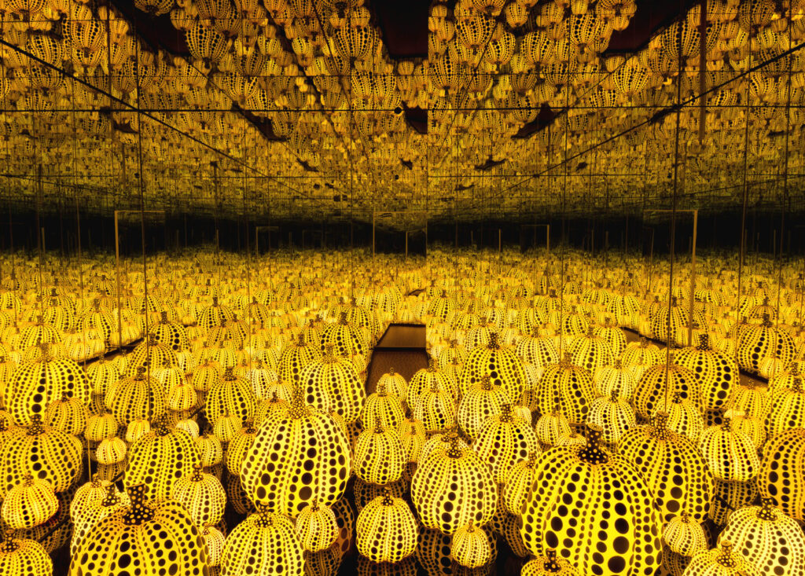(Fig.1)
Next the work of Edmund de Wall and his relationship with repetition. De wall creates numerous porcelain vessels by hand which at first glance look identical, although as he quotes “The great thing about repetition is that it’s endlessly renewing. Each return is slightly different.” (Walton 2021). In this quote it is clearly stated that although De Wall uses the same technique, the same materials and the same tools every time, every time he sits at the wheel to throw each session is different and produces slight variations in his work accordingly.
Repetition is of great interest to De Wall and interestingly it is the fact that he uses repetition to produce numerous similar looking pieces out of the same material and all generally in white that makes his work what it is. It is the whiteness of his work that is most interesting to note. The whiteness of his pieces is linked to his experiences of life, as for his family lost everything during the second world war. Everything except a vast collection of netsuke, Japanese carved sculptures. The following quote explains this further by explaining how De Wall felt after his family lost everything. “His work is haunted by these absences, these voids, these displacements”. (Lancelin 2025). In retrospect because of these losses, De walls porcelain pieces are left blank, white and vast in quantity, almost as if to represent all the things, materialistic, or even people, that he and his family have lost. You could view the ceramic pots as gravestones, each standing silently in amongst a vast cemetery, each one a reminder to something that is lost. By creating these ceramic pieces, De wall can keep the image of everything that's lost alive in his mind and importantly, keep the memories of his family alive every time he is throwing at the wheel. De walls work Signs and Wonders is perhaps the best representation of this and is the result of de wall digging up the past and bringing forth to the present day the memories of the past for the present to see.
Another of his exhibitions that De Wall uses repetition to display and bring back to life the memory of the past is his library of exile which he created in 2019. De Wall has created numerous glazed books, again all from white porcelain to stand as memorials to lost libraries. The use of blank white porcelain to coat these books is there to deliberately create blank pages, where there is nothing there to distract the viewer away from the primary fact that these books are like standing stones, built to remember something that no longer is there and no longer exists. It is not only the physical act of De Wall returning time after time to his wheel, picking up the white porcelain and throwing basically the same items that is using repetition for its also the way that the finished result of his work is all about repetition. For most of his displays are all incorporating repetitive versions of the same items. For De Wall repetition appears and influences himself throughout the timeline of his works, from the beginning of throwing to the finished display. Repetition is also displayed by the fact that basically De Wall is repeating the exact same art instillation again, for consistently his work is white, consistent in form, scale and similar in meaning. It is the mostly the same, or it could be seen as that, if it wasn't for the fact that none of his works are completely identical due to the hand-crafted way in which he creates them.
Repetition is further used within De Walls work that his works quietly contain so much energy within their ceramic walls and so many stories are told through each piece that although they visually don't look as if they are alive, they however very much are. Each piece sits in silence and silently speaks tales of sadness, loss and memory. Each piece is like how De wall must feel, full of emotion, stories and life but silent and keeping those narratives to themselves. The repetitious element of this is how De Wall knows what works for him, so as a result he continuously works the same way with silence and memory time and time over.
The ceramic collections represent humanity and the repetitious cycle of life. As each generation lives and experiences disasters and life through the good and bad, and experiences different people who come and go, every person gathers memories through their lives which are recorded or lost. Each porcelain piece easily could represent a person containing individual memories, each clinging onto something different, something from the past that may no longer physically exist.
De Wall quotes whilst talking about the process of creating his work “I remember sitting down at the wheel, throwing my first pot, then feeling this strange, transformational moment of something inert becoming alive. Then it becomes a vessel, having an inside as well as an outside. I go back the next week, and I glaze my first pot white, and then I keep going back for this somatic experience between my hands and my body”. (Edmund De Wall with Phong H 2023). By this quote De Wall tells us that the physical act of throwing and producing his ceramic ware has from the very beginning been a powerful experience. By using repetition and again repeating the same performance with his body, he can feel a powerful sense of energy through the process. When De Wall returns each time to his wheel or to the glazing area, he is not just returning to two areas of a room, but returning to a space of comfort, of familiarity and peace where his thoughts flow with ease. Overall, repetition is present in De Walls work in numerous ways even through the physical areas that he visits and revisits whilst making his ceramic creations.

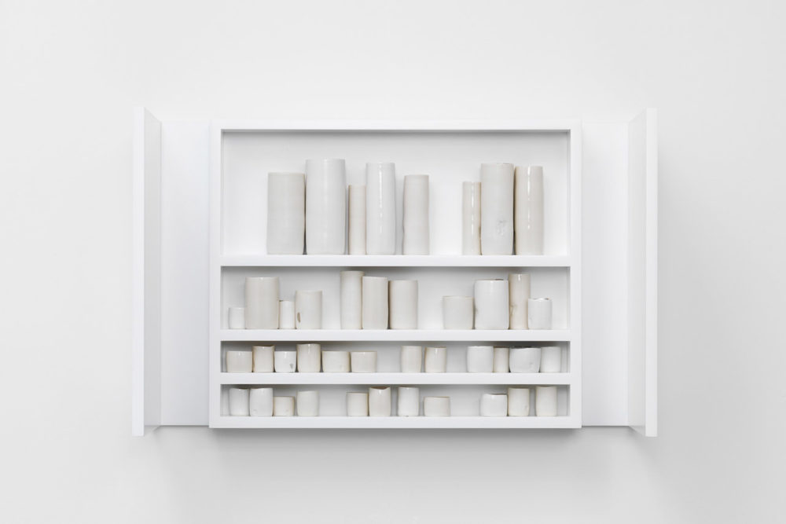(Fig.2)

Lastly the main comparisons and contrasts between Yayoi Kusama and Edmund De Wall regarding repetition and time theory, beginning with the comparisons. Both artists have been heavily haunted by images within their minds. For Kusama she is haunted by repeat patterns which form in her subconscious. For De Wall he is haunted by the past with regards to his family and in general of what has been lost to him in life and of what no longer exists. Regarding these reasons, it is these hauntings which enable to use of repetition to be so profound within both artist's work. A further comparison between both artists is that they both repeat the same basic art style time and time over throughout their careers. De Wall repeats the colour choice, style and shapes of his vessels and the material he works with. It doesn't change as for him the repetition is everything and a type of meditative rhythm for him to carry out the creative process. Kusama is similar as she always uses repeat patterns of shapes within her work to convey a similar story every time she creates a new instillation. Lastly the most important comparison is undoubtedly the way in which both artists use repetition and time and temporality to create their own environments to get into a meditative state which then helps them mentally deal with everything they have been through or that preoccupies their thoughts. This is either by losing themselves in the process of throwing on the wheel or by creating endless patterns out of mixed media.
The main contrasts between Yayoi Kusama and Edmund De Wall begin with the most easily noticeable which is the way that both artists work visually looks like. For instance, Kusama's work is heavily adorned with shape, pattern and complexity. Her work is the visual representation of her mind and the representation of chaos, anxiety and trauma. However, for De Wall his work visually represents peace, order and a silent calmness. In relation to repetition both artists use it as the basic order to create their very different styles of art. A further contrast between the two is how De Walls use of repetition within his work includes every time using the same non-existent colour palette of white which is to turn the focus away from the visual qualities of his work and instead towards the meaning behind them. To get the viewer to investigate the story behind the work more than the physical nature and attributes of the physical vessels. For Kusama her use of colour is a major player in getting across the narratives and energies behind her work to the viewer as much as possible. Her use of colour is extreme to portray the emotions and feelings she experiences within her life. Their use of or lack of colour is also governed by repetition as both artists use it repeatedly to convey their individual meanings behind their work.
To conclude Yayoi Kusama and Edmund De Wall are two very different people and two very different artists who create very contrasting work both visually and conceptually. However, what brings the two together is their profound use or repetition. Repetition is used in every circumstance for each artist, from their use of colour to the visual forms and styles of their physical work to how repetition influences their lives and the way they both cope with, understand and most importantly, enjoy to some extent, their lives. It has been seen that repetition is also linked to mental health and the mind as how it can transform from images for example within Yayoi Kusama's mind and turn into whole worlds of life, pattern and imagery, or how repetition quietly impacts and effects Edmund De Walls work. It has been seen also that repetition has the power to bring a sense of enjoyment and peace by the act of creating repeatedly in the same ways. As for Edmund De wall and how so much narrative and stories can be told through the inclusion of repetition and in the way that he uses his ceramic objects to convey meaning and showcase stories for the viewer to experience.
Overall, it has been seen that repetition is linked with time and temporality by repetitions ability to hold such strong influence over people's lives as for Yayoi Kusama and Edmund De Wall. Also, on how repetition manifests itself within the work of the artists accordingly.

List of figures
Fig.1
Kusama, Y, (2021), Infinity mirrors, (Online photograph), Available at https://high.org/exhibition/yayoi-kusama-infinity-mirrors/, Accessed 25th April 2026

Fig.2
De Wall, E, (2010), By the wall, standing, (Online photograph), Available at https://www.edmunddewaal.com/making/works/by-the-wall-standing, Accessed 25th April 2026

References
Allen, Barry, Living in Time: The Philosophy of Henri Bergson (New York, 2023; online edn, Oxford Academic, 18 May 2023), https://doi-org.uwtsd.idm.oclc.org/10.1093/oso/9780197671610.001.0001, accessed 29 Mar 2026.
Anonymous, 2021, from here to infinity, Tate modern, London. Iss.51, pp 26-31, https://www.proquest.com/docview/2916713792?RAO=true&accountid=130472&parentSessionId=I16d%2FbKPeQMWGCo%2Fsp8yf3%2B0U2EtK3E6%2BxQzKjB3m2o%3D&pq-origsite=primo&searchKeywords=yayoi%20kusama%20and%20repetition&sourcetype=Magazines , accessed, 29 Mar 2026.
Bergsons philosophy of repetition in dance, (n.d.), SCRIBD, https://www.scribd.com/document/337260233/Dance-and-Repetition, accessed 29 Mar 2026.
Edmund De Wall with Phong H. Bui, 2023, The Brooklyn Rail, Critical Perspectives on Arts, Politics and Culture. Independent and Free, https://brooklynrail.org/2023/10/art/Edmund-de-Waal-with-Phong-H-Bui , accessed 30 Mar 2026.

Herve Lancelin, 2025, The Silent Witness of Edmund DE Wall, Art Critic the Power of Words in Art, https://www.artcritic.com/en/the-silent-whiteness-of-edmund-de-waal, accessed 30 Mar 2026.
Harper, C. (2015, March 1). In the Spotlight: Dr. Catherine Harper explores the work of Yayoi Kusama and pattern’s potential to overwhelm. Selvedge (London), 63, 66–69, accessed 30 Mar 2026.
Hodges M, 2008, Rethinking time's arrow: Bergson, Deleuze and the anthropology of time, Volume 8, issue 4, https://doi-org.uwtsd.idm.oclc.org/10.1177/1463499608096646, accessed 30 Mar 2026.
Los Angeles Magazine (Vol. 62, Issue 10) Emmis Publishing L.P. dba Los Angeles, accessed 30 Mar 2026.
Mulhall, S. (2013) 'Heidegger's (Re)visionary Moment: Time as the Human Horizon' in The Routledge Guidebook to Heidegger’s Being and Time. Routledge Guides to the Great Books, London, England: Routledge, [152]-180, available: https://link-gale-com.uwtsd.idm.oclc.org/apps/doc/CX3613400016/GVRL?u=walamp&sid=bookmark-GVRL&xid=c4a456e3, accessed 19 Apr 2026.
Wakim, M. (2017) “The art of repetition: it’s been two decades since Yayoi Kusama has had a significant show in L.A. the broad hosts six of her immersive installations--and then some,” Los Angeles magazine, p.86, accessed 19 Apr 2026.
Walton, M, 2021, Repetition is Endlessly Renewing: Edmund De Wall, https://www.trebuchet-magazine.com/edmund-de-waal-interview , accessed 19 Apr 2026.
Yi, C. L, 2017, Loss, Repetition and the everyday, https://doi.org/10.15123/PUB.6362, accessed 19 Apr 2026.

