Paul Gormlie
pgormlie.149642@student.uwtsd.ac.uk
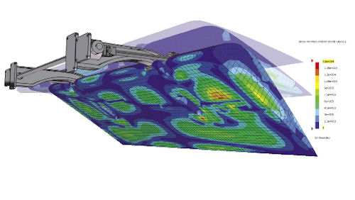

Advanced FEA and stress analysis m6x00420
Can FEA replace physical testing?
Abstract
This report will examine the advances in Finite Element Analysis and compare with traditional testing methods in a case study format.
Contents:
Introduction: 2
1. Why companies use F.E.A alongside physical testing: 3
2. How a physical test may be correlated to an F.E model: 4
3. Feasibility of F.E testing replacing Physical testing: 5
Conclusion: 6
References: 7
Appendix: 8

Figure 1: ZwickRoell composite test machinery. (ZwickRoell, 2013) 4
Figure 2: Example of cleavage tension failure, shown bottom left of image. (AZ of materials, 2001) 4
Figure 3: Modal analysis of n aerospace structure F.E model. (I. Mendoza-Muñoza, 2015) 6
Figure 4: Jaguar XE and S-type CFD comparison. (Gaylard, 2008) 7
Figure 5: Placement of virtual strain gauges on Helicopter tail structure F.E model. (R. J. Plaskitt, 2013) 8
Figure 6: Radioss crash test F.E model and physical crash test. 12
Figure 7: VVUQ flowchart 12
Figure 8: Section of rudder NASTRAN FEA model from American Airlines flight 587. 13
Figure 9: Study into MH370 mystery, modelling of Gliding water entry. 13
Figure 10: Conference proceedings from FENET discussing tech. requirements in Aerospace. 2005 14

Introduction:

The purpose of this report is to carry out a case study type analysis on the role of Finite Element Method (F.E.M) testing of engineering products in a modern related industry. The study will look at how the use of F.E.M is implemented when testing components within an industry of the candidate’s choice and how these methods compare with more traditional, physical testing methods or even how they are used in conjunction. In this instance, a study of the aerospace industry will be carried out as it is the author’s belief that this industry has the most developed F.E modelling infrastructure in place and also relies on findings from simulations in many areas of the design and validation process’ more so than most other engineering industries.
Further discussion will include, how a physical test may be correlated to a F.E model by deciphering what type of analysis may be necessary, how the model is bound and loaded methods and equipment required for physical testing and methods of correlating between physical and simulation.
To conclude the report, further discussion on whether physical testing of components can be phased out completely from the design process will ensue, with considerations to some of the items raised in the previous section explored in further detail.

Why companies use F.E.A alongside physical testing:

As mentioned previously, this study will be analysing the aerospace industry and their use of finite element testing, as this industry has been at the forefront of computer simulated testing since the very early days of this process, namely with Boeing in the early 1960’s albeit using very simplified models and basic elements to identify load paths through materials. (Abbey, 2014)
Nowadays, the aerospace industry relies on the results of F.E testing heavily in the design process of aircraft and their associated components, this reliance can be attributed to the fact that the strive for lighter, stronger and more economical aircraft is in high demand in the modern world and in order to achieve this, more and more manufacturers are utilizing composite materials for their designs. (Peeters P.M., 2005). The use of composites poses an issue when it comes to physical testing in the aerospace sector due to the complexity of the fibre construction. This area has been studied extensively in aircraft design, particularly in relation to modelling of wings and fuselage components that may encounter bird strikes or tool damage to the laminate layers during manufacture or transport, or indeed in flight.
Studies carried out by Myler and Farook (Umar Farook, 2016) have used finite element method to predict the possibility of delamination of composite materials when encountering a strike from a blunt object, utilizing Abaqus™ software to non-linearly analyse the components and determine their failure modes. The ability to perform these simulations is invaluable in this instance, as physical testing of the impact strains would be extremely difficult in these complex materials due to their orthotropic and quasi-brittle nature.
The results of their study concluded that the simulated model could accurately predict laminate failure based on Hashin’s failure criteria, hence highlighting the credibility of the F.E simulation in relation to composite materials.
Conversely, physical testing of components is still widely used in the aerospace industry due to the demand for impeccable safety of aircraft and strict regulations imposed by transport authorities worldwide.
These physical tests must be carried out on the composite materials to determine the flexural and compressive stresses encountered by the components in order to validate simulated data in these areas, as these properties cannot be predicted from empirical tensile properties (ZwickRoell, 2013).
In order to perform the required testing and meet international standards, new testing equipment has been developed, specifically for the purpose of testing composite materials whereby a 9-component stress tensor is utilized to account for the material complexity and provides greater accuracy in results.
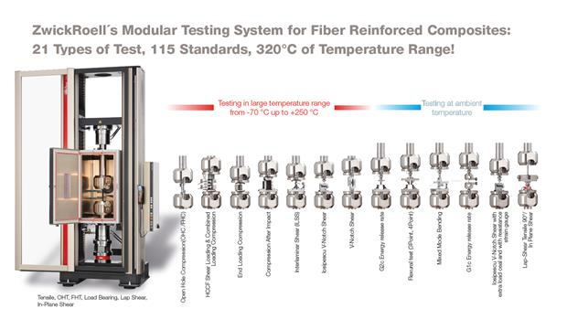
Figure 1: ZwickRoell composite test machinery. (ZwickRoell, 2013)
Another area that F.E analysis is used in aerospace, is in the analysis of air-crash investigations. Many accidents in the past have utilized the power of these analyses to find the cause of a failure of an aircraft component due to fatigue or abnormal loading due to contact with an object.
Most notably in the case of the MH370 mystery, where a suspected piece of debris from the flight was recovered from the ocean, part of a flaperon. When the damage was inspected, investigators had to determine if the part had fallen from a supposed height of 5000ft, the aircraft’s last known altitude or was it still attached to the plane as it made contact with the surface of the ocean? By creating an FEA simulation of both scenarios, including wave movements , tides and the projected flight path of the aileron from this altitude, engineers were able to ascertain that the aileron was in fact still intact as the plane struck the ocean, it was also possible to determine the position of the aileron from the damage incurred and although the mystery remains unsolved, some light was shed on the final movements of the aircraft as a result of these findings, suggesting that the aircraft may have been ditched.
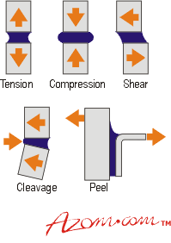
This process was also used in the case of American Airlines flight 587 and actually resulted in the cause of the accident being established by using the F.E data, along with flight data recorder data to recreate the static and dynamic loads encountered by a failed mounting lug on a vertical stabiliser, which was subsequently physically tested in the laboratory and conclusively proved the failure mode as a cleavage-tension failure at the mounting lug holes on the composite stabiliser structure. (Griffioen, 2009)
Figure 2: Example of cleavage tension failure, shown bottom left of image. (AZ of materials, 2001)

How a physical test may be correlated to an F.E model:

When attempting to correlate or validate F.E models, the procedure can be split into two distinct areas, linear and non-linear. (Harish, 2019) (neglecting thermal, buckling, NVH etc. for the purposes of this section). Each of these areas of analysis has a critical impact on the validity of the results from the F.E test and will directly affect how they correlate with the physical test.

2a. Linear Analysis:
In a static or quasi-static linear analysis, the stiffness matrix will not change when loaded, loads are applied gradually and the accelerations within the system considered negligible, (i.e. displacement/time) and the results will only display as a comparison of values for stress encountered vs. U.T.S or yield stress (Altair University, 2015). Generally, linear static analyses will deal with small deformations.
For dynamic linear analysis, a system exhibiting simple harmonic motion could be considered, as the mass in the system will oscillate linearly as a function of force applied and spring stiffness.

2b. Non-linear Analysis:
Non-linear analysis should be considered in a material sense when materials are expected to exceed their yield strength, whereby they encounter plastic deformation and the stiffness matrix alters, the F.E analysis must account for this change in stiffness iteratively in order to yield favourable results. Consideration must also be given to geometry of the part being analysed non-linearly as large changes in geometry will also affect the results of a study as the material deforms. (Altair University, 2015). Non-linear analysis can be useful in analysing crash safety evaluations using software such as Altair Radioss.
With dynamic non-linear systems, the response of a system can be found analytically by implementing differential equations, this can be performed in an F.E analysis and provides a good benchmark for expected response that would be difficult to replicate experimentally.

Correlation:
In the first instance, a physical experiment may be carried out on a material or a structure, whereby the estimated loads are applied to the structure and a variety of tests performed to determine stress, strain and deformation. Specialist equipment is required such as, strain gauges and load cells that measure these parameters accurately, and naturally the test machinery itself that can apply the necessary loading, whether it be compressive, tensile, shear or bending amongst many others.
Using classical analytical methods, a simplified model of the structure can be assessed quickly and conclusively and will generally provide 100% accurate results for the simplified structure, this is useful for linear static studies and can be compared with the prototype physical test results to determine validity.
The numerical results from the F.E model can then be compared to both previous methods to then ascertain validity also. Generally, in the first instance F.E results will not correlate with experimental or analytical and will require reconfiguration of the model parameters, boundary conditions, mesh quality and determination of local stress concentrations (Proulx, 2011).
It is suggested that correlation within 10-15% between experimental and F.E.A models is considered successful. (Altair University, 2015)
As an aside relating to aerospace:

2c. Modal Analysis:
In the case of the aerospace industry, modal analysis is an extremely important aspect of F.E.A, as this area is often used to determine the aerodynamic response of aircraft structures in a given frequency range. Modal analysis is used to determine phenomena such as “flutter” on aerodynamic surfaces that may result in a loss of dynamic stability in the aircraft due to wind-shear or other unexpected factors affecting the dynamics of the aircraft structure. (V. Quaranta, 2013) Vibration can also be modelled using modal analysis, again particularly useful in aircraft engines where resonance could prove fatal. Rigorous standards exist for these analyses and several levels of validation are required to correlate F.E models in this procedure.
To correlate modal F.E analyses, physical experiments are set up that excite the component or structure using a modal shaker device and measure its response at its natural frequencies, by means of accelerometers fixed to the structure. This also determines the mode-shapes and damping co-efficient for the particular frequency. The F.E model is then created, and the same loads and boundary conditions applied within the software and results compared regarding deflection and comparison of mode-shapes. (Crystal Instruments, 2016)
If results are found not to be in agreeance, it is possible to adjust the mass (inertia) of the component, redesign the model and/or increase or decrease the stiffness of the material thus allowing correlation for a particular mode.
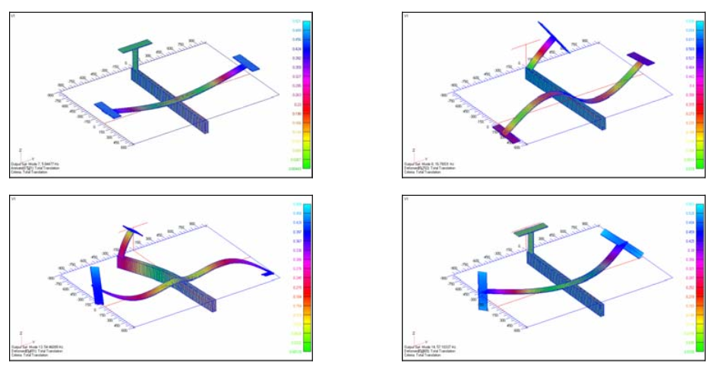
Figure 3: Modal analysis of n aerospace structure F.E model. (I. Mendoza-Muñoza, 2015)

Feasibility of F.E testing replacing Physical testing:

At the current time, we are not yet at a stage where F.E simulations can fully replace physical testing. Many advances have been made in this field, but the requirement is still there to physically test components and materials in order to provide certification and conformity to standards. This is of particular concern in the aerospace industry as previously discussed.
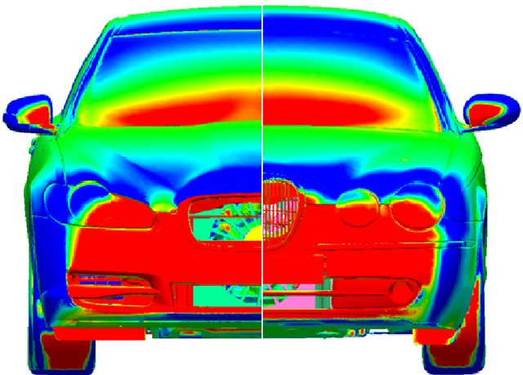
Possible methods of moving towards complete reliance on simulation results are in practice today, with many aspects of simulation being relied on fully, particularly in the areas of CFD and crash testing. As an example, the Jaguar XE was fully modelled and certified with a co-efficient of drag of 0.26 without a single prototype being built. (Vyas, 2015).
Figure 4: Jaguar XE and S-type CFD comparison. (Gaylard, 2008)
This process resulted in massive cost benefits in the development of the vehicle by making the requirement for wind tunnel testing and clay modelling etc. obsolete. (Schweinsberg, 2015). It is estimated that more reliance in these areas could save car manufactures between $3-10 billion per year in the United States alone.
The advent of exa-scale computing is providing a platform by which many environmental considerations can be included in global F.E models thus providing a more robust picture of loading, boundary and environmental conditions, this is made possible by the huge computing power available through cloud computing with up to 10¹⁸ calculations being performed per second.
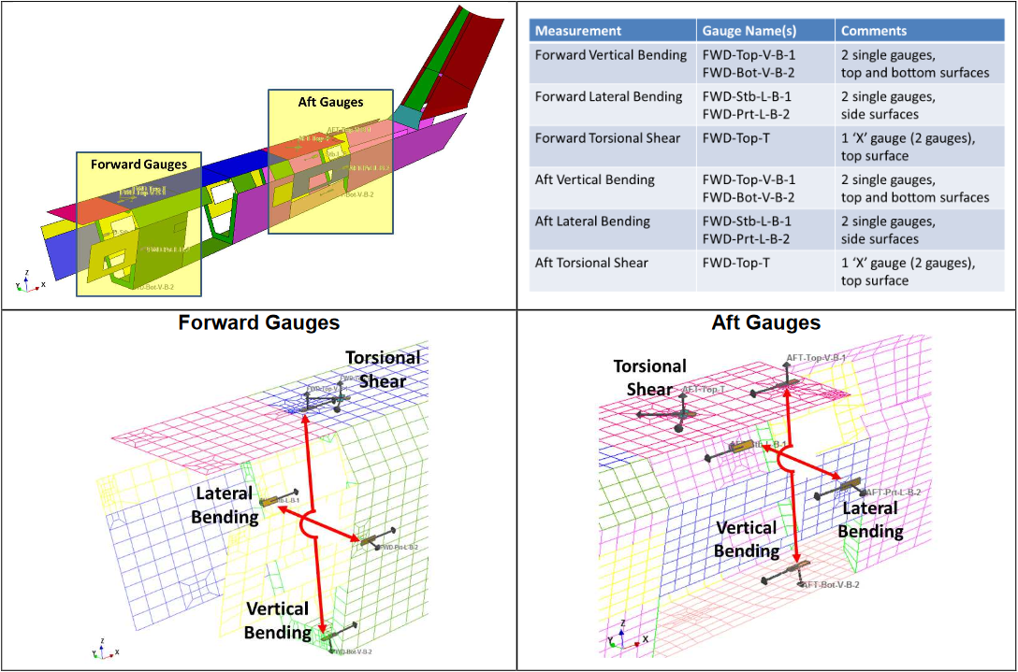
This also leads on to the development of software based measurement devices, such as virtual strain gauges, developed by companies such as Altair (Virtual Gauge Director) and nCode becoming more commonplace in the automotive and aerospace industries, whereby a virtual strain gauge is placed in the F.E model at the same position as a physical gauge would be on the real-life counterpart. This would eliminate the requirement for a physical test in various applications by allowing correlation of previously collected data and again, could result in massive time and cost benefits for manufacturers.
Figure 5: Placement of virtual strain gauges on Helicopter tail structure F.E model. (R. J. Plaskitt, 2013)
Although still expensive technology, this is a game changer for industry as it provides greater corroboration with materials and structures non-linear behaviour when encountered by a real-world scenario, and also can iteratively model F.E at the macro-scale and cellular automata at the mesa and micro-scales as proposed by Shterenlikht et al. (Anton Shterenlikht, 2017) to predict crack propagation in composite materials.
As this technology becomes cheaper and more readily available it is possible that we could see a shift towards full simulation capability and reliance within the next 10-25 years, provided the same rate of progression follows.
An area that is also important in the simulation field is Verification, Validation and Uncertainty Quantification (VVUQ), this is a framework designed to assess the credibility of simulations by ensuring that correlation is met by verifying mathematical models with F.E, validating the model against real world scenarios and applying comparisons between physical and experimental results to understand uncertainties in the simulation. These frameworks are currently supported by the ASME and provide clarification in credibility of simulation results if VVUQ policies are adhered to. (American Society of Mechanical Engineers, 2020).
This is a step in the right direction to provide reliable, repeatable and accurate standards in the simulation and modelling industries and when further developed could see a marked increase in the use of standalone F.E.A methods becoming widespread in industry, coupled with the aforementioned practices.

Conclusion:
This report has conclusively discussed the various reasons why companies, in particular aerospace companies use finite element methods in parallel with traditional physical test methods in the design of their components and structures. These methods allow for greater understanding of the dynamic loads encountered by said components, in a flight environment that would be difficult to replicate with physical testing, being the main point. It also allows for a greater understanding of the product lifecycle and a more detailed fatigue analysis which is prevalent in the industry due to the cyclical environment in which it operates.
Various methods of analysis have been discussed and practices which are commonly used to correlate them within industry. This has also touched on some of the equipment required and specialist methods undertaken in the aerospace industry, although only brief discussion has commenced regarding these methods, it does give a basic insight as to how the results may be correlated as the entire field may be a little outside the scope of this report.
To answer the question of whether or not F.E testing can replace physical testing, as previously mentioned the most likely answer is no, at the moment there is still a lot of reliance on physical experiments to verify and calibrate the F.E models, if the VVUQ framework is adhered to however, and the implementation of extremely powerful processing, there may be a paradigm shift towards full reliance on simulated results in the near future.

References:
Abbey, T., 2014. Flying with structural FEA. [Online]
Available at: https://www.digitalengineering247.com/article/flying-structural-fea/
[Accessed 24 March 2020].
Altair University, 2015. Practical aspects of Finite element simulation. 3rd ed. Troy, MI: Altair University.
American Society of Mechanical Engineers, 2020. Verification, Validation and Uncertainty Quantification (VVUQ). [Online]
Available at: https://www.asme.org/codes-standards/publications-information/verification-validation-uncertainty
[Accessed 05 April 2020].
Anton Shterenlikht, L. M. S. M. N. K. B., 2017. Towards mechanism-based simulation of impact damage using exascale computing. Online, AIP Publishing.
AZ of materials, 2001. Adhesives - Application and Joint Design. [Online]
Available at: https://www.azom.com/article.aspx?ArticleID=190
[Accessed 07 April 2020].
Crystal Instruments, 2016. Basics of modal testing and analysis. [Online]
Available at: https://www.crystalinstruments.com/basics-of-modal-testing-and-analysis
[Accessed 03 April 2020].
G. Boothroyd, P. D. W. K., 1994. Product design for manufacture and assembly. 1 ed. New York: Marcel Dekker.
Gaylard, A., 2008. ResearchGate. [Online]
Available at: https://www.researchgate.net/publication/245535453_Aerodynamic_Development_of_the_New_Jaguar_XF/figures
[Accessed 29 March 2020].
Griffioen, H., 2009. Air crash investigation, The crash of American Airlines flight 587. 1 ed. -: Mabuhay publishing.
Hans Peter de Koning, D. F., 2005. A REVIEW OF FEA TECHNOLOGY ISSUES CONFRONTING THE AEROSPACE INDUSTRY. Valetta, Malta, FENET.
Harish, A., 2019. Simscale - What Is Modal Analysis and Why Is It Necessary?. [Online]
Available at: https://www.simscale.com/blog/2016/12/what-is-modal-analysis/
[Accessed 06 April 2020].
Hearne, E., 1997. Mechanics of materials 1. 3rd ed. Warwick: Butterworth-Heinemann.
Hearne, E., 1997. Mechanics of materials 2. 3rd ed. Warwick: Butterworth-Heinemann.
I. Mendoza-Muñoza, V. N.-M. A. G.-Á. M. S.-H. L. M.-A. M. M.-R., 2015. Design analysis of a machined part in a single step to replace a structural component assembled through non-destructivetesting and FEA. Science Direct, 132(1), pp. 561-568.
Peeters P.M., M. J. ,. H. A., 2005. Fuel efficiency of commercial aircraft - An overview of historical and future trends, Ede, NL: National Aerospace Laboratory NLR.
Proulx, T., 2011. Advanced aerospace applications, Vol. 1, Proceedings of the 29th IMAC, A conference on structural dynamics. Bethel, CT, Springer.
Pugh, S., 1996. Creating innovative products using total design. 1 ed. Reading, Ma.: Addison-Wesley.
R. J. Plaskitt, A. H. P. R., 2013. Using virtual strain gauges to correlate with bending and torsion measured on a helicopter tail cone using strain gauges., Rotheram: nCode.
Schweinsberg, C., 2015. when the wind tuinnel is not enough. [Online]
Available at: https://www.wardsauto.com/technology/when-wind-tunnel-not-enough
[Accessed 09 April 2020].
Umar Farook, P. M., 2016. Finite element simulation of damage and failure predictions of relatively thick carbon fibre-reinforced laminated composite panels subjected to flat and round noses low velocity drop-weight impact.. Elsevier, Volume 104, pp. 82-105.
V. Quaranta, I. D. M. d. G. D., 2013. Modal Analysis on a Schematic Aerospace Structure: FEM Simulation and Experimental Updating, Capua, Italy: Italian aerospace research centre.
Vyas, K., 2015. Can Simulation Tools Replace Physical Tests Completely?. [Online]
Available at: https://www.designworldonline.com/can-simulation-tools-replace-physical-tests-completely/
[Accessed 9 April 2020].
ZwickRoell, 2013. Solutions for Materials Testing for Aerospace Composites. [Online]
Available at: https://www.azom.com/article.aspx?ArticleID=8480
[Accessed 1 April 2020].

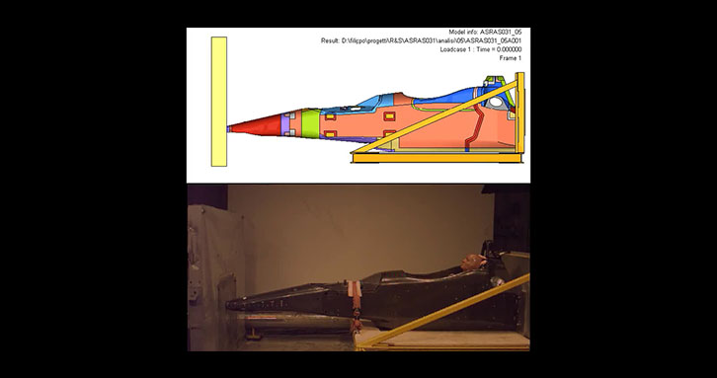
Appendix:
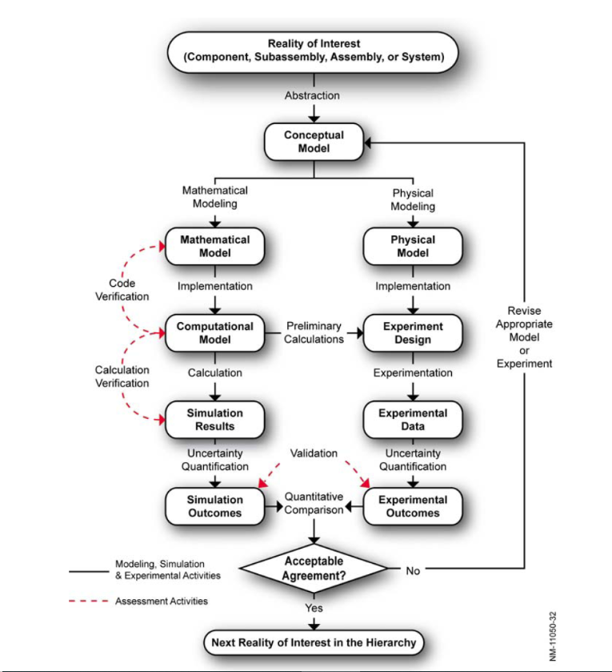
Figure 6: Radioss crash test F.E model and physical crash test.
Figure 7: VVUQ flowchart

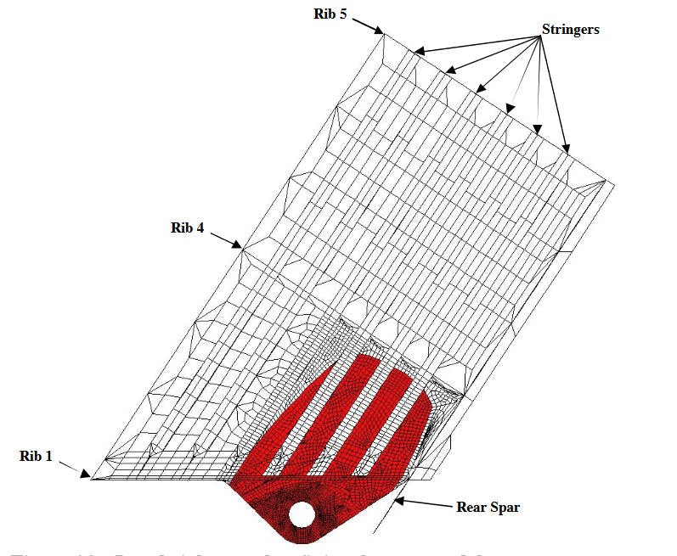
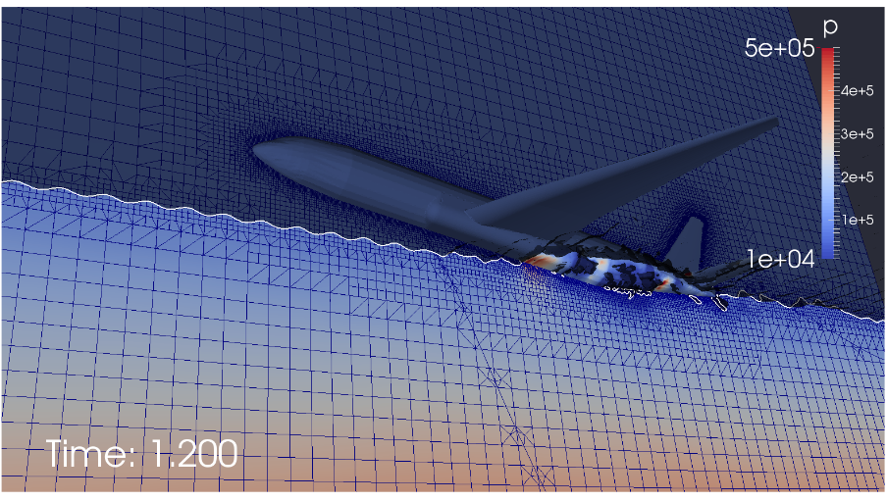
Figure 8: Section of rudder NASTRAN FEA model from American Airlines flight 587.
Figure 9: Study into MH370 mystery, modelling of Gliding water entry.
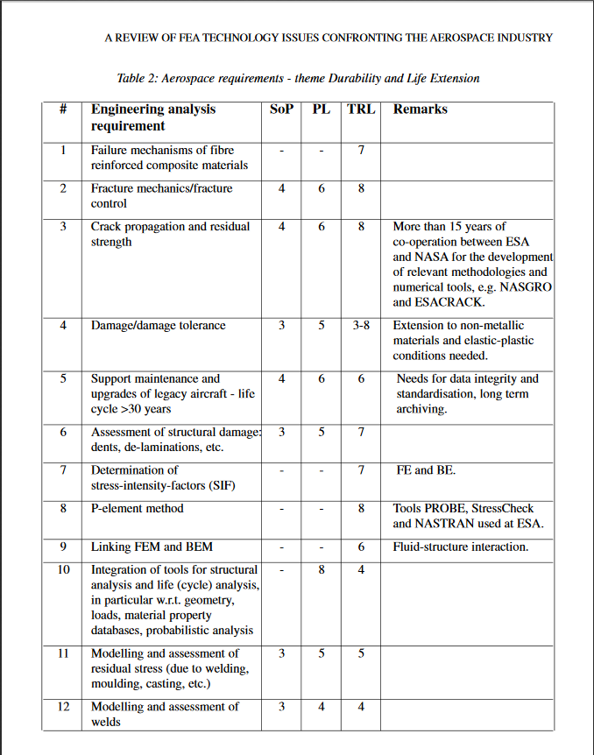
Figure 10: Conference proceedings from FENET discussing tech. requirements in Aerospace. 2005

