

Odd 2 Even
by
Meher Kiran Arasada

Supervisor: Gaynor Thomas
Second Marker: Mabrouka Abuhmida

Project submitted as part of the requirements for the award of MSc Applied Computing

September 2019

DECLARATION

I, .......................................MEHER KIRAN ARASADA………………………………… declare that I am the sole author of this Project; that all references cited have been consulted; that I have conducted all work of which this is a record, and that the finished work lies within the prescribed word limits.

This work has not previously been accepted as part of any other degree submission.

Signed : ......Meher Kiran Arasada........................................

Date : .......September 2019........................................

FORM OF CONSENT

I .......................................MEHER KIRAN ARASADA………………………………… hereby consent that my Project, submitted in candidature for the MSc Applied Computing degree, if successful, may be made available for inter-library loan or photocopying (subject to the law of copyright), and that the title and abstract may be made available to outside organisations.

Signed : ......Meher Kiran Arasada.......................................

Date : ......September 2019.........................................

Abstract
This piece of work focuses on applying usability testing in the agile methodology with the help of an application called Odd2Even. The aim of the Odd2Even project is to develop high-quality interactive software for the users who perform usability testing within the agile methodology. This is done by means of software model-driven activities and continuous assessment in which some usability evaluation techniques have been suitably integrated at the end of the development. The approach presented here has been used in the development process of a web application, which can also be a mobile application because it has been developed as a Progressive Web App (PWA). An attempt has been made to prove it is possible to correctly integrate usability evaluation techniques in agile methodologies, such as Odd2Even. On the one hand, this integration promotes development tailored and designed to users’ expectations; on the other hand, it helps to plan the agile process of activities. In this project, agile methodology has been used to manage these challenges. Also, improvements have been made in the steps involved in the development process.
HTML, CSS, and JavaScript were used for the Odd2Even web application development since PWA is a modern web compatibility to provide an app-like experience to the consumers. The deliverable of this research is a web application and the findings from usability testing within the first sprint of the agile methodology. End users have been recruited to perform the usability testing who have provided their feedback using the questionnaire provided.
Projects or applications can be developed by using an agile lifecycle where a group of people are involved in the development and testing. The process and purpose of this lifecycle is to find the issues during the initial phase of the development and fix them immediately rather than identifying at the end of the product completion. Progressive Web application acts like an app and some of the companies using it are Starbucks, Uber, MakeMyTrip, etc., because it saves the memory of the mobile phone which is one of the major advantages for the customers. Additional pros and cons have been discussed in much detail further within the project documentation.
It is expected that the usability testing can be implemented within the cycle of the scrum to improve software and overcome challenges like lack of users’ participation in testing and lack of software quality. As part of the results gathered from the survey, suggestions were implemented in the development as a proof of concept.
Contents
Abstract 3
Figures 6
Tables 6
1. Introduction 7
1.1 About the App 7
2. Literature Review 8
2.1 Search Terms 8
2.2 Existing Apps 8
2.3 Proposed Application 10
2.2 Agile Methodology 10
2.3 Usability Testing 12
2.3.1 What to test 13
2.3.2 How many to test 13
2.4 Associated Work 14
2.5 Case Study 15
3. Research Methods 15
3.1 Survey 15
3.1.1 Initial Questions 16
3.1.2 Initial Survey Design 17
3.1.3 Result of the pilot survey 17
3.1.4 Final Survey Design 18
4. Design of Application 20
4.1 Requirements 20
4.2 Progressive Web Applications 21
4.3 Database 27
4.4 Database Connection 29
4.5 Updating UI 32
4.6 Offline 33
4.7 Push Notifications 35
5. Results and Discussion 39
5.1 Objective 39
5.2 Usability testing story 39
5.3 Find Participants 40
5.4 Pilot test 40
5.5 Invite participants 40
5.6 Feedback 40
5.7 Discussion on Feedback 42
5.8 Usability testing within Agile 48
6. Conclusion 49
7 Recommendations and Future work 49
8. Personal Reflection 49
9. References 51

Figures
Figure 1: Meerkat - 2 for 1 on food and film 9
Figure 2:2FOR1 9
Figure 3: Agile team: Range of stakeholders managed by product owner [16] 11
Figure 4: Flow of user story [18] 12
Figure 5: Before a pilot survey was performed 16
Figure 6: Add app to the home screen in a mobile device 21
Figure 7: Mobile Version Figure 8: Web Version 22
Figure 9: Service Worker 23
Figure 10: IndexedDB supporting Browsers [39] 25
Figure 11: Application Audit report 26
Figure 12:Odd2Even NoSql Database Schema 27
Figure 13: Collection in Database 28
Figure 14: Unique ID in the document 28
Figure 15: Add field, edit and delete options 29
Figure 16: Register Firebase App 29
Figure 17: snapShot object with docChanges 31
Figure 18: Type of changes 31
Figure 19: App in an offline state 33
Figure 20: App offline state with data display 35
Figure 21: Plan of the Survey 39
Figure 22: Age group and Home Country 42
Figure 23: Appearance-based on gender 43
Figure 24: Combination of Appearance and Navigation 43
Figure 25: Appreciable Loading time 44
Figure 26: Design Improvement 45
Figure 27Content related to App is missing 46
Figure 28: Easy to finish the task 47
Figure 29: App rating (out of 5) 47

Tables
Table 1: Number of participants by testing technique 14
Table 2: Prioritised requirements 20
Table 3: Participant's Feedback 41

1. Introduction
Nowadays many people are doing business and operating it globally and the business environment is rapidly changing. People need to act in response to the new technology, opportunities and changing economic conditions. People start working with new technology when required and incorporate new changes in their lifestyle like clothing, entertainment, food, travel, etc., Software is part of most of the business activities because most people use a smartphone these days where they try to do everything online. So, businesspersons need a software application through which customers can discover them easily. New software needs to be developed quickly to take advantage of the market and to avoid competitive pressure. Developing a software application quickly is therefore the most critical requirement for all businesses. Businesses are willing to trade-off software quality and compromise on their requirements if IT teams or companies can deploy essential new software quickly.
In a plan-driven software development process, the complete requirements followed by the design, structure and testing the application is not rapid software development. More time will be consumed before delivering the application and changes in the requirements cannot be implemented in the middle of the development and debugging the errors at the last stage will have an impact on meeting the project timelines. Therefore, a conventional waterfall or a specification-based testing process is usually a lengthy one. It has been recognized that the rapid change of requirements can be handled in parallel to the development and testing which has implied in starting or running more software development projects within the organization at the same time. However, faster software development really took off in the late 90s with the development of the idea of “agile methods” such as Extreme Programming (Beck 1999), Scrum (Schwaber and Beedle 2001), and DSDM (Stapleton 2003) [1].
Usability is a key element of testing for every project or product development lifecycle. Every client requires this testing because consumers need an application or an app which is user-friendly. This testing has traditionally been performed at the end of the project or when it is ready to publish but why not at the initial stages / cycles of the development? This project will undertake the research around applying usability testing in a software development life cycle which uses agile methodology.

About the App
The concept of this app, titled “Odd2Even” is to allow the users to check and/or send a request to the fellow users asking them to join them on any offers such as “2 for 1” to save some money. This is not just limited to “2 for 1” type offer but they can also use this for other offer types too, for example “2 for £20”, “buy 1 get 1 free” and many more similar offers that are available in their local area.
If a user sees any offer on the high street and is looking for someone else who is interested in the same offer, then the user can post the offer. They can also reply to another user who has posted. It would be difficult for some of the users to type a complete offer so instead of typing, it is proposed that the users are also able to take a picture and upload it into the app.
This app acts like an intermediate search, connect and share platform for the end-users where it consists of a customer database, their events, offers, etc. There are existing apps that are like similar to this concept, but they are confined to company’s own products. Whereas this app is open source to all the consumers who can promote their product offers and end-users who are really interested in saving money.
People might be thinking about why this app is necessary as they can see the offers in daily newspapers or by surfing the internet. In the present world, reading the newspaper is very less rather buying it physically they are using e-paper and reading it online [2]. There are several considerations regarding the lack of people reading a newspaper. At first, people tend to have a sense of the nature of economic behavior. If there is a free thing we can get, then they feel not to buy. So, that is the reason that we commonly found in people’s minds. This is a tough time for newspapers and they are facing financial crises [3], and the internet can offer many things that a physical paper cannot.
This app should be a lightweight app so that it does not occupy much space on the mobile, should be able to look at any offers posted by other users even with limited connectivity and load the pages quickly. This app is then proposed to be developed with a concept called Progressive Web Application which is an open echo system developed by Google which satisfies all of these requirements.

2. Literature Review
This literature review was completely based on the usability testing within the agile methodology and the name of this literature was ‘’Usability testing within the Agile methodology”. Articles published related to this title were found in ACM digital library and IEEE Xplore digital library.

2.1 Search Terms
Based on the name, the databases were searched using the search terms ‘progressive web app*’, ‘usability testing’, ‘performance testing’, ‘cloud’, ‘agile’, ‘agile methodology’, and ‘sprint’ and combining them with Boolean operators like ‘and’/‘or’. The search resulted in 64 articles from ACM digital library and 67 from the IEEE Xplore digital library which are relevant to the topic area. These were further refined in the ACM digital library and found 14 articles that are relevant.
During the search in some of the articles [4] [5], there is a term called user-centred design(UCD), which is one of the testing processes usually performed by the designers.

2.2 Existing Apps

There are some applications that are related to the proposed application, but they are not the same. A few of the such apps are “Meerkat” and “2for1”. The Meerkat application, which occupies space of up to 36MB in the mobile, is used to avail the offers or discounts only if you are already a member of it. Whereas when compared with the proposed application, users can browse through the offers without having to register or be a member of. The proposed application will not occupy much space in the user’s mobile phone because it is developed as a Progressive Web App. Literally speaking, there is no exact application or a similar application to compare to but the common thing in these applications is sharing the information regarding deals.

Figure 1: Meerkat - 2 for 1 on food and film
Figure 3 is an advertisement sent to email to raise awareness of this application. This application compares the deals between products. When a product is bought from this application and the product qualifies for 2 FOR 1 deal, then the coupon will be given to that user who bought the product. So, the concept of the Meerkat application and Odd2Even application is different with a commonality about offers. Meerkat is the concept of comparing the different products present in the market, whereas Odd2Even provides information about specific deals and users will also be able to add the deal. Whereas users and ratings of the Meerkat app are adequate to say that the app is still existing.
There is another similar app called “2FOR1” and again this app shows all the deals added in this app and users can allow their current location to the app which show offers around their location. But all the deals are related to food near your location. The user needs to check whether any deals related to food are available if so they can avail themselves of the deal and enjoy the food.

Figure 2:2FOR1
Figure 4 is the logo of the application and it gives the best deals in the best business area. The 2for1 app was developed only for iOS and Android devices but not to the latest versions [6] [7]. This application cannot be used without having to download the app from the App Store or Google Play. Which means it takes up about 19MB of mobile space. This application can be a competitor in terms of its concept as it is a bit similar to Odd2Even but not quite the same. With Odd2Even application, users can also ping other users asking them to share the offer which will then save some money, for example with 2 for 1 offer on a movie, user can share that price with the other user without having to be friends or connected permanently on the app.
We can see some of the applications which are individual to one specific concept but not altogether like food, travel, shop, and movies. Most of the applications are related to the movies, food and few of them are related to shop and travel. And the above application 2for1 fro Android is still in progress as the login functionality wasn’t working even after the registration and it is redirecting to the play store where the version of app was not supporting the latest android devices.
The now-defunct mobile operator Orange has began to offer 2 for 1 movie tickets on Wednesdays back in 2003 to Orange customers [8]. This also allowed Orange customers to share the offer with their friends who do not necessarily be with Orange network. To avail themselves of the offer or coupon, all customers had to do was apply by the test message and Orange network will send back a code to use when buying the tickets. Orange and T-Mobile announced their merger in 2010 [9]. Meerkat Movies has then taken over, offering both Tuesday and Wednesday after the end of Orange Wednesday offer [8].

2.3 Proposed Application
There are competitors as stated above, but with some conditions. Users are locked into individual companies. It is not easy for users to avail themselves of a deal if they are a single person. Odd2Even is proposed to providing information about the offers or deals across many companies (not offering the offers or deals themselves at present). People with small businesses could increase their business by placing their offers in this application, which might not be costing much. Customers may also add offers or deals if they do not already exist in the application, which is also helpful for the people who are running small businesses.
The idea of the proposed app is that if the users see any offers on the high street and are looking for someone else who is interested in the same offer, he/she can use this app to check if anyone else is ready and posted similar interest. If yes, then ping the user to see if he/she can come now or arrange a time that is convenient for both. If no same offer is found, then add a new event with the picture of this offer and see if anyone else is interested who are online and can come to the place of the offer. It is not compulsory for the users to communicate among themselves through this application. They may communicate via different means with their mutual understandings.

2.2 Agile Methodology
Agile methodology was adopted by software engineering companies to deal with common problems present in the traditional software methodologies such as costly software modification and delay in the development process as a whole [10]. A period that is allocated for a particular phase of the project is known as sprint and it is a complete cycle in agile methodology [11]. Sprints are completed when the time period expires. To develop a successful product with an agile approach, a prioritized list of features and some capabilities are required. A scrum is an agile approach for developing a product and service [12]. The main advantages of this methodology are to improve productivity, motivate the development team, flexibility, predictable cost, delivering within the timeframe, transparency, improved quality, quickly adaptable with the changes, reliability, early and predictable delivery [13].
There will be continuous planning, testing, integration, and evaluation of the project. There will be regular communication between the customer and the project team, not just at the end and the beginning of the project but also through project life cycle. The advantage of this communication is, can be handled at the time of major changes like requirements, change in design, change in software and environment changes before the project is been delivered. So, most customers prefer the agile team because they will be involved in the process of product development. There are high chances of resolving the errors in the early stage rather than identifying at the end of the project.
Scrum uses iterative development, where each 30 days iteration is called “sprint” [14]. For an easy understanding of the developer, the project is broken down into some manageable units. These units can make the developer focus on developing and testing quality code. Whereas in the Waterfall model there is no sprint concept. The development team can decide initially i.e., before developing the product, what can be completed within the sprint or a timeframe. They start the development and deliveries of their piece of work to the customer which is planned in that timeframe. There will be teamwork where each concept of the project will be discussed before taking the initiative of the project development. Ultimately the team will achieve the goal as per the customer requirements within the timeframe.
Extreme programming (XP) is a more disciplined approach to the Agile project management where there will be a high customer involvement, continuous planning, thorough testing, close monitoring of teamwork, feedback loops to deliver working product quickly. In this programing, the period or timeframe of the sprint has been reduced from 30 days to one to three weeks [15]. Most of the companies generally take two weeks as a sprint for giving a meaningful delivery of the product. Here team must prioritize, estimate and plan the delivery within the time by grooming user-stories, which helps in getting the product in a systematic approach. Daily reporting to the stakeholders, so that easy to understand the progress of the project. Communication helps in taking off the ego between the stakeholders and keep them on track and solving the issues if they are struck with the application or software.
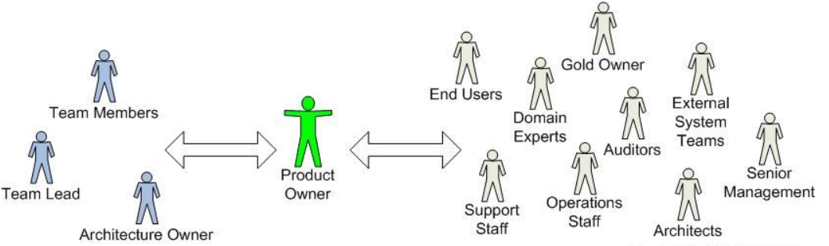
Figure 3: Agile team: Range of stakeholders managed by product owner [16]
Figure1 gives an idea of an agile team. A small agile team needs an architecture, team member and a product owner. XP and Scrum are the most popular agile methods which have more directed cycles [17]. The key point of the agile approach was not defining the tasks, but what the client has understood about the features is the priority.
The agile process starts by writing user stories. User stories are a simple and short line of words formed through customer requirements. These are generally handwritten because these were formed during meetings in regard to discussing the project development. After creating the user stories, they get prioritized and proceed accordingly. The flow of the user stories is shown in figure 4.

Type of user
Specific Goal
Specific Action

Figure 4: Flow of user story [18]
These are written to cover large functionalities; such type of user stories is said to be epic. These are divided into small stories to cover the functionality in a focused way.
As part of this project development, it is not possible to implement this agile methodology because of the size of this project which has just one developer apart from the client. A scrum or XP requires an architecture, team member and project manager to handle the deliveries of the sprints and communicate with the client. But, this project or development of the product has undergone like the Waterfall life cycle model as step one is gathering the requirements, step two is analyzing and designing the requirements, next is development, testing and then delivering the product. Agile best practice should contain sprint for a new release in a short cycle, sprint planning like technical estimates and business priorities, daily meetings to know the status, pair programming like two developers working on the same system, and refactoring means making some changes in software without disturbing the functionality [19].

2.3 Usability Testing
A product is developed for the customer who can access and accomplish their needs without any trouble implies that the product has gone through usability testing. Making things more functional and easier to use is part of large control of user-centered design (UCD), which covers a few methods and techniques. Most of the companies prefer to go with usability testing and spend more money and time on satisfying the customer experience for improving their business. Nowadays most of the users have some exposure towards the technical knowledge of computers and smart devices, have more patience for playing with the product before purchasing and might also have completely different thinking around the designs compared to those designers.
Most of the designers are now trained professionals educated in computer interaction, or computer science or a combination of these. The design of the usable product is difficult, unpredictable work, yet many organizations consider it as just “common sense” [20]. Usability goals and objectives are usually specified in measurable terms (which is said as ratings) of one or more of the aspects. While the ratings can tell us whether the product works or not and at the same time it also helps in identifying the problems within the app when a low rating was given. It would be better for the designers to go with iterative design and testing i.e., the process of design, test, redesign and retest activities which gives a better shape for the product [20]. Minimizing the design problems will help the organization to maintain a good relationship with the customers, improves the reputation of the company, customers will have a good feeling that the organization is caring for them and trust all the products delivered by that organization. Customer finds it useful, effective, efficient and satisfying only when the released product is user-friendly.
It is always better to have a professional to do a better job of usability testing of a product. In addition to have an experienced designer and perform tests, a professional will have seen the usability problems many times before and will know a lot about the solutions. The problem is that, most website clients cannot afford to hire a professional distinctly. At least one round of testing is preferred to be done with the professionals so that there is a chance of identifying and fixing the major issues [21].
The usability test identifies areas where people struggle with the product and help you make recommendations for improvement. It helps in identifying how people are interacting with the product and which areas need to be improved based on the results. The main intention of usability testing is to improve the design, performance and understanding the functionality from user’s perspective. It helps to check whether real-time users are satisfied by accomplishing typical tasks with the product under controlled conditions. To watch, listen, take notes and collect the data during usability testing is to further improve the app either technically or design-wise [22].

2.3.1 What to test
It is always better to understand what must be tested i.e., any specific area which can improve the product’s usability. Description of the product and the reasons that are generated while testing is very important and maintained as a feedback in the background. Recruitment of appropriate users or customers is to be done who will be performing usability testing. It is difficult to identify the customer who really wants this product, but in a random pick, there is a chance of getting a customer who gets their work done. One of the key points in this testing is the questionnaire. The team prepares list of questions for which the users performing usability testing, need to know the answers. The questionnaire may contain actions or features that need to be examined and provide the result.
That test should contain some time limit. This can be achieved by checking the time each user or participant has utilized to complete the test. Based on that, page loading performance can also be analyzed. The team needs to decide when to discuss the test results and apply the changes. This includes adding or removing any additional information from the list before going for the retest. The first thing that needs to be checked is whether the concept of the application was understandable and how far it has achieved the user's needs. This test will tell whether the product in future requires more support calls or not. The questions in the questionnaire should be also cover if the features of the new product are making sense to the current users.
Most of the companies or organizations apply usability testing when the product or application version is alpha or beta. There is also a release version where it plays a major role because it reaches the customers and the product must be tested thoroughly right from the beginning to the end as per the workflow. Difference between these versions of testing will help in identifying the defects or errors before it goes to live or into customer's hands. But, before releasing these versions, the developers will perform testing with their experience which is like a flash version of the product’s user interface and interactivity.

2.3.2 How many to test
It depends on the project, because small projects may require one to two testers whereas long-running projects require a huge number of participants. The main advantage of testing with the help of users is to collect different opinions from them. It is recommended to have at least four participants for each project where the user types are determined by the stakeholders and developers when determining the testing goals [22]. Below table 1 shows a different number of participants for different types of testing techniques.
 | Benchmark Metrics | Formative Evaluation | Summative testing
Number of participants | 8 to 24 users | 4 to 6 users | 6 to 12 users
Metrics & Measures | More focus on metrics for time, failures, etc.  Test current process | Less focus.  Increase focus on quantitative data | Measure the success of the new design
Why | Establish baseline metrics | Find and Fix problems | Measure success for new design
When | Before design project begins or early development | During design | End of the process
How often | Once | Iterative | Once
Table 1: Number of participants by testing technique
The more the participants for the testing the better the product output as it covers more user types. Gathering the participants, who are not involved directly as part of the product development project, is not so easy. Whereas, participants who are involved in development will be more eager to attend and watch for different opinions.
We all will be having family and friends who are qualified to participate in testing the application. If it is decided to go with family and friends, then do everything exactly as you generally would, being sure not to talk about the study until it is completed, and do not be overly close during the test.

2.4 Associated Work
Companies mostly follow agile methodology to handle different challenges that come by using the old approaches like change in requirements, schedule delays, redesign and find the defects at the end movement of the release. There are some benefits of following this agile method which is like developing software which is cost effective and can make the team focus on the development where they can come up with a reliable product.
Research shows the significance of the usability in agile methodology; regardless of its importance, the most important thing is to know your essential users in software development. In software development, the word “client” is hard most of the time, where the client is the actual software user or works as a user responsible for almost all the projects. The client is responsible for providing the requirements, taking part in the software design, and testing right from starting till the final release.
Agile focuses on iterative and task increasing approach that help developer to release a product in a little amount of time which was not so easy when compared with other methodologies [23]. Many software development companies are stating that they are achieving great success with agile software development techniques, but none of the major agile development methods clearly incorporates usability-engineering practices. The agile method itself is not ensuring that the application is UI usable. It shares some of the purposes as user-centered design (UCD), but there are some problems that make them difficult at the time of integration like communication issues, time variance between the designers and developers and equal involvement of the users was not happening.
There are different UCD approaches for different development lifecycles [24]. Once the User Interface (UI) elements have been implemented, the UI team will send back to the User Experience (UX) designer for the sake of verification and usability.
Usability does not require a long-time duration or a higher budget. Discount usability [25] allows working in a team by thinking clearly, card sharing, paper prototyping, scenario-based, walkthrough and using heuristic approach – making the method much lower in cost, fast and simple. These techniques can be applied in the early stage of the life cycle and during the implementation for evaluating the usability issues. The most effective method in agile was iterative [26] and should be usable in software development projects these days which are developed using this agile method. The reason for using agile with usability measure was so that agile has a tested system at any time in the development process. It is made useful by the user experience team to play as a customer to estimate the usability of the product.
In this study, audio and video recordings in the set of practice was not possible because of concern time and confidentiality. Therefore, collected the feedback information by interviews and surveys with the participants, but did not attempt to influence the participants during the study. In order to ensure the company in regard to the data confidentiality between the researcher and the companies, the researcher would be signing the non-disclosure agreement (NDA) with the companies. This restricts the researcher’s capability in revealing the complete functionality in the future releases of the company’s product which can overcome by the users, who test the app, by signing the NDA form agreeing not to reveal about the product. As part of this research there was no NDA signed by the participants because it's in the initial stage of product development. In future releases, NDA will be signed by the participants accordingly. To allow smooth integration between the usability evaluation and the agile method within this research “Odd 2 Even” application has been chosen.

2.5 Case Study
This project seeks to introduce an application with a concept of “odd2even” that’s developed using PWA as discussed above, providing information about the offers or any sale in their respective areas. As part of this project, the software will be implemented using agile methodology with usability testing integrated within.

3. Research Methods
In this research, the application will be developed in agile because it is suitable for software development within the provided timeframe. The initial stage of any software project life cycle is to gather the requirements. As per the client's need, requirements have been gathered and the outline of the requirement is to handle all types of offers into a single application which helps customers to maintain a single app rather than maintaining individual apps for each company’s offers. As per the business logic, this application can become challenging to the competitors in the market with regards to this concept.

3.1 Survey
Getting reliable results completely depends on a good questionnaire. It is nice to have a clear and short survey with regards to the application. A survey must be clear in such a way that it has a clear definition that is able to serve the purpose since the process is related to enhance the application development and the process can be applied to an extraordinarily wide range of investigation. Gathering people and conducting the survey is one of the good examples of a survey. It can either be a group or related to a category of individuals selected. Most surveys pay less concentration to achieve 100% results and in covering the feedback from all the gathered people [27]. In any research, ethical issues must be considered, irrespective of the content, so seeking for the right advice is important and consider these issues around any implementation and requirements gathering.
A pilot survey is a strategy of testing the questionnaire with a small size of samples when compared with the planned size of samples. Approaching such types of strategies is necessary because the questionnaire is administered to a percentage of sample population. Practically speaking, finding the mistakes in the questionnaire at the time of survey or interview, leads to unreliable results so starting the survey right from beginning is very important. It also helps in finding whether the respondent is able to understand the application in the pilot stage and also able to follow the correct process. [28].

3.1.1 Initial Questions
As per the project requirements and initial stage of testing, below questionnaire has been prepared as it gives a piece of information about the app functionality, user-interface and to know whether the application is useful in the current market.
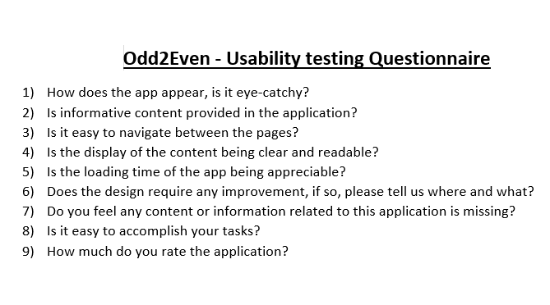
Figure 5: Before a pilot survey was performed
Figure 5 shows the questionnaire which was prepared initially. We can identify some corrections to be made but after performing the first stage of the pilot survey like discussed with the professionals about each question and try to understand it, some questions were added and modified which gives more value to the questionnaire. These modifications are shown in the following section.

3.1.2 Initial Survey Design

Odd2Even - Usability testing Questionnaire
- Age group 18-24… ?
- Male / Female / Other ….
- Country

- How does the app appear, is it eye-catchy?

- Is the informative content provided in the application?

- Is it easy to navigate between the pages?

- Is the display of the content clear and readable?

If no, please give more detail:

- Is the loading time of the app appreciable?

- Does the design require any improvement, if so, please tell us where and what?

- Do you feel any content or information related to this application is missing?
If yes, please state…

- Is it easy to accomplish your tasks?

- How much do you rate the application? (out of 5)

3.1.3 Result of the pilot survey
By performing the pilot survey finally came up with a quality questionnaire. Below is the questionnaire, but there were only minor changes. Two people have participated in this pilot survey and suggested changes.
Below soft copy questionnaire shows the questions with all the changes that were applied for the first time. You will not find the first three questions in the initial questionnaire, 4th question has the same meaning, but it was modified as part of readability. It will now read “Does the appearance of the app entices you to use it?”
Question 5 did not make any meaningful sentence, so it is been removed. The remaining questions were modified with little changes and few additions. After applying all the changes, the questionnaire contains more meaningful questions which are useful to conduct the survey for this app. Based on the initial feedback on the questions within the questionnaire additional 2 questions related to age group and gender have been added. As part of the feedback, some changes were made to the vocabulary used. All the feedbacks were implemented and came up with the final questionnaire is shown below.

3.1.4 Final Survey Design

Odd2Even - Usability testing Questionnaire
- Age group: ☐ 18-24 ☐25-35 ☐36-45 ☐46-55 ☐56-75

- Male: ☐ Female: ☐ Other: ☐

- Home Country: Click or tap here to enter text.

- Does the appearance of the app entice you to use it?

Yes ☐ No ☐

- Is it easy to navigate between the pages?

Yes ☐ No ☐

- Is the display of the content clear and readable?

If no, please give more detail:

- Is the loading time of the app appreciable?

Yes ☐ No ☐

- Does the design require any improvement, if so, please tell us where and what?

Click or tap here to enter text.

- Do you feel any content or information related to this application is missing?
Yes ☐ No ☐
If yes, please state: Click or tap here to enter text.
- Is it easy to accomplish your tasks?

Yes ☐ No ☐

- How much do you rate the application? (out of 5)

1 ☐ 2 ☐ 3 ☐ 4 ☐ 5 ☐ (Excellent)

Any other feedback please Click or tap here to enter text.

We can see the difference between the first pilot survey and initial preparation. The above questionnaire is the final version used for the survey. It is to say that, by performing a pilot survey we can get an accurate questionnaire which in turn lead to better results from the population. Above shown questionnaire is the best example for doing the pilot survey.
It often provides the researcher with ideas, approaches, and clues which may not have foreseen before conducting the pilot study. Such ideas and clues will increase the chances of clear findings in the future work [29].
There are some disadvantages that may include delays in the distribution of application findings. It is a time-consuming process and there is a chance of confusion while implementing or making changes to the document based on the pilot data. Implementing a pilot study does not guarantee that it leads to a successful survey. It is not necessary to always include all the opinions received when it does not seem to be a new idea to implement. There are chances of changing the questions if they do not understand the concept correctly which results in losing the efforts and time [30].
Question number 7 can be the best example in proving that peer review or pilot study can be an advantage before approaching the huge population for conducting the survey. That one question can create differences in the results with a poor response rate [31]. Participants should understand all the questions in the questionnaire to make the survey successful [32]. Explained in detail in the feedbacks below.
The objective of this questionnaire is to know the usability of the developed application called Odd2Even. It consists of eleven questions, where customers can understand them with their basic web browsing knowledge. This questionnaire has been sent to 30 customers, who are not related to this application but few of them have basic knowledge of Information Technology and the age of each participant is above 18 years.

4. Design of Application
Requirements of the application were collected from an IT company called DiggIT Solutions Limited based in the UK and the website of the company is http://www.diggitsolutions.com/ . This company’s business solution is to provide the best IT solutions with the help of current digital technologies. This company provides various consultancy services but mainly focusing on Web Design & Development, Mobile Applications, Microsoft Business Intelligence, Data Analytics, Big Data, Cloud technologies using Azure & AWS, SEO, Logo Design and Corporate Branding. This company is planning to introduce a service-oriented web application and have come up with these requirements and are in search of a Full Stack Frontend developer. After having a technical design discussion with the client, it has been agreed that the application will be developed with the new technology called PWA.

4.1 Requirements
The design of the application was based on the below requirements.

Must | Should | May
Login | Location or Place | Ping the users
Shielding user information with the other user. Will be shown based on their request | Search for an event | Login with FB users
Add new events like Movies, Travel, Food, Shopping, etc., | Remove duplicate event | Change profile information
Categories and Elastic Search | Logged in users view their event calendar | Upload new pics
Display the Content | User confirmation required | Ping users, who are interested in availing the offer
Database connectivity | Both the users will receive a confirmation via email | Might get more than one requests, accept based on interest
Push notifications | Order the event list according to the expiry date | Display event details along with the interested customers
Table 2: Prioritised requirements
Table 2 illustrates that the requirements have been prioritized as must/should/may. Requirements in the “must” column indicates that those functionalities are mandatory to support the application. These requirements create a layout for the app and from there it can be developed further to give shape to the app. Requirements in “should” are in the next priority which indicates that displayed content or information in the application is accurate. “Should” also consists of mandatory requirements, but without requirements under “must”, application does not exist. Now, requirements in “may” can be implemented in the later versions when compared with the other two columns. The application development starts form “must” requirements and ends with the requirements in “may”. A list of requirements presented in the table are related to the application “Odd2Even”. Prioritizing these requirements will make ease to the developers in developing a project.
The main task headings of this application are Login, My Events, Search, and Adding events. There are some subtasks within the headings, from that a few tasks were picked and developed the application as Progressive Web App (PWA), which is a challenging concept as part of the development.

4.2 Progressive Web Applications
The progressive web app is a new approach to develop a mobile application that was introduced by Google in the year 2015. It is a pure web application because it is built with technologies like HTML, CSS, and JavaScript and it behaves like a hybrid application [33]. Hybrid means, it works as a web application and as a mobile application. Odd2Even is developed with this technology because it acts as a website and as a mobile application but not exactly as a native application. Instead of developing an individual application for a native app, PWA has become an alternative to the native mobile app [34].
The desktop progressive web application can be opened in the mobile devices and asks to add the app to the home screen of the device, as shown in figure 6.
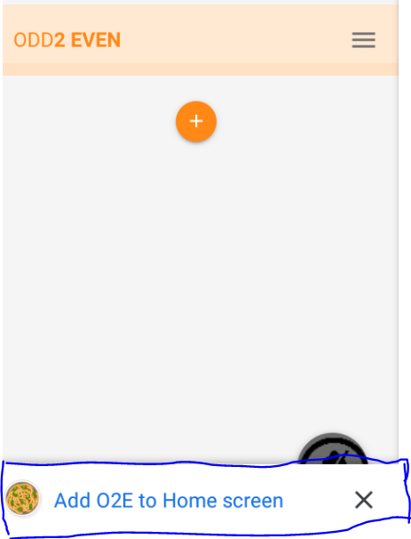
Figure 6: Add app to the home screen in a mobile device
Once the request was clicked, then automatically an icon related to that application will be added to the home screen. Figure 7 and figure 8 show the difference between the screens, to know which is the app version and the web version.
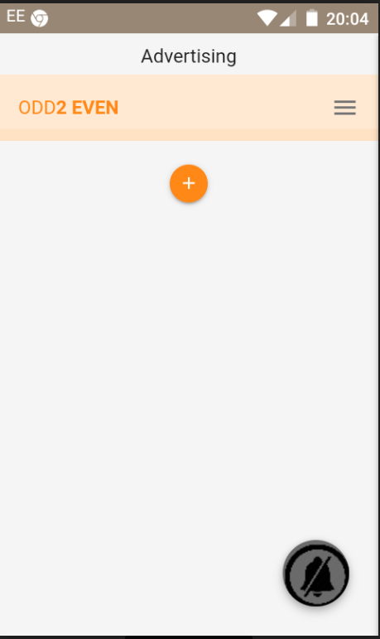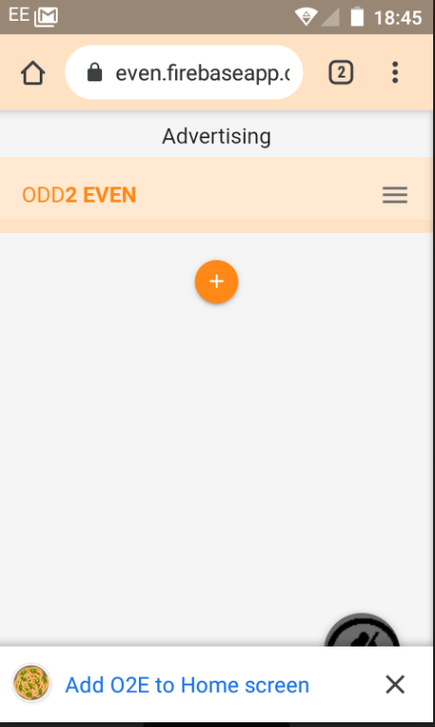
Figure 7: Mobile Version Figure 8: Web Version
In the above figures, there is a blue color arrow mark which shows the difference between them.
The integration between the database and UI was easy and very much successful. Developing the application with this technology will increase the speed of communication between the pages and servers, where data will be presented successfully [35]. The word PWA is the combination of keywords like responsive, safe, app-like, and speed connectivity. There are some best features and benefits with this technology like receiving a push notification, work offline gives mobile experience, a web app can be installed and distributed without app market and looks like a regular app [36]. These features are enabled due to the service worker API (Application Programming Interface). To use an application on your mobile phone, API will make the application to interact with the internet and send data to the server and vis-versa [37].
The main heart of the PWA application is Service Worker which is top in the directory. The service worker has a limited approach to the files in the directory. This is part of a larger method of treating the URL path as a file system. Notification is one of the key compatibilities that depends on the service worker. It allows the data to be updated in the background so that it makes the customers know the current state of the application.

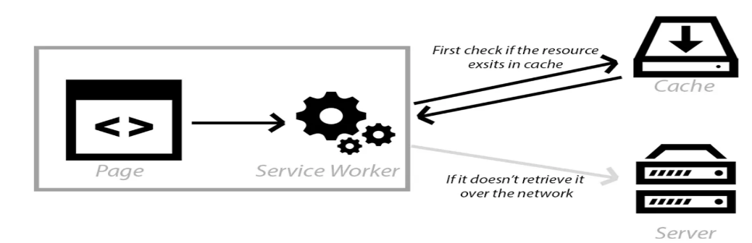
Figure 9: Service Worker
Figure 8 shows the benefit of the service worker. It allows for cache resources on the user’s device when they visit any PWA application for the first time. When the user visits the same site for the second time then it gives the information present in the devices rather than connecting to the server again, if any information available apart from previous then server connection will be established. Due to this, there will be less CPU usage and less energy consumed [38]. Reducing the HTTP requests will save the energy of the device and customers will be accessing the websites easy and fast.
//install Service Worker
self.addEventListener('install', evt => {
//console.log('service worker has been installed');
evt.waitUntil(
caches.open(staticCacheName).then(cache => {
console.log('catching shell assets');
cache.addAll(assets);
})
);

});

//activate service worker
self.addEventListener('activate', evt => {
//console.log('service worker has been activated');
evt.waitUntil(
caches.keys().then(keys => {
//console.log(keys);
return Promise.all(keys
.filter(key => key !== staticCacheName && key !== dynamicCacheName)
.map(key => caches.delete(key))
)
})
)
});

Above shown is the sample code of service workers implemented in Odd2Even. The service worker script is very important for an app or a website because it will handle the event listener and commands such as “fetch”, which are same as the HTTP commands “Get / Post/ Set”. It handles the requests with a suitable response depending on whether there is an internet connection or not as it allows the customized offline page.
The major requirements like push notifications, caching all the files, secured way of handling the data and many more are correctly implemented by the service worker.
Manifest is a JSON file that is associated with the progressive application. It allows defining how to install or add the application to the user’s home screen device. It allows the developer to a greater number of possible ways to customize the app, where customers will interact with the application easily.
{
"name": "Odd 2 Even",
"short_name": "O2E",
"start_url": "index.html",
"display": "standalone",
"background_color": "#FFE9D2",
"theme_color": "#FFE1C4",
"orientation": "portrait-primary",
"icons": [
{
"src": "img/dish.png",
"type": "image/png",
"sizes": "159x159"
},
{
"src": "img/food.png",
"type": "image/png",
"sizes": "512x512"
},
{
"src": "img/movie.png",
"type": "image/png",
"sizes": "192x192"
}
],
"author": {
"name": "O2E",
"website": "https://o2even.firebaseapp.com/"
},
"gcm_sender_id": ""
}

The above code is the sample web manifest of Odd2Even. The words in the blue color are the main properties of the manifest file saved in JSON format.
The purpose of the PWA is to increase the performance, fault tolerance, online activity by the users. It can be differentiated from native apps and regular web apps by these elements like reduces the regular updates and installation process optimizes the memory and reduce internet usage. Applications developed in this technology are compatible in these browsers like the Android browser, Chrome for Android are related to mobile devices and Opera, Chrome and Firefox are related to desktop [34].
There is local storage, IndexedDB, which is the local storage of the browser. It is asynchronous in addition to the larger transactions and has a large capacity. A key feature for HTML5 programming is asynchronous and promises also improved the reliability of the asynchronous program. This style can make application responsive instead of having single threading.
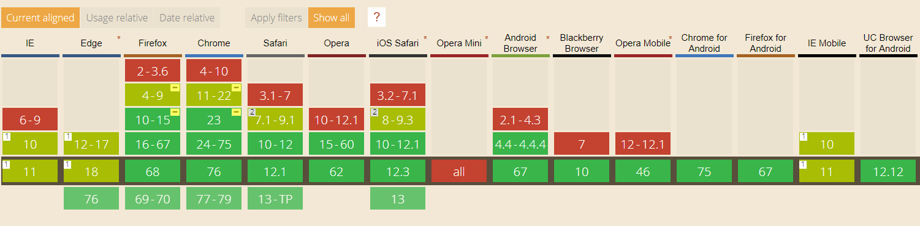
Figure 10: IndexedDB supporting Browsers [39]
Figure 9 shows the browser support table for modern web technology. In the above figure, we can find few browsers supports partially and Opera Mini is not supported as per the version released in the year 2015. Whereas most of the browsers have supported the IndexedDB. As per the above figure, IE is partially supporting the IndexedDB as there is an issue [40], which might be a disadvantage but still Chrome supports the application in full length.
Google fundamental group has minimal HTML, CSS, and JavaScript powering a user interface, which is defined as an Application shell for a progressive web application. It is been categorized by fast loading time due to lightweight application, cached is used to save the usage of the internet, and displaying dynamic content, as data is pulled from API.
Progressive web application needs to have a secure connection through HTTPS, rather than having the only HTTP. As the customers can feel quite safe and allowing permissions. The application developed in PWA will do the network requests via service worker script, adding HTTPS request to the server helps mitigate the certain vulnerability. This secure connection will increase the trust of the customer and hassle-free from internet viruses to some extent.
In favour of the developer, Google has introduced Lighthouse which is an open source to audit whether the developed application is a PWA or not. It is available by default in the Chrome browser and audits can be performed on any page either it can be public or private. Based on the result, developers can easily identify the status of the application. The generated report consists of web performance, best practices, accessibility, progressive web application and search engine optimization (SEO).
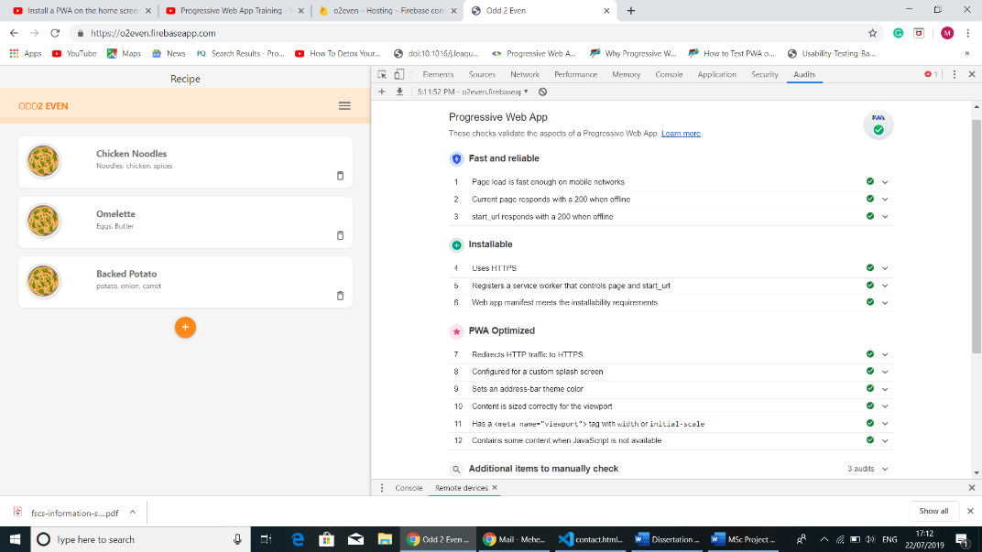
Figure 11: Application Audit report
Lighthouse performs an audit on any sort of URL which is provided by the users. It generates the score out of 100 upon selected factors which is suitable to prove that it is a responsive website. Figure 10 shows the report of Odd2Even and it proves that this application is a progressive web app. Fast and reliable, installable and PWA optimized are the key factors tested by the Lighthouse. This report can be shared with the client and with the other developer to build confidence [41].
After completion of service worker registration, it can be checked in the Application panel of Chrome Dev Tools. It can be manually operated on the same panel, only if the option Update on reload was unchecked. If that option was checked then automatically it will be updated whenever the application was refreshed, only if any changes were made in the service worker application.
At present, PWA applications are not supported by IOS and are only compatible with Android and Chrome only in the recent versions [42].

4.3 Database
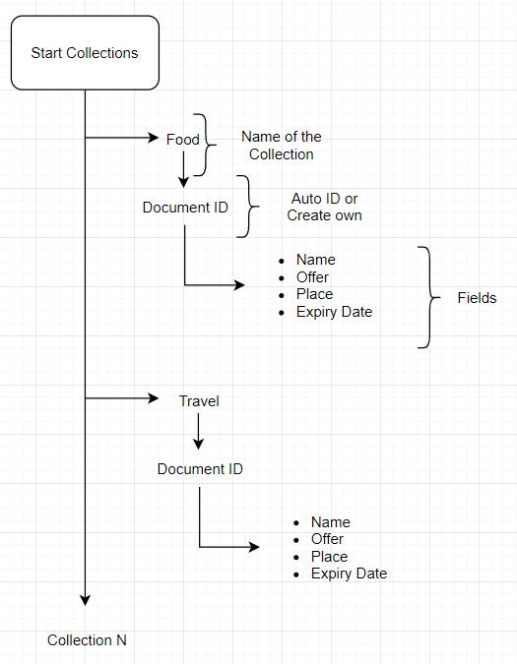
Figure 12:Odd2Even NoSql Database Schema
The database used for this application was provided by Firebase is the typical NoSQL schema where data is stored in documents [43]. It is like a Realtime Database, where the data will be stored in the cloud and provides an easy way to retrieve the data and synchronizes the data with any kind of device.
The name of the database is Cloud Firestore. It supports flexible and hierarchical data structures and builds more like a natural data model. It also features richer and faster than Realtime Database. Performance, functionality, and scalability on an infrastructure design are the most efficient features. It is easy and simple to retrieve and read a JSON formatted file in any device. Many of the clients look for a normalized database to minimize redundancy, whereas in Firestore requires less denormalization. All the documents must be stored in collections. The document can contain nested objects or fields and subcollections. In Cloud Firestore both Collections and Documents were created implicitly. Easily create a document with the collection. Data can be retrieved based on the unique names stored in the collection. Names in the collection are case sensitive.
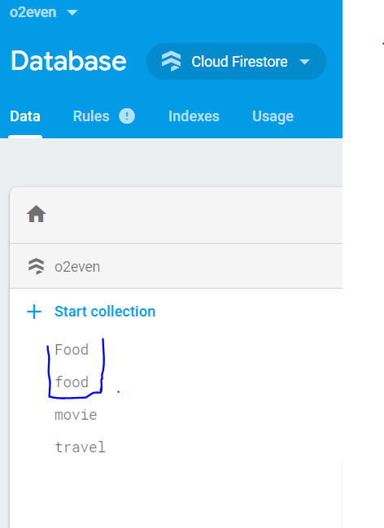
Figure 13: Collection in Database
For example, if we try to add data to the collection with the existing name and different field names, fields will be stored in the existing name in the collection but a duplicate name in the collection will not be created unless the duplicate name is case sensitive. Figure 13 shows the difference in collection names.
The collection consists of documents, these documents generates auto-id or can specify a name. For this application documents have a unique id that is auto generated. Figure 14 shows the unique id of each document.
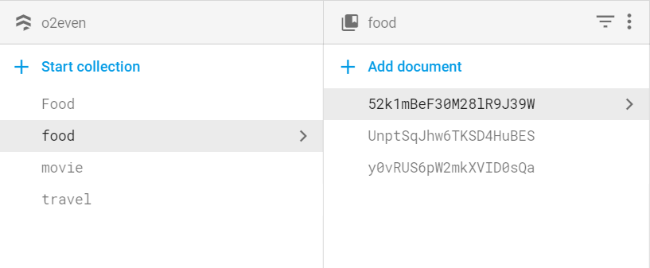
Figure 14: Unique ID in the document
Users can add their own unique key id to the documents rather than using the auto-id. Documents can contain different fields or different data in those fields.
Fields are added in the subcollection, where the data is placed in an appropriate manner and respected fields. There is an option to add extra fields and value to the same field and existing fields can be edited and if required fields can be deleted. If all the documents were deleted, then automatically the collection will be deleted, and the same thing happens with the document as the fields were deleted. Only for the subcollection has the deleting and editing options.
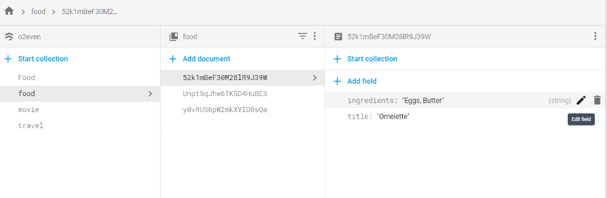
Figure 15: Add field, edit and delete options
Figure 15 provides a proper view of the options. CURD operation can be performed on the data and fields in the subcollections. Documents in the subcollection can contain subcollection that allows further nest data. Data can be nested up to 100 deep levels [44].

4.4 Database Connection
In real time scenarios working with the data is very important. With the help of service worker in this application will establish the connection between the server and app. In order to establish a connection with Firestore data, you need to register an app.
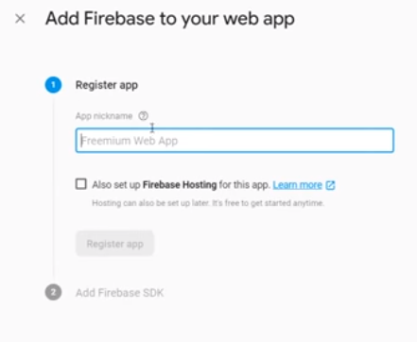
Figure 16: Register Firebase App
The layout of the app registration is shown in figure 16. Then a code is generated by the Firebase, which needs to be copied in the application code. Here is that piece of code added to the index.html page.
<script src="https://www.gstatic.com/firebasejs/6.3.0/firebase-app.js"></script>
<script src="https://www.gstatic.com/firebasejs/6.3.0/firebase-firestore.js"></script>
<script src="https://www.gstatic.com/firebasejs/5.9.1/firebase-auth.js"></script>

<script>
// Your web app's Firebase configuration
var firebaseConfig = {
apiKey: "AIzaSyByTBLD39HcHVMC9S19Y2rl",
authDomain: "o2even.firebaseapp.com",
databaseURL: "https://o2even.firebaseio.com",
projectId: "o2even",
storageBucket: "o2even.appspot.com",
messagingSenderId: "238792274026",
appId: "1:238792274026:web:de6886454a6d450c"
};
// Initialize Firebase
firebase.initializeApp(firebaseConfig);
//const db = firebase.firestore();
//db.settings({timestampInSnapshots: true});
</script>

The above piece of code will trigger when the application is executed. In this code, we have established the connection between the application and firebase by proving firebase-app.js and as we are using Firestore, so firebase-firestore.js has been used and those are known as libraries. Firebase-auth.js was used to execute the login functionality within the application. We have created the instance as “db” to establish communication between frontend and database like GET and POST the queries.
Now create a db.js file after setting up the libraries and creating an instance on the page. In this, we will write some function which helps in retrieving the data. We can see different types of collections can be seen in figure 15, that is the thing to be communicated.
//real-time listener
db.collection('food').onSnapshot((snapshot) => {
console.log(snapshot.docs);
snapshot.docChanges().forEach(change => {
// console.log(change, change.doc.data(), change.doc.id );
if(change.type === 'added'){
//add the document data to the web page
renderRecipe(change.doc.data(), change.doc.id);
}
if(change.type === 'removed'){
//remove the document data to the web page
removeRecipe(change.doc.id);
}
});
});

To interact with database constant “db” was created and it can be accessed with a method called the collection. This collection method is going to get a reference to a specific collection in the database. For example, in the above code, we can see ‘food’ as an argument and a string. “db.collection(‘food’)” this gives us a complete reference to a collection in the database and that argument can be anything like travel, movies, etc.,
Now setting up a real-time listener that works in the background and continues to listen. If any changes were made with the data in the application like the update, delete and add can be listened by setting up a real-time listener and send that changes back to the database.
There is another method called “onSnapshot” and it takes a callback function as an argument. This takes a “snapshot” object, it gives the information or snapshot of the changes happened at that moment of time. Firebase sends back the information to that object whenever the changes happened. We will use a method called “.docChanges()” to get all the data that has changes or modifications in the database.
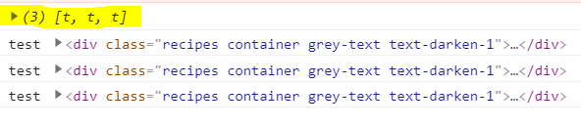
Figure 17: snapShot object with docChanges
Figure 17 shows the object of the snapshot in the console of the application once the page is reloaded. And Figure 18 shows the type changes happened with the database and the changes will reflect in the console immediately.
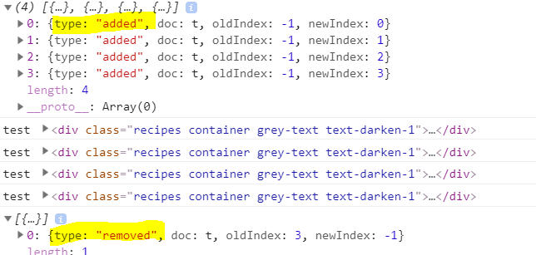
Figure 18: Type of changes

Based on the type, that action can be reflected accordingly with the data in the user-interface. As the data can be retrieved by a loop through the “dochanges” and the syntax is “snapshot.docChanges().forEach()”. Now “forEach()” method will loop through that array and perform a function on each object inside the array and pass the callback function into a parameter called “change”, the difference is we can see the elements come out of the array.
Now use the method “data()”, on the “doc” property of the “change” to get the data of any object. The syntax “changes.doc.data()”, this gets the data object of the change happened with the data. Data was shown in the console every time when an object was added to the database. We can take this data and output it to the DOM that it to the actual developed application. If the content is removed from the database, then in the same way object will be displayed with the type “remove”.
With the help of “if()” check, data can be separated based on the type. In the code, it can be seen that “change.type === ‘ added’” is a check parameter to add the document data to the web page and if it is “removed” then data will be removed from the web page, which means maintaining the user-interface with immediate changes.
The above code is implemented in this application to set up a realtime listener to maintain the relationship between the DOM and dataset.

4.5 Updating UI
Now displaying the real-time data in the user-interface. “renderRecipe” is a function that is declared as a constant used in the “ui.js” file where the DOM code is present.
The “renderRecipe” is equal to a function that has two arguments i.e., data and id and this function consists of the HTML template with the data embedded into it. In this function, a template string is an addition to the JavaScript ES6 specification, and it allows the output data directly into a string.
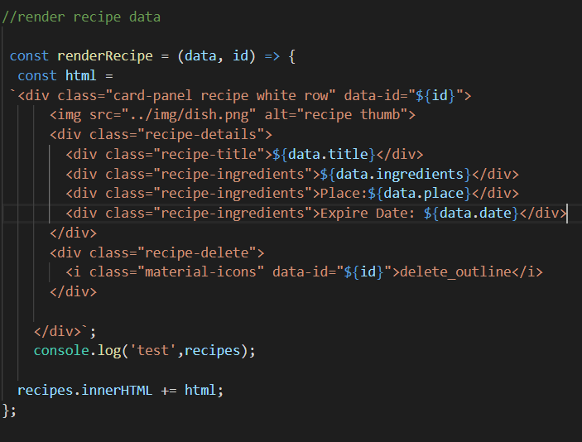
The above code is a template stored in a constant variable which will generate the output to the DOM. Now we need to bind the data that is retrieved from the database within the code by using the binding syntax “$ { }”. In the code, we can see that the “title” bind as “${data.title}”, it means that the value of the “title” places in that object. In the same way, remaining data also bind in their respected objects. And the “id” is going to make easier in removing the item in the database as well in the DOM and it very light which accessing the data through a network and it is unique. A variable is declared for the whole template called “data-id” where id is bind to it and the same is added to the delete button. The Class name in the HTML will be handled by the javascript file with the help of a “querySelector()” method by passing the class name into it. Now the constant which is with the class name will be replaced with new “html” by using the property name called “.innerHTML”. This is how the data is been outputted on the DOM.

4.6 Offline
In PWA, work offline with dynamic data is one of the features when there is no internet.

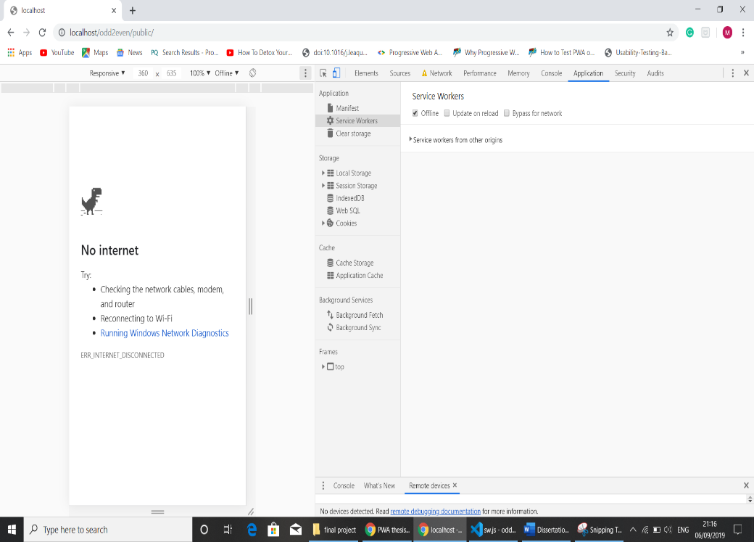
Figure 19: App in an offline state
Figure 19 shows the state of the application when the network is offline, that state or the error can be handled by the service worker. Modern browsers come with IndexedDB [45] which is a database based in the browser. When we are online and accessing the data from remote, that data can be stored in the indexedDB, so that if anything happened with network in the future does not matter that we cannot reach the data from the database because we are storing the data locally within the browser and still data can be shown on the page.
When the application is offline, we can still add the items or remove the items in the app and that action will be stored in the IndxedDB and it reaches the database only when the application is online and vice-versa. There will not be any interruption and figure 19 page will not be seen in the application and both remote and local databases will be together.
Firestore of the Firebase makes easy in accessing the data offline [46]. Firestore comes with all the inbuilt libraries and they handle all the process and perhaps writing sperate code for IndexedDB happens if the Firestore not used. Here is the code that is implemented in this application and placed in the “db.js” file.
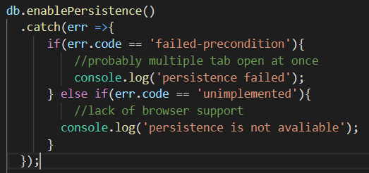
We used a method called “enablePersistance()”, persisting with the data offline. Initially, we will catch errors as there might be a chance of occurring. In the first case, check has been made to catch whether multiple tabs have been opened, this is going to work only in one tab. The Second check was made to catch if there is a lack of browser compatibility. This code enables the Firestore to handle all these offline behaviours.
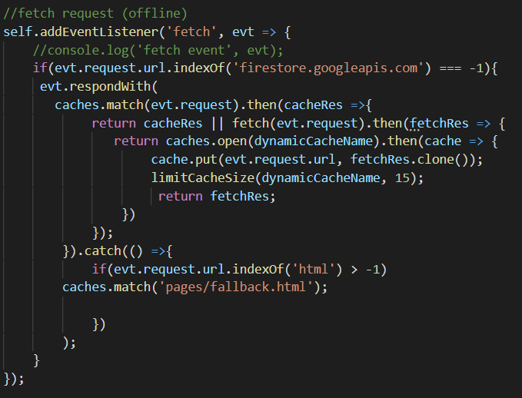
There is a check made to prevent any kind of data response coming from the API URL “firestore.googleapi.com”, if so then run the below code.

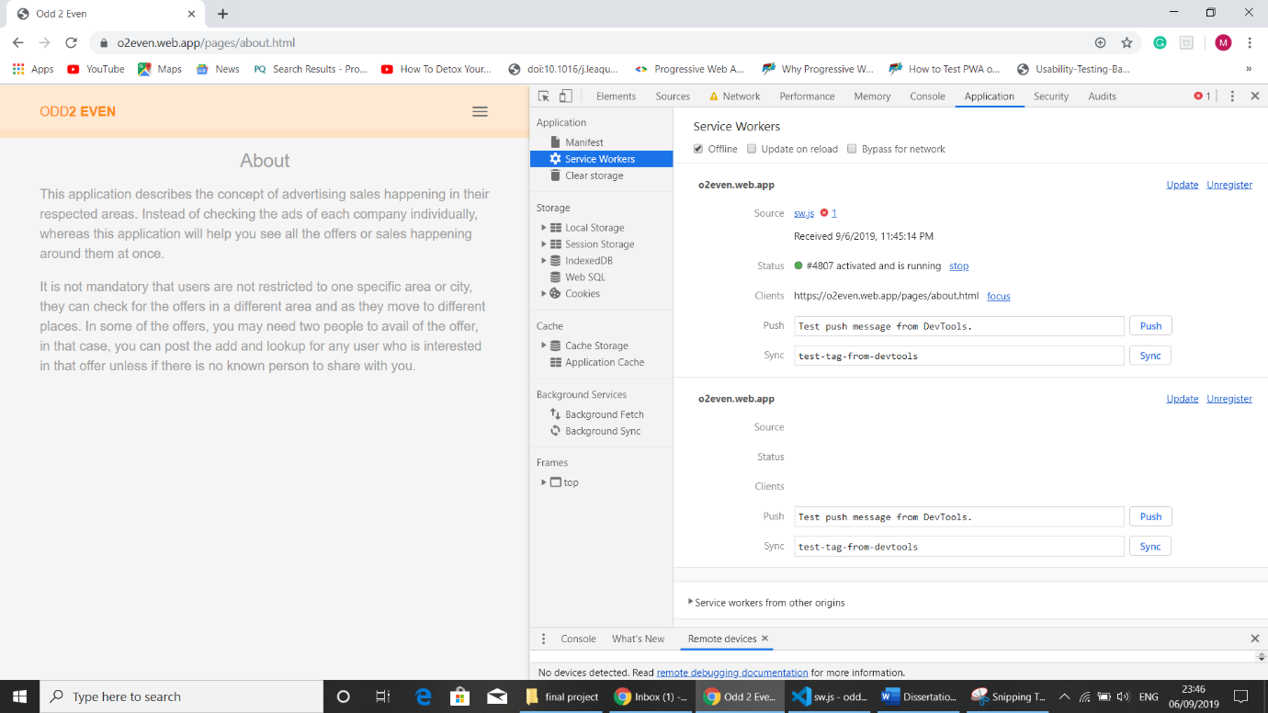
Figure 20: App offline state with data display
Figure 20 illustrates that the application can be displayed data even after the network is offline. But still, in the background, Firestore tries to fetch the data.

4.7 Push Notifications
This feature was included in this application, but partially. Subscribers will receive push notifications like updates or any cloud messages which are related to this application. Users can unsubscribe the push notification at any point in time and they will not receive messages from the cloud. Active members receive messages via the service worker’s push manager. An API needs to be created to handle deleted and save the active user’s ID and at the same time need to be responsible for sending the messages to active users.
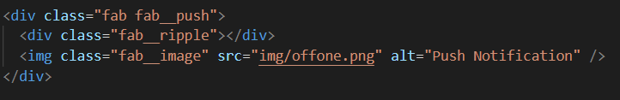

The above code is for adding a push button in the HTML file to indicate that the push notification is active or not.
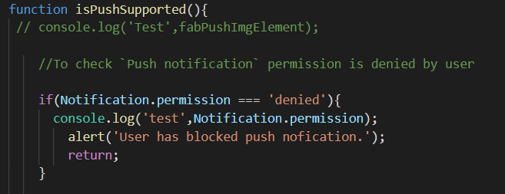
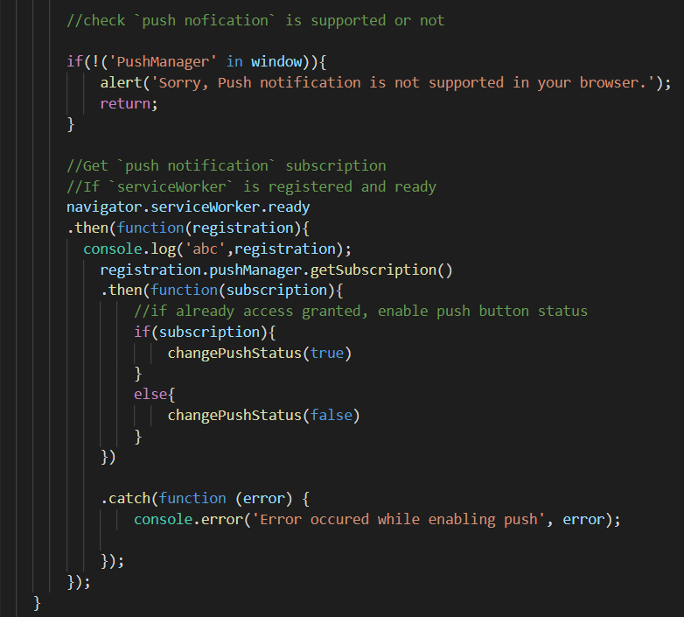
This code will check the browser compatibility whether push notification is supported or not. A method “isPushSupported” is determined to check the browser compatibility. For this, the service worker needs to be registered before subscribing and receiving the push notifications. “navigate.serviceWorker.ready” will check whether the service worker is registered or not. Errors were handled and can be solved if required.
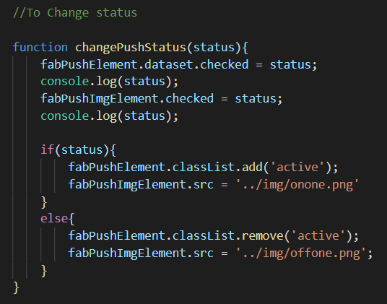
“changePushStatus()” is a function that enables the status of the push notification. Users can notice whether they are subscribed to push notifications or not. Based on the status, images will be displayed respectively.
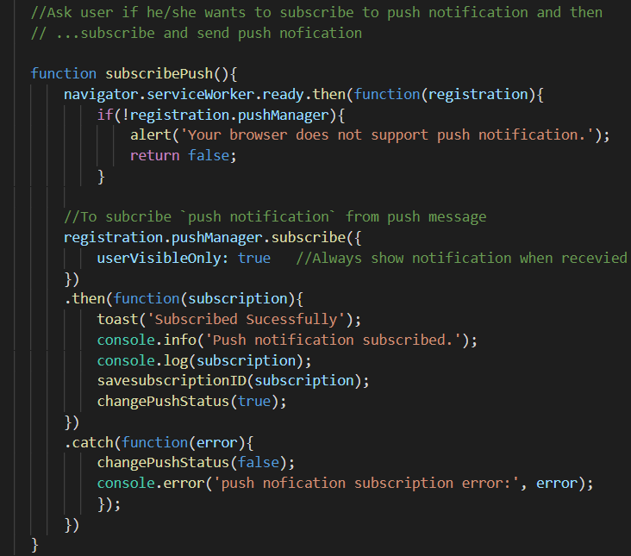
Once the service worker is registered checks for browser compatibility and sends the message to the pushManager, users will receive it and asks for the approval which is shown by toast message. The colour of the icon will be changed and subscription ID will be registered. If the browser does not support, the message will not be displayed.
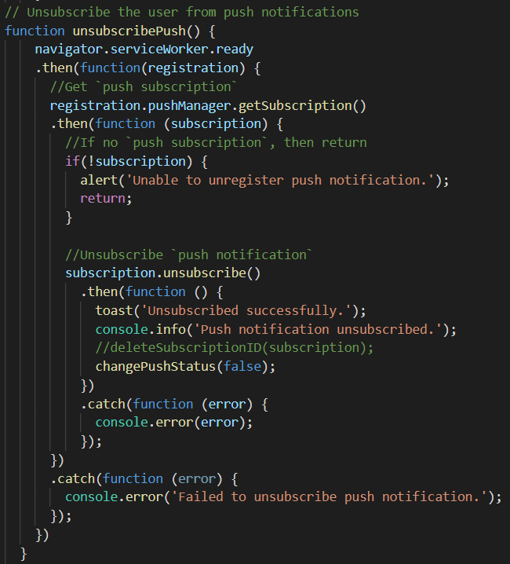
The above code is responsible to unsubscribe from push notification as soon as users request it. The icon comes to a normal state and saved subscription ID will be deleted.
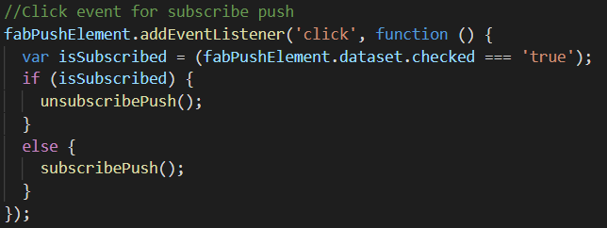

It is a simple code, eventListner for the click event. It toggles the button as required.

5. Results and Discussion
Approaching the usability testing like a professional by creating a simple, informative and usability test plan for doing the test of the application design work.

Create test
Define the task

Conducting pilot test

Prepare findings

Present findings
Schedule the participants

Presenting the study

Figure 21: Plan of the Survey

5.1 Objective
To test the design of the new requirements and experience the major components of Progressive web application like the service worker, application, offline, push notification and web app manifest. Also, in the direction of focusing the preliminary stage of performance and user experience for the end-users and a solution that wants to combine the best of native app and Web technology.

5.2 Usability testing story
Looking at the questionnaire, participants feel like answering it rather than feeling bored or providing feedback as an obligation. In this survey, the questionnaire was understood by majority of the users and had no problems while answering it. Modifications can be made in the application and can learn more based on their qualitative feedback.
Below are some points where participants can understand even if they are not from the IT background.
- Finding offers that are related to the categories.
- Adding offers that suits the respected category.
- Navigating between the pages.
- Identifying the loading time
In later development, this application consists of communication between the customers during which there can be a different set of questions asked during the usability testing some of which are given below:
- Asking the users about their regular shopping habits.
- Frequency of shopping or travel or entertainment.
- Preferred shops or locations to travel to or their favourite cuisines
Asking users related to their daily lifestyle can give them comfortable in answering them without revealing their identity and will move to further questions with interest. The answers also help to analyse how far the app is useful and can cope in the market.

5.3 Find Participants
Finding the participants and scheduling them at the same place and time is not an easy task. There are some online tools to perform usability testing [47], whereas pears are the participants with regards to this application.
Chose pears as participants because we can make sure of their commitment and a chance of adjusting their precious time for the survey and gets good and genuine feedback which helps in getting the robust output of the application. Some of the participants have tested remotely as the application has been hosted on a server and URL was provided to them. In fact, none of the participants have tested on localhost.
Prior to beginning of the test, it is always better to give a briefing about the application. Usability testing is about creating the tasks that actual users would perform in real-time with the app and then observe the behaviour of the app.

5.4 Pilot test
As previously explained, having a pilot test will help in avoiding the worst situation and makes it error-free. It is always better to verify the prototype functionality instead of pausing the participants and loss of faith that affects their feedback and the expected outcome.

5.5 Invite participants
I have communicated with the participants via media and personally with couple of them. 15 participants have given the feedback in which I have interacted with 2 participants personally and the remaining 13 communicated via media. I took two days in gathering the feedback.

5.6 Feedback
Age Group | Gender | Country | Appearance good | Easy Navigation | Clear Content | Loading appreciable | Design Improvement | Information missing | Easy to finish the task | Rating (out of 5)
18-24 | Male | China | Yes | Yes | Yes | Yes | Yes | Yes | Yes | 4
25-35 | Male | China | Yes | Yes | No | Yes | Yes | No | Yes | 5
25-35 | Female | India | Yes | Yes | Yes | No | Yes | No | Yes | 4
18-24 | Male | India | No | Yes | Yes | Yes | Yes | No | Yes | 3
18-24 | Female | India | Yes | No | Yes | Yes | Yes | No | Yes | 4
36-45 | Male | India | No | Yes | Yes | No | No | Yes | Yes | 5
46-55 | Male | India | No | Yes | Yes | No | No | No | Yes | 5
18-24 | Female | India | No | Yes | Yes | No | Yes | No | No | 3
18-24 | Male | India | Yes | Yes | Yes | Yes | No | Yes | Yes | 4
18-24 | Male | India | Yes | Yes | Yes | No | No | No | Yes | 4
25-35 | Male | India | Yes | Yes | Yes | Yes | Yes | No | Yes | 5
25-35 | Male | India | Yes | Yes | No | Yes | Yes | No | Yes | 3
18-24 | Male | India | Yes | Yes | Yes | Yes | No | Yes | Yes | 4
36-45 | Male | Uk | Yes | Yes | Yes | No | Yes | Yes | Yes | 4
18-24 | Male | India | Yes | Yes | Yes | No | No | No | Yes | 4
Table 3: Participant's Feedback
Q1: Age group
Q2: Gender
Q3: Home country
Q4: Appearance is good
Q5: Easy to navigate
Q6: Clear Content display
Q7: Loading appreciable
Q8: Requires improvement in design
Q9: Missing app information
Q10: Easy to finish the task
Q11: App rating (out of 5)
*In the above list, Q refers to “Question”.
Table 3 illustrates the feedback provided by the participants. In the table, the iPhone user’s data was marked with a different colour.

5.7 Discussion on Feedback

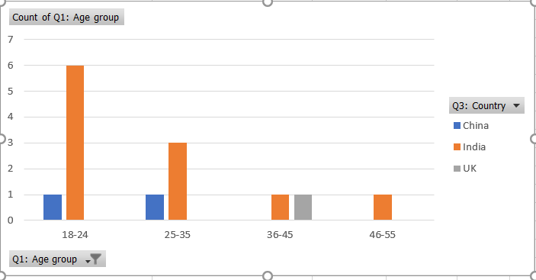
Figure 22: Age group and Home Country
Figure 21 provides information about the different age groups and their countries. We can easily identify that most of the participants are in the age group of 18-24 and the country is India. Two people are from China and one from the United Kingdom. The reason why I have chosen India rather than the United Kingdom because when compared with India, iPhone user's percentage is more in the United Kingdom [48].
As part of the analysis, it has been identified that PWA on the iOS platform is not yet fully compatible and is not ready for prime time yet, especially if we compare with Android devices PWA works without any limitations or conditions. After opening the web app on the iPhone and taped the Add to Home screen popup, that has created an icon on the screen. Taped the icon to load the app, but the Splash screen with icon and background colours that are set up in the Manifest file cannot be seen because both are not supported [49] on the IOS platform.
<!--ios support-->
<link rel="apple-touch-icon" href="public/img/dish.png">
<meta name="apple-mobile-web-app-status-bar" content="#aa7700">
<meta name="theme-color" content="#FFE1C4">

The above code has been included to support the application and make it open on the iPhone devices.

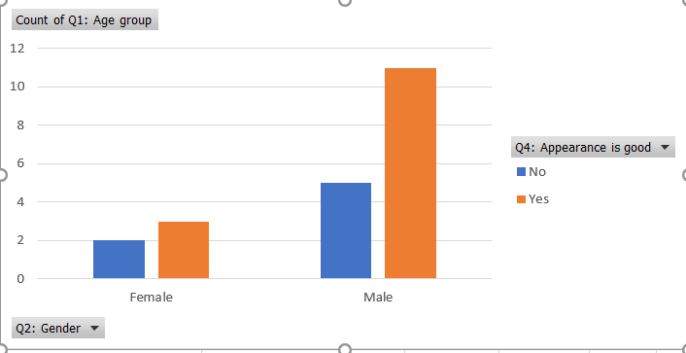
Figure 23: Appearance-based on gender
In the above figure22 shows the information about the appearance is good or bad based on gender. Each user has a different taste in visualizing the web page. It is also one way of knowing the user’s visual preferences when using web applications [50]. As per the result, 2 out of 3 in females did not like the appearance of the app and less than 50% of males said that the appearance of the application is bad. Now a day’s users are much found off the product-based and service-based applications for their needs. Gender-based differences can be considered for which a web application can be customized and can increase the usage of the application. Females have more creative thoughts when compared with males. Generally, we can find more varieties of items with different colour combinations when compared with men.
In the above charts, “Count of Q1: Age group” refers to the total number of participants.

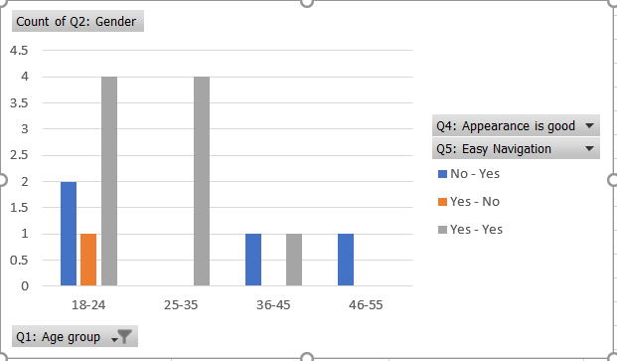
Figure 24: Combination of Appearance and Navigation
In figure 23 we can see the appearance combined with nav navigation, where both are related in finding the performance of the web application. From the above chart, web accessibility can be analysed. Navigation between the pages will know by loading time between the pages. One of the most frustrating things for the users is loading time while navigating between pages because users expect a page to load in less than two seconds including data of the app. We can observe that a very less percentage of people said the navigation and appearance are bad. It means that people can find what they are looking for. Based on the Q6’s result content of the application displayed clearly.
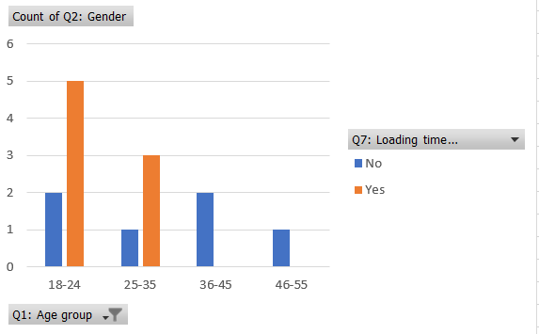
Figure 25: Appreciable Loading time
From the above questionnaire noticed that question number 7 is a bit tricky because the word “appreciable” means noticeable. Basically, the meaning of the question seems to be like this “Is the loading time of the app noticeable?” whereas peers have answered as “yes” rather than “no”. If the answer is “no”, it means that the app has maintained good speed in loading the data. But, “yes” will be like they are waiting for the data to be loaded, which is like a warning to the developer to enhance the app’s loading time where data can be loaded in a good amount of time.
Based on the results, it is been noticed that 40% of the participants have miss understood the meaning of the “appreciable” and as a result, the perception of the output has been changed. After communicating with the participants, they have commented that there is no delay in loading time while navigating between the pages.
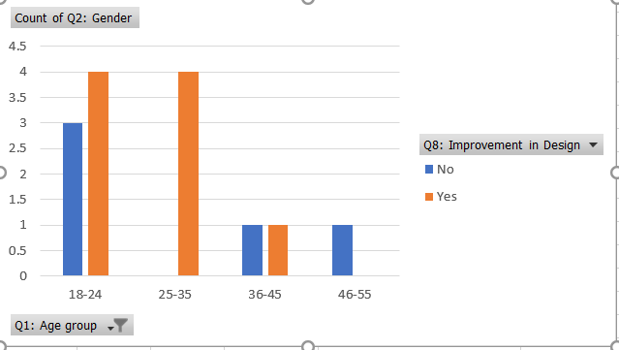
Figure 26: Design Improvement
In figure 25 we can see that there are some comments on the application in regard to the design improvement. As per the above chart, more than 50% of the participants require to improve the application’s design.
P1: Required more content.
P2: Include more food content
P3: Please also provide comparability for IOS users
P4: Show the true picture
P5: It will be better if this app can add some geographic information like the place where the restaurant is located.
P6: Add some pictures or icons, if possible.
P7: Yes, currently each page doesn’t show if it’s Movies/Travel/Food. Having a navigation page
title on top/on the side will help in knowing which category we are looking at.
*p = participants
Above are some of the comments which are commented by the users. Comments are very useful in improvising the design and content. Users will become central to product design and provide genuine feedback on the issues while interacting with the application.
One of the processes introduces by UCD (User-Centred Design) has become standers for the industries while measuring the usability of an application [51]. Implementing the UCD framework there will be an improvement in the user experience.
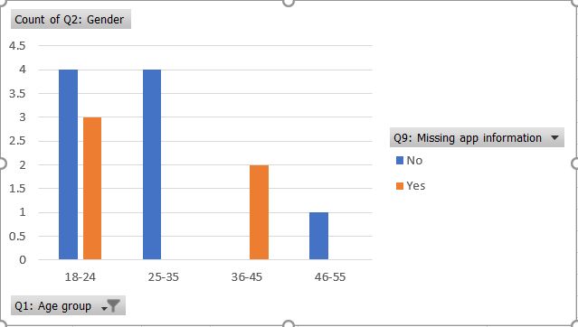
Figure 27Content related to App is missing
Figure 26 shows, how many participants are said that content is missing that is related to the application. As per the chart, less than 50% of the participants say that content related to the application is missing. Comments provided by the people were informative that leads the application as a good data provider.
P1: Show the price
P2: Please integrate time count how much time I am using this.
P3: Need more content
P4: To have an offer location and its expiry date will be very helpful. The logout is missing.
The above comments are provided by some of the participants. Implemented the functionality with regards to the P4 comment. It seems to me that functionality is missing, so immediately fixed them and uploaded the application in the right format. Providing the correct information is like summarizing what the application dose. So, getting the right feedback from the users will help a lot to increase the count of the website visitors. Home page should offer the users a clear detail product information and corporate information which can help them to get the area that will serve their goal and attain the customers confidence.
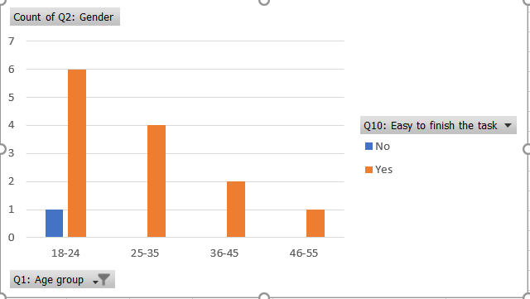
Figure 28: Easy to finish the task
Figure 27 has illustrated about how easy to accomplish their task. Making the tasks easy for the users is most important. If user gets tension by seeing the questionnaire, obviously user will lose the confidence and the feedback of the users will not be satisfactory. The tasks should be simple as part of questionnaire and with the application. Customers should feel in such a way that they can play with the app or web page and should feel easy by looking at the questionnaire. Need to give a confidence that application can be fix if any mistakes happened while working with application. Tell the participant that it not compulsory to write the comments and happy if provided, that gives them a moral support. If the customer play confidently with the application, then the feedback will be useful to develop the application more effective way. Tasks that explore the potential problem [52]. Providing clues to the user is not the correct thing, that leads to wrong feedback [53].
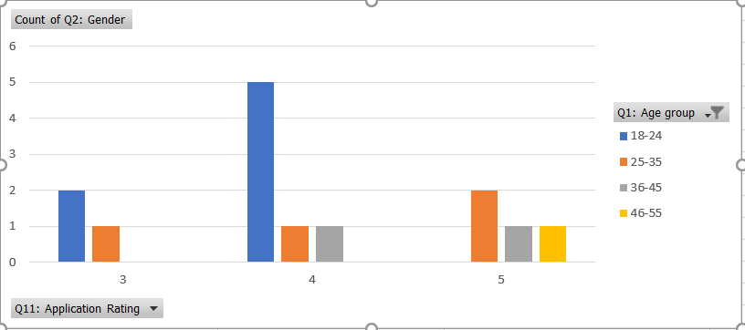
Figure 29: App rating (out of 5)
Figure 28 provides information about the app rating on the scale of 5. There are different age groups rages from 18 to 75 years old. As per the chart age group 18-24 has rated the app between 3 and 4 and the percentage of their rating is 50%. There is an orange colour that is shown in all the values i.e., 3, 4, and 5 where the percentage of this group in 29%. Next group 36-45, this group has rated between 4 and 5 and percentage is 14%. In the group 46-55, there is only one rating that is 5 and the percentage is 7%. More participants are from the age group is 18-24, so the percentage of rating is high. Participants were not selected based on any criteria, particularly not on age and gender. Communicated with them in a normal way and initiated the survey.
In the above charts, “Count of Q2: Gender” refers to the total number of participants.

5.8 Usability testing within Agile
As part of the research, an application was developed with the new technology called PWA which was introduced by Google. Invited some users as part of usability testing within the sprint development. This process was invited at the end of the sprint development to gather users’ feedback regarding usability of the application.
As there are 14 participants, the source of gathering is online. There are 3 female and 9 male participants. There is no bias in gender-wise in the selection process and all are above 18 years of age. Table 3 shows the results and followed by the feedback discussion. Based on the study usability testing can be introduced in the agile method [54]. This survey states that before application release, we can test the appearance, page loading, functionality, etc., which are much related to the usability testing.

6. Conclusion
In this paper, an application has been developed in Progressive Web Application (PWA) using agile methodology and the application has given a good experience to the users. Improved the quality of the questionnaire by performing the pilot survey and implemented the modifications as such and came up with an elegant questionnaire. It is always suggested to have a pilot survey before approaching to the participants who are part of the usability testing. The Pilot survey will build confidence and avoids problems between the researcher and the participants. As a researcher of this survey I have had the most useful and enriching experiences.
Usability testing was performed by the users who have been given a brief on the application and were not provided with any suggestions or clues around testing of this application. The result of one of the questions has improved the questionnaire to a great extent. Overall results of the survey say that the loading time, page navigation and appearance of the app is good, and consistency has been maintained across the site.
Integrating usability testing to the Scrum will improve software development and improves product quality. At the end of the sprint a software developer can give assurance of the quality output from the application. There might be delay in receiving the feedback and difficulty in finding the participants online, but it can be overcome by recruiting participants with the help of HR department. Aim of the study is to introduce the usability testing within Scrum, which is one of the agile methods, was implemented and one of the user’s feedback was taken into account and changes were applied to the app as part of the sprint cycle and uploaded the modified version. Hence it is proven that introducing usability testing within the agile process will deliver a satisfiable product.

7 Recommendations and Future work
There are many recommendations that can arise from this research, some of which are outlined below: a) It would be ideal to create more user stories that are related to each iteration of the design. b) Maintaining unit testing, user acceptance testing and usability testing throughout the process will be helpful. c) Collaboration between users, managers, developers will maximize the quality of the product. d) Recruiting participants might be difficult initially, but this usually becomes easier for later iterations, so it would be important to pursue with this. e) Instead of losing time in the end, it is always better to spend time before the release of each sprint. f) Rather than working on a whole user story, it would be better to work on short stories for better results.
The research carried out for this dissertation lays the foundation for promising future research in the field. As a first step, future work will involve continuing with the development of this application by implementing all the other requirements that are left over in table 2. I will be working more on the detailed level of integrating quality within the agile methods, so that the software projects will benefit from meeting the targets within the available budget, while still maintaining the quality of the software.

8. Personal Reflection
Progressive web Application (PWA) is a new technology and based on my previous experience I have managed to handle HTML and CSS, but it was a bit challenging to learn Vanilla JavaScript as it is mandatory to create a Service Worker. The Service Worker handles all technical queries and runs in the background of the web page. This is my first web application in PWA which has given me a good understanding of how a mobile app can be delivered through the web.
The past year has been an interesting period of learning in my professional life. I have learned immensely over the past year, especially in the process of preparing this dissertation. As part of this dissertation, I developed a software application with the knowledge gained from my previous semester subjects on this course as well as from my prior professional work experience. Data mining was an entirely new field to me, but I enjoyed learning about it in the previous semester, especially because the concepts were clearly explained, with hands-on experience to analyze the data. In addition to the professional skills I gained, the course and this dissertation immensely helped improve my exploratory and learning skills, my vocabulary and ability to express myself clearly, and above all enhanced my professional and personal levels of confidence.
Finally, I am thankful to my supervisor who supported me throughout in developing my knowledge and this research work. The research carried out for this dissertation will add weight to my curriculum vitae. It has enhanced my knowledge in the development of software applications and will help in furthering my career prospects in the brightest way than ever before.

9. References

[1] | I. Sommerville, Software Engineering, Essex: Pearson Education Limited, 2016.
[2] | M. Lopez, “5 Biggest Differences between an Online News Site and a Printed Newspaper,” Sullivan's Finance Journal, 26 August 2017. [Online]. Available: https://www.sullivanjournal.com/5-differences/5-biggest-differences-online-news-site-printed-newspaper/. [Accessed 24 August 2019].
[3] | T. Rogers, “Are Newspapers Dead or Adapting in the Age of Digital News?,” Thoughtco, 28 January 2019. [Online]. Available: https://www.thoughtco.com/adapting-in-the-age-of-digital-news-consumption-2074132. [Accessed 2019 August 24].
[4] | J. Patton, “Hitting the target: adding interaction design to agile software development,” Hitting the target: adding interaction design to agile software development, pp. 1-6, 04 November 2002.
[5] | M. T. S. M. H. L. S. Peter Wolkerstorfer, “Probing an agile usability process,” Probing an agile usability process, pp. 2153-2156, 05 April 2008.
[6] | “2for1,” Google play, 15 December 2018. [Online]. Available: https://play.google.com/store/apps/details?id=com.mediajackagency.m2for1.discountnetwork&hl=en. [Accessed 27 August 2019].
[7] | 2. Team, “About the 2for1 team,” 2FOR1, 15 December 2018. [Online]. Available: https://www.2for1.com/about-us/. [Accessed 27 August 2019].
[8] | V. team, “Orange Wednesdays: Can You Still Get 2for1?,” VUE, 7 February 2017. [Online]. Available: https://www.myvue.com/news-competitions/orange-wednesdays-what-it-was-and-whats-replaced-it. [Accessed 28 August 2019].
[9] | J. Crutchlow-Porter, “EE is finally closing the doors on Orange and T-mobile, four years after the two networks merged in 2010.,” Choose: Fair Price Comparison, 29 April 2014. [Online]. Available: https://www.choose.co.uk/news/ee-orange-tmobile-merger-delay.html. [Accessed 28 August 2019].
[10] | A. N. A. P.-S. Carolina Salvador, “A systematic review of usability techniques in agile methodologies,” A systematic review of usability techniques in agile methodologies, pp. 1-6, 02 April 2014.
[11] | T. Linchpin, “LINCHPINSEO,” LINCHPINSEO, 23 January 2019. [Online]. Available: https://linchpinseo.com/the-agile-method/. [Accessed 29 July 2019].
[12] | K. S. Rubin, Essential Scrum, New Jersey: Pearson Education, 2013.
[13] | M. Thariyan, “Importance of agile methodology in software development,” medium.com, 8 May 2017. [Online]. Available: https://medium.com/@meenu.thariyan/importance-of-agile-methodology-in-software-development-d8049ac2096. [Accessed 05 August 2019].
[14] | J. M. A. Shari Lawrence Pfleeger, “Modeling the Process and Life Cycle,” in Software Engineering Theory and Practice, New Jersey, Pearson Education, Inc., 2006, pp. 59-63.
[15] | J. MacKay, “The Ultimate Guide to Implementing Agile Project Management (and Scrum),” Planio, 11 January 2018. [Online]. Available: https://plan.io/blog/ultimate-guide-to-implementing-agile-project-management-and-scrum/. [Accessed 05 August 2019].
[16] | S. W. Ambler, “Roles on Agile Teams: From Small to Large Teams,” Ambysoft Inc, 2 January 2005. [Online]. Available: http://www.ambysoft.com/essays/agileRoles.html. [Accessed 05 August 2019].
[17] | A. C. J. Highsmith, “Agile software development: the business of innovation,” Computers, vol. 34, no. 9, pp. 120-127, 2001.
[18] | N. S. D. Mrs. Rupali M. Chopade, “Agile software development: Positive and negative user stories,” in 2nd International Conference for Convergence in Technology (I2CT), Mumbai, India, 2017.
[19] | P. A. N. T. P. Adeola Y. Wale-Kolade, “Integrating Usability Practices into Agile Development: A Case Study,” in 23RD INTERNATIONAL CONFERENCE ON INFORMATION SYSTEMS DEVELOPMENT, CROATIA, 2014.
[20] | D. C. Jeffrey Rubin, Handbook of Usability Testing, Indianapolis, Indiana: Wiley Publishing, Inc., 2008.
[21] | S. Krug, Rocket Surgery Made Easy, Berkeley: New Riders, 2010.
[22] | T. Team, “Usability Testing Basics,” [Online]. Available: http://webservices.itcs.umich.edu/drupal/wwwsig/sites/webservices.itcs.umich.edu.drupal.wwwsig/files/Usability-Testing-Basics.pdf. [Accessed 2019 August 2019].
[23] | K. K. Osama Sohaib, “Integrating usability engineering and agile software development: A literature review,” in IEEE, Qinhuangdao, China, 2010.
[24] | M. S. S. F. M. Tiago Silva da Silva, “Usability Evaluation Practices within Agile Development,” in 48th Hawaii International Conference on System Sciences, IEEE, Kauai, HI, USA, 2015.
[25] | J. Nielsen, “Discount Usability: 20 Years,” Nielsen Norman Group, 13 September 2009. [Online]. Available: https://www.nngroup.com/articles/discount-usability-20-years/. [Accessed 15 September 2019].
[26] | D. Sy, “Adapting Usability Investigations for Agile User-centered Design,” Journal of usability studies, vol. 2, no. 3, pp. 112-132, 2007.
[27] | J. B. W. S. Waters, “Approaches to research,” in Doing your Research Project, Berkshire, England, McGraw-Hill Education, 2014, pp. 14-17.
[28] | S. M. Sincero, “Pilot Survey,” Explorable, [Online]. Available: https://explorable.com/pilot-survey. [Accessed 01 September 2019].
[29] | E. R. H. V. van Teijlingen, “The importance of pilot studies,” 2001. [Online]. Available: http://aura.abdn.ac.uk/bitstream/handle/2164/157/SRU35%20pilot%20studies.pdf?sequence=1&isAllowed=y. [Accessed 4 September 2019].
[30] | M. Kelt, “Advantages and disadvantages of peer review,” Glasgow Caledonian University, [Online]. Available: https://www.gcu.ac.uk/library/pilot/publication/peerreview/advantagesanddisadvantages/. [Accessed 4 September 2019].
[31] | C. R, “Research: is an 'ideal' questionnaire possible?,” International Journal of Clinical Practice, vol. 54, no. 6, pp. 356-359, 2000.
[32] | I. Ajzen, “Constructing A Theory Of Planned Behavior Questionnaire,” 15 August 2019. [Online]. Available: http://people.umass.edu/~aizen/pdf/tpb.measurement.pdf. [Accessed 11 September 2019].
[33] | G. G. Slavina Ivanova, “Using modern web frameworks when developing an education application: a practical approach,” in IEEE, Opatija, Croatia, Croatia, 2019.
[34] | A. Luntovskyy, “Advanced software-technological approaches for mobile apps development,” in IEEE, Slavske, Ukraine, 2018.
[35] | S. A. C. A. F. H. K. Z. H. Z. A. Z. H. C. S. Nazeb Zurati, “Mobile App For Speed Reading Test In Bahasa Malaysia,” in IEEE, Malaysia, 2019.
[36] | T. A. M. T.-M. G. Andreas Biørn-Hansen, “Progressive Web Apps: The Possible Web-native Unifier for Mobile Development,” in In Proceedings of the 13th International Conference on Web Information Systems and Technologies (WEBIST 2017), pages 344-351, 2017.
[37] | M. Developers, “What is an API? (Application Programming Interface),” MuleSoft, 7 December 2016. [Online]. Available: https://www.mulesoft.com/resources/api/what-is-an-api. [Accessed 28 August 2019].
[38] | D. H. Blog, “Service Worker can save the environment,” deanhume, 24 April 2018. [Online]. Available: https://deanhume.com/service-workers-can-save-the-environment/. [Accessed 29 August 2019].
[39] | Lensco, “Method of storing data client-side, allows indexed database queries,” Can I use, 29 July 2019. [Online]. Available: https://caniuse.com/#home. [Accessed 29 August 2019].
[40] | M. Team, “Blob-Workers can't access IndexedDB,” Microsoft, 21 December 2015. [Online]. Available: https://developer.microsoft.com/en-us/microsoft-edge/platform/issues/5942817/. [Accessed 29 August 2019].
[41] | A. Gent, “The SEO guide to the Google Lighthouse tool,” SALT Agency, 2 March 2018. [Online]. Available: https://salt.agency/blog/google-lighthouse-seo-guide/. [Accessed 30 August 2019].
[42] | B. Developers, “Minimum requirements for implementing Progressive Web Apps,” BBVA API_Market, 8 May 2019. [Online]. Available: https://bbvaopen4u.com/en/actualidad/minimum-requirements-implementing-progressive-web-apps. [Accessed 30 August 2019].
[43] | P. A. Martínez, “Lessons learnt (the hard way) using Firebase RealTime Database,” Medium, 24 February 2018. [Online]. Available: https://pamartinezandres.com/lessons-learnt-the-hard-way-using-firebase-realtime-database-c609b52b9afb. [Accessed 4 September 2019].
[44] | G. Developers, “Cloud Firestore Data model,” Firebase, [Online]. Available: https://firebase.google.com/docs/firestore/data-model?authuser=0. [Accessed 4 September 2019].
[45] | F. Copes, “A quick but complete guide to IndexedDB and storing data in browsers,” freecodecamp, 1 June 2019. [Online]. Available: https://www.freecodecamp.org/news/a-quick-but-complete-guide-to-indexeddb-25f030425501/. [Accessed 6 September 2019].
[46] | G. Developer, “Access Data Offline,” Firebase, [Online]. Available: https://firebase.google.com/docs/firestore/manage-data/enable-offline. [Accessed 6 September 2019].
[47] | D. M. Team, “16 Usability Testing Tools for Optimizing User Experience,” Dynor Mapper, 2019. [Online]. Available: https://dynomapper.com/blog/19-ux/271-usability-testing-tools. [Accessed 08 September 2019].
[48] | J. Dunn, “Here’s how Apple’s iPhone sales break down by region,” Business Insider, 20 March 2017. [Online]. Available: https://www.businessinsider.com/apple-iphone-sales-region-china-chart-2017-3?r=US&IR=T. [Accessed 10 September 2019].
[49] | S. Team, “How to Test PWA on iOS devices,” SUPERPWA Team, 28 August 2018. [Online]. Available: view-source:https://superpwa.com/doc/test-pwa-ios-devices/. [Accessed 10 September 2019].
[50] | T. T. J. H. E. M. K. O. J. B. Soussan Djamasbi, “Gender Preferences in Web Design: Usability Testing through Eye Tracking,” in Reaching New Heights. 13th Americas Conference on Information Systems, AMCIS 2007, Keystone, Colorado, USA, 2007.
[51] | V. H. W. Elizabeth A. Fisher, “Improving Online Course Design through Usability Testing,” MERLOT Journal of Online Learning and Teaching , vol. 6, no. 1, pp. 228-245, 2010.
[52] | J. C. R. Joseph S. Dumas, A practical guide to Usability Testing, Portland, Oregon, USA: Intellect Books, 1999.
[53] | F. Muniz, “Usability Testing Examples: 4 Usability & Task Scenario Examples,” TestLodge, 11 September 2018. [Online]. Available: https://blog.testlodge.com/usability-testing-examples/. [Accessed 11 September 2019].
[54] | D. I. S. W. R. F. I. N. R. M. H. N. R. Puji Rahayu, “Applying usability testing to improving Scrum methodology in develop assistant information system,” in 2016 International Conference on Information Technology Systems and Innovation (ICITSI), Bandung, Indonesia, 2016.

