
APPENDIX GA36a

LEVEL 4 ASSESSMENT SPECIFICATION

Student name: | Matteo Grattraola | Student ID number: | 2011667
Programme: | Construction Portfolio
Module: | Fundamentals of Construction Technology
Module code: | ACBA4001 | Contribution to Overall Module Assessment (%): | 50%
Lecturer: | Allan Nantel | Internal Verifier: | Mr. Gavin Traylor
Assignment Title: | Site Investigation Case study | Word count (or equivalent): | 2,500 words (or equivalent)
Submission deadline: | 17th November, 2020 | Return date of provisional marks & written feedback: | Within 20 working days
Submission method: | Preferred submission method: Turnitin online & hard copy (Technium 2)  Late submission of the assessment will result in a late penalty mark. Penalties for late submission: Up to one week late, maximum mark of 40%. Over one week late, 0%. Only the Extenuating Circumstances Panel may approve a change to submission dates.
Academic honesty / referencing: | Academic honesty is required. In the main body of your submission, you must give credit to authors on whose research and ideas your work is based. Append to your submission a reference list that indicates the books, articles, etc. that you have used, cited or quoted in order to complete this assessment.

Module Learning Outcomes
(from module syllabus)
1. Describe appropriate site evaluation, site and soil investigation techniques.

2. Identify the different types of substructure available for a range of low-rise building systems and their production.

TASK DESCRIPTION

City and County of Swansea have chosen to enter into a joint agreement with Marriot Hotels to create a new restaurant and ice-cream parlour (with manager’s apartment) on Swansea foreshore, in the position indicated. The site is located between County Hall and the Marriot Hotel and is illustrated on the attached images. The building, which is to share parts of the car park of both of the existing adjacent facilities, is to have a GIA (Gross Internal Area) at ground floor level of approximately 300 square metres.
The building is to contain the restaurant, café bar, ice-cream parlour, kitchen, food-stores etc. At second floor level, there is to be a self-contained manager’s apartment and staff welfare facilities. This project is procured via a Design and Build contract.

You are to assume that you work as a junior construction professional, requested to initiate a preliminary study for a full site investigation as part of the feasibility stage of the project.

TASKS:

- Describe the historical background of the site and local area via a preliminary desktop study, drawing upon archival material. Your study should include plans and photographs, with full referencing of both illustration and archival information gained.

- Describe, given the historic background, your recommendations for the contents of a detailed site investigation (which is to be undertaken by a specialist geotechnical contractor). You must advise them of which elements of the site investigation you consider being most significant and applicable to this particular site, given its historic background, and where you believe the greatest risk lies.

- State the Building Regulations / Codes of Practice from which your recommendations are derived. State the necessary involvement of local authorities.

- With the aid of sketches, describe a suitable foundation detail for the building, based on your preliminary observations.

GUIDANCE FOR Students IN THE COMPLETION OF TASKS

- You are required to widely research the topic area, reviewing course notes and power points; and content resulting from attendance at lectures and tutorials. Drawings, plans and sketches must be neat, traditionally drawn images. The chosen solutions should be your own work, applied to the case study context and must not simply be scans of standard text-books and internet images.

- There is much written on this topic and you should read widely, seeking out appropriate sources. Historical sources of information with regards this site will be available from the Swansea Reference Library and County Archive Service, both of which are based at County Hall, adjacent to the chosen site. If access to these buildings is restricted due to COVID, you may use online archival source.
- Locate archival material that provides data on local ground conditions.

You will be assessed against the five common assessment as detailed on Page 5.

NOTE:
This is an academic approach case study, which MUST contain Research Informed Literature

- You will be assessed via the quality of the literature sourced and reviewed.
- The Moodle content outlines some of the core reading material. The Construction Information Service (CIS) located on the Swansea On-line Library electronic database (see the IHS database entry) contains a wealth of more detailed information that can be researched, and which is produced by expert organisations such as: BRE, CIRIA, British Standards, Building Regulation Approved Document guidance etc.

Student FEEDBACK FORM

This section details the extent to which the assessment criteria are demonstrated by you, which in turn determines your mark. The marks available for each category of skill are shown. Lecturers will use the space provided to comment on the achievement of the task(s), including those areas in which you have performed well and areas that would benefit from development/improvement.
Generic Assessment Criteria | Marks available | Marks  awarded
1.- Engagement with literature  . | 10
2. Knowledge and Understanding | 30
3. Cognitive and Intellectual Skills | 30
4. Practical Skills | 20
5. Transferable Skills for life and professional practice | 10

Assessment Mark (Assessment marks are subject to ratification at the Exam Board. These comments and marks are to give feedback on module work and are for guidance only until they are confirmed. ) | Late Submission Penalties (tick if appropriate) |  | %
 | Up to 1 week late (40% Max) |  | %
 | Over 1 week late (0%) |  | %

GENERIC ASSESSMENT CRITERIA

Level 4
In accordance with the Framework for Higher Education Qualifications, at the end of Level 4 students will be expected to have demonstrated knowledge of the basic underlying concepts and principles of a subject, and an ability to evaluate and interpret these within the context of that area of study. They should be able to present, evaluate and interpret qualitative and quantitative data in order to develop lines of argument and make sound judgements in accordance with basic theories and concepts of their subject(s) of study. They will have learned how to evaluate different approaches to solving problems, and will be able to communicate the results of their study/work accurately and reliably, and with structured and coherent arguments. They will be able to undertake further training and develop new skills within a structured and managed environment and will have the qualities and transferable skills necessary for employment requiring the exercise of some personal responsibility.

Level 4 | FAIL | MARGINAL FAIL | SATISFACTORY  (3rd / Pass) | GOOD  (2.2 / Pass) | VERY GOOD  (2.1 / Merit) | EXCELLENT  (1st / Distinction) | EXCEPTIONAL  (1st / Distinction)
Category | 0-29% | 30-39% | 40-49% | 50-59% | 60-69% | 70-84% | 85-100%
Engagement with literature (including reading, referencing,  academic conventions and  academic honesty) | Little or no evidence of reading and/or reliance on inappropriate sources.  Views and findings mostly unsupported and non-authoritative.  Referencing conventions used incoherently or largely absent. | Poor engagement with essential reading. No evidence of wider reading. Reliance on inappropriate sources, and/or indiscriminate use of sources. Heavily reliant on information gained through class contact. Inconsistent and weak use of referencing. | Engagement with a limited range of mostly relevant and credible sources but with some reliance on information gained through class contact. Some omissions and minor errors.  Referencing conventions evident though not always applied accurately or consistently. | Engagement with an appropriate range of literature, including sources retrieved independently. Some over-reliance on texts rather than other sources. Referencing may show minor inaccuracies or inconsistencies. | Engagement with a wide range of literature, including sources retrieved independently.  Selection of relevant and credible sources. Generally sound referencing, with no/very few inaccuracies or inconsistencies. | Engagement with an extensive range of relevant and credible literature. Consistently accurate application of referencing. | Exceptional engagement with an extensive range of relevant and credible literature. High-level referencing skills consistently applied.
Knowledge and understanding (Knowledge of the basic underlying concepts and principles of a subject.) | Major gaps in knowledge and understanding of the basic underlying concepts and principles of the subject matter. Inclusion of irrelevant material. Substantial inaccuracies. | Gaps in knowledge of the basic underlying concepts and principles, with flawed or superficial understanding. Some significant inaccuracies and/or irrelevant material. | Limited knowledge and understanding of the basic underlying concepts and principles within the subject area. Some elements may be missing. | Knowledge of the basic underlying concepts and principles is accurate with a good understanding of the field of study but lacks depth and/or breadth. | Competent knowledge of the basic underlying concepts and principles. Exhibits very good understanding. | Excellent knowledge and understanding of the basic underlying concepts and principles of the subject. | Exceptional, detailed knowledge and understanding of the basic underlying concepts and principles
Cognitive and intellectual skills  (Evaluate underlying concepts and principles of a subject and interpret qualitative and quantitative data in order to develop lines of argument and make sound judgements.) | Wholly or almost wholly descriptive work. Little or no evaluation of the underlying concepts and principles.  Failure to develop arguments, leading to illogical or invalid judgements. Minimal or no use of  evidence to back up views. | Largely descriptive work, with superficial evaluation of the underlying concepts and principles. Weak interpretation of data, flawed development of arguments and judgements. Information accepted uncritically, uses generalised statements made with scant evidence and unsubstantiated opinions. Ideas sometimes illogical and contradictory. | Limited attempt at evaluation of the underlying concepts and principles, tending towards description.  Can interpret qualitative and quantitative data but with some errors. Some evidence to support emerging arguments and judgements but these may be underdeveloped or with a little inconsistency / mis-interpretation. | Good evaluation of the underlying concepts and principles. Can interpret qualitative and quantitative data, with minor errors.  An emerging ability to use evidence to support the argument.  Mostly valid arguments and logical judgements. | Sound evaluation of the underlying concepts and principles. Can interpret qualitative and quantitative data accurately. Ability to devise arguments using evidence to make mostly appropriate and valid judgements. | Excellent evaluation of the underlying concepts and principles. Can interpret qualitative and quantitative data accurately and with some insight. Excellent ability to devise arguments using evidence and make appropriate and valid judgements. | Exceptional evaluation of the underlying concepts and principles based evidence. Outstanding interpretation of qualitative and quantitative data.  Exceptional ability to devise arguments using evidence and make wholly appropriate and valid judgements.
Practical skills  (Different approaches to solving problems in particular contexts.) | Limited or no use of taught, basic methods, materials, tools and/or techniques.  Little or no appreciation of the context of the application.  Very weak evidence of different approaches to problem-solving in particular contexts. | Rudimentary application of taught, basic methods, materials, tools and/or techniques but without consideration and competence. Flawed appreciation of the context of the application.  Weak evidence of different approaches to problem-solving in particular contexts. | An adequate awareness and mostly appropriate application of basic methods, materials, tools and/or techniques.  Basic appreciation of the context of the application.  Can identify problems in particular contexts and propose basic alternative approaches or solutions though there may be errors. | A good and appropriate application of basic methods, materials, tools and/or techniques.  Clear appreciation of the context of the application.  Good evidence of different approaches to problem-solving in particular contexts and proposes mostly appropriate solutions. | A very good application of a range of basic methods, materials, tools and/or techniques.  Very good consideration of the context of the application. Very good evidence of different approaches to problem-solving in particular contexts and proposes appropriate solutions. | An advanced application of a range of taught, basic methods, materials, tools and/or techniques.  The context of the application is well considered, and insightful.  Excellent evidence of different approaches to problem-solving in particular contexts and proposes appropriate solutions. | Exceptional levels of application and deployment skills in particular practical contexts. Outstanding identification of problems in particular contexts and formulation of wholly appropriate, thoughtful solutions / different approaches.
Transferable skills for life and professional practice  (Communicate the results of their study/work accurately and reliably, and with structured and coherent arguments; the qualities needed for employment requiring the exercise of some personal responsibility within a structured and managed environment.) | Work is poorly structured, disorganised, inaccurate and/or confusingly expressed. Very weak use of language and/or very inappropriate style. Failure to work effectively individual or as part of a group. Little or no evidence of the skills for employment requiring the exercise of some personal responsibility. | Work is poorly presented in a disjointed manner. It is loosely, and at times incoherently, structured, with information and ideas often poorly expressed. Weak use of language and/or inappropriate style. Flawed approach to individual or group work, meeting only partial obligations to others. Limited evidence of the skills for employment requiring the exercise of some personal responsibility. | Mostly ordered presentation and structure in which relevant ideas / concepts are reasonably expressed. Work may lack coherence and/or accuracy in places. Can work as part of a group, meeting most obligations to others but perhaps with limited involvement in group activities.  Demonstrates the basic skills for employment requiring the exercise of some personal responsibility, with some areas of minor weakness. | Mostly coherent, organised and accurate work, in a suitable structure and is for the most part clearly expressed. Can work effectively independently and/or as part of a team, with clear contribution to group activities.  Demonstrates the skills for employment requiring the exercise of some personal responsibility, with some areas of strength and some of minor weakness. | Work is accurate, coherent, fluent, well-structured and organised.  Can work effectively independently and/or as part of a team, with very good contribution to group activities. Demonstrates very good skills for employment requiring the exercise of some personal responsibility, with just occasional minor weakness. | Work is coherent, very fluent and is presented professionally. Can work effectively independently and/or as part of a team, with an excellent contribution to group activities. Demonstrates excellent skills for employment requiring the exercise of some personal responsibility with an appetite for further development. | Work is accurate, exceptionally coherent, very fluent and presented well. Can work effectively independently and/or as part of a team, with an exceptional contribution to group activities. Demonstrates exceptional skills for employment requiring the exercise of some personal responsibility with an appetite for further development.

THIS DOCUMENT IS ALSO AVAILABLE IN WELSH

Assignment 1

Task 1 - Describe the historical background of the site and local area via a preliminary desktop study, drawing upon archival material. Your study should include plans and photographs, with full referencing of both illustration and archival information gained.

Location and history
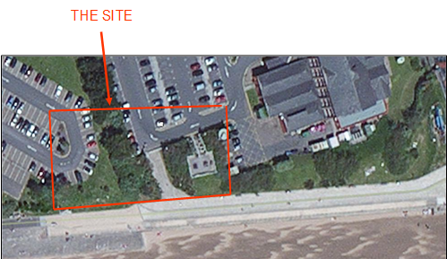
( obtained from the assignment brief )

What was there before:-
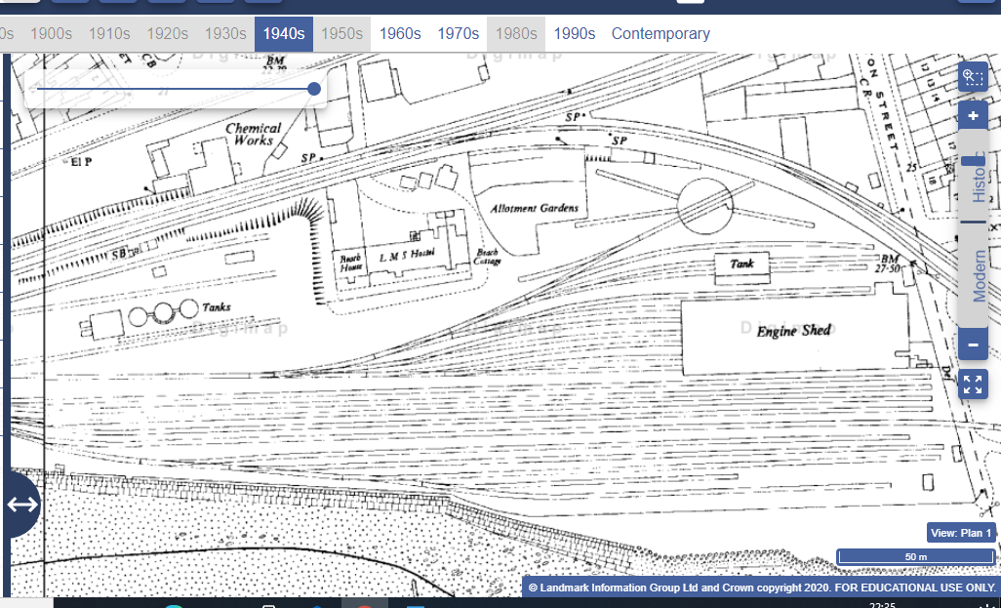
(Image one)

The mumbles railway or mumbles tram as it was called was the first railway built as an industrial horse drawn tramway in 1805. It also become the first railway/tram line to transport passengers on a regular basics. The trams were powered by horses until 1896, diesel was used until 1929 when it was replaced with electricity. This became the iconic look of the tram line and marked the mumbles area as well as SA1 with the rail lines and power lines.

Trams train yard was situated very close to the site. From the maps I’ve seen I it was some kind of small-scale warehouse with rolling farm doors, this building had a raft type base. This was put there I presume because this was the most common type of base, they could make in 1910, I don’t believe reinforced concrete was used however I can’t go see it as its not there anymore. They did big some bore holes but I have yet to see those in my research.

The engine bay was a stone’s throw away from the train yard, while the rail was busy at the time, it wouldn’t be classed as busy by our modern standards. The machine bay serviced between 2 and 7 engines a week; this is still classed as heavy maintenance so I can assume there were heavy machinery operating in the building. At the time dumping of oils and other hazards chemicals was considered okay so I can also assume that they any oils or excess grease they might have had into the land. So, from this brief assumption the land is contaminated and was kept contaminated until the 1960s when the trams were finally closed.

There are storage tanks located on the site, it isn’t documented on what was heled in the tanks. I believe these to be LPG storage tank from the gas worked which is across the road. I believe when the trams ran and diesel this is where the diesel was stored. This also makes me think that the ground is contaminated with oils from small leaks and the odd spills.

During the war 1939 to 1945, in particular the blitz, certain areas of Swansea were bombed. Bunkers and AA nests were put-up all-over Swansea, one bunker was built right next to beach in case of beach landing, this was only an MG nest and was enforced by London despite what the local authorities said. The bunker was bricked up in 1946 and then was demolished in 1951, it isn’t document well in the plans as the bunker didn’t have electricity or any kind of running water, nothing remains of the bunker now which is why it isn’t documented well. Some bombs were found that hadn’t exploded, these have all been removed and it was a nation-wide effort to remove all of the unexploded bombs as there were too many accidents to avoid this problem. The site was littered with craters and so was a lot of Swansea, these were back filed soon after war had ended but the shrapnel remained so very small chemical contamination from some of the chemicals like white phosphoresces which hasn’t been used up in the explorations.

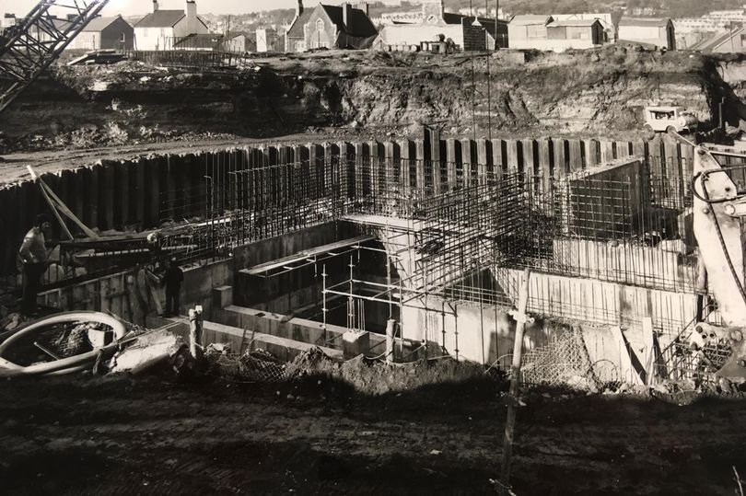

( image two )

In 1982 the county hall was constructed, it’s also known as the civic centre, this building has a library built in too. The building was renamed the Civic Centre on March 19, 2008, and Swansea Central Library was moved in as part of a redevelopment scheme, where it has remained ever since. During its construction, there were buildings in Dunvant Place and Sloane Street which had to make way for the Civic Centre's arrival in 1972.
Task 2 – Describe, given the historic background, your recommendations for the contents of a detailed site investigation (which is to be undertaken by a specialist geotechnical contractor). You must advise them of which elements of the site investigation you consider being most significant and applicable to this particular site, given its historic background, and where you believe the greatest risk lies.

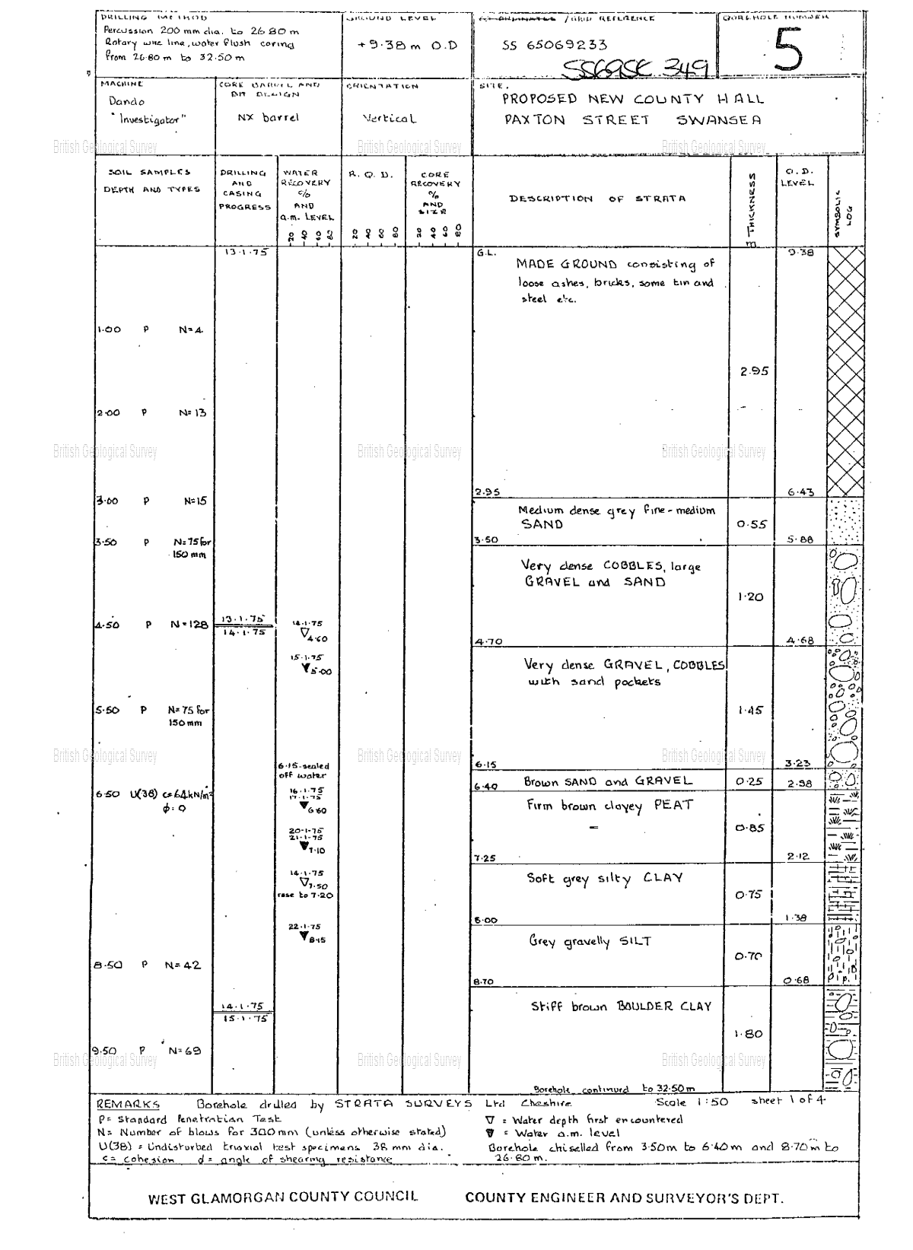

This is the bore hole log I obtained from the BGS site. This was the only bore hole that was close to the site, the other ones were more than 200 meters away and I didn’t think they would be worth noting. So, from this bore hole I can see that my presumption of shrapnel being present in the ground as well as some small remains from the bunker and I presume from the back filling in the 1950s was local rubble, this explains the first three meters of the bore hole.

Possible remaining Chemical ground contamination was my other assumption; however, this was clearly not picked up and was probably taken take of at the time. Its extremely unlikely that there would be any remaining chemicals. Looking at the bore hole log I can see that for the next 3.4 meters is dense sand, gravel and lose stones, the remaining 3 meters is a mix of gravel, silt and clay. They didn’t hit ground water until 4.75 meters down, and not much came up as stated in the bore hole log.

I would advice several more bore holes. Mainly because a lot of the area on the site hasn’t been documented. I also believe a lot of the ground would have settled between now and when the hole was first bored.

Task 3 – State the Building Regulations / Codes of Practice from which your recommendations are derived. State the necessary involvement of local authorities.

The Health and Safety at Work Act 1974

The Act sets out the general duties which employers have towards employees and members of the public, and employees have to themselves and to each other. These duties are qualified in the Act by the principle of ‘so far as is reasonably practicable’. In other words, an employer does not have to take measures to avoid or reduce the risk if they are technically impossible or if the time, trouble or cost of the measures would be grossly disproportionate to the risk. What the law requires here is what good management and common sense would lead employers to do anyway: that is, to look at what the risks are and take sensible measures to tackle them.
http://www.hse.gov.uk/pubns/hsc13.pdf

Provision and Use of Work Equipment Regulations 1998

PUWER stands for the Provision and Use of Work Equipment Regulations (1998). The regulations deal with the work equipment and machinery used every day in workplaces and it aims to keep people safe wherever equipment and machinery is used at work(on and off site). PUWER replaces the Provision and Use of Work Equipment Regulations 1992, carrying forward the existing requirements with a number of changes and additions. The PUWER Regulations aim to make working life safer for everyone using and coming into contact with machinery and equipment, including employers, employees, contractors, suppliers, and anyone else who might use or have access to machinery in the workplace. The regulations aim to ensure that all equipment is, suitable for its intended purpose, regularly maintained to ensure safety, only used by people who have received adequate training, inspected by a competent worker. http://www.hse.gov.uk/

Control of Substances Hazardous to Health (COSHH) Regulations 2002

The occupational use of nanomaterials is regulated under the Control of Substances Hazardous to Health (COSHH). COSHH is the law that requires employers to control substances that are hazardous to health and includes nanomaterials. Sometimes substances are easily recognised as harmful i.e oil and hydraulic fluid. As a new technology, the risks of exposure associated with nanomaterials are not currently fully understood You can prevent or reduce workers' exposure to hazardous substances by, finding out what the health hazards are, deciding how to prevent harm to health (risk assessment), providing control measures to reduce harm to health (PPE) and making sure they are used, planning for emergencies like fires and power cuts. http://www.hse.gov.uk/

Lifting Operations and Lifting Equipment Regulations 1998

These Regulations (often abbreviated to LOLER) place duties on people and companies who own, operate or have control over lifting equipment. This includes all businesses and organisations whose employees use lifting equipment, whether owned by them or not. In most cases, lifting equipment is also work equipment so the Provision and Use of Work Equipment Regulations (PUWER) will also apply (including inspection and maintenance). All lifting operations involving lifting equipment must be properly planned by a competent person, appropriately supervised and carried out in a safe manner

Manual Handling Operations Regulations 1992

The Regulations define manual handling as "Any transporting or supporting of a load (including the lifting, putting down, pushing, pulling, carrying or moving thereof) by hand or bodily force". The load can be an object, person or animal. In the machine shop this would be steel, tools and either parts of the machines or the machine itself. The manual handling operation regulation (1992) set out a clear ranking of measures for dealing with risks from manual handling, these are: first, avoid hazardous manual handling operations so far as is reasonably practicable. Second, assess any hazardous manual handling operations that cannot be avoided. Third and finally, reduce the risk of injury so far as is reasonably practicable. http://www.hse.gov.uk/

Personal Protective Equipment at Work Regulations 1992,
Employers have duties concerning the provision and use of personal protective equipment (PPE) at work.
PPE is equipment that will protect the user against health or safety risks at work. It can include items such as safety helmets, gloves, eye protection, high-visibility clothing, safety footwear and safety harnesses. It also includes respiratory protective equipment (RPE). http://www.hse.gov.uk/

Task 4 – With the aid of sketches, describe a suitable foundation detail for the building, based on your preliminary observations.

A number of different foundations could be used and the first if which is strip foundation. Strip foundations are most useful for small buildings, they have their advantages, for example they spread the load at a 45-degree angle through ground. This works best on firmer ground on some hard clays, it allows for some movement within the clay from moister, and it keeps it nice and structurally sound. This however, isn’t the one ill be using as the weight will sink through the sand gravel and back filled layers. While this is a good idea it just wont work with the ground, it will move way too much.

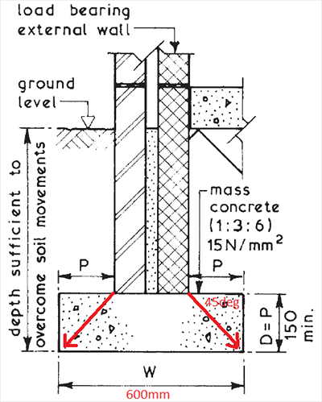
( image three )

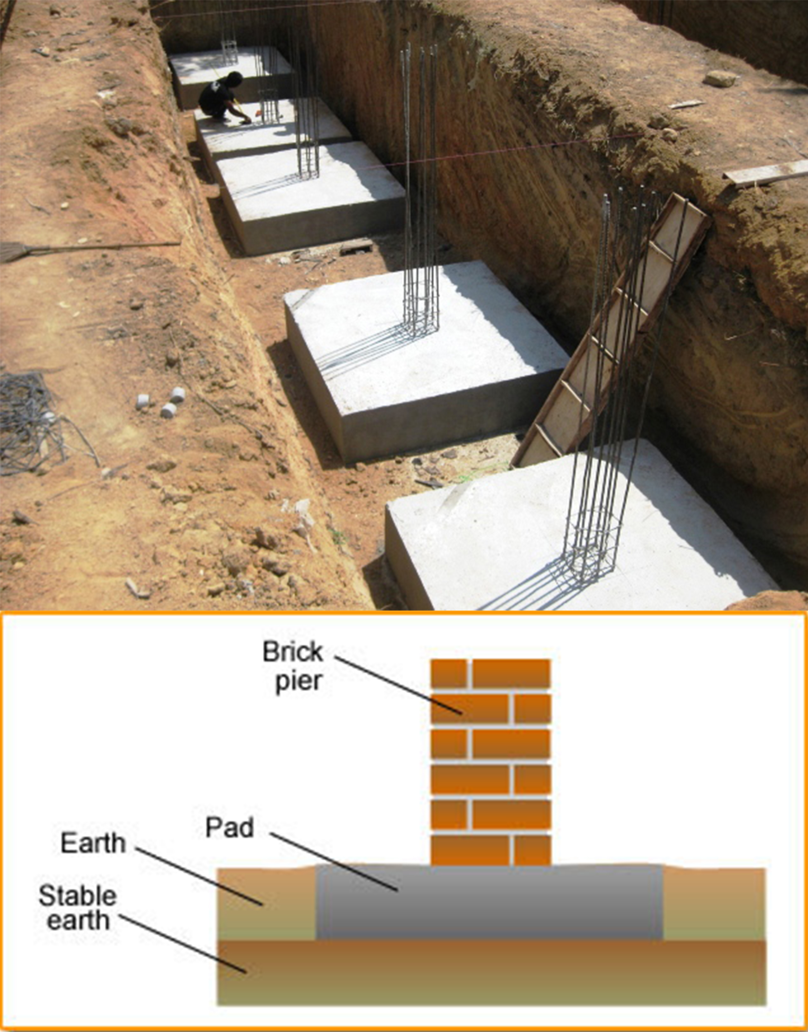

( image four )

Pad foundations are nice and quick. The moulds are made from either chip board or ply wood, the concrete is poured onto rebar and some rebar is exposed in the middle. These stick out and the rest of the moulds can be added to the and the rest of the building can be formed from this. This helps spread the load nice and evenly over what usually is 9 times the area or in some occasions more. The pads are also formed in the ground and allow for extra items to be bolted to it, for example a decking or some other kind of low load structure which needs support. We can use this type either because it will sink and slowly the building will be consumed.

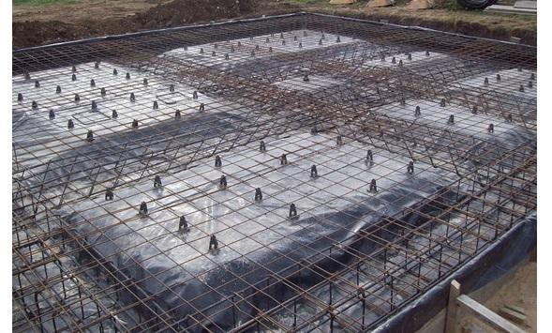

( image five )

The image above shows another viable option, raft foundations. The way this work is an elongated trench is dug to a certain depth and after that they then carve hump out in a certain manner. The workers then lay a damp proof material down and stake this in, they then get these blocks which will hold the rebar at the right height and stop it from moving when the pour is being done. The rebar is either manufactured off site of if the contractor doing the work has a team of welders capable of this task then the rebar in length is delivered and then its manufactured-on site, this may save some time a perhaps some cost but isn’t necessary.

When the rebar has been placed the different sheets or box sections are tied together with twain or thin steel wire, this keeps the rebar together and prevents it from moving. Once all of this has been done the cement can be poured, however this is often large and needs to be completed in one pour which means a lot of planning need to be done on order for this to run smoothly. A way around this is by ordering cement truck/lorries which proved a large amount of concrete in on go, another way around this is filling in sections slowly and using a longer curing concrete mix therefore keeping the cement in a liquid state longer and providing a solid pour at the end.
This is often the most expensive as the shear amount of raw materials and man power to construct. However, this platform which as now been created has the ability to share the entire load the building evenly across its whole area, but unfortunately, we can use this type either, the ground just isn’t right for this.
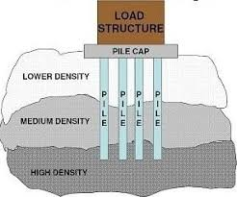
( image six )

Plied foundation are the logical foundations we should use. The first reason is they can be anchored below the or in the clay layer, this is accomplished by boring a hole using an arguer either diesel or hydraulicly driven into to round down to the desired depth. Once the ground has been removed then a small batch of concrete is mixed and poured into the hole through a tube which makes sure that it gets to the bottom and doesn’t splash on the sides wasting it. A hammered is then either dropped repeatedly into the cement at the bottom, this will make the cement move into the cracks into the ground former a much firmer anchor into the ground, a vibrating hammer or a hydraulic hammer can be used to produce the same outcome, I think hydraulic would be best.

After this the rebar reinforcement is placed into the now hollow ground whist the cement is still wet, meaning hasn’t cured, we have to wait until the concrete at the bottom has cured before moving onto the next step. The next step is to fill in the remaining void with concrete, this is achieved by placing a tube down to the bottom and a funnel at the top, the converted is slowly poured into the tube and the tube is kept submerged in the concrete to prevent air gaps. in addition to this as the tube is removed it vibrated to help prevent any air bubbles trapped from forming voids, this prevents the concrete from having major structural floors. This will work best as we are able to big past the back, the sand and gravel, the clay and whatever is below it, we can then make anchors that will not move.

Reference

Image one

https://digimap.edina.ac.uk/roam/map/historic

date 1/11/2020

image two

https://www.walesonline.co.uk/news/wales-news/forgotten-houses-birth-one-swanseas-15905059

date 20/10/2020

image three

https://www.google.com/url?sa=i&url=https%3A%2F%2Fwww.labc.co.uk%2Fnews%2Foffset-foundations-when-youre-tight-to-the-boundary&psig=AOvVaw2fgPYaPMsWxM9DVPf83qZv&ust=1605219573413000&source=images&cd=vfe&ved=0CAIQjRxqFwoTCMjloJTD--wCFQAAAAAdAAAAABAJ

11/11/20

Image four

https://www.google.com/search?q=pad+foundation&sxsrf=ALeKk037eLRYskycRxbXH6aO-03rRJseTw:1605134171889&source=lnms&tbm=isch&sa=X&ved=2ahUKEwiy84bhxvvsAhWMgVwKHbz2BEIQ_AUoAXoECBAQAw&biw=1366&bih=657#imgrc=uOU_5PapftUOfM

date 11/11/2020

Image five

https://www.google.com/url?sa=i&url=https%3A%2F%2Fwww.labc.co.uk%2Fnews%2Fraft-foundation-basics&psig=AOvVaw3yat7Nl9NV95FJEHYFtIKG&ust=1605360829185000&source=images&cd=vfe&ved=0CAIQjRxqFwoTCIja2qrR_-wCFQAAAAAdAAAAABAD

date – 13/11/2020

image six

https://www.google.com/imgres?imgurl=https%3A%2F%2Fi1.wp.com%2Ftheconstructor.org%2Fwp-content%2Fuploads%2F2017%2F09%2Fpile-foundation-cost.jpg%3Fresize%3D297%252C247%26ssl%3D1&imgrefurl=https%3A%2F%2Ftheconstructor.org%2Fgeotechnical%2Fpile-foundation-cost%2F18374%2F&tbnid=JCexqiYWdC3GtM&vet=12ahUKEwj6gJu56P_sAhUC7eAKHVmvAIQQMygNegUIARDlAQ..i&docid=X46ykDkJDoXbkM&w=297&h=247&q=pile%20foundations&safe=strict&ved=2ahUKEwj6gJu56P_sAhUC7eAKHVmvAIQQMygNegUIARDlAQ

date 13/11/2020

information sourced from:-

https://digimap.edina.ac.uk/roam/map/historic

date 1/11/2020

https://www.walesonline.co.uk/news/wales-news/forgotten-houses-birth-one-swanseas-15905059

date 20/10/2020

bore hole log

http://scans.bgs.ac.uk/sobi_scans/boreholes/370250/images/10677933.html

date 1/11/2020

For all health and safety https://www.hse.gov.uk/

date 4/11/2020

https://www.diydoctor.org.uk/projects/strip-foundation.htm

date 11/11/2020

https://www.self-build.co.uk/piled-foundations-explained/

date 13/11/2020

