Architecture in your home town

This assignment will be comparing two buildings in Carmarthen where I live. The two buildings are in direct contrast with each other as one is a new build, the S4C building, and County Hall built in 1955. The features of the buildings discussed include the following: style, form, aesthetic appearance and historic context. Also being discussed will be a personal reflection of the two buildings and their use today.

Carmarthenshire County Hall, designed by Percy Thomas (1883-1969) was completed in 1955, 20 years after the designs for the building were produced. Thomas became the first Welsh president of the Royal Institute of British Architects the same year the hall was built (RIBA, 1955). Moreover his practice was also the biggest in Wales at the time and he was knighted in 1946 (History Points, n.d.). The building replaced the majority of the jail, occupying the site of the ruins of the Carmarthen Castle from the 18th century. The County Hall is used as meeting rooms and offices (History Points, n.d). (Refer to Figure 1 for a plan view of the site).
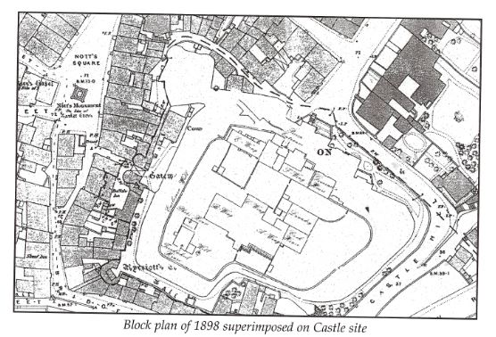
When initially sighting Carmarthen County Hall there are many features that are appealing. Its Chateau style structure reflects the French Renaissance, which creates a sense of authority to the surrounding environment due to the position of the building, which is sited at the top of Jail Hill. Its medieval style French windows emerge from the heavy Portland stone, probably sourced from Dorset, which almost creates a dark gothic feeling, which can appear to be quite eerie.
Figure 1: Discover Carmarthenshire http://www.discovercarmarthenshire.com/places/carmarthen-the-west/castle-house/
When approaching this building it gives the appearance of a modernised castle, consisting of a striking central bay and curved outpost bay areas with sloped roofs. Its form is almost trying to depict a majestic dominance; as if it rules the surrounding land which is what a castle usually tries to depict. Furthermore, the orientation of the building is facing towards the water with the majority of the land situated behind the building. In relation to the positional approach to a castle, the river is almost acting like a moat around this structure, protecting it. Moreover, the position of the structure is south facing (refer to Figure 2) and positioned at the highest point within the valley of Carmarthen, it is a commanding building.
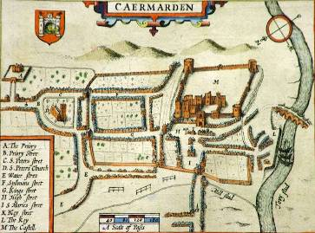
Figure 2: Carmarthen Town Council. http://www.carmarthentowncouncil.gov.uk/Merlins_Town_4514.aspx

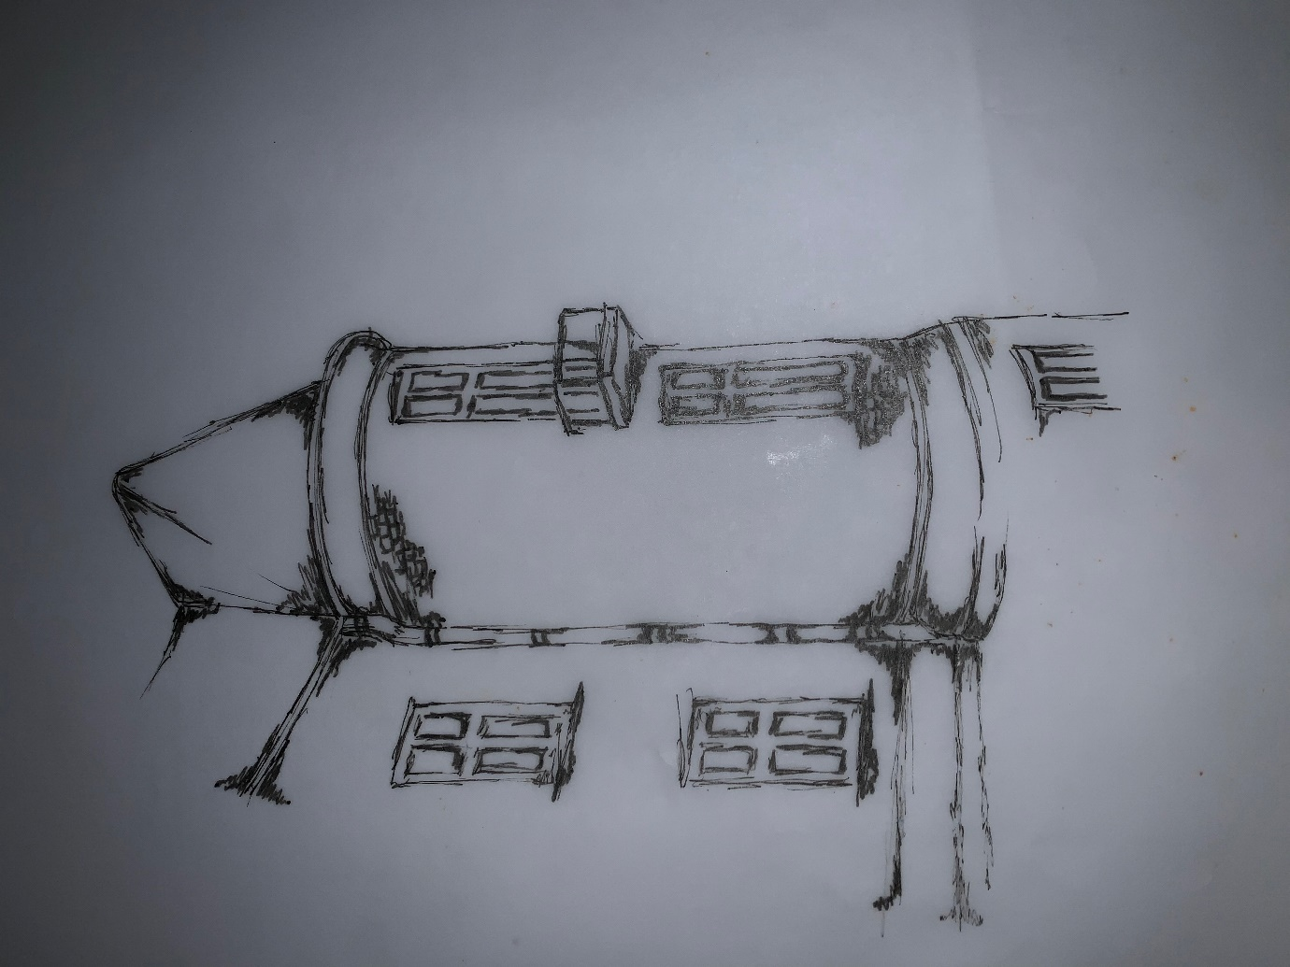
Figure3: County Hall, South facing, corner tower.
During a visit to the site, I quickly sketched a particular area of the structure which attracted me (Refer to Figure 3). The heavy plinths emphasised the curvatures which extended around the entire structure. I particularly noticed how the light from the sun created unusual shadows around the building. Inside the foyer the light was quite restrictive because of where the windows are situated. I also noticed the variation sizes of the French windows. Additionally, the Romanesque style continues into the interior of the building, this adopted style dominates this structure. When entering the building, within the main glass doors there a two plaster quadripartite vaults which lead into the main entrance hall. According to British listed buildings criteria the council chamber interior is an excellent example of its period (n.d.). The interior has an almost cathedral like feel: unwelcoming, cold and masculine.

In complete contrast the other building identified is the newly opened S4C headquarters building in College Road. S4C facilitates broadcastings, has a range of offices and studios (Lewis, 2017). Light floods through the open plan structure and you can view different perspectives from all angles, in contrast to County Hall which is enclosed and claustrophobic. S4C on the other hand exudes’ creativity and light. According to Cooper, the building design was an opportunity to celebrate Welsh creativity, he also goes onto to say that the building is a representation of the Welsh language and identity, providing opportunities for the surrounding community (Cooper, 2015).

Additionally, the vernacular shape of the S4C building is very aesthetically appealing to me because I like the way it incorporates itself within the surrounding environment (Refer to Figures 4 & 5). The use of the materials is subtle, with the steel and glass complimenting each other; the structures high-tech steel frame is light and corresponds with the use of glass which connects the environment to the IT hub.
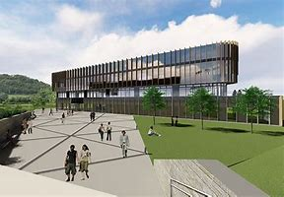
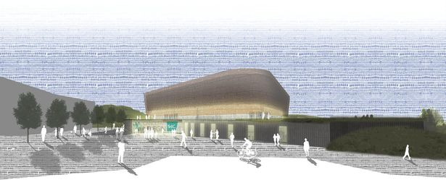

Figure 4 & 5: S4C building, conceptual perspectives.
It has been interesting selecting these two very different types of architecture, the modern with Romanesque. The materials used in each building create such a contrast in shape and form, but both buildings are majestic and commanding. County Hall asserts itself as being powerful and dominant with its focus on formal meetings, procedures, rules and regulations, whereas S4C is more multi-functional, flexible and encourages generational integration and participation, learning and development. In terms of materials used County Hall was built from stone which can be seen as an unsustainable material, however you could also argue this is the same for the steel used for S4C. However, S4C has been built with less impact on the environment because of the materials used. Materials were locally sourced as much as possible before seeking an alternative source. According to (Thompson, 2017) there are only two sections of the entire building which have been sourced from Spain, however the steel used was originally fabricated within the UK. In addition, 97% of the building is made from British steel. His article also mentions that the construction team was required to import 11,000 tonnes of stone which can be seen as unsustainable, although 25% of the material was made up of recycled aggregate, which can be seen as sustainable as well. Furthermore, the landscaping was also a main aspect of the design. The construction team assembled a 20m x 10m x 1.5m deep soak way to facilitate the storm water run off, this water is also returned throughout the building rather than wasted into the sewerage system (Thompson, 2017).

Detailed information for both these building was hindered firstly the archived material in the local library was being refurbished and there was very little information about the S4C building in terms of any drawings, sections and elevations available online. Therefore, I would be more mindful about which buildings I would select in future, carrying out the research before deciding on the buildings purely because of their aesthetic appeal. Although Carmarthen is the oldest town in Wales this study has shown that both styles of architecture sit well with all the other buildings in the town.

References

Site layout of Carmarthenshire county hall, Available at https://www.carmarthenshire.gov.wales
(Accessed: 12 January 2019)

County hall analysis, Available at https://britishlistedbuildings.co.uk/300082151-county-hall-carmarthen#.XDo5H2BFDIV (Accessed: 12 January 2019)

County Hall, Carmarthen. History and appearance of Carmarthen County Hall. Available at: http://historypoints.org/index.php?page=county-hall-carmarthen (Accessed: 12 January 2019).

County hall, British listed buildings. (Accessed: 13 January 2019)

Cooper, J (2015). Designers appointed for S4C building. Available at: http://www.carmarthenshireherald.com/5984/designers-appointed-for-s4c-building/ (Accessed: 13 January 2019)

Lewis, I. (2017) Wales online: Inside S4C’s colourful and high tech new West Wales headquarters. Available at: https://www.google.co.uk/amp/s/www.walesonline.co.uk/news/wales-news/inside-s4cs-colourful-hi-tech-15162984.amp (Accessed: 15 January 2019)

Thompson, P. (2017) Construction News, Kier does its best on S4C new home. Available at: https://www.constructionnews.co.uk/projects/project-reports/kier-does-its-level-best-on-s4cs-new-home/10021690.article (Accessed: 15 January 2019)

