Introduction
Nowadays, there are more universities compared to a certain period in history. A survey of the academic world, discussions or exchanges with academics including employers, highlights the importance of developing academic skills for students' success at university by showing the link between academic skills, employability, and professional achievement. It makes an innovative proposal on how to connect academic skills and employability in program development. Having a good academic level in writing, critical thinking, and research, as well as skills like adaptability, problem-solving, and communication, prepares you to succeed both in your academic years and your career.

Task 01 A
Essential skills required for academic studies and future employment
- Essential skills required for academic studies (use at least 2 credible sources which talk about Essential skills required for academic studies (apply IEEE referencing) (150 words)

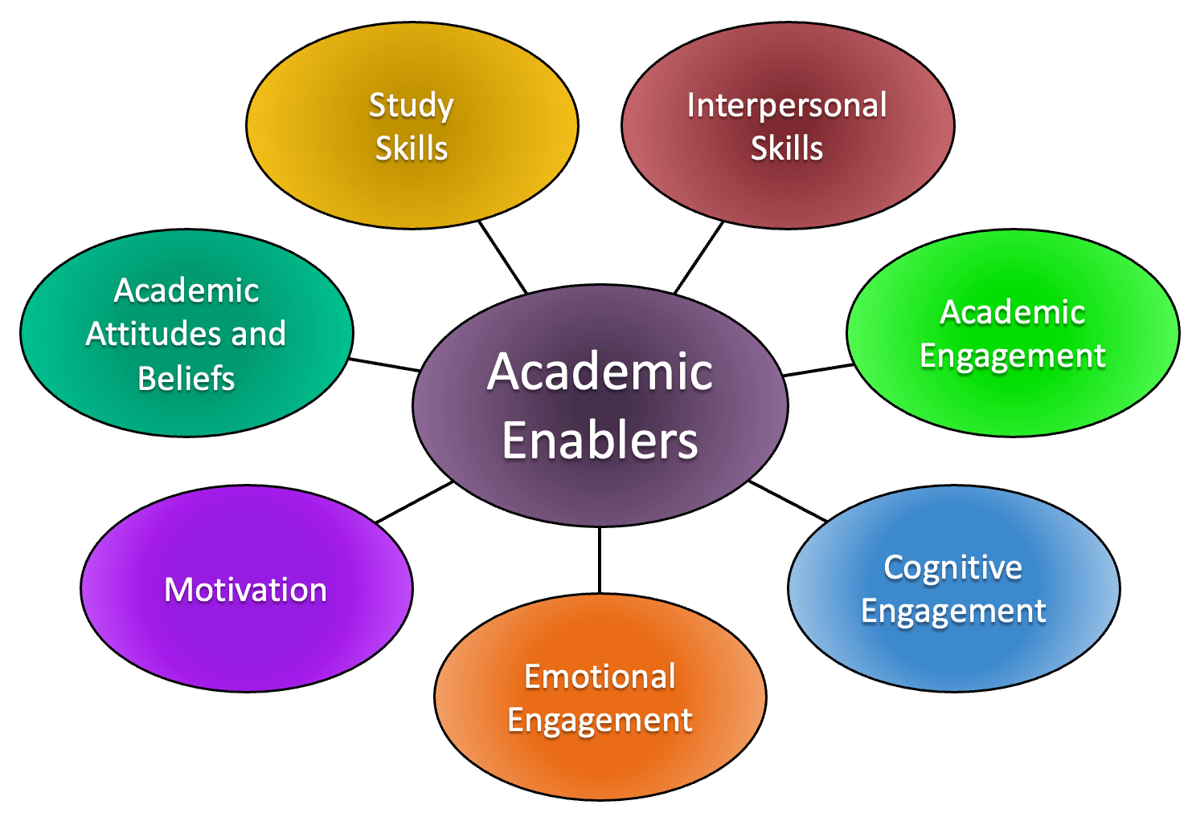
Critical thinking skills are defined by understanding, logical thinking and rationality, as well as the ability to evaluate based on the evidence presented. When it comes to commenting on the work of experts in the field, like authors of groundbreaking research or even their teachers, students might hold back. As long as you can back up your arguments with explanations and evidence, it’s not disrespectful or rude, but essential. You’ve probably heard: 'Good prior planning prevents poor performance.' It’s totally true. Effective time management is key at university and is something that will stick with you even after you graduate.
Writing and reading are really important and will dominate your time at university.
Importantly, develop effective reading techniques to improve your speed and choose the right content to read. [1]
In the context of education, certain skills serve as some of the most essential tools for learning in general. Every learner possesses aptitudes that, at times, are neither fully recognized nor sufficiently developed—often due to a lack of practice.
Citing Hermida (2009), the majority of students, even from their first year, lack basic academic skills—particularly in the area of ​​reading.
Academic reading differs from the type of reading practiced in secondary education.
Competence is significant in all areas of human life.
Consequently, adopting an approach based on the development of skills will help learners assimilate information more easily. [2]

Bibliography

[1] | S. A, “UniAdmission,” 4 August 2025. [Online]. Available: https://www.uniadmissions.co.uk/application-guides/6-essential-skills-for-university-students/. [Accessed 8 October 2026].
[2] | Z, Giedrius and K, Alexander, “London School Of Science And Technology,” 09 March 2022. [Online]. Available: https://www.lsst.ac/blogs/the-importance-of-study-skills-in-he-for-learners-to-enhance-and-develop-their-studies-further/. [Accessed 15 October 2026].

- Essential skills required for future employment (use at least 2 credible sources which talk about Essential skills required for academic studies (apply IEEE referencing) (150 words)
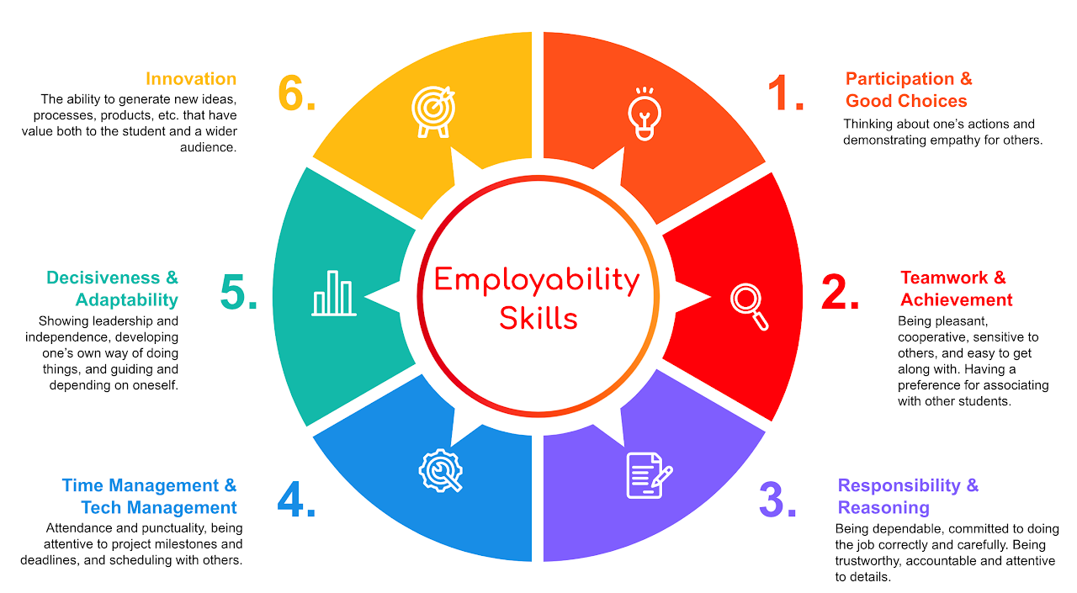
A five-year study conducted by the National Foundation for Education has identified six skills that will be necessary for securing and retaining employment over the coming decades.
Organisation and the Management of multiple tasks simultaneously. Many employers expect their staff to possess the ability to Solve Problems and handle unforeseen situations. Collaboration in an interconnected environment , every department functions as a single team.
Candidates should be able to discuss their personal experiences regarding collaboration. Creativity can take many forms. When faced with a problem, a creative approach often leads to the best solutions. Ability to evaluate Data in the age of AI, the capacity to understand and oversee data processing, as well as the ability to master information is a priority. [3]

Technology skills related to Artificial Intelligence and Big Data are seeing the most rapid growth. While the ability to design AI models is not a requirement, understanding how they function, as well as their capabilities and limitations is important. Furthermore, resilience, flexibility and agility are three skills highly sought after by employers. Possessing management skills specifically the ability to identify a team’s limitations and guide its members toward making informed decisions, foster talent development and contributes directly to a company’s resilience. [4]

Bibliography

[1] | S. A, “UniAdmission,” 4 August 2025. [Online]. Available: https://www.uniadmissions.co.uk/application-guides/6-essential-skills-for-university-students/. [Accessed 8 October 2026].
[2] | Z, Giedrius and K, Alexander, “London School Of Science And Technology,” 09 March 2022. [Online]. Available: https://www.lsst.ac/blogs/the-importance-of-study-skills-in-he-for-learners-to-enhance-and-develop-their-studies-further/. [Accessed 15 October 2026].
[3] | J. Branwen and R. Hope, “Want your job application to stand out? Employers say they look for these six skills,” BBC, London, 2026.
[4] | T. Gregor, “Lepaya,” 10 August 2021. [Online]. Available: https://www.lepaya.com/blog/top-10-skills-of-the-future. [Accessed 22 October 2026].

- analyse 3-5 current popular AI assistants and briefly document the best use for each. use several screenshots of 3 – 5 AI assistants. ( 200 words)

Criteria | ChatGPT  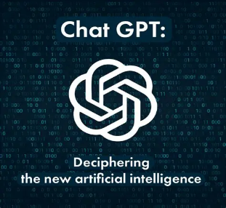 | Copilot  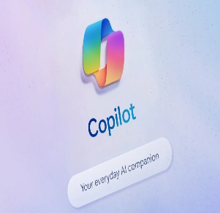 | Gemini  
Generating answers | ChatGPT is a really good conversational assistant with an adaptability. Based on a language model (LLM), ChatGPT is trained on texts from various sources. The training is based on statistical relationships between words, sentences, and concepts. | Using GPT-4 Turbo and Bing search to generate answers, Copilot is integrated into Windows 11 and Microsoft 365, Copilot provides real-time assistance in Word, Excel, PowerPoint, Outlook, Teams, and system settings | Gemini is the best at multimodal reasoning and real-time factual reliability generating answers.  Also, It powers Bard and Gemini for Workspace.
creative work, code/diagram generation | ChatGPT is a really good conversational assistant with an adaptability that is ideal for creativity, deep reasoning, and technical support. High-quality text generation, advanced coding help. | It's complementary to GitHub Copilot in VS Code. | It's really skilled at coding, document generation, and data analysis, and it also supports long content and offers proactive suggestions.
data analysis | and even data analysis thanks to its integrated Python environment | It automates document creation, email writing, data analysis, and presentation preparation; for developers | It's really skilled at coding, document generation, and data analysis, and it also supports long content and offers proactive suggestions.
problem-solving | It is used to solve conceptual, creative, or exploratory problems. | It is used to solve documents, spreadsheets, meetings, or business workflows problems. | It used for problem requiring current data, multimodal analysis, or large-context research.

- Identify a course available in LinkedIn which talks about AI assistance.
Introduction to Artificial Intelligence Online Class | LinkedIn Learning, formerly Lynda.com
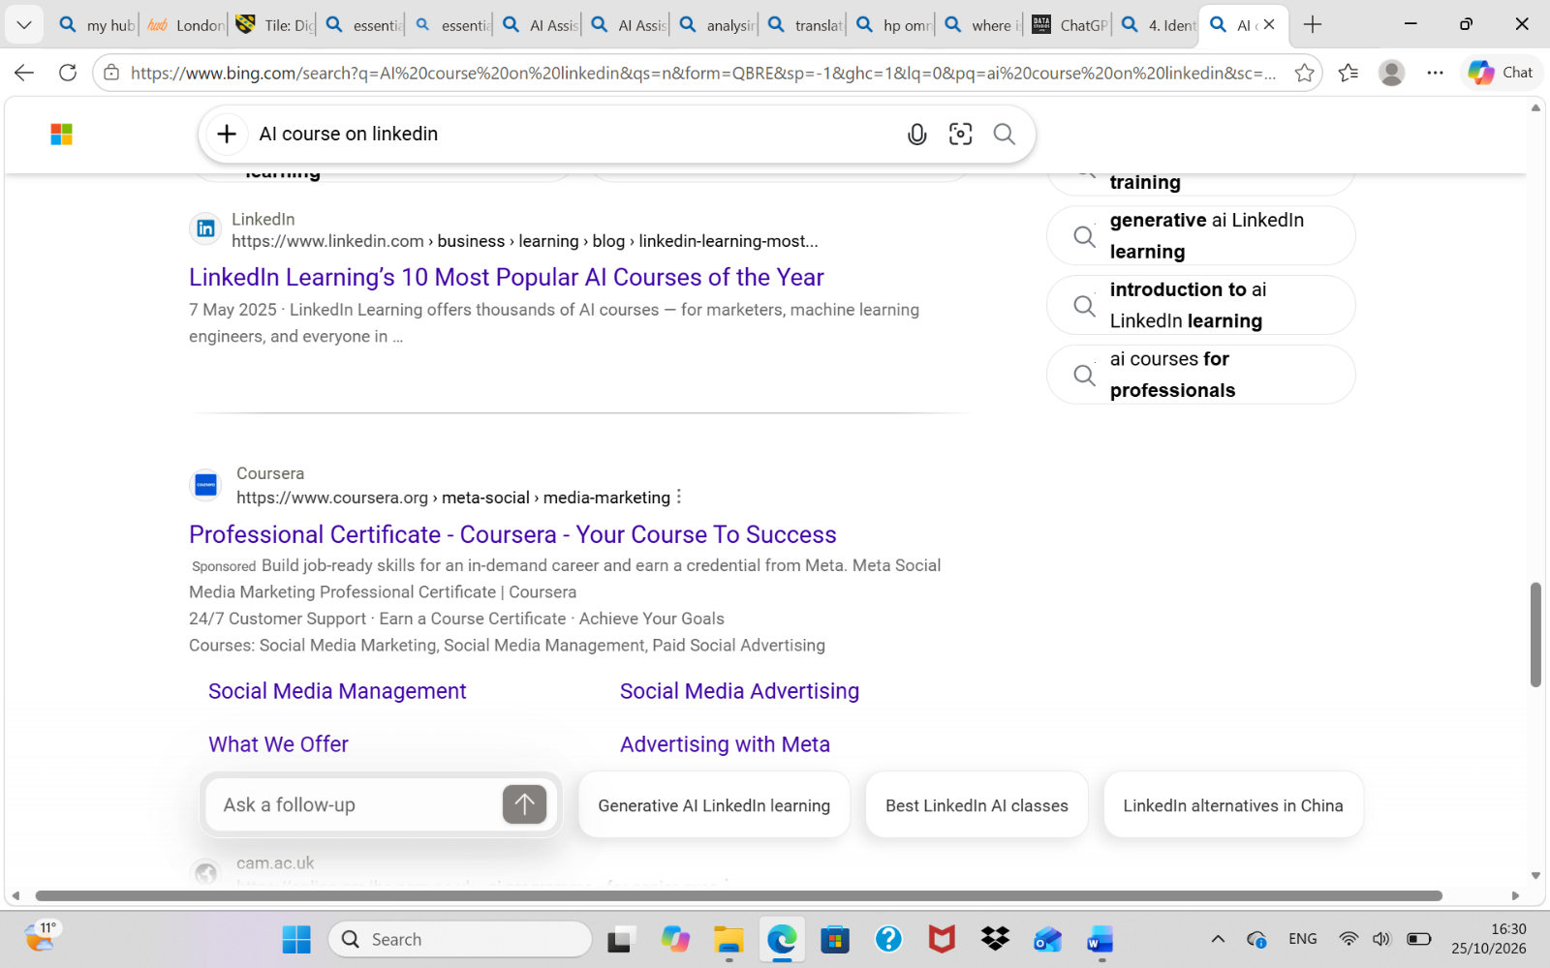
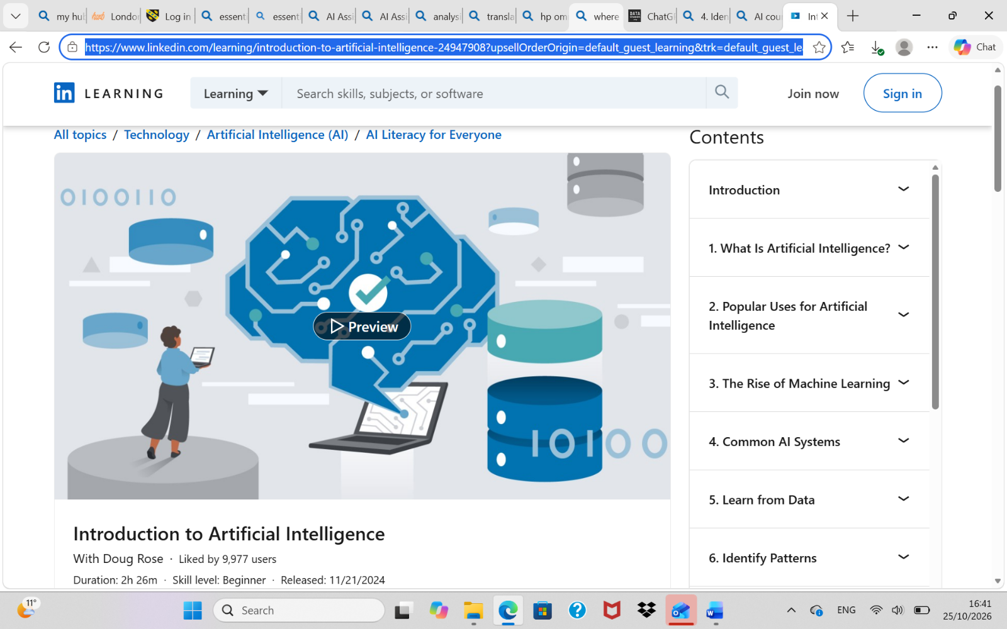

- Submit this document to Turnitin and generate the similarity report and take a screenshot of your similarity report and paste it here. Please evaluate your similarity percentage. (200 words) – self evaluation

References

[1] | S. A, “UniAdmission,” 4 August 2025. [Online]. Available: https://www.uniadmissions.co.uk/application-guides/6-essential-skills-for-university-students/. [Accessed 8 October 2026].
[2] | Z, Giedrius and K, Alexander, “London School Of Science And Technology,” 09 March 2022. [Online]. Available: https://www.lsst.ac/blogs/the-importance-of-study-skills-in-he-for-learners-to-enhance-and-develop-their-studies-further/. [Accessed 15 October 2026].

