

Marketing Management

Assessment 1

LCMB7001

NAME : SONA VADAKKEKARA
ID : 2212235

Table of Contents
Introduction 3
Shell Mission Statement 4
Shell’s vision statement 4
Communication 4
Integrated Marketing Communication 5
Shell’s IMC 6
Recommendations for Shell 7
Branding 8
Brand Equity 8
Keller’s brand equity model 8
Customer journey map 11
Strengths and weaknesses of Shell’s customer journey map 11
Customer touchpoints 12
Recommendations 13
Conclusion 13
References 14

Introduction
All are familiar with the names Albert Einstein, Martin Luther King, Pablo Picasso, Richard Branson, and Muhammed Ali, but have they ever stopped to think about what these great brains and leaders have in common. To achieve their goals, they have each made the conscious decision to go their own separate paths and to do it in creative ways. Only by dogged perseverance and confidence in one's own skills did they reach their current level of success. Now more than ever, technological advancement is essential to the success of nearly every market. In reality, we're the ones who depend on modern conveniences. These days, people are always on the lookout for new ways to advance their own businesses. There is, however, a hurdle that must be cleared. Organizational stagnation can be attributed, in part, to a lack of willingness or incapacity to experiment. SHELL's most well-known and widely-disseminated slogan is "Think Different," which conveys the company's belief in the importance of exploring undiscovered frontiers of creativity and uniqueness. To paraphrase a famous saying, "If they don't like what they do, they won't have been any good at it." This astute individual followed his intuition and turned Shell into a worldwide telecom’s giant. Shell Inc. continues the tradition of excellence set by the corporation and lives up to the name's association with innovation and perseverance. Shell's path over the years defies explanation. The company's hard work and determination are evident in everything from the logo's retro look to the present day. Shell is, without a question, still among the best, and its success has not been limited by any national or geographic limits.

Shell Mission Statement
Providing cutting-edge value-added services while ensuring the secure distribution of energy and petrochemical goods. Each employee at Shell is expected to uphold the company's principles of honesty, integrity, and respect for others. They also place a premium on doing our best job and treating their work and each other with the respect and dignity they deserve. The commitment to sustainable development is a tenet of the Business Principles (Shell Annual Report and Accounts 2021 - Home. 2022).

Shell’s vision statement
Their mission is to protect the health and safety of company workers, contractors, customers, communities, and the environment while they supply energy to their consumers (Shell Annual Report and Accounts 2021 - Home. 2022).

Communication
Communicating effectively means, in a nutshell, learning to see things from another person's perspective. To be competitive in today's corporate world, they need excellent communication skills more than anything else. Simply described, communication is the act of exchanging ideas and information with other people. That pretty much sums up what each day is like for us. Successful candidates, officers, senior management, and employees all share a need for strong communication skills. When it comes to reaching their professional goals, their communication skills are just as crucial as the words they choose to use (Hanna and Rowley, 2019). It is undeniable that effective communication is crucial to running a profitable business.
Source (Idea)
↓
Channel (The manner in which the information is communicated by ensuring that there are little interruptions while the dialogue is taking place).
↓ Signal
↓
The Recipient (Receives the signal)
↓
Final Destination (gets the message)
At the very end, all of the information is compiled and then delivered to the group of people who are in charge of the student services. During the time that we were compiling the information, there were just a few occasions in which we were interrupted. The message does not accurately reflect reality since there are constantly fresh views to consider. Once a message has been sent to both the sender and the person for whom it was meant, the original meaning of the message might be transformed into a new one (Perera et al, 2022).
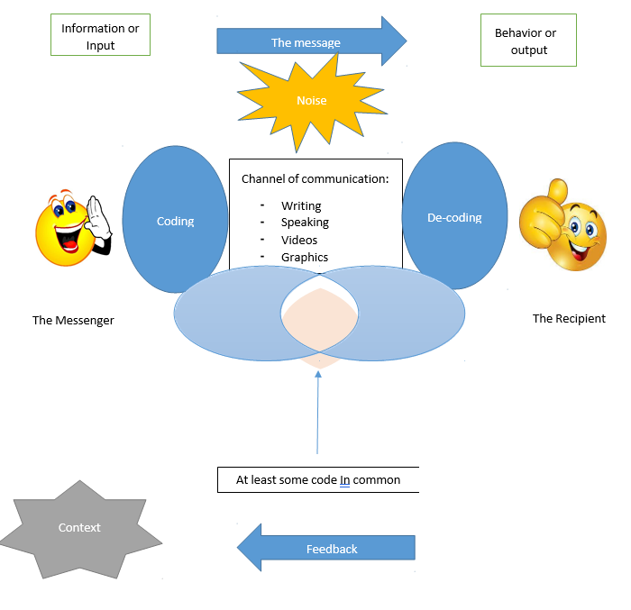

Integrated Marketing Communication
In his book titled Integrated Marketing Communications, Philip Kotler defines integrated marketing communications as the process of "carefully integrating and organising the company's many communications channels to generate a clear, consistent, and compelling message about the organisation and its commodities." Integrated marketing communications refers to the process of "carefully integrating and organising the company's many communications channels to generate a clear, consistent, and compelling message about the organisation and its strategy (Hu and Trivedi, 2020).
A buyer will undertake market research on all of the accessible alternatives, even those that are provided by rival brands, before committing to a single alternative. Because of IMC, any business will be able to develop its own marketing strategy and brand touchpoints in their own unique way. Building trust and goodwill among one's clientele is essential to the financial and operational success of any business (Shell Annual Report and Accounts 2021 - Home. 2022). This highlights not only how IMC assists its customers in locating answers to the challenges they face, but also how this helps to contribute to the establishment of a fruitful working relationship between the two companies. The individual sales pitches will each consist of adverts, banners, and visuals that have been purchased from a range of different companies (Shafiee et al, 2020).

Shell’s IMC
Integrated marketing communications are a significant factor in the success of the company's expansion efforts. The successes that Shell has achieved in the present day may be traced back to IMC's initiatives in large part. Touchpoints are also quite significant, in addition to the interactive media content that they contain. Not only does Shell sell the products, but it also brings in new customers and works to maintain the loyalty of its present clientele, which helps to strengthen the company's position in the market (Kotsi and Pike, 2021).
There are many different types of advertising, some examples of which are posters, newspapers, and magazines. Shell will learn more about who is using their goods and why when consumers sign up for a Shell ID in order to download Shells or other software upgrades. Shell IDs are required in order to download Shells.
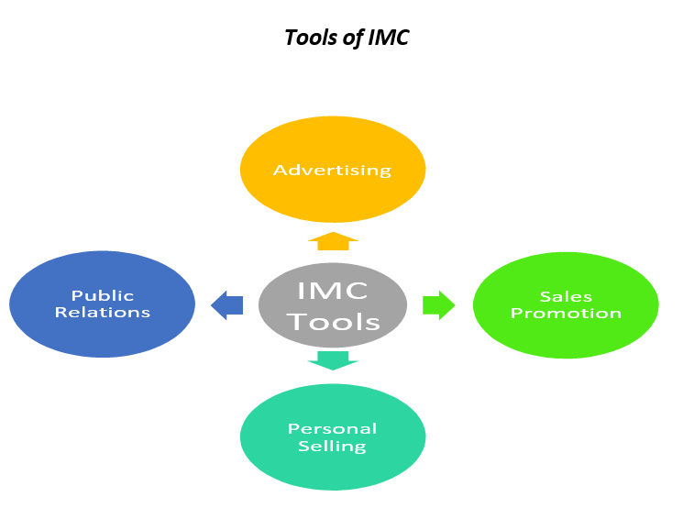
Source: Author
After realising the need to simplify operations and address any difficulties that may develop, Shell employs software upgrades and changes to the Google Play store to identify whether or not consumers are still utilising its items (Heinberg et al, 2020).
The promotion and marketing of a company's commodities should always be one of the top priorities of any company. Shell utilises IMC across a number of different channels in an effort to increase sales. IMC is utilised with the goal of boosting brand awareness and, as a result, product sales to a more extensive audience. The website of the corporation showcases dazzling pictures of brand-new products in an effort to attract customers (Shell Annual Report and Accounts 2021 - Home. 2022).
In order to bring in new customers, the corporation engages in several forms of advertising and marketing (Akbari et al, 2021). The marketing strategies that Shell employs are quite diverse. The following kinds of actions can be considered promotional; however, this list is not exhaustive.

Recommendations for Shell
As of the law of diminishing marginal utility, which is applicable to all different kinds of commodities and services, the price of a product almost always goes down in the years that follow its first release. Customers with moderate and low incomes tend to resort back to purchasing older models of the phone. As a result of this development, there is a diminishing need for brand-new products.
If Shell wants to bring in more consumers who have a wider variety of spending capacities, the company ought to make some of its products available at costs that are more reasonable. It is possible that Shell would shift its attention to seniors as a target market because they have lots of time on their hands to consume media like newspapers and television. Guerrilla marketing may also involve (Iyer et al, 2019). Guerrilla marketing is a non-traditional kind of promotion that seeks to surprise and astonish customers in the hopes that they would take notice of a certain brand or product. It is the most effective strategy for luring in new clients at the moment. This marketing plan, in which the company promotes CSR through all available venues, will be beneficial to the company's reputation and the morale of its employees (Shell Annual Report and Accounts 2021 - Home. 2022).
Benefits of this model
When compared to traditional advertising mediums like newspapers and television, guerrilla marketing may save they a lot of money. To a greater extent, it is useful for businesses.
Verbal communication has led to its rapid dispersal - These days, customers may capture a terrific impression and broadcast it to the globe owing to the proliferation of technology and the increasing number of individuals with access to the internet (Klein et al, 2019). It is possible that a marketing campaign may become viral, drawing in millions of new viewers overnight.

Branding
A brand name is a company's way of being instantly recognisable to consumers as the source of a certain product or service. Name, word, sign, symbol, etc. all come together to form this. The value of a product can be increased if consumers believe in and trust the brand behind it. There is more to a brand than just its name and logo.

Brand Equity
Brands don't actually exist outside of customers' minds. Products are created in the factory, but brands are made in the imagination, as one wise marketer once put it. CEO of internet video business Hulu Jason Kilar defines a brand as the talk about the company while its leaders are absent (Bandyopadhyay and Ray, 2020).
A trustworthy name is crucial to the success of any product. When consumers are familiar with and receptive to a brand's name and marketing, we say that the brand has high brand equity. It is a measure of a brand's success in gaining the trust and loyalty of its target audience.

Keller’s brand equity model
To build a great brand, according to Keller's rationale, they need to provide ideal customer service and other brand interactions. Their clients should walk away from every interaction feeling good about doing business with their firm. They have built brand equity when their customers believe in their product because of the emotions it evokes in them (Baiquni and Ishak, 2019).
- Brand identity
An individual's salience is at the very base of the pyramid in the first stage. And similar to how a logo or tagline may increase a company's brand awareness, salience can do the same for a person or cause. These days, it is essential for a company to promote its name and logo digitally so that customers can recognise it wherever they go and understand what it is that they provide (Shell Annual Report and Accounts 2021 - Home. 2022).
Shell, whose slogan is "Think Different," offers something no other company does. It is a pioneer in many different fields. Shell's advertisements are easy to understand and informative. Their ads and social media profiles are quite engaging (Bartikowski et al, 2019). As the old adage goes, "A picture is worth a thousand words," and thus visuals are used to pique viewers' interest. Customers are drawn to them because of their innovative style and functionality.
- Brand meaning
In the following step of the CBBE model, we will focus on the brand's importance. Defining their brand is explaining to people what it does and who it caters to. This may be done through the use of performance and/or visuals to demonstrate the brand's ability to meet the social and psychological demands of either the advertiser or the target audience.
The term "performance and imagery" is used inside the Company to refer to a comprehensive understanding of how Product Features, Product Reliability, Consumer Service, Design, and Pricing all contribute to the overall impression made upon the customer. Given its commitment to being at the forefront of technical advancement, Shell has a near-monopoly on the bleeding edge of innovation (Garachkovska et al, 2021). Customers love Shell because of the excellent service they receive after making a purchase.
- Brand response
In the third tier, brand reaction, consumers are asked to describe their overall impression of the product. There are 4 stages to it.
- Brand’s quality
- Brand’s credibility
- Brand’s consideration
- Brand’s superiority
There are two methods for achieving this result. One way is for the consumer to use their own discretion and intuition. The emotions they stand for, like excitement, enjoyment, etc., are exposed to these commercials. Products made by Shell are unparalleled. However, the items are out of reach for the middle and lower classes due to their exorbitant prices (Coffie, 2020).
- Brand resonance
Brand resonance is the pinnacle of the pyramid. In terms of the broader equity notion, this is what every company ultimately seeks. It is the feeling they get when they take one glance at a product and realise it is perfect for, they. They have got a thorough familiarity with the ins and outs of the brand.
The foundation is laid by 4 factors.
- Behavioural loyalty – Meaning they buy a specific brand frequently. Examples include paste, salt, and other pantry staples (Tien et al, 2019).
- Attitudinal attainment – Their products are highly regarded by consumers, who adore their brand.
- Sense of community – The power of branding lies in its ability to create a sense of community and belonging.
- Active engagement – Likes, comments, and shares on a brand's social media pages give the impression that they're actively involved with the brand.
Shell's exceptional performance in this area may be attributed to the company's ability to rapidly and effectively adjust to the needs of their customers in response to both macro and micro changes. Shell is customer-centric, making it easy for them to reach the highest level of Keller's model (Fayvishenko, 2018). Shell is dedicated to its beliefs and the realisation of its goals, which include providing clients with the most accessible and high-quality material possible at all times (Shell Annual Report and Accounts 2021 - Home. 2022).
Advantages of Keller’s equity model
- To help customers make educated purchasing decisions and provide constructive criticism of advertising efforts, Keller recommends a brand equity model.
- This strategy works to keep customers because it fosters brand loyalty. Companies like Shell, Coca-Cola, etc. are changing their strategy to focus less on client retention and more on customer satisfaction in order to save money (Hanna and Rowley, 2019).
- Successful firms are able to charge higher prices or conduct more extensive and effective marketing campaigns because they have established an emotional connection with their target audience.
- The positive responses they get from clients will make this a successful business move. Because of their strengthened negotiating position, prices may also rise.
- The value of a product may be increased by advertising and other means of marketing. The competitive edge it provides may be substantial in markets where competing products offer equal benefits in terms of, say, brand recognition, reach, and physical design (Perera et al, 2022).
Dis-advantages of Keller’s equity model
- The pyramid restricts judgements and ignores the customer's experience with the sales team, which is a weakness in Keller's technique because the method concentrates on consumer markets. Additionally, the pyramid does not account for the customer's satisfaction with the product.
- The most significant downside is the amount of time and resources required to achieve this level, as well as the number of resources required to build a positive reputation for the brand among customers.
- This strategy is primarily directed against the business-to-consumer (B2C) market as its major focus (Hu and Trivedi, 2020).

Customer journey map
The map of the customer's trip is analogous to the customer's decision-making process. A person is interested in purchasing a particular item. The steps he takes during the purchasing process, as well as those he takes before and after making a purchase. There are five steps on the customer journey map.
Awareness – At this point, they will become aware that they have a requirement for or a want for the specific goods in question (Shafiee et al, 2020).
Consideration – After becoming aware of their want, they immediately begin looking for the information. They are going to conduct research on the product, and then they are going to compare it to the many available options.
Decision – After they have made up their mind about the brand or goods to purchase. They are the one who will decide whether to purchase it offline or online (Shell Annual Report and Accounts 2021 - Home. 2022).
Retention – Tell us whether they're happy with the product once they have actually bought it. Have their needs been met by this brand?
Advocacy – Once they have bought the goods, they're essentially an ambassador for the maker. Many people in their social circle, including family and friends, will hear from they about the firm and its products (Koch and Gyrd-Jones, 2019).

Strengths and weaknesses of Shell’s customer journey map
Strengths- Shell stands apart from the competition because to its superior omnichannel customer service. This suggests that the customer service may be reached via several channels, such as live chat and social media. When this is employed, it may be possible to help a large number of customers without making them wait. Maps of the customer's experience with a certain product are intended to encourage firms to improve their systems for displaying and providing such services digitally. Shell's customer journey map illustrates the steps involved in providing a satisfying experience for the customer from the perspective of both the company and the customer. Shell took the perspective of the customer during the sales process by creating a customer journey map (Kotsi and Pike, 2021).
Weaknesses- Although Shell's customer map is designed from the perspective of a single buyer, shoppers' behaviours and preferences differ depending on the channel or point of interaction. The customer's trip may last forever, but they will only have so long to use the map. In its customer map, Shell focuses only on touchpoints and not on the overall quality of the service provided.

Customer touchpoints
At each crossroad along the company's path, there is a potential point of contact, or "customer touch point," where the consumer can engage only with business. They may have these conversations either online or in person. These client interactions consist of three stages:
- Touchpoints before a purchase
Users of social media platforms may easily find these businesses' wares by doing product searches on platforms like Instagram, Facebook, Twitter, etc. They may expect to read a lot of content and hear a variety of perspectives on the product. Shell's interface innovations are noteworthy (Heinberg et al, 2020). They have always related to the ads for their brand on an emotional level. Peer recommendation was the quickest way to obtain it, however it was available on all social media platforms, in online advertisements, and as personalised web surfing suggestions.
- Touchpoints during the purchase
Shell's website is straightforward and easy to navigate, so customers can quickly learn about the company's offerings, schedule appointments, and locate convenient locations. Customers may readily sample things before making a purchase because to the abundance of demo devices. I think giving away free samples is the greatest way to get the word out when a product is truly exceptional. The method of sampling is improved by salespeople whose job it is to describe the goods for sale in each store (Akbari et al, 2021).
Consumers who invest in brand new computers can take advantage of two years of "One to One" training at no extra cost. The One to One programme at Shell allows customers to schedule training sessions at their leisure with specialists across all of Shell's software categories. The instructors will provide each student individualised attention to make sure they fully understand and are able to apply the concepts and methods covered in class. Consequently, the customers are at ease when working with us.
- Touchpoints post purchase
Shell has a fantastic group of people working to answer consumer questions via their website and phone line. After a consumer makes a purchase, the firm follows up with a "thank they" email designed to make them feel special (Iyer et al, 2019).

Recommendations
Shell's innovative ability to increase brand recognition through new customer touchpoints. Shell might improve its marketing relationships by rewarding customers for their continued patronage. Emailing a letter of involvement to their most regular clients is a new touch point that may be established to entice buyers. No one has to remind they that Shell has an impeccable track record when it comes to customer security. However, people may still make use of apps like voice call recorder, despite the fact that they can't download many other programmes. These days, phone chargers are no longer included in the box when they buy a new smartphone (Klein et al, 2019). Bundle pricing is when many things are sold together at a reduced price (for example, an AirPods set including a charger and a Shell Watch).

Conclusion
It was recommended to implement a marketing plan to raise exposure for an existing popular brand. It is no secret that Shell is a fantastic product with a solid global reputation, and the sheer volume of employees who buy its goods is astonishing. Their innovative technologies and fresh content help them win the devotion of their customers. They originally focused on computer manufacturing, but have now expanded into other technological fields. The high cost of a luxury item is indicative of its high-quality construction and distinctive design. Promoting the company's CSR efforts can help the company gain favour with present and potential stakeholders. The premiums paid by customers must be seen as an investment in the greater good. However, the company is making an effort to fulfil the needs of its customers. They have boosted their R&D investment to better meet the needs of their customers.

References
Akbari, M., Nazarian, A., Foroudi, P., Seyyed Amiri, N. and Ezatabadipoor, E., (2021) How corporate social responsibility contributes to strengthening brand loyalty, hotel positioning and intention to revisit?. Current Issues in Tourism, 24(13), pp.1897-1917. https://westminsterresearch.westminster.ac.uk/download/7c73d164928a7b6a4ebfd1d4c9c32987a90e004cc6b05bb2ae37aa67ed0ff2b4/508275/How%20Corporate%20Social%20Responsibility%20Contributes%20to%20Strengthening%20Brand%20Loyalty.pdf
Baiquni, A.M. and Ishak, A., (2019) The green purchase intention of Tupperware products: the role of green brand positioning. Jurnal Siasat Bisnis, pp.1-14. https://journal.uii.ac.id/JSB/article/download/12033/9307
Bandyopadhyay, C. and Ray, S., (2020) Finding the sweet spot between ethics and aesthetics: A social entrepreneurial perspective to sustainable fashion brand (Juxta) positioning. Journal of global marketing, 33(5), pp.377-395. https://www.tandfonline.com/doi/pdf/10.1080/08911762.2020.1772935
Bartikowski, B., Fastoso, F. and Gierl, H., (2019) Luxury cars Made-in-China: Consequences for brand positioning. Journal of Business Research, 102, pp.288-297. https://www.sciencedirect.com/science/article/am/pii/S0148296319300359
Coffie, S., (2020) Positioning strategies for branding services in an emerging economy. Journal of Strategic Marketing, 28(4), pp.321-335. https://www.researchgate.net/profile/Stanley-Coffie-3/publication/326559296_Positioning_strategies_for_branding_services_in_an_emerging_economy/links/5b83e8f84585151fd13549d8/Positioning-strategies-for-branding-services-in-an-emerging-economy.pdf
Fayvishenko, D., (2018) Formation of brand positioning strategy. Baltic Journal of Economic Studies, 4(2), pp.245-248. http://baltijapublishing.lv/index.php/issue/article/download/407/pdf/
Garachkovska, O., Sytnyk, O., Fayvishenko, D., Taranskiy, I., Afanasieva, O.M. and Prosianyk, O.P., (2021) Strategic management of brand positioning in the market. http://repository.hneu.edu.ua/jspui/bitstream/123456789/25069/1/%D0%90%D1%84%D0%B0%D0%BD%D0%B0%D1%81_e%D0%B2%D0%B0%2C_%D0%9F%D1%80%D0%BE%D1%81%D1%8F%D0%BD%D0%B8%D0%BA.pdf
Hanna, S. and Rowley, J., (2019) The projected destination brand personalities of European capital cities and their positioning. Journal of Marketing Management, 35(11-12), pp.1135-1158. https://research.bangor.ac.uk/portal/files/24283043/2019_Projected_Destination.pdf
Heinberg, M., Katsikeas, C.S., Ozkaya, H.E. and Taube, M., (2020) How nostalgic brand positioning shapes brand equity: Differences between emerging and developed markets. Journal of the Academy of marketing Science, 48(5), pp.869-890. https://link.springer.com/article/10.1007/s11747-019-00637-x
Hu, F. and Trivedi, R.H., (2020) Mapping hotel brand positioning and competitive landscapes by text-mining user-generated content. International Journal of Hospitality Management, 84, p.102317. https://bradscholars.brad.ac.uk/bitstream/handle/10454/17120/Trivedi_IJHM.pdf?sequence=2
Iyer, P., Davari, A., Zolfagharian, M. and Paswan, A., (2019) Market orientation, positioning strategy and brand performance. Industrial Marketing Management, 81, pp.16-29. https://jangalban.com/wp-content/uploads/edd/iyer2018.pdf
Klein, K., Völckner, F., Bruno, H.A., Sattler, H. and Bruno, P., (2019) Brand positioning based on brand image–country image fit. Marketing Science, 38(3), pp.516-538. https://www.hernanbruno.com/uploads/Klein_Bruno_etal_2019.pdf
Koch, C.H. and Gyrd-Jones, R.I., (2019) Corporate brand positioning in complex industrial firms: Introducing a dynamic, process approach to positioning. Industrial Marketing Management, 81, pp.40-53. https://research-api.cbs.dk/ws/files/61389531/richard_gyrd_jones_et_al_corporate_brand_positioning_acceptedmanuscript.pdf
Kotsi, F. and Pike, S., (2021) Destination brand positioning theme development based on consumers’ personal values. Journal of Hospitality & Tourism Research, 45(3), pp.573-587. https://zuscholars.zu.ac.ae/cgi/viewcontent.cgi?article=2208&context=works
Perera, C.H., Nayak, R. and Nguyen, L.T.V., (2022) Social brand engagement and brand positioning for higher educational institutions: an empirical study in Sri Lanka. Journal of Marketing for Higher Education, 32(2), pp.179-196. https://www.researchgate.net/profile/Charitha-Perera/publication/346702725_Social_brand_engagement_and_brand_positioning_for_higher_educational_institutions_An_empirical_study_in_Sri_Lanka/links/5fceff15299bf188d40013b6/Social-brand-engagement-and-brand-positioning-for-higher-educational-institutions-An-empirical-study-in-Sri-Lanka.pdf
Shafiee, M., Gheidi, S. and Khorrami, M.S., (2020) Proposing a new framework for personal brand positioning. European research on management and business economics, 26(1), pp.45-54. https://www.sciencedirect.com/science/article/pii/S2444883419300567

Shell Annual Report and Accounts 2021 - Home. (2022) Retrieved 30 December 2022, from https://reports.shell.com/annual-report/2021/

Tien, N.H., Hung, N.T. and Tien, N.V., (2019) The role of brand and brand management in creating business value-case of Facebook Vietnam. International Journal of Research in Marketing Management and Sales, 1(2), pp.124-128. https://www.researchgate.net/profile/Hung-Nguyen-232/publication/341441669_The_role_of_brand_and_brand_management_in_creating_business_value_case_of_Facebook_Vietnam/links/61231b410c2bfa282a6325ec/The-role-of-brand-and-brand-management-in-creating-business-value-case-of-Facebook-Vietnam.pdf

