ECAD6007 The Learner: Who am I Teaching?

Assessment:
A critical evaluation and the identification of next teaching and learning steps focusing on a case study of an individual learner or a group of learners, based on an observed critical incident.

By: Jessica Lloyd
PGCE Primary UWTSD 2022
Contents

Introduction ……………………………………………………………………………………..2
The role of critical reflection in teaching…………………………………………………... 2-4
Observation (School and Class context) ………………………………………………….…4
Critical Incident (linked to Donaldson’s Four Purposes)…………………………………5-6
Literature Review …………………………………………………………………………..6-10
Reflection/Evaluation and Next Steps ………………………………………………….10-12
Conclusion……………………………………………………………………………………..12
References …………………………………………………………………………………13-14
Appendices………………………………………………………………………………….15-

Introduction

This assessment aims to critically analyse one specific example of commonplace teaching practices, as noted during a two-day observation period at a primary school. One incident has been selected from a variety of incidents and will be analysed using David Tripp’s Critical Incident Methodology (2012). Tripp defines a ‘critical incident’ as “an interpretation of the significance of an event” (2012, p. 8) According to Tripp, the purpose of analyses such as this in the context of reflective teaching practice, is to gain a deeper professional awareness of not only why teachers do what they do to address certain challenging behaviours and meet the needs of specific children in their class, but further to examine what influences the teacher’s decisions as to whether or not to implement specific strategies.
Guided by this principle, I will engage with several academic research findings and attempt to critically review the existing justifications for, and present some evidence against, the use of specific sensory-based interventions (SBIs) for children with perceived sensory processing challenges within the classroom. In order to inform my next steps as a beginner teacher, I will attempt to answer the question that Tripp poses in his Critical Incidents in Teaching (2012): “How am I going to decide what I ought to do and how can I justify why I ought to do it?” (Tripp, 2012 p. 10) as it relates to effective use of SBIs for children with sensory dysregulation. Examining the specific incident in detail through the lens of Tripp’s Critical Incident Methodology, will shed light on the wider social and cultural influences that shape the way schools choose to adapt their practices to suit these students’ needs, but will also examine the unintended effects of these interventions within the wider classroom context.

The Role of Critical Reflection
It is evident through the decision of the Welsh Government (2018) to drastically reform education in Wales, that the previous curriculum was not meeting the desired outcomes for learners (Barnes, 2018, p.151). Thus, the latest curriculum for Wales (CfW) designed by Professor Graham Donaldson, has sought to reimagine the way that schools and their teaching staff shape and influence the next generation of students’ lives (Donaldson, 2015). In accordance with these changes, the Initial Teacher Education (ITE) curriculum itself, as well as the professional standards against which student teachers are held in order to gain Qualified Teacher Status (QTS), have also had to be modified in order to better align with the principles of the CfW. One of the significant changes to these has been increasing the emphasis on research and critical reflection in teaching practice. Professor John Furlong, in his report on ITE Curriculum reform entitled ‘Teaching Tomorrow’s Teachers’ (2015), notes that under the previous ITE curriculum, there was “virtually no explicit recognition of the role of research or critical reflection in teachers’ professional learning” (2015, p.12).
However, changes to the ITE curriculum and the professional standards have placed greater emphasis on student teachers’ commitment to being actively engaged in research and using methods of critical reflection to guide how they interpret the teaching and learning that they observe and engage in throughout their PGCE. Furlong summarises the changes in ITE as creating a program for student teachers which is, “expansive rather than restricted, one that gives teachers themselves the skills, knowledge and dispositions to lead the changes that are needed” (Furlong, 2015, p.38). In order for Graham Donaldson’s curriculum vision to be realised, he argued that education in Wales “requires high-quality teachers with a sound understanding of the ‘why’ and ‘how’ of teaching as well as the ‘what’ (Donaldson, 2015 p.71). Accordingly, the latest professional standards have been adjusted to include a commitment not only for newly qualified teachers, but also for teachers beyond their induction period, to continually engage with educational research findings to develop their professional growth and inform changes to their own teaching, as well as collaborate with professional networks and communities, regionally and internationally. (Welsh Government, 2018)
According to Paula Zwozdiak-Myers (2012), reflecting on teaching practices using models such as the Framework of Reflective Practice allows beginning teachers “to reflect regularly on what is happening in [their] own lessons to improve the learning experiences [they] provide for pupils” (Zwozdiak-Myers, 2012, p.33). As it relates to ITE, Zwozdiak-Myers argues that what separates average student teachers from those that are outstanding is the characteristic of being able to reflect on their own teaching in order to address changes to their practice professionally in the future (Myers, 2012).
As such, it is clear that the new direction of education for both students and student teachers in Wales requires a fundamental shift away from simply acquiring and delivering subject specific knowledge to actively engaging with the theories of pedagogy and child development that drive teachers’ professional habits. Thus, in the following sections, I will review and critically evaluate existing research on the classroom incident identified during my observation, and through my investigation, gain a more profound understanding of the role of critical reflection in developing my professional teaching habits.

Observation (School and Class Context)
The observation took place over a period of two days, within a Year 5 class at a primary school in a suburban area of Swansea, Wales. For the purposes of anonymity, and in accordance with the guidelines set out by BERA, I will be referring to the school as ‘School X’ and any students identified in the incident as ‘Student A’, ‘B’, ‘C’ and ‘D’.
According to the Welsh Government website (2021), the most recent data provided for School X states that there were 627 students enrolled at the school in 2021, with 13.4% of the students eligible for Free School Meals. The percentage of students with a Local Authority statement of Additional Learning Needs (ALN) (therein referred to as Special Education Needs) was 4.2% in 2021. However, a critical point to note for this assignment is that there has been a significant increase of the percentage of students who, though they did not have a Local Authority statement, were identified by their class teacher as having ALN and thus have received a School Action Plan of ALN, from 3.7% in 2015 to 9.5% in 2020 (no data exists for this area for 2021).
The current Year 5 cohort observed consisted of three classes with between 20-22 students each. The specific class observed for this assignment had 1 class teacher and no Teaching Assistant (TA) present for the duration of the two-day observation period. The class teacher noted that none of the pupils in this particular Year 5 class had a Local Authority statement of ALN.
Critical incident

It was evident throughout the observation at School X, that Donaldson’s Four Purposes as outlined in his Successful Futures Review (2015), underpin the values being promoted within the school. Attempts to develop students into “Healthy, confident individuals” can be seen in various ways; from visual displays illustrating ‘Growth Mindsets’ and healthy eating, to the use of mental health ‘check-in’ systems as part of the daily routine.
The incident is detailed below and its connection to Donaldson’s Four Purposes analysed thereafter.

Incident:

Student A has spoken to the class teacher and (presumably based on some prior accommodation set in place for the student) is excused from the classroom to speak to a member of the Pastoral staff outside. Shortly thereafter, Student A returns to her desk holding a ‘fidget toy’. Student B admires the fidget toy. The class is then dismissed for lunch break and playtime.
Upon returning to the classroom, Student B is noted to have also acquired a fidget toy. A third student seated nearby, Student C, is seen to be stretching one of the pieces from Student A’s fidget toy and this gets passed on to Student D. The class teacher remarks that there is much disruption over the toy and that he understands that Student A might need to have it, but that it must be used responsibly and will be taken away if it causes further disruption. He questions why Students C and D are playing with pieces of the toy and this results in a discussion about which student gave whom the broken-off pieces, and further dialogue ensues.
The numeracy task is then set for the students and their attention is required by the teacher. Student A is engaged in the numeracy task. However, Student B can now be seen distracted by her fidget toy. The teacher addresses Student B about the use of the fidget toy and redirects her to the task. Despite the teacher’s explicit instructions to stop playing with it, Student B complies only for a short time and is then seen returning to the toy whilst instructions are being given and participation is being required.

To put this incident into the broader context of ‘Healthy, confident individuals’ I will focus on three specific elements of this Purpose. Firstly, Donaldson outlines that the CfW must provide opportunities for students to “know how to find the information and support to keep safe and well” (Donaldson, 2015, p.30). It is evident that Student A feels comfortable and confident seeking support from her class teacher, and that prior understanding of this student’s needs have put provision in place for her to receive support from the Pastoral team. The support comes in the form of a sensory based intervention (fidget toy). It can be surmised therefore, that Student A is able to recognize that she has challenges regulating her level of focus and that the fidget toy provides the solution needed for her to “face and overcome [this] challenge” (2015, p.30). Lastly, the level of engagement seen in Student A after that SBI has been put in place, clearly demonstrates that she is working towards developing the knowledge and skills required to “manage everyday life as independently as [she] can” (2015, p.30).

Literature Review

As noted in the Observation, there has been a significant increase in the percentage of students identified within School X, as needing a School Action Plan, which is defined as providing “interventions that are additional to or different from those provided as part of the school’s usual curriculum” (Welsh Government, 2021). These interventions are targeted to students with a range of perceived learning and/or behavioural disorders including (but not limited to) Autism Spectrum Disorders (ASD) and attention-deficit/hyperactivity disorder (ADHD) and can include strategies such as differentiating tasks and providing movement breaks (Case Smith et al., 2015, p.136). Further research indicates that this increase is indicative of a wider trend across the United Kingdom, as can be seen from the findings of Croll and Moses in their survey of Special Educational Needs across Two Decades (2003). This survey reported that between 1981 and 1998 the percentage of students regarded as requiring additional provisions to access learning within the mainstream school setting had risen by 38.8% (2003, p.735). Indeed, more recent statistics provided by the Welsh Government and taken from a selection of five other schools within Swansea, Wales report similar increases. Over the previous six years, all five schools (selected at random, within a 3 mile radius of School X) reported increases ranging from 7% (Fig. 2) to 16.4% (Fig. 5) of School Action Plans for students perceived to require interventions to support their learning, even without acquiring a statement of ALN from the Local Authority (Welsh Government, 2021).
Tripp’s critical Incident Methodology would likely point to these statistics as being ‘critical’ in the sense that they clearly suggest that there has been a shift in the perception of schools as to what constitutes Additional Learning Needs. Croll and Moses outline several possible explanations for these increases alluding also to changes in teachers’ perceptions as well as what they term “real changes” in the children’s learning needs and ability, changes in pedagogy and curriculum, new processes for diagnosing ALN and the “interplay” between some or all of these factors (Croll, 2003, p.735). The fact that increases are consistent across both Wales and England over the past four decades, points to what Tripp terms as a “problematic”. That is, there has been an identification of a ‘problem’, which can be summarised as students not meeting the academic targets prescribed by the governments’ curricula, and the ‘problematic’ as the research and solutions that schools seek to engage in and implement in order to address these issues (Tripp, 2012). If we are to adopt his methodology in order to challenge what are the expected norms of education, such as students will meet academic targets at specific ages, then we ought to examine these widespread increases in School Action Plans as part of a wider social, cultural phenomenon that shapes the way that school’s aim to solve this ‘problem’.
Naturally, schools that are committed to fulfilling Donaldson’s Four Purposes, will have likewise committed to implementing strategies that provide support for those students to manage their learning and behavioural challenges as independently as possible. One such strategy, is the use of sensory based interventions to help regulate students with sensory processing dysfunction. One of the leading authors of research in this area is Dr A. Jean Ayres who developed the theory of ‘sensory integration’ and her work is critical to framing a discussion on the use of SBIs in modern day classroom settings. According to Ayres, sensory integration is a natural neurological process that allows children to “give meaning to what is experienced by sifting through information and selecting what to focus on" (Ayres and Robbins, 2005, p.5). She argues that sensory integration is therefore the foundation to academic learning, as being able to filter through the multitude of sensory stimuli that a child experiences at all times, is paramount to being engaged in any type of learning. Children with poor sensory integration therefore, are unable to prioritise that auditory information coming from their teacher’s explanation of a topic over the noise that they hear coming from outside the classroom, or the chatter from their classmates. Thus, without that crucial ‘sensory integration’, much instruction and attention is lost amongst the naturally overstimulating environment of most classrooms (Ayres and Robbins, 2005). Ayres developed a programme to address poor sensory processing called the Ayres Sensory Integration (ASI) intervention, which aims to expose children to challenging sensory activities to improve responses to various sensory stimuli and has been adopted by more than 95% of occupational therapists (Schaaf et al., 2018, p.1).
As diagnoses for developmental and behavioural disorders in children such as ASD increased dramatically (Russell et al., 2010, p.431), so too have education professionals and parents become increasingly more aware of the links between sensory processing and students’ focus on academic tasks. Thus, a solution to the ‘problem’ of poor sensory processing and subsequent behavioural regulation has become widespread in the modern classroom: the use of the SBI intervention strategy of the ‘fidget toy’. According to Case-Smith et al., the use of sensory fidget toys “promote calming, enhance self-regulation, [and] improve behaviour” (2015, p.136). These toys come in varying shapes and forms, though the common features amongst almost all of them are that they provide a tactile experience for the user, who can derive some deep pressure stimulation in their hands and fingers, which should in theory prevent them from seeking that stimulation in less disruptive ways such as playing with or tapping pencils or rulers, or perhaps swinging on chairs which could result in injury (Wan Yunus et al., 2015, p. 3566). Empowering students with these challenges to choose appropriate SBIs to satisfy their movement needs, should develop students’ self-awareness and give them tools to manage their challenges independently (Wild, 2018, p.764).
A recent study carried out by Aspiranti and Hulac entitled Using Fidget Spinners to Improve On-Task Behaviours for Students with ADHD (2021), highlights their effectiveness also, as the authors report that “immediate and large increases” were seen in students’ abilities to remain engaged with their academic tasks, after they had been provided with a SBI (2021, p.460). There are several key aspects to their findings that are critical to note, if they are to be relevant in discussing this critical incident. Firstly, all students included in their study had previously received official diagnoses of ADHD and were not receiving the interventions based on perceived challenges alone (as might be the case with students on School Action Plans, whereby teachers identify characteristics of challenges). Further, the subjects of the study were given clear rules before the implementation of the SBI, in order to prevent misuse of the toy, including a time restriction of 5 minutes. Finally, the toy was given at the time of a high-demand classroom task with a clear link between the expectation of managing the need for fine motor/sensory movement during sustained attention and completing a task (Aspiranti and Hulac, 2021, p.460).
The incident identified during the observation period exemplified such a strategy and indeed, Student A was observed to have engaged well with the numeracy task she was assigned after receiving the SBI. However, the implications on the other students in the classroom and the need to recognise and meet their needs, warrants further discussion. Ledford et al., in their Brief Report on Evaluation of the Noncontingent Provision of Fidget Toys offers some interesting insight on this issue. According to Ledford, there has been an increase in the provision of “non-evidence based treatments” due to the current “social and cultural milieu” (2020, p. 101) influenced by the prevalence of social media, allowing for instant access to information which can be misleading or misunderstood by teachers and parents if not guided by specialists in the field of intervention such as occupational therapists (2020). This is a critical point to note: the rise in percentages of students placed on School Action Plans over recent decades coincides with the increased access to, and reliance on, the internet and social media across all areas of modern life, including as a tool for parents and educators to guide their practices. However, what Ledford et al., argue is that without the specific guidance from occupational therapists on how best to implement and monitor SBIs, the resulting behaviours can have a negative overall effect on classroom management and are in fact more likely to distract students. This was indeed the case with the observed incident: although Student A benefited from the provision of the fidget toy in terms of her level of engagement, the unintended effect of disrupting others’ learning was evident.
Ledford argues that allowing students to determine for themselves, without the guidance of a trained specialist (occupational therapist or other ALN trained school staff), whether they need a fidget toy and to select the toy of their choice, can be the cause of the disruption (Ledford et al., 2020, p.106). By contrast, when strategies are guided by the expertise of specialists, for students with definite diagnoses of sensory dysfunction and interventions are carefully time-monitored, studies show that outcomes are improved (2020). However, surveys where these have been implemented effectively and consistently are most often carried out in schools specifically for students with ASD (Mills et al., 2016) and there remains a need for more research on the implications of integrating SBIs into the mainstream classroom. Without these controls in place, schools face the possibility of causing disruptive classroom behaviours for some, while aiming to decrease the triggers of negative behaviours for others.

Reflection/ Evaluation and Next Steps
With Donaldson’s Four Purposes at the heart of schools’ behaviour management plans as well as their curricula, it is clear that finding the right balance is key to meet the needs of all students in the inclusive classroom environment. As the Welsh government embarks on the rollout of the latest CfW, so too must the institutions which provide ITE equip student teachers with the requisite knowledge of, and appreciation for, the role of critical reflection in developing effective teaching practice. That is, student teachers must be encouraged to embrace an attitude of self-reflection even before they begin their own teaching careers, from their initial observation periods in the classroom environments as part of their ITE programs. Exposing student teachers to methodologies such as Tripp’s Critical Incidents and Zwozdiak-Myers’ Dimensions of Reflective Practice should instil in soon-to-be teachers that not only is it good practice to reflect on the everyday professional habits that seem standard in today’s classrooms, but it is essential to ensuring that they meet the ever-changing needs of the learners they encounter.
Tripp’s methodology is particularly enlightening for student teachers as it requires us to question and challenge our views of the professional habits that appear at first to be standard. We are forced instead to examine them critically for what they imply about our own views of education and in the case of this observation, inclusivity in the mainstream classroom. As a student teacher with a passion for pursuing an ALN specialty, I am forced to consider and confront the implications of the following: the ‘fad’ interventions purported by the media to provide solutions to sensory dysfunction and its associated behaviours in the classroom, must be implemented thoughtfully and guided through thorough research provided by specialists in the field such as occupational therapists and educational psychologists. Although the principles of providing a fidget toy are based on scientifically based theories such as Ayres ‘sensory integration’, the toys themselves have not been developed by these specialists and have in fact deviated quite considerably from the original sensory-motor stimulation activities these professionals have designed. While it is undeniable that all good teachers’ intentions are to provide an inclusive classroom environment for their students, we must seek to achieve this through interventions and strategies that are backed by evidence.
I am inclined therefore to further my examination of the critical incident, using Zwozdiak-Myers’ Dimensions of Reflective Practice and apply it to my experience as a critical observer and a student teacher. Based on the earlier works of Dewey (1933) and his elements of reflective practice open-mindedness, responsibility and wholeheartedness, Zwozdiak-Myers’ Dimensions provide a nine-step process to guide student teachers through their reflections. Observing the teacher’s classroom management strategies at School X provided excellent insight into the relentless challenges faced by teachers as they try to meet the varying needs of students. Linking these practices with theories on SBIs has guided me through the first three steps of Zwozdiak-Myers’ reflective journey and has led me to steps four and five: “consider my personal beliefs” and “consider alternative perspectives and possibilities” (Zwozdiak-Myers, 2012, p.5).
As an aspiring teacher who aims to be critical, reflective and research-informed, I am eager to embark on the sixth step of this journey: ‘Try out new strategies and ideas’ (2012). Throughout my future professional teaching experiences in placement schools and in the future, I will continue to seek out and engage with the literature on strategies for students with ALNs and be critical of the sources of the information I encounter. Before testing new strategies with SBIs, I will question whether the strategies have been backed by controlled studies and examine the comparability of the results with the educational setting I am working in (whether mainstream or specialised teaching facility). Further, I will take care to monitor the strategies I implement for indicators of improved performance and any unintended outcomes by developing or adopting a system of reflection after each use of an SBI. Working in collaboration with the Teaching Assistant (if available), the ALN Coordinator, parents and students themselves, I will aim to use the data I collect through careful observation and monitoring, to continually refine my approaches in order to achieve the best possible outcome for all learners in my classroom.

Conclusion
As I reflect on the process of investigation I have undertaken, I am grateful to be entering the teaching profession at this moment in Wales’ history. It is clear that there has been a renewed focus on delivering a programme of ITE that will provide a solid foundation for me as a practitioner to be actively engaged in the development of schools’ curricula, and to continually reflect on all aspects of my teaching. The Welsh Government’s professional standards provide a framework for ensuring the highest teacher quality by requiring that we engage in continued professional learning. Having the experience of investigating and questioning the theories of pedagogy and classroom behaviour management relating to ALN and the use of SBIs has prompted me to reconsider my own beliefs about how these strategies can be effectively implemented in the modern day inclusive classroom. With access to a vast range of educational research and evidence-based theories to help inform my decisions, I am certain that I will be better equipped than ever before to adopt the best practices for the learners in my classroom. Guided by the experts both past and present, and in collaboration with my colleagues, I feel confident that I will be able to justify my professional decisions and implement innovative strategies that best serve my students.
Meeting these standards of professional learning, collaboration and innovation will naturally result in improved pedagogical practices, as I employ these to refine my teaching, advance learning through best practice methods and influence learners by putting their views and interests at the heart of what I do.

References
Aspiranti, & Hulac, D. M. (2022). ‘Using Fidget Spinners to Improve On-Task Classroom Behavior for Students With ADHD’. Behavior Analysis in Practice, 15(2), 454–465. DOI: https://doi-org.ezproxy.uwtsd.ac.uk/10.1007/s40617-021-00588-2

Ayres, A.J. & Robbins, J., 2005. Sensory integration and the child: Understanding hidden sensory challenges. Western psychological services.

Barnes, & Waters, J. (2018). Reform of Initial Teacher Education in Wales: taking an analytical approach to the issues using activity theory. Foundation for the Development of the Education System. Polish National Agency for the Erasmus+ Programme Al. Jerozolimskie 142a, 02-305 Available at: tepe-2018_michelle-attard-tonna-joanna-madalic584ska-michalak.pdf (Accessed 30 October 2022)

Case-Smith, Weaver, L. L., & Fristad, M. A. (2015). ‘A systematic review of sensory processing interventions for children with autism spectrum disorders’. Autism, 19(2), 133–148. DOI https://doi.org/10.1177/1362361313517762

Croll, & Moses, D. (2003). ‘Special educational needs across two decades: survey evidence from English primary schools’. British Educational Research Journal., 29(5), 731–747. DOI https://doi.org/10.1080/0141192032000133695

Donaldson, G., 2015. The Donaldson review of curriculum and assessment. Cardiff: Welsh Government.

Furlong, J., 2015. Teaching tomorrow’s teachers. Available at: 150309-teaching-tomorrows-teachers-final.pdf (cscjes-cronfa.co.uk) (Accessed: 29 September 2022)

Ledford et al.,(2020). ‘Brief Report: Evaluation of the Noncontingent Provision of Fidget Toys During Group Activities’. Focus on Autism and Other Developmental Disabilities, 35(2), 101–107. https://doi.org/10.1177/1088357620902501

Mills, C., Chapparo, C. & Hinitt, J. (2016). ‘The impact of an in-class sensory activity schedule on task performance of children with autism and intellectual disability: A pilot study’. British Journal of Occupational Therapy, 79, 530–539, DOI: 10.1177/0308022616639989

Mills, & Chapparo, C. (2018). ‘Listening to teachers: Views on delivery of a classroom based sensory intervention for students with autism’. Australian Occupational Therapy Journal, 65(1), 15–24. DOI: https://doi.org/10.1111/1440-1630.12381

Schaaf, Dumont, R. L., Arbesman, M., & May-Benson, T. A. (2018). ‘Efficacy of Occupational Therapy Using Ayres Sensory Integration ® : A Systematic Review’. The American Journal of Occupational Therapy, 72(1), 7201190010p1–7201190010p10. DOI: https://doi.org/10.5014/ajot.2018.028431
Wan Yunus, F., Liu, K.P.Y., Bissett, M. et al. ‘Sensory-Based Intervention for Children with Behavioral Problems: A Systematic Review’. J Autism Dev Disord 45, 3565–3579 (2015). DOI: https://doi.org/10.1007/s10803-015-2503-9
Welsh Government Education and Skills Department (2021) My Local School. Available at: https://mylocalschool.gov.wales/ (Accessed: 28 September 2022)
Wild G. & Steeley S.L. (2018). ‘A Model for Classroom-Based Intervention for Children with Sensory Processing Differences’, International Journal of Special Education, 33(3), 745–764. Available at: https://search-ebscohost-comexproxy.uwtsd.ac.uk/login.aspx?direct=true&db=eue&AN=133903277&site=ehost-live (Accessed: 3 November 2022)
Zwozdiak-Myers, P., The Teacher’s Reflective Practice Handbook : Becoming an Extended Professional Through Capturing Evidence-Informed Practice. Routledge, 2012.

Appendices
Charts showing Percentage Increase of students with School Action Plans (taken from Welsh Government website: mylocalschool.gov.wales)

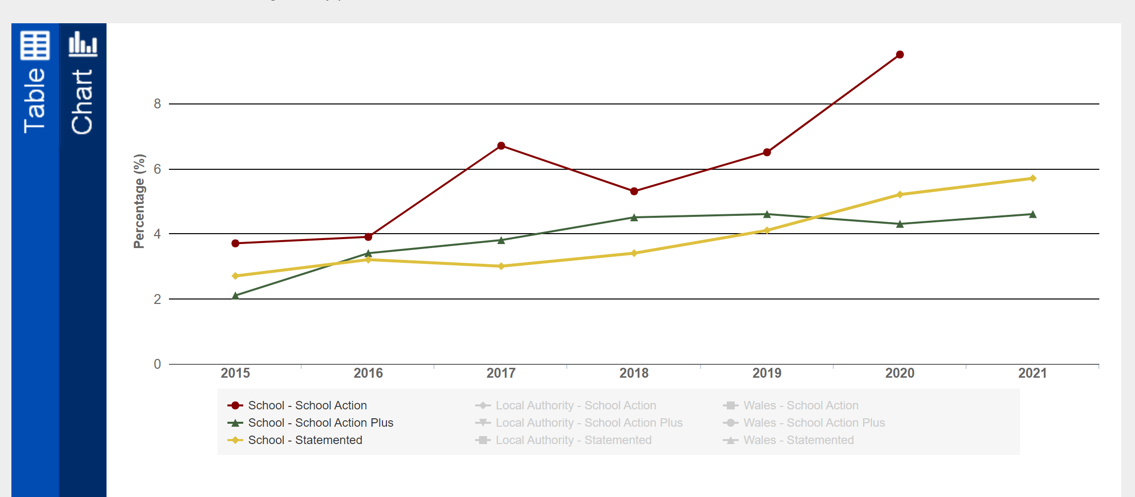
Fig 1. Showing increase of 5.8% of School Action Plans at School ‘X’ between 2015-2021

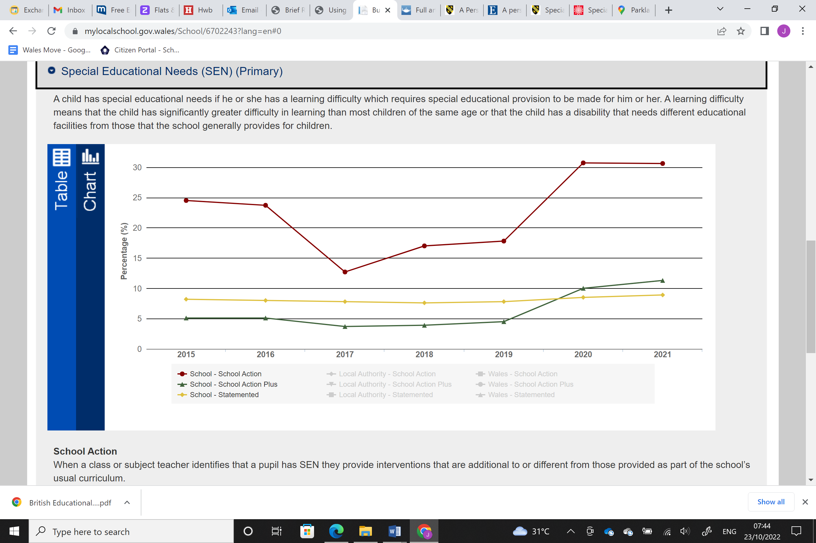

Fig 2. Neighbouring school (i) showing 7% increase in School Action plan between 2015-2021

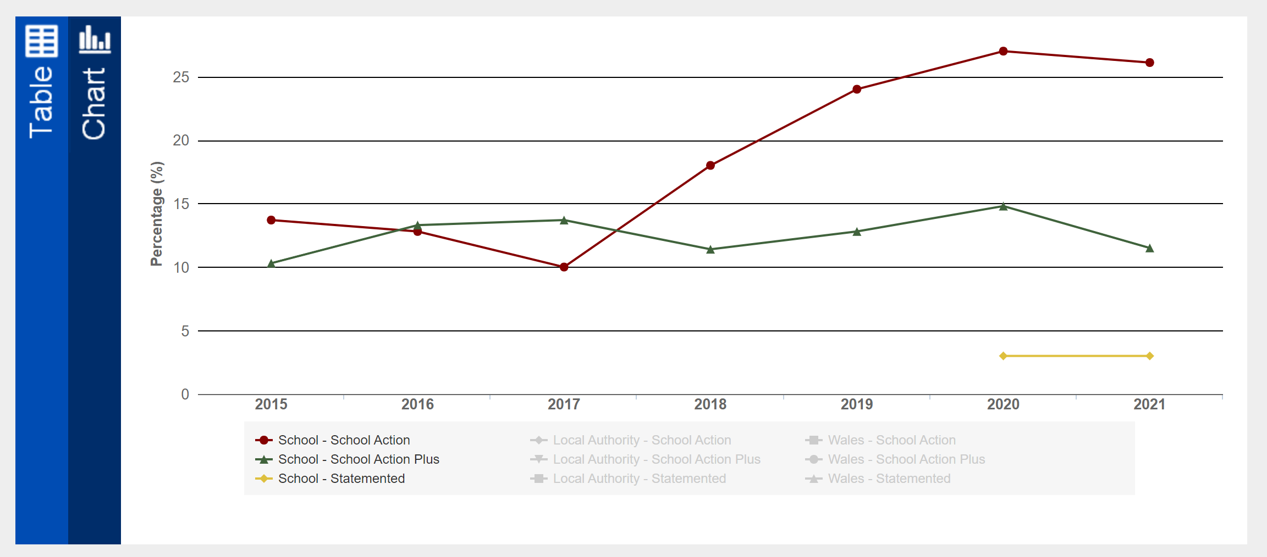

Fig 3. Neighbouring school (ii) showing 12.4% increase in School Action plan between 2015-2021

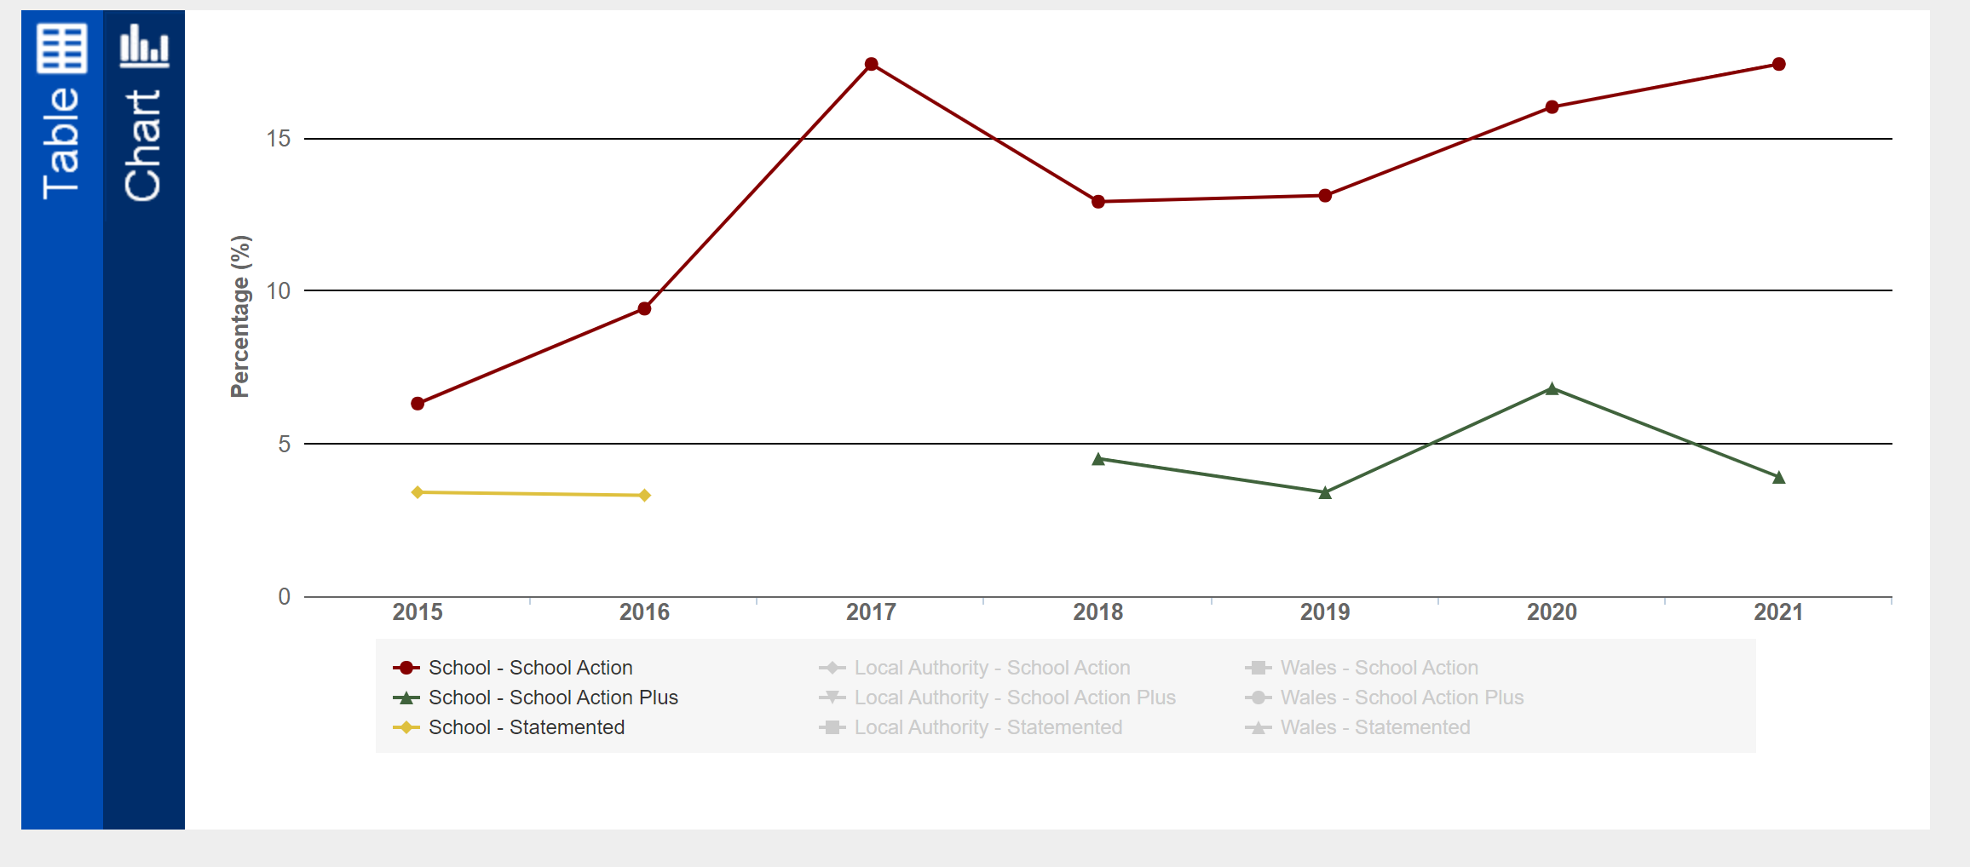
Fig 4. Neighbouring school (iii) showing 10.9% increase in School Action plans between 2015-2021

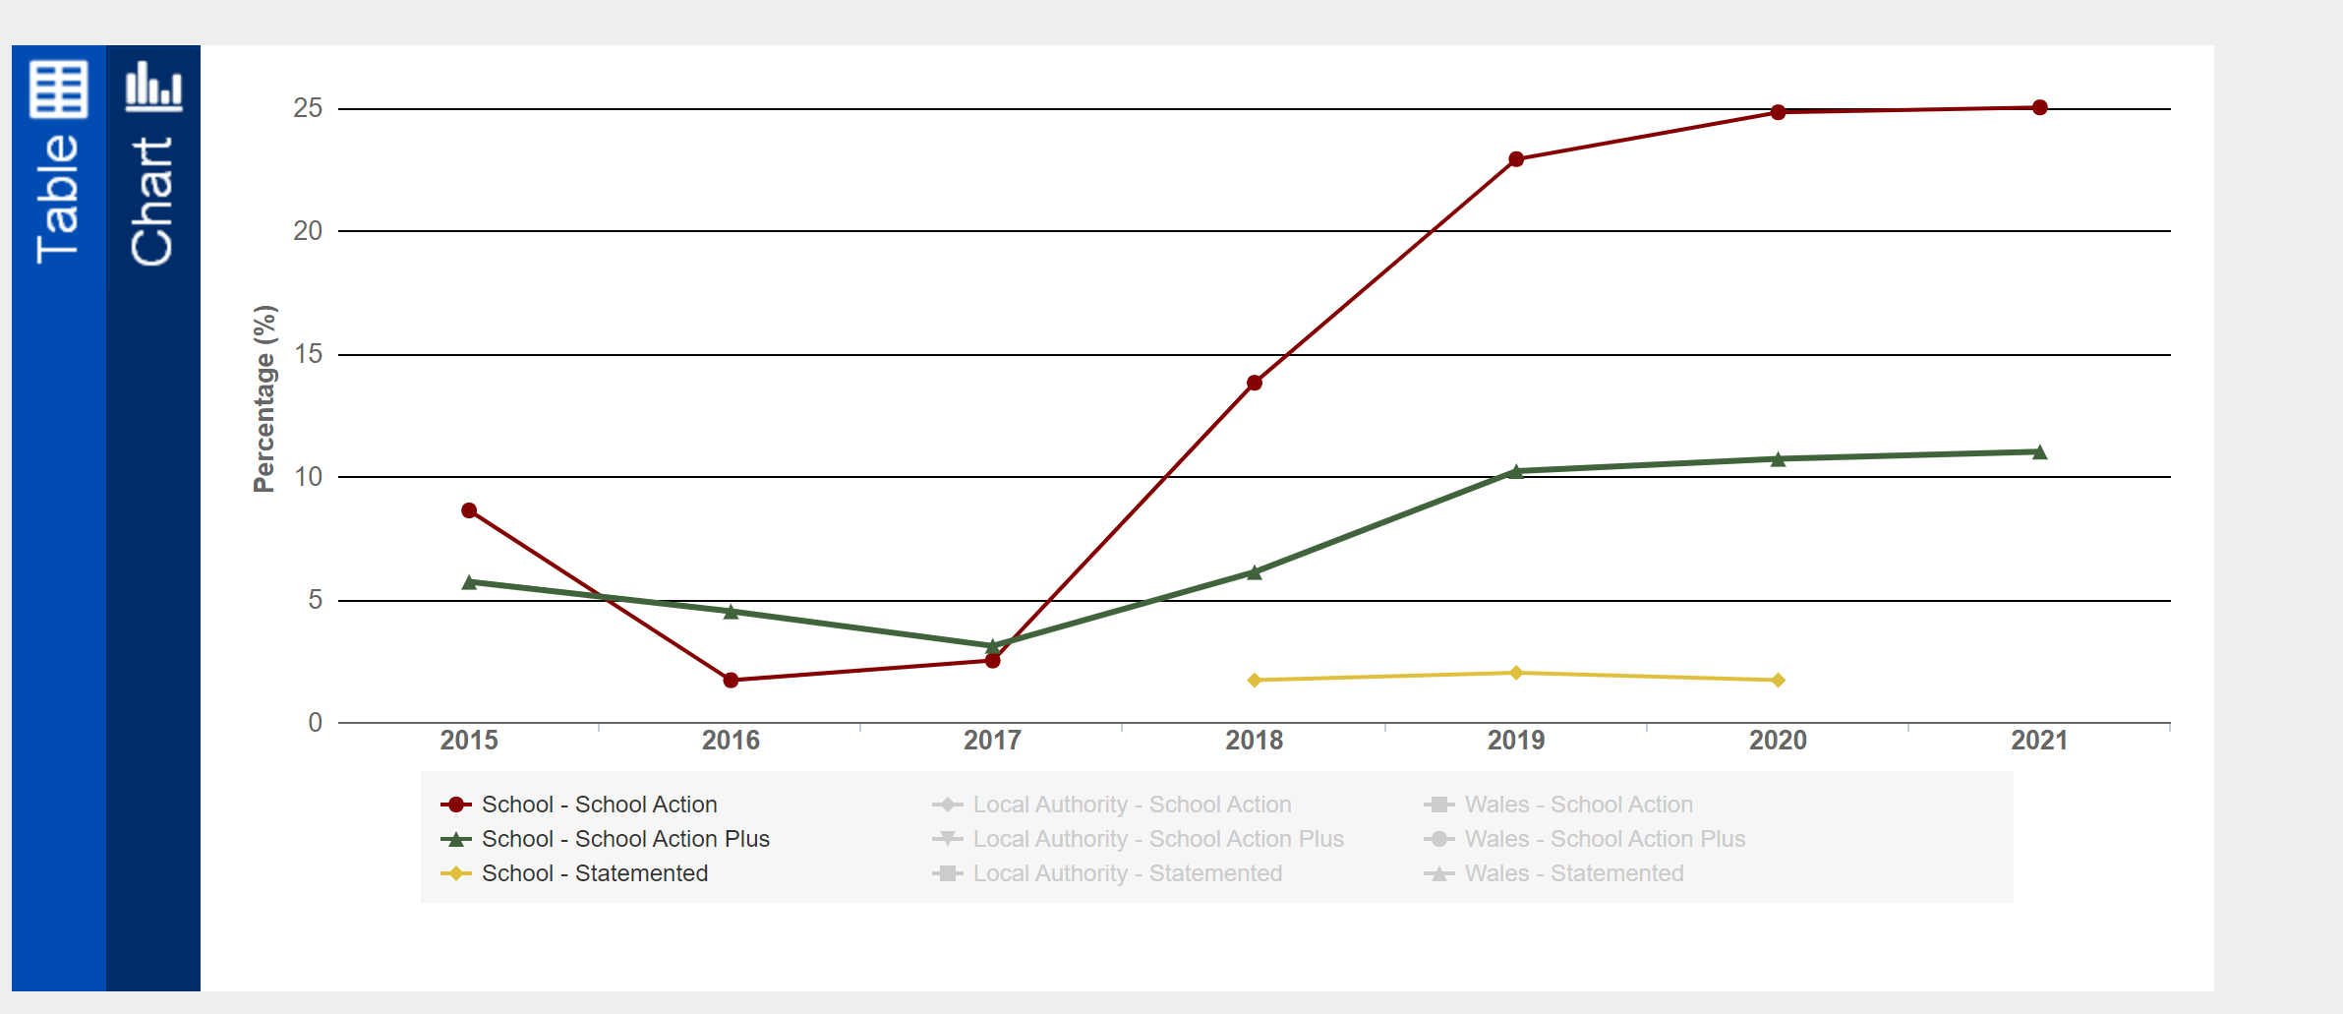
Fig 5. Neighbouring school (iv) showing 16.4% increase in School Action plans between 2015-2021

